High hydrogel SERS platform based on Ag-Au alloy nanoparticles and its application for quantitative analysis of methyl parathion and triazophos
Rongjing Hu^{1,#}, Shilan Fu^{2,#}, Jingwen Zhang¹, Jiadan Zhang¹, Fengfu Fu¹, Zhenyu Lin¹, Yongqiang Dong^{1,}*
¹MOE Key Laboratory for Analytical Science of Food Safety and Biology, College of Chemistry, Fuzhou University, Fuzhou, China
²School of Chemistry and Chemical Engineering, Shanghai Jiao Tong University, Shanghai 200240, China
*Corresponding author: dongyq@fzu.edu.cn (Y. Dong)
#These authors contributed equally: Rongjing Hu, Shilan Fu

EXPERIMENTAL SECTION
Instruments：TEM, HRTEM and cryo-TEM images were recorded on a HRTEM JEOL 2100 system operating at 200 kV. FTIR spectra were measured on a FTIR spectrophotometer (Thermo Nicolet 360). UV/Vis spectra were obtained by a UV/Vis spectrophotometer (Lambda 750). XRD pattern was obtained from a Rigaku D/max-3C (Japan) using Cu Ka radiation. XPS spectra of a-NRs were measured using an ESCAlab 250 XPS system having an Al K source. The SERS spectra data were measured by a Renishaw Invia Raman spectrometer, equipped with a laser of different 532nm). The laser power is ~8 mW, the laser spot is 1.25 μm² , and the accumulation time ias 10 s. The objective lens of the microscope was 50× magnification, with a numerical aperture of 0.5.

Calculation of the enhancement factor ^{[S1]}
The EFs were calculated according to the Equation 1:
EF=$\frac{I_{SERS}}{I_{NR}}$×$\frac{N_{NR}}{N_{SERS}}$ (1)
N_{NR} can be calculated according to the Equation 2:
$N_{NR}$=$\frac{A_{Raman}•h•ρ}{M}N_{A}$ (2)
N_{SERS} can be calculated according to the Equation 3:
$N_{SERS}$=C•V•$N_{A}\frac{A_{Raman}}{A_{Sub}}$ (3)
Thus, the EFs were finally calculated according to the Equation 4:
EF=$\frac{I_{SERS}}{I_{NR}}$×$\frac{A_{sub}•h•ρ}{M•C•V}$ (4)
where I_{SERS} represents the SERS intensity of the typical peak of the target molecule on the substrate, I_{NR} represents the normal Raman intensity of target molecule powder, N_{SERS} and N_{NR} are the corresponding molecule number in the laser excitation area in SERS measurements and normal Raman measurements, respectively, A_{Raman} is the laser spot area (1.26 μm in diameter) of Raman scanning, h is the confocal depth of the laser beam (70 μm here), ρ is the density of bulk target molecule, M is the molecular weight of target molecule, and N_{A} is Avogadro constant (6.02×10²³). C is the concentration of target molecule, V is the volume of the droplet (20 μL here), N_{A} is Avogadro constant, A_{Raman} is the laser spot area (1.25×10⁻¹² m² here), and A_{sub} is the area of the substrate (2.5×10⁻⁵ m² here).
For example, the EF of 4-MBA on the substrate could be calculated as following:
$EF = \frac{I_{SERS}}{I_{NR}}$×$\frac{A_{sub}•h•ρ}{M•C•V}$
= $\frac{6229}{4735}$×$\frac{2.5×{10}^{-5 }m^{2}×7{×10}^{-5} m×1.30{×10}^{6} g/m^{3}}{135.15 g/mol×1×{10}^{-12 }mol/L×2×{10}^{-4} L}$ $= 1.11×{10}^{11}$

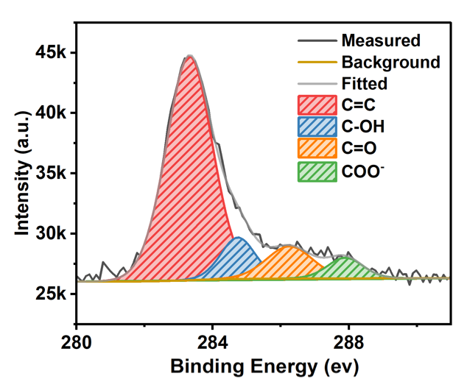
Figure S1. The high resolution XPS spectrum of C.

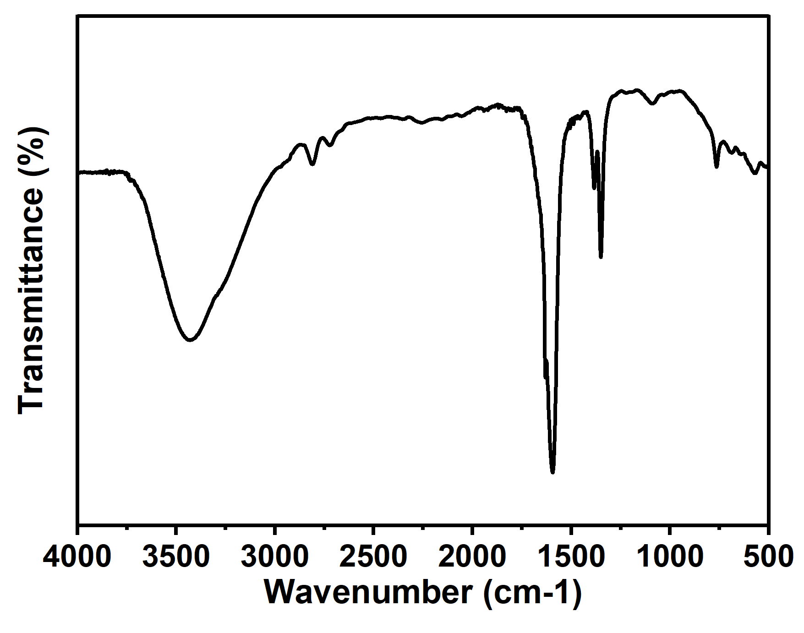
Figure S2. FTIR spectrum of Au/Ag-NPs.

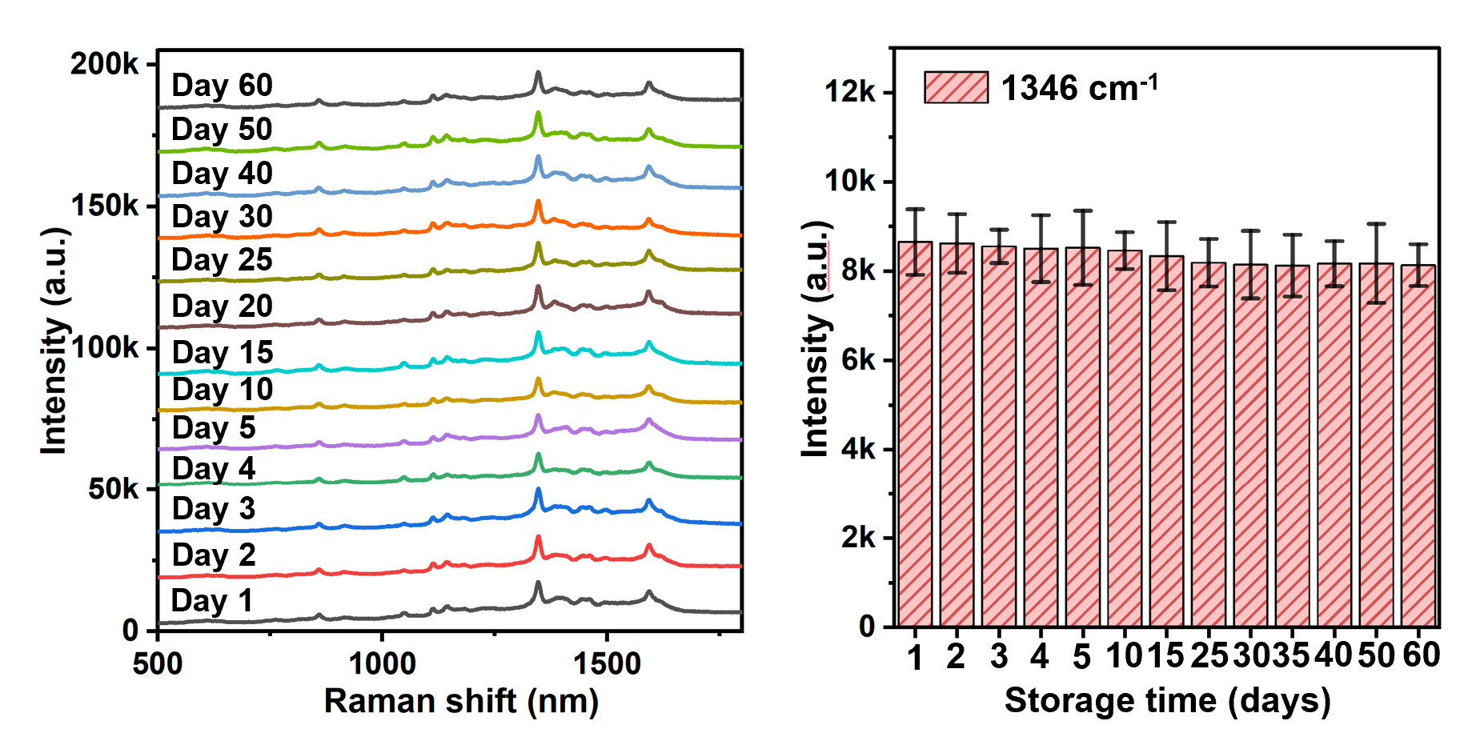
Figure S3. SERS spectra of 4-MBA (1 × 10⁻¹⁰ mol/L) on Au/Ag hydrogel SERS chips after different storage times (a). Effect of storage time on the SERS activities of Au/Ag hydrogel SERS chips, which is evaluated based on the typical peak intensity of 4-MBA at 1071 cm⁻¹ (b).

Computational Details:
DFT calculations were carried out with B3LYP^{1,2}/6-31G* method using the Gaussian 16 package³. Molecular orbital plots were made by using Multiwfn⁴ and VMD⁵.

Table S1. The calculated HOMO, LUMO energies, and HOMO-LUMO gap.
Compound | HOMO (eV) | LUMO (eV) | Gap (eV)
 | -6.664 | -1.418 | 5.246

Figure S4. The calculated molecular orbital plots: (a) HOMO and (b) LUMO.

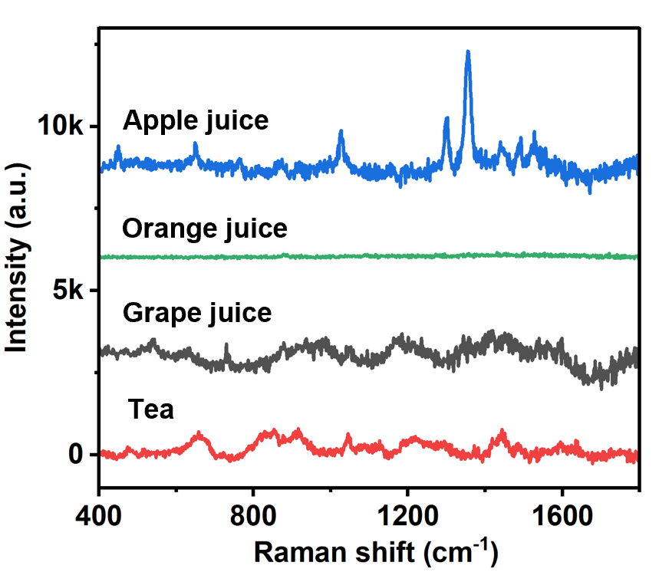
Figure S5. The background signals four real samples including apple, grape, orange and tea are used.

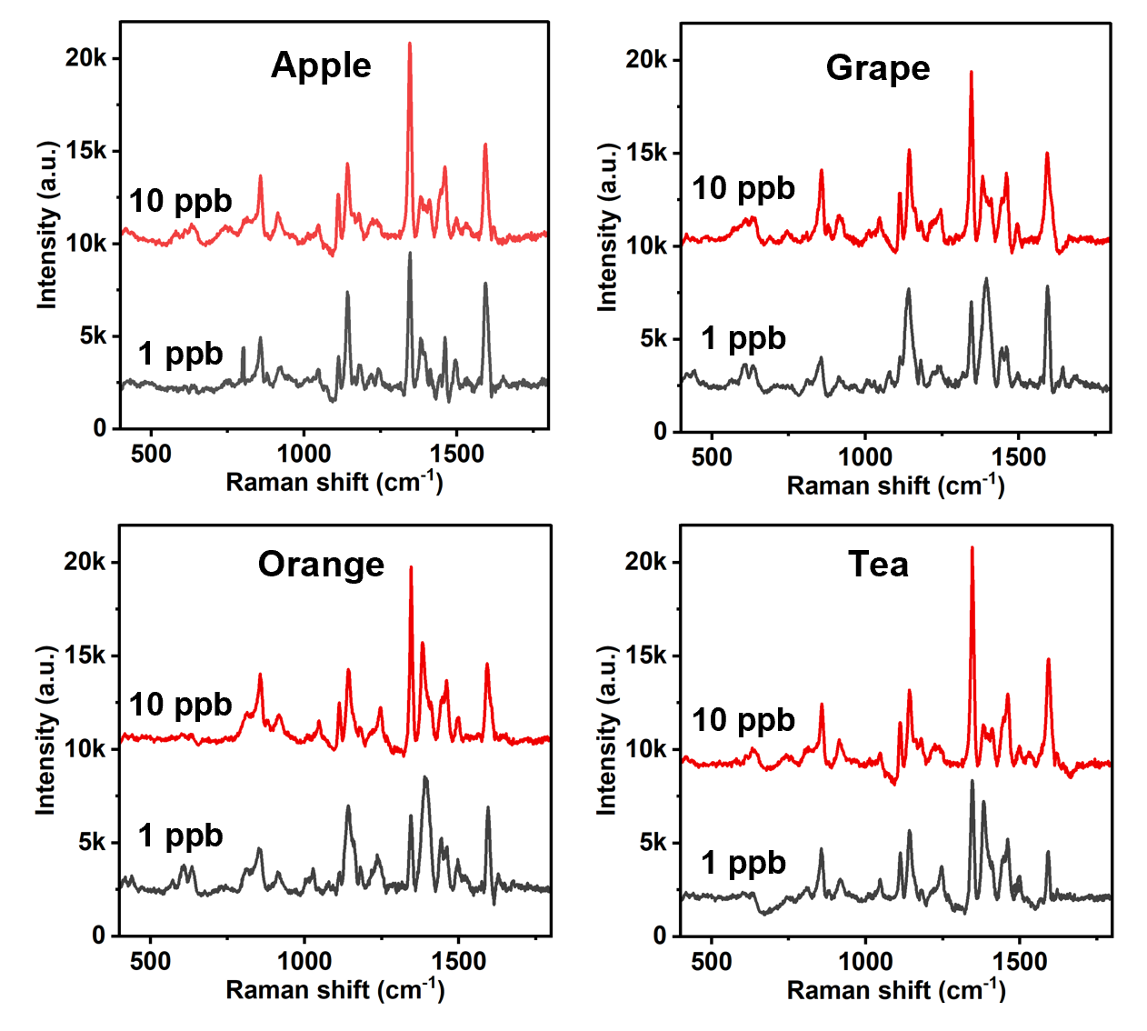
Figure S6. SERS spectra of collected aquaculture apple, grape, orange and tea spiked with different concentrations of methyl parathion.

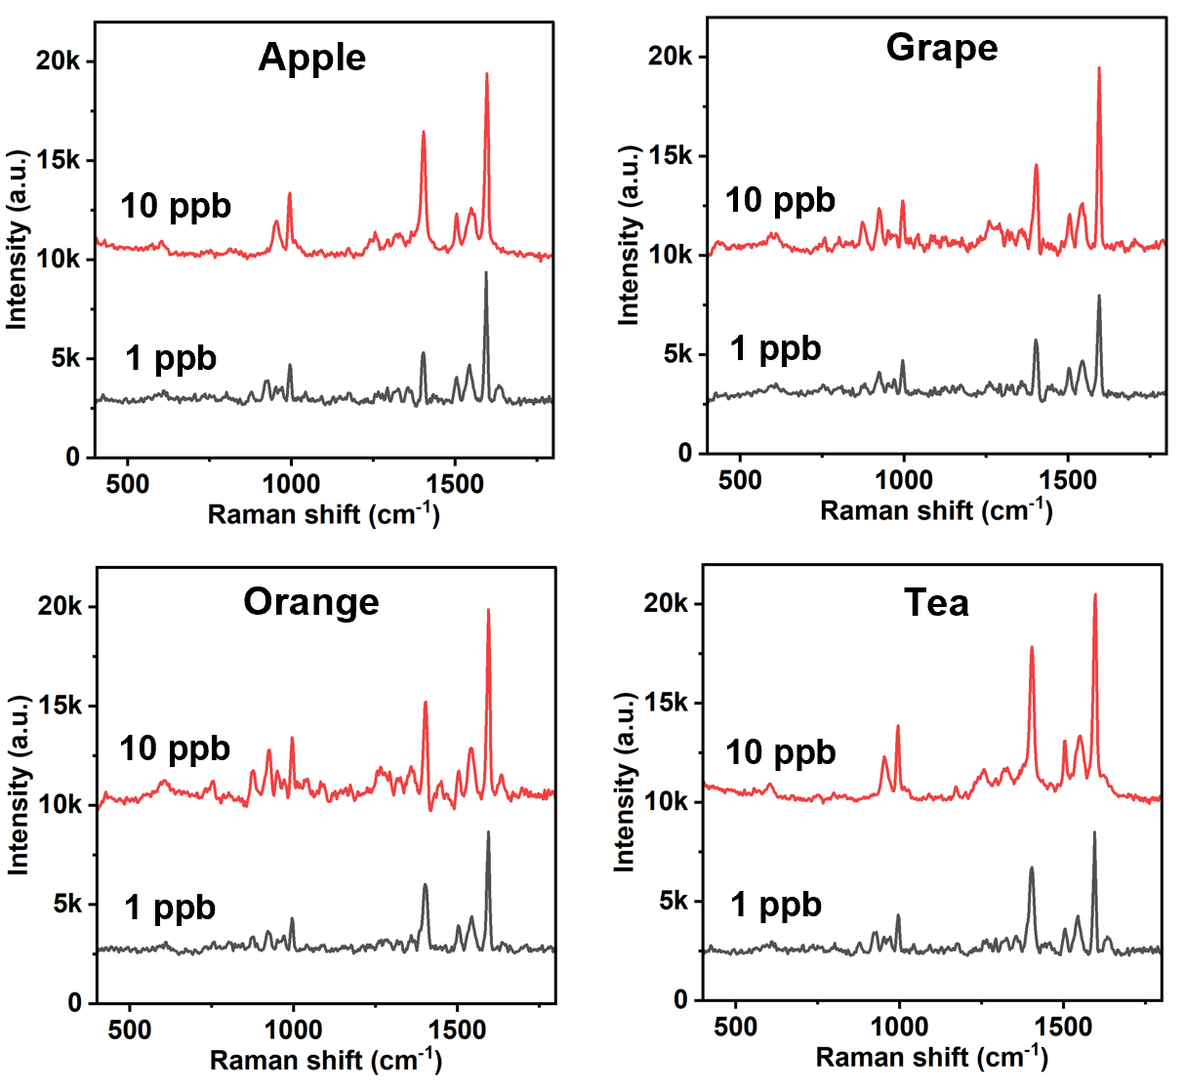
Figure S7. SERS spectra of collected aquaculture apple, grape, orange and tea spiked with different concentrations of triazophos.

Table S2: The application of SERS in methyl parathion detection.
Target analyte | SERS Substrate | LOD | Ref.
Methyl parathion | Silver nanocorals (AgNCs) | 0.17 ng/cm² | S2
Methyl parathion | Fe₃O₄@NH2-MIL-101(Fe)@Ag (FNMA) SERS nanosensor | 4.55 × 10⁻¹² M | S3
Methyl parathion | Ti3C2Tx (MXene)-noble substrate with flower-like Ag nanoparticles (AgNFs), | 2.8 ng/ mL | S4
Methyl parathion | graphene oxide (GO) and quantum-sized ZrO₂ nanoparticles (GO/ZrO₂) | 0.12 μM | S5
Methyl parathion | MP aptamer | 0.49 pM | S6
Methyl parathion | Ag nanoparticles (Ag NPs) onto the graphitic carbon nitride (g-C₃N₄) fake and molybdenum disulfde (MoS₂) nanofower. | 10− 6 mg/mL | S7
Methyl parathion | Au (50%)-Ag(50%) alloy plasmonic layer | 10 nM | S8
Methyl parathion | filter paper and gold nanoparticles (Au NPs) | 0.011 μg/cm² | S9
Methyl parathion | gold nanorod (Au NR) | 1 μM | S10
Methyl parathion | Ag/Au nanowires (NWs) on PDMS ﬁlm | 10−6 mg/mL | S11

Table S3: The application of SERS in triazophos detection
Target analyte | SERS Substrate | LOD | Ref.
Triazophos | Gold nanoparticles (AuNPs) spherical liquid array (SLA) | 0.005 µg/mL | S12
Triazophos | Hybridizing aggregated gold nanoparticles | 50 ppb | S13
Triazophos | Snowflake-like gold nanoparticles | 0.031 ng cm⁻² | S14
Triazophos | Silve-gold nanostars coated with graphene oxide (GO-SGNS) | 100 ppm | S15
Triazophos | Gold nanoparticles decorated 201 red silanized diatomaceous supports | 0.01 mg/L | S16
Triazophos | FeO-COOH@UiO-66/Au@Ag (FCUAA) | 2.96 × 10 mg/kg | S17
Triazophos | Biomimetic enzyme-linked immunosorbent assay (BELISA) of platinum nanoparticles (PtNPs) | 1 ng mL^{–1} | S18

References
S1. Lee, C.; Yang, W.; Parr, R. G. Development of The Colle-Salvetti Correlation-Energy Into A Function of The Electron Density. Phys. Rev. B: Condens. Matter 1988, 37, 785–789.
S2. Becke, A. D. Density‐Functional Thermochemistry. III. The Role of Exact Exchange. J. Chem. Phys. 1993, 98, 5648–5652.
S3. Frisch, M. J.; Trucks, G. W.; Schlegel, H. B.; Scuseria, G. E.; Robb, M. A.; Cheeseman, J. R.; Scalmani, G.; Barone, V.; Petersson, G. A.; Nakatsuji, H.; Li, X.; Caricato, M.; Marenich, A. V.; Bloino, J.; Janesko, B. G.; Gomperts, R.; Mennucci, B.; Hratchian, H. P.; Ortiz, J. V.; Izmaylov, A. F.; Sonnenberg, J. L.; Williams-Young, D.; Ding, F.; Lipparini, F.; Egidi, F.; Goings, J.; Peng, B.; Petrone, A.; Henderson, T.; Ranasinghe, D.; Zakrzewski, V. G.; Gao, J.; Rega, N.; Zheng, G.; Liang, W.; Hada, M.; Ehara, M.; Toyota, K.; Fukuda, R.; Hasegawa, J.; Ishida, M.; Nakajima, T.; Honda, Y.; Kitao, O.; Nakai, H.; Vreven, T.; Throssell, K.; Montgomery, J. A., Jr.; Peralta, J. E.; Ogliaro, F.; Bearpark, M. J.; Heyd, J. J.; Brothers, E. N.; Kudin, K. N.; Staroverov, V. N.; Keith, T. A.; Kobayashi, R.; Normand, J.; Raghavachari, K.; Rendell, A. P.; Burant, J. C.; Iyengar, S. S.; Tomasi, J.; Cossi, M.; Millam, J. M.; Klene, M.; Adamo, C.; Cammi, R.; Ochterski, J. W.; Martin, R. L.; Morokuma, K.; Farkas, O.; Foresman, J. B.; Fox, D. J. Gaussian 16, Revision C.01; Gaussian, Inc.: Wallingford CT, 2016.
S4. Lu, T.; Chen, F. Multiwfn: A Multifunctional Wavefunction Analyzer. J. Comput. Chem. 2012, 33, 580–592.
S5. Humphrey, W.; Dalke, A.; Schulten, K. VMD: Visual Molecular Dynamics. J. Mol. Graph. 1996, 14, 33–38.
S6. Shao, J. D.; Tong, L. P.; Tang, S. Y. Z.; Guo, N.; Zhang, H.; Li, P. H.; Wang, H. Y.; Du, C.; Yu, X. F., PLLA nanofibrous paper-based plasmonic substrate with tailored hydrophilicity for focusing SERS Detection. Acs Appl. Mater. & Interf., 2015,7(9): 5391-5399.
S7. Zheng, W.; Li, M.; Zhang, Z.; Lou, Z.; Liu, Y.; Yao, Y.; Chen, L.; Lin, B.; Wang, Y.; Guo, L., On-site preparation of sandwich plasmonic coupled SERS tape toward pesticide residue determination on food surface. Micro. Acta 2024, 191:224.
S8. Yang, N.; Pu, H.; Sun, D.-W., Developing a magnetic SERS nanosensor utilizing aminated Fe-Based MOF for ultrasensitive trace detection of organophosphorus pesticides in apple juice. Food Chem. 2024, 446(15): 138846.
S9. Xiong, S.; Wang, D.; Qiu, H.; He, T.; Wang, C.; Wang, Y.; Dai, C.; Liu, W., Toward Flexible Metal Semiconductor Sandwich Surface-Enhanced Raman scattering (SERS) sensors Pesticide Duplex Detection. Materi. Design 2023, 229.
S10. Vargas-Zamarripa, M.; Rivera, A. A.; Sierra, U.; Salas, P.; Serafín-Muñoz, A. H.; Ramírez-García, G., Improved charge-transfer resonance in graphene oxide/ZrO₂ substrates for plasmonic-free SERS determination of methyl parathion. Chemosphere 2023, 320: 138081
S11. Guo, W.; Hu, C.; Li, S.; Wei, D.; Zhou, J.; Liu, X.; Chen, H.; Li, S.; Deng, Y., Selection and electrochemical-sensor application of an DNA-aptamer for methyl parathion detection. Anal. Chim. Acta 2023, 1241(8) 340780.
S12. Wang, R.; Ma, J.; Dai, X.; Gao, Y.; Gu, C.; Jiang, T., Highly active SERS chip with both structure-ameliorated chemical enhancement and nanocavity-mediated electromagnetic enhancement. Sensor. Actuat. B 2023, 374(1): 132782.
S13. Midha, S.; Sarkar, S., Is 3D surface structuring always a prerequisite for effective SERS? Surf. Interf. 2022, 33:102223.
S14. Xie, J.; Li, L.; Khan, I. M.; Wang, Z.; Ma, X., Flexible paper-based SERS substrate strategy for rapid detection of methyl parathion on the surface of fruit. Spectrochimica Acta Part A: Molecul. Biom. Spec. 2020, 231.
S15. Wu, H.; Luo, Y.; Hou, C.; Huo, D.; Wang, W.; Zhao, J.; Lei, Y., Rapid and fingerprinted monitoring of pesticide methyl parathion on the surface of fruits/leaves as well as in surface water enabled by gold nanorods based casting-and-sensing SERS platform. Talanta 2019, 200, (1): 84-90.
S16. Ma, Y.; Du, Y.; Chen, Y.; Gu, C.; Jiang, T.; Wei, G.; Zhou, J., Intrinsic Raman signal of polymer matrix induced quantitative multiphase SERS analysis based on stretched PDMS film with anchored Ag nanoparticles/Au nanowires. Chem. Eng. J.2019, 381(1): 122710.
S17. Wei, Q.; Pan, C.; Wang, T.; Pu, H.; Sun, D.-W., A three-dimensional gold nanoparticles spherical liquid array for SERS sensitive detection of pesticide residues in apple. Spectrochim. Acta, Part A 2024, 304.
S18. Zhang, J.; Zhu, X.; Chen, M.; Chen, T.; Liu, Z.; Huang, J.; Fu, F.; Lin, Z.; Dong, Y., Hybridizing aggregated gold nanoparticles with a hydrogel to prepare a flexible SERS chip for detecting organophosphorus pesticides. Analyst 2022, 147: 2802-2808.
S19. Huang, D.; Zhao, J.; Wang, M.; Zhu, S., Snowflake-like gold nanoparticles as SERS substrates for the sensitive detection of organophosphorus pesticide residues. Food Control 2020, 108.
S20. Atta, S.; Sharaf, T.; Vo-Dinh, T., Rapid Solution-Based SERS Detection of Pesticides Using Graphene Oxide-Coated Silver–Gold Nanostars. ACS Appl. Nano Mater. 2024, 10(7): 11518–11529.
S21. Zhang, H.; Sun, L.; Zhang, Y.; Kang, Y.; Hu, H.; Tang, H.; Du, Y., Production of stable and sensitive SERS substrate based on commercialized porous material of silanized support. Talanta 2017. 174(1): 301-306.
S22. Lv, M.; Pu, H.; Sun, D.-W., A tailored dual core-shell magnetic SERS substrate with precise shell-thickness control for trace organophosphorus pesticides residues detection. Spectrochim. Acta, Part A 2024, 316.
S23. Yan, M.; Chen, G.; She, Y.; Ma, J.; Hong, S.; Shao, Y.; Abd El-Aty, A. M.; Wang, M.; Wang, S.; Wang, J., Sensitive and Simple Competitive Biomimetic Nanozyme-Linked Immunosorbent Assay for Colorimetric and Surface-Enhanced Raman Scattering Sensing of Triazophos. J. Agric. Food Chem. 2019, 67(34): 9658–9666.

