Appendix 1 : Studies Excluded at Full-Text Review with Reasons for Exclusion

A total of 27 studies were excluded following full-text review. Reasons for exclusion are categorised according to the primary criterion not met.

# | Study | Full Citation | Exclusion Reason | Explanation
1 | Abuhasira 2022 | Abuhasira R et al. Intensive care unit capacity and mortality in older adults: a three nations retrospective observational cohort study. Ann Intensive Care. 2022;12(1):20. | Wrong strain metric | Strain metric did not meet inclusion criteria for real-time direct measurement of ICU activity
2 | Carlesi 2017 | Carlesi KC et al. Patient Safety Incidents and Nursing Workload. Rev Latino-Am Enfermagem. 2017;25:e2841. | Wrong setting | Study included a number of non-ICU settings
3 | Castro-Avila 2023 | Castro-Avila A et al. Six-month post-intensive care outcomes during high and low bed occupancy due to the COVID-19 pandemic. PLoS One. 2023;18(11):e0294631. | Wrong strain metric | Strain metric did not meet inclusion criteria for real-time direct measurement of ICU activity
4 | Duggal 2022 | Duggal A, Mathews KS. Impact of ICU strain on outcomes. Curr Opin Crit Care. 2022;28(6):667–673. | Wrong study design | Narrative review; no primary data analysis
5 | French 2021 | French G et al. Impact of Hospital Strain on Excess Deaths During the COVID-19 Pandemic — United States, July 2020–July 2021. MMWR Morb Mortal Wkly Rep. 2021;70(46):1613–1616. | Wrong study design | Ecological analysis; strain metrics not measured at individual ICU level at ≤24-hour intervals
6 | Kennedy 2020 | Kennedy TK, Numa A. Factors associated with discharge delay and direct discharge home from paediatric intensive care. J Paediatr Child Health. 2020;56(7):1101–1107. | Wrong strain metric | Discharge delay used as outcome rather than as a strain metric; strain not directly measured
7 | Kohn 2016 | Kohn R, Halpern SD, Kerlin MP. The implications of intensive care unit capacity strain for the care of critically ill patients. Rev Bras Ter Intensiva. 2016;28(4):366–368. | Wrong study design | Editorial/commentary; no primary data analysis
8 | Laffey 2016 | Laffey JG et al. Potentially modifiable factors contributing to outcome from acute respiratory distress syndrome: the LUNG SAFE study. Intensive Care Med. 2016;42(12):1865–1876. | Wrong strain metric | Strain metric did not meet inclusion criteria for real-time direct measurement of ICU activity
9 | Mathews 2018 | Mathews KS et al. Effect of Emergency Department and ICU Occupancy on Admission Decisions and Outcomes for Critically Ill Patients. Crit Care Med. 2018;46(5):720–727. | Wrong setting | Focus on emergency department occupancy; ICU impact not assessed independently
10 | Ohbe 2024 | Ohbe H, Matsui H, Yasunaga H. Regional Critical Care Bed Capacity and Incidence and Mortality of Mechanical Ventilation in Japan. Am J Respir Crit Care Med. 2024;210(3):358–361. | Wrong strain metric | Regional bed capacity used as exposure; not a real-time measure of ICU-level strain
11 | Olivieri 2021 | Olivieri A, Palù G, Sebastiani G. COVID-19 cumulative incidence, intensive care, and mortality in Italian regions compared to selected European countries. Int J Infect Dis. 2021;102:363–368. | Wrong strain metric | Country/region-level ICU utilisation data; not a real-time ICU-level strain metric
12 | Ou 2016 | Ou X, Hua Y. Patient Mortality Is Associated With Staff Resources and Workload in the ICU. Crit Care Med. 2016;44(2):e108–9. | Wrong study design | Letter to the editor; no primary data analysis
13 | Rubinson 2021 | Rubinson L. Intensive Care Unit Strain and Mortality Risk Among Critically Ill Patients With COVID-19. JAMA Netw Open. 2021;4(1):e2035041. | Wrong study design | Editorial/invited commentary; no primary data analysis
14 | Santos 2021 | Santos AC et al. Intensive Care Unit prioritization: The impact of ICU bed availability on mortality in critically ill patients who requested ICU admission in court in a Brazilian cohort. J Crit Care. 2021;66:126–131. | Wrong strain metric | ICU bed availability assessed as access to admission rather than as a real-time operational strain metric
15 | Stretch 2018 | Stretch R et al. Effect of Boarding on Mortality in ICUs. Crit Care Med. 2018;46(4):525–531. | Wrong strain metric | Boarding (delayed admission) used as exposure; this is a downstream consequence of strain rather than a direct real-time measure
16 | Tran 2016 | Tran B. ICU Capacity Strain. Crit Care Alert. 2016;24(2):9–13. | Wrong study design | Narrative review/commentary; no primary data analysis
17 | Tran 2019 | Tran DT et al. Association between strained ICU capacity and healthcare costs in Canada. J Crit Care. 2019;51:175–183. | Wrong outcomes | Outcomes reported were healthcare costs (economic); no clinical patient outcomes assessed
18 | Veleze 2024 | Veleze DR, Duncan AJ, Zreik K. Traumatic Brain Injury Patients Admitted on High-Census Days Receive Less Critical Care and Have an Increased Risk for Delirium. Cureus. 2024;16(8):e65957. | Wrong strain metric | High-census days in hospital used as proxy exposure; strain metric not directly or prospectively measured
19 | Wang 2024 | Wang L et al. Association of medical care capacity and the patient mortality of septic shock: a cross-sectional study. Anaesth Crit Care Pain Med. 2024;43(3):101364. | Wrong strain metric | Medical care capacity measured at hospital/regional level; not a real-time ICU-specific strain metric
20 | Wortel 2021 | Wortel SA et al. Number of intensivists per bed is associated with efficiency of Dutch intensive care units. J Crit Care. 2021;62:223–229. | Wrong outcomes | Primary outcome was ICU efficiency in terms of resource utilisation; Strain metric was also measured by using number of employed intensivists rather then actual real time capacity
21 | Demoule 2022 | Demoule A et al. ICU strain and outcome in COVID-19 patients — A multicenter retrospective observational study. PLoS One. 2022;17(7):e0271358. | Wrong strain metric | ICU strain measured as a time-averaged occupancy measure rather than a direct, real-time ICU-specific metric meeting the ≤24-hour measurement interval criterion
22 | Faisy 2016 | Faisy C et al. Nurse workload and inexperienced medical staff members are associated with seasonal peaks in severe adverse events in the adult medical intensive care unit: A seven-year prospective study. Int J Nurs Stud. 2016;62:60–70. | Wrong strain metric | Workload measured as seasonal staffing patterns rather than a contemporaneous real-time metric
23 | Gershengorn 2022 | Gershengorn HB et al. Association of patient-to-intensivist ratio with hospital mortality in Australia and New Zealand. Intensive Care Med. 2022;48(2):179–189. | Wrong strain metric | Patient-to-intensivist ratio measured from annual resourcing metrics , not a dynamic real-time measure of ICU strain
24 | Wilson 2024 | Wilson T, Nolte D, Omar S. Bed occupancy and nosocomial infections in the intensive care unit: A retrospective observational study in a tertiary hospital. S Afr J Crit Care. 2024;40(2):71–75. | Wrong strain metric | ICU strain measured as a time-averaged occupancy measure rather than a direct, real-time ICU-specific metric meeting the ≤24-hour measurement interval criterion
25 | Choi 2016 | Choi M, Lee HS. Critical Patient Severity Classification System predicts outcomes in intensive care unit patients. Nurs Crit Care. 2016;21(4):206–213. | Wrong strain metric | Strain metric is a patient acuity/severity classification score; explicitly excluded per protocol as these are derived from patient-level mortality risk rather than real-time operational ICU activity
26 | Hall 2018 | Hall AM et al. Association between afterhours admission to the intensive care unit, strained capacity, and mortality: a retrospective cohort study. Crit Care. 2018;22(1):97. | Wrong strain metric | After-hours admission used as the primary strain exposure; this is a downstream operational response to antecedent pressure rather than a direct contemporaneous measure of ICU workload or capacity
27 | Harris 2018 | Harris S et al. Impact on mortality of prompt admission to critical care for deteriorating ward patients: an instrumental variable analysis using critical care bed strain. Intensive Care Med. 2018;44(5):606–615. | Wrong strain metric | Critical care bed strain used as an instrumental variable rather than as the primary exposure of interest; strain metric not directly validated against outcomes

Appendix 2: Search Strategy
OVID Medline
- ("Intensive care" OR (intensive adj2 (department* OR unit*)) OR "Critical Care" OR "Critical* ill*" OR (ICU* OR NICU* OR PICU*) OR (HDU OR "High dependency") OR Intensivist*).tw.
- Intensive Care Units/ OR Critical Illness/ OR Critical Care Nursing/
- Bed Occupancy/ OR Workload/ OR Resource Allocation/ OR Health Resources/
- (("Intensive care" OR (intensive adj2 (department* OR unit*)) OR "Critical Care" OR "Critical* ill*" OR (ICU* OR NICU* OR PICU*) OR (HDU OR "High dependency") OR Intensivist*) adj2 Strain).tw.
- (1 OR 2)
- (5 AND 3) OR 5
- Limit 7 to yr="2016 – Current"

EMBASE
  - (("Intensive care*" adj2 (department* OR unit*)) OR "Critical Care" OR "Critical* ill" OR (ICU* OR NICU* OR PICU*) OR (HDU OR "High dependency") OR Intensivist*).ti,ab.
  - (Strain OR Stress OR Occupancy OR Capacity OR Demand OR Busy OR Activity OR bed* OR workload OR caseload OR Census).ti,ab.
  - ((("Intensive care*" adj2 (department* OR unit*)) OR "Critical Care" OR "Critical* ill" OR (ICU* OR NICU* OR PICU*) OR (HDU OR "High dependency") OR Intensivist*) adj3 (Strain OR Stress OR Occupancy OR Capacity OR Demand OR Busy OR Activity OR bed* OR workload OR caseload OR Census)).ti,ab.
  - "Intensive Care Units"/ OR "Critical Illness"/ OR "Critical Care Nursing"/
  - "Bed Occupancy"/ OR Workload/ OR "Resource Allocation"/ OR "Health Care Rationing"/ OR "Efficiency, Organizational"/ OR "Health Services Accessibility"/ OR "Health Resources"/ OR "Hospital Bed Capacity"/ OR "Patient Discharge"/
  - 4 AND 5
  - 3 AND 6
  - Limit 7 to yr="2016–2024"
  - Limit 8 to conference abstract status
  - 8 NOT 9
  - Limit 10 to "remove medline records"

Web of Science
(
((("Intensive care*" NEAR/2 (department* OR unit*)) OR "Critical Care" OR "Critical* ill" OR (ICU* OR NICU* OR PICU*) OR (HDU OR "High dependency") OR Intensivist*) NEAR/3 (Strain OR Stress OR Occupancy OR Capacity OR Demand OR Busy OR Activity OR bed* OR workload OR caseload OR Census))
)
AND
(
("Intensive Care Units" OR "Critical Illness" OR "Critical Care Nursing")
AND
("Bed Occupancy" OR Workload OR "Resource Allocation" OR "Health Care Rationing" OR "Efficiency, Organizational" OR "Health Services Accessibility" OR "Health Resources" OR "Hospital Bed Capacity" OR "Patient Discharge")
)

CINAHL
( ((((TI "Intensive care*" OR AB "Intensive care*") N2 ((TI department* OR AB department*) OR (TI unit* OR AB unit*))) OR (TI "Critical Care" OR AB "Critical Care") OR (TI "Critical* ill" OR AB "Critical* ill") OR ((TI ICU* OR AB ICU*) OR (TI NICU* OR AB NICU*) OR (TI PICU* OR AB PICU*)) OR ((TI HDU OR AB HDU) OR (TI "High dependency" OR AB "High dependency")) OR (TI Intensivist* OR AB Intensivist*)) N3 ((TI Strain OR AB Strain) OR (TI Stress OR AB Stress) OR (TI Occupancy OR AB Occupancy) OR (TI Capacity OR AB Capacity) OR (TI Demand OR AB Demand) OR (TI Busy OR AB Busy) OR (TI Activity OR AB Activity) OR (TI bed* OR AB bed*) OR (TI workload OR AB workload) OR (TI caseload OR AB caseload) OR (TI Census OR AB Census))) )

AND

( ((MH "Intensive Care Units") OR (MH "Critical Illness") OR (MH "Critical Care Nursing")) AND ((MH "Bed Occupancy") OR (MH Workload) OR (MH "Resource Allocation") OR (MH "Health Care Rationing") OR (MH "Efficiency, Organizational") OR (MH "Health Services Accessibility") OR (MH "Health Resources") OR (MH "Hospital Bed Capacity") OR (MH "Patient Discharge")) )

Appendix 3: Risk of Bias Scores

Study | Representativeness | Non Exposed | Exposure Ascertainment | Outcome Not Present | Comparability | Outcome Assessment | FollowupDuration | Followup Adequacy | Selection Score | Comparability Score | Outcome Score | Total Score
Anesi 2018 | C | A | A | A | A/b | B | A | B | 3 | 2 | 3 | 8
Anesi 2020 | C | A | A | A | A/b | B | A | C | 3 | 2 | 2 | 7
Bagshaw 2018 | B | A | A | A | A/b | A | A | B | 4 | 2 | 3 | 9
Bihari 2021 | B | A | A | A | A/b | B | A | C | 4 | 2 | 2 | 8
Blayney 2018 | A | A | A | A | C | C | A | B | 4 | 0 | 2 | 6
Campbell 2024 | B | A | A | A | A/b | B | A | A | 4 | 2 | 3 | 9
Beltempo 2023 | C | A | A | A | A/b | B | A | B | 3 | 2 | 3 | 8
Cardoso 2019 | C | A | A | A | A/b | B | A | B | 3 | 2 | 3 | 8
Choi 2016 | C | A | A | A | B | B | A | B | 3 | 1 | 3 | 7
Choi 2024 | B | A | A | A | B | B | A | B | 4 | 1 | 3 | 8
Endo 2024 | B | A | A | A | A/b | B | A | B | 4 | 2 | 3 | 9
Ergan 2016 | B | A | A | A | A/b | B | A | A | 4 | 2 | 3 | 9
Ersoy 2017 | C | A | A | A | 0 | B | A | A | 3 | 0 | 3 | 6
Fasoi 2021 | C | A | A | A | C | B | A | A | 3 | 0 | 3 | 6
Fergusson 2020a | C | A | A | A | A/b | B | A | B | 3 | 2 | 3 | 8
Fergusson 2020b | C | A | A | A | A/b | B | A | C | 3 | 2 | 2 | 7
Fundora 2021 | C | A | A | A | A/b | B | A | A | 3 | 2 | 3 | 8
Hua 2016 | B | A | A | A | A/b | B | A | B | 4 | 2 | 3 | 9
Johnson 2024 | C | A | A | A | B | B | A | B | 3 | 1 | 3 | 7
Kahn 2023 | A | A | A | A | A/b | B | A | B | 4 | 2 | 3 | 9
Kim 2016 | B | A | A | A | A/b | B | A | D | 4 | 2 | 2 | 8
Kim 2025 | C | A | A | A | A/b | B | A | B | 3 | 2 | 3 | 8
Lee 2017 | C | A | B | A | A/b | B | A | B | 3 | 2 | 3 | 8
Ohnstad 2023 | C | A | A | A | C | B | A | B | 3 | 0 | 3 | 6
Parpucu 2024 | B | A | A | A | 0 | B | A | D | 4 | 0 | 2 | 6
Pilcher 2023 | A | A | A | A | A/b | B | A | B | 4 | 2 | 3 | 9
Roos-Blom 2020 | C | A | A | A | A/b | B | A | A | 3 | 2 | 3 | 8
Sagy 2021 | C | A | A | A | B | B | A | B | 3 | 1 | 3 | 7
Chung 2024 | C | A | A | A | A/b | B | A | A | 3 | 2 | 3 | 8
Wilcox 2020 | A | A | A | A | A/b | B | A | B | 4 | 2 | 3 | 9
Wilcox 2022 | A | A | A | A | A/B | a | a | b | 4 | 2 | 3 | 9
Wilde 2021 | C | A | A | a | B | B | A | B | 3 | 1 | 3 | 7
Zajic 2024 | B | A | A | A | A/B | B | A | b | 4 | 2 | 3 | 9
Zhilkova 2023 | A | A | A | A | A/B | B | A | A | 4 | 2 | 3 | 9
Gulin 2024 | C | A | A | A | A/B | B | A | A | 3 | 2 | 3 | 8

Appendix 4a: Impact of increasing strain on ICU mortality and Hospital Mortality
Left column labelled with strain metric

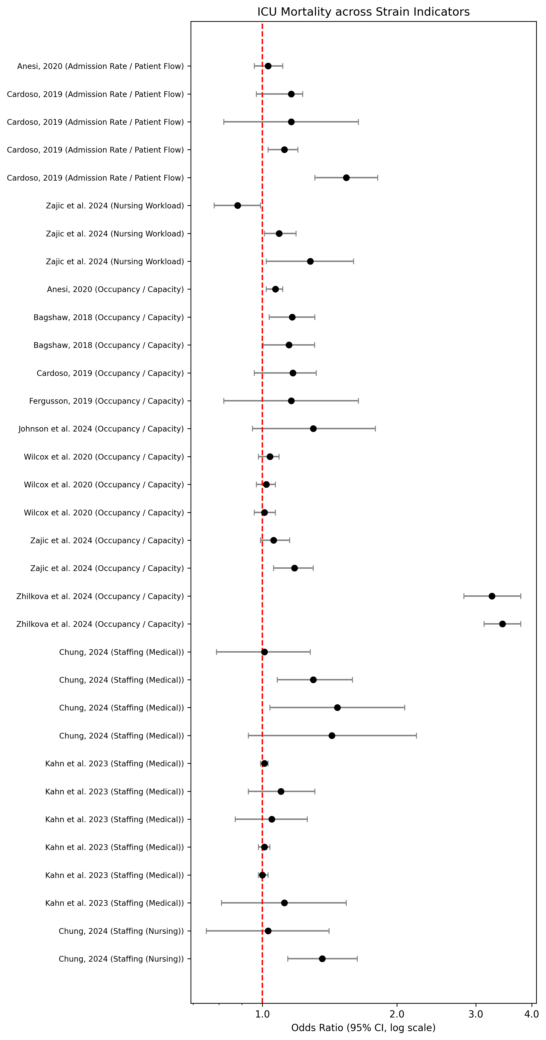

Appendix 4b: Impact of increasing strain on Hospital mortality
Left column labelled with strain metric

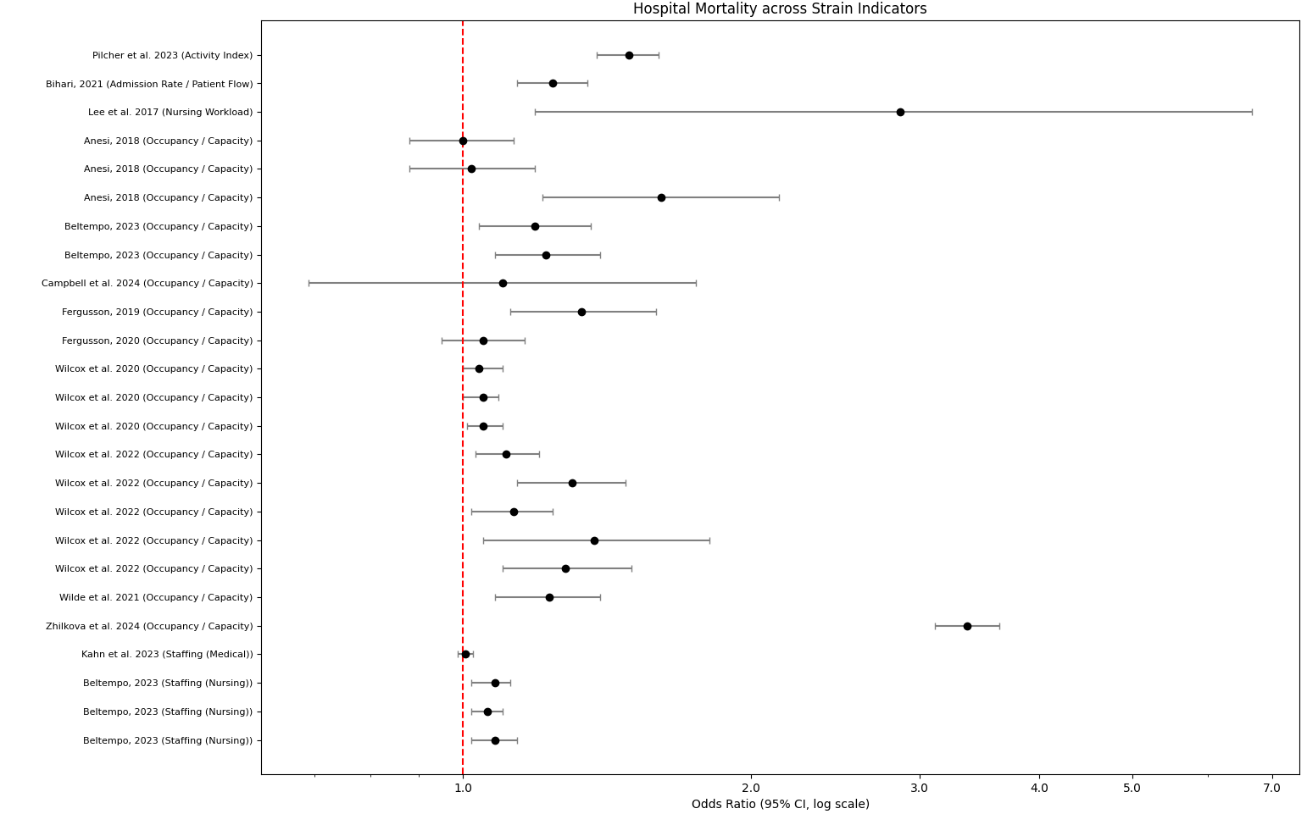

Appendix 6a: Impact of increasing occupancy on outcomes
Left column labelled with outcome of interest
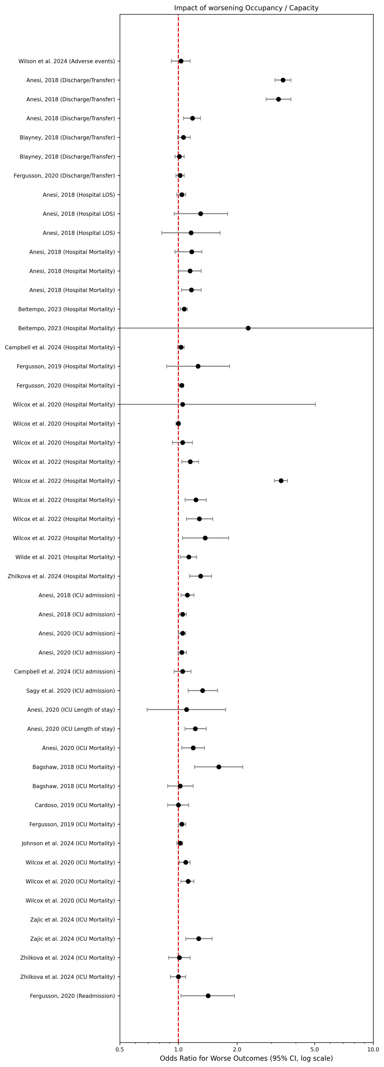

Appendix 6a: Impact of increasing turnover and medical staffing on outcomes
Left column labelled with outcome of interest

