Supporting Information

In Situ Imaging of Adjacent Biomolecules via Proximity Anchored Modules Assembly

Yuting Zou, Zhangling Liu, Yunpeng Shu, Shasha Zhu, Haiping Wu, Tiantian Yang, Xiaoxue Cheng, Yuanyuan Huang, Yangli Zhang, Wenlong Ren, Yi Zhang, Shijia Ding, Wei Cheng,* and Jia Li*

Figure S1. Optimization of polymerization temperature and duration triggered by homologous target.
Figure S2. Optimization of polymerization temperature and duration triggered by heterologous target.

 | 1 | 2 | 3 | 4 | 5 | 6 | M |  |  | 1 | 2 | 3 | 4 | 5 | 6 | M |  | 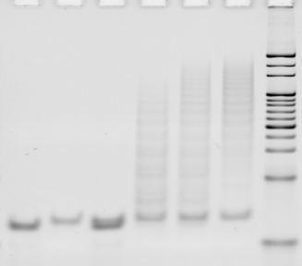 | 1 | 2 | 3 | 4 | 5 | 6 | M

Figure S3. 12% Native-PAGE analysis of PER reaction of three sets of linear primers and hairpin templates used in this study (fixed concentration of 100 nM) with different incubating time periods (15, 30, 45 min). Lane 1: primer, lane 2: hairpin, lane 3: primer + hairpin, lane 4: primer + hairpin + Bst polymerase (37℃ 15 min), lane 5: primer + hairpin + Bst polymerase (37℃ 30 min), lane 6: primer + hairpin + Bst polymerase (37℃ 45 min), M: 20 bp DNA marker.
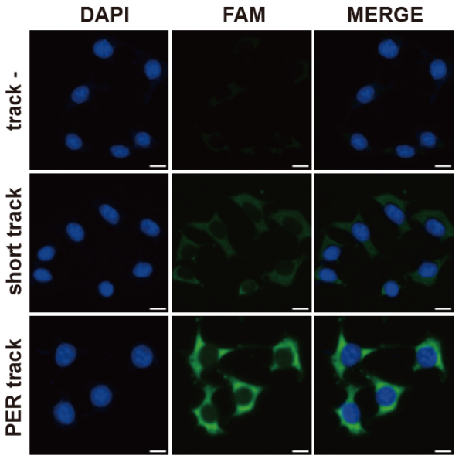
Figure S4. Comparison of the in situ imaging performance of HER2-HER2 homodimers with no tracks, short DNA tracks with one binding site, and long DNA tracks constructed by PER with more binding sites. The images were captured by 40× objective lens, scale bar is 10 μm. The excitation light channels employed were 327-383 nm (DAPI, blue) and 460-500 nm (FAM, green), respectively.

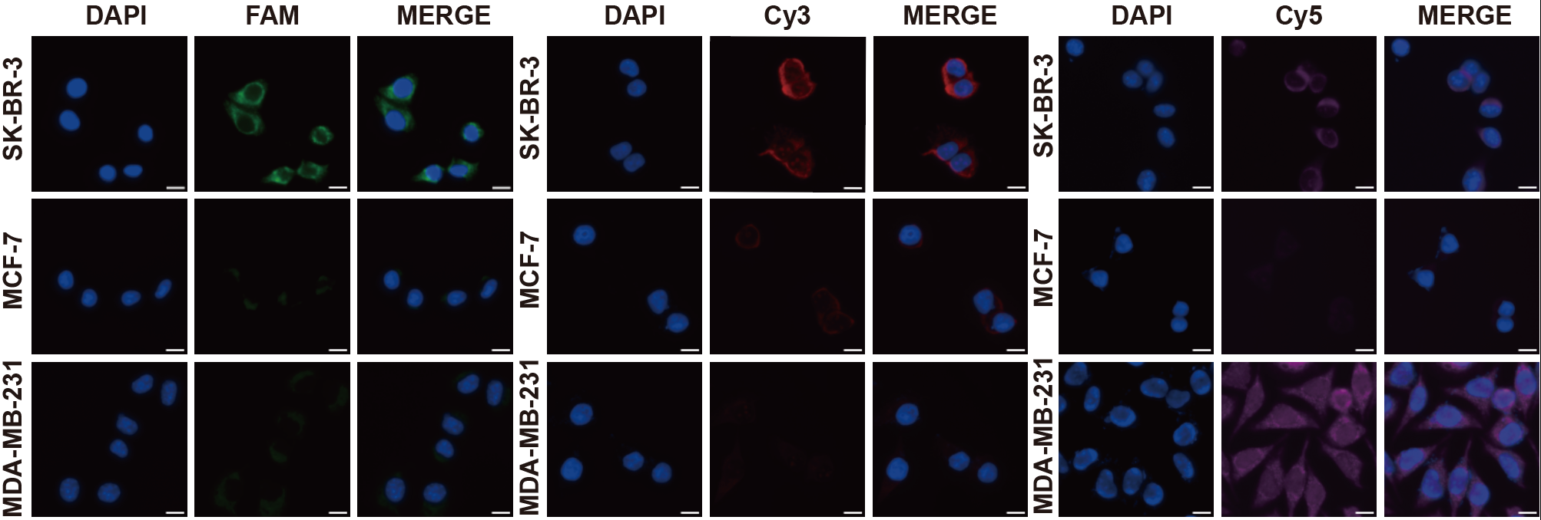
Figure S5. Verification of aptamer binding specificity in breast cancer cell lines. Representative images showing the membrane localization of Apt 2, Apt 3, and Apt E. All three aptamers specifically bound to SK-BR-3 cells, whereas only Apt E showed strong binding to MDA-MB-231 cells, reflecting the differential receptor expression profiles. Images were captured by 40× objective lens; scale bar is 10 μm. The excitation light channels employed were 327-383 nm (DAPI, blue), 460-500 nm (FAM, green), 532-558 nm (Cy3, red), and 592-650 nm (Cy5, magenta), respectively.

Figure S6. PAMA analysis of HER2-HER2 homodimers in SK-BR-3 under full reaction conditions versus conditions lacking tracks, Bst polymerase, or aptamers. The images were captured by 40× objective lens, scale bar is 10 μm. The excitation light channels employed were 327-383 nm (DAPI, blue) and 460-500 nm (FAM, green), respectively. Data are presented as mean ± standard deviation (s.d., n = 3 independent experiments). Statistical significance: ****, P < 0.0001.

Figure S7. PAMA analysis of HER2-HER3 heterodimers in SK-BR-3 under full reaction conditions versus conditions lacking tracks, Bst polymerase, or aptamers. The images were captured by 40× objective lens, scale bar is 10 μm. The excitation light channels employed were 327-383 nm (DAPI, blue), 460-500 nm (FAM, green), and 532-558 nm (Cy3, red), respectively. Data are presented as mean ± standard deviation (s.d., n = 3 independent experiments). Statistical significance: ****, P < 0.0001.

Figure S8. PAMA analysis of HER2-EGFR heterodimers in SK-BR-3 under full reaction conditions versus conditions lacking tracks, Bst polymerase, or aptamers. The images were captured by 40× objective lens, scale bar is 10 μm. The excitation light channels employed were 327-383 nm (DAPI, blue), 460-500 nm (FAM, green), and 590-650 nm (Cy5, magenta), respectively. Data are presented as mean ± standard deviation (s.d., n = 3 independent experiments). Statistical significance: ****, P < 0.0001.

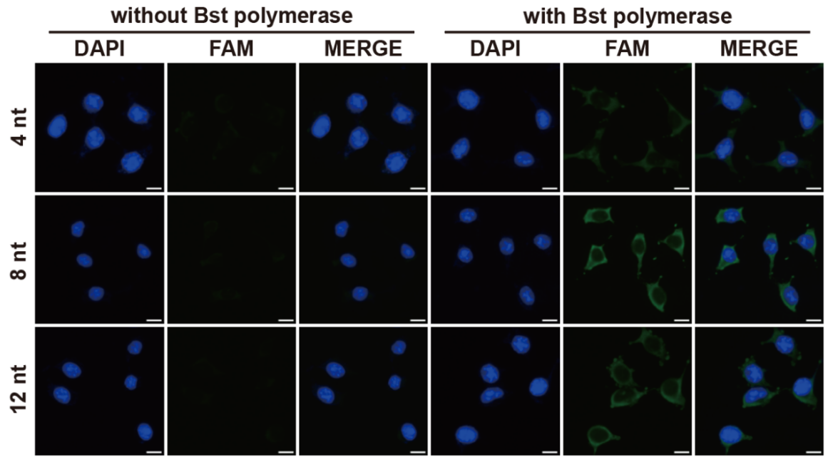
Figure S9. Optimization of the palindromic overlap length at the 3’-terminus of the ES strand for the in situ imaging of HER2 protein dimers. The images were captured by 40× objective lens, scale bar is 10 μm. The excitation light channels employed were 327-383 nm (DAPI, blue) and 460-500 nm (FAM, green).

Figure S10. Flow cytometric validation of HER2 dimerization specificity in breast cancer cell lines. Representative histograms comparing the fluorescence intensity distributions for HER2/HER2 (green), HER2/HER3 (red), and HER2/EGFR (purple) dimers. The gray shaded histograms represent negative controls treated with fluorescent probes only, while the colored curves represent the specific signals generated by the complete PAMA reaction system. A significant fluorescence shift is observed only in the presence of the target dimers.

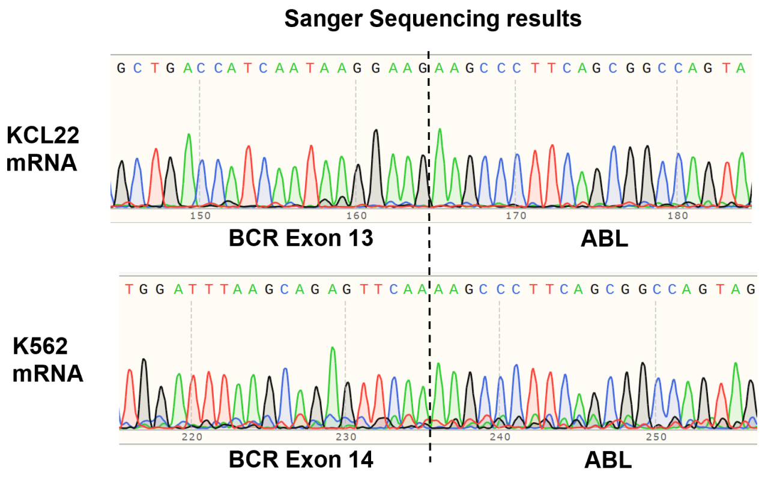
Figure S11. The Sanger sequencing results of KCL22 mRNA and K562 mRNA.

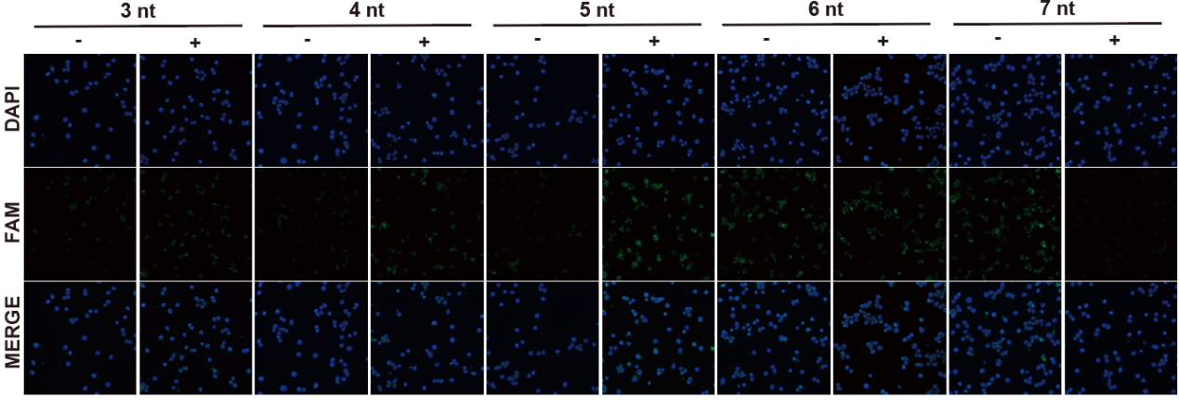
Figure S12. Optimization of the complementary overlap length at the 3’-terminus of the ES strand for the in situ imaging of fusion transcript variants. The group without Bst polymerase was set up as negative while positive group was treated with Bst polymerase. The images were captured by 40× objective lens, scale bar is 10 μm. The excitation light channels employed were 327-383 nm (DAPI, blue) and 460-500 nm (FAM, green).

Figure S13. Fluorescence microscope images of 30 clinical samples diagnosed as BCR-ABL^{P210} negative, analyzed via PAMA. The images were captured by 40× objective lens, scale bar is 10 μm. The excitation light channels employed were 327-383 nm (DAPI, blue), 460-500 nm (FAM, green), 532-558 nm (Cy3, red), and 592-650 nm (Cy5, magenta), respectively.

Table S1. The DNA sequences employed in this work.
Name | Sequence(5’→3’)
Homogeneous Assay
Target_{hom} | CCGCAGTATCAGCCTTTCCGCAGTATCAGCC
Target_{het} | CTAATGTCTCAGCCTTTTGTTACCGTTGCCATA
Probe_{B} | TATGGCAACGGTAACTTTTTTACACTATCATACACTATCATTTTTTTT
Probe_{C} | AGGCTGAGACATTAGTTTTTTACTAACCATTACTAACCATTTTTTTTT
Probe_{A} | GGCTGATACTGCGGTTTTTACACTATCATACACTATCATTTTTTTT
P_{a2} | AAGCCCTTCAGCGGCCAGTATTTTTTACACTATCATACACTATCATTTTTTTT
P_{e13} | GCTGACCATCAATAAGGAAGTTTTTTACTAACCATTACTAACCATTTTTTTTT
P_{e14} | TGGATTTAAGCAGAGTTCAATTTTTTACTAACCATTACTAACCATTTTTTTTT
FAM-S | FAM-TATCGAGATGACTGCCTATGATAGTGTATGATAGTGTTTTTTTTT
BHQ-1-CS | GGCAGTCATCTCGAT-BHQ1
S_{A} | ATCGAGATGACTGCCTATGATAGTGTATGATAGTGTTTTTTTTT
S_{B} | CTAACGACTGATGCTTAATGGTTAGTAATGGTTAGTTTTTTTTT
S_{C} | TCGCACAGTGATACCTGAGAGTTATAGAGAGTTATATTTTTTTT
ES_{hom1} | GGCAGTCATCTCGATTCGA
ES_{hom2}/ES₀ | GGCAGTCATCTCGATTTCGAA
ES_{hom3} | GGCAGTCATCTCGATTTCTAGAA
ES_{hom4} | GGCAGTCATCTCGATTTCTCGAGAA
ES_{hom5} | GGCAGTCATCTCGATTTCTCTAGAGAA
ES1_{het1} | GGCAGTCATCTCGATACGA
ES1_{het2} | GGCAGTCATCTCGATACTGA
ES1_{het3}/ES_{A} | GGCAGTCATCTCGATACTCGA
ES1_{het4} | GGCAGTCATCTCGATACTCTGA
ES1_{het5} | GGCAGTCATCTCGATACTGCTGA
ES2_{het1} | AGCATCAGTCGTTAGTCGT
ES2_{het2} | AGCATCAGTCGTTAGTCAGT
ES2_{het3}/ES_{B} | AGCATCAGTCGTTAGTCGAGT
ES2_{het4} | AGCATCAGTCGTTAGTCAGAGT
ES2_{het5} | AGCATCAGTCGTTAGTCAGCAGT
FAM-CS | GGCAGTCATCTCGAT-FAM
Cy3-CS | AGCATCAGTCGTTAGT-Cy3
Cy5-CS | GGTATCACTGTGCGAT-Cy5
Hairpin A | ACACTATCATGGGCCTTTTGGCCCATGATAGTGTATGATAGTGT
Hairpin B | ACTAACCATTGGGCCTTTTGGCCCAATGGTTAGTAATGGTTAG
Hairpin C | TATAACTCTCGGGCCTTTTGGCCCGAGAGTTATAGAGAGTTATA
Membrane Protein-Dimers In Situ Imaging Assay
Apt 2 | CTGACTAGCTCATCGTTTTTTTTTTCCGCAACCACGACCGAAAGACAACGCAATCTGACACGTGG
Apt 3 | CTAATGTCTCAGCCTTTTTTTTTCGGACGAATGCTTTGATGTTGTGCTGGATCCAGCGTTCATTCTCA
Apt E | GCAGTAGCCACCGTTTTTTTTTGTACGAGTTTTCGTTTTTTTCGCTTTCTCTTCTTTGCCGT
P_{Her2} | CGATGAGCTAGTCAGTTTTTTACACTATCAT
P_{HER3} | AGGCTGAGACATTAGTTTTTTACTAACCATT
P_{EGFR} | ACGGTGGCTACTGCTTTTTTTATAACTCTC
Isoform-Specific In Situ Genotyping Assay
e13a2  e14a2 | TACTGGCCGCTGAAGGGCTTCTTCCTTATTGATGGTCAGCTACTGGCCGCTGAAGGGCTTTTGAACTCTGCTTAAATCCA
s-e13a2 | TACTGGCCGCTGAAGGGCTTCACAGTACGTCGATGTCTCGTTGAACTCTGCTTAAATCCA
s-e14a2 | TACTGGCCGCTGAAGGGCTTCACAGTACGTCGATGTCTCGTTGAACTCTGCTTAAATCCA
P_{a2} | AAGCCCTTCAGCGGCCAGTATTTTTTACACTATCAT
P_{e13} | GCTGACCATCAATAAGGAAGTTTTTTACTAACCATT
P_{e14} | TGGATTTAAGCAGAGTTCAATTTTTTTATAACTCTC
KCl22-Forward Primer | CCGCAACGGCAAGAGTTA
K562-Forward Primer | TGTCGGAGCAGGAGTCAC
Reverse Primer | GGTCCAGCGAGAAGGTTT
Notes: Interaction sequences at the 3’ terminus of the ES are bolded; aptamer sequences are italicized; The primer sequences for PER are underlined.
Table S2. Clinical characteristics and comparative genotyping results of the study cohort.
ID | Gender | Age | Type | BCR-ABL^{P210} / ABL Copy Number Ratio (%) Determined by qRT-PCR | Clinical Diagnostic Result | Genotyping Results
 |  |  |  |  |  | PAMA Assay | Sanger Sequencing
#1 | male | 46 | blood | 9.8451 | BCR-ABL^{P210}(+) | e14a2 | e14a2
#2 | male | 26 | blood | 45.9649 | BCR-ABL^{P210}(+) | e14a2 | e14a2
#3 | male | 62 | blood | 26.072 | BCR-ABL^{P210}(+) | e14a2 | e14a2
#4 | male | 53 | blood | 112.2222 | BCR-ABL^{P210}(+) | e14a2 | e14a2
#5 | male | 39 | blood | 10.8805 | BCR-ABL^{P210}(+) | e13a2 | e13a2
#6 | female | 63 | blood | 4.717 | BCR-ABL^{P210}(+) | e14a2 | e14a2
#7 | male | 72 | blood | 1.2102 | BCR-ABL^{P210}(+) | e14a2 | e14a2
#8 | female | 29 | blood | 26.8837 | BCR-ABL^{P210}(+) | e14a2 | e14a2
#9 | male | 50 | blood | 76.8939 | BCR-ABL^{P210}(+) | e14a2 | e14a2
#10 | male | 55 | blood | 69.5364 | BCR-ABL^{P210}(+) | e14a2 | e14a2
#11 | male | 53 | blood | 9.8077 | BCR-ABL^{P210}(+) | e14a2 | e14a2
#12 | female | 34 | blood | 1.5064 | BCR-ABL^{P210}(+) | e14a2 | e14a2
#13 | female | 19 | blood | 50.8850 | BCR-ABL^{P210}(+) | e13a2 | e13a2
#14 | female | 57 | bone marrow | 5.1712 | BCR-ABL^{P210}(+) | e13a2 | e13a2
#15 | female | 19 | blood | 1.9071 | BCR-ABL^{P210}(+) | e14a2 | e14a2
#16 | female | 42 | blood | 9.2405 | BCR-ABL^{P210}(+) | e13a2 | e13a2
#17 | male | 60 | bone marrow | 137.7358 | BCR-ABL^{P210}(+) | e14a2 | e14a2
#18 | female | 39 | blood | 129.5359 | BCR-ABL^{P210}(+) | e13a2 | e13a2
#19 | male | 62 | blood | 29.4000 | BCR-ABL^{P210}(+) | e14a2 | e14a2
#20 | male | 26 | blood | 42.1714 | BCR-ABL^{P210}(+) | e14a2 | e14a2
#21 | male | 60 | bone marrow | 201.0142 | BCR-ABL^{P210}(+) | e14a2 | e14a2
#22 | male | 36 | blood | 32.2000 | BCR-ABL^{P210}(+) | e14a2 | e14a2
#23 | male | 55 | bone marrow | 253.9063 | BCR-ABL^{P210}(+) | e14a2 | e14a2
#24 | male | 57 | blood | 103.5714 | BCR-ABL^{P210}(+) | e13a2 | e13a2
#25 | female | 46 | bone marrow | 5.1532 | BCR-ABL^{P210}(+) | e14a2 | e14a2
#26 | female | 72 | blood | 246.8354 | BCR-ABL^{P210}(+) | e14a2 | e14a2
#27 | female | 54 | blood | 2.1438 | BCR-ABL^{P210}(+) | e13a2 | e13a2
#28 | female | 83 | blood | 194.5578 | BCR-ABL^{P210}(+) | e14a2 | e14a2
#29 | male | 76 | blood | 8.0769 | BCR-ABL^{P210}(+) | e14a2 | e13a2
#30 | female | 61 | blood | 2.0251 | BCR-ABL^{P210}(+) | e14a2 | e14a2
#31 | male | 65 | blood | 0.0000 | BCR-ABL^{P210}(-) | (-) | N/A
#32 | female | 54 | blood | <0.0032 | BCR-ABL^{P210}(-) | (-) | N/A
#33 | male | 38 | blood | <0.0032 | BCR-ABL^{P210}(-) | (-) | N/A
#34 | male | 55 | blood | <0.0100 | BCR-ABL^{P210}(-) | (-) | N/A
#35 | female | 46 | blood | <0.0100 | BCR-ABL^{P210}(-) | (-) | N/A
#36 | male | 66 | blood | <0.0100 | BCR-ABL^{P210}(-) | (-) | N/A
#37 | female | 73 | blood | <0.0100 | BCR-ABL^{P210}(-) | (-) | N/A
#38 | male | 22 | blood | <0.0100 | BCR-ABL^{P210}(-) | (-) | N/A
#39 | female | 61 | blood | <0.0100 | BCR-ABL^{P210}(-) | (-) | N/A
#40 | female | 57 | blood | <0.0100 | BCR-ABL^{P210}(-) | (-) | N/A
#41 | female | 69 | blood | <0.0100 | BCR-ABL^{P210}(-) | (-) | N/A
#42 | male | 52 | blood | <0.0032 | BCR-ABL^{P210}(-) | (-) | N/A
#43 | female | 50 | blood | 0.0000 | BCR-ABL^{P210}(-) | (-) | N/A
#44 | male | 43 | blood | <0.0032 | BCR-ABL^{P210}(-) | (-) | N/A
#45 | male | 34 | blood | 0.0000 | BCR-ABL^{P210}(-) | (-) | N/A
#46 | male | 70 | blood | <0.0100 | BCR-ABL^{P210}(-) | (-) | N/A
#47 | female | 73 | blood | 0.0000 | BCR-ABL^{P210}(-) | (-) | N/A
#48 | female | 46 | blood | <0.0100 | BCR-ABL^{P210}(-) | (-) | N/A
#49 | female | 30 | bone marrow | 0.0000 | BCR-ABL^{P210}(-) | (-) | N/A
#50 | male | 44 | blood | 0.0000 | BCR-ABL^{P210}(-) | (-) | N/A
#51 | female | 56 | blood | 0.0000 | BCR-ABL^{P210}(-) | (-) | N/A
#52 | female | 51 | blood | 0.0000 | BCR-ABL^{P210}(-) | (-) | N/A
#53 | female | 69 | blood | 0.0000 | BCR-ABL^{P210}(-) | (-) | N/A
#54 | female | 29 | blood | 0.0000 | BCR-ABL^{P210}(-) | (-) | N/A
#55 | female | 59 | blood | 0.0000 | BCR-ABL^{P210}(-) | (-) | N/A
#56 | male | 71 | blood | 0.0000 | BCR-ABL^{P210}(-) | (-) | N/A
#57 | male | 64 | blood | 0.0000 | BCR-ABL^{P210}(-) | (-) | N/A
#58 | male | 61 | blood | 0.0000 | BCR-ABL^{P210}(-) | (-) | N/A
#59 | male | 78 | blood | <0.0100 | BCR-ABL^{P210}(-) | (-) | N/A
#60 | male | 71 | blood | 0.0000 | BCR-ABL^{P210}(-) | (-) | N/A

