Table: Primer and Probes for Real-time PCR
Gene | Primers/  Probes | Sequence | Amplicon  Size (bp) | Annealing  Tempt | References
OXA-48 | Forward | 5′-CTTAAACGGGCGAACCAAGC-3′ | 101 | 55 ºC | Lund et al [1]
OXA-48 | Reverse | 5′- GTTCATCCTTAACCACGCCC-3′ | 101 | 55 ºC | Lund et al [1]
OXA-48 | Probe | 6-FAM-TTCCCAATAGCTTGATCGCCCTCGATT-BHQ | 101 | 55 ºC | Lund et al [1]
VIM | Forward | 5′- -GATTGATACAGCGTGGGGTG-3′ | 204 | 54 ºC | Lund et al [1]
VIM | Reverse | 5′- -AGGGCGATGCGTACGTCGC-3′ | 204 | 54 ºC | Lund et al [1]
VIM | Probe | Cy5-GACGCGGTCGTCATGAAAGTGCGT-BHQ | 204 | 54 ºC | Lund et al [1]
KPC | Forward | 5′- -CACTGTGCAGCTCATTCAAGG-3′ | 309 | 58 ºC | Lund et al [1]
KPC | Reverse | 5′- -CGCCGATAGAGCGCATGAA-3′ | 309 | 58 ºC | Lund et al [1]
KPC | Probe | LC610-CTGCCGCTGTGCTGGCTCGCA-BHQ | 309 | 58 ºC | Lund et al [1]
NDM-1 | Forward | 5′- -GCAAATGGAAACTGGCGACC -3′ | 541 | 56 ºC | Lund et al [1]
NDM-1 | Reverse | 5′--TACCGCCCATCTTGTCCTGA-3′ | 541 | 56 ºC | Lund et al [1]
NDM-1 | Probe | VIC-TCGCACCGAATGTCTGGCAGCACA-MGB | 541 | 56 ºC | Lund et al [1]

Quality control plots for the DNA purification used for WGS
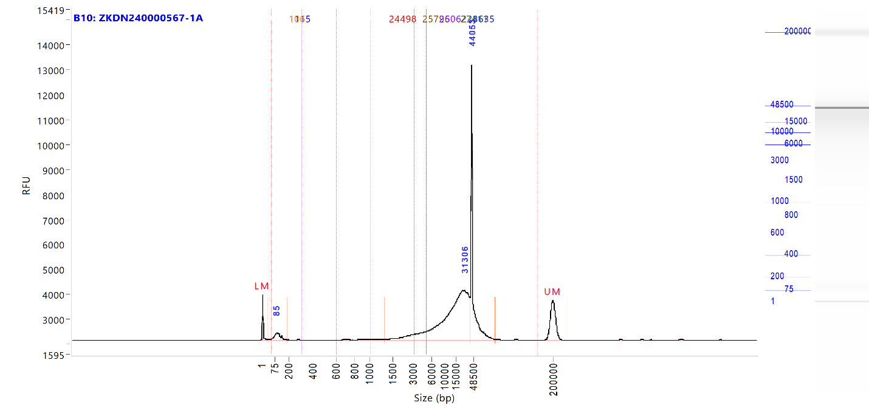

Genes Application plots

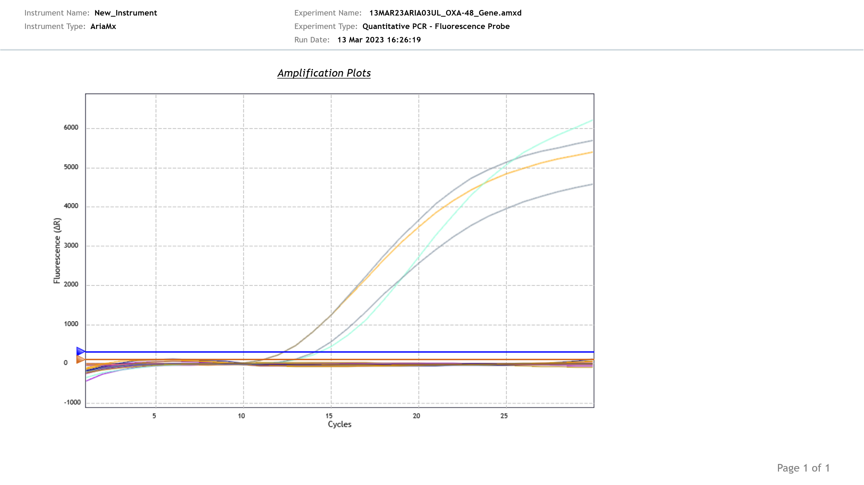

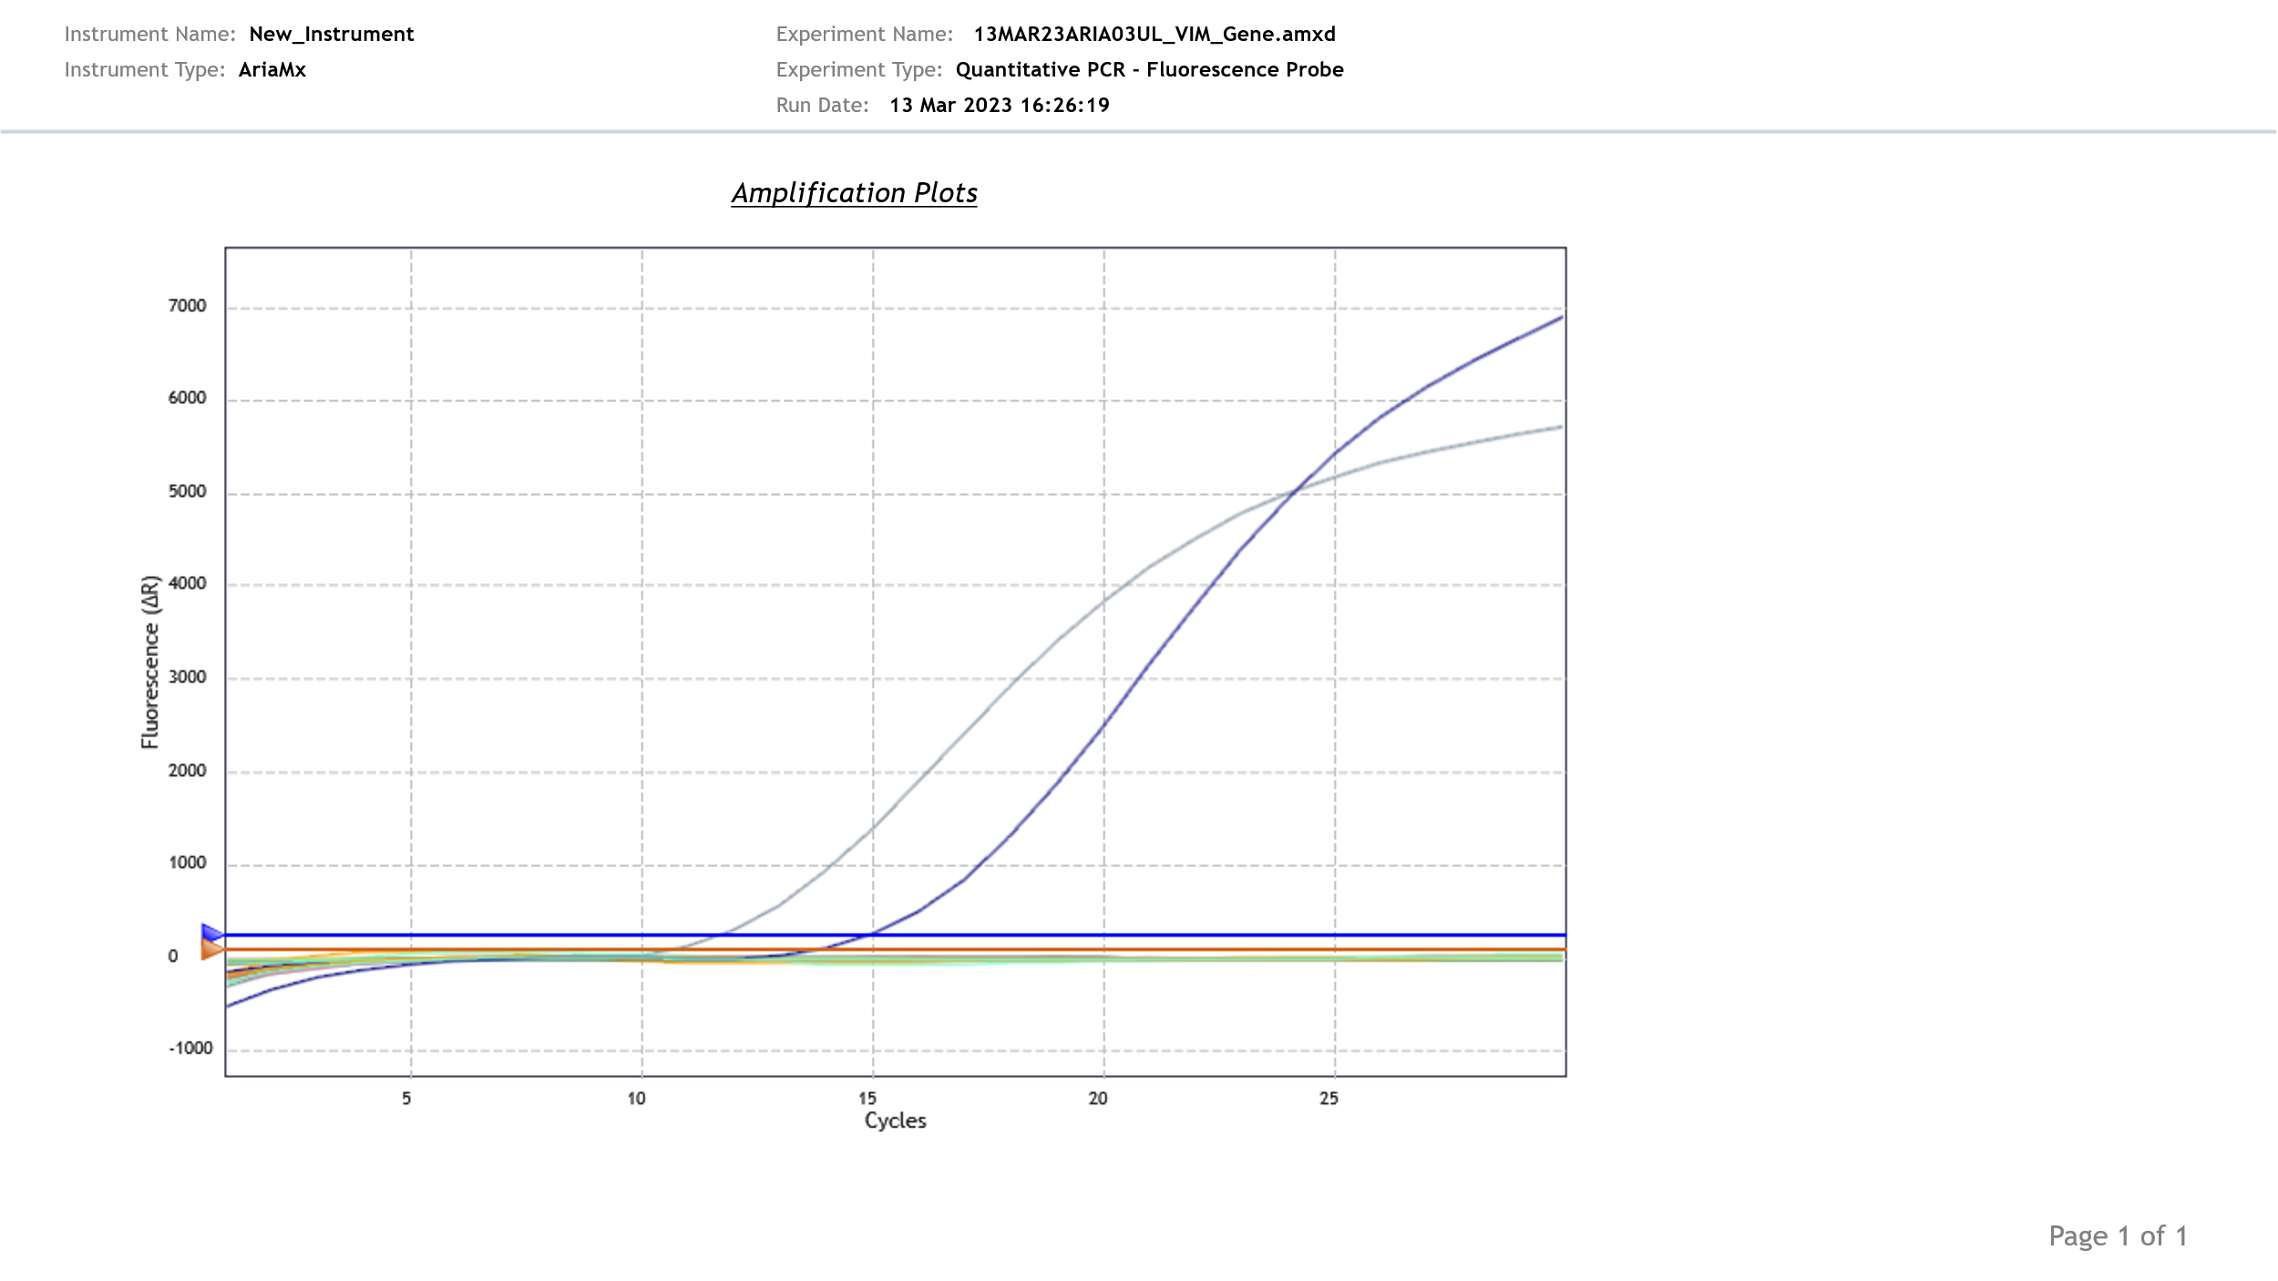

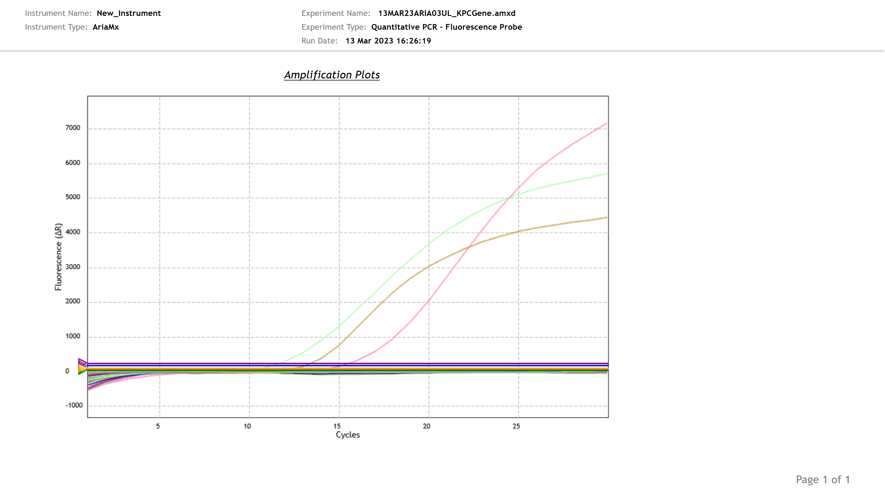

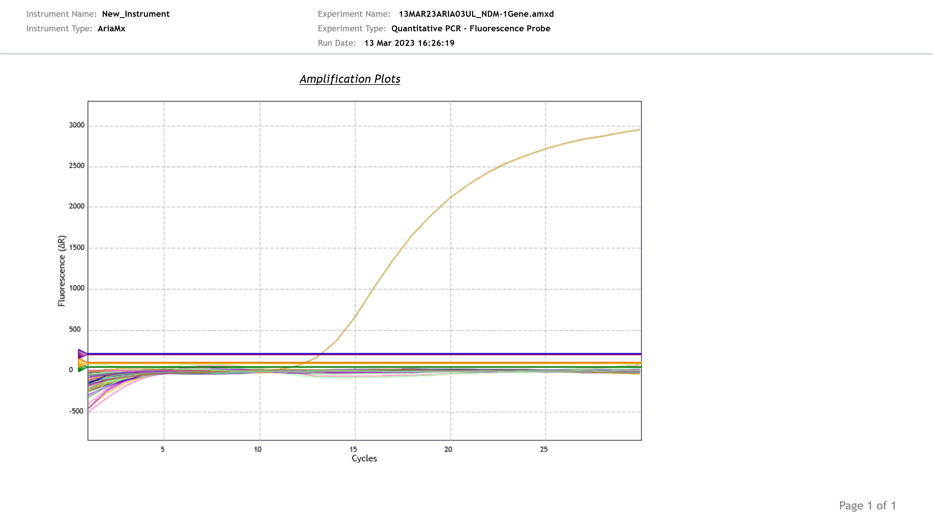

References
1. Lund M, Petersen MB, Jørgensen AL, Paulmann D, Wang M. Rapid real-time PCR for the detection of IMP, NDM, VIM, KPC and OXA-48 carbapenemase genes in isolates and spiked stool samples. Diagn Microbiol Infect Dis. 2018;92:8–12. https://doi.org/10.1016/j.diagmicrobio.2018.04.002.

