Supplementary Information for
“Intensified atmosphere–sea ice coupling reshapes Arctic sea ice decline and downstream climate extremes”

Shaoyin Wang^{1, 2*}, Jiping Liu^{3,2*}, Zehao Wang^{1, 2}, Deliang Chen⁴, Peter Braesicke^{5, a}, Shengping He^{6,11}, Annette Rinke⁷, Edward Hanna⁸, Jingfang Fan⁹, Hua Li¹⁰, and Xiao Cheng^{1, 2*}
¹School of Geospatial Engineering and Science, Sun Yat-sen University, and Southern Marine Science and Engineering Guangdong Laboratory (Zhuhai), Zhuhai, China.
²Key Laboratory of Comprehensive Observation of Polar Environment (Sun Yat-sen University), China.
³School of Atmospheric Science, Sun Yat-sen University, and Southern Marine Science and Engineering Guangdong Laboratory (Zhuhai), Zhuhai, China.
⁴Department of Earth System Science, Tsinghua University, Beijing 100084, China.
⁵Institute of Meteorology and Climate Research Atmospheric Trace Gases and Remote Sensing (IMKASF), Karlsruhe Institute of Technology, Karlsruhe, Germany.
⁶Geophysical Institute, University of Bergen and Bjerknes Centre for Climate Research, Bergen, Norway.
⁷Alfred Wegener Institute, Helmholtz Centre for Polar and Marine Research, Potsdam, Germany.
⁸Department of Geography and Lincoln Climate Research Group, University of Lincoln, Lincoln, United Kingdom.
⁹School of Systems Science/Institute of Nonequilibrium Systems, Beijing Normal University, Beijing 100875, China.
¹⁰State Key Laboratory of Climate System Prediction and Risk Management/Key Laboratory of Hydrometeorological Disaster Mechanism and Warning of Ministry of Water Resources/Collaborative Innovation Center on Forecast and Evaluation of Meteorological Disasters, Nanjing University of Information Science & Technology, Nanjing, 210044, China.
¹¹Nansen Environmental and Remote Sensing Center, Bergen, Norway.
ªNow at: Business Area Research and Development, Deutscher Wetterdienst, Offenbach am Main, Germany.

Correpondance to:
wangshy96@mail.sysu.edu.cn; liujp63@mail.sysu.edu.cn; chengxiao9@mail.sysu.edu.cn

(1) Transfer Entropy Analysis of GH–SIE Coupling
To assess the directionality of coupling between the June Greenland High (GH) and September Arctic sea ice extent (SIE), we complement correlation analysis with transfer entropy (TE), an information-theoretic measure of directed statistical dependence. Unlike correlation, which quantifies symmetric linear association, transfer entropy measures how much the past of one variable reduces uncertainty about the future of another, beyond what is already known from the target's own history. This approach can detect both linear and nonlinear coupling and distinguish the direction of information flow.We estimate transfer entropy using the Kraskov–Stögbauer–Grassberger k-nearest-neighbor method, which is well-suited for short, continuous-valued time series. Transfer entropy is computed separately for each direction (GH to SIE and SIE to GH) and each period (P1: 1979–2003; P2: 2004–2025) using detrended indices. Statistical significance is assessed through permutation testing (1,000 shuffles), and differences between periods are evaluated using block bootstrap resampling (1,000 iterations, block length = 3 years) to preserve autocorrelation structure. To examine the temporal evolution of information flow, we compute rolling transfer entropy using an 11-year sliding window and apply change point detection to identify potential regime shifts. The analysis consistently places the regime shift in the early 2000s (2004–2006 depending on window length), corroborating the regime shift identified by correlation analysis.

(2) Supplementary Figures

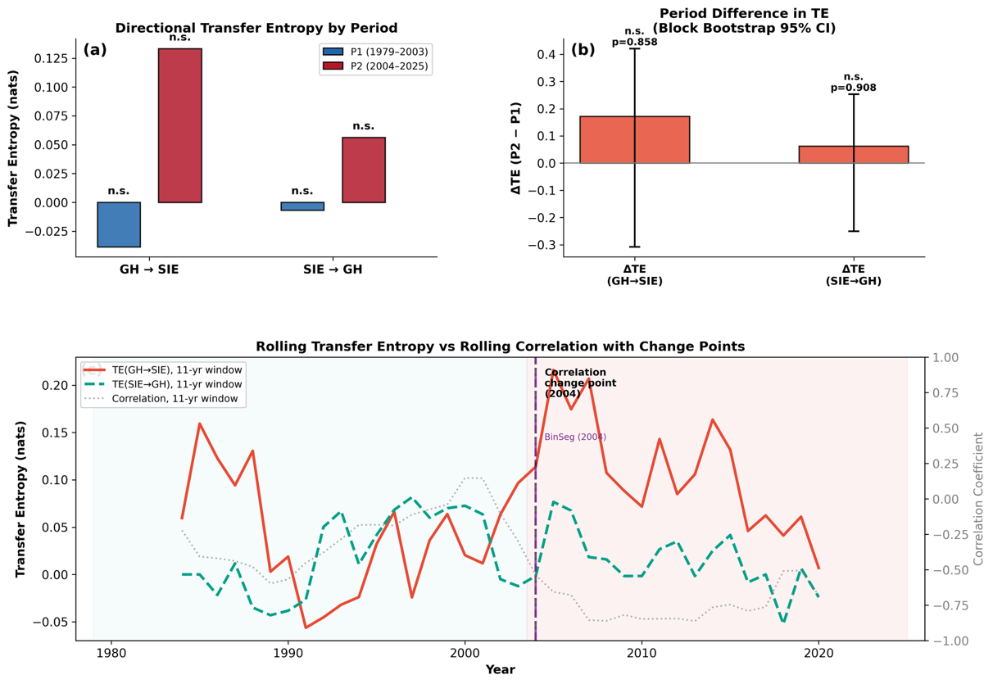
Figure S1. Transfer entropy analysis of directional information flow between the June Greenland High (GH) and September Arctic sea ice extent (SIE). (a) Transfer entropy (TE) is estimated separately for each direction (GH to SIE and SIE to GH) and period (P1: 1979–2003, blue; P2: 2004–2025, red), using the Kraskov k-nearest-neighbor estimator (k = 3, history = 1 year). Significance is assessed by permutation testing; n.s. = not significant. (b) Period difference in TE (P2 minus P1) for each direction, with 95% confidence intervals from block bootstrap resampling (1000 iterations, block length = 3 years). (c) Rolling TE (11-year window) for GH to SIE (red solid) and SIE to GH (green dashed), overlaid with rolling Pearson correlation (11-year window, grey dotted; right axis). The vertical dashed black line marks the correlation-based change point (2004); the vertical dash-dotted purple line marks the change point detected by binary segmentation applied to the rolling TE (GH to SIE) series. Blue and red shading denote P1 and P2, respectively. The detected TE change point shifts from 2004 to 2005 and 2006 when the rolling window is increased to 13 and 15 years, respectively, reflecting the smoothing effect of wider windows on the timing of the transition while consistently placing the regime shift within the early 2000s.

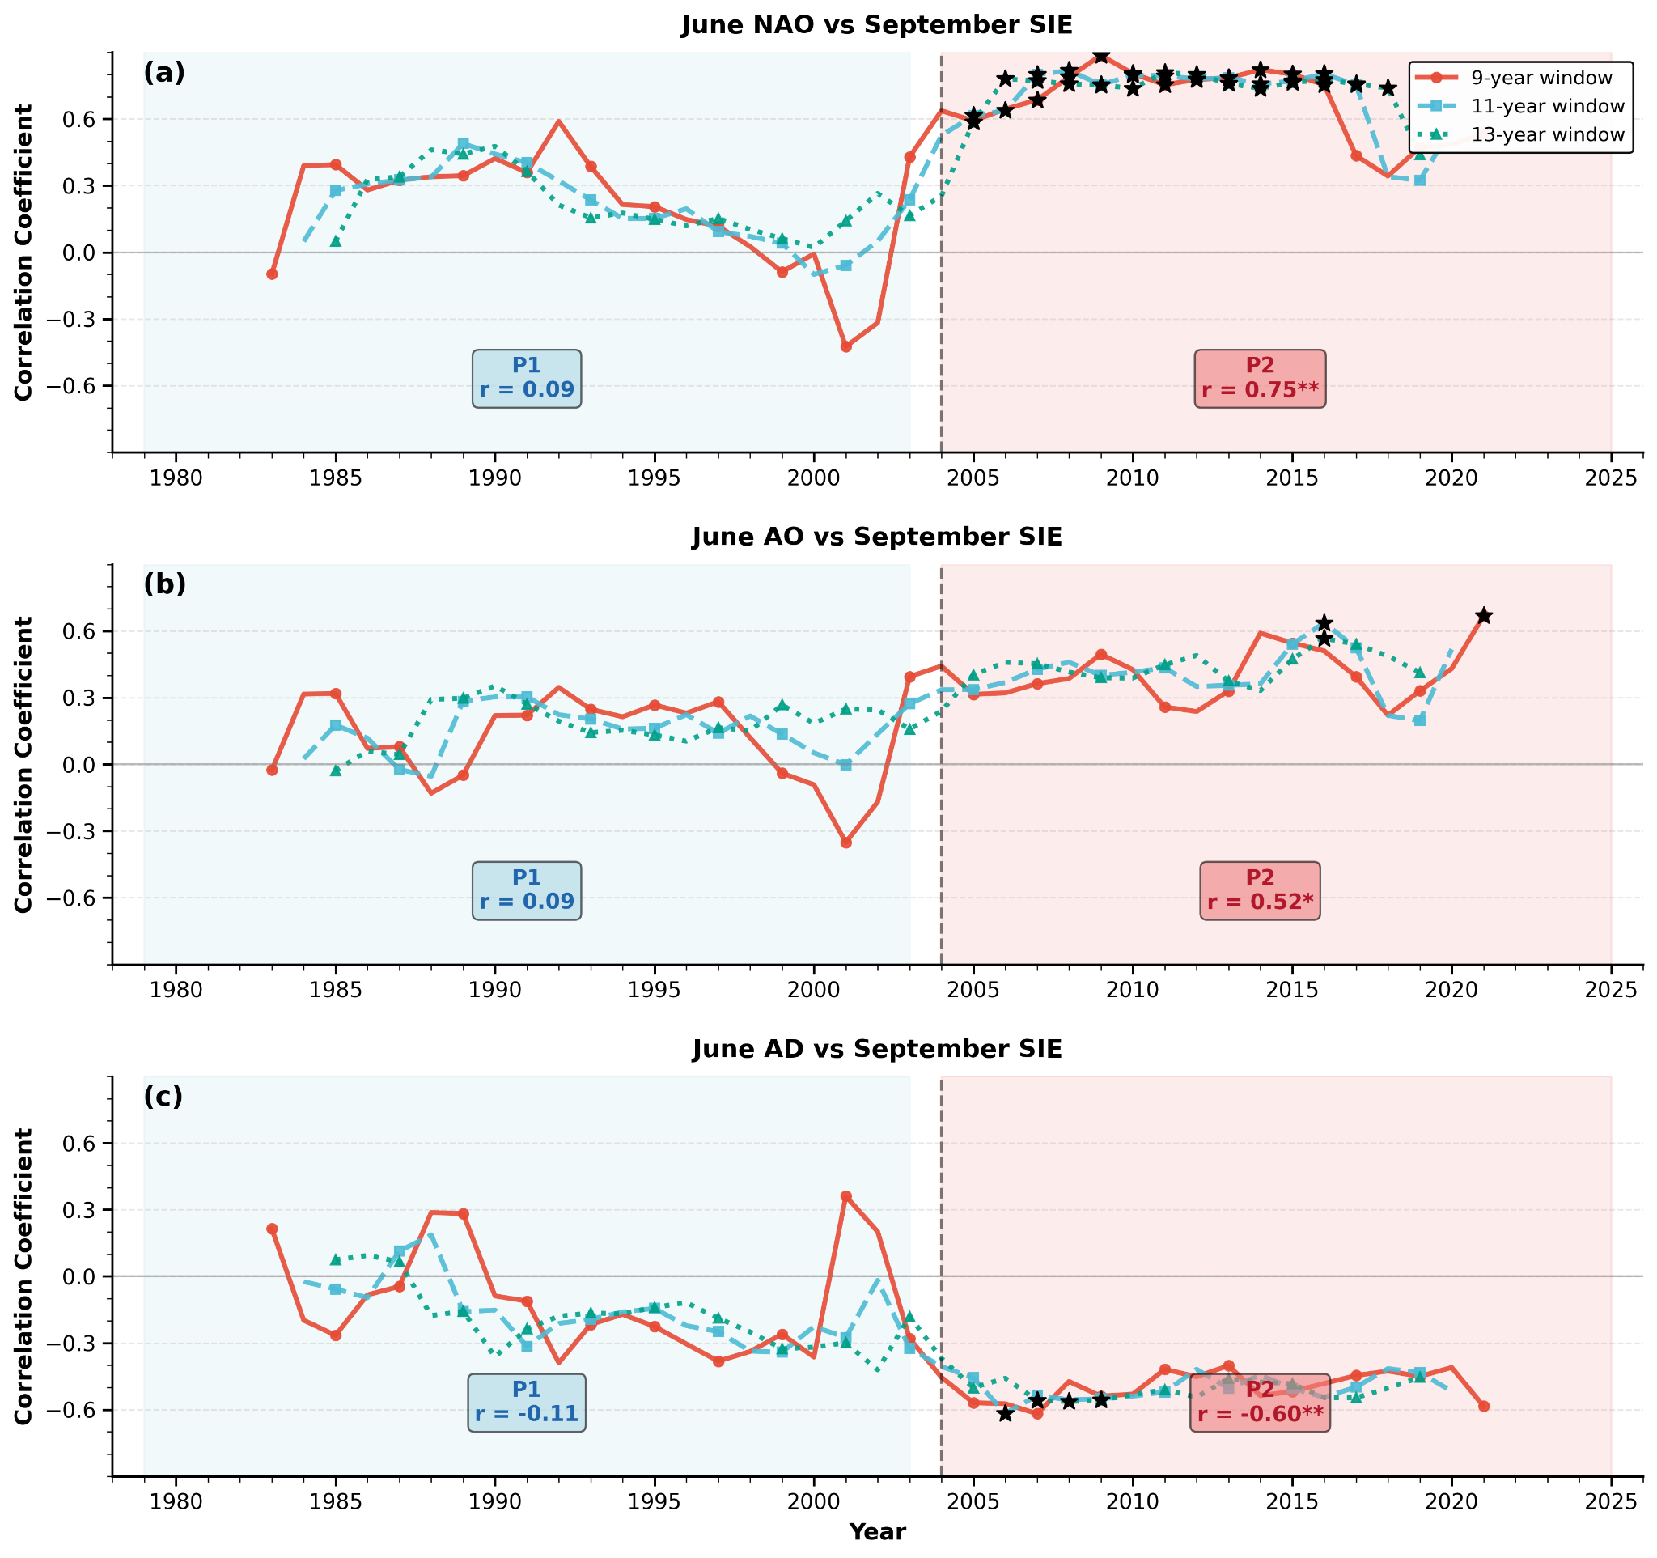
Figure S2. Running correlations between June climate indices and September Arctic sea ice extent (1979–2025). Each panel shows running correlations calculated using 9-year (red solid), 11-year (cyan dashed), and 13-year (green dotted) moving windows between June climate indices and September sea ice extent. (a) North Atlantic Oscillation (NAO); (b) Arctic Oscillation (AO); (c) Arctic Dipole (AD). Blue shading denotes Period 1 (P1, 1979–2003) and red shading denotes Period 2 (P2, 2004–2025), with mean correlations and significance levels for each period displayed in the inset boxes. All time series were linearly detrended prior to analysis. Black stars indicate running correlations significant at p < 0.05. Significance levels for period means: *p < 0.05, **p < 0.01. Note the strengthening of NAO–SIE and AO–SIE correlations in P2, consistent with the intensified GH–SIE coupling documented in the main text, reflecting the heightened sensitivity of the thinner ice regime to large-scale atmospheric circulation patterns.
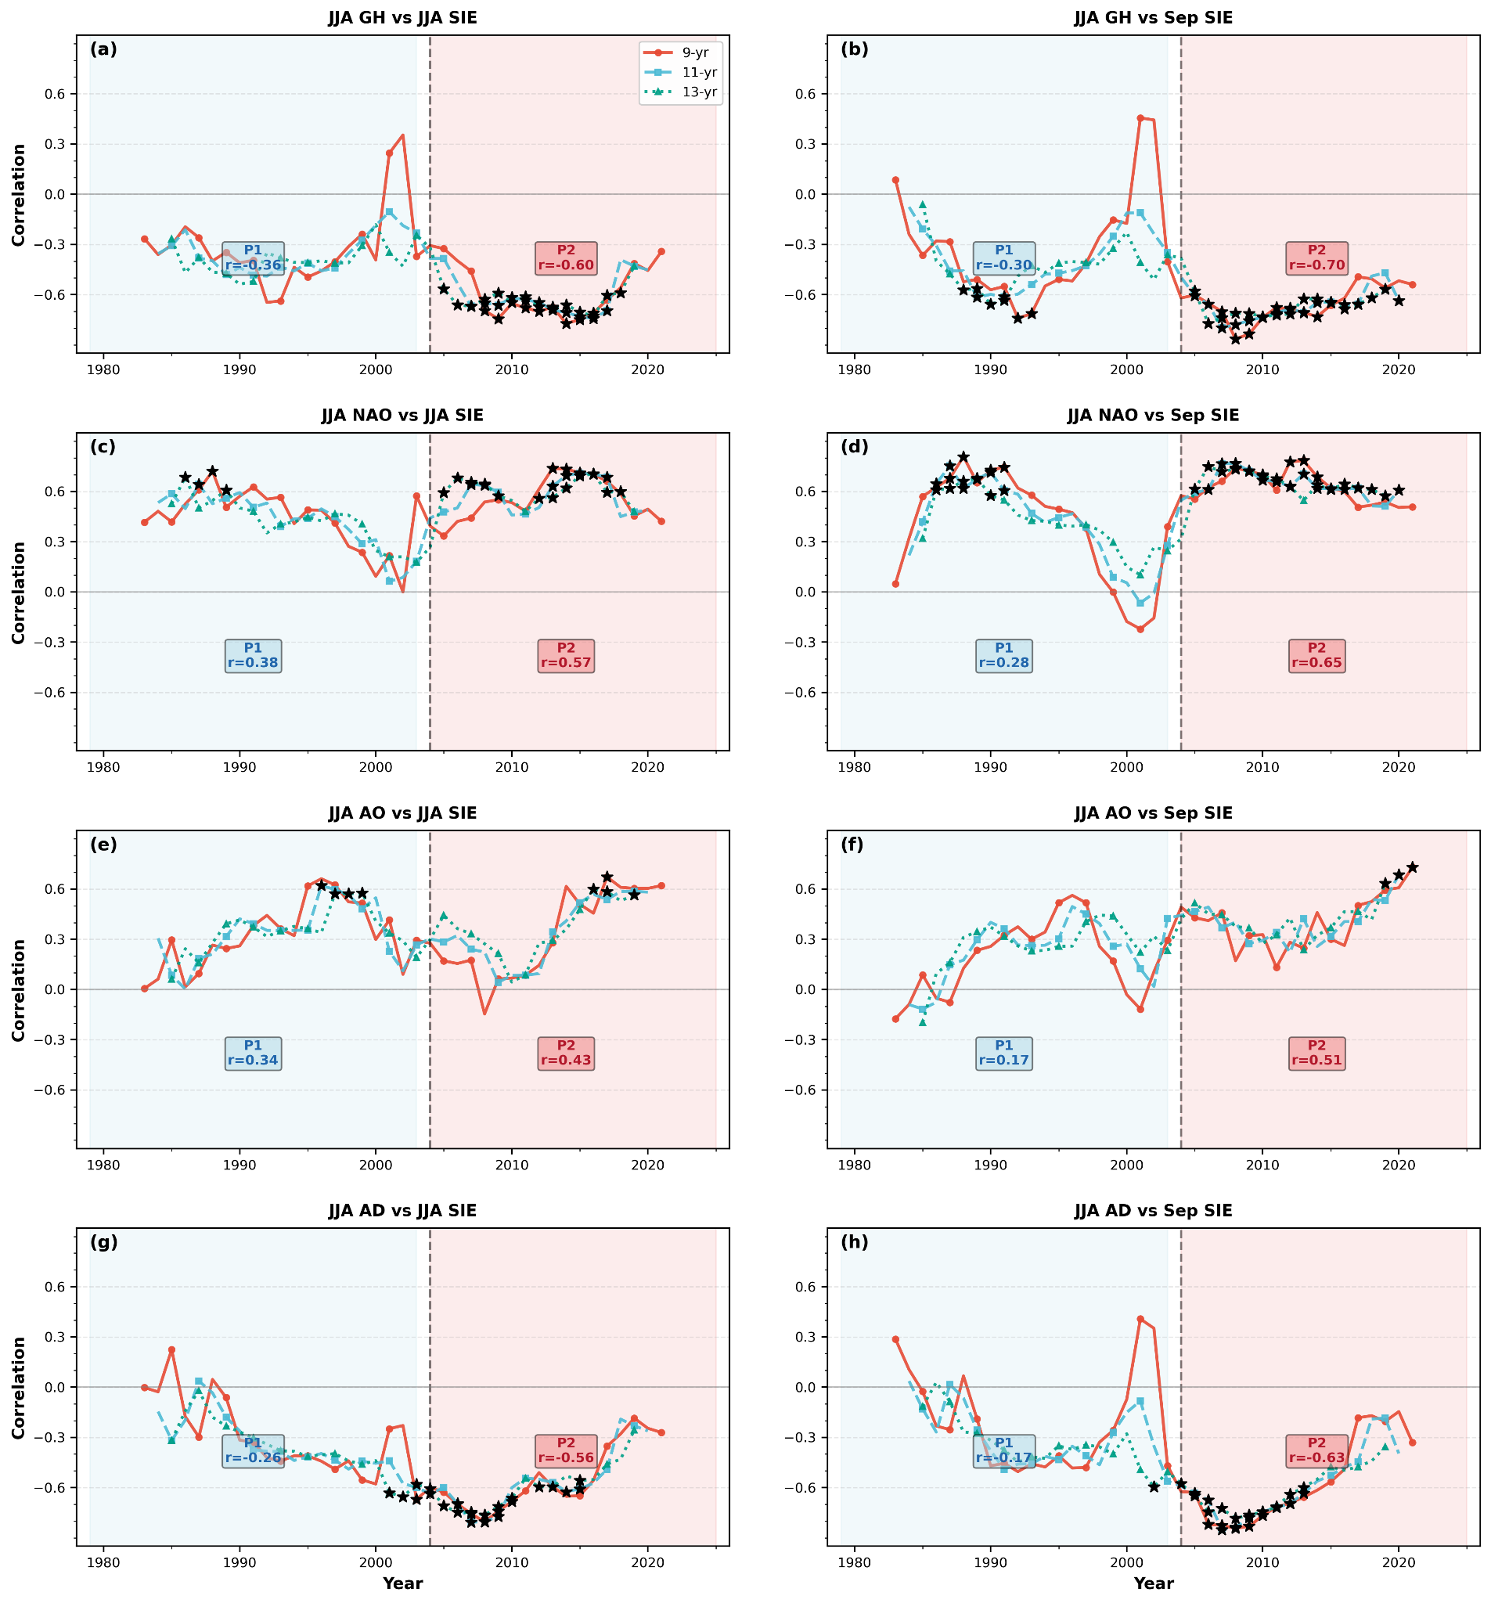
Figure S3. Running correlations between JJA climate indices and Arctic sea ice extent (1979–2025). Each panel shows running correlations calculated using 9-year (red solid), 11-year (cyan dashed), and 13-year (green dotted) moving windows between JJA-averaged climate indices and sea ice extent. Left column: correlations with JJA sea ice extent; right column: correlations with September sea ice extent. (a, b) Greenland High (GH) index; (c, d) North Atlantic Oscillation (NAO) index; (e, f) Arctic Oscillation (AO) index; (g, h) Arctic Dipole (AD) index. Blue shading denotes Period 1 (P1; 1979–2003) and red shading denotes Period 2 (P2; 2004–2025), with mean correlations for each period shown in the inset boxes. All time series were linearly detrended prior to analysis. Black stars indicate correlations significant at p < 0.05. Note the marked strengthening of Arctic cirulation–SIE correlations after 2003, indicating intensified atmosphere–sea ice coupling in the new ice regime.

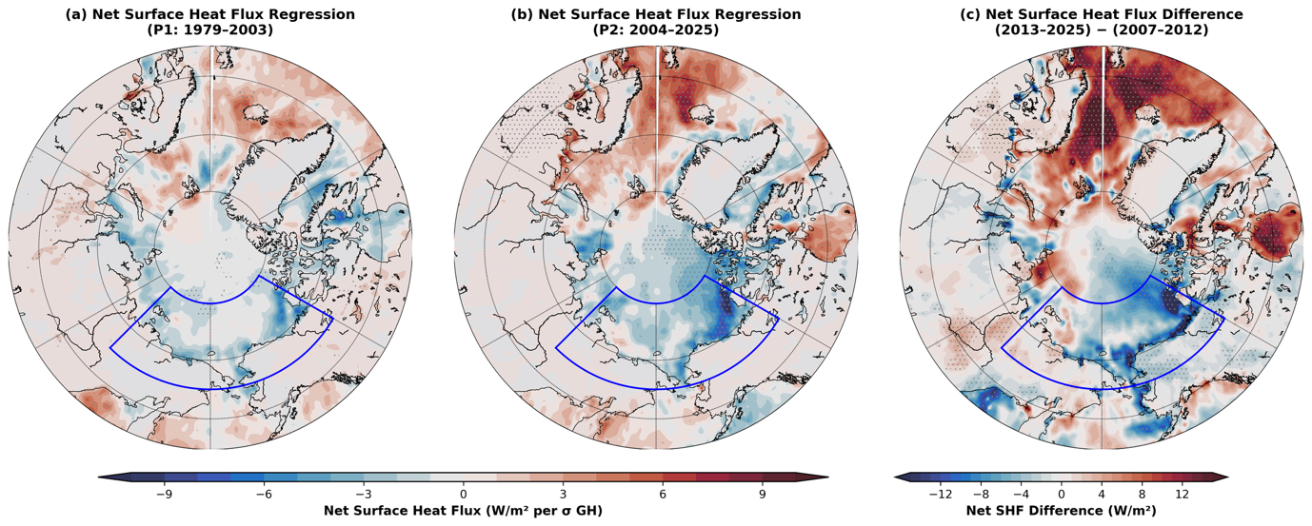
Figure S4. Net surface heat flux response to the June Greenland High variability. (a, b) Spatial pattern of JJAS net surface heat flux regressed onto the standardized June Greenland High (GH) index for (a) the “Old Arctic” period (P1: 1979–2003) and (b) the “New Arctic” period (P2: 2004–2025). Positive (negative) regression coefficients indicate increased (decreased) downward energy flux into the surface associated with a weaker GH. (c) Composite difference in net surface heat flux between the weak GH phase (2013–2025) and the strong GH phase (2007–2012). Net surface heat flux is calculated from ERA5 reanalysis as the sum of net longwave radiation, net shortwave radiation, latent heat flux, and sensible heat flux (positive downward). Stippling denotes grid cells where regressions or differences are statistically significant at the 95% confidence level (p < 0.05; two-tailed t-test for regressions, independent samples t-test for composite). The blue box outlines the Pacific Arctic Sector (PAS; 65–80°N, 135–240°E). Regressions are expressed per standard deviation of the inverted GH index and both time series are linearly detrended prior to analysis. The regression magnitude in P2 substantially exceeds that of P1 across the Arctic marginal seas, indicating that the transition to a thinner, more responsive ice cover has amplified the surface energy budget’s sensitivity to atmospheric circulation variability. The composite difference reveals reduced net surface heat flux across the PAS during the weak GH phase, reflecting diminished shortwave absorption under enhanced cloud cover and reduced turbulent heat loss.

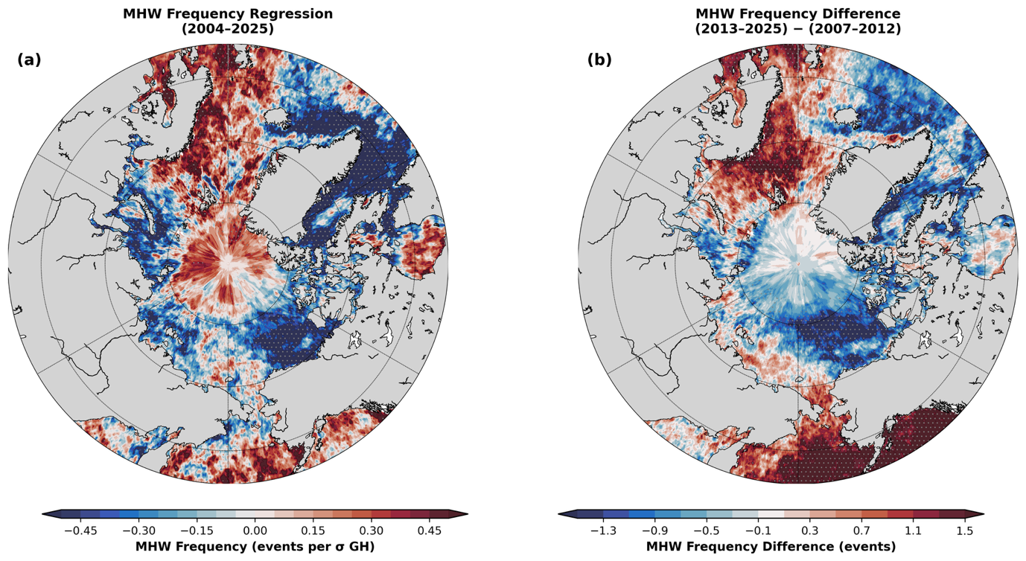
Figure S5. Summer marine heatwave (MHW) frequency and its relationship with the June Greenland High (GH). (a) Regression of JJAS MHW frequency onto the detrended, sign-inverted June GH index (2004–2025), showing the spatial pattern of MHW frequency change per standard deviation decrease in GH strength. (b) Difference in JJAS MHW frequency between the weak GH phase (2013–2025) and the strong GH phase (2007–2012). Stippling indicates p < 0.05. Regressions are expressed per standard deviation of the inverted GH index and both time series are linearly detrended prior to analysis. Both panels reveal increased MHW frequency in the Norwegian–Barents Sea region during periods of GH weakening.

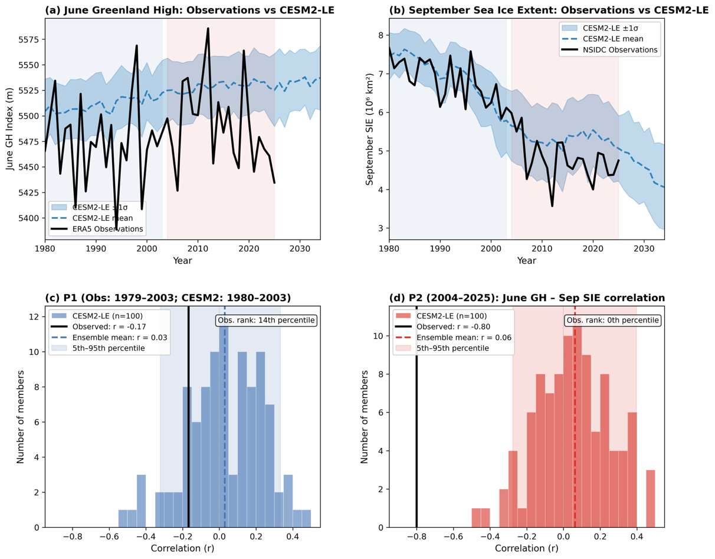
Figure S6. Comparison of observed and CESM2-LE simulated June Greenland High–September sea ice extent relationships. (a) Time series of June Greenland High (GH) index from ERA5 observations (black) and CESM2 Large Ensemble (CESM2-LE; blue dashed line shows ensemble mean, shading indicates ±1 standard deviation across 100 members). (b) Time series of September Arctic sea ice extent (SIE) from NSIDC observations (black) and CESM2-LE (blue). Light blue and light red background shading in (a) and (b) denote P1 and P2 periods, respectively. (c) Histogram of detrended June GH–September SIE correlations for P1 (observations: 1979–2003; CESM2-LE: 1980–2003) across 100 CESM2-LE ensemble members. The observed correlation (r = −0.17; black vertical line) falls at the 17th percentile of the ensemble distribution, which is centered near zero (ensemble mean r = 0.03). (d) Same as (c) but for P2 (2004–2025). The observed P2 correlation (r = −0.80) is more extreme than all 100 ensemble members (0th percentile), while the ensemble mean remains near zero (r = 0.06). All correlations are computed after linearly detrending the time series (1979–2025 for observations; 1980–2025 for CESM2-LE) to isolate interannual variability.

