Supplementary Information for:

Chebulagic acid limits mTOR activity leading to TFEB-driven autophagy and lysosomal biogenesis to suppress the arecoline-induced NLRP3-mediated inflammasome axis in OSCC
Authors:
Prakash Kumar Senapati ¹, Amruta Singh¹, Rakesh Kumar Kar¹, Kewal Kumar Mahapatra², Swatilekha Maiti³, Mrutyunjay Jena⁴, Sujit Kumar Bhutia^{1,} *
¹Cancer and Cell Death Laboratory, Department of Life Science, National Institute of Technology Rourkela, Rourkela, 769008, Odisha, India
*Corresponding Author
Sujit Kumar Bhutia, Professor, Department of Life Science, National Institute of Technology Rourkela, Rourkela-769008, Odisha, India, Phone: 91-6612462686, Fax. 91661-2472926, E-mail: sujitb@nitrkl.ac.in, bhutiask@gmail.com

Fig. S1
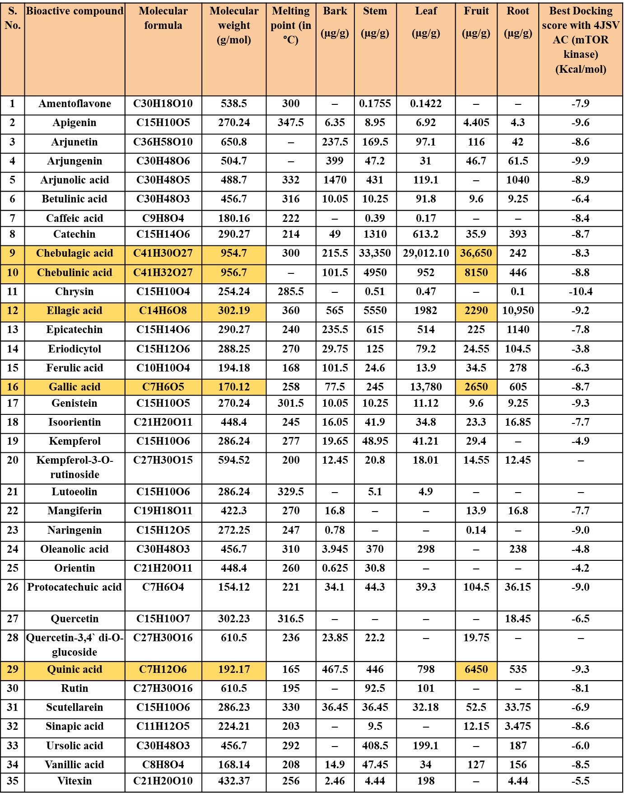
Fig. S1: List of bioactive compounds (µg/g) Present in the various parts of Terminalia bellerica and their best docking score with the mTOR kinase domain (4JSV-AC chain).

Fig. S2
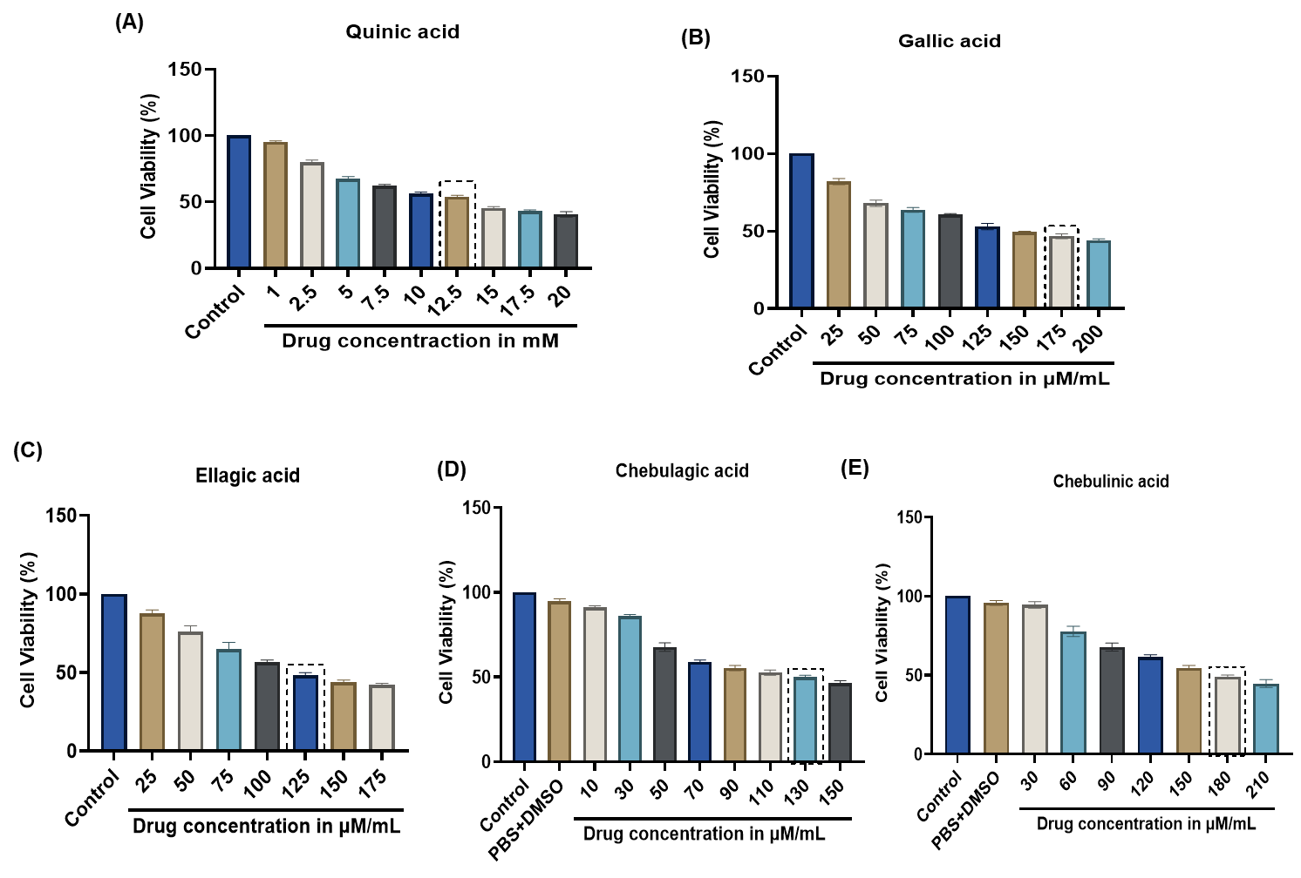

Fig. S2: Cell viability assay of (a) Quinic acid, (b) Gallic acid, (c) Ellagic acid, (d)Chebulagic acid, and (e) Chebulinic acid by using the CAL33 cell line. All data are represented as the mean ± SD of three different experiments. Error bars: ± S.D. ns: not significant, *p < 0.05, **p < 0.01, and ***p < 0.001, ****p < 0.0001.

Fig. S3

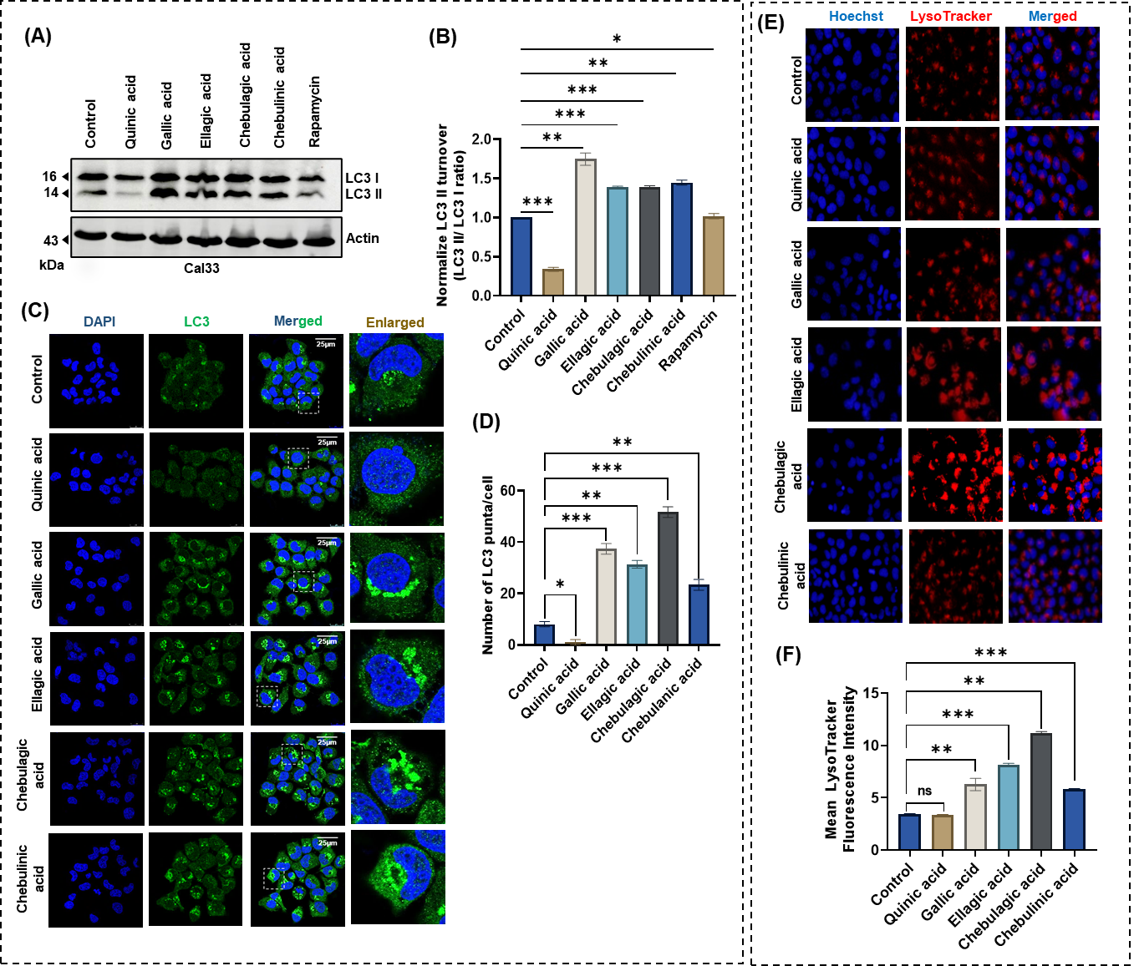

Fig. S3: Screening of autophagy and mTOR-inducing potential of selected compounds of Terminalia bellirica. (A) Western blot analysis of LC3 I to LC3 II conversion, (B) normalized expression of LC3 turnover, (C) LC3 puncta analysis, (D) quantification of number of LC3 puncta/cell, (E) LysoTracker staining of selected bioactive compounds, and (F) mean LysoTracker fluorescence intensity quantification. All data are represented as the mean ± SD of three different experiments. Error bars: ± S.D. ns: not significant, *p < 0.05, **p < 0.01, and ***p < 0.001, ****p < 0.0001.

Fig. S4
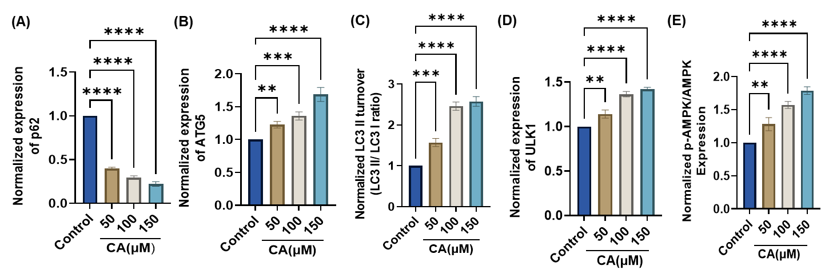

Fig. S4: Normalized expression levels of key autophagy-related proteins (A) p62, (b) ATG5, (C) LC3, (D)ULK1, and (E) AMPK. Error bars: ± S.D. ns: not significant, *p < 0.05, **p < 0.01, and ***p < 0.001, ****p < 0.0001.

