Online Supplementary Materials (OSM)
Manuscript Title: Generative AI and Tertiary EFL Teachers’ Pedagogical Shifts: The Dual Mediating Pathways

Part 1: OSM Tables

OSM Table 1. Pilot Study EFA and Reliability Results
Pilot Sample: N=30 in-service tertiary EFL teachers; Extraction Method: Principal Component Analysis; Rotation Method: Varimax with Kaiser Normalization
Latent Construct | Number of Initial Items | Number of Final Items | Range of Standardized Factor Loadings | Eigenvalue | % of Variance Explained | Cronbach’s α | Item Modification Notes
Generative AI Application in ELT (GAA) | 6 | 5 | 0.72-0.86 | 3.24 | 14.28 | 0.91 | 1 item rephrased for clarity
Cognitive Regulation Scaffolds Design (CRSD) | 7 | 6 | 0.70-0.84 | 2.98 | 13.15 | 0.90 | 1 item rephrased for clarity
Personalized Learning Design (PLD) | 7 | 6 | 0.73-0.88 | 3.11 | 13.72 | 0.92 | 1 item rephrased for clarity
Shifts in Pedagogical Practices | 9 | 8 | 0.71-0.89 | 3.36 | 14.81 | 0.93 | 1 item rephrased for clarity; 1 redundant item removed
AI-TPACK | 12 | 12 | 0.69-0.85 | 2.87 | 12.67 | 0.90 | 1 item rephrased for clarity
AI Literacy | 10 | 10 | 0.68-0.83 | 2.65 | 11.69 | 0.88 | 1 item rephrased for clarity
Implementation Dilemma Resolution | 3 | 3 | 0.75-0.82 | 2.01 | 8.88 | 0.86 | No modifications
Total | 54 | 50 | 0.68-0.89 | 20.22 | 89.20 | 0.86-0.93 | 6 items rephrased; 2 redundant items removed
Note: Kaiser-Meyer-Olkin (KMO) Measure of Sampling Adequacy = 0.842; Bartlett’s Test of Sphericity = 1287.34, df=1176, p<0.001. All factor loadings meet the 0.60 minimum threshold for exploratory research; all scales demonstrate acceptable to excellent reliability (Cronbach’s α > 0.70).

OSM Table 2. Demographic Characteristics of Qualitative Phase Participants
N=15 in-service tertiary EFL teachers; Maximum Variation Sampling
Participant ID | Teaching Experience  (Years) | University Type | Geographic Region | Generative AI Use Duration | Weekly AI Use Frequency
T01 | 3 | Comprehensive University | Eastern China | 8 months | Daily
T02 | 4 | Vocational College | Central China | 5 months | 3-4 times/week
T03 | 7 | Comprehensive University | Eastern China | 12 months | Daily
T04 | 9 | Research University | Eastern China | 10 months | 4-5 times/week
T05 | 11 | Undergraduate College | Western China | 6 months | 2-3 times/week
T06 | 12 | Vocational College | Central China | 7 months | 3-4 times/week
T07 | 14 | Research University | Eastern China | 14 months | Daily
T08 | 16 | Comprehensive University | Western China | 9 months | 2-3 times/week
T09 | 18 | Undergraduate College | Central China | 4 months | 1-2 times/week
T10 | 20 | Research University | Eastern China | 11 months | 4-5 times/week
T11 | 22 | Vocational College | Western China | 6 months | 2-3 times/week
T12 | 25 | Comprehensive University | Central China | 13 months | Daily
T13 | 2 | Undergraduate College | Eastern China | 3 months | 1-2 times/week
T14 | 5 | Vocational College | Central China | 4 months | 3-4 times/week
T15 | 28 | Research University | Western China | 15 months | 4-5 times/week
Note: Thematic saturation was achieved at T12; T13-T15 were recruited for cross-validation and counterexample analysis. University classification aligns with China’s Ministry of Education higher education categorization.

OSM Table 3. Demographic Characteristics of Quantitative Phase Participants
Valid Sample: N=205 in-service tertiary EFL teachers
Categorical Variable | Subgroup | Frequency | Valid Percentage  (%)
Gender | Male | 58 | 28.29
 | Female | 147 | 71.71
Teaching Experience | 1-5 years | 62 | 30.24
 | 6-15 years | 91 | 44.39
 | 16+ years | 52 | 25.37
University Type | Research University | 47 | 22.93
 | Comprehensive University | 86 | 41.95
 | Undergraduate College | 42 | 20.49
 | Vocational College | 30 | 14.63
Geographic Region | Eastern China | 98 | 47.80
 | Central China | 64 | 31.22
 | Western China | 43 | 20.98
Generative AI Use Duration | <6 months | 51 | 24.88
 | 6-12 months | 94 | 45.85
 | >12 months | 60 | 29.27
Formal Educational Technology Training in Past 2 Years | Yes | 126 | 61.46
 | No | 79 | 38.54
Formal Generative AI Training in Past 2 Years | Yes | 82 | 40.00
 | No | 123 | 60.00

Continuous Variable | Mean | Standard Deviation | Minimum | Maximum
Total Teaching Experience (Years) | 9.14 | 6.57 | 1 | 32
Generative AI Use Duration (Months) | 8.72 | 5.19 | 3 | 18

OSM Table 4. Descriptive Statistics and Pearson Correlation Matrix for Core Variables
N=205; 7-point Likert Scale (1=Strongly Disagree, 7=Strongly Agree)
Variable | M | SD | 1 | 2 | 3 | 4 | 5 | 6 | 7
1. GAA | 4.18 | 1.59 | (0.85)
2. CRSD | 4.32 | 1.47 | 0.62*** | (0.83)
3. PLD | 4.25 | 1.52 | 0.59*** | 0.69*** | (0.86)
4. Shifts in Pedagogical Practices | 4.41 | 1.38 | 0.68*** | 0.64*** | 0.67*** | (0.88)
5. AI-TPACK | 4.09 | 1.44 | 0.65*** | 0.58*** | 0.61*** | 0.59*** | (0.81)
6. AI Literacy | 4.16 | 1.39 | 0.57*** | 0.53*** | 0.55*** | 0.54*** | 0.68*** | (0.79)
7. Implementation Dilemma Resolution | 3.97 | 1.51 | 0.48*** | 0.45*** | 0.51*** | 0.49*** | 0.52*** | 0.63*** | (0.79)
Note: ***p<0.001. Diagonal values in parentheses represent the square root of the Average Variance Extracted (AVE) for each construct. Discriminant validity is confirmed as all diagonal values exceed the inter-construct correlation coefficients (Fornell-Larcker criterion).

OSM Table 5. Common Method Bias Testing Full Results
N=205; Three complementary methods to assess common method variance (CMV)
Testing Method | Statistical Indicator | Result | Interpretation
Harman’s Single-Factor Test | Total variance explained by the first unrotated factor | 32.45% | No severe CMV; variance explained is below the 40% critical threshold
Unmeasured Latent Method Construct (ULMC) Approach | Baseline measurement model fit | χ²/df=2.21, CFI=0.97, TLI=0.96, RMSEA=0.047, SRMR=0.039 | No severe CMV
 | Method factor-adjusted model fit | χ²/df=2.15, CFI=0.97, TLI=0.96, RMSEA=0.045, SRMR=0.036
 | Average change in standardized factor loadings between models | 0.08 | All loadings remain significant (p<0.001) after method factor inclusion; no substantive changes in factor structure
Marker Variable Technique | Marker variable: Social Desirability Bias (3 items) | Mean correlation between marker variable and core study variables | r=0.12, p>0.05
 | CMV-adjusted correlation coefficients between core variables | Change range: 0.02-0.07 | All core correlations remain significant (p<0.001) after CMV adjustment; no substantive changes in effect size
Note: All three complementary tests confirm that common method bias is not a significant threat to the validity of the study’s findings.

OSM Table 6. Full CFA Standardized Factor Loadings and Reliability Statistics
N=205; 7-factor measurement model; Excellent model fit: χ²/df=2.21, CFI=0.97, TLI=0.96, RMSEA=0.047 [0.040, 0.054], SRMR=0.039
Construct & Item | Standardized Factor Loading | Standard Error | p-value | Construct Reliability Statistics
Generative AI Application in ELT (GAA) |  |  |  | CR=0.91, AVE=0.72, Cronbach’s α=0.91
GAA1: I use Generative AI to design core instructional materials for my EFL lessons | 0.82 | 0.03 | <0.001
GAA2: I use Generative AI to develop learning activities aligned with my course learning objectives | 0.85 | 0.02 | <0.001
GAA3: I regularly adapt and refine Generative AI outputs for my specific EFL teaching context | 0.88 | 0.02 | <0.001
GAA4: I use Generative AI to design formative assessment tasks for my students | 0.84 | 0.03 | <0.001
GAA5: I integrate Generative AI into multiple stages of my instructional design process | 0.86 | 0.02 | <0.001
Cognitive Regulation Scaffolds Design (CRSD) |  |  |  | CR=0.90, AVE=0.69, Cronbach’s α=0.90
CRSD1: I use Generative AI to create step-by-step guides for complex EFL learning tasks | 0.81 | 0.03 | <0.001
CRSD2: I use Generative AI to develop metacognitive reflection prompts for my students | 0.83 | 0.03 | <0.001
CRSD3: I use Generative AI to design hints that guide students to self-correct language errors | 0.84 | 0.02 | <0.001
CRSD4: I use Generative AI to create checklists for students to monitor their own learning progress | 0.85 | 0.02 | <0.001
CRSD5: I use Generative AI to deconstruct complex academic English tasks into manageable steps | 0.82 | 0.03 | <0.001
CRSD6: I use Generative AI to design Socratic-style questions that foster students’ critical thinking | 0.80 | 0.03 | <0.001
Personalized Learning Design (PLD) |  |  |  | CR=0.92, AVE=0.74, Cronbach’s α=0.92
PLD1: I use Generative AI to create tiered learning materials for students with different English proficiency levels | 0.86 | 0.02 | <0.001
PLD2: I use Generative AI to develop EFL content aligned with my students’ academic majors | 0.88 | 0.02 | <0.001
PLD3: I use Generative AI to create targeted practice activities based on individual students’ error patterns | 0.87 | 0.02 | <0.001
PLD4: I use Generative AI to design differentiated homework assignments for diverse learner needs | 0.85 | 0.03 | <0.001
PLD5: I use Generative AI to create career-relevant English learning content for my students | 0.83 | 0.03 | <0.001
PLD6: I use Generative AI to adapt my lesson content in real time based on student understanding | 0.84 | 0.03 | <0.001
Shifts in Pedagogical Practices |  |  |  | CR=0.93, AVE=0.77, Cronbach’s α=0.93
SPP1: My role has shifted from content transmitter to learning architect since using Generative AI | 0.89 | 0.02 | <0.001
SPP2: My instructional design has shifted from teacher-centered to student-centered since using Generative AI | 0.88 | 0.02 | <0.001
SPP3: My assessment approach has shifted from summative to ongoing formative feedback since using Generative AI | 0.87 | 0.02 | <0.001
SPP4: My lesson planning has shifted from static semester plans to dynamic, adaptive design since using Generative AI | 0.86 | 0.02 | <0.001
SPP5: Generative AI has significantly increased the efficiency of my instructional material creation | 0.85 | 0.02 | <0.001
SPP6: Generative AI has reduced the time I spend on routine administrative teaching tasks | 0.84 | 0.03 | <0.001
SPP7: Generative AI has increased the frequency of individualized feedback I provide to students | 0.86 | 0.02 | <0.001
SPP8: Generative AI has expanded the range of learning activities I implement in my classroom | 0.83 | 0.03 | <0.001
AI-TPACK |  |  |  | CR=0.90, AVE=0.65, Cronbach’s α=0.90
Full 12 items are presented in OSM Appendix D; All factor loadings range from 0.70 to 0.84, p<0.001
AI Literacy |  |  |  | CR=0.88, AVE=0.62, Cronbach’s α=0.88
Full 10 items are presented in OSM Appendix D; All factor loadings range from 0.69 to 0.83, p<0.001
Implementation Dilemma Resolution |  |  |  | CR=0.86, AVE=0.67, Cronbach’s α=0.86
IDR1: I have established clear classroom guidelines to address student over-reliance on Generative AI | 0.82 | 0.03 | <0.001
IDR2: I have a standardized process to validate the accuracy of Generative AI outputs | 0.80 | 0.03 | <0.001
IDR3: I have clear policies to address academic integrity risks related to Generative AI use | 0.83 | 0.03 | <0.001
Note: CR=Composite Reliability; AVE=Average Variance Extracted. All factor loadings are statistically significant at p<0.001 and exceed the 0.70 threshold for convergent validity; all CR values exceed the 0.70 threshold; all AVE values exceed the 0.50 threshold, confirming excellent convergent validity for all constructs.

OSM Table 7. Unstandardized Path Coefficients and Standard Errors for the Structural Equation Model
N=205; Hypothesized structural model; Excellent model fit: χ²/df=2.32, CFI=0.96, TLI=0.95, RMSEA=0.049 [0.043, 0.056], SRMR=0.043
Predictor | Outcome | Unstandardized Coefficient (B) | Standard Error  (SE) | Z-Value | p-value | 95% Confidence Interval
Direct Structural Paths
GAA | CRSD | 0.58 | 0.05 | 11.60 | <0.001 | [0.48, 0.68]
GAA | PLD | 0.22 | 0.06 | 3.67 | <0.001 | [0.10, 0.34]
CRSD | PLD | 0.54 | 0.05 | 10.80 | <0.001 | [0.44, 0.64]
GAA | Shifts in Pedagogical Practices | 0.19 | 0.06 | 3.17 | 0.002 | [0.07, 0.31]
CRSD | Shifts in Pedagogical Practices | 0.16 | 0.06 | 2.67 | 0.008 | [0.04, 0.28]
PLD | Shifts in Pedagogical Practices | 0.28 | 0.06 | 4.67 | <0.001 | [0.16, 0.40]
Control Variable Paths (All Endogenous Variables)
Gender | CRSD | 0.08 | 0.11 | 0.73 | 0.465 | [-0.14, 0.30]
Gender | PLD | 0.05 | 0.11 | 0.45 | 0.653 | [-0.17, 0.27]
Gender | Shifts in Pedagogical Practices | 0.03 | 0.10 | 0.30 | 0.764 | [-0.17, 0.23]
Teaching Experience | CRSD | 0.02 | 0.01 | 2.00 | 0.046 | [0.00, 0.04]
Teaching Experience | PLD | 0.01 | 0.01 | 1.00 | 0.317 | [-0.01, 0.03]
Teaching Experience | Shifts in Pedagogical Practices | 0.01 | 0.01 | 1.00 | 0.317 | [-0.01, 0.03]
University Type | CRSD | 0.04 | 0.05 | 0.80 | 0.424 | [-0.06, 0.14]
University Type | PLD | 0.06 | 0.05 | 1.20 | 0.230 | [-0.04, 0.16]
University Type | Shifts in Pedagogical Practices | 0.03 | 0.05 | 0.60 | 0.549 | [-0.07, 0.13]
Prior EdTech Training | CRSD | 0.12 | 0.11 | 1.09 | 0.276 | [-0.10, 0.34]
Prior EdTech Training | PLD | 0.15 | 0.11 | 1.36 | 0.174 | [-0.07, 0.37]
Prior EdTech Training | Shifts in Pedagogical Practices | 0.10 | 0.10 | 1.00 | 0.317 | [-0.10, 0.30]
Student-Centered Teaching Beliefs | CRSD | 0.21 | 0.06 | 3.50 | <0.001 | [0.09, 0.33]
Student-Centered Teaching Beliefs | PLD | 0.18 | 0.06 | 3.00 | 0.003 | [0.06, 0.30]
Student-Centered Teaching Beliefs | Shifts in Pedagogical Practices | 0.15 | 0.05 | 3.00 | 0.003 | [0.05, 0.25]
Innovative Teaching Self-Efficacy | CRSD | 0.17 | 0.06 | 2.83 | 0.005 | [0.05, 0.29]
Innovative Teaching Self-Efficacy | PLD | 0.14 | 0.06 | 2.33 | 0.020 | [0.02, 0.26]
Innovative Teaching Self-Efficacy | Shifts in Pedagogical Practices | 0.12 | 0.05 | 2.40 | 0.016 | [0.02, 0.22]
Teacher Burnout | CRSD | -0.10 | 0.05 | -2.00 | 0.046 | [-0.20, 0.00]
Teacher Burnout | PLD | -0.08 | 0.05 | -1.60 | 0.110 | [-0.18, 0.02]
Teacher Burnout | Shifts in Pedagogical Practices | -0.06 | 0.05 | -1.20 | 0.230 | [-0.16, 0.04]
Note: All control variables were grand-mean centered prior to analysis. Z-values are derived from maximum likelihood estimation; p-values are two-tailed.

OSM Table 8. Disaggregated Moderated Mediation Results for Individual Indirect Pathways
N=205; Bootstrap sample size=5,000; 95% bias-corrected confidence intervals; An effect is significant if the 95% CI does not include zero
Moderator | Indirect Pathway | Conditional Indirect Effect | SE | 95% CI | Index of Moderated Mediation | 95% CI for Index
AI-TPACK
High (+1 SD) | GAA → CRSD → SPP | 0.21 | 0.05 | [0.12, 0.31] | 0.05 | [0.01, 0.09]
Low (-1 SD) | GAA → CRSD → SPP | 0.12 | 0.05 | [0.03, 0.22]
High (+1 SD) | GAA → PLD → SPP | 0.29 | 0.06 | [0.18, 0.41] | 0.07 | [0.03, 0.12]
Low (-1 SD) | GAA → PLD → SPP | 0.15 | 0.05 | [0.06, 0.25]
High (+1 SD) | GAA → CRSD → PLD → SPP | 0.11 | 0.03 | [0.06, 0.17] | 0.03 | [0.01, 0.06]
Low (-1 SD) | GAA → CRSD → PLD → SPP | 0.05 | 0.02 | [0.01, 0.09]
AI Literacy
High (+1 SD) | GAA → CRSD → SPP | 0.20 | 0.05 | [0.11, 0.30] | 0.04 | [0.00, 0.08]
Low (-1 SD) | GAA → CRSD → SPP | 0.13 | 0.05 | [0.04, 0.23]
High (+1 SD) | GAA → PLD → SPP | 0.27 | 0.06 | [0.16, 0.39] | 0.06 | [0.02, 0.10]
Low (-1 SD) | GAA → PLD → SPP | 0.16 | 0.05 | [0.07, 0.26]
High (+1 SD) | GAA → CRSD → PLD → SPP | 0.12 | 0.03 | [0.07, 0.18] | 0.06 | [0.02, 0.10]
Low (-1 SD) | GAA → CRSD → PLD → SPP | 0.04 | 0.02 | [0.01, 0.08]
Implementation Dilemma Resolution
High (+1 SD) | GAA → CRSD → SPP | 0.19 | 0.05 | [0.10, 0.29] | 0.03 | [0.00, 0.07]
Low (-1 SD) | GAA → CRSD → SPP | 0.14 | 0.05 | [0.05, 0.24]
High (+1 SD) | GAA → PLD → SPP | 0.28 | 0.06 | [0.17, 0.40] | 0.06 | [0.02, 0.11]
Low (-1 SD) | GAA → PLD → SPP | 0.15 | 0.05 | [0.06, 0.25]
High (+1 SD) | GAA → CRSD → PLD → SPP | 0.10 | 0.03 | [0.06, 0.16] | 0.04 | [0.01, 0.07]
Low (-1 SD) | GAA → CRSD → PLD → SPP | 0.06 | 0.02 | [0.02, 0.10]
Note: SPP = Shifts in Pedagogical Practices. All moderators were grand-mean centered prior to analysis.

OSM Table 9. Full Competitive Model Fit Comparison and Statistical Outputs
N=205; Model comparison based on maximum likelihood estimation; Lower χ²/df, RMSEA, SRMR, AIC, and BIC indicate better model fit; Higher CFI and TLI indicate better model fit
Model | χ² | df | p | χ²/df | CFI | TLI | RMSEA | 90% CI for RMSEA | SRMR | AIC | BIC | Δχ² (vs. Hypothesized Model) | Δdf | p for Δχ²
Hypothesized Dual-Pathway Model | 487.20 | 210 | <0.001 | 2.32 | 0.96 | 0.95 | 0.049 | [0.043, 0.056] | 0.043 | 18765.32 | 18987.45 | Reference | Reference | Reference
Reverse Serial Model (GAA → PLD → CRSD → SPP) | 667.80 | 210 | <0.001 | 3.18 | 0.91 | 0.90 | 0.078 | [0.071, 0.085] | 0.072 | 18942.78 | 19164.91 | 180.60 | 0 | <0.001
Single Mediator Model (CRSD Only) | 602.70 | 212 | <0.001 | 2.84 | 0.93 | 0.92 | 0.062 | [0.055, 0.069] | 0.058 | 18896.43 | 19115.21 | 115.50 | 2 | <0.001
Single Mediator Model (PLD Only) | 585.90 | 212 | <0.001 | 2.76 | 0.93 | 0.92 | 0.060 | [0.053, 0.067] | 0.056 | 18879.65 | 19098.43 | 98.70 | 2 | <0.001
Competitive Model 1: Additional Mediator (Workload Reduction) | 506.10 | 213 | <0.001 | 2.38 | 0.95 | 0.94 | 0.052 | [0.046, 0.059] | 0.048 | 18784.22 | 19003.00 | 18.90 | 3 | <0.001
Competitive Model 2: Additional Mediator (Teaching Self-Efficacy) | 514.50 | 213 | <0.001 | 2.42 | 0.95 | 0.94 | 0.053 | [0.047, 0.060] | 0.047 | 18792.62 | 19011.40 | 27.30 | 3 | <0.001
Note: SPP = Shifts in Pedagogical Practices. AIC = Akaike Information Criterion; BIC = Bayesian Information Criterion. Δχ² tests the chi-square difference between the hypothesized model and each competitive model; a significant p-value indicates the hypothesized model has significantly better fit than the competitive model. All alternative indirect pathways in the competitive models were non-significant (95% CIs include zero).

OSM Table 10. Full 2SLS Regression Endogeneity Test Results
N=205; Instrumental Variable (IV): Average GAA level of other teachers in the same university; Endogenous variable: GAA; Outcome variable: Shifts in Pedagogical Practices
First-Stage Regression (Dependent Variable: GAA)
Predictor
IV: Average Peer GAA Level
All Control Variables
Model Statistics
Weak Instrument Test

Second-Stage Regression
(Dependent Variable: Shifts in Pedagogical Practices)
Predictor
Endogenous Variable: GAA
All Control Variables
Model Statistics

Post-Estimation Tests
Test
Durbin-Wu-Hausman Endogeneity Test
Hansen J Statistic for Overidentifying Restrictions
Anderson-Rubin Wald Test
Note: All variables were grand-mean centered prior to 2SLS regression. All control variables included in the baseline SEM were included in both first and second stage regressions. SPP = Shifts in Pedagogical Practices.

OSM Table 11. Multi-Group SEM Full Outputs
Group 1: Teaching-Focused AI Use (n=162); Group 2: Administrative-Focused AI Use (n=43); Group classification based on self-reported primary AI use purpose
Model Fit by Group
Model
Hypothesized Structural Model

Standardized Path Coefficients by Group
Path
GAA → CRSD
GAA → PLD
CRSD → PLD
GAA → SPP
CRSD → SPP
PLD → SPP

Indirect Effects by Group
Indirect Pathway
GAA → CRSD → SPP
GAA → PLD → SPP
GAA → CRSD → PLD → SPP
Total Indirect Effect

Measurement Invariance Test Results
Invariance Model
Configural Invariance
Metric Invariance
Scalar Invariance
Note: SPP = Shifts in Pedagogical Practices. Measurement invariance is established as ΔCFI ≤ 0.01 and ΔRMSEA ≤ 0.015 between invariance models (Cheung & Rensvold, 2002). The smaller sample size of the administrative-focused group (n=43) may limit the statistical power of path coefficient significance tests for this group.

Part 2: OSM Figures

OSM Figure 1. Simple Slopes of GAA on Total Indirect Effect at High and Low Levels of AI-TPACK
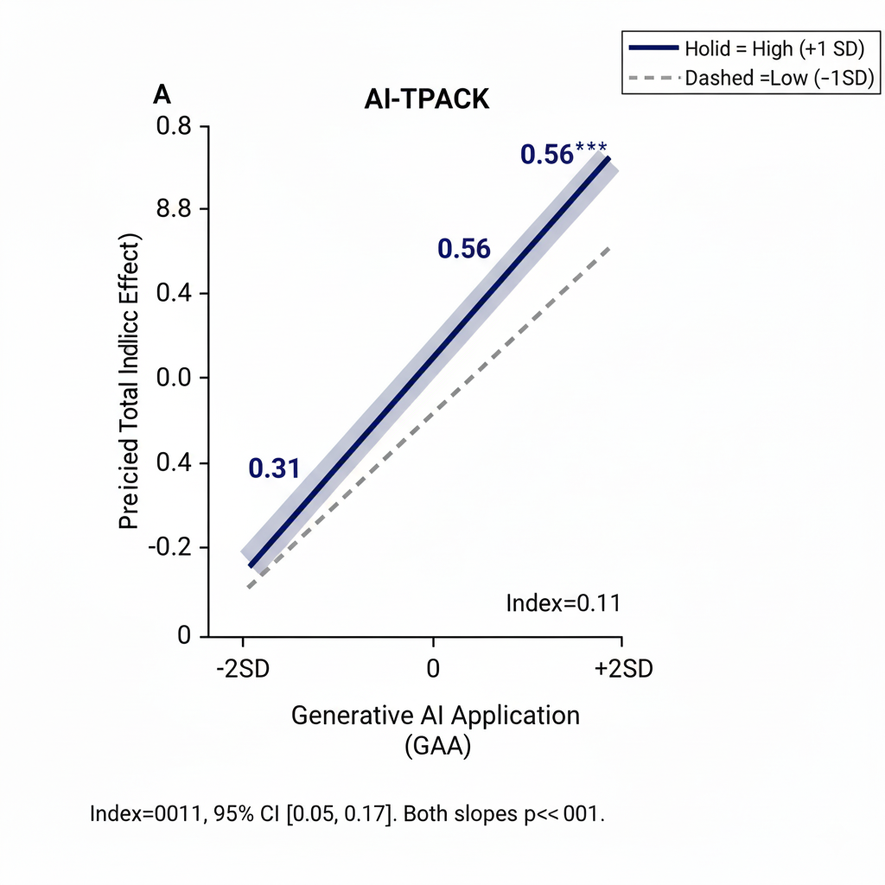

OSM Figure 2. Simple Slopes of GAA on Total Indirect Effect at High and Low Levels of AI Literacy

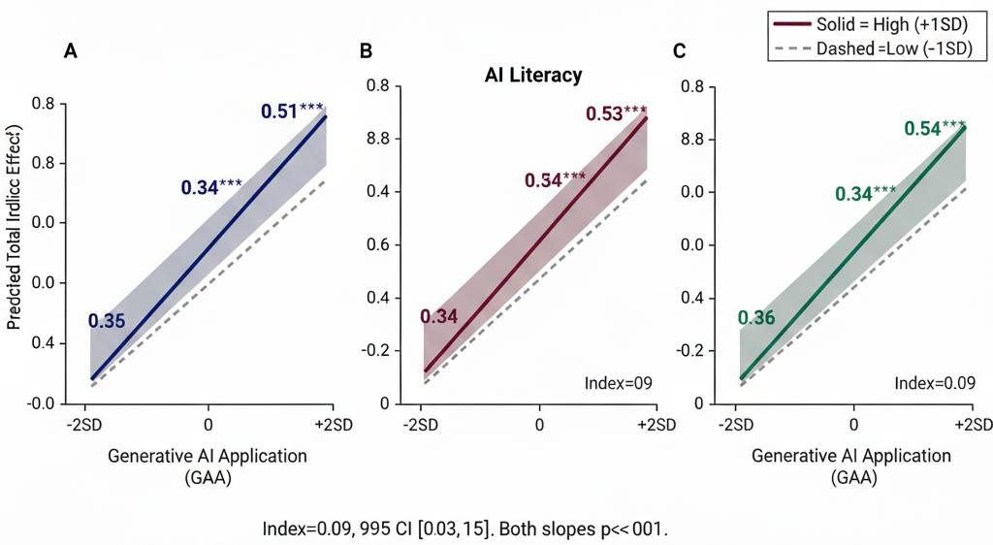OSM Figure 3. Simple Slopes of GAA on Total Indirect Effect at High and Low Levels of Implementation Dilemma Resolution

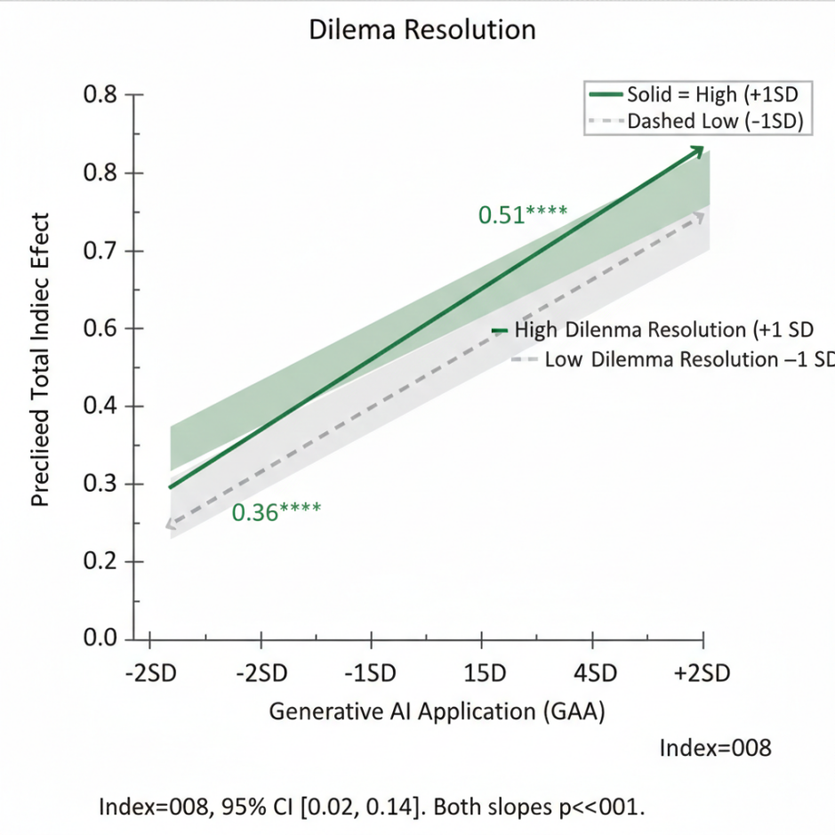

OSM Figure 4. Qualitative Thematic Coding Saturation Curve
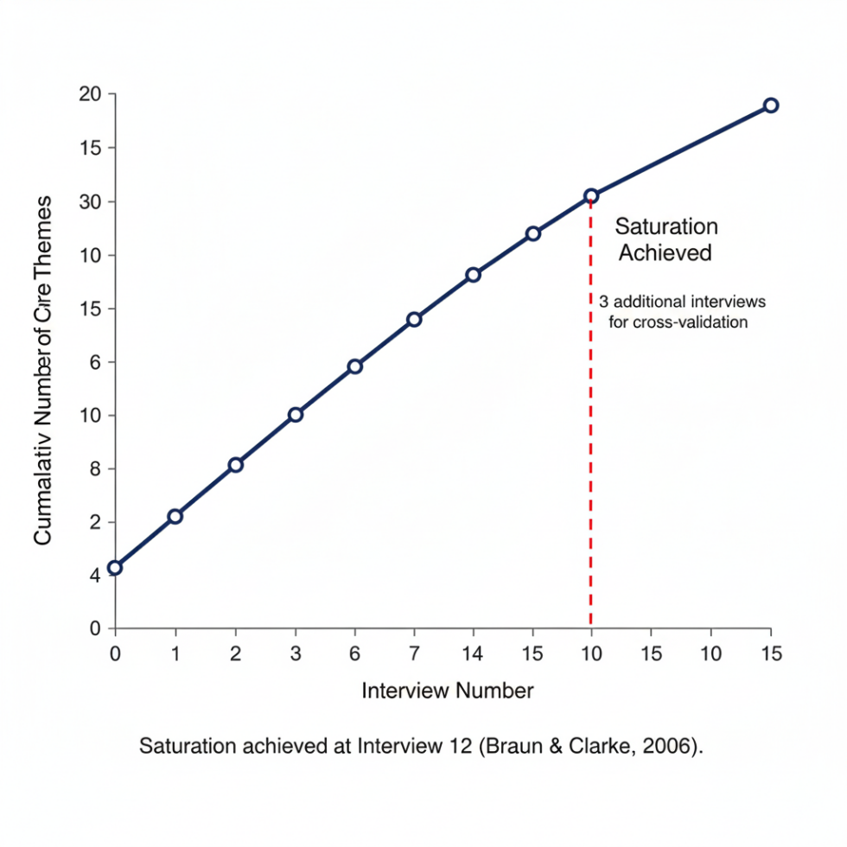

OSM Figure 5. Full Structural Equation Model Modification Indices Plot
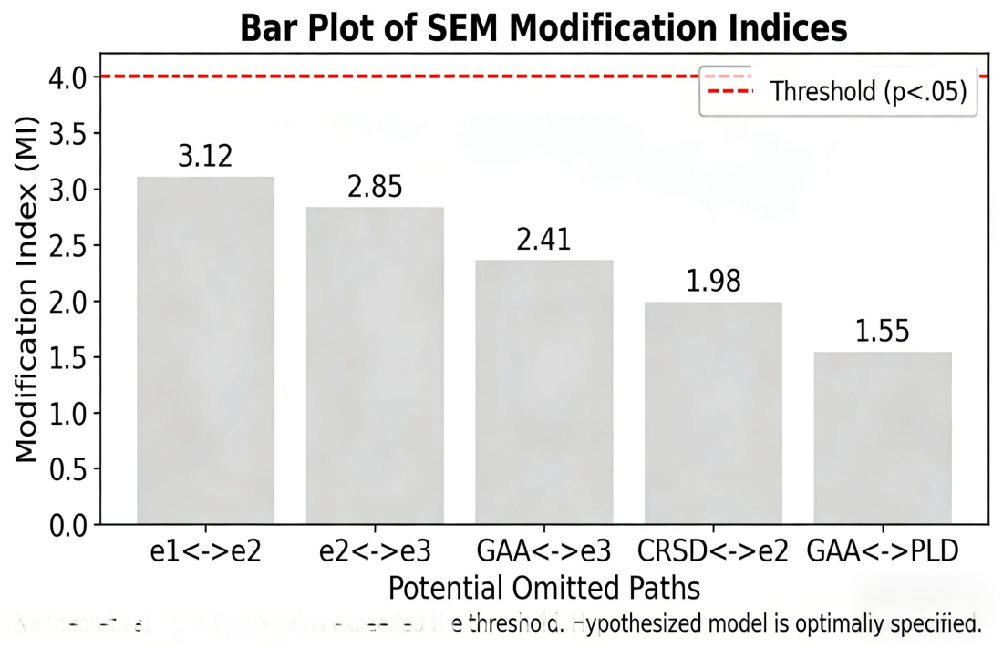

Part 3: OSM Appendices

OSM Appendix A. Semi-Structured Interview Protocol
For Tertiary EFL Teachers Generative AI Integration Study; IRB Approval #2025-EDU-AI-0119; Estimated Completion Time: 45-60 minutes

Introduction & Informed Consent Review
Thank you for agreeing to participate in this interview. The purpose of this study is to explore how tertiary EFL teachers use Generative AI in their teaching practice, and how this use shapes their instructional approach. All of your responses will be anonymized, and you may stop the interview at any time without penalty. Do you have any questions before we begin? Do you consent to the interview being audio-recorded for transcription and analysis?

Section 1: Background and Generative AI Use Context
- How long have you been teaching tertiary EFL, and what types of courses do you currently teach?
- How long have you been using Generative AI tools (e.g., ChatGPT, Claude, Gemini, education-specific AI tools) in your teaching work?
- On average, how frequently do you use Generative AI for teaching-related tasks? What are the primary tools you use, and why?
- What initially motivated you to start using Generative AI in your EFL teaching?

Section 2: Cognitive Regulation Scaffolds Design (CRSD) with Generative AI
- Have you used Generative AI to design learning supports that help your students monitor, reflect on, or regulate their own English learning process? If yes, could you share specific examples of these materials or activities?
- How has using Generative AI changed the way you design metacognitive or cognitive scaffolding for your students, compared to before you used the technology?
- What do you see as the biggest benefits and challenges of using Generative AI to design these cognitive regulation scaffolds for your EFL students?

Section 3: Personalized Learning Design (PLD) with Generative AI
- Have you used Generative AI to create differentiated or personalized learning materials/activities for your students (e.g., tiered content for different proficiency levels, major-aligned materials)? If yes, could you share specific examples?
- How has using Generative AI changed your ability to deliver personalized instruction to your students, especially given your class size and curriculum constraints?
- What do you see as the biggest benefits and challenges of using Generative AI to design personalized learning experiences for your EFL students?

Section 4: Shifts in Pedagogical Practices
- Has your overall approach to teaching EFL changed since you began using Generative AI? If yes, how would you describe these changes (e.g., to your lesson planning, feedback approach, classroom role, assessment methods)?
- Have these changes been primarily in your day-to-day teaching tasks, or in your core beliefs about how students learn English? Could you explain?
- Is there anything about your teaching practice that has NOT changed, even after you began using Generative AI? Why?

Section 5: Implementation Dilemmas, Barriers, and Resolution Strategies
- What have been the biggest challenges, dilemmas, or risks you have faced when integrating Generative AI into your EFL teaching?
- How have you addressed or managed these challenges? Are there any dilemmas that remain unresolved for you?
- What support or resources would have helped you integrate Generative AI more effectively into your teaching?

Section 6: Professional Competencies and Professional Development
- What skills, knowledge, or competencies do you believe are most important for tertiary EFL teachers to use Generative AI effectively in their teaching?
- Have you received any formal training or professional development related to Generative AI in education? If yes, what was most/least helpful? If no, what type of training would you find most valuable?

Closing
- Is there anything else about your experience using Generative AI in your EFL teaching that we haven’t discussed, but you think is important to share?
- Would you be willing to share anonymized examples of your AI-integrated lesson plans, materials, or other instructional artifacts for further analysis? Would you be open to a follow-up classroom observation (in-person or recorded) to further explore your AI integration practices?
Thank you so much for your time and valuable insights. We will share a summary of the study’s findings with all participants once the research is complete. If you have any questions now or in the future, please feel free to contact the research team.

OSM Appendix B. Instructional Artifact Analysis Guide
For Generative AI-Integrated EFL Instructional Artifacts; Aligned with Study Core Constructs; Inter-Coder Reliability Target: Cohen’s Kappa ≥ 0.80

1. Analysis Purpose
This guide provides a systematic framework for coding and analyzing tertiary EFL teachers’ instructional artifacts (lesson plans, learning materials, assessment tasks, feedback templates, activity guides) to identify evidence of Generative AI-enabled Cognitive Regulation Scaffolds Design (CRSD) and Personalized Learning Design (PLD). All artifacts were created by interview participants and shared with informed consent for research use only.

2. Pre-Analysis Preparation
- Artifact Inclusion Criteria: Artifacts must be created for use in a tertiary EFL course, explicitly integrate Generative AI in the design process, and be used for actual classroom instruction.
- Anonymization Protocol: All identifying information (teacher name, university name, student names) is redacted from artifacts prior to coding.
- Coder Training: Two independent coders with ≥5 years of EFL methodology research experience complete a 4-hour training on this coding guide, followed by a pilot coding of 5 artifacts to resolve discrepancies and align coding interpretation.
- Coding Procedure: Double-blind independent coding of all artifacts; coding discrepancies are resolved via consensus discussion between the two coders.

3. Core Coding Framework
All coding uses a 4-point Likert scale (0=No Evidence, 1=Minimal Evidence, 2=Moderate Evidence, 3=Extensive Evidence) for each dimension, with explicit coding definitions and anchor examples for each score.

Dimension 1: Cognitive Regulation Scaffolds Design (CRSD)
Overall Definition: Evidence that the artifact includes instructional supports designed to guide students’ metacognitive and cognitive regulation of their English learning process
Sub-Dimension | Coding Definition | Anchor Examples for Each Score
1.1 Task Deconstruction Scaffolds | The artifact breaks complex EFL tasks into sequential, manageable steps aligned with students’ Zone of Proximal Development (ZPD) | 0: No task breakdown; single, unstructured task instruction  1: Basic numbered steps for the task, no alignment with learner needs  2: Sequential step-by-step breakdown with guidance for each stage of the task  3: Hierarchical task deconstruction with embedded checkpoints for student self-monitoring at each stage
1.2 Metacognitive Reflection Prompts | The artifact includes prompts that guide students to reflect on their learning process, strategies, and progress | 0: No metacognitive reflection elements  1: Single generic reflection question (e.g., "What did you learn?")  2: Targeted reflection prompts focused on language learning strategies and process  3: Structured, sequential reflection prompts that guide students to monitor, evaluate, and adjust their learning strategies
1.3 Self-Correction Scaffolds | The artifact includes supports that guide students to identify and correct their own language errors, rather than providing direct correction | 0: No self-correction elements; direct error correction only  1: Basic error identification prompts with no guidance for correction  2: Guided hints and prompts to help students identify and correct specific language errors  3: Structured self-correction framework with tiered hints, error category guidance, and self-assessment checklists
1.4 Self-Regulated Learning (SRL) Process Supports | The artifact includes tools to help students plan, monitor, and evaluate their own learning progress | 0: No SRL support elements  1: Basic due date timeline for the task  2: Planning guide and progress tracking checklist for the learning task  3: Comprehensive SRL framework including goal-setting templates, progress monitoring tools, and self-evaluation rubrics

Dimension 2: Personalized Learning Design (PLD)
Overall Definition: Evidence that the artifact includes differentiated, tailored content/activities aligned with individual students’ proficiency, academic background, and learning needs
Sub-Dimension | Coding Definition | Anchor Examples for Each Score
2.1 Proficiency-Based Differentiation | The artifact includes tiered content/activities matched to different English proficiency levels | 0: Single, one-size-fits-all content with no differentiation  1: Basic "easy/hard" options for a single task  2: Multiple tiered versions of the learning material/activity aligned to specific proficiency levels (e.g., CET-4 vs. CET-6, B1 vs. B2)  3: Fully differentiated learning pathways with progressive difficulty levels, adaptive challenge, and targeted support for each proficiency band
2.2 Major/Discipline-Aligned Content | The artifact includes EFL content tailored to students’ academic majors and professional fields | 0: Generic, decontextualized EFL content with no major alignment  1: Single passing reference to a general academic field  2: Content and examples aligned to 2-3 broad academic disciplines relevant to the student cohort  3: Highly specific, discipline-aligned content tailored to the students’ exact majors, with career-relevant language tasks and authentic disciplinary texts
2.3 Individualized Error/Need Targeting | The artifact includes content/activities targeted to specific student error patterns or individual learning needs | 0: No targeting of individual student needs; generic whole-class content only  1: General reference to common class-wide error patterns  2: Targeted practice activities for specific sub-groups of students with shared error patterns/needs  3: Individualized learning materials/feedback tailored to each student’s unique error patterns, learning gaps, and needs
2.4 Adaptive/Paced Learning Options | The artifact includes flexible options for learning pace, task complexity, and support level | 0: Fixed, rigid task requirements with no flexible options  1: Basic optional extension activity for advanced students  2: Multiple optional pathways for the task with varying levels of support and complexity  3: Fully adaptive learning design with self-paced progression, optional support scaffolds, and differentiated extension opportunities

4. Supplementary Coding Dimensions
Dimension | Coding Definition | Coding Options
Artifact Type | The type of instructional artifact being coded | Lesson Plan, Learning Material/Worksheet, Assessment Task, Feedback Template, Activity Guide, Other (specify)
Generative AI Integration Type | The role of Generative AI in the artifact’s design | AI co-created the artifact with teacher input; AI generated the initial draft, revised by the teacher; AI generated specific elements of the artifact; Other (specify)
Student-Facing AI Use | Whether the artifact includes guided student use of Generative AI | No student AI use included; Guided, structured student AI use included; Unrestricted student AI use permitted; Other (specify)

5. Inter-Coder Reliability Calculation
- Cohen’s Kappa coefficient is calculated for the overall CRSD and PLD dimension scores, as well as each sub-dimension.
- A Kappa coefficient ≥ 0.80 is considered excellent reliability; any sub-dimension with Kappa < 0.80 is re-reviewed by the coding team to resolve interpretive discrepancies.
- All final coding decisions are made via consensus between the two independent coders.

OSM Appendix C. Classroom Observation Protocol
For Generative AI-Integrated Tertiary EFL Lessons; Aligned with Study Core Constructs; Estimated Completion Time: 90-minute lesson + 15-minute post-observation notes

1. Observation Overview
This protocol is designed to systematically observe and document the implementation of Generative AI-enabled Cognitive Regulation Scaffolds Design (CRSD) and Personalized Learning Design (PLD) in tertiary EFL classrooms, and to identify evidence of shifts in teachers’ pedagogical practices. All observations are conducted with written informed consent from the teacher and students, in compliance with IRB approval #2025-EDU-AI-0119.

2. Pre-Observation Preparation
- Confirm lesson details: course name, class size, lesson topic, learning objectives, and planned Generative AI integration with the teacher prior to the observation.
- Review any pre-shared lesson plans or instructional materials to align observation with the teacher’s intended design.
- Prepare observation materials: printed protocol, digital voice recorder (with consent), and field notes template.

3. Lesson Context & Background Information
Observation Details | Record
Teacher ID
University Type
Course Name & Level
Lesson Date & Duration
Class Size
Lesson Topic & Core Learning Objectives
Planned Generative AI Integration (per teacher pre-observation briefing)
Lesson Format (In-Person / Synchronous Online / Hybrid)

4. Core Observation Dimensions
All dimensions use a 4-point Likert scale (0=Not Evident, 1=Minimally Evident, 2=Moderately Evident, 3=Extensively Evident), with space for detailed field notes, specific examples, and timestamped observations for each dimension.

Dimension 1: Generative AI Application (GAA) Implementation
Definition: The extent to which Generative AI is integrated into the lesson in pedagogically intentional, instructionally meaningful ways
Sub-Dimension | Rating  (0-3) | Detailed Field Notes & Examples
1.1 AI integration is aligned with the lesson’s core learning objectives
1.2 Teacher demonstrates intentional curation, adaptation, and contextualization of AI outputs
1.3 AI is integrated into multiple stages of the lesson (input, activity, feedback, reflection)
1.4 Teacher provides clear guidance on the purpose and appropriate use of AI for the lesson’s tasks

Dimension 2: Cognitive Regulation Scaffolds Design (CRSD) Classroom Implementation
Definition: The extent to which the lesson implements AI-enabled scaffolds that guide students’ metacognitive and cognitive regulation of their English learning
Sub-Dimension | Rating  (0-3) | Detailed Field Notes & Examples
2.1 Teacher implements AI-designed task deconstruction scaffolds to guide students through complex learning tasks
2.2 Teacher facilitates metacognitive reflection using AI-designed prompts and activities
2.3 Teacher uses AI-designed scaffolds to guide student self-correction of language errors
2.4 Teacher implements AI-designed tools to support students’ planning, monitoring, and evaluation of their learning progress
2.5 Scaffolds are implemented in a way that fosters student autonomy, rather than over-reliance on AI

Dimension 3: Personalized Learning Design (PLD) Classroom Implementation
Definition: The extent to which the lesson implements AI-enabled differentiated, personalized learning experiences for diverse students
Sub-Dimension | Rating  (0-3) | Detailed Field Notes & Examples
3.1 Teacher implements AI-designed tiered activities/materials for students with different proficiency levels
3.2 Teacher uses AI-designed content aligned with students’ academic majors and career needs
3.3 Teacher provides targeted, individualized support to students based on their specific learning needs/error patterns
3.4 Teacher offers flexible, paced learning options for students with diverse needs
3.5 Personalized activities are implemented in a way that is inclusive and accessible for all students

Dimension 4: Shifts in Pedagogical Practices
Definition: Evidence of the teacher’s enacted pedagogical approach, aligned with the study’s definition of deep vs. surface-level pedagogical change
Sub-Dimension | Rating  (0-3) | Detailed Field Notes & Examples
4.1 Teacher enacts a student-centered, facilitative role (learning architect), rather than a teacher-centered content transmission role
4.2 Teacher uses dynamic, adaptive instruction, adjusting the lesson in response to real-time student understanding
4.3 Teacher implements ongoing, formative feedback practices, rather than only summative assessment
4.4 Teacher prioritizes student learning process and skill development, rather than only content delivery
4.5 Teacher explicitly addresses ethical AI use and academic integrity with students

Dimension 5: Student Engagement & Response
Definition: Student participation, engagement, and interaction with the AI-integrated lesson activities
Sub-Dimension | Rating  (0-3) | Detailed Field Notes & Examples
5.1 Students are actively engaged with the AI-integrated learning activities
5.2 Students demonstrate use of metacognitive and self-regulation skills during the lesson
5.3 Students participate in meaningful peer and teacher-student interaction around the lesson content
5.4 Students use AI in guided, pedagogically appropriate ways aligned with the lesson objectives

5. Post-Observation Documentation
- Overall Lesson Summary: A 200-300 word narrative summary of the lesson, including the core AI integration approach, key strengths of the CRSD/PLD implementation, and any challenges or dilemmas observed.
- Triangulation with Teacher Interview: Notes on how the observed lesson aligns with (or diverges from) the teacher’s self-reported practices in the pre-lesson interview.
- Artifact Collection: Record of any instructional artifacts (slides, worksheets, activity guides) shared by the teacher after the lesson for supplementary analysis.
- Coder Reliability: For 20% of observations, two independent raters complete the protocol; Cohen’s Kappa coefficient is calculated to ensure inter-coder reliability ≥ 0.80.

OSM Appendix D. Full Survey Instrument
For Tertiary EFL Teachers Generative AI Integration Study; IRB Approval #2025-EDU-AI-0119; 7-point Likert Scale (1=Strongly Disagree, 2=Disagree, 3=Somewhat Disagree, 4=Neutral, 5=Somewhat Agree, 6=Agree, 7=Strongly Agree); Estimated Completion Time: 12 minutes

Page 1: Informed Consent
Informed Consent for Research Participation
You are invited to participate in a research study investigating how tertiary EFL teachers use Generative AI in their teaching practice, and how this use shapes their instructional approach. The study is conducted by a research team from [University Name], with IRB approval #2025-EDU-AI-0119.
What participation involves: Completing this anonymous online survey, which will take approximately 12 minutes of your time. All questions are about your professional experiences and opinions related to Generative AI in EFL teaching.
Risks and benefits: There are minimal risks to participation. Your responses are completely anonymous, and no identifying information will be collected. There is no direct compensation for participation, but you will have the option to receive a summary of the study’s findings once the research is complete. The study will contribute to our understanding of effective Generative AI integration in tertiary EFL teaching, and inform evidence-based teacher professional development.
Voluntary participation: Your participation is completely voluntary. You may stop completing the survey at any time, for any reason, without penalty. You may skip any questions you do not wish to answer.
By clicking "Next" to begin the survey, you confirm that you are a full-time in-service tertiary EFL teacher in a Chinese higher education institution, that you have read and understood the informed consent information, and that you voluntarily agree to participate in the study.

Page 2: Screening & Demographic Information
- Are you a full-time in-service EFL teacher in a Chinese higher education institution?
- Yes
- No (If no, you will be directed to the end of the survey)
- What is your gender?
- Male
- Female
- Prefer not to say
- How many years of total tertiary EFL teaching experience do you have?
- 1-5 years
- 6-15 years
- 16+ years
- What type of higher education institution do you work at?
- Research University (Double First-Class/Project 985/211)
- Comprehensive University
- Undergraduate College
- Vocational College
- Which geographic region of China is your institution located in?
- Eastern China
- Central China
- Western China
- Have you received any formal professional development/training on educational technology in the past 2 years?
- Yes
- No
- Have you received any formal professional development/training on Generative AI in education in the past 2 years?
- Yes
- No
- How long have you been using Generative AI tools for teaching-related purposes?
- Less than 3 months (If less than 3 months, you will be directed to the end of the survey)
- 3-6 months
- 7-12 months
- More than 12 months
- On average, how frequently do you use Generative AI for teaching-related tasks?
- Less than once a month
- 1-2 times a month
- 1-2 times a week
- 3-4 times a week
- Daily
- What year/month did you begin systematic, pedagogical use of Generative AI in your EFL teaching? (Open text: MM/YYYY)
- What year/month did your core pedagogical approach to EFL teaching undergo systematic, sustained change? (Open text: MM/YYYY; If no change, write "No change")

Page 3: Generative AI Application in ELT (GAA)
Instructions: For each of the following statements, please select the response that best reflects your experience.
- I use Generative AI to design core instructional materials for my EFL lessons.
- I use Generative AI to develop learning activities aligned with my course learning objectives.
- I regularly adapt and refine Generative AI outputs for my specific EFL teaching context.
- I use Generative AI to design formative assessment tasks for my students.
- I integrate Generative AI into multiple stages of my instructional design process.

Page 4: Cognitive Regulation Scaffolds Design (CRSD)
- I use Generative AI to create step-by-step guides for complex EFL learning tasks.
- I use Generative AI to develop metacognitive reflection prompts for my students.
- I use Generative AI to design hints that guide students to self-correct language errors.
- I use Generative AI to create checklists for students to monitor their own learning progress.
- I use Generative AI to deconstruct complex academic English tasks into manageable steps.
- I use Generative AI to design Socratic-style questions that foster students’ critical thinking.

Page 5: Personalized Learning Design (PLD)
- I use Generative AI to create tiered learning materials for students with different English proficiency levels.
- I use Generative AI to develop EFL content aligned with my students’ academic majors.
- I use Generative AI to create targeted practice activities based on individual students’ error patterns.
- I use Generative AI to design differentiated homework assignments for diverse learner needs.
- I use Generative AI to create career-relevant English learning content for my students.
- I use Generative AI to adapt my lesson content in real time based on student understanding.

Page 6: Shifts in Pedagogical Practices
- My role has shifted from content transmitter to learning architect since using Generative AI.
- My instructional design has shifted from teacher-centered to student-centered since using Generative AI.
- My assessment approach has shifted from summative to ongoing formative feedback since using Generative AI.
- My lesson planning has shifted from static semester plans to dynamic, adaptive design since using Generative AI.
- Generative AI has significantly increased the efficiency of my instructional material creation.
- Generative AI has reduced the time I spend on routine administrative teaching tasks.
- Generative AI has increased the frequency of individualized feedback I provide to students.
- Generative AI has expanded the range of learning activities I implement in my classroom.

Page 7: AI-TPACK
- I can use Generative AI tools to design instruction that aligns with EFL curriculum standards.
- I know how to select Generative AI tools that are appropriate for my EFL teaching content.
- I can integrate Generative AI into my teaching in ways that match my students’ English learning needs.
- I know how to use Generative AI to create activities that develop students’ academic English skills.
- I can adapt Generative AI outputs to fit the specific linguistic level of my students.
- I know how to use Generative AI to assess student learning of EFL content effectively.
- I can use Generative AI to create learning activities that address common EFL learning difficulties.
- I know how to combine Generative AI tools with effective EFL teaching pedagogies.
- I can use Generative AI to design student-centered learning activities for my EFL classroom.
- I know how to troubleshoot basic technical issues with Generative AI tools during teaching.
- I can evaluate the quality and accuracy of Generative AI outputs for EFL teaching purposes.
- I can use Generative AI to differentiate instruction for students with diverse English proficiency levels.

Page 8: AI Literacy
- I understand the basic technical principles of how Generative AI tools work.
- I can write effective prompts to get high-quality outputs from Generative AI tools for EFL teaching.
- I can critically evaluate the accuracy and reliability of content generated by AI tools.
- I can identify and correct AI hallucinations/factual errors in Generative AI outputs.
- I understand the copyright and intellectual property issues related to Generative AI use in education.
- I can teach my students how to use Generative AI ethically and responsibly for their English learning.
- I understand the academic integrity risks associated with Generative AI use in EFL education.
- I can develop clear guidelines for appropriate student use of Generative AI in my courses.
- I keep up to date with new developments in Generative AI tools relevant to EFL teaching.
- I can adapt my use of Generative AI tools to address emerging challenges in EFL teaching.

Page 9: Implementation Dilemma Resolution
- I have established clear classroom guidelines to address student over-reliance on Generative AI.
- I have a standardized process to validate the accuracy of Generative AI outputs.
- I have clear policies to address academic integrity risks related to Generative AI use in my courses.

Page 10: Control Variables
Instructions: For each of the following statements, please select the response that best reflects your experience.
- I hold strong student-centered beliefs about English language teaching and learning.
- I am confident in my ability to implement innovative teaching practices in my EFL classroom.
- I often feel emotionally drained from my teaching work. (Teacher Burnout)
- I feel a sense of personal accomplishment from my teaching work. (Reverse-coded for Burnout)
- I feel overwhelmed by the demands of my teaching job. (Teacher Burnout)

Page 11: Final Page
Thank you for completing the survey! Your valuable insights are greatly appreciated.
If you would like to receive a summary of the study’s findings once the research is complete, please enter your email address below (this will be stored separately from your survey responses, and will not be linked to your answers in any way):
[Open text box for email address]
If you are interested in participating in a follow-up semi-structured interview (with a small token of appreciation for your time), please enter your contact information below (stored separately from survey responses):
[Open text box for contact information]
Have a great day!

OSM Appendix E. G*Power Sample Size Calculation Results
Software: GPower [3.1.9.7](3.1.9.7); Test Family: F tests; Statistical Test: Multiple Linear Regression – Fixed Model, R² Deviation from Zero; Two-Tailed Significance Level α=0.05*

Input Parameters
Parameter | Value | Rationale
Effect size f² | 0.15 | Medium effect size, consistent with prior research on educational technology and teacher pedagogical change (Cohen, 1988; Plonsky & Oswald, 2014)
α err prob | 0.05 | Standard two-tailed significance level for social science research
Power (1-β err prob) | 0.95 | High statistical power, exceeding the 0.80 minimum standard, to reduce Type II error risk
Number of predictors | 12 | Includes core independent variable, 2 mediators, 3 moderators, and 6 control variables in the primary regression model

Output Parameters
Output Statistic | Value
Noncentrality parameter λ | 30.75
Critical F value | 1.83
Numerator df | 12
Denominator df | 126
Total minimum required sample size | 138
Actual sample size of the study | 205
Achieved power with actual sample size | 0.99

Supplementary Power Analysis for Mediation Analysis
Test Family: F tests; Statistical Test: Linear Multiple Regression – Mediation Analysis (Sobel Test); α=0.05, Power=0.95, Medium Effect Size f²=0.15
- Minimum required sample size for mediation analysis: 115
- Actual sample size of the study: 205
- Achieved power for mediation analysis: >0.99

Interpretation
The study’s final sample size of 205 exceeds the minimum required sample size of 138 for the primary regression analysis, and 115 for mediation analysis. The achieved statistical power of >0.99 is well above the 0.80 standard, indicating that the study has sufficient statistical power to detect medium effect sizes, and to conduct the planned mediation, moderation, and moderated mediation analyses without excessive Type II error risk.

References
Cohen, J. (1988). Statistical power analysis for the behavioral sciences (2nd ed.). Lawrence Erlbaum Associates.
Plonsky, L., & Oswald, F. L. (2014). How big is "big"? Interpreting effect sizes in L2 research. Language Learning, 64(4), 878-912. https://doi.org/10.1111/lang.12079

OSM Appendix F. Qualitative Coding Manual
For Generative AI in Tertiary EFL Teaching Study; Braun & Clarke (2006) Reflexive Thematic Analysis; IRB Approval #2025-EDU-AI-0119

1. Coding Principles
This manual outlines the systematic coding framework for the study’s qualitative interview, classroom observation, and instructional artifact data. The coding process follows Braun & Clarke’s (2006) six-phase reflexive thematic analysis, with a focus on both deductive coding (aligned with the study’s core theoretical constructs and research questions) and inductive coding (capturing emergent themes from the data).
Key coding principles:
- Reflexivity: Coders document their own positionalities and interpretive decisions throughout the coding process.
- Systematicity: Coding follows a standardized, replicable procedure across all data sources.
- Triangulation: Coding integrates data from interviews, observations, and artifacts to validate thematic findings.
- Saturation: Coding continues until thematic saturation is achieved (three consecutive interviews with no new core codes).

2. Coding Process
- Familiarization: Coders read and re-read all interview transcripts, observation notes, and artifact analysis records, taking initial memos about key insights and patterns.
- Initial Code Generation: Line-by-line open coding of the first 6 interview transcripts, generating both deductive codes (from the study’s research questions) and inductive codes (emergent from the data).
- Codebook Development: Initial codes are grouped into potential themes and sub-themes, with clear definitions and anchor examples for each code, forming the initial codebook.
- Pilot Coding: Two independent coders use the initial codebook to code 3 additional interview transcripts, resolving discrepancies and refining the codebook to improve clarity and reliability.
- Full Coding: Double-blind independent coding of all 15 interview transcripts, observation notes, and artifact analysis records using the finalized codebook.
- Theme Review & Refinement: Codes are collated into potential themes, which are reviewed against the coded data extracts and the entire dataset to ensure coherence and accuracy.
- Theme Definition & Naming: Final themes are defined, named, and mapped to the study’s research questions, with illustrative data extracts selected for each theme.
- Final Write-Up: Thematic findings are integrated into the study’s results, with triangulation across data sources.

3. Finalized Coding Framework
The coding framework includes 6 core themes, 18 sub-themes, and 42 tertiary codes, with deductive codes aligned to the study’s research questions and inductive codes capturing emergent insights.
Core Theme | Sub-Theme | Tertiary Code | Code Definition | Anchor Example
Theme 1: Generative AI Application (GAA) in Tertiary ELT | 1.1 Motivations for GAA | 1.1.1 Instructional Capacity Constraints | Teachers use AI to address long-standing limits on their instructional capacity (large class sizes, time constraints) | "With 120 students in a class, I could never give every student individualized feedback before. AI lets me do that."
Theme 1: Generative AI Application (GAA) in Tertiary ELT |  | 1.1.2 Pedagogical Innovation | Teachers use AI to implement learner-centered pedagogies they could not enact previously | "AI lets me finally do the differentiated, student-centered teaching I learned in my master’s program, but never had time for."
Theme 1: Generative AI Application (GAA) in Tertiary ELT |  | 1.1.3 Efficiency & Workload Reduction | Teachers use AI to reduce time spent on routine administrative and material creation tasks | "AI cuts the time I spend making worksheets and lesson plans in half, so I can focus on actually teaching."
Theme 1: Generative AI Application (GAA) in Tertiary ELT | 1.2 GAA Implementation Patterns | 1.2.1 Pedagogically Intentional Instructional Use | AI is integrated into core instructional design, material creation, assessment, and feedback | "I use AI in every stage of my lesson planning, from designing activities to creating formative assessments."
Theme 1: Generative AI Application (GAA) in Tertiary ELT |  | 1.2.2 Superficial Administrative Use | AI is used only for routine administrative tasks, with no integration into core instructional design | "I only use AI to format my lesson plans and write answer keys for the textbook. I don’t use it for actual teaching."
Theme 1: Generative AI Application (GAA) in Tertiary ELT |  | 1.2.3 Student-Facing Guided AI Use | Teachers design structured activities for students to use AI for their learning | "I have my students use AI as a conversation partner for oral practice, with clear guidelines and reflection tasks."
Theme 1: Generative AI Application (GAA) in Tertiary ELT | 1.3 Tool Selection & Use | 1.3.1 General-Purpose LLMs | Teachers use general-purpose models (ChatGPT, Claude, Gemini) for most teaching tasks
Theme 1: Generative AI Application (GAA) in Tertiary ELT |  | 1.3.2 Education-Specific AI Tools | Teachers use education-specific AI tools for targeted teaching functions
Theme 1: Generative AI Application (GAA) in Tertiary ELT |  | 1.3.3 Prompt Engineering Practices | Teachers’ approaches to writing, refining, and iterating on AI prompts for teaching
Theme 2: Cognitive Regulation Scaffolds Design (CRSD) | 2.1 CRSD Implementation Dimensions | 2.1.1 Task Deconstruction & ZPD Alignment | AI is used to break complex tasks into sequential steps aligned with students’ ZPD
Theme 2: Cognitive Regulation Scaffolds Design (CRSD) |  | 2.1.2 Metacognitive Reflection Prompts | AI is used to create prompts that guide students to reflect on their learning process
Theme 2: Cognitive Regulation Scaffolds Design (CRSD) |  | 2.1.3 Self-Correction Scaffolds | AI is used to design hints that guide student self-correction, rather than direct error correction
Theme 2: Cognitive Regulation Scaffolds Design (CRSD) |  | 2.1.4 SRL Process Supports | AI is used to create planning guides, checklists, and progress trackers for self-regulated learning
Theme 2: Cognitive Regulation Scaffolds Design (CRSD) | 2.2 CRSD Enablers & Barriers | 2.2.1 AI Affordances for CRSD | Teachers’ perceptions of AI’s benefits for designing cognitive regulation scaffolds
Theme 2: Cognitive Regulation Scaffolds Design (CRSD) |  | 2.2.2 CRSD Implementation Barriers | Challenges teachers face when designing AI-enabled cognitive scaffolds
Theme 2: Cognitive Regulation Scaffolds Design (CRSD) |  | 2.2.3 CRSD Implementation Strategies | Teachers’ approaches to overcoming barriers to effective CRSD design
Theme 3: Personalized Learning Design (PLD) | 3.1 PLD Implementation Dimensions | 3.1.1 Proficiency-Based Differentiation | AI is used to create tiered materials for different English proficiency levels
Theme 3: Personalized Learning Design (PLD) |  | 3.1.2 Major-Aligned Content Creation | AI is used to develop EFL content aligned with students’ academic majors
Theme 3: Personalized Learning Design (PLD) |  | 3.1.3 Targeted Error Remediation | AI is used to create practice activities based on individual students’ error patterns
Theme 3: Personalized Learning Design (PLD) |  | 3.1.4 Adaptive Paced Learning Options | AI is used to create flexible learning pathways for diverse student paces
Theme 3: Personalized Learning Design (PLD) | 3.2 PLD Enablers & Barriers | 3.2.1 AI Affordances for PLD | Teachers’ perceptions of AI’s benefits for personalized learning design
Theme 3: Personalized Learning Design (PLD) |  | 3.2.2 PLD Implementation Barriers | Challenges teachers face when designing AI-enabled personalized learning
Theme 3: Personalized Learning Design (PLD) |  | 3.2.3 PLD Implementation Strategies | Teachers’ approaches to overcoming barriers to effective PLD design
Theme 4: Shifts in Pedagogical Practices | 4.1 Deep Ideological Shifts | 4.1.1 Role Shift: From Content Transmitter to Learning Architect | Fundamental shift in teachers’ professional identity and classroom role
Theme 4: Shifts in Pedagogical Practices |  | 4.1.2 Pedagogical Shift: From Teacher-Centered to Student-Centered | Fundamental shift in core instructional design philosophy
Theme 4: Shifts in Pedagogical Practices |  | 4.1.3 Assessment Shift: From Summative to Formative Feedback | Fundamental shift in approach to assessment and feedback
Theme 4: Shifts in Pedagogical Practices | 4.2 Surface Behavioral Shifts | 4.2.1 Material Creation Efficiency Gains | Reduced time spent on routine instructional material creation
Theme 4: Shifts in Pedagogical Practices |  | 4.2.2 Administrative Task Automation | Reduced time spent on routine administrative teaching tasks
Theme 4: Shifts in Pedagogical Practices |  | 4.2.3 Expanded Learning Activity Range | Increased variety of learning activities implemented in the classroom
Theme 4: Shifts in Pedagogical Practices | 4.3 Unchanged Pedagogical Elements | 4.3.1 Core Teaching Principles | Core pedagogical beliefs and principles that remain unchanged after AI adoption
Theme 4: Shifts in Pedagogical Practices |  | 4.3.2 Non-AI Teaching Practices | Teaching practices that teachers continue to implement without AI
Theme 5: Implementation Dilemmas & Boundary Conditions | 5.1 Core Implementation Dilemmas | 5.1.1 Student Over-Reliance vs. Learning Autonomy | Tension between AI support and fostering independent learner autonomy
Theme 5: Implementation Dilemmas & Boundary Conditions |  | 5.1.2 AI Hallucinations & Output Inaccuracy | Challenges related to factual errors and inaccuracies in AI outputs
Theme 5: Implementation Dilemmas & Boundary Conditions |  | 5.1.3 Ethical & Academic Integrity Risks | Concerns about student misuse of AI and academic integrity violations
Theme 5: Implementation Dilemmas & Boundary Conditions | 5.2 Dilemma Resolution Strategies | 5.2.1 Scaffolded Release Approach | Gradual release of AI use responsibility to students to build autonomy
Theme 5: Implementation Dilemmas & Boundary Conditions |  | 5.2.2 AI Output Validation Process | Systematic process for fact-checking and refining AI outputs
Theme 5: Implementation Dilemmas & Boundary Conditions |  | 5.2.3 Classroom AI Use Guidelines | Co-created clear guidelines for ethical student AI use
Theme 5: Implementation Dilemmas & Boundary Conditions | 5.3 Critical Counterexamples | 5.3.1 AI Use Without Pedagogical Change | Cases of regular AI use with no meaningful pedagogical shift
Theme 5: Implementation Dilemmas & Boundary Conditions |  | 5.3.2 Root Causes of Implementation Failure | Core reasons why AI use does not drive pedagogical change
Theme 6: Professional Competencies for Effective GAA | 6.1 Core Competency Dimensions | 6.1.1 AI-TPACK | Synergistic integration of AI tools with EFL pedagogy and content knowledge
 |  | 6.1.2 AI Literacy | Technical, critical, and ethical competencies for AI use in EFL teaching
 |  | 6.1.3 Pedagogical Reasoning Capacity | Ability to design effective AI-integrated learning experiences
 | 6.2 Professional Development Needs | 6.2.1 Current Training Gaps | Teachers’ perceptions of gaps in their AI-related training and support
 |  | 6.2.2 Effective Training Design | Teachers’ preferences for effective AI professional development
 |  | 6.2.3 Peer Learning & Support | The role of professional learning communities in effective GAA

4. Inter-Coder Reliability Procedure
- Two independent coders with ≥5 years of qualitative EFL research experience complete all coding.
- Double-blind coding is conducted for all transcripts; coders do not see each other’s coding until both have completed their work for each transcript.
- Cohen’s Kappa coefficient is calculated for each core theme after coding is complete.
- A Kappa coefficient ≥ 0.80 is considered excellent reliability; any coding discrepancies are resolved via consensus discussion between the two coders.
- A coding audit trail is maintained, documenting all coding decisions, codebook revisions, and consensus discussions.

5. Thematic Saturation Assessment
- Thematic saturation is assessed after each interview transcript is coded.
- Saturation is defined as three consecutive interview transcripts with no new core codes identified at the tertiary code level.
- Saturation was achieved at the 12th interview; the 13th, 14th, and 15th interviews were conducted for cross-validation and counterexample analysis, with no new core codes identified.
- A saturation curve is included in OSM Figure 4, documenting the number of new core codes identified per interview.

Reference
Braun, V., & Clarke, V. (2006). Using thematic analysis in psychology. Qualitative Research in Psychology, 3(2), 77-101. https://doi.org/10.1191/1478088706qp063oa

OSM Appendix G. Full Abbreviation List
Alphabetical Order; Aligned with APA 7th Edition Guidelines
Abbreviation | Full English Term
AI | Artificial Intelligence
AI-TPACK | Artificial Intelligence-specific Technological Pedagogical Content Knowledge
APA | American Psychological Association
AVE | Average Variance Extracted
CFA | Confirmatory Factor Analysis
CFI | Comparative Fit Index
CI | Confidence Interval
CR | Composite Reliability
CRSD | Cognitive Regulation Scaffolds Design
df | Degrees of Freedom
EAP | English for Academic Purposes
EFA | Exploratory Factor Analysis
ELT | English Language Teaching
EFL | English as a Foreign Language
ESL | English as a Second Language
GAA | Generative AI Application in Tertiary ELT
Generative AI | Generative Artificial Intelligence
G*Power | Statistical Power Analysis Program
IRB | Institutional Review Board
i+1 | Comprehensible Input Hypothesis Notation
LLMs | Large Language Models
MI | Modification Index
OSM | Online Supplementary Materials
PLD | Personalized Learning Design
QUAL | Qualitative Research Phase
QUAN | Quantitative Research Phase
RCT | Randomized Controlled Trial
RMSEA | Root Mean Square Error of Approximation
SE | Standard Error
SEM | Structural Equation Modeling
SRL | Self-Regulated Learning
SPP | Shifts in Pedagogical Practices
SRMR | Standardized Root Mean Square Residual
TEM | Test for English Majors (China)
TLI | Tucker-Lewis Index
ZPD | Zone of Proximal Development
2SLS | Two-Stage Least Squares Regression

