ATR-FTIR spectroscopy combined with chemometric methods for the classification of polyethylene residues containing different contaminants
(Supplementary Information)

Daniel José da Silva^{1,2}*, Hélio Wiebeck¹**

¹ Department of Metallurgical and Materials Engineering, Polytechnic School, University of São Paulo, Av. Prof. Mello Moraes, 2643, Cidade Universitária, São Paulo, SP 05508-900, Brazil
² Engineering, Modeling and Applied Social Sciences Center (CECS), Federal University of ABC (UFABC), Av. dos Estados, 5001, Bangú, Santo André, SP 09210-210, Brazil
*dankuruta@hotmail.com
**hwiebeck@usp.br

Thermogravimetric analysis (TGA)

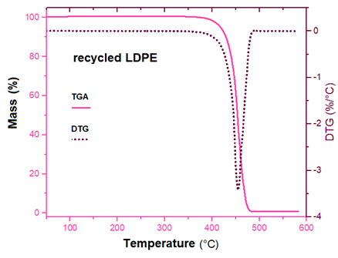
Figure 1S. TGA and DTG curves from recycled LDPE.

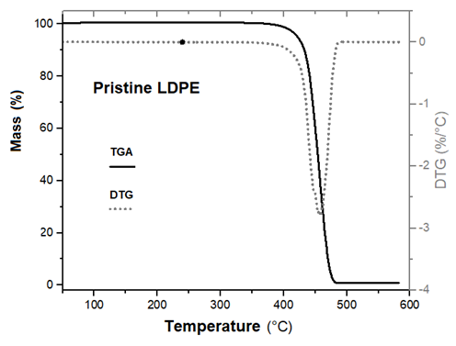
Figure 2S. TGA and DTG curves from pristine LDPE.

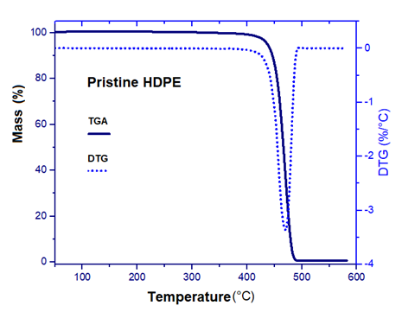
Figure 3S. TGA and DTG curves from pristine HDPE.

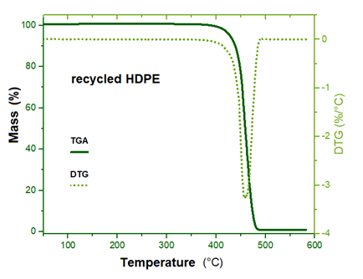
Figure 4S. TGA and DTG curves from recycled HDPE.

ATR-FTIR
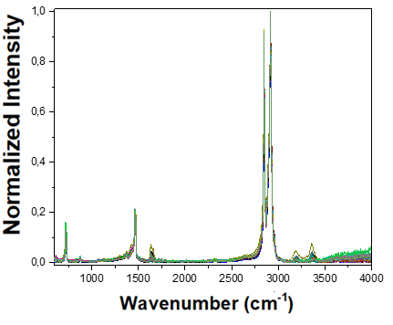
Figure 5S. ATR-FTIR spectra of recycled HDPE/LDPE blends containing calcium carbonate.

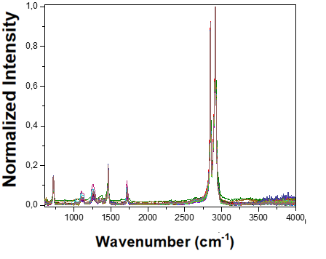
Figure 6S. ATR-FTIR spectra of recycled HDPE/LDPE blends containing PET.

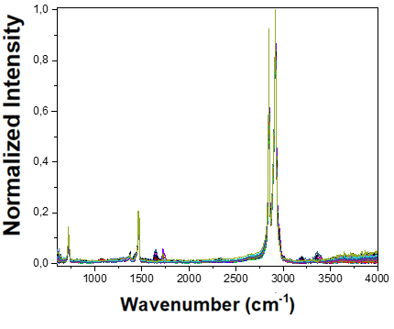
Figure 7S. ATR-FTIR spectra of recycled HDPE/LDPE blends containing PP.

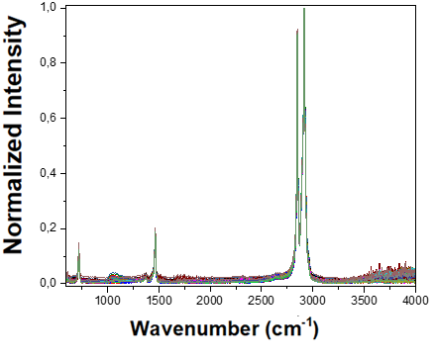
Figure 8S. ATR-FTIR spectra of recycled HDPE/LDPE blends containing silica gel.

