Von Mises
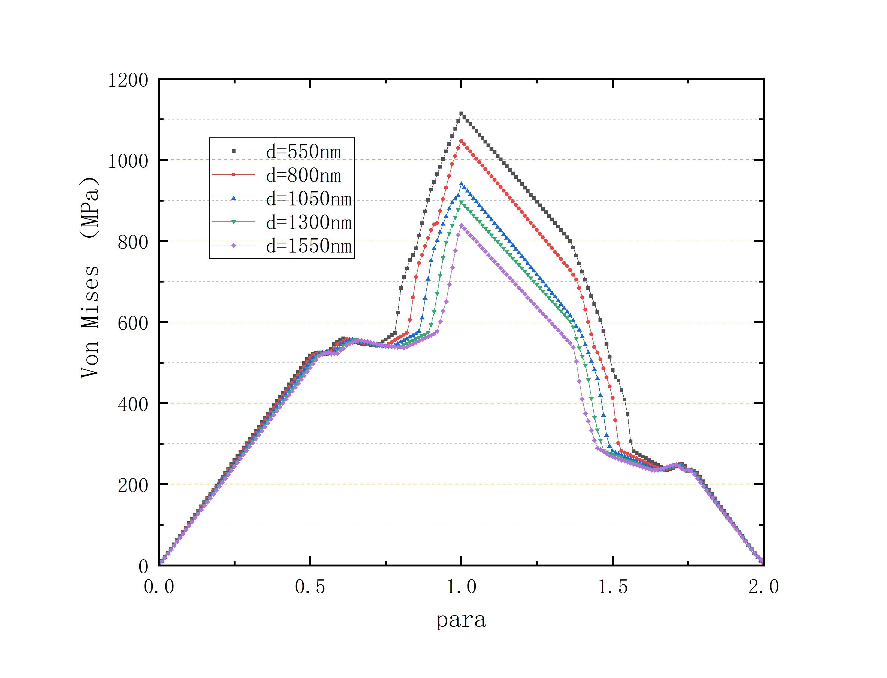r=0.18inch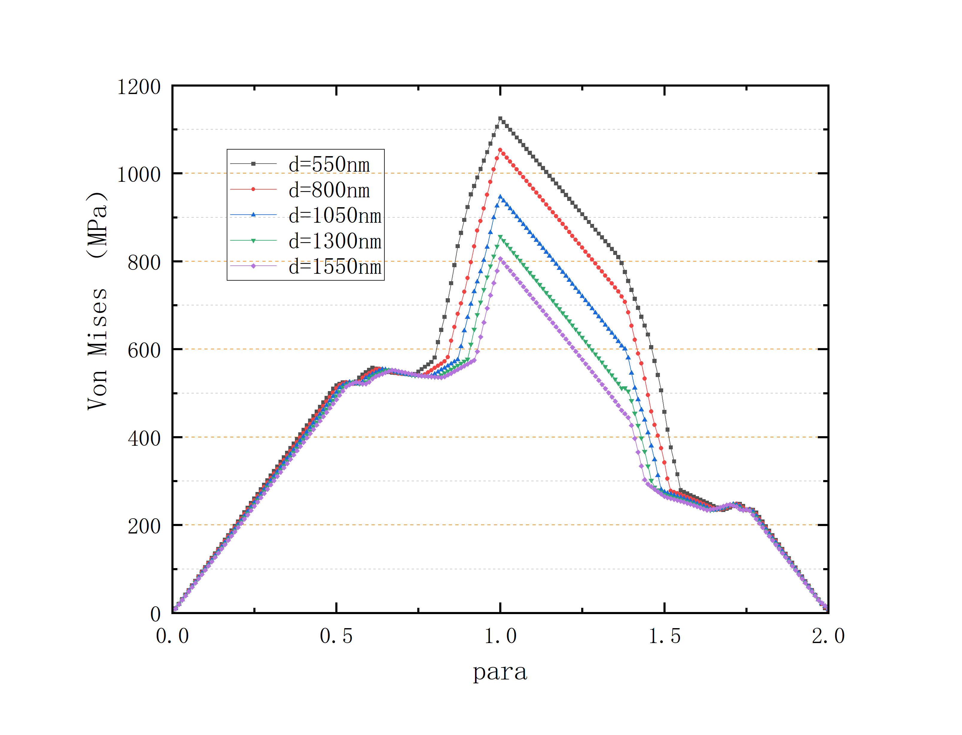r=0.16inch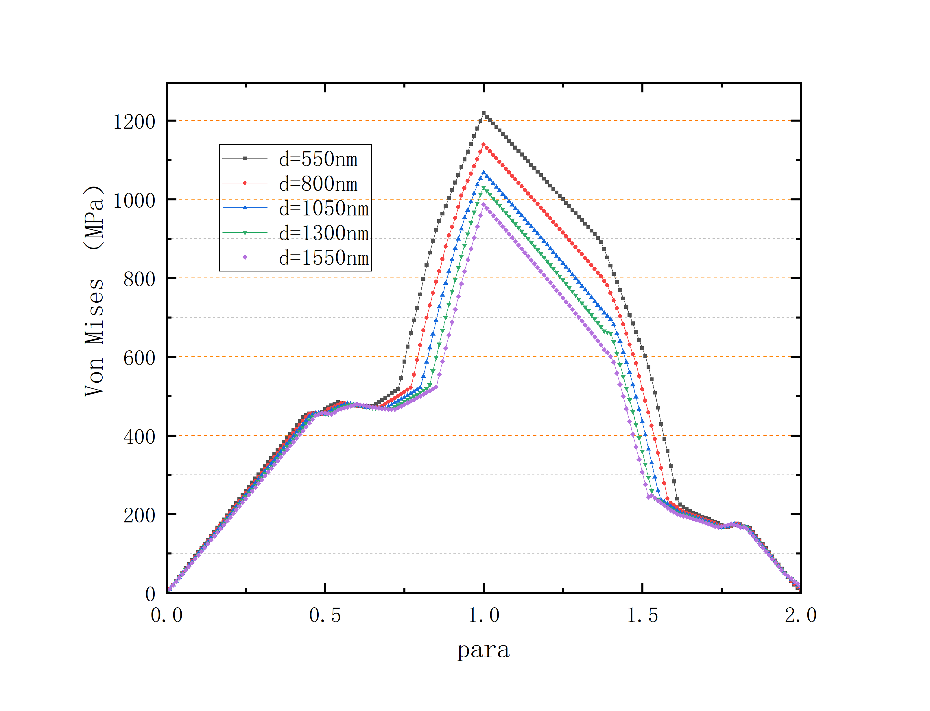 r=0.14inch
Axial Displacement
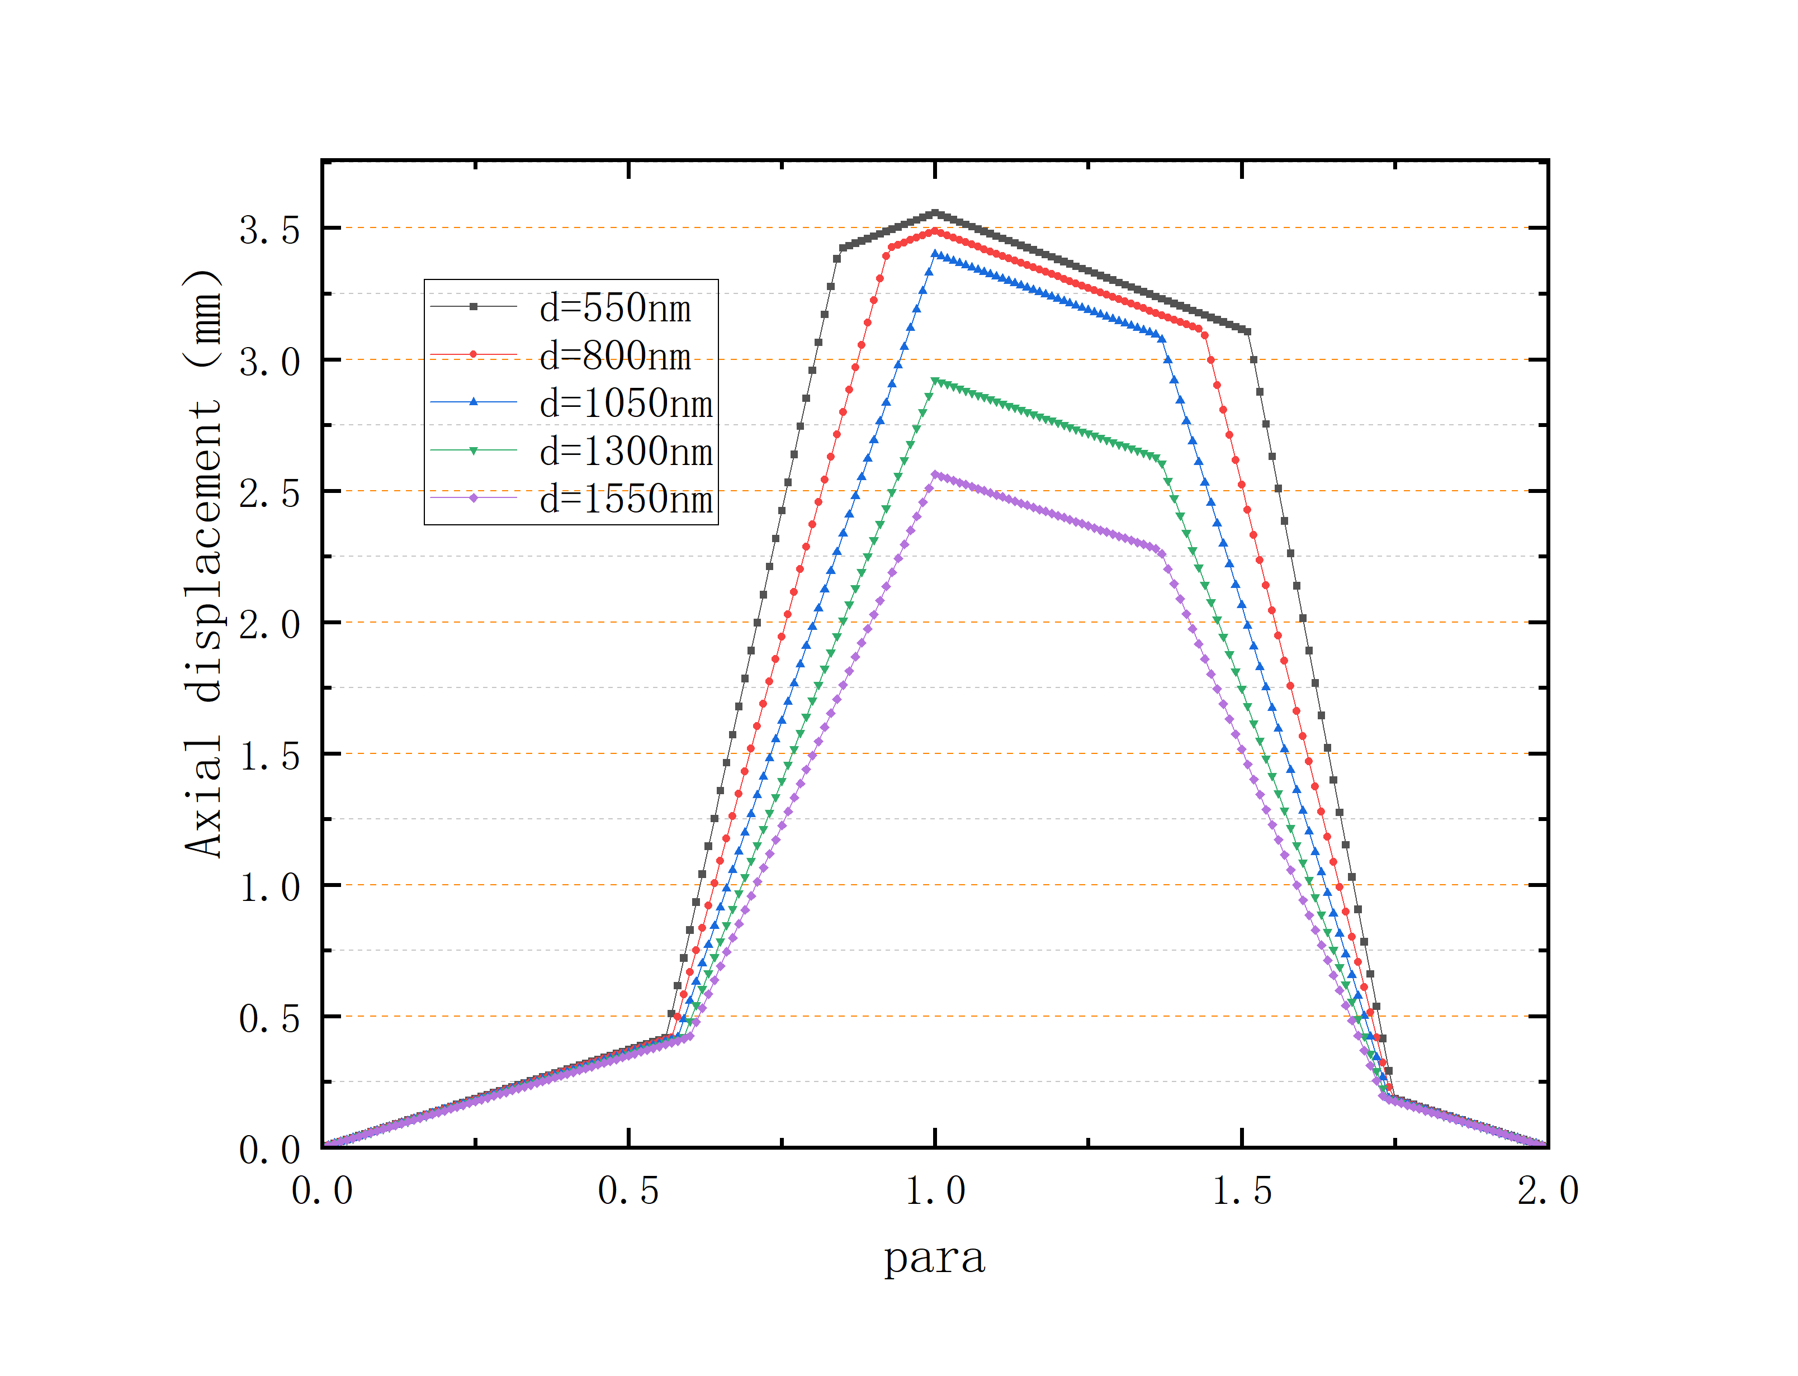r=0.18inch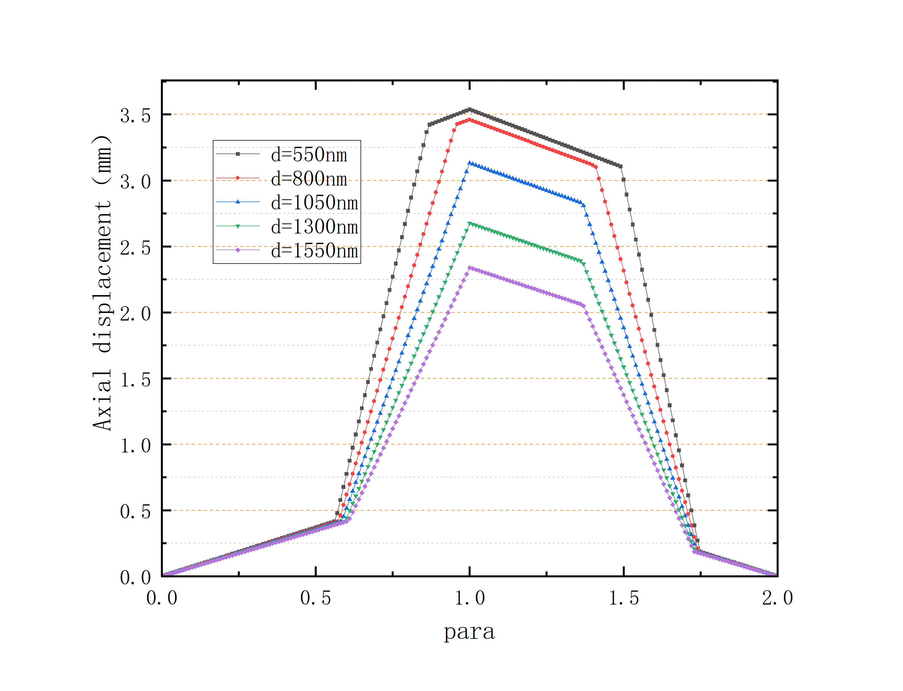r=0.16inch 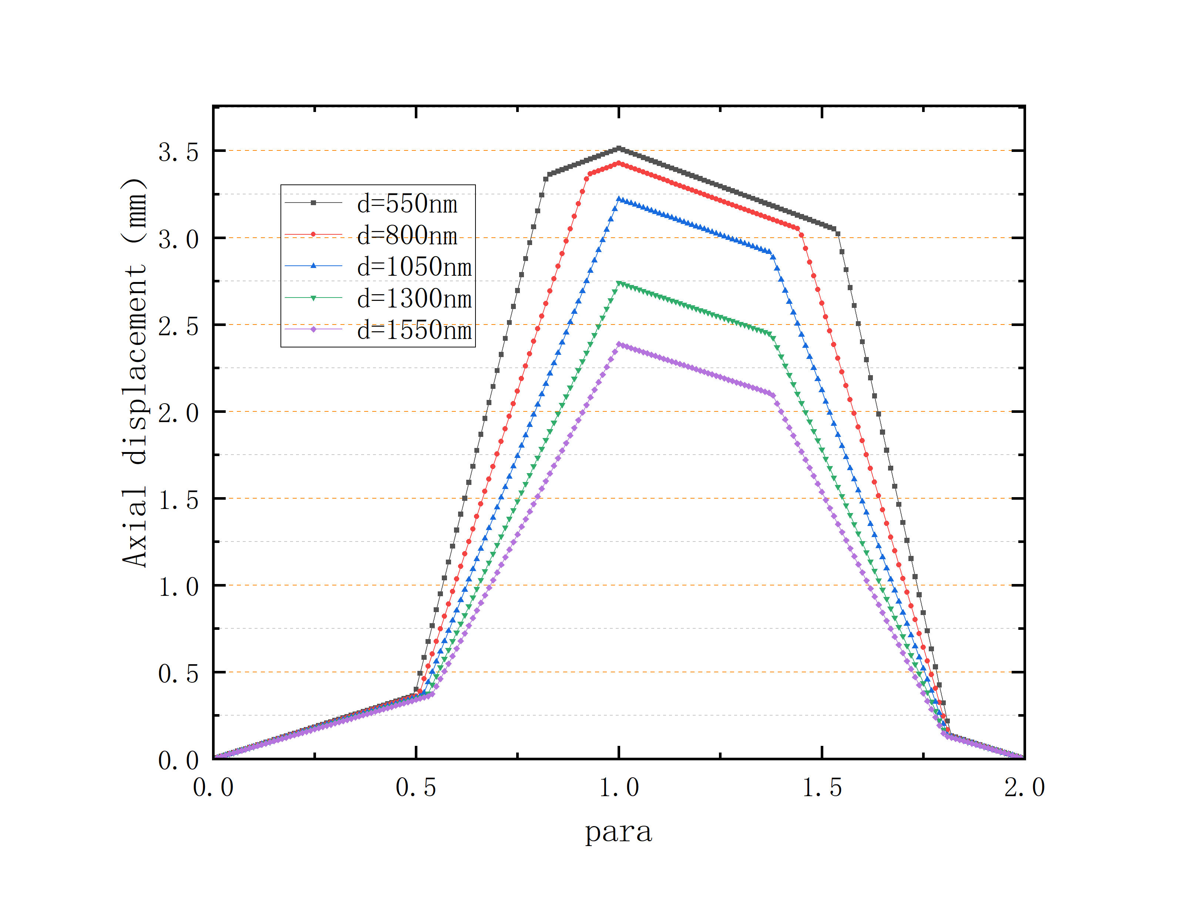 r=0.14inch

Equivalent partial strain
d=1500nm
Left: 0.5mm,Right: 2.5mm
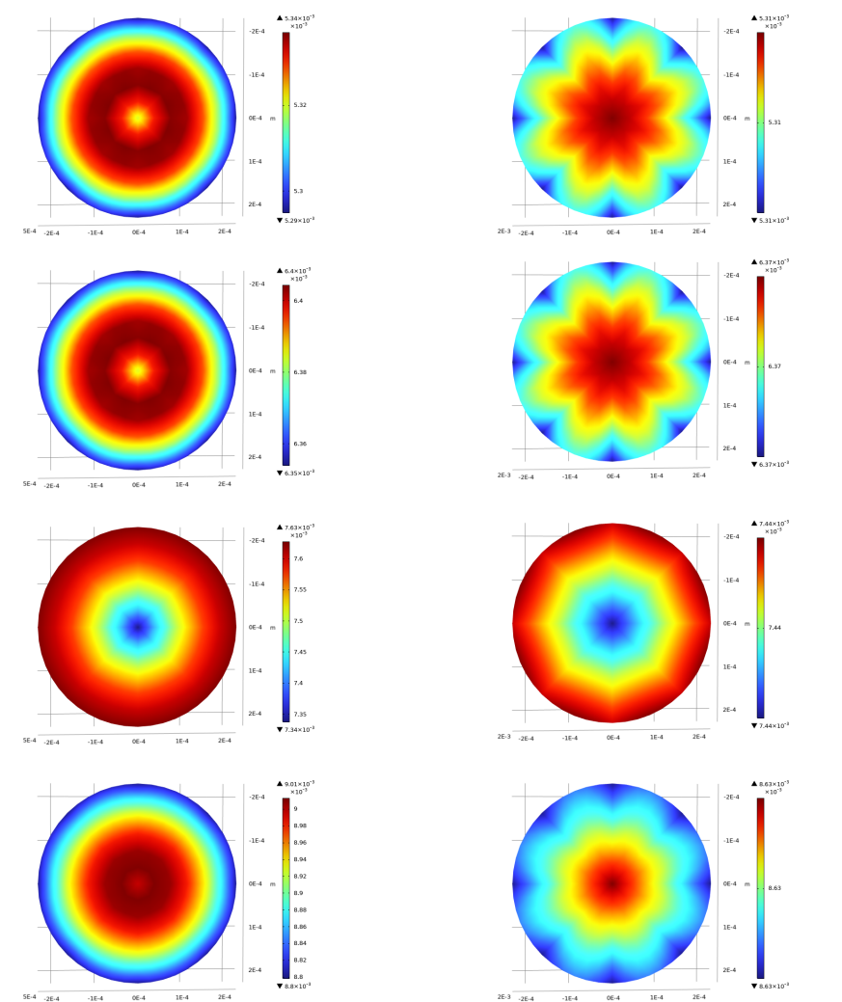

d=1050nm
Left: 0.5mm, Right: 2.5mm
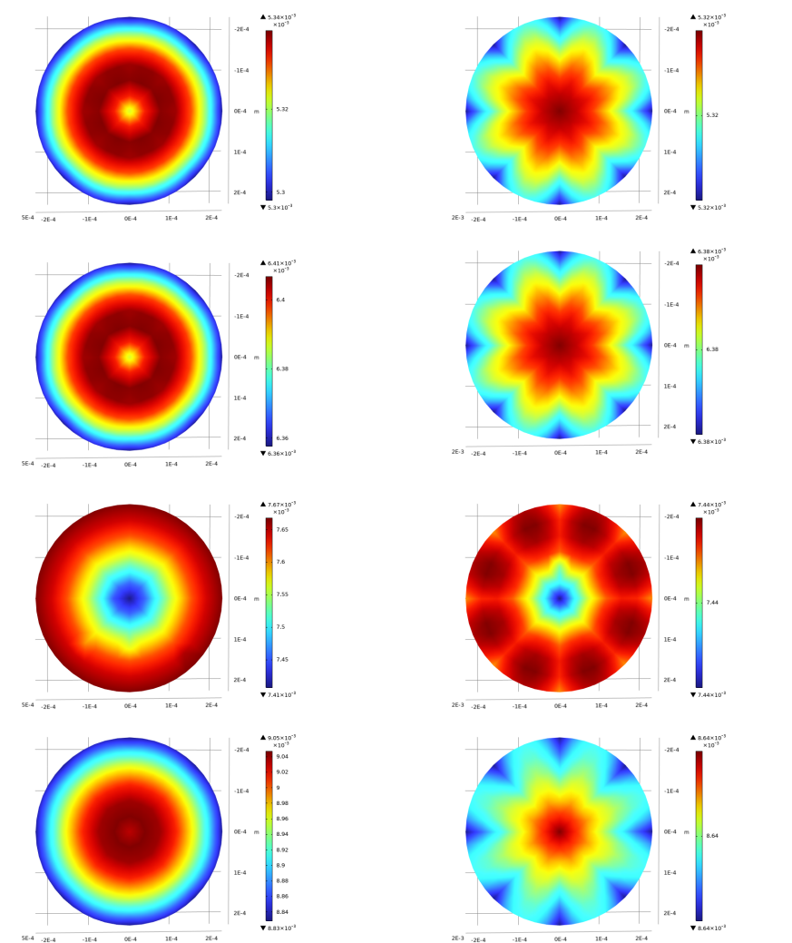

d=800nm
Left: 0.5mm, Right: 2.5mm
