Supplementary Information
This supplementary information supports the manuscript titled “Phytochemical-Guided Green Synthesis of Structurally Defined ZnO Nanoparticles from Butea monosperma Root Extract and Their Antibacterial Potential”
Rajeshreeba A. Jadeja¹, Suranjana V. Mayani^{1*}
¹Department of Chemistry, Marwadi University, Rajkot-Morbi Road, P.O. Gauridad, Rajkot 360003, Gujarat, India, E mail: rajeshreeba.jadeja129444@marwadiuniversity.ac.in, Tel: +91-9512501125, ORCID: 0009-0002-2940-1820
^{1*}Department of Chemistry, Faculty of Science, Marwadi University, Rajkot-Morbi Road, P.O. Gauridad, Rajkot 360003, Gujarat, India, E mail: suranjana.mayani@marwadieducation.edu.in, Tel: +91-9979980770, ORCID: 0000-0002-2624-3305

1.Tannin 2. Flavonoid 3. Steroid 4. Saponin 5.Alkaloid
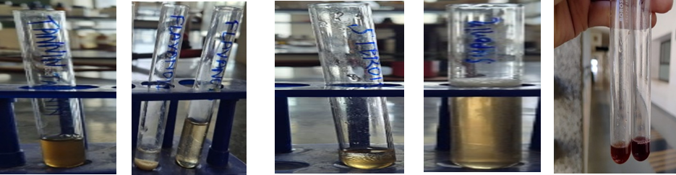
Figure S1: - Visual proof of phytochemical testing on the water-based extract of the Butea monosperma root.

Table: - S1 TLC fingerprint of Flavonoids (AlCl₃ spray)
UV 254 nm | UV 365 nm | After spray (254 nm) | After spray (365 nm)
No. of spots: 3–4  0.18 | Rf values: 0.22 | 0.45 | 0.70
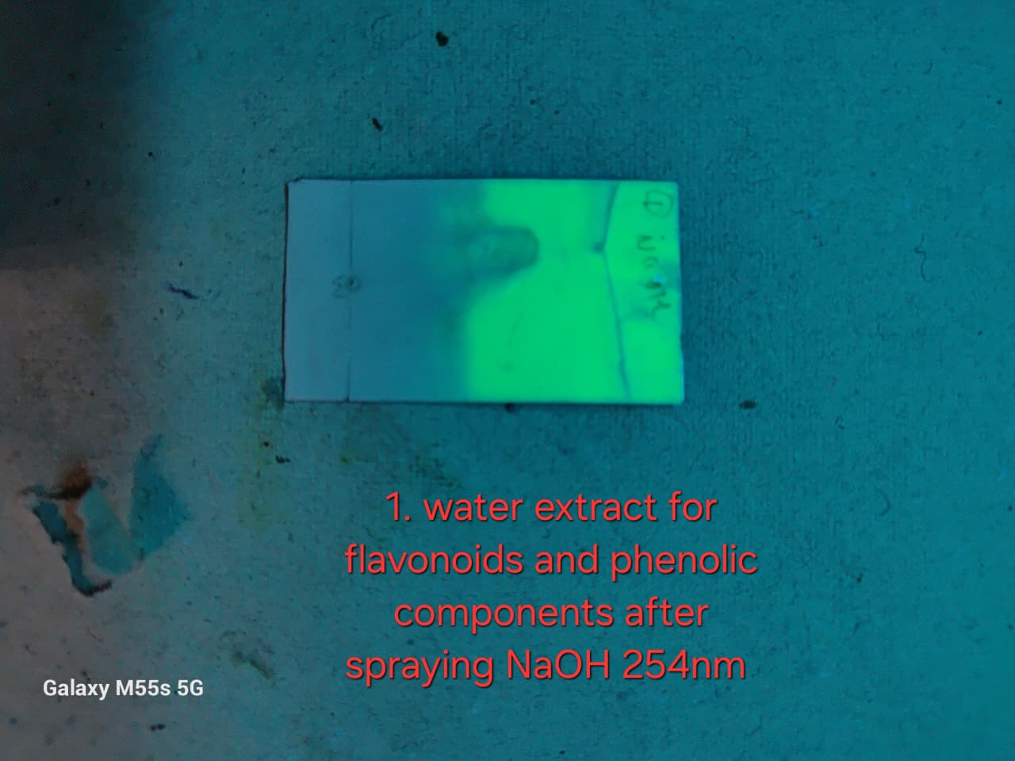 | 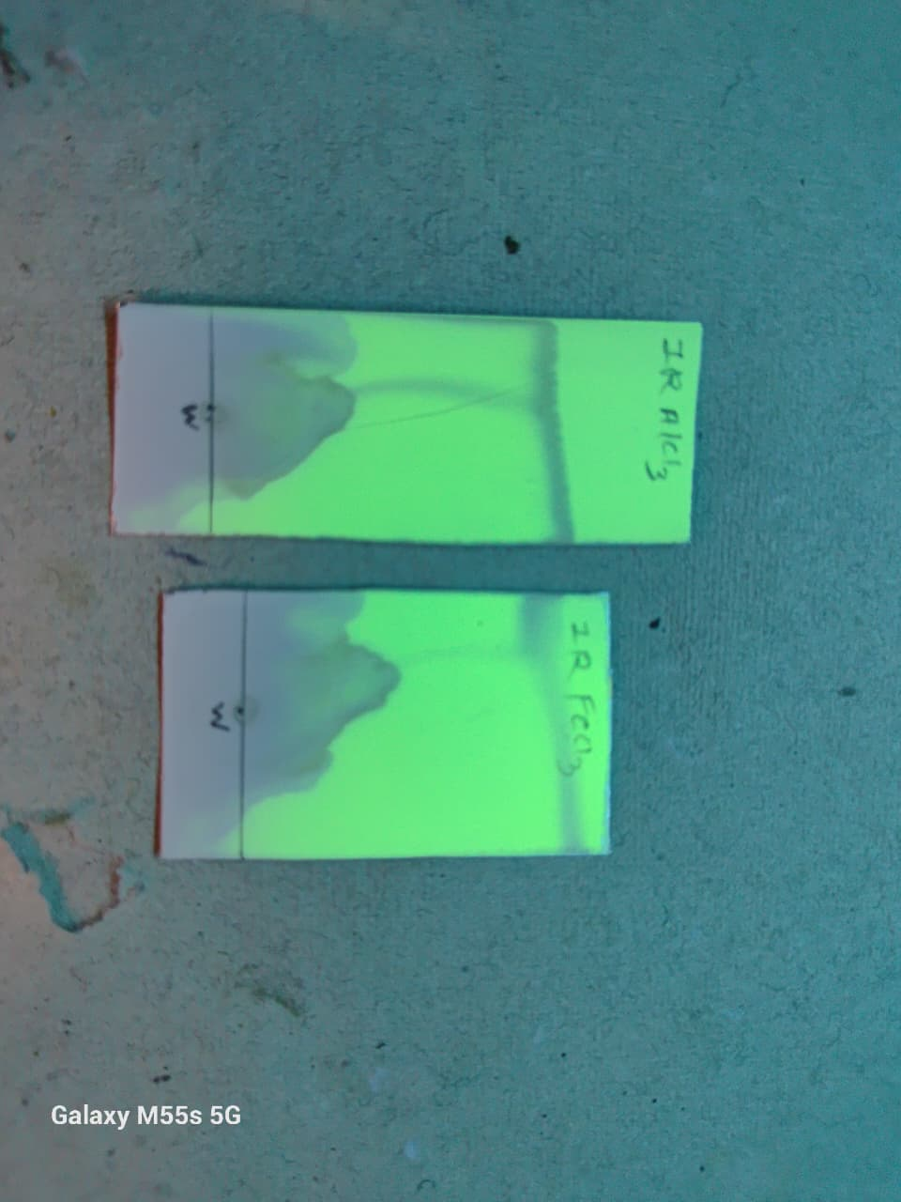 | 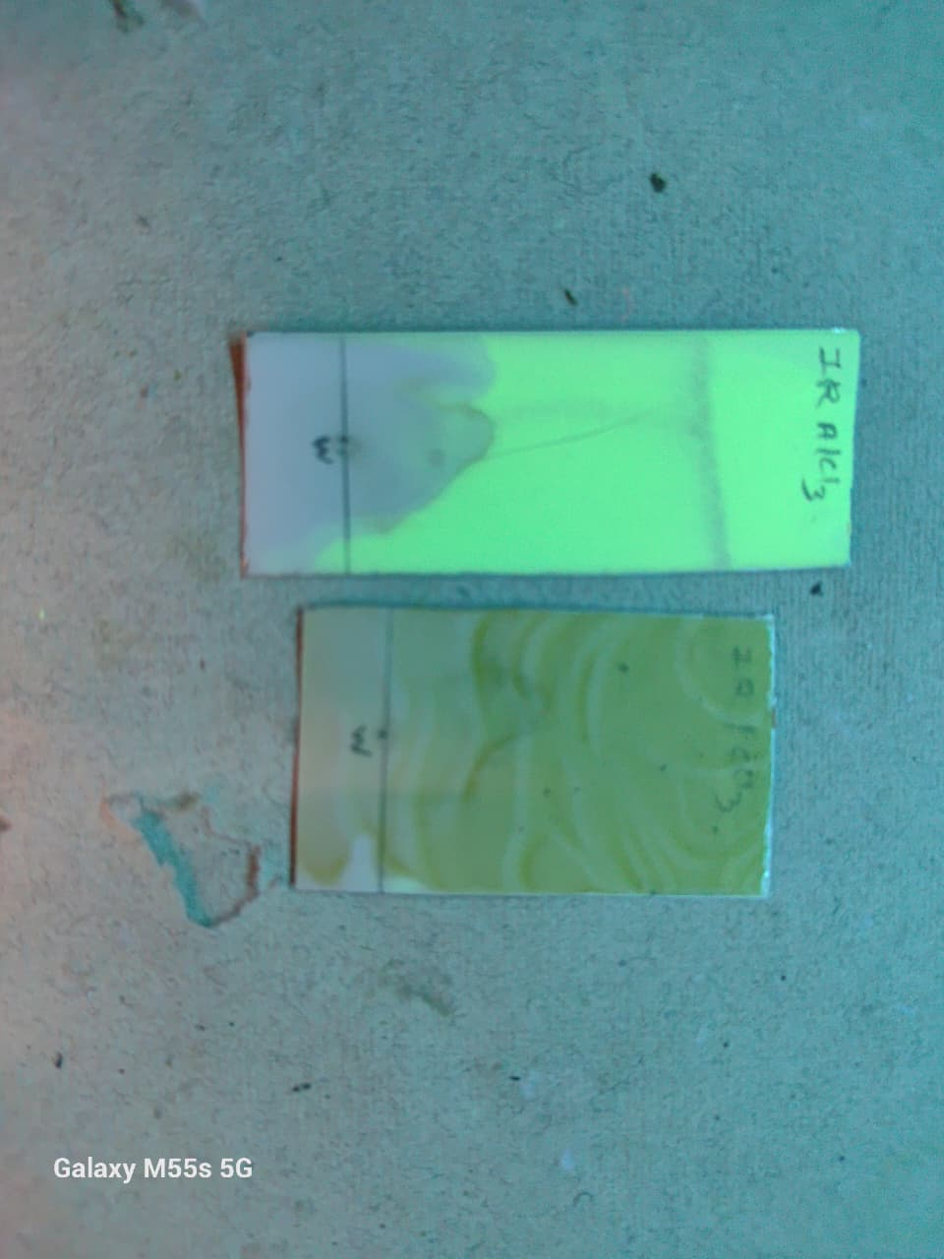 | 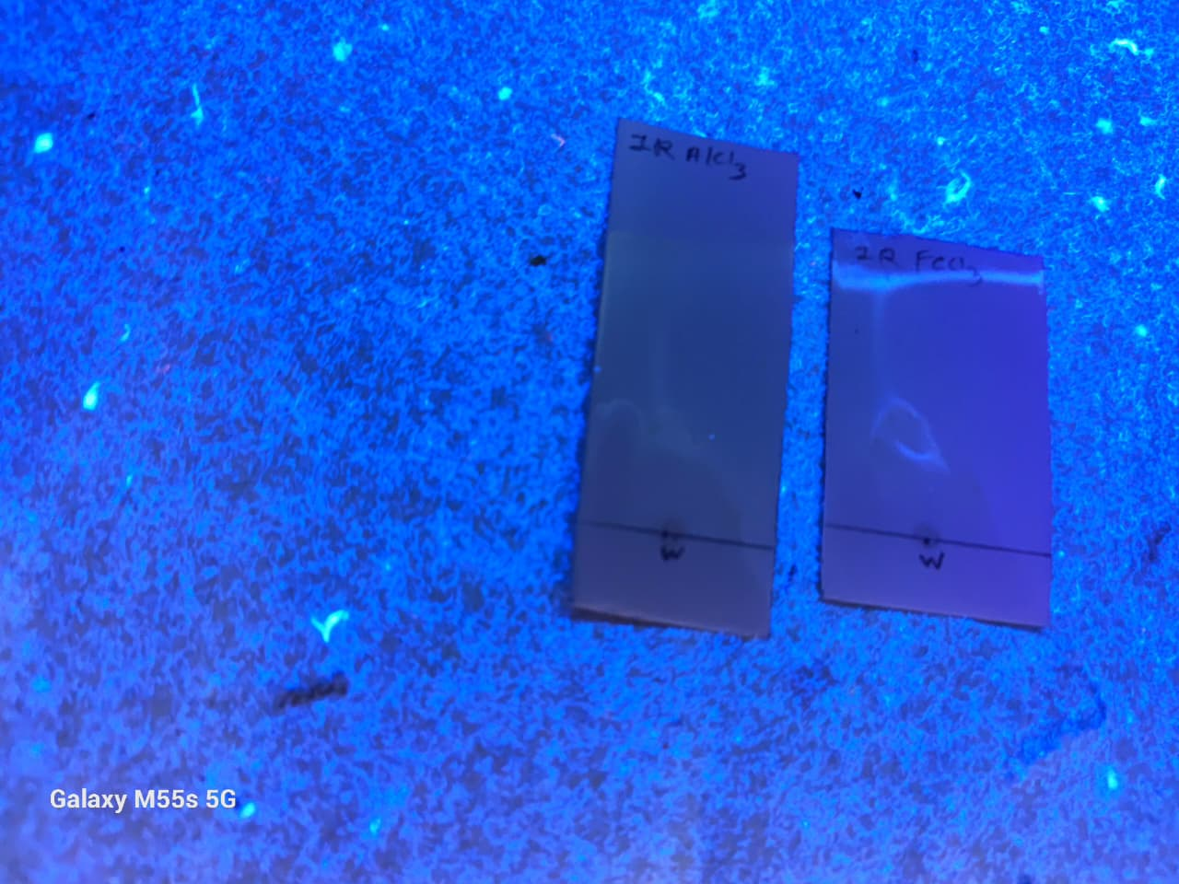

Table: - S1.2TLC fingerprint of Flavonoids (FeCl₃ spray)
UV 254 nm | UV 365 nm | After spray (254 nm) | After spray (365 nm)
No. of spots: 3 | Rf values: 0.18 | 0.46 | 0.72
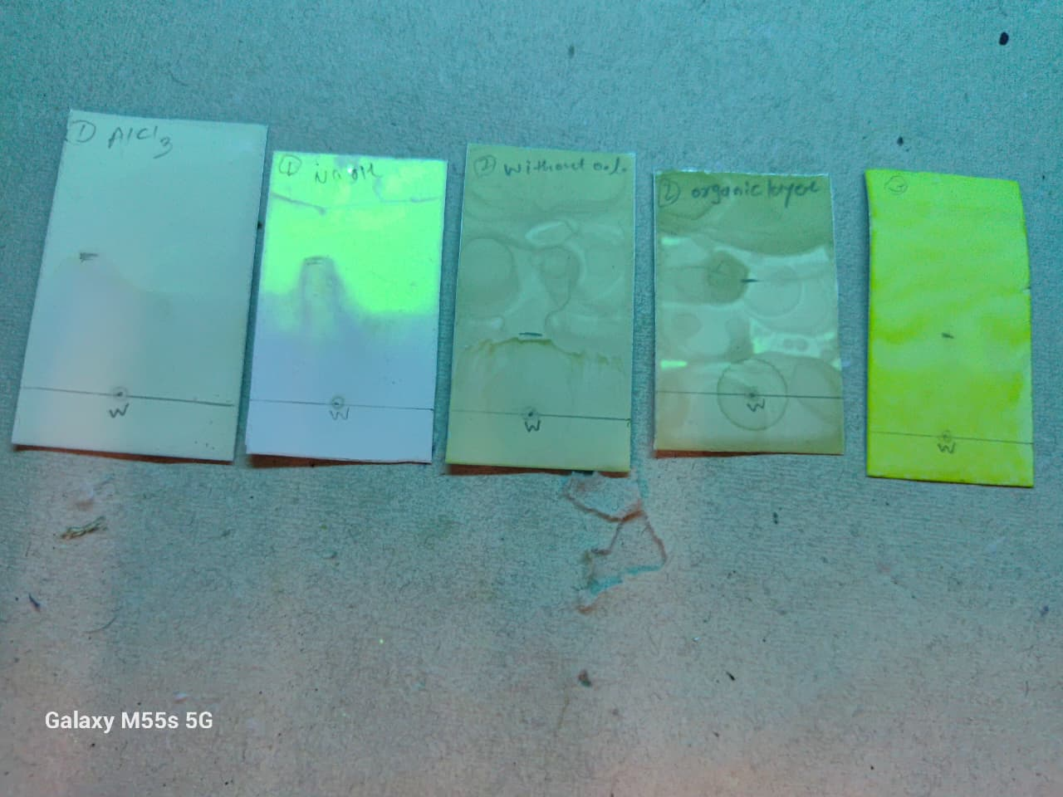 | 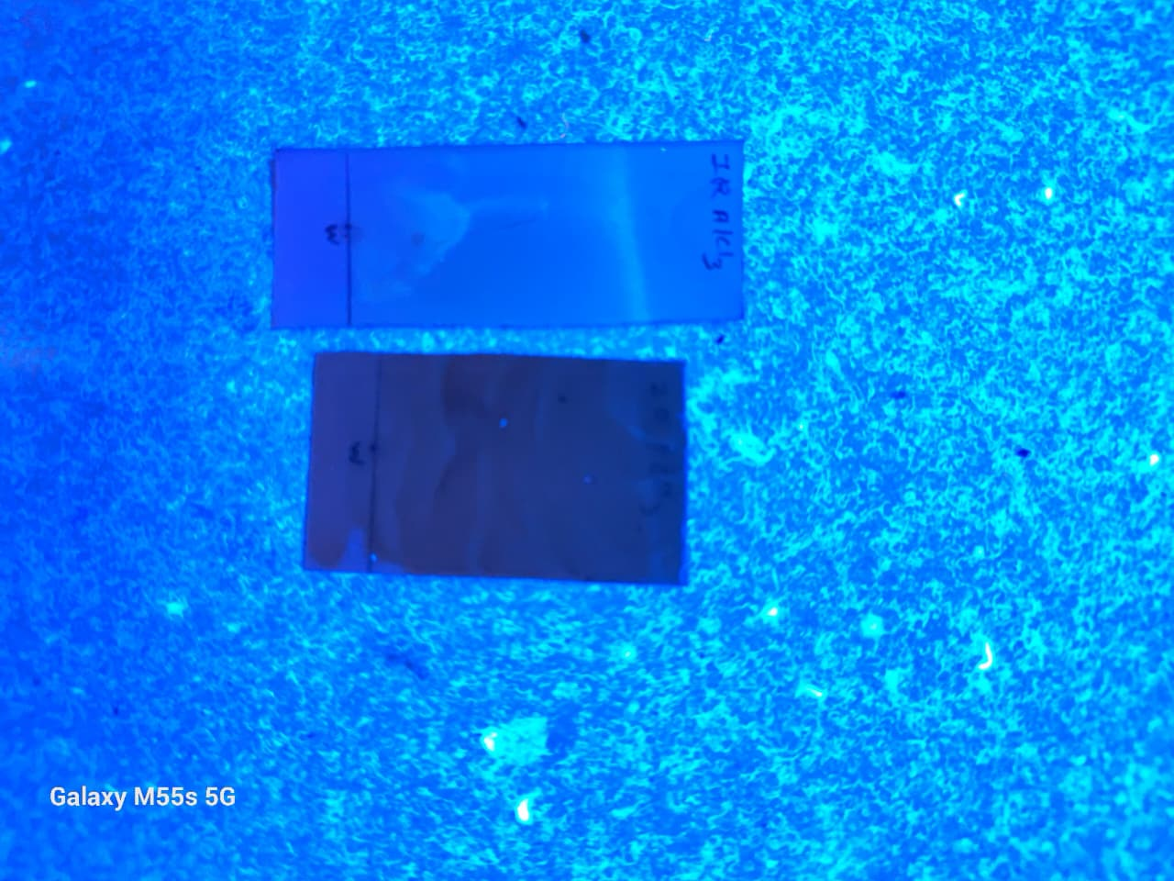 |  | 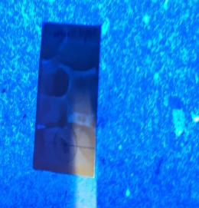

Table: - S1.3TLC fingerprint of Flavonoids (NaOH spray)
UV 254 nm | UV 365 nm | After spray (254 nm) | After spray (365 nm)
No. of spots: 4  0.20 | Rf values: 0.38 | 0.65 | 0.82
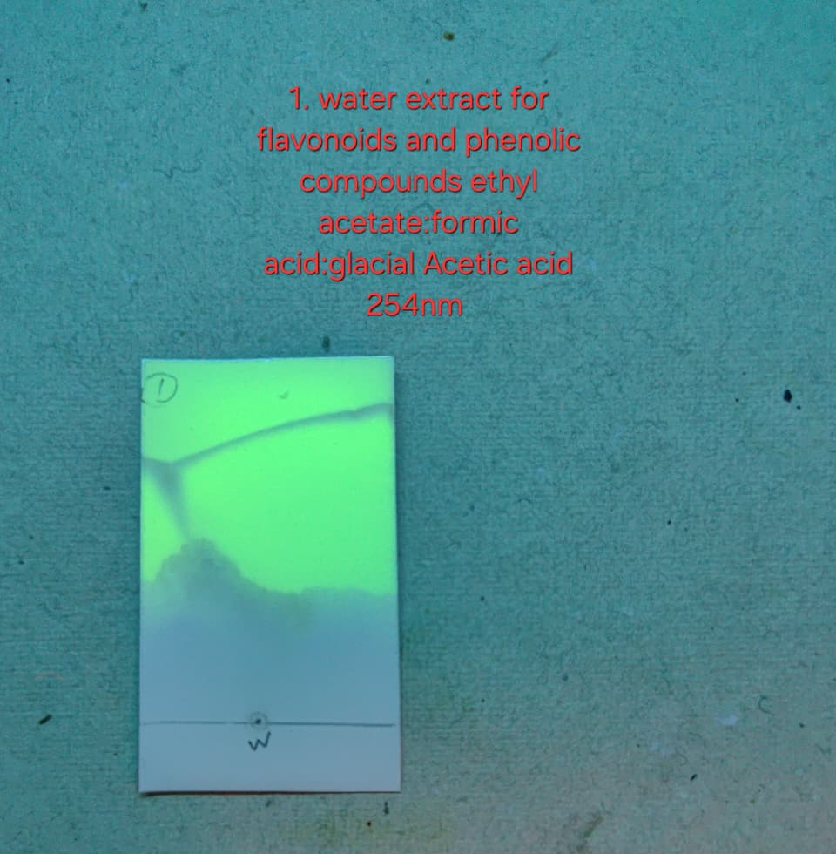 | 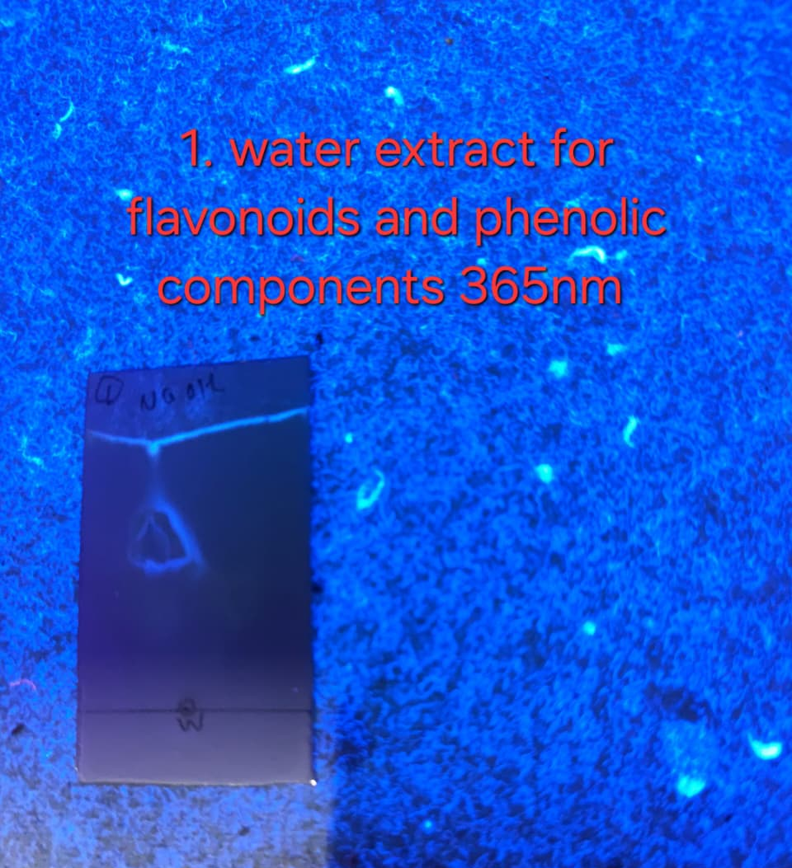 | 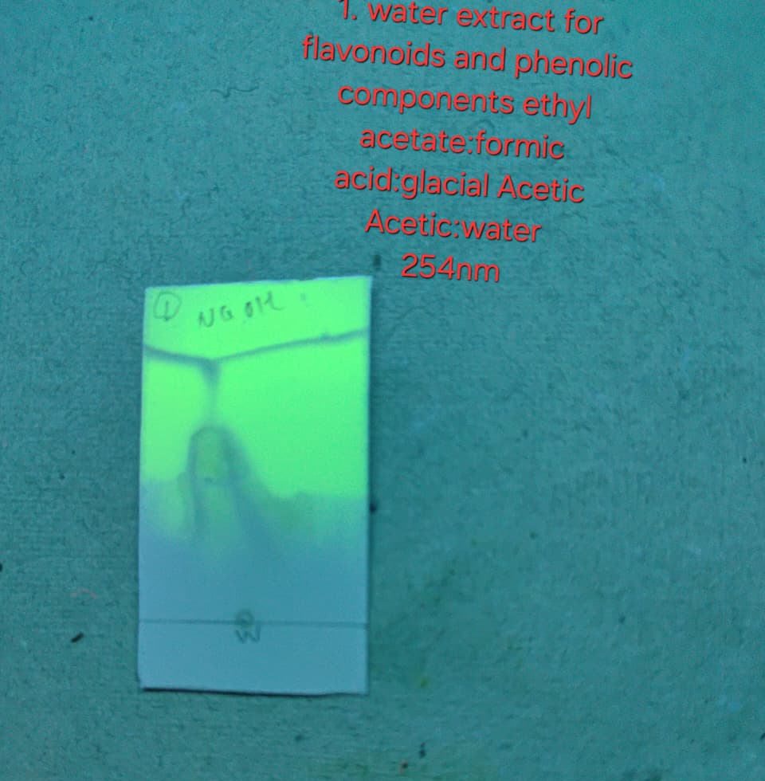 | 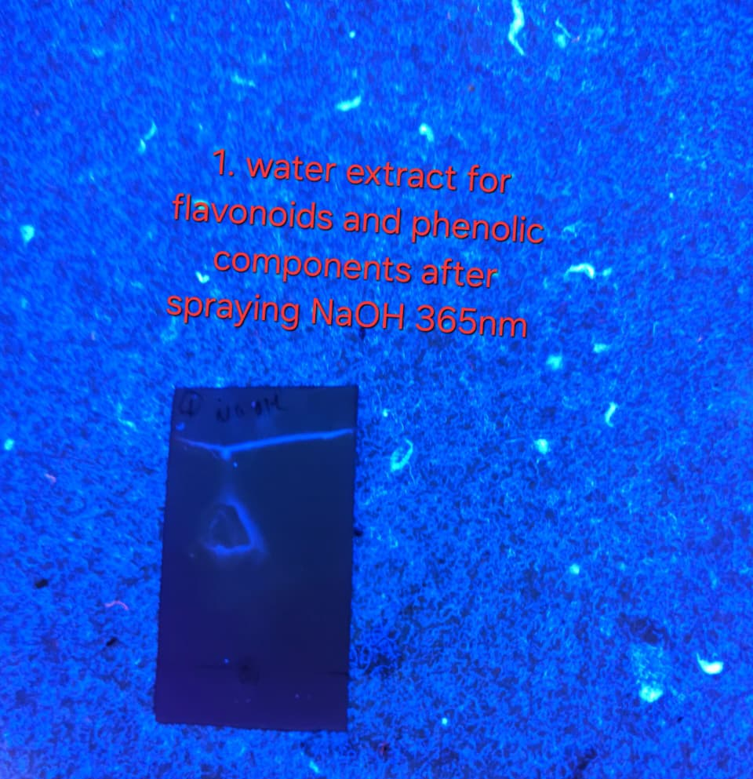

Table: - S1.4TLC fingerprint of Tannins (FeCl₃ spray)
UV 254 nm | UV 365 nm | After spray (254 nm) | After spray (365 nm)
No. of spots: 4  0.14 | Rf values: 0.16 | 0.44 | 0.74
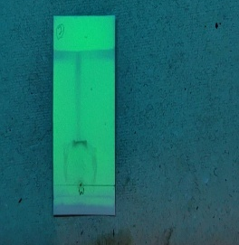 | 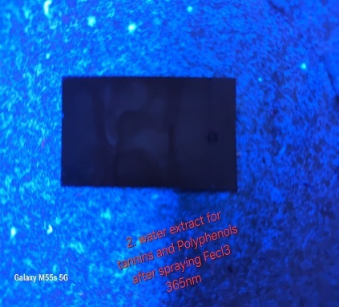 | 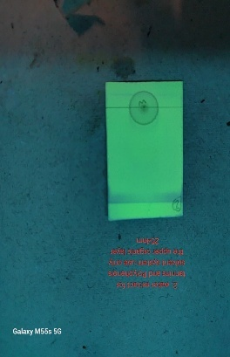 | 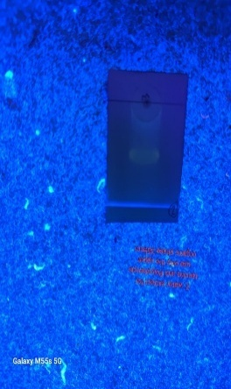

Table: -S1.5 TLC fingerprint of Universal Phenolics (PEG+FeCl₃ spray)
UV 254 nm | UV 365 nm | After spray (254 nm) | After spray (365 nm)
No. of spots:5  0.22,0.38 | Rf values: 0.48 | 0.54 | 0.79
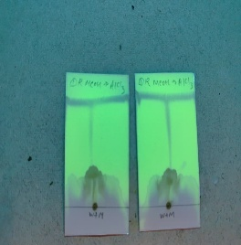 | 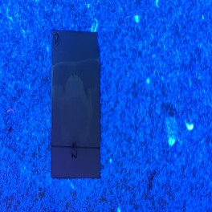 | 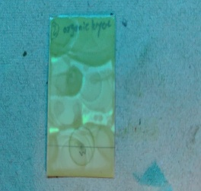 | 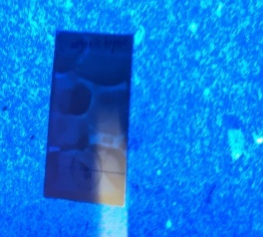

Table: - S1.6TLC fingerprint of Alkaloids (Dragendorff’s spray)
UV 254 nm | UV 365 nm | After spray (254 nm) | After spray (365 nm)
No. of spots:4  0.22 | Rf values: 0.40 | 0.65 | 0.78
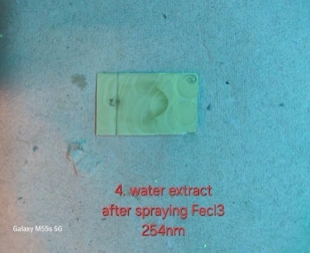 | 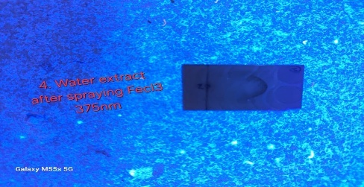 | 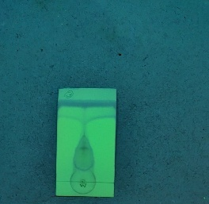 | 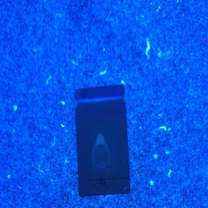
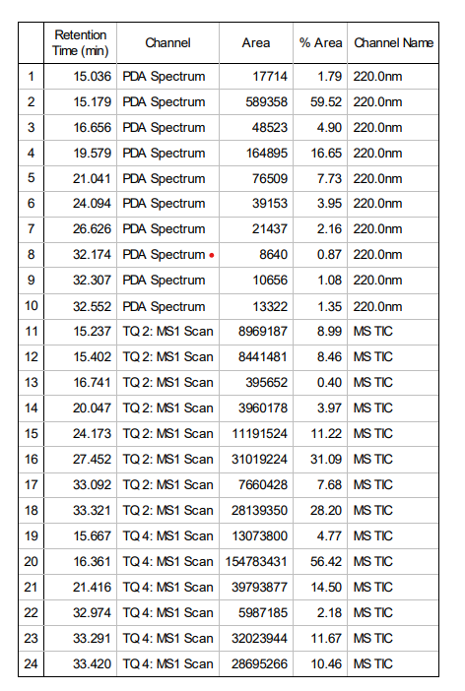
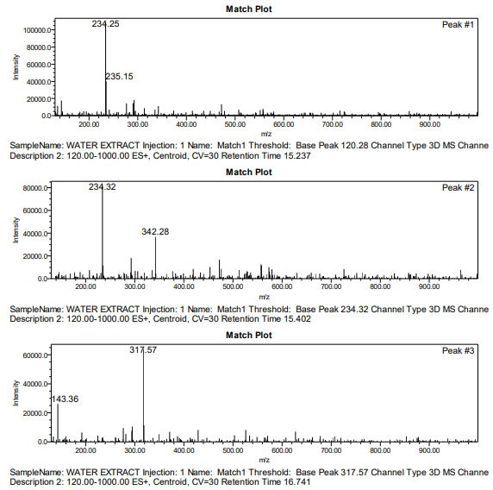
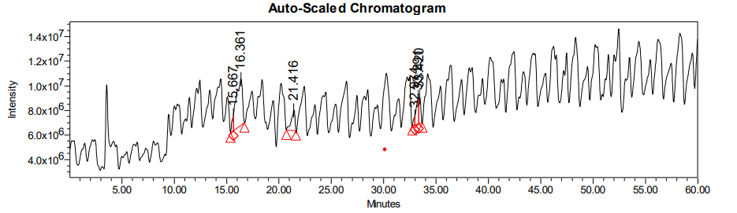
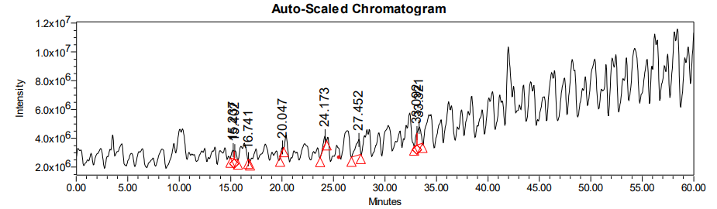
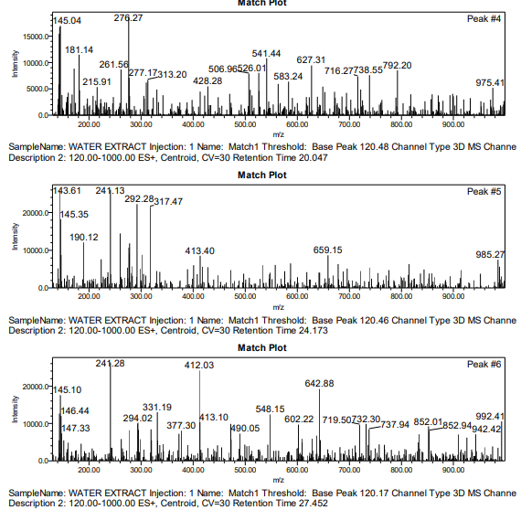
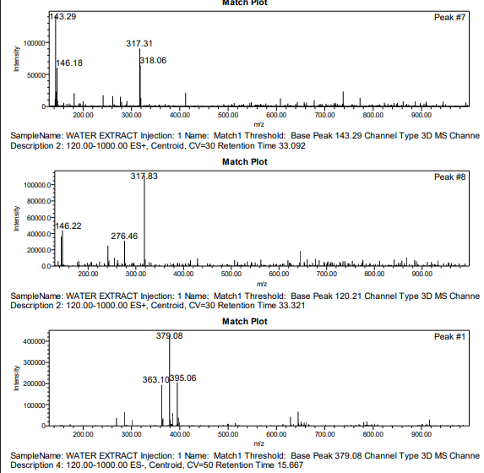
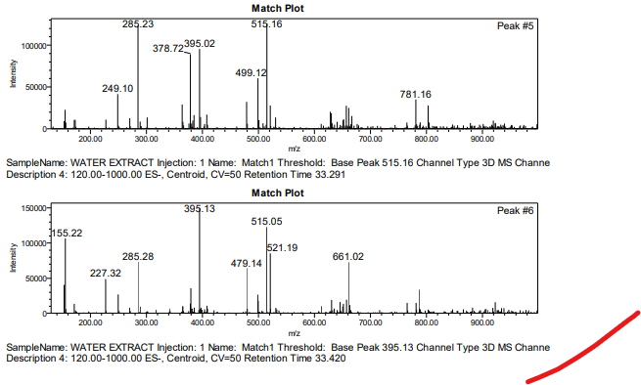
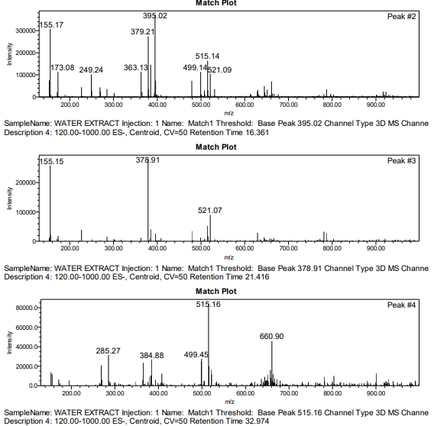
Figure: - S2 LC-MS peak list + total ion chromatogram + spectra of major tentatively identified phytochemicals constituents present in Butea monosperma root extract.
Table S2. LC–MS peak list of Butea monosperma root extract showing tentatively identified phytochemical constituents.
Peak No. | Retention Time (min) | m/z (M–H) ⁻ | Tentative Compound | Compound Class
1 | 1.78 | 169 | Gallic acid | Phenolic acid
2 | 6.20 | 289 | Catechin | Flavonoid
3 | 7.12 | 289 | Epicatechin | Flavonoid
4 | 11.45 | 303 | Quercetin | Flavonol
5 | 14.80 | 609 | Rutin | Flavonoid glycoside
6 | 19.55 | 426 | Lupeol | Triterpenoid

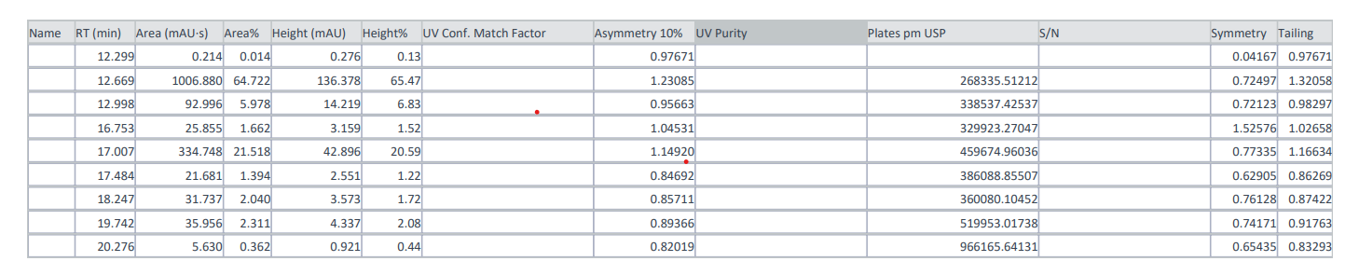
Figure: - S3 LC–MS analysis of Butea monosperma root extract revealed six major phytoconstituents
Figure: - S4 HPLC peak table of Butea monosperma root extract, indicating retention times (RT), peak area (%), height, and symmetry parameters corresponding to identified phytochemical constituents.
Table: - S3 HPLC chromatographic peak summary of aqueous root extract of Butea monosperma.
Peak No. | Retention time (min) | Area (%) | Tentative compound
1 | 12.669 | 64.7 | Flavonoid derivative
2 | 17.007 | 21.5 | Phenolic compound
3 | 12.998 | 5.9 | Tannin-related compound
4 | 16.753 | 3.2 | Polyphenol
5 | 18.247 | 2.1 | Triterpenoid fragment
6 | 19.742 | 1.4 | Unidentified

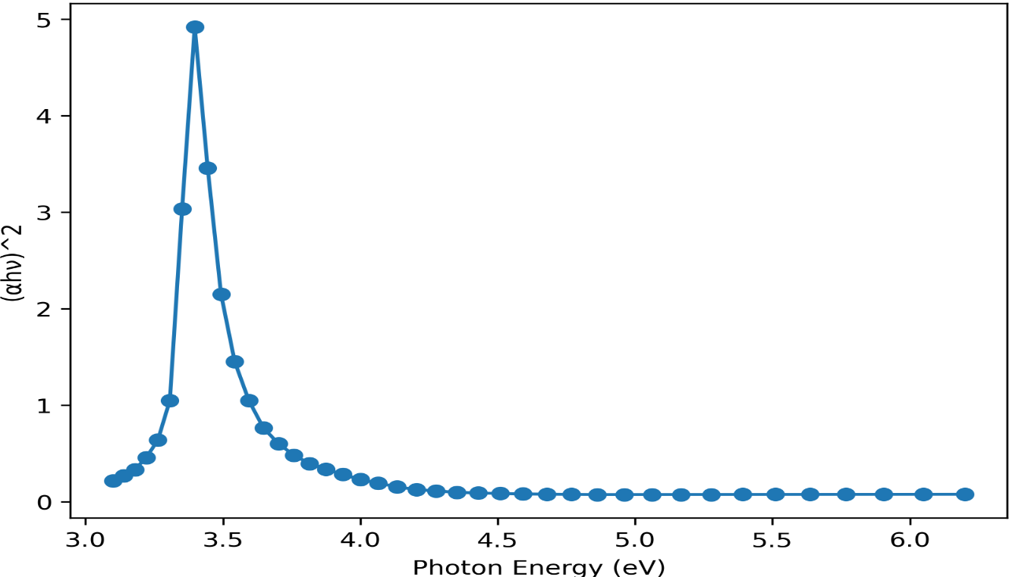
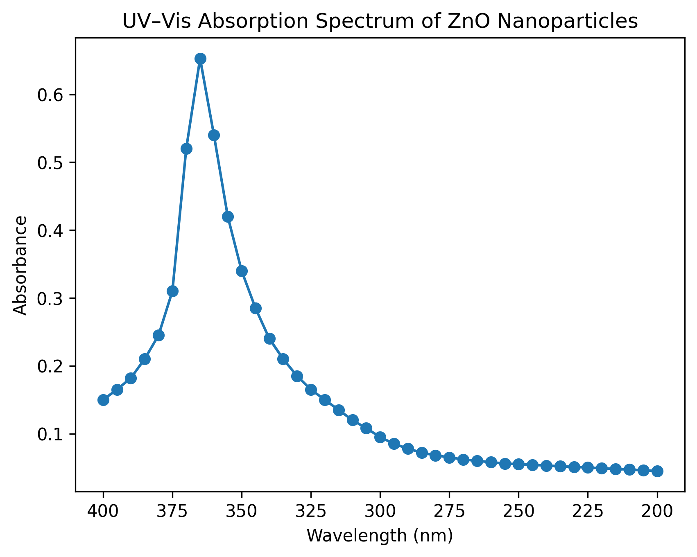

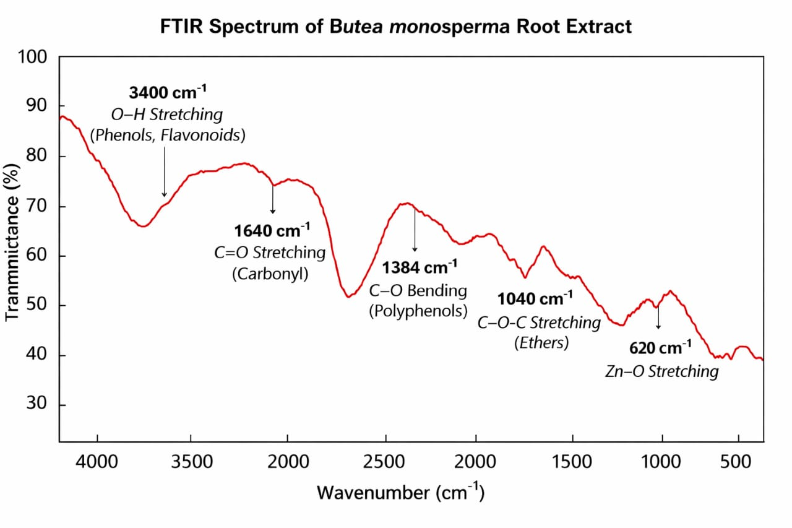
Figure: - S5 UV-Vis absorption and Tauc relation for direct allowed transitions, by plotting (αhν) ² versus photon energy (hν) spectrum of green-synthesized zinc oxide nanoparticles.
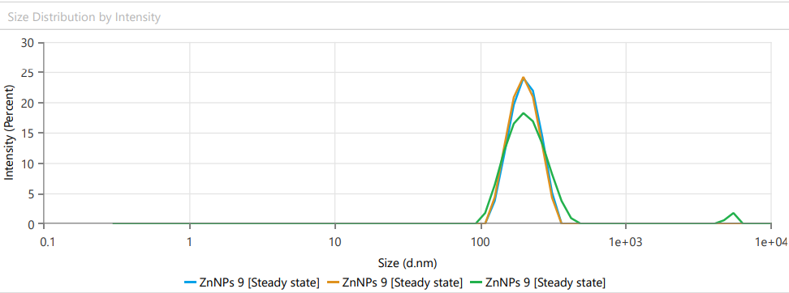
Figure: - S6 FTIR spectrum of ZnO nanoparticles demonstrating functional groups involved in nanoparticle stabilization.

Figure: - S7 DLS size distribution and zeta potential analysis of zinc oxide nanoparticles synthesized using Butea monosperma root extract.
Parameter | Value | Interpretation
Z-average size (nm) | 255.8 | Hydrodynamic diameter
Polydispersity index (PDI) | 0.389 | Moderate size
Zeta potential (mV) | -25.0 | Moderate colloidal stability
Table: - S4 Hydrodynamic size distribution and zeta potential of ZnO nanoparticles synthesized using Butea monosperma root extract.
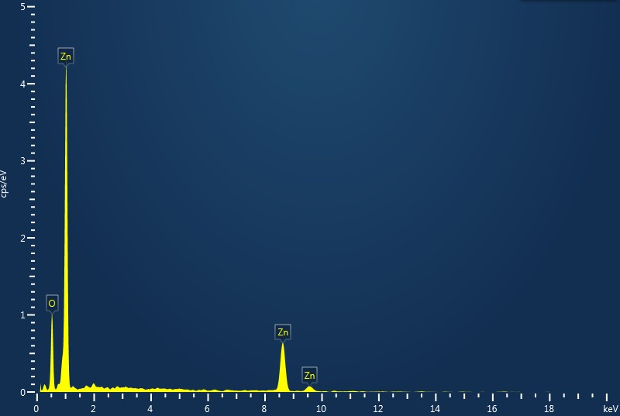
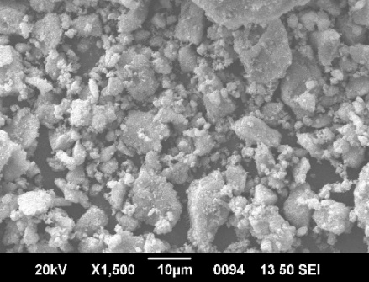
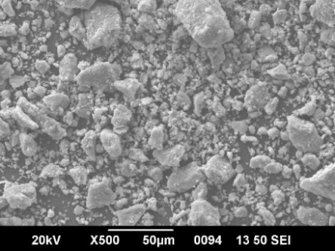
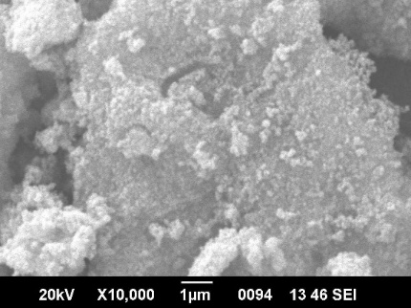
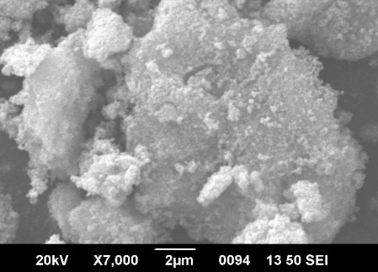
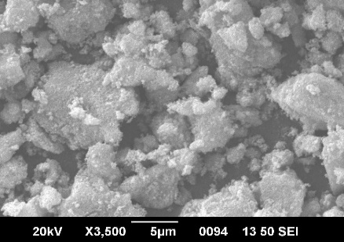
Figure: - S8 Additional SEM micrographs of zinc oxide nanoparticles at different magnifications + EDX spectrum.

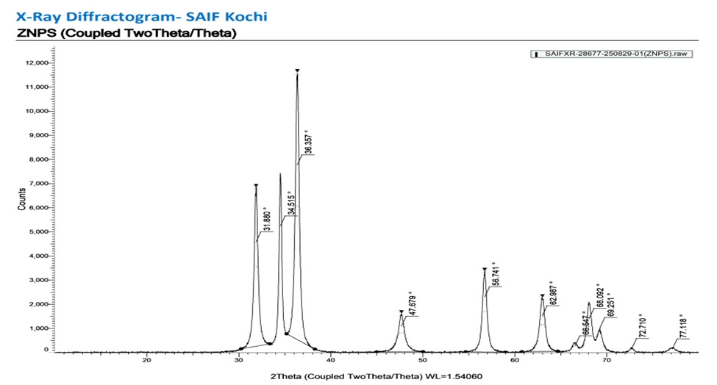
Figure: - S9 Estimation of crystallite size of green-synthesized ZnO nanoparticles using the Scherrer equation based on PXRD diffraction peaks corresponding to the hexagonal wurtzite structure (JCPDS No. 36-1451).
Detailed crystallite size calculations using of the ZnO nanoparticles was estimated from the PXRD data using the Scherrer equation:
D=Kλ
βcosθ

where D is the crystallite size (nm), K is the shape factor (0.9), λ is the X-ray wavelength (Cu Kα, 1.5406 Å), β is the full width at half maximum (FWHM) in radians, and θ is the Bragg diffraction angle. The crystallite size was calculated using the most intense diffraction peaks corresponding to the (100), (002), (101), (102), (110), and (103) planes. All PXRD measurements correspond ZnO nanoparticles calcined at 450⁰C, confirming phase pure hexagonal wurtzite structure (JCPDS No. 36-1451).
Table: - S5 PXRD data and crystallite size calculation of ZnO nanoparticles using the Scherrer equation.
2θ (°) | d-spacing (Å) | hkl | FWHM (rad) | Crystallite size (nm)
31.88 | 2.8048 | (100) | 0.0081 | 17.8
34.51 | 2.5965 | (002) | 0.0081 | 17.8
36.36 | 2.4689 | (101) | 0.0094 | 12.4
47.68 | 1.9069 | (102) | 0.0087 | 15.7
56.74 | 1.6211 | (110) | 0.0091 | 16.6
62.99 | 1.4745 | (103) | 0.0085 | 14.6
The average crystallite size of the ZnO nanoparticles was found to be in the range of 12–18 nm.
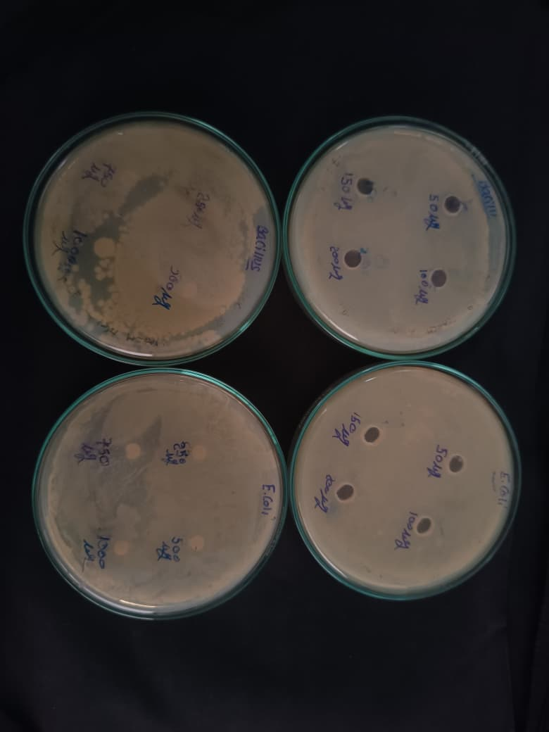
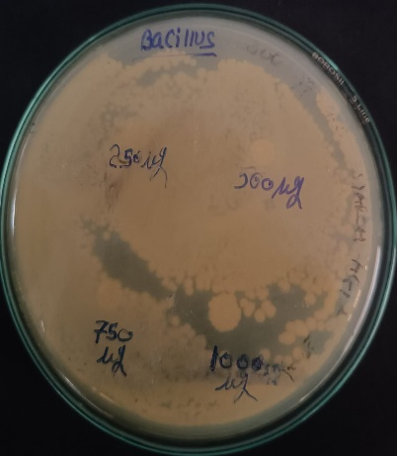
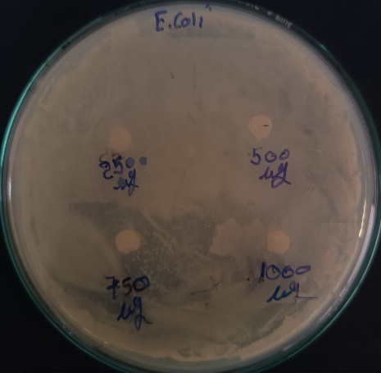
Figure: - S10 Raw agar well diffusion plates showing antimicrobial activity of ZnO nanoparticles against Escherichia coli and Bacillus sp. at different concentrations (250–1000 µg/mL).
Table: - S6 Zone of inhibition (mm) of ZnO nanoparticles against tested bacterial strains at different concentrations.
Microorganism | Concentrations µg/mL | Zone of inhibition (mm)*
E. coli | 250 | Not detected
 | 500 | Not detected
 | 750 | 10
 | 1000 | 15
Bacillus sp. | 250 | 1
 | 500 | 5
 | 750 | 10
 | 1000 | 20

*Zone of inhibition values represent single measurements obtained from agar well diffusion assays. No statical analysis was performed due to the absence of biological replicates.
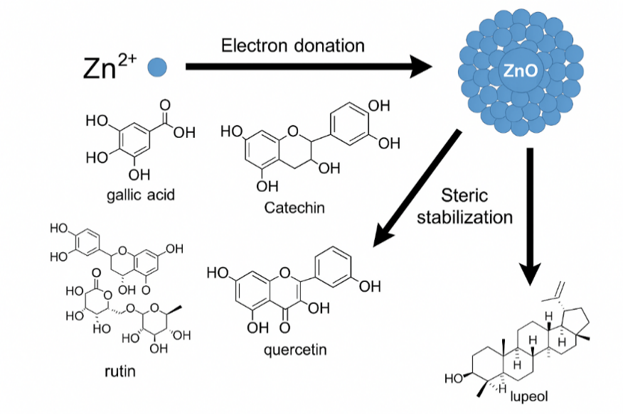
Figure: - S11 Proposed phytochemical mechanism diagram.

Instrumental Details
Instrument | Model | Parameters
UV–Vis | Shimadzu UV-2600 | 200–800 nm scan
FTIR | Bruker Alpha II | KBr pellet, 4000–400 cm⁻¹
LC–MS | Agilent 6545 Q-TOF | ESI mode, 100–1000 m/z
HPLC | Shimadzu LC-20AT | C18 column, 280 nm detection
SEM–EDX | JEOL JSM-IT500 | 15 kV, ×1500–×10,000
PXRD | Rigaku Ultima IV | Cu Kα, 20–80°, 0.02° step
Zetasizer | Malvern Nano ZS | 25 °C, water medium

