Supplementary Table-1: PGX Resistance Weight Score (RWS)

Supplementary Table-1A: PGX Resistance Weight Score (RWS) for NRTIs and NNRTIs

Mutation | ABC | AZT | FTC | 3TC | TDF |  | Mutation | DOR | EFV | ETR | NVP | RPV
E40F | 0 | 0 | 0 | 0 | 0 |  | V90I | 0 | 0 | 0 | 0 | 8.3
M41L | 8.3 | 24.9 | 0 | 0 | 8.3 |  | A98G | 16.6 | 16.6 | 16.6 | 49.8 | 24.9
E44A | 0 | 0 | 0 | 0 | 0 |  | L100I | 16.6 | 74.7 | 49.8 | 99.6 | 74.7
E44D | 0 | 0 | 0 | 0 | 0 |  | L100V | 8.3 | 24.9 | 16.6 | 49.8 | 24.9
A62V | 8.3 | 8.3 | 0 | 0 | 8.3 |  | K101E | 8.3 | 24.9 | 16.6 | 49.8 | 74.7
K65E | 16.6 | 0 | 0 | 0 | 16.6 |  | K101P | 8.3 | 99.6 | 74.7 | 99.6 | 99.6
K65N | 49.8 | 0 | 24.9 | 24.9 | 49.8 |  | K101H | 0 | 16.6 | 16.6 | 24.9 | 16.6
K65R | 74.7 | -16.6 | 24.9 | 24.9 | 74.7 |  | K103H | 0 | 99.6 | 0 | 99.6 | 0
D67E | 8.3 | 24.9 | 0 | 0 | 8.3 |  | K103N | 0 | 99.6 | 0 | 99.6 | 0
D67G | 8.3 | 24.9 | 0 | 0 | 8.3 |  | K103S | 0 | 74.7 | 0 | 99.6 | 0
D67H | 8.3 | 24.9 | 0 | 0 | 8.3 |  | K103T | 0 | 24.9 | 0 | 99.6 | 0
D67N | 8.3 | 24.9 | 0 | 0 | 8.3 |  | K103R | 0 | 0 | 0 | 0 | 0
D67S | 8.3 | 24.9 | 0 | 0 | 8.3 |  | V106A | 99.6 | 74.7 | 0 | 99.6 | 8.3
D67T | 8.3 | 24.9 | 0 | 0 | 8.3 |  | V106I | 8.3 | 8.3 | 8.3 | 8.3 | 8.3
D67del | 24.9 | 49.8 | 24.9 | 24.9 | 24.9 |  | V106L | 49.8 | 16.6 | 0 | 49.8 | 0
S68del | 24.9 | 0 | 24.9 | 24.9 | 24.9 |  | V106M | 49.8 | 99.6 | 0 | 99.6 | 0
S68G | 0 | 0 | 0 | 0 | 0 |  | V108I | 8.3 | 16.6 | 0 | 24.9 | 8.3
S68N | 0 | 0 | 0 | 0 | 0 |  | E138K | 0 | 16.6 | 16.6 | 16.6 | 74.7
T69G | 16.6 | 8.3 | 0 | 0 | 8.3 |  | E138G | 0 | 16.6 | 16.6 | 16.6 | 33.2
T69ins | 99.6 | 99.6 | 49.8 | 49.8 | 99.6 |  | E138Q | 0 | 16.6 | 16.6 | 16.6 | 33.2
T69del | 24.9 | 0 | 24.9 | 24.9 | 24.9 |  | E138R | 0 | 16.6 | 16.6 | 16.6 | 33.2
T69D | 0 | 0 | 0 | 0 | 0 |  | E138A | 0 | 0 | 16.6 | 0 | 16.6
K70E | 24.9 | 0 | 16.6 | 16.6 | 24.9 |  | V179F | 8.3 | 16.6 | 24.9 | 24.9 | 24.9
K70G | 24.9 | 0 | 16.6 | 16.6 | 24.9 |  | V179D | 0 | 16.6 | 16.6 | 16.6 | 16.6
K70N | 24.9 | 0 | 16.6 | 16.6 | 24.9 |  | V179E | 0 | 16.6 | 16.6 | 16.6 | 16.6
K70Q | 24.9 | 0 | 16.6 | 16.6 | 24.9 |  | V179L | 0 | 16.6 | 16.6 | 16.6 | 16.6
K70R | 8.3 | 49.8 | 0 | 0 | 8.3 |  | V179T | 0 | 0 | 0 | 0 | 0
K70S | 24.9 | 0 | 16.6 | 16.6 | 24.9 |  | Y181C | 8.3 | 49.8 | 49.8 | 99.6 | 74.7
K70T | 24.9 | 0 | 16.6 | 16.6 | 24.9 |  | Y181I | 16.6 | 49.8 | 99.6 | 99.6 | 99.6
K70del | 24.9 | 0 | 16.6 | 16.6 | 24.9 |  | Y181V | 16.6 | 49.8 | 99.6 | 99.6 | 99.6
L74I | 24.9 | 0 | 0 | 0 | 8.3 |  | Y181F | 0 | 24.9 | 24.9 | 99.6 | 49.8
L74V | 49.8 | 0 | 0 | 0 | 0 |  | Y181G | 0 | 24.9 | 24.9 | 99.6 | 49.8
V75I | 8.3 | 8.3 | 8.3 | 8.3 | 8.3 |  | Y181S | 0 | 24.9 | 24.9 | 99.6 | 49.8
V75A | 0 | 16.6 | 0 | 0 | 0 |  | M184I | 0 | 0 | 0 | 0 | 0
V75M | 0 | 16.6 | 0 | 0 | 0 |  | Y188F | 49.8 | 99.6 | 0 | 99.6 | 49.8
V75S | 0 | 16.6 | 0 | 0 | 0 |  | Y188L | 99.6 | 99.6 | 24.9 | 99.6 | 99.6
V75T | 0 | 16.6 | 0 | 0 | 0 |  | Y188C | 0 | 49.8 | 0 | 99.6 | 0
F77L | 8.3 | 8.3 | 8.3 | 8.3 | 8.3 |  | Y188H | 0 | 49.8 | 0 | 99.6 | 0
Y115F | 49.8 | 0 | 0 | 0 | 24.9 |  | G190C | 16.6 | 99.6 | 16.6 | 99.6 | 16.6
F116Y | 8.3 | 16.6 | 8.3 | 8.3 | 8.3 |  | G190E | 99.6 | 99.6 | 74.7 | 99.6 | 99.6
Q151L | 49.8 | 49.8 | 16.6 | 16.6 | 16.6 |  | G190Q | 49.8 | 99.6 | 74.7 | 99.6 | 74.7
Q151M | 99.6 | 99.6 | 24.9 | 24.9 | 24.9 |  | G190S | 16.6 | 99.6 | 16.6 | 99.6 | 24.9
M184I | 24.9 | -16.6 | 99.6 | 99.6 | -16.6 |  | G190T | 16.6 | 99.6 | 16.6 | 99.6 | 16.6
M184V | 24.9 | -16.6 | 99.6 | 99.6 | -16.6 |  | G190V | 16.6 | 99.6 | 16.6 | 99.6 | 16.6
L210W | 8.3 | 24.9 | 0 | 0 | 8.3 |  | G190A | 0 | 74.7 | 16.6 | 99.6 | 24.9
T215F | 16.6 | 99.6 | 0 | 0 | 16.6 |  | H221Y | 8.3 | 16.6 | 16.6 | 24.9 | 16.6
T215Y | 16.6 | 99.6 | 0 | 0 | 16.6 |  | P225H | 16.6 | 74.7 | 0 | 74.7 | 0
T215A | 0 | 16.6 | 0 | 0 | 0 |  | F227C | 99.6 | 74.7 | 49.8 | 74.7 | 74.7
T215C | 0 | 16.6 | 0 | 0 | 0 |  | F227I | 74.7 | 16.6 | 0 | 49.8 | 0
T215D | 0 | 16.6 | 0 | 0 | 0 |  | F227L | 99.6 | 24.9 | 0 | 49.8 | 8.3
T215E | 0 | 16.6 | 0 | 0 | 0 |  | F227V | 74.7 | 16.6 | 0 | 49.8 | 0
T215I | 0 | 33.2 | 0 | 0 | 0 |  | F227Y | 24.9 | 0 | 0 | 16.6 | 24.9
T215L | 0 | 16.6 | 0 | 0 | 0 |  | M230L | 99.6 | 74.7 | 49.8 | 99.6 | 99.6
T215N | 0 | 16.6 | 0 | 0 | 0 |  | M230I | 0 | 16.6 | 0 | 49.8 | 49.8
T215S | 0 | 16.6 | 0 | 0 | 0 |  | L234I | 74.7 | 0 | 0 | 0 | 0
T215V | 0 | 33.2 | 0 | 0 | 0 |  | P236L | 8.3 | 0 | 0 | 0 | 0
K219E | 0 | 16.6 | 0 | 0 | 0 |  | K238N | 0 | 16.6 | 0 | 16.6 | 0
K219N | 0 | 16.6 | 0 | 0 | 0 |  | K238T | 0 | 49.8 | 0 | 49.8 | 0
K219Q | 0 | 16.6 | 0 | 0 | 0 |  | Y318F | 99.6 | 16.6 | 0 | 49.8 | 0
K219R | 0 | 16.6 | 0 | 0 | 0 |  | N348I | 0 | 0 | 0 | 24.9 | 0
K219W | 0 | 16.6 | 0 | 0 | 0 |  | V106T | 30 | 40 | 5 | 35 | 5
E40F | 15 | 5 | 0 | 0 | 5 |  | F227C | 25 | 30 | 15 | 35 | 20
E44A | 20 | 10 | 0 | 0 | 10 |  | F227R | 30 | 35 | 20 | 40 | 25
E44D | 25 | 15 | 0 | 0 | 15 |  | V179T | 20 | 25 | 10 | 30 | 15
S68Del | 30 | 20 | 0 | 0 | 25
T69D | 35 | 25 | 5 | 5 | 30

Supplementary Table-1B: PGX Resistance Weight Score (RWS) for PIs and INSTIs

Mutation | ATV/r | DRV/r | LPV/r |  | Mutation | BIC | CAB | DTG | EVG | RAL
L10F | 8.3 | 8.3 | 8.3 |  | A49G | 0 | 0 | 0 | 0 | 0
V11I | 0 | 0 | 0 |  | H51Y | 16.6 | 24.9 | 16.6 | 24.9 | 24.9
V11L | 0 | 0 | 0 |  | T66A | 8.3 | 8.3 | 8.3 | 99.6 | 24.9
K20T | 8.3 | 0 | 0 |  | T66I | 8.3 | 16.6 | 8.3 | 99.6 | 24.9
L23I | 0 | 0 | 0 |  | T66K | 24.9 | 33.2 | 24.9 | 99.6 | 99.6
L24F | 8.3 | 0 | 8.3 |  | L74F | 8.3 | 8.3 | 8.3 | 8.3 | 8.3
L24I | 16.6 | 0 | 16.6 |  | L74M | 8.3 | 8.3 | 8.3 | 8.3 | 8.3
L24M | 8.3 | 0 | 8.3 |  | L74I | 0 | 16.6 | 0 | 0 | 0
D30N | 0 | 0 | 0 |  | V75A | 0 | 16.6 | 0 | 0 | 0
V32I | 24.9 | 24.9 | 24.9 |  | V75I | 0 | 0 | 0 | 0 | 0
L33F | 8.3 | 8.3 | 8.3 |  | E92Q | 16.6 | 24.9 | 16.6 | 99.6 | 49.8
K43T | 0 | 0 | 0 |  | E92G | 0 | 16.6 | 0 | 49.8 | 24.9
M46I | 16.6 | 0 | 16.6 |  | E92V | 0 | 16.6 | 0 | 99.6 | 49.8
M46L | 16.6 | 0 | 16.6 |  | Q95K | 0 | 0 | 0 | 16.6 | 16.6
M46V | 8.3 | 0 | 8.3 |  | T97A | 0 | 0 | 0 | 16.6 | 16.6
I47V | 16.6 | 16.6 | 24.9 |  | G118R | 74.7 | 99.6 | 99.6 | 99.6 | 99.6
I47A | 0 | 16.6 | 99.6 |  | F121C | 24.9 | 49.8 | 24.9 | 99.6 | 99.6
G48A | 16.6 | 0 | 16.6 |  | F121Y | 16.6 | 24.9 | 16.6 | 99.6 | 99.6
G48L | 16.6 | 0 | 16.6 |  | T122N | 0 | 16.6 | 0 | 0 | 0
G48M | 49.8 | 0 | 16.6 |  | E138A | 16.6 | 24.9 | 16.6 | 24.9 | 24.9
G48Q | 16.6 | 0 | 16.6 |  | E138K | 16.6 | 24.9 | 16.6 | 24.9 | 24.9
G48S | 16.6 | 0 | 16.6 |  | E138T | 16.6 | 24.9 | 16.6 | 24.9 | 24.9
G48T | 16.6 | 0 | 16.6 |  | G140A | 16.6 | 24.9 | 16.6 | 49.8 | 49.8
G48V | 49.8 | 0 | 16.6 |  | G140C | 16.6 | 24.9 | 16.6 | 49.8 | 49.8
I50L | 99.6 | -16.6 | -16.6 |  | G140R | 16.6 | 99.6 | 16.6 | 49.8 | 49.8
I50V | 0 | 33.2 | 49.8 |  | G140S | 16.6 | 24.9 | 16.6 | 49.8 | 49.8
F53L | 16.6 | 0 | 0 |  | Y143A | 0 | 8.3 | 0 | 16.6 | 99.6
F53Y | 8.3 | 0 | 0 |  | Y143C | 0 | 8.3 | 0 | 16.6 | 99.6
I54A | 24.9 | 0 | 24.9 |  | Y143G | 0 | 8.3 | 0 | 16.6 | 99.6
I54L | 24.9 | 33.2 | 33.2 |  | Y143H | 0 | 8.3 | 0 | 16.6 | 99.6
I54M | 24.9 | 33.2 | 33.2 |  | Y143K | 0 | 8.3 | 0 | 16.6 | 99.6
I54S | 24.9 | 0 | 24.9 |  | Y143R | 0 | 8.3 | 0 | 16.6 | 99.6
I54T | 24.9 | 0 | 24.9 |  | Y143S | 0 | 8.3 | 0 | 16.6 | 99.6
I54V | 24.9 | 0 | 24.9 |  | P145S | 0 | 0 | 0 | 99.6 | 0
Q58E | 0 | 0 | 0 |  | Q146I | 8.3 | 16.6 | 8.3 | 99.6 | 24.9
G73A | 16.6 | 0 | 8.3 |  | Q146L | 8.3 | 16.6 | 8.3 | 49.8 | 0
G73C | 16.6 | 0 | 8.3 |  | Q146P | 8.3 | 16.6 | 8.3 | 99.6 | 0
G73D | 8.3 | 0 | 8.3 |  | Q146R | 8.3 | 16.6 | 8.3 | 8.3 | 8.3
G73S | 16.6 | 0 | 8.3 |  | S147G | 16.6 | 24.9 | 16.6 | 99.6 | 16.6
G73T | 16.6 | 0 | 8.3 |  | Q148H | 41.5 | 99.6 | 41.5 | 99.6 | 99.6
G73V | 8.3 | 0 | 8.3 |  | Q148K | 49.8 | 99.6 | 49.8 | 99.6 | 99.6
T74P | 16.6 | 8.3 | 8.3 |  | Q148R | 41.5 | 99.6 | 41.5 | 99.6 | 99.6
L76V | 0 | 33.2 | 49.8 |  | Q148N | 0 | 16.6 | 0 | 16.6 | 16.6
V82A | 24.9 | 0 | 49.8 |  | G149A | 8.3 | 8.3 | 8.3 | 8.3 | 8.3
V82C | 24.9 | 0 | 24.9 |  | V151L | 24.9 | 24.9 | 24.9 | 99.6 | 49.8
V82F | 24.9 | 24.9 | 49.8 |  | V151A | 0 | 0 | 0 | 49.8 | 24.9
V82L | 16.6 | 0 | 16.6 |  | V151I | 0 | 0 | 0 | 8.3 | 8.3
V82M | 16.6 | 0 | 41.5 |  | S153F | 24.9 | 41.5 | 24.9 | 41.5 | 16.6
V82S | 49.8 | 0 | 49.8 |  | S153Y | 24.9 | 41.5 | 24.9 | 41.5 | 16.6
V82T | 49.8 | 0 | 49.8 |  | N155H | 16.6 | 41.5 | 16.6 | 99.6 | 99.6
N83D | 16.6 | 0 | 0 |  | N155S | 0 | 16.6 | 0 | 49.8 | 49.8
I84A | 99.6 | 49.8 | 99.6 |  | N155T | 0 | 16.6 | 0 | 49.8 | 49.8
I84C | 74.7 | 24.9 | 16.6 |  | E157Q | 0 | 0 | 0 | 16.6 | 16.6
I84V | 99.6 | 24.9 | 49.8 |  | G163K | 0 | 0 | 0 | 24.9 | 24.9
N88D | 16.6 | 0 | 0 |  | G163R | 0 | 0 | 0 | 24.9 | 24.9
N88G | 24.9 | 0 | 0 |  | S230R | 16.6 | 24.9 | 16.6 | 33.2 | 33.2
N88S | 99.6 | -8.3 | 0 |  | D232N | 0 | 0 | 0 | 16.6 | 16.6
N88T | 24.9 | 0 | 0 |  | R263K | 49.8 | 99.6 | 49.8 | 49.8 | 24.9
L89T | 8.3 | 0 | 0 |  | L74I | 5 | 5 | 5 | 15 | 20
L89V | 0 | 8.3 | 0
L90M | 33.2 | 0 | 16.6
F35Y | 15 | 5 | 20
I85V | 25 | 10 | 30
V11I | 10 | 0 | 10
L10I | 5 | 0 | 5
L10R | 10 | 5 | 10
L10V | 10 | 5 | 10
L10F | 15 | 5 | 15
K20M | 10 | 0 | 10
K20R | 10 | 0 | 10
A71V | 15 | 5 | 15
A71T | 15 | 5 | 15
M36I | 5 | 0 | 5
M36L | 5 | 0 | 5
M36V | 10 | 0 | 10
K43T | 10 | 5 | 20
M46L | 20 | 10 | 25
Q58E | 15 | 5 | 15
H69K | 5 | 0 | 5
H69R | 5 | 0 | 5
L89I | 10 | 5 | 10
L89V | 15 | 10 | 15
V77I | 5 | 0 | 5
D30N | 0 | 0 | 40
I54L | 20 | 10 | 25
I62V | 10 | 5 | 10
V11L | 5 | 0 | 5
V11I | 10 | 0 | 10
L23I | 5 | 0 | 5
D30N | 0 | 0 | 40
K43T | 10 | 5 | 20
F53Y | 20 | 10 | 25
Q58E | 15 | 5 | 15
I85V | 25 | 10 | 30

Note: This mutation list is retrieved from Stanford HIVdb mutation score list, IAS-USA 2025 HIVDR mutations review, and WHO HIVDR SDRM (2021)

Supplementary Table-2: PGX Training Model Performance (Disaggregated by each models)
Drug | Model | R2 | RMSE | CRPS_Total | R2_Score | Spearman_Score | MAE_Score | Accuracy_Score | Stability_Score
ABC | RandomForest | 0.57 | 2.51 | 59.80 | 3.48 | 7.96 | 19.23 | 13.10 | 16.02
ABC | XGBoost | 0.12 | 2.58 | 57.06 | 2.50 | 8.15 | 19.19 | 11.72 | 15.50
ABC | LightGBM | 0.17 | 2.52 | 61.22 | 3.32 | 8.82 | 19.20 | 13.45 | 16.43
ABC | ElasticNet | 0.30 | 2.31 | 63.26 | 6.01 | 10.40 | 19.27 | 12.76 | 14.83
ABC | Ensemble | 0.53 | 2.31 | 64.17 | 6.05 | 8.97 | 19.27 | 13.79 | 16.07
D4T | RandomForest | 0.64 | 0.96 | 75.34 | 12.73 | 15.56 | 19.73 | 13.65 | 13.67
D4T | XGBoost | 0.63 | 0.97 | 73.65 | 12.59 | 15.10 | 19.71 | 12.70 | 13.54
D4T | LightGBM | 0.47 | 1.16 | 71.86 | 9.47 | 15.50 | 19.69 | 12.70 | 14.50
D4T | ElasticNet | 0.74 | 0.82 | 75.53 | 14.76 | 14.74 | 19.75 | 12.70 | 13.58
D4T | Ensemble | 0.76 | 0.79 | 78.08 | 15.13 | 15.91 | 19.76 | 13.02 | 14.26
NVP | RandomForest | 0.80 | 15.56 | 78.97 | 15.92 | 17.73 | 16.47 | 16.77 | 12.08
NVP | XGBoost | 0.77 | 16.35 | 78.79 | 15.49 | 17.62 | 16.47 | 17.42 | 11.80
NVP | LightGBM | 0.77 | 16.57 | 77.60 | 15.37 | 17.20 | 15.88 | 16.77 | 12.38
NVP | ElasticNet | 0.26 | 29.71 | 58.20 | 5.11 | 10.80 | 9.73 | 15.81 | 16.76
NVP | Ensemble | 0.78 | 16.00 | 78.30 | 15.68 | 17.50 | 15.30 | 16.13 | 13.69
3TC | RandomForest | 0.89 | 14.36 | 83.40 | 17.70 | 19.30 | 17.45 | 16.10 | 12.84
3TC | XGBoost | 0.85 | 16.66 | 81.55 | 16.91 | 18.84 | 17.44 | 15.58 | 12.78
3TC | LightGBM | 0.87 | 15.41 | 82.19 | 17.36 | 18.74 | 16.93 | 16.36 | 12.80
3TC | ElasticNet | 0.15 | 39.07 | 50.55 | 3.02 | 10.71 | 5.99 | 14.03 | 16.81
3TC | Ensemble | 0.84 | 17.11 | 77.78 | 16.74 | 17.92 | 14.84 | 14.03 | 14.25
EFV | RandomForest | 0.85 | 12.35 | 78.52 | 16.96 | 18.40 | 16.83 | 15.63 | 10.71
EFV | XGBoost | 0.84 | 12.65 | 77.35 | 16.81 | 18.25 | 16.95 | 15.31 | 10.02
EFV | LightGBM | 0.74 | 16.23 | 73.12 | 14.75 | 16.50 | 15.05 | 15.00 | 11.82
EFV | ElasticNet | 0.13 | 29.55 | 53.42 | 2.60 | 11.32 | 10.87 | 12.81 | 15.82
EFV | Ensemble | 0.79 | 14.34 | 76.39 | 15.90 | 18.30 | 15.55 | 13.75 | 12.90
AZT | RandomForest | 0.74 | 14.67 | 78.00 | 14.81 | 16.81 | 16.02 | 18.10 | 12.27
AZT | XGBoost | 0.71 | 15.41 | 76.93 | 14.27 | 16.72 | 16.06 | 18.10 | 11.78
AZT | LightGBM | 0.71 | 15.44 | 75.61 | 14.25 | 16.58 | 15.77 | 16.51 | 12.50
AZT | ElasticNet | 0.33 | 23.64 | 63.56 | 6.52 | 14.21 | 13.14 | 14.92 | 14.77
AZT | Ensemble | 0.74 | 14.66 | 76.87 | 14.81 | 16.98 | 15.70 | 16.19 | 13.18
DDI | RandomForest | 0.54 | 0.57 | 70.14 | 10.87 | 10.35 | 19.83 | 12.70 | 16.39
DDI | XGBoost | 0.36 | 0.68 | 64.40 | 7.15 | 8.39 | 19.80 | 13.02 | 16.04
DDI | LightGBM | 0.17 | 0.77 | 62.74 | 3.37 | 9.71 | 19.76 | 13.65 | 16.25
DDI | ElasticNet | 0.61 | 0.53 | 76.46 | 12.23 | 12.23 | 19.85 | 15.56 | 16.59
DDI | Ensemble | 0.58 | 0.55 | 72.57 | 11.61 | 10.47 | 19.83 | 13.97 | 16.68
TDF | RandomForest | 0.61 | 0.78 | 76.33 | 12.14 | 16.40 | 19.80 | 14.44 | 13.55
TDF | XGBoost | 0.49 | 0.89 | 74.07 | 9.73 | 16.47 | 19.78 | 14.81 | 13.28
TDF | LightGBM | 0.55 | 0.83 | 75.18 | 10.99 | 16.87 | 19.78 | 12.96 | 14.59
TDF | ElasticNet | 0.62 | 0.76 | 77.75 | 12.48 | 14.90 | 19.78 | 16.67 | 13.92
TDF | Ensemble | 0.70 | 0.68 | 79.46 | 13.95 | 16.87 | 19.82 | 14.44 | 14.37
ETR | RandomForest | 0.68 | 6.72 | 70.35 | 13.61 | 17.26 | 18.72 | 15.86 | 4.89
ETR | XGBoost | 0.64 | 7.11 | 66.06 | 12.84 | 16.72 | 18.80 | 15.86 | 1.85
ETR | LightGBM | 0.41 | 9.10 | 57.72 | 8.27 | 13.78 | 18.06 | 11.03 | 6.58
ETR | ElasticNet | 0.72 | 6.33 | 59.80 | 14.33 | 12.63 | 18.38 | 8.97 | 5.50
ETR | Ensemble | 0.69 | 6.58 | 70.23 | 13.86 | 15.81 | 18.80 | 15.86 | 5.88
FTC | RandomForest | 0.95 | 9.42 | 86.21 | 18.95 | 19.24 | 17.92 | 17.33 | 12.78
FTC | XGBoost | 0.91 | 12.51 | 86.75 | 18.14 | 18.71 | 17.47 | 20.00 | 12.42
FTC | LightGBM | -0.03 | 41.58 | 39.47 | 0.00 | 0.00 | 4.80 | 14.67 | 20.00
FTC | ElasticNet | -0.23 | 45.54 | 36.05 | 0.00 | 1.44 | 3.73 | 14.67 | 16.21
FTC | Ensemble | 0.68 | 23.34 | 73.41 | 13.53 | 18.29 | 11.12 | 14.67 | 15.80
EVG | RandomForest | 0.83 | 14.08 | 81.24 | 16.69 | 17.52 | 16.18 | 17.04 | 13.82
EVG | XGBoost | 0.62 | 21.23 | 73.00 | 12.46 | 14.64 | 14.85 | 17.04 | 14.02
EVG | LightGBM | 0.74 | 17.57 | 74.84 | 14.84 | 17.04 | 13.90 | 14.81 | 14.24
EVG | ElasticNet | 0.38 | 27.33 | 61.97 | 7.51 | 12.62 | 10.37 | 16.30 | 15.17
EVG | Ensemble | 0.74 | 17.49 | 77.29 | 14.89 | 17.34 | 14.15 | 16.30 | 14.63
RAL | RandomForest | 0.76 | 15.73 | 76.11 | 15.17 | 17.38 | 15.70 | 15.71 | 12.15
RAL | XGBoost | 0.58 | 20.72 | 71.90 | 11.61 | 15.74 | 16.19 | 17.14 | 11.23
RAL | LightGBM | 0.59 | 20.42 | 67.86 | 11.85 | 16.59 | 14.68 | 12.86 | 11.88
RAL | ElasticNet | 0.56 | 21.27 | 66.91 | 11.16 | 15.82 | 13.96 | 12.86 | 13.12
RAL | Ensemble | 0.72 | 17.00 | 71.66 | 14.35 | 16.56 | 15.40 | 12.86 | 12.48
DTG | RandomForest | 0.77 | 5.80 | 76.91 | 15.33 | 18.49 | 18.45 | 14.78 | 9.86
DTG | XGBoost | 0.81 | 5.20 | 79.18 | 16.25 | 18.35 | 18.61 | 16.52 | 9.45
DTG | LightGBM | 0.28 | 10.18 | 60.80 | 5.63 | 15.52 | 17.28 | 10.43 | 11.94
DTG | ElasticNet | 0.79 | 5.53 | 75.09 | 15.76 | 17.27 | 18.85 | 16.52 | 6.69
DTG | Ensemble | 0.78 | 5.60 | 77.20 | 15.65 | 18.83 | 18.66 | 13.91 | 10.14
BIC | RandomForest | 0.52 | 5.10 | 70.21 | 10.48 | 17.16 | 18.93 | 12.86 | 10.78
BIC | XGBoost | 0.58 | 4.77 | 73.56 | 11.67 | 15.62 | 19.14 | 17.14 | 9.99
BIC | LightGBM | -0.02 | 7.47 | 40.60 | 0.00 | 0.00 | 17.74 | 2.86 | 20.00
BIC | ElasticNet | 0.83 | 3.03 | 74.41 | 16.63 | 15.62 | 19.23 | 18.57 | 4.36
BIC | Ensemble | 0.65 | 4.39 | 69.74 | 12.92 | 16.11 | 19.03 | 10.00 | 11.69
NFV | RandomForest | 0.63 | 17.19 | 78.93 | 12.65 | 17.62 | 14.94 | 18.33 | 15.38
NFV | XGBoost | 0.62 | 17.38 | 75.82 | 12.49 | 16.75 | 15.11 | 17.33 | 14.14
NFV | LightGBM | 0.55 | 19.10 | 74.83 | 10.93 | 15.93 | 14.40 | 18.00 | 15.57
NFV | ElasticNet | 0.23 | 24.82 | 63.54 | 4.68 | 11.80 | 12.60 | 18.00 | 16.46
NFV | Ensemble | 0.58 | 18.30 | 76.68 | 11.67 | 16.72 | 14.51 | 18.00 | 15.78
SQV | RandomForest | 0.62 | 19.73 | 73.12 | 12.34 | 15.90 | 15.45 | 17.63 | 11.80
SQV | XGBoost | 0.35 | 25.70 | 63.99 | 7.01 | 13.94 | 14.32 | 17.29 | 11.43
SQV | LightGBM | 0.66 | 18.60 | 71.34 | 13.20 | 15.69 | 14.28 | 14.92 | 13.25
SQV | ElasticNet | 0.44 | 23.95 | 63.35 | 8.72 | 13.31 | 11.95 | 13.90 | 15.47
SQV | Ensemble | 0.68 | 18.09 | 71.84 | 13.57 | 15.71 | 14.55 | 14.24 | 13.78
FPV | RandomForest | 0.80 | 11.67 | 74.65 | 15.95 | 16.30 | 17.10 | 14.92 | 10.39
FPV | XGBoost | 0.80 | 11.73 | 71.85 | 15.90 | 16.23 | 16.99 | 12.88 | 9.84
FPV | LightGBM | 0.75 | 13.03 | 69.57 | 14.94 | 15.55 | 16.52 | 12.54 | 10.02
FPV | ElasticNet | 0.64 | 15.54 | 71.13 | 12.81 | 17.02 | 15.82 | 12.88 | 12.59
FPV | Ensemble | 0.81 | 11.33 | 74.96 | 16.18 | 16.63 | 16.88 | 14.24 | 11.04
IDV | RandomForest | 0.71 | 12.47 | 78.19 | 14.16 | 16.05 | 16.43 | 17.93 | 13.62
IDV | XGBoost | 0.48 | 16.65 | 70.36 | 9.59 | 14.86 | 15.52 | 17.59 | 12.80
IDV | LightGBM | 0.73 | 11.95 | 77.09 | 14.64 | 16.39 | 16.15 | 16.55 | 13.36
IDV | ElasticNet | 0.51 | 16.20 | 70.52 | 10.14 | 14.96 | 14.85 | 15.86 | 14.71
IDV | Ensemble | 0.72 | 12.30 | 77.74 | 14.32 | 16.34 | 16.20 | 16.90 | 13.98
RTV | RandomForest | 0.84 | 12.95 | 85.44 | 16.86 | 18.49 | 16.44 | 18.25 | 15.40
RTV | XGBoost | 0.81 | 14.27 | 83.95 | 16.18 | 18.31 | 16.22 | 17.89 | 15.35
RTV | LightGBM | 0.75 | 16.42 | 80.87 | 14.95 | 16.95 | 15.26 | 18.25 | 15.46
RTV | ElasticNet | 0.49 | 23.36 | 69.34 | 9.78 | 13.56 | 12.44 | 17.19 | 16.36
RTV | Ensemble | 0.81 | 14.06 | 83.66 | 16.30 | 18.15 | 15.77 | 17.54 | 15.91
LPV | RandomForest | 0.77 | 14.02 | 81.15 | 15.34 | 17.64 | 15.99 | 18.11 | 14.06
LPV | XGBoost | 0.71 | 15.56 | 79.21 | 14.27 | 17.20 | 15.82 | 18.49 | 13.44
LPV | LightGBM | 0.74 | 14.91 | 79.32 | 14.74 | 17.20 | 15.43 | 17.74 | 14.23
LPV | ElasticNet | 0.52 | 20.09 | 72.28 | 10.43 | 16.45 | 13.60 | 16.23 | 15.57
LPV | Ensemble | 0.79 | 13.44 | 81.45 | 15.72 | 18.16 | 15.89 | 16.98 | 14.69
TPV | RandomForest | 0.89 | 4.02 | 74.73 | 17.88 | 18.39 | 19.07 | 12.43 | 6.95
TPV | XGBoost | 0.91 | 3.74 | 74.55 | 18.16 | 18.25 | 19.14 | 11.89 | 7.10
TPV | LightGBM | 0.60 | 7.85 | 64.46 | 11.92 | 14.79 | 17.99 | 10.27 | 9.49
TPV | ElasticNet | 0.88 | 4.22 | 72.95 | 17.67 | 17.89 | 18.66 | 9.73 | 9.00
TPV | Ensemble | 0.91 | 3.62 | 73.18 | 18.28 | 18.02 | 19.02 | 9.19 | 8.67
ATV | RandomForest | 0.46 | 21.81 | 70.62 | 9.26 | 14.00 | 14.35 | 19.15 | 13.86
ATV | XGBoost | 0.29 | 25.10 | 63.77 | 5.77 | 12.55 | 13.07 | 19.15 | 13.23
ATV | LightGBM | 0.59 | 19.13 | 74.25 | 11.73 | 16.00 | 14.45 | 18.30 | 13.77
ATV | ElasticNet | 0.49 | 21.27 | 68.91 | 9.78 | 14.00 | 13.32 | 17.02 | 14.80
ATV | Ensemble | 0.55 | 19.97 | 74.62 | 10.99 | 15.58 | 14.51 | 19.15 | 14.39

Supplementary Table-3: Optimal ML Models per Drug: R², CRPS, and Feature Counts
Drug | Best_R² | Best_CRPS | Mutation_Count | Samples
ABC | 0.530 | 64.17 | 193 | 2233
D4T | 0.76 | 78.08 | 209 | 2379
NVP | 0.78 | 78.30 | 204 | 2454
3TC | 0.84 | 77.78 | 255 | 2706
EFV | 0.79 | 76.39 | 212 | 2567
AZT | 0.74 | 76.87 | 207 | 2383
DDI | 0.58 | 72.57 | 209 | 2380
TDF | 0.70 | 79.46 | 180 | 2014
ETR | 0.69 | 70.23 | 94 | 1195
FTC | 0.68 | 73.41 | 48 | 556
EVG | 0.74 | 77.29 | 89 | 1624
RAL | 0.72 | 71.66 | 93 | 1690
DTG | 0.78 | 77.20 | 74 | 962
BIC | 0.65 | 69.74 | 46 | 609
NFV | 0.58 | 76.68 | 197 | 2418
SQV | 0.68 | 71.84 | 195 | 2368
FPV | 0.81 | 74.96 | 195 | 2321
IDV | 0.72 | 77.74 | 191 | 2361
RTV | 0.81 | 83.66 | 187 | 2331
LPV | 0.79 | 81.45 | 176 | 2048
TPV | 0.91 | 73.18 | 122 | 1327
ATV | 0.55 | 74.62 | 154 | 1661

Supplementary Table-4: Determination of cutoff values for PGX
Drug | N | Susceptible (S) | Low-Level Res (LLR) | Intermediate Res (IR) | High-Level Res (HLR) | Clinical Note
3TC | 655 | FC ≤ 5 | 5 < FC ≤ 15 | 15 < FC ≤ 50 | FC > 50 | High cutoff reflects M184V mutation
ABC | 462 | FC ≤ 3.6 | 3.6 < FC ≤ 5.5 | 5.5 < FC ≤ 7.2 | FC > 7.2 | Standard susceptibility range
ATV | 290 | FC ≤ 5.4 | 5.4 < FC ≤ 22.5 | 22.5 < FC ≤ 60.7 | FC > 60.7 | Elevated but clinically acceptable
AZT | 607 | FC ≤ 4.6 | 4.6 < FC ≤ 30.1 | 30.1 < FC ≤ 135.3 | FC > 135.3 | Standard susceptibility range
BIC | 540 | FC ≤ 1.1 | 1.1 < FC ≤ 2.2 | 2.2 < FC ≤ 3.5 | FC > 3.5 | INSTI - high genetic barrier
D4T | 611 | FC ≤ 1.8 | 1.8 < FC ≤ 2.5 | 2.5 < FC ≤ 3.8 | FC > 3.8 | Highly susceptible
DDI | 609 | FC ≤ 1.7 | 1.7 < FC ≤ 2.0 | 2.0 < FC ≤ 2.6 | FC > 2.6 | Highly susceptible
DTG | 889 | FC ≤ 1.4 | 1.4 < FC ≤ 1.9 | 1.9 < FC ≤ 4.5 | FC > 4.5 | INSTI - high genetic barrier
EFV | 691 | FC ≤ 2.9 | 2.9 < FC ≤ 9.6 | 9.6 < FC ≤ 81.7 | FC > 81.7 | Standard susceptibility range
EVG | 1532 | FC ≤ 3.3 | 3.3 < FC ≤ 18.0 | 18.0 < FC ≤ 69.4 | FC > 69.4 | INSTI - good susceptibility prediction
FPV | 797 | FC ≤ 1.6 | 1.6 < FC ≤ 4.5 | 4.5 < FC ≤ 13.9 | FC > 13.9 | Highly susceptible
IDV | 801 | FC ≤ 3.3 | 3.3 < FC ≤ 10.0 | 10.0 < FC ≤ 22.6 | FC > 22.6 | Standard susceptibility range
LPV | 501 | FC ≤ 12.1 | 12.1 < FC ≤ 35.1 | 35.1 < FC ≤ 69.3 | FC > 69.3 | Elevated but acceptable for PIs
NFV | 836 | FC ≤ 10.0 | 10.0 < FC ≤ 23.8 | 23.8 < FC ≤ 52.2 | FC > 52.2 | Elevated but acceptable for PIs
NVP | 706 | FC ≤ 11.4 | 11.4 < FC ≤ 72.3 | 72.3 < FC ≤ 97.3 | FC > 97.3 | Use with caution - higher resistance potential
RAL | 1636 | FC ≤ 2.9 | 2.9 < FC ≤ 10.2 | 10.2 < FC ≤ 60.4 | FC > 60.4 | INSTI - good susceptibility prediction
RTV | 802 | FC ≤ 7.4 | 7.4 < FC ≤ 30.6 | 30.6 < FC ≤ 82.8 | FC > 82.8 | Elevated but acceptable for PIs
SQV | 824 | FC ≤ 1.9 | 1.9 < FC ≤ 7.8 | 7.8 < FC ≤ 40.0 | FC > 40.0 | Highly susceptible
TDF | 296 | FC ≤ 1.4 | 1.4 < FC ≤ 2.1 | 2.1 < FC ≤ 3.4 | FC > 3.4 | Highly susceptible
TPV | 148 | FC ≤ 1.2 | 1.2 < FC ≤ 3.4 | 3.4 < FC ≤ 8.9 | FC > 8.9 | Highly susceptible

Supplementary Table 5: X² values and observed agreements for PGX rule-based engine
 | X² | p_value | Observed_Agreement
3TC | 2094.46 | 0.00 | 0.85
FTC | 2094.46 | 0.00 | 0.85
ABC | 1993.27 | 0.00 | 0.78
AZT | 732.67 | 0.00 | 0.66
TDF | 611.76 | 0.00 | 0.71
DOR | 1700.51 | 0.00 | 0.77
EFV | 2022.52 | 0.00 | 0.79
ETR | 2002.50 | 0.00 | 0.77
NVP | 1729.45 | 0.00 | 0.83
RPV | 2110.84 | 0.00 | 0.81
ATV | 289.27 | 0.00 | 0.89
DRV | 413.68 | 0.00 | 0.93
LPV | 206.78 | 0.00 | 0.88

Supplementary Table 6: INSTI performance for the PGX-Rule based engine (Total number of sequences analyzed N=2,539)
Drug | HIVDB resistant n (%) | Exact agreement (%) | ±1 agreement (%) | Major discrepancy (%) | PGX higher (%) | PGX lower (%) | MAE (0–3) | PABAK | MCC
BIC | 65 (2.6%) | 97.5 | 99.1 | 0.9 | 0.5 | 2 | 0.038 | 0.95 | 0.355
CAB | 200 (7.9%) | 92.1 | 98.7 | 1.3 | 0.8 | 7.1 | 0.103 | 0.842 | 0.22
DTG | 65 (2.6%) | 97.5 | 99 | 1 | 0.5 | 2 | 0.041 | 0.95 | 0.355
EVG | 198 (7.8%) | 93.3 | 97.8 | 2.2 | 0.7 | 6 | 0.107 | 0.865 | 0.394
RAL | 198 (7.8%) | 93.3 | 97.6 | 2.4 | 0.7 | 6 | 0.112 | 0.866 | 0.394

Supplementary Figure 1: PGX ML Data set characteristics for the training and validation data
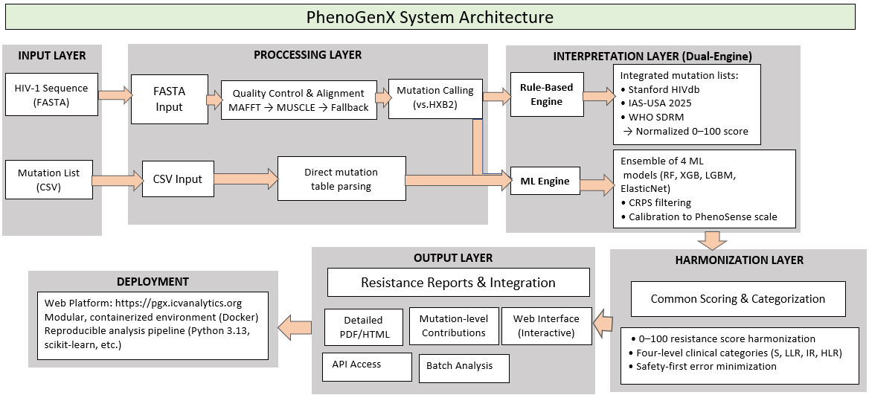
Supplementary Figure 2: PGX architecture from input to deployment

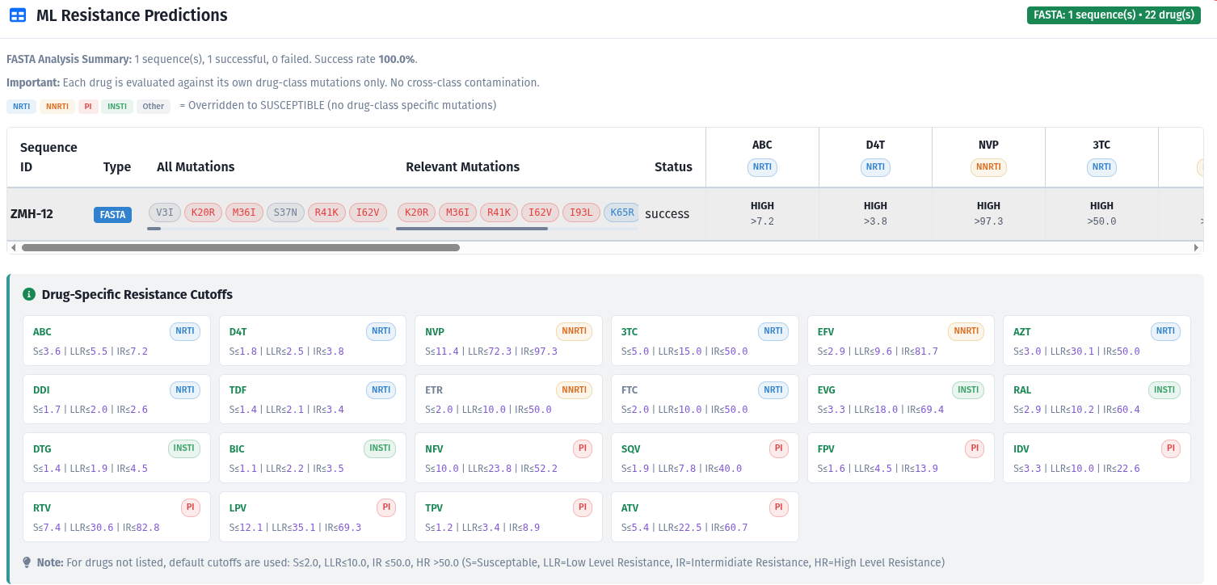
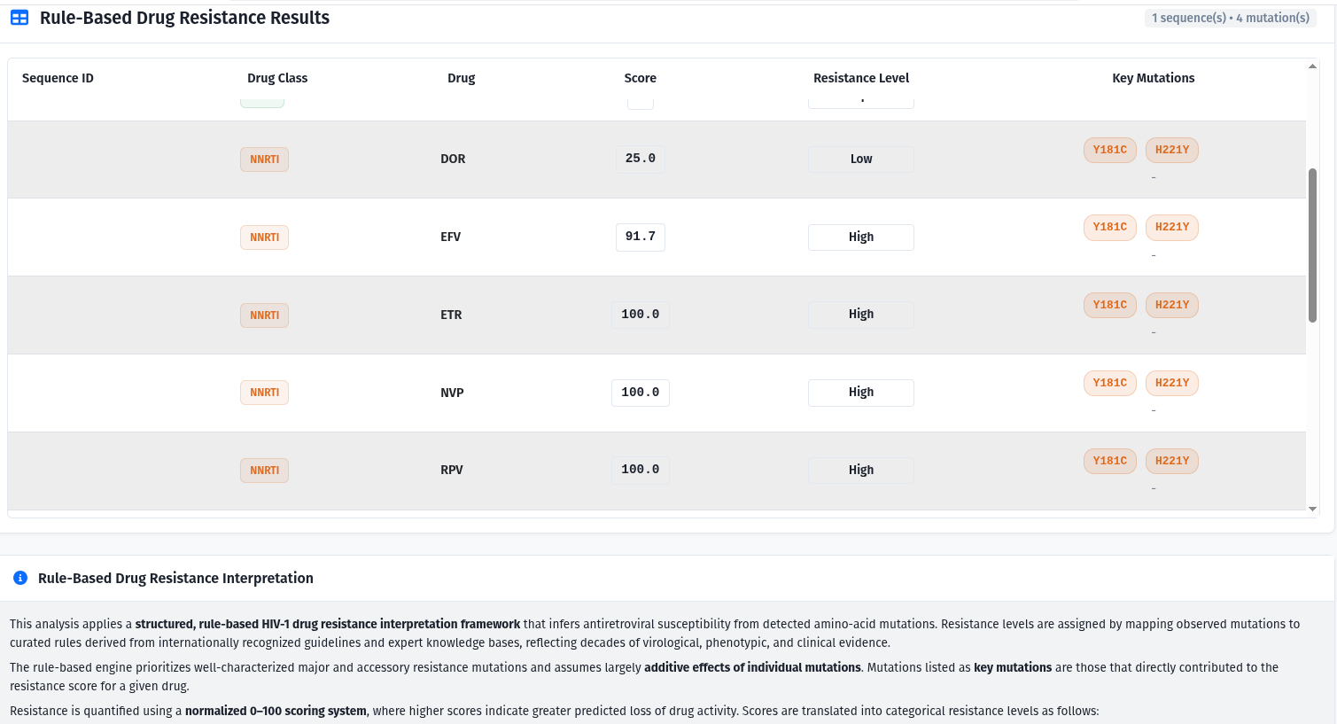

Supplementary Figure 3: PGX result output for the ML and rule based analysis (A and B)

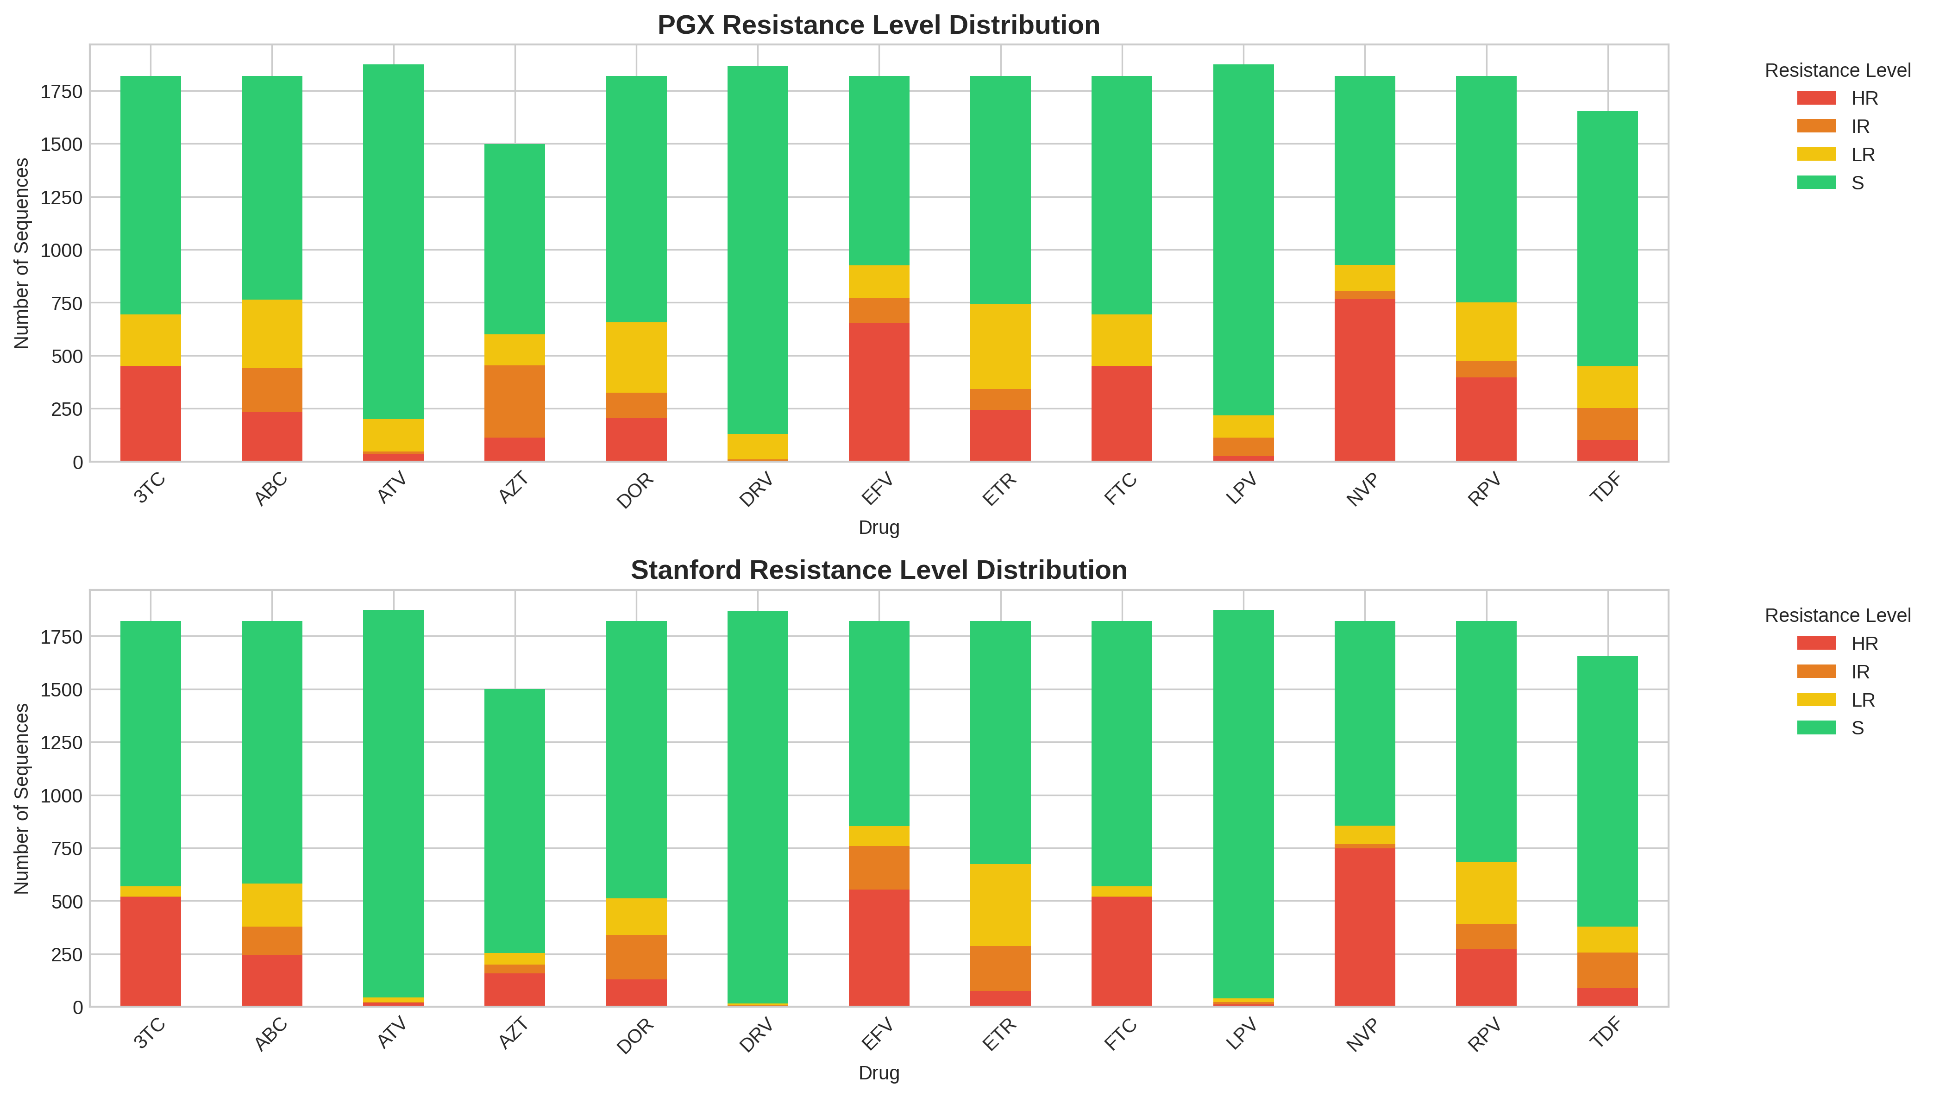
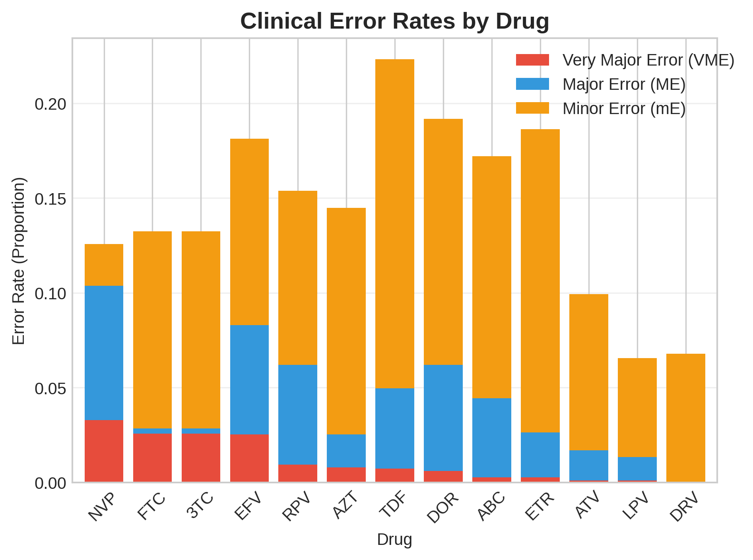
Supplementary Figure 4: Clinical Error Rates Across Antiretroviral Drugs
Stacked bars show the distribution of Very Major Errors (VME: false susceptibility), Major Errors (ME: false resistance), and Minor Errors (mE: categorical disagreements within adjacent levels) for each antiretroviral drug when comparing PGX predictions with Stanford HIVdb classifications. Minor errors were the most frequent across drugs, while VMEs-clinically the most critical-remained low for all drugs, indicating that PGX rarely misclassifies resistant sequences as susceptible.
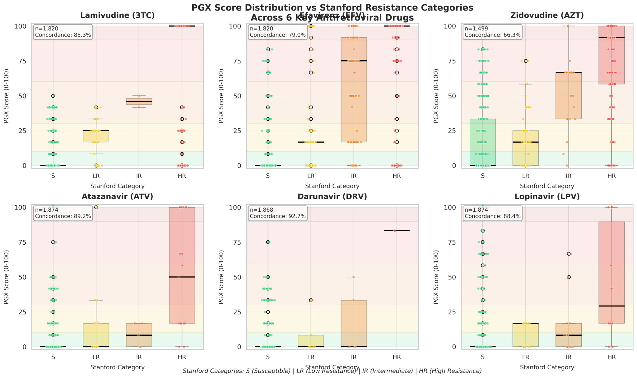

Supplementary Figure 5: Association Between PGX Susceptibility Scores (0-100) and Stanford HIVdb Resistance Categories Across Six Protease Inhibitors
LR=Low-level Resistance, IR=Intermediate Resistance, HR=High-level Resistance. Concordance values indicate the agreement between PGX score-based predictions and Stanford HIVdb genotypic resistance interpretations. Data represent results from clinical isolates tested against Atazanavir (ATV), Darunavir (DRV), and Amprenavir (APV). PGX=Pharmacogenetic; Stanford categories refer to the Stanford HIV Drug Resistance Database classification.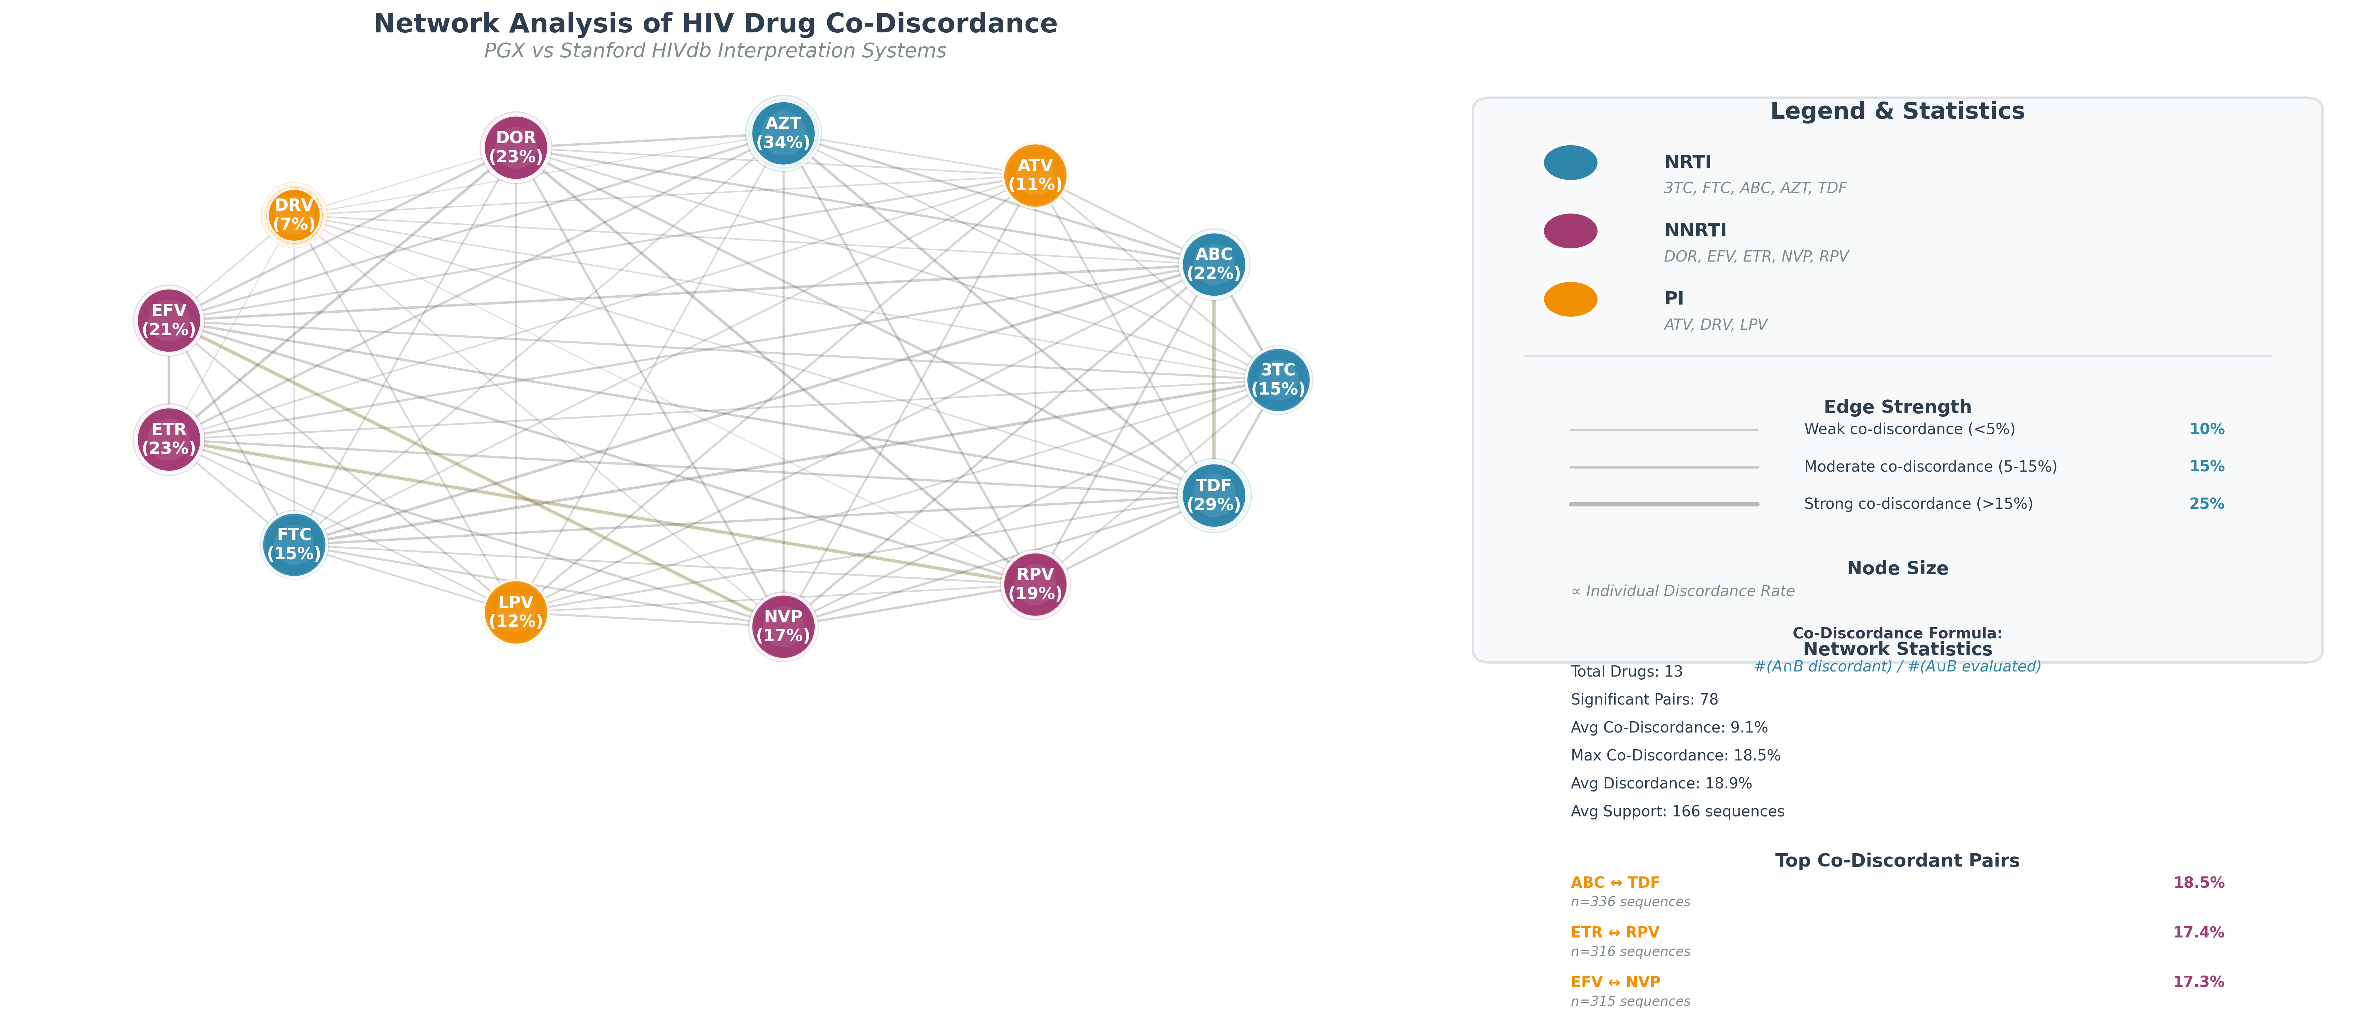
Figure 6: Network Analysis of Drug Co-Discordance Between PGx and Stanford HIVdb Genotypic Resistance Interpretation Systems
NRTI=Nucleoside Reverse Transcriptase Inhibitor; NNRTI=Non-Nucleoside Reverse Transcriptase Inhibitor; Protease Inhibitor. Node size is proportional to the rate of discordance for individual drugs. Edge strength and color indicate the frequency of co-discordance between drug pairs (weak: <5%, moderate: 5-15%, strong: >15%). Co‑discordance is defined as the proportion of sequences where both drugs in a pair were discordant between the two interpretation systems. Network statistics are based on 1,068 clinical HIV sequences. PGx+Pharmacogenetic interpretation system; Stanford HIVdb = Stanford University HIV Drug Resistance Database.

