Droplet -Based Image Colorimetry Method for Quantitative Detection of Common Milk Adulterants
Rohit¹, Rishabh Tomar¹, Aayush Khaire², Raj Nandini³, Abhishek Raj^{1*}
¹ Bio Microfluidics Lab, Indian Institute of Technology Patna, India 801106
² Shri Ramdeobaba College of Engineering & Management, Nagpur, India 440013
³ Jaypee Institute of Information Technology, Noida, India 201309
*Corresponding Author: araj@iitp.ac.in
Supplementary Information
For Water mixed as adulterants we use virdis colormap from where we get different colormap for different concentrations as shown in fig S 1 (a) and (b) which shows the change in No. of Pixel for different color with change in concentration of water as adulterants
Fig S1 (a) Image of Droplet with Virdis color map applied on different concentrations of water (b) Masked images of Droplet of water adulterants for different concentrations

In Fig. S1(a) and (b), we quantified the number of pixels in different color regions (yellow, green, and purple) for varying water concentrations as shown in Fig. S2. However, the resulting plot did not show a clear or meaningful trend, so pixel counts could not be used to reliably relate concentration with pixel values.
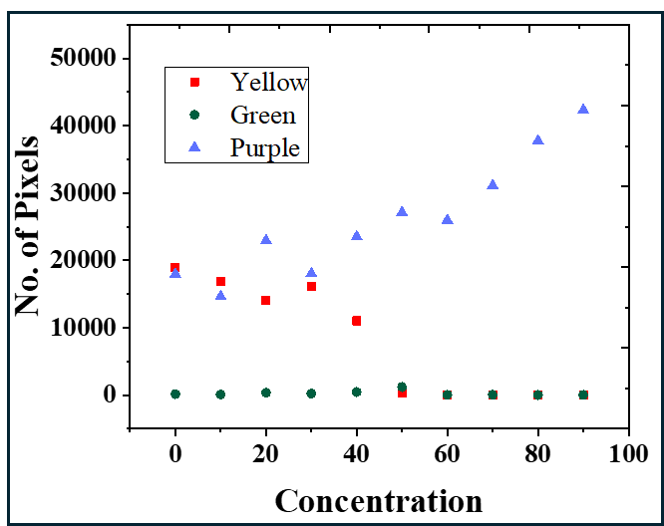
Fig S2 Plot for data

For Urea-
Milk droplets adulterated with varying concentrations of Urea were placed on a PDMS-coated glass slide. P-DMAB was then added in droplet to get yellow color mixture of droplet as shown in Fig. S3 and then cropped the region of interest (ROI) where the image-processing algorithm was applied.
Fig S3 Different concentration of urea adulterants milked droplet

For Sodium Bicarbonate-
Milk droplets adulterated with varying concentrations of sodium bicarbonate were placed on a PDMS-coated glass slide. Phenolphthalein was then added to develop a pink color, and the resulting color intensity increased with concentration, as shown in Fig. S4.
Fig S4: Image of sodium bicarbonate mixed adulterants in milk with different concentration
From the images in Fig: S4, we cropped the region of interest (ROI) for analysis. The image-processing algorithm was then used to extract RGB, HSV, and CIELAB features, and a few of these parameters showed a relationship with concentration, as presented in Fig. S5.

Fig S5: (a) plot shows relation between concentration vs $S_{mean}$ and $A_{mean}$ (b) Plot shows relation between concentration vs $G_{mean}$, $H_{mean}$, and$L_{mean}$
But still only $R_{normalised}$ show clear relation with the concentration and give good match when taken for unknown samples

