Chitosan Nanoparticles as Interfacial Adjuvants to Enhance the Biodegradation of Polyethylene Terephthalate by Ideonella sakaiensis
Zhichao Shi^{a,#}, Tingbiao Wu^{a,#}, Lihong Wuª, Xiaomin Chi^{b}, Yingjuan Wang^{b}, Tingting Fan^{a,*}, Yuyang Jiangª

ª Institute of Biomedical Health Technology and Engineering, Shenzhen Bay Laboratory, Shenzhen, 518132, China.
^{b} National Innovation Center for Molecular Drug, GrandBio Molecular Drug Innovations Center Co., Ltd. 518102, China.

#These authors equally contributed to this work.
*Corresponding author.
Email addresses: fantt@szbl.ac.cn (T. Fan)

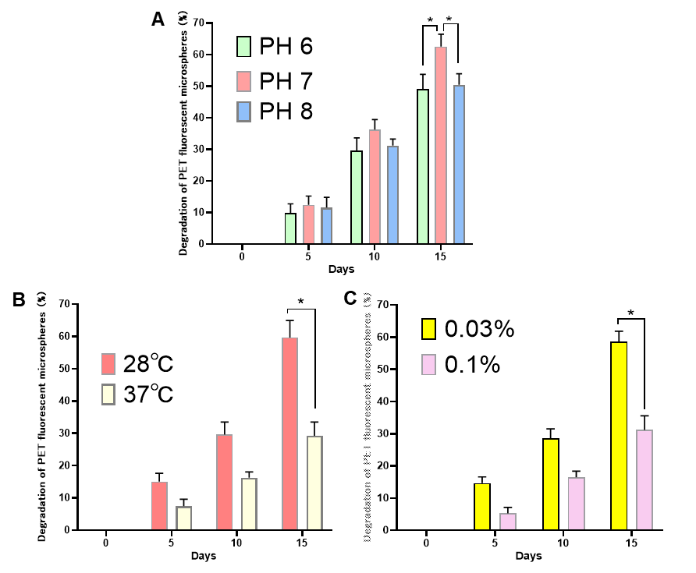
Fig. S1. Degradation of PET fluorescent microspheres by Ideonella sakaiensis under different conditions. (A) Effect of pH (6, 7, 8) on degradation over 15 days. (B) Effect of temperature (28 °C, 37 °C) on degradation over 15 days. (C) Effect of substrate concentration (0.03%, 0.1%) on degradation over 15 days. Data are mean ± SD (n = 3). *p < 0.05.

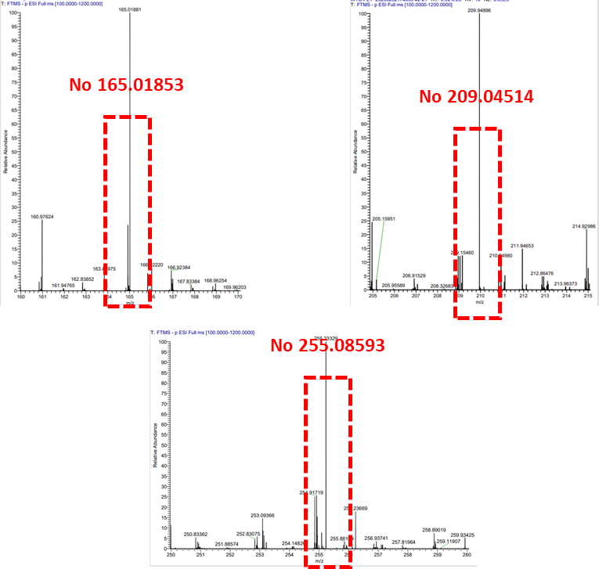
Fig. S2. LC-MS analysis of PET powder degradation products in the control group (without Ideonella sakaiensis).
LC-MS spectra showing the absence of characteristic monomer peaks for terephthalic acid (TPA, m/z = 165.01853), mono(2-hydroxyethyl) terephthalate (MHET, m/z = 209.04514), and bis(2-hydroxyethyl) terephthalate (BHET, m/z = 255.08593) in the control group, confirming that no significant PET hydrolysis occurred in the absence of Ideonella sakaiensis.

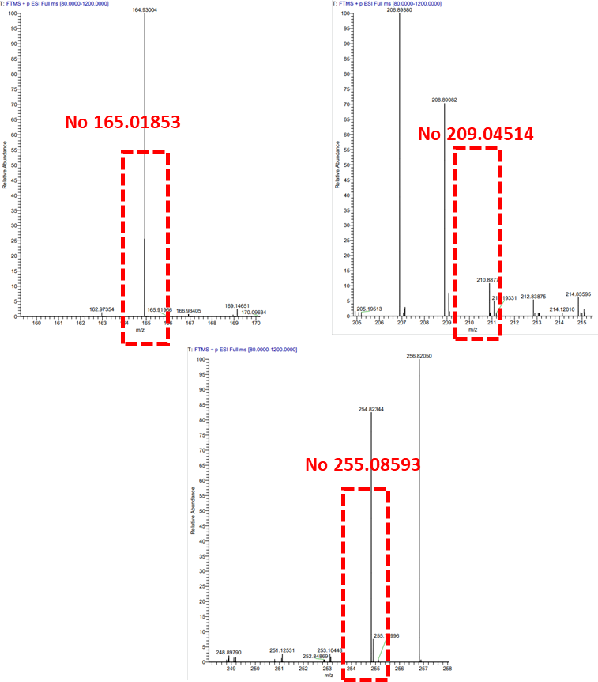
Fig. S3. LC-MS analysis of the Ideonella sakaiensis only control group (without PET powder).
LC-MS spectra confirm the absence of characteristic monomer peaks for terephthalic acid (TPA, m/z = 165.01853), mono(2-hydroxyethyl) terephthalate (MHET, m/z = 209.04514), and bis(2-hydroxyethyl) terephthalate (BHET, m/z = 255.08593), verifying that these products are derived from PET hydrolysis, not bacterial metabolism.

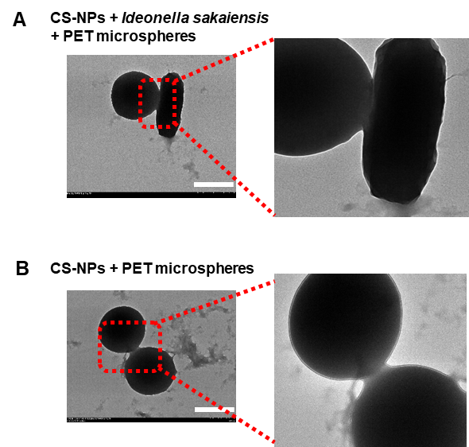
Fig. S4. TEM analysis of chitosan nanoparticles (CS-NPs) mediated adsorption of Ideonella sakaiensis to PET microspheres. (A) CS-NPs mediates tight adsorption of rod-shaped Ideonella sakaiensis to PET microspheres, with the magnified inset showing intimate contact. (B) Control (CS-NPs + PET microspheres only) confirms no rod-shaped structures in the absence of bacteria. CS-NPs acts as an interfacial mediator to enhance bacterial adhesion to PET, a prerequisite for efficient biodegradation. Scale bar: 1 μm.

Table S1. Zeta potential analysis of Ideonella sakaiensis, PET fluorescent microspheres, and chitosan nanoparticles
Group | CS-NPs | Ideonella sakaiensis | PET microspheres
Zeta (mV) | 40.1±2.20 | -10.1±1.19 | -2.64±0.10

