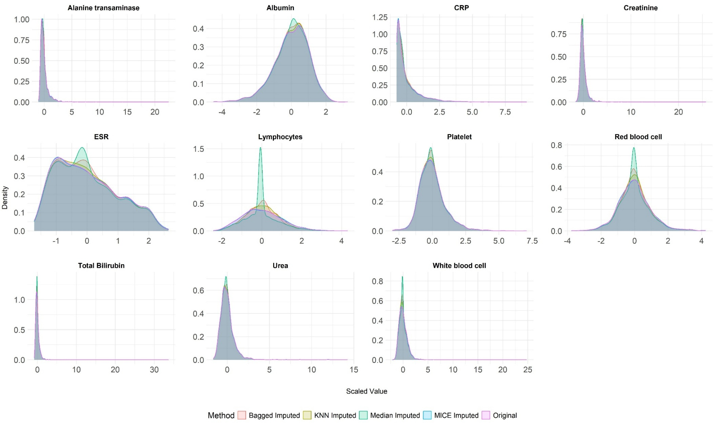
Supplemental Figure 1: Density distributions of biomarkers across different imputation methods compared to original data
The imputation method that best preserved the original distributional characteristics was selected as the final approach
CRP: C-reactive protein; ESR: erythrocyte sedimentation rate; MICE: Multiple Imputation by Chained Equations; KNN: K-nearest neighbors
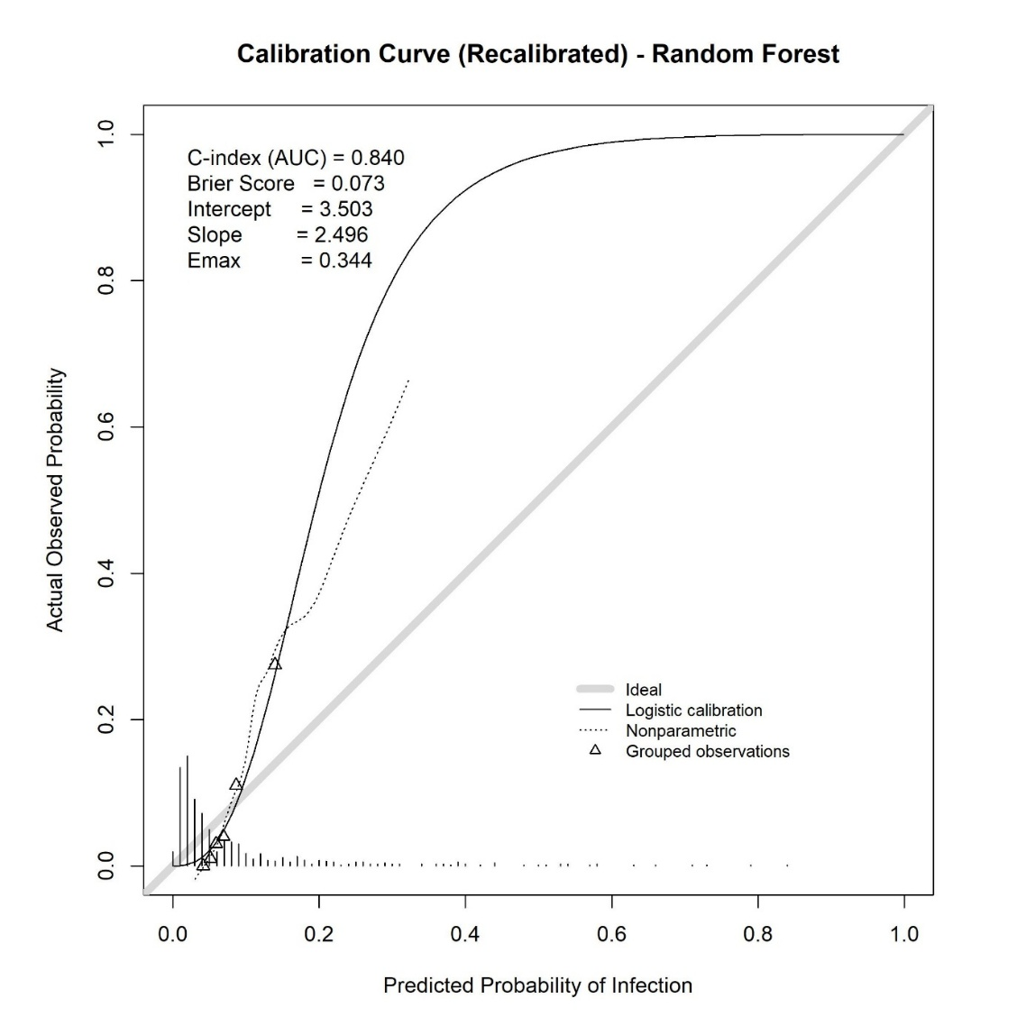
Supplemental Figure 2: Calibration curve of the recalibrated random forest model for predicting infection
Calibration plot comparing predicted probabilities versus actual observed probabilities of infection. The gray diagonal line represents ideal calibration. The solid curve indicates logistic calibration, and the dotted curve represents nonparametric calibration. Triangles denote grouped observations. The rug plot along the x-axis shows the distribution of predicted probabilities.
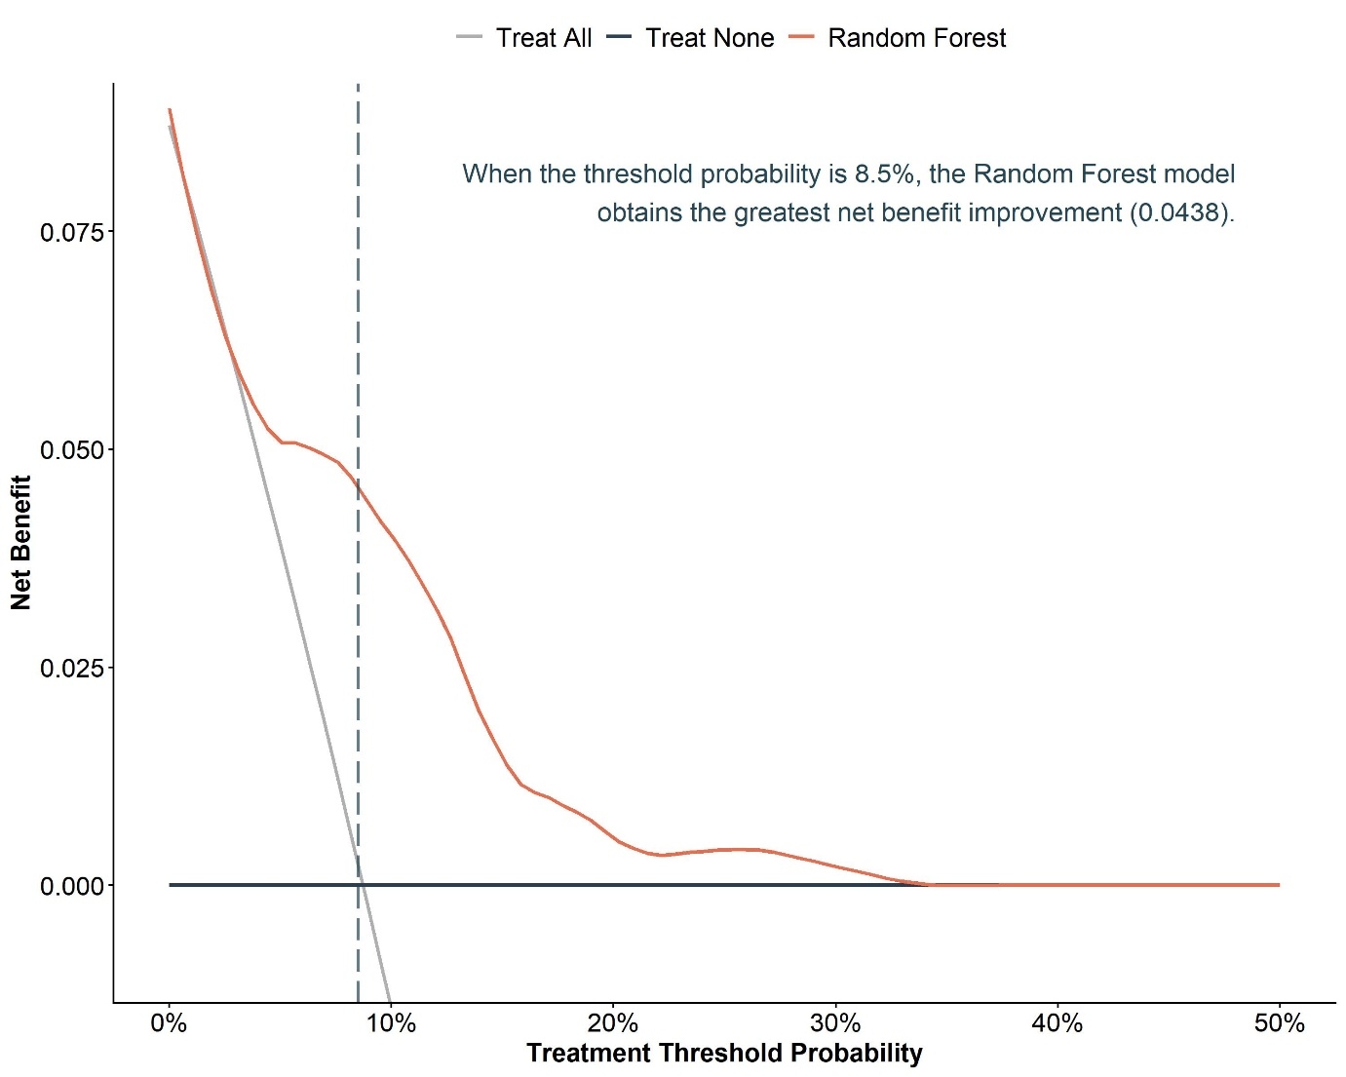
Supplemental Figure 3: Decision curve analysis evaluating the clinical utility of the random forest model for predicting infection
The x-axis represents the threshold probability at which clinicians would consider initiating treatment, and the y-axis represents net benefit. The gray line indicates the "treat-all" strategy (assume all patients require intervention), the black horizontal line represents the "treat-none" strategy (assume no patients require intervention), and the red curve shows the net benefit of using the random forest model
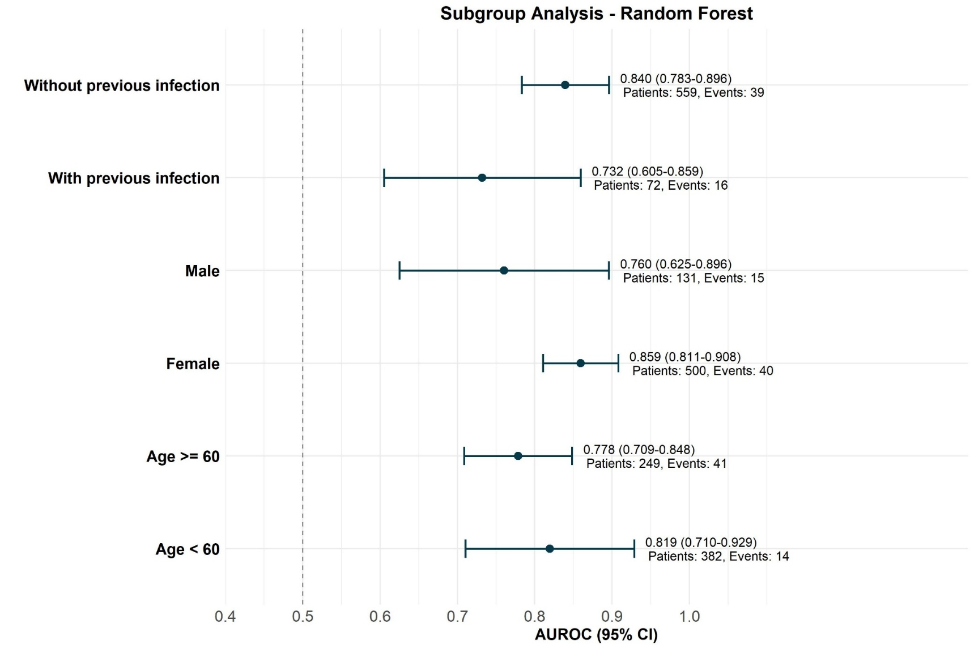
Supplemental Figure 4: Subgroup analysis of the random forest model's discriminative performance across clinically relevant subgroups
Forest plot shows the area under the receiver operating characteristic curve (AUROC) with 95% confidence intervals (CI) for the random forest model across predefined subgroups. Subgroups were stratified by previous infection history, sex, and age (≥60 vs. <60 years). The vertical dashed line at 0.5 represents the reference for no discrimination. The number of patients and infection events are displayed for each subgroup.

Supplemental Table 1: Diagnostic codes used to identify infection and co-morbidities
Description | ICD-9 Codes | ICD-10 Codes
Infection outcomes
Tuberculosis | 010-018 | A15-A19
Atypical mycobacterial infections | 031 | A31
Cryptococcosis | 117.5 | B45
Histoplasmosis | 115 | B39
Aspergillosis | 117.3 | B44
Coccidioidomycosis | 114 | B38
Blastomycosis | 116 | B40
Candidiasis | 112 | B37
Cytomegalovirus | 078.5 | B25
Hepatitis B | 070.2, 070.3 | B16, B18.0, B18.1, B19.1
Hepatitis C | 070.41, 070.44, 070.51, 070.54, 070.70, 070.71 | B17.1, B18.2, B19.2
Toxoplasmosis | 130 | B58
Pneumocystis carinii | 136.3 | B59
Herpes zoster | 053 | B02
Herpes simplex | 054 | B00
Listeriosis | 027.0 | A32
Pneumonia | 480-486, 513 | J12-J18, J85.1
Sepsis/bacteraemia | 038, 790.7 | A40, A41, R78.81
Meningitis/encephalitis | 320,323 | G00, G01, G02, G04, G05 -
Endocarditis | 421, 422.92 | I33, I40.0
Pyelonephritis | 590 | N10
Septic arthritis | 711.0, 711.9 | M00, M01.X0
Osteomyelitis | 730 | M86
Salmonella | 003 | A02
Prosthetic joint infection | 996.66 | T84.5
Infections of skin and subcutaneous tissue | 680-686 | L00-L08
Abscess of anal and rectal regions | 566 | K61
Peritonitis | 567 | K65
Acute bronchitis and bronchiolitis | 466 | J20, J21
Liver abscess | 572.0 | K75.0
Acute pelvic inflammatory disease | 614.0, 614.3, 614.5 | N70.0, N70.1, N70.9
Orchitis and epididymitis | 604 | N45
Urinary tract infection | 599.0 | N39.0
Acute upper respiratory infection | 465 | J06
Submandibular gland infection | 527.8 | K11.8
Infection of external ear | 380.1 | H60
Necrotizing fasciitis | 728.86 | M72.6
Bacterial infection in conditions classified elsewhere and of unspecified site | 041 | B99, A49
Ill-defined intestinal infections | 009 | A09
Viral infection in conditions classified elsewhere and of unspecified site | 079 | B34
Comorbidities
Coronary artery disease and heart failure | 410-414, V45.81, 428, 398.91, 402.01, 402.11, 402.91, 404.01, 404.03, 404.11, 404.13, 404.91, 404.93 | I20-I25, Z95.1, I50, I09.81, I11.0, I13.0, I13.2
Hyperlipidaemia | 272.0, 272.1, 272.2, 272.4 | E78.0, E78.1, E78.2, E78.4, E78.5
Thyroid disorder | 242-244 | E05, E03.0, E03.1, E03.2, E03.8, E03.9, E89.0
Osteoporosis | 733.0 | M80-M81
Hypertension | 401-405, 437.2 | I10-I15, I67.4
Diabetes mellitus | 250 | E08-E13
Cerebrovascular disease | 430-438 | I60-I69
Chronic obstructive pulmonary disease and Pneumoconiosis | 490-496, 500-505 | J40-J47, J60-J64, J66, J67
Dementia | 290 | F01-F03
Chronic renal failure | 582, 585, 586, 588, 583.0, 583.1, 583.2, 583.4 | N03, N18, N19, N25, N05.2, N05.5, N05.9
Liver disease | 571.2, 571.4, 571.5, 571.6, 456.0-456.2, 572.2-572.4, 572.8 | K70.3, K73, K74.3, K74.4, K74.5, K74.6, I85.0, I85.1, K72.9, K76.6, K76.7, K72.1, K72.9
Ulcers | 531-534 | K25-K28
Primary immunodeficiency syndrome | 279 | D80-D84, D89
Hemiplegia | 342 | G81
Malignancy | 140-165, 170, 171, 172, 174, 175, 176, 179-208, | C00-C39, C40-C43, C45-C76, C81-C96
ICD-9: International Classification of Diseases, Ninth Revision; ICD-10: International Classification of Diseases, Tenth Revision
Supplemental Table 2: World Health Organization (WHO) defined daily dose used to standardise the medications
Description | WHO defined daily dose (mg) | Drug category
Diclofenac | 100 | NSAID
Celecoxib | 200 | NSAID
Etoricoxib | 60 | NSAID
Ketorolac | 30 | NSAID
Ibuprofen | 1200 | NSAID
Mefenamic | 1000 | NSAID
Meloxicam | 15 | NSAID
Naproxen | 500 | NSAID
Piroxicam | 20 | NSAID
Sulindac | 400 | NSAID
Prednisolone | 10 | STERIOD
Codeine | 100 | OPIOID
Dextropropoxyphene | 200 | OPIOID
Dihydrocodeine | 150 | OPIOID
Methadone | 25 | OPIOID
Morphine | 100 | OPIOID
Oxycodone | 75 | OPIOID
Tramadol | 300 | OPIOID
NSAID: non-steroidal anti-inflammatory drug
Supplemental Table 3: Laboratory test studied within 90 days before starting biologic or targeted synthetic disease-modifying antirheumatic drugs and their corresponding completion rate in the developing cohort (CDARS) and the validation cohort (All of Us)
Description | Completion rate - CDARS | Completion rate – All of Us
Albumin | 96% | 56.69%
Alanine transaminase | 96% | 47.26%
Platelet | 96% | 50.57%
Creatinine | 96% | 61.30%
Urea | 96% | 55.72%
C-Reactive Protein | 94% | 29.32%
Erythrocyte Sedimentation Rate | 94% | 24.93%
Total Bilirubin | 92% | 54.20%
Red blood cell | 88% | 40.76%
White blood cell | 88% | 50.19%
Lymphocytes | 70% | 52.47%
Aspartate | 22% | -
Haemoglobin | 18% | -
IgG | 18% | -
Anti-nuclear antibodies | 18% | -
Complement 3 | 16% | -
Complement 4 | 14% | -
Haematocrit | 14% | -
Activated Partial Thromboplastin Time | 13% | -
IgM | 12% | -
IgA | 11% | -
Ferritin | 8% | -
Fibrinogen | 3% | -
Prothrombin Time | 3% | -
Thrombin Time | 1% | -
Indirect Bilirubin | 0% | -
IgE | 0% | -
Laboratory tests with completion rate below 70% were removed from the model construction and not investigated for the external validation cohort.

Supplemental Table 4: Area under the receiver operating characteristic (AUROC) and other metrics
Model | AUROC | Sensitivity | Specificity | PPV | NPV | F1_Score | Accuracy
CDARS - Validation set (N=631)
Logistic Regression | 0.83 (0.778-0.882) | 0.818 | 0.729 | 0.224 | 0.977 | 0.352 | 0.737
LASSO Regression | 0.836 (0.786-0.886) | 0.855 | 0.743 | 0.241 | 0.982 | 0.376 | 0.753
Random Forest | 0.84 (0.793-0.888) | 0.727 | 0.767 | 0.23 | 0.967 | 0.349 | 0.764
XGBoost | 0.795 (0.741-0.849) | 0.745 | 0.715 | 0.2 | 0.967 | 0.315 | 0.718
Neural Network | 0.804 (0.747-0.862) | 0.855 | 0.639 | 0.184 | 0.979 | 0.303 | 0.658
SVM | 0.833 (0.782-0.884) | 0.727 | 0.76 | 0.225 | 0.967 | 0.343 | 0.758
External validation - All of Us (N= 1845)
Random Forest | 0.729 (0.665-0.793) | 0.712 | 0.602 | 0.049 | 0.986 | 0.092 | 0.605
PPV: Positive predictive value; NPV: Negative predictive value; LASSO: Least Absolute Shrinkage and Selection Operator; XGBoost: Extreme Gradient Boosting; SVM: Support Vector Machine

Supplemental Table 5: Quantitative characteristics of Partial Dependence Plots (PDP) for laboratory biomarkers
Biomarkers | Effect range | Threshold value | Max slope
Alanine transaminase (U/L) | 0.0015 | 47.8682 | -0.0006
Albumin (g/L) | 0.0071 | 30.3101 | -0.0036
CRP (mg/dL) | 0.0132 | 7.1048 | 0.0053
Creatinine (µmol/L) | 0.0054 | 95.3469 | 0.0008
ESR (mm/hr) | 0.0089 | 103.0070 | 0.0005
Lymphocytes (%) | 0.0089 | 23.5842 | -0.0012
Platelet (×10⁹/L) | 0.0047 | 191.1661 | -0.0001
Red blood cell (×10¹²/L) | 0.0094 | 3.4515 | -0.0305
Total bilirubin (µmol/L) | 0.0022 | 5.2224 | 0.0012
Urea (mmol/L) | 0.0047 | 3.0225 | 0.0040
White blood cell (×10⁹/L) | 0.0047 | 9.6323 | 0.0032
CRP: C-reactive protein; ESR: erythrocyte sedimentation rate.
Effect range represents the difference between maximum and minimum predicted probabilities across the PDP curve, indicating the total impact of each biomarker on infection risk. Threshold value indicates the biomarker level at which the predicted probability changes most rapidly (point of maximum absolute slope). Max slope represents the first derivative at the threshold point, with positive values indicating increased infection risk at higher biomarker levels and negative values indicating inverse relationships.

