AGU Advances
Supporting Information for
Reconciling Discrepancies Between Observed and Model-Simulated Cloud Radiative Trends and Their Implications in Earth’s Energy Imbalance
Chanyoung Park¹*, Brian J. Soden¹
¹ Rosenstiel School of Marine, Atmospheric, and Earth Science, University of Miami, Miami, FL, USA.

*Corresponding author: Chanyoung Park (chanyoung.park@miami.edu)

Contents of this file

Text S1 to S2
Figures S1 to S6
Tables S1

Introduction
This Supporting Information provides additional dataset details and supplementary analyses that complement the main text. Text S1 discusses potential impacts of orbital drift and satellite transitions on long-term trend estimates, providing context for interpreting differences between EBAF and FBCT. Text S2 summarizes key differences between the FBCT-based CRK and the alternative CRK formulation of Zhou et al. (2013) and explains choices made to ensure consistent CTP–COD binning across kernels. The accompanying supplementary figures and a table provide additional diagnostics, robustness checks, and expanded results that support the interpretations in the main text.

Text S1: CERES observations
We restrict our analysis to January 2003 through December 2022 to ensure a consistent set of input satellites because FBCT relies on observations from the Terra and Aqua satellites from July 2002 through February 2023 and subsequently incorporates NOAA-20 Edition 1B data.

A key consideration for long-term trend analysis is orbital drift, which changes the satellite mean local time (MLT) of observations and can introduce time-dependent sampling biases in radiative flux records. Terra began drifting from its nominal 10:30 AM equatorial crossing time in early 2020 (NSIDC, 2021), and by October 2022 the offset reached ~15 minutes (~10:15 AM), the recommended stability threshold for CERES trend analyses (Loeb et al., 2024). Aqua began drifting from its nominal 1:30 PM equatorial crossing time in July 2021 (NSIDC, 2021) and reached a ~15-minute offset (~1:45 PM) by February 2023.

EBAF Edition 4.2 addresses this issue by using a combined Terra and Aqua configuration from July 2002 through April 2022, during which the Terra and Aqua MLTs drifted by 9 and 2 minutes, respectively, then relying primarily on NOAA-20 thereafter to preserve temporal stability (Loeb et al., 2024).

Despite differences in satellite usage and orbit evolution between FBCT and EBAF, the two products exhibit similar global-mean trends in $dR_{cld}\text{-Adj}$ over 2003–2022 (Fig. S2). This agreement is important as it indicates that the inferred cloud radiative trends are not primarily driven by late-period orbit drift or satellite transition, but instead reflect more fundamental aspects of the radiative diagnostics and cloud property retrievals used in the two datasets.

Text S2: Differences in FBCT CRK and Zhou et al. (2013) CRK
Some differences between the FBCT-based CRK and the Zhou et al. (2013) CRK are worth noting. First, FBCT stratifies clouds vertically using cloud effective pressure rather than cloud top pressure, which can lead to modest differences in how cloud layers are mapped into CTP categories. Second, the FBCT kernels are derived using CERES–MODIS observed cloud properties within CERES footprints, so the resulting sensitivities implicitly reflect the observed distribution of cloud scenes and their sampling. In contrast, the Zhou et al. (2013) kernels are computed using an ISCCP-like CTP–COD discretization with synthetic cloud scenes and radiative transfer calculations based on zonal-mean atmospheric profiles, which by construction does not represent longitudinal variations in atmospheric state or radiative environment, although the kernels are provided for discrete surface-albedo bins to account for variations in shortwave reflection. Third, because FBCT only reports cloud properties for optical depths greater than 0.25 owing to larger retrieval uncertainties for very thin clouds (Minnis et al., 2011; Sun et al. 2022), we likewise omit the thinnest COD bin (0–0.3) from the Zhou et al. (2013) CRK and use six COD bins for consistency with FBCT. Excluding this bin has been shown to have a negligible impact on cloud feedback estimates and is therefore unlikely to affect the trend estimates examined here (Chao et al., 2024). Finally, although FBCT fluxes are constrained by CERES observations, the FBCT framework partitions observed radiative fluxes among cloud types under the full range of contemporaneous surface and meteorological variability, whereas radiative-kernel development is typically designed to isolate cloud radiative sensitivities under controlled conditions with other factors held fixed (e.g., Zelinka et al., 2012a; Zhou et al., 2013).

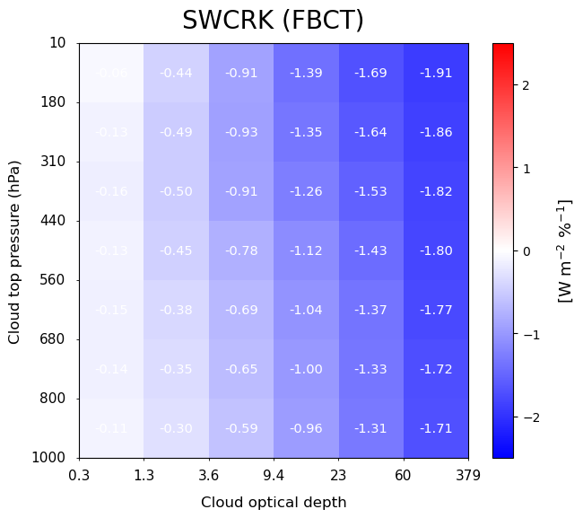
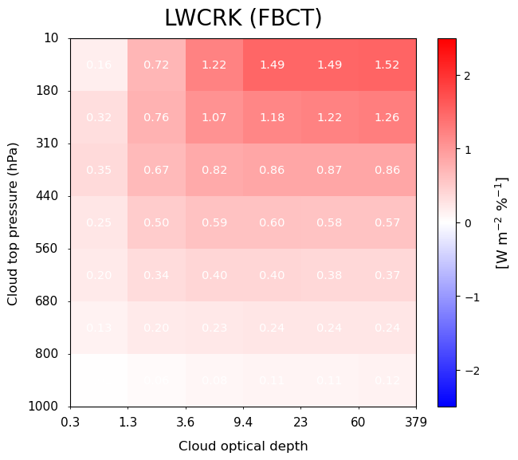
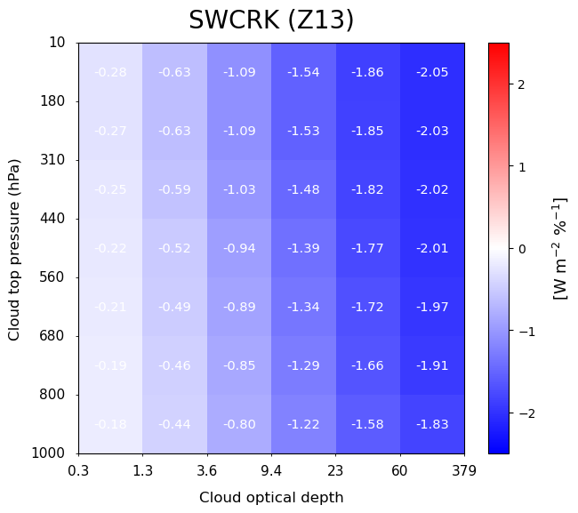
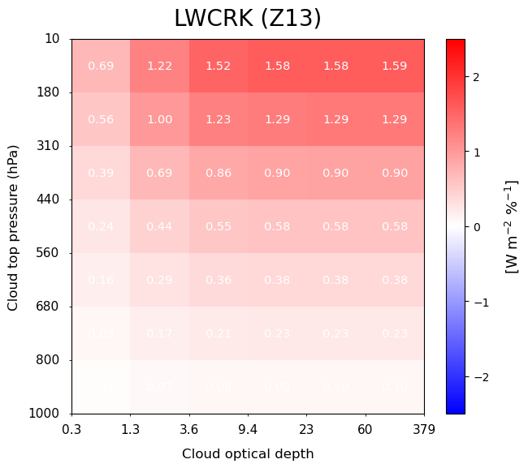
Figure S1. Annual-mean, global-mean cloud radiative kernels (CRKs) in cloud top pressure (CTP)–cloud optical depth (COD) space. (a) Shortwave CRK (SWCRK) and (b) longwave CRK (LWCRK) derived from CERES FBCT. (c) SWCRK and (d) LWCRK from Zhou et al. (2013) (Z13). Values in each bin represent the TOA radiative sensitivity to a 1% change in cloud fraction for the corresponding cloud type. The shortwave kernel is negative in all bins and becomes more negative for optically thicker clouds, consistent with thicker clouds reflecting more incoming solar radiation and thus producing a larger shortwave cooling effect. In contrast, the LWCRK is positive in most bins and generally increases for higher, colder clouds, reflecting their stronger greenhouse effect and greater reduction of outgoing longwave radiation to space.
(a)
(b)
(c)
(d)

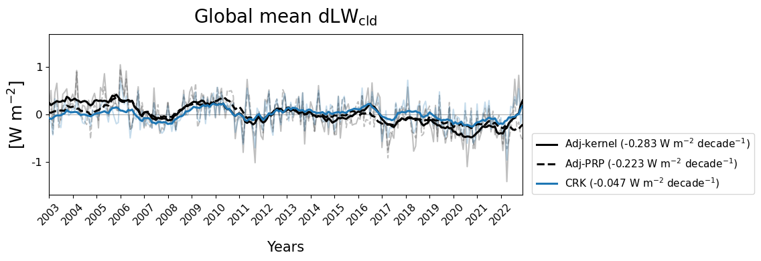
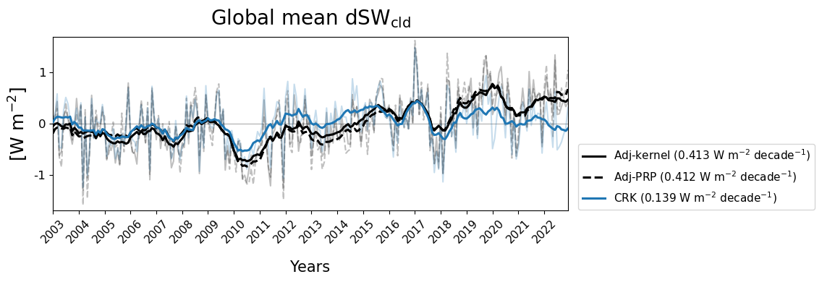
Figure S2. Global-mean cloud radiative responses estimated from the adjustment (Adj) and cloud radiative kernel (CRK) methods over 2003–2022. (a) Shortwave cloud radiative response, $dSW_{cld}$ (b) Longwave cloud radiative response, $dLW_{cld}$. In each panel, the solid black line denotes the radiative-kernel-based adjustment estimate (Adj-kernel), the dashed black line denotes the PRP-based adjustment estimate (Adj-PRP), and the blue line denotes the CRK-based estimate. Thin lines show monthly anomalies, and thick lines show 12-month running averages. The corresponding linear trends are listed in the legend.
(a)
(b)

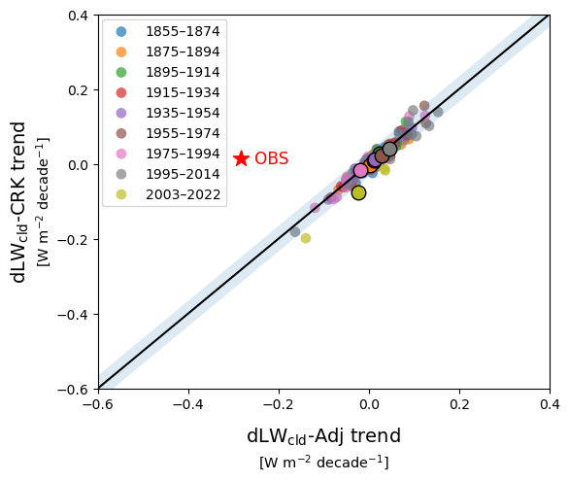
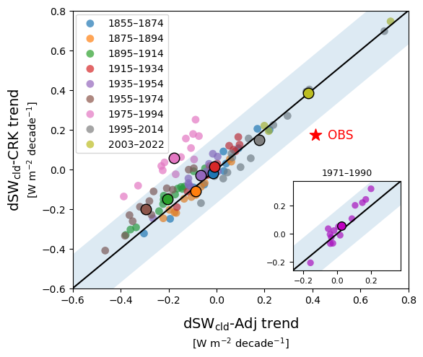
Figure S3. Same as Fig. 2, but with $dR_{cld}\text{-CRK}$ on the y-axis computed using the cloud radiative kernels from Zhou et al. (2013).
(a)
(b)

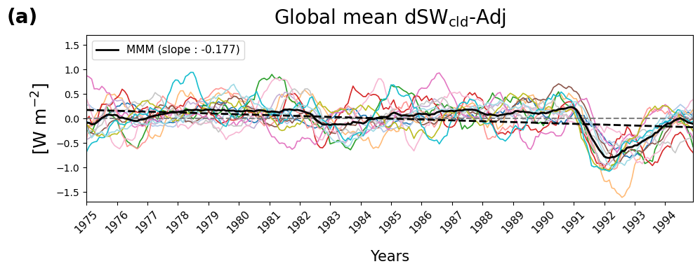
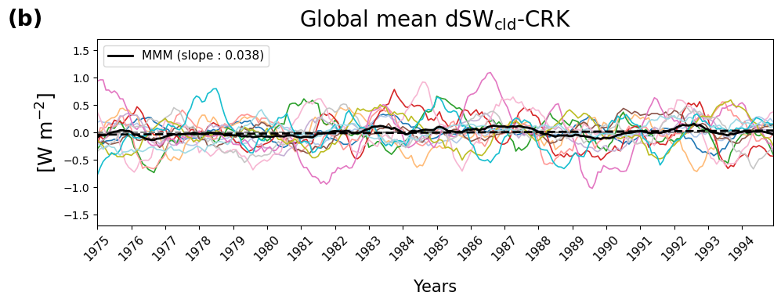
Figure S4. Global-mean shortwave cloud radiative response, $dSW_{cld}$, in CMIP6 historical simulations over 1975–1994, a period that includes the 1991 Mount Pinatubo eruption. (a) Adjustment-based estimate of $dSW_{cld}\text{-Adj}$. (b) CRK-based estimate of $dSW_{cld}\text{-CRK}$. Time series show 12-month running means of monthly anomalies from 14 CMIP6 models, with the multi-model mean (MMM) shown in black. Dashed black lines denote linear trends, with the corresponding trend values reported in the legends.

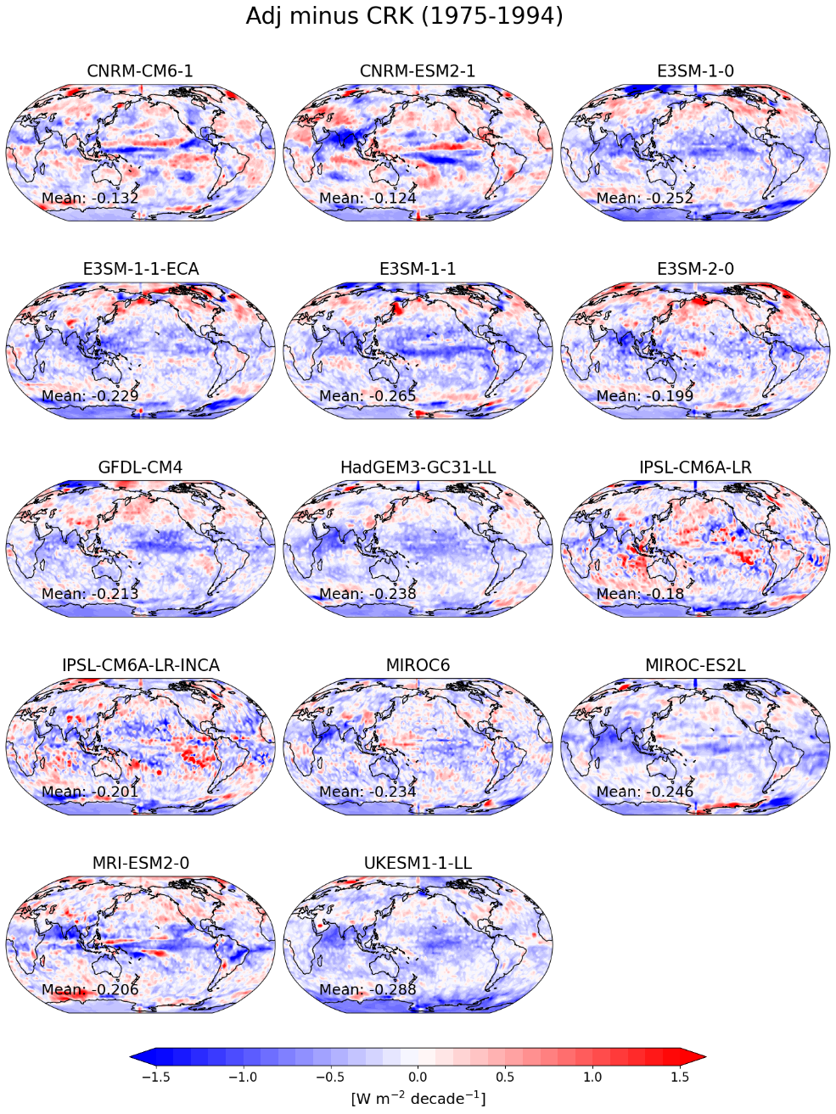
Figure S5. Spatial distributions of the residual shortwave cloud radiative trend, defined as $dSW_{cld}\text{-Adj}$ minus $dSW_{cld}\text{-CRK}$, for the 1975–1994 period in 14 CMIP6 models. This analysis period includes the 1991 Mount Pinatubo eruption. Global-mean values are shown in the lower-left corner of each panel.

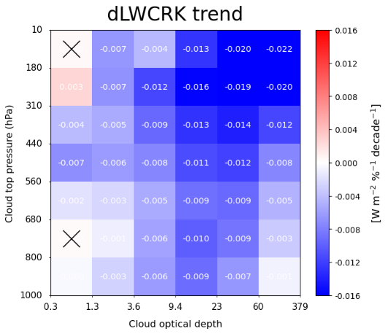
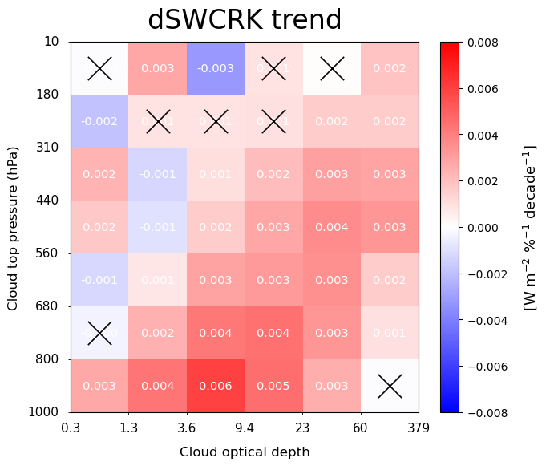
Figure S6. Global-mean trends in the cloud radiative kernel (dCRK) over 2003–2022, shown in 7 × 6 CTP–COD space from CERES FBCT. (a) Shortwave cloud radiative kernel trend ($dSWCRK$). (b) Longwave cloud radiative kernel trend ($dLWCRK$). Values in each bin indicate the trend for the corresponding cloud type. Bins marked with an “X” indicate trends that are not significantly different from zero at the 95% confidence level using two-sided Student’s t-test.
(a)
(b)

Table S1. CMIP6 models included in the analysis, with circles indicating the models used for each figure. Figure 2 compares cloud radiative trends derived from the adjustment and CRK-based methods across nine non-overlapping 20-year periods. Figure 8 shows cloud radiative trends using adjustment method together with TOA radiative flux trends over 2003–2022.

