Geophysical Research Letters
Supporting Information for
Reconciling Discrepancies Between Observed and Model Predicted Shortwave Cloud Radiative Trends
Chanyoung Park¹*, Brian J. Soden¹
¹ Rosenstiel School of Marine, Atmospheric, and Earth Science, University of Miami, Miami, FL, USA.

*Corresponding author: Chanyoung Park (chanyoung.park@miami.edu)

Contents of this file

Text S1 to S3
Figures S1 to S8
Tables S1 to S3

Introduction
This Supporting Information provides additional methodological details and sensitivity tests that complement the main text. Text S1 documents the CERES satellite configurations and discusses potential impacts of orbital drift and satellite transitions on long-term trend estimates, providing context for interpreting differences between EBAF and FBCT. Text S2 describes the CMIP6 implementation, including model selection, the construction of multiple independent 20-year trend windows, and preprocessing steps required to apply the FBCT-derived cloud radiative kernel (CRK) to model output. Text S3 summarizes key differences between the FBCT-based CRK and the alternative CRK formulation of Zhou et al. (2013) and explains choices made to ensure consistent CTP–COD binning across kernels. The accompanying supplementary figures and tables provide additional diagnostics, robustness checks, and expanded results that support the interpretations in the main text.

Text S1: CERES observations
We restrict our analysis to January 2003 through December 2022 to ensure a consistent set of input satellites because FBCT relies on observations from the Terra and Aqua satellites from July 2003 through February 2023 and subsequently incorporates NOAA-20 Edition 1B data.

A key consideration for long-term trend analysis is orbital drift, which changes the satellite mean local time (MLT) of observations and can introduce time-dependent sampling biases in radiative flux records. Terra began drifting from its nominal 10:30 AM equatorial crossing time in early 2020 (NSIDC, 2021), and by October 2022 the offset reached ~15 minutes (~10:15 AM), the recommended stability threshold for CERES trend analyses (Loeb et al., 2024). Aqua began drifting from its nominal 1:30 PM equatorial crossing time in July 2021 (NSIDC, 2021) and reached a ~15-minute offset (~1:45 PM) by February 2023.

EBAF Edition 4.2 addresses this issue by transitioning away from Terra and using an Aqua-only configuration from July 2002 through March 2022, during which the Terra and Aqua MLTs drifted by 9 and 2 minutes, respectively, then relying primarily on NOAA-20 thereafter to preserve temporal stability (Loeb et al., 2024). As a result, the EBAF record over 2003–2022 is effectively constrained by afternoon-orbit satellites with minimal MLT drift. Loeb et al. (2020) demonstrate that the global-mean climatological SWTOA flux difference between Terra/Aqua and Aqua-only configurations is less than 0.01 W m⁻², with a trend difference smaller than 0.03 W m⁻² decade⁻¹.

Despite differences in satellite usage and orbit evolution between FBCT and EBAF, the two products exhibit nearly identical global-mean and spatial trends in $dSW_{cld}\text{-Adj}$ over 2003–2022 (Fig. 1). This agreement is important as it indicates that the inferred cloud radiative response trends are not primarily driven by late-period orbit drift or satellite transition, but instead reflect more fundamental aspects of the radiative diagnostics and cloud property retrievals used in the two datasets.

Text S2: CMIP6 analysis
We analyze 14 CMIP6 models that provide the required variables to compute both. For consistency with the observational analysis, the same radiative kernel framework introduced in Kramer et al. (2021), based on CloudSat/CALIPSO kernels, is used to compute $dSW_{cld}\text{-Adj}$. The cloud radiative kernel derived from CERES FBCT (Sun et al., 2022) is used to estimate $dSW_{cld}\text{-CRK}$ from model-simulated cloud fraction resolved in CTP–COD space. In addition, the independent CRK formulation of Zhou et al. (2013) is applied to assess the robustness of the results to kernel choice.

To ensure statistical independence and to sample a wide range of forcing environments, we compute linear trends over nine non-overlapping 20-year periods. Eight periods are drawn from the historical simulations spanning 1855–2014, encompassing intervals with varying greenhouse gas forcing, aerosol loading, and volcanic influences. An additional period covering 2003–2022 is constructed using concatenated historical and SSP2-4.5 simulations to match the observational record. Only three models (GFDL-CM4, HadGEM3-GC31-LL, and IPSL-CM6A-LR) provide the necessary variables for this recent period. The use of multiple independent 20-year segments allows the relationship between $dSW_{cld}\text{-Adj}$ and $dSW_{cld}\text{-CRK}$ to be assessed across diverse climatic states and forcing conditions.

For the CMIP6 analysis using the FBCT-derived CRK, an additional preprocessing step is required because the FBCT kernel is available only where the corresponding observed cloud-type information is defined, leaving missing values in some grid cells. To ensure a consistent global kernel field and to make the FBCT-based analysis directly comparable to the Zhou et al. (2013) CRK, we fill missing SWCRK values using the zonal-mean kernel at the same latitude. In the few cases where missing values remain within specific CTP bins, we additionally infill using CTP-averaged kernel values at the same COD, motivated by the fact that SWCRK varies approximately linearly with cloud optical depth and shows relatively weak sensitivity to CTP (Fig. S1). This infilling approach preserves the large-scale latitudinal structure of the kernel while avoiding artificial discontinuities associated with missing grid cells.

Text S3: Differences in FBCT CRK and Zhou et al. (2013) CRK
Some differences between the FBCT-based CRK and the Zhou et al. (2013) CRK are worth noting. First, FBCT stratifies clouds vertically using cloud effective pressure rather than cloud top pressure, which can lead to modest differences in how cloud layers are mapped into CTP categories. Second, the FBCT kernels are derived using CERES–MODIS observed cloud properties within CERES footprints, so the resulting sensitivities implicitly reflect the observed distribution of cloud scenes and their sampling. In contrast, the Zhou et al. (2013) kernels are computed using an ISCCP-like CTP–COD discretization with synthetic cloud scenes and radiative transfer calculations based on zonal-mean atmospheric profiles, which by construction does not represent longitudinal variations in atmospheric state or radiative environment, although the kernels are provided for discrete surface-albedo bins to account for variations in shortwave reflection. Third, because FBCT only reports cloud properties for optical depths greater than 0.25 owing to larger retrieval uncertainties for very thin clouds (Minnis et al., 2011; Sun et al. 2022), we likewise omit the thinnest COD bin (0–0.3) from the Zhou et al. (2013) CRK and use six COD bins for consistency with FBCT. Excluding this bin has been shown to have a negligible impact on cloud feedback estimates and is therefore unlikely to affect the trend estimates examined here (Chao et al., 2024). Finally, although FBCT fluxes are constrained by CERES observations, the FBCT framework partitions observed radiative fluxes among cloud types under the full range of contemporaneous surface and meteorological variability, whereas radiative-kernel development is typically designed to isolate cloud radiative sensitivities under controlled conditions with other factors held fixed (e.g., Zelinka et al., 2012a; Zhou et al., 2013).

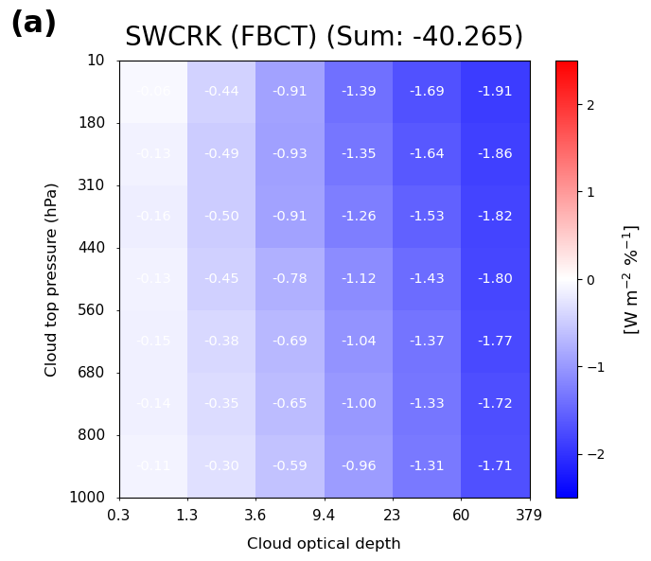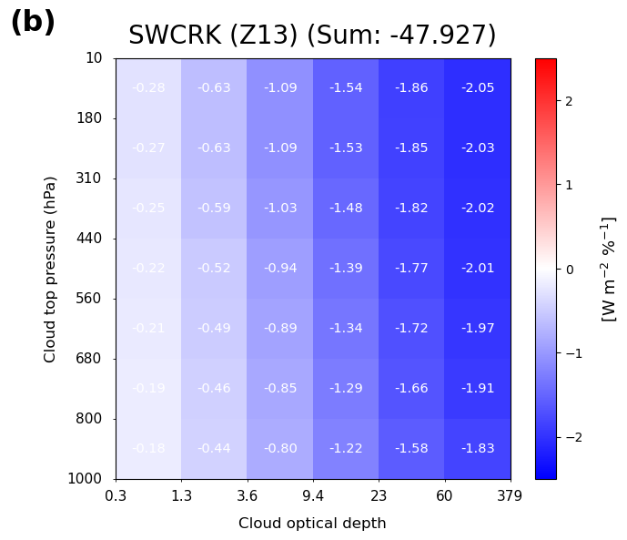
Figure S1. Annual-mean, global-mean shortwave cloud radiative kernels ($SWCRK$). (a) SWCRK from the FBCT product. (b) $SWCRK$ from Zhou et al. (2013). Kernels are shown in cloud-top pressure (CTP) and cloud optical depth (COD) space, with values in each bin indicating the SWTOA radiative sensitivity to a 1 % change in cloud fraction for that cloud type. The shortwave kernel is negative in all bins and becomes more negative for optically thicker clouds, consistent with thicker clouds reflecting more incoming solar radiation and thus producing a larger shortwave cooling effect.

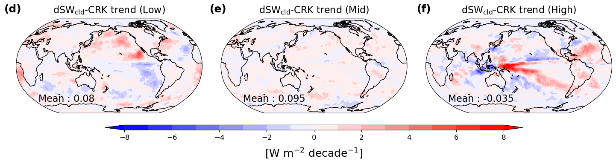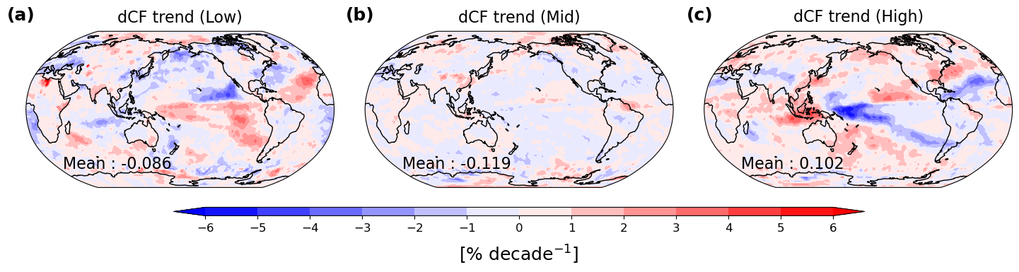
Figure S2. Spatial trends in cloud fraction and CRK-derived shortwave cloud radiative response ($dSW_{cld}\text{-CRK}$) by cloud height. Spatial distribution of cloud fraction trends for (a) low (> 680 hPa), (b) mid (440–680 hPa), and (c) high (< 440 hPa) clouds, respectively. Corresponding trend in $dSW_{cld}\text{-CRK}$ for (d) low, (e) mid, and (f) high clouds, respectively. Global-mean values are reported in the lower-left corner of each map.

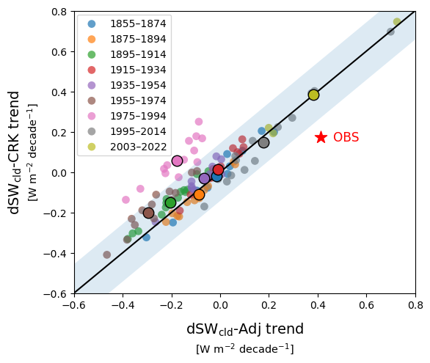
Figure S3. Same as Fig. 3, but with $dSW_{cld}\text{-CRK}$ on the y-axis computed using the cloud radiative kernel from Zhou et al. (2013). Numerical values for each scatter are listed in Table S3.

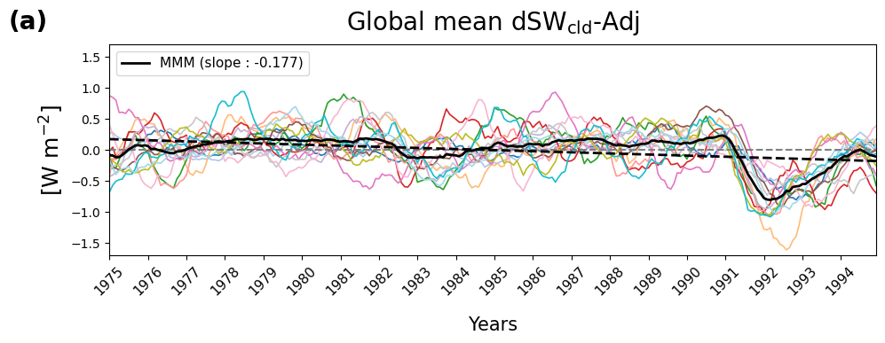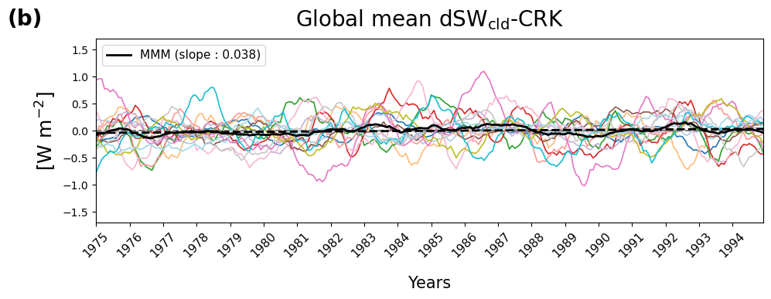
Figure S4. Global-mean shortwave cloud radiative response in CMIP6 historical simulations during 1975–1994, a period that includes the Mount Pinatubo eruption. Time series show 12-month running means of monthly anomalies from 14 CMIP6 models, with the multi-model mean shown in black. (a) Adjustment-based estimate of $dSW_{cld}\text{-Adj}$. (b) CRK-based estimate of $dSW_{cld}\text{-CRK}$. Dashed black lines denote linear trends, with trend slopes reported in the legends.

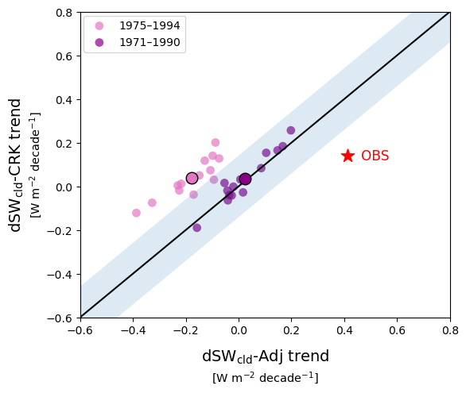
Figure S5. Comparison of adjustment- and CRK-based SW cloud radiative response trends for Pinatubo-related and pre-Pinatubo periods. Same as Fig. 3, but showing the 1975–1994 window (includes the 1991 Pinatubo eruption; pink) and the 1971–1990 window (excludes Pinatubo; purple).

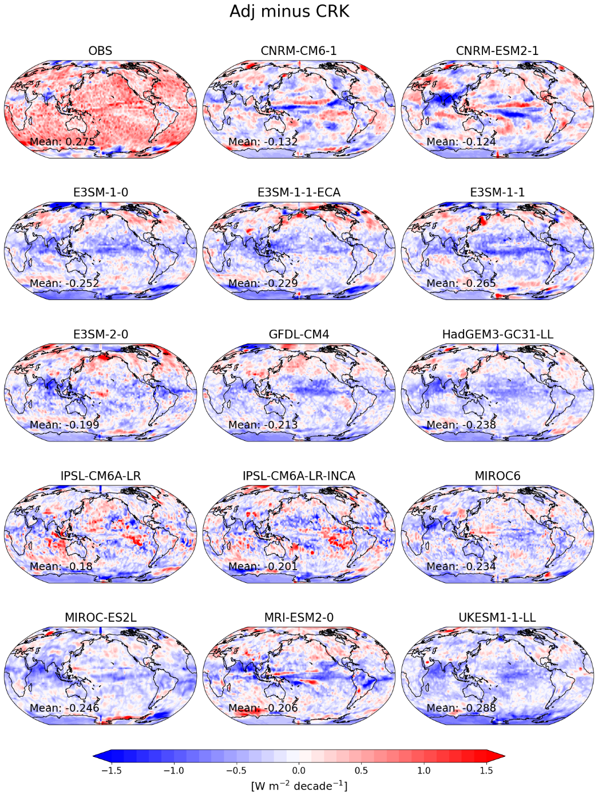
Figure S6. Spatial maps of the residual shortwave cloud radiative trend ($dSW_{cld}\text{-Adj}$ minus $dSW_{cld}\text{-CRK}$). Maps show the spatial distribution of the residual between the adjustment-based and CRK-based trend estimates. The observational panel (OBS) is computed over 2003–2022, whereas the 14 CMIP6 model panels are shown for 1975–1994, a period that includes the Mount Pinatubo eruption. Global-mean values are reported in the lower-left corner of each map.
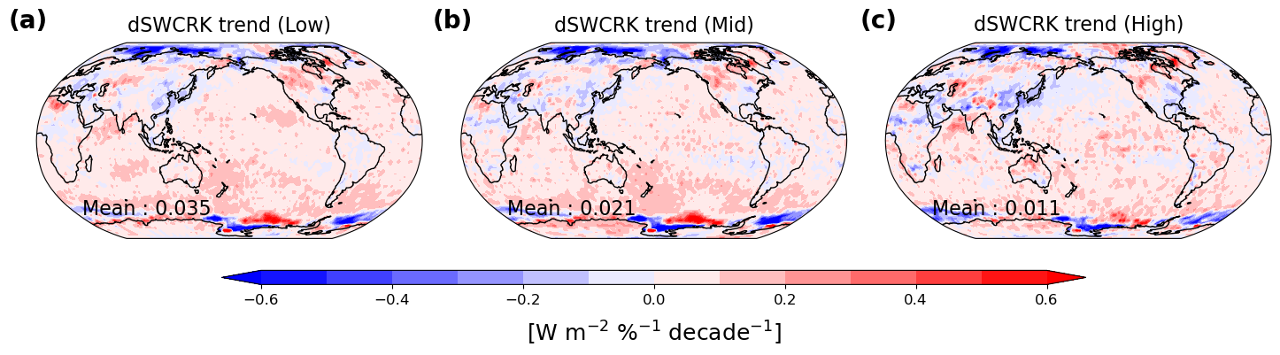
Figure S7. Spatial trends in $dSWCRK$ over 2003-2022 by cloud height. Spatial distribution of $dSWCRK$ trends for (a) low (>680hPa), (b) mid (440-680hPa), and (c) high (<440hPa) clouds, respectively. Global-mean values are reported in the lower-left corner of each map.

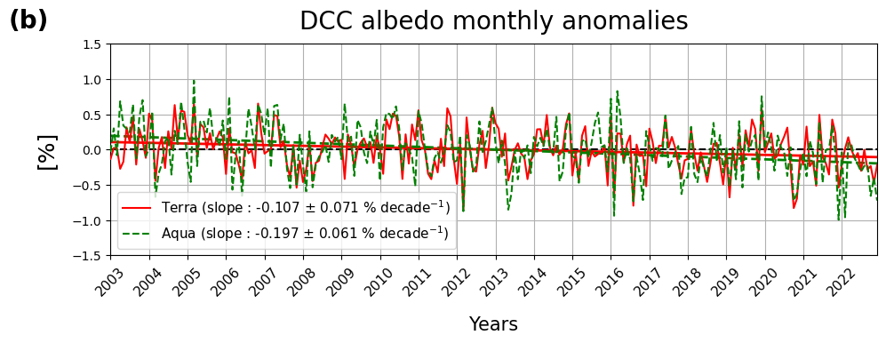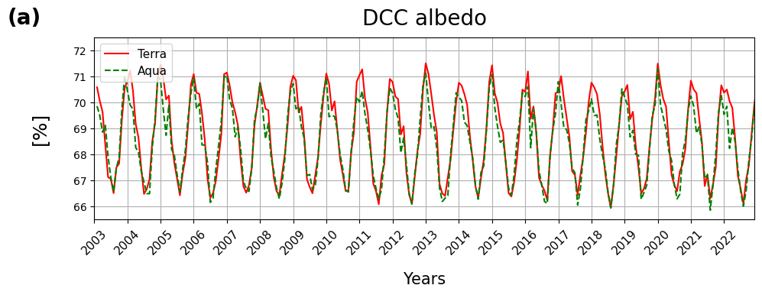

Figure S8. Deep convective cloud (DCC) albedo time series and trends from CERES SSF. (a) Monthly mean DCC albedo for CERES Terra (solid red) and Aqua (dashed green) over 2003–2022, and (b) corresponding monthly DCC albedo anomalies with the fitted linear trend and its 95% confidence interval, accounting for autocorrelation following Santer et al. (2000).

Table S1. CMIP6 models included in the analysis. Circles indicate data availability for each model, including variables required to compute both $dSW_{cld}\text{-Adj}$ and $dSW_{cld}\text{-CRK}$.
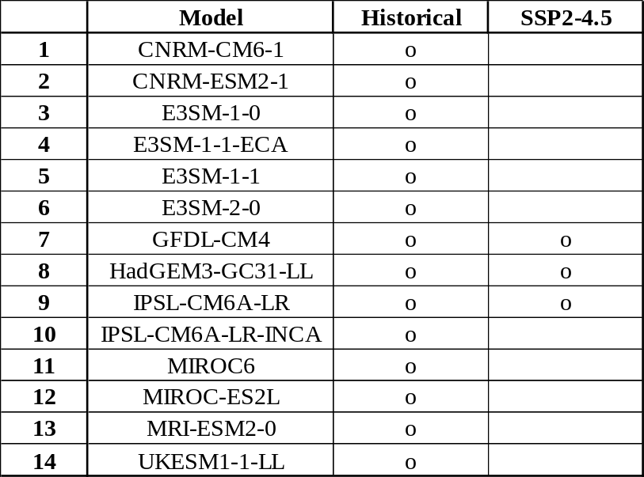

Table S2. CMIP6 model estimates of $dSW_{cld}\text{-Adj}$ and $dSW_{cld}\text{-CRK}$ trends (units: W m⁻² decade⁻¹) for nine non-overlapping 20-year periods. This windowed analysis provides statistically independent samples and evaluates whether agreement between the two diagnostics holds across different historical forcing regimes. For consistency with the observational estimate, the same radiative kernels (Kramer et al., 2019) and the FBCT-derived cloud radiative kernels (Sun et al., 2022) are used.
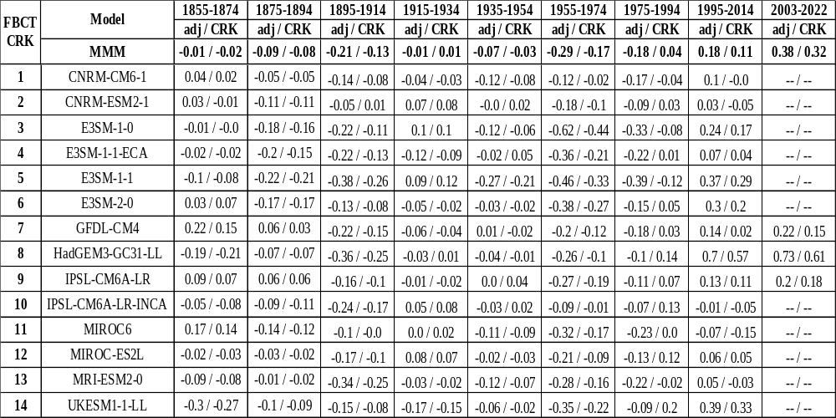

Table S3. Same as Table S2 but with $dSW_{cld}\text{-CRK}$ computed using the cloud radiative kernel from Zhou et al. (2013).
