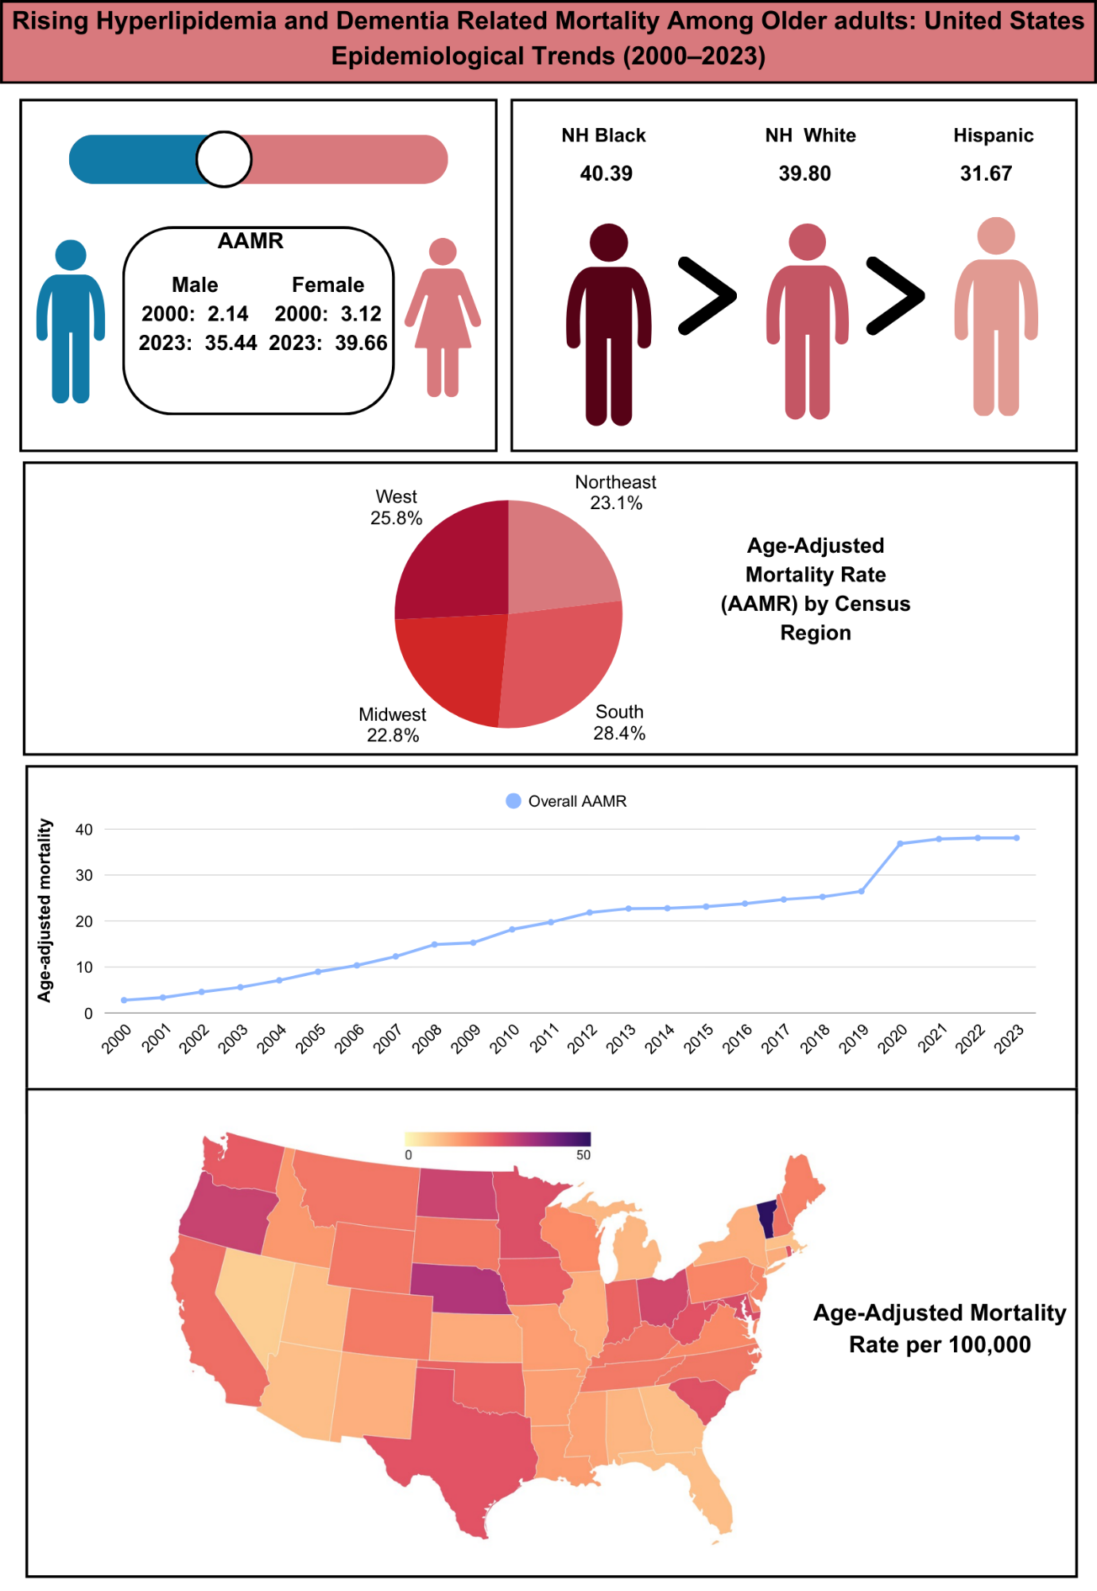
Central illustration: Trends in Hyperlipidemia- and Dementia-related deaths in the United States, 2000–2023

