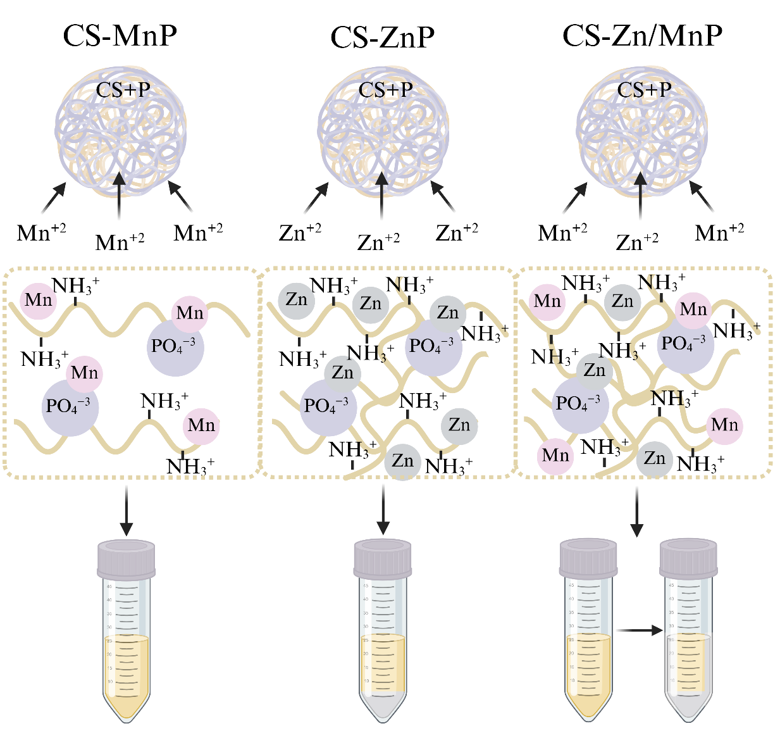
Scheme 1: Schematic representation of the in situ synthesis mechanism and colloidal behavior of CS–MnP, CS–ZnP, and CS–Zn/MnP systems. Chitosan (CS) acts as a soft polymeric template that interacts electrostatically with phosphate anions, favoring the subsequent coordination of metal cations. (Made in Biorender).

