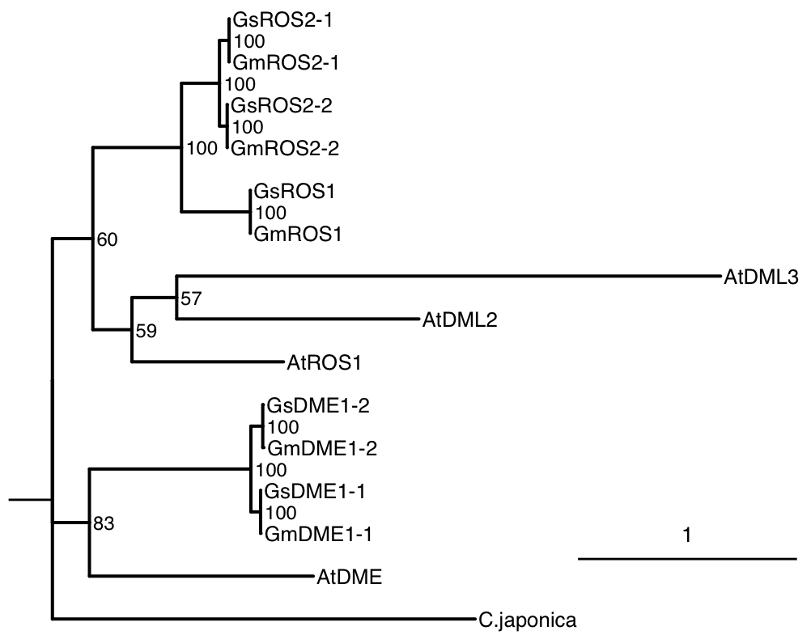
Figure S1: Phylogenetic analysis of dMTase proteins. These rooted maximum likelihood trees were clustered with 1000 bootstrap replicates. Branch length phylogenetic tree of Arabidopsis, Soybean and G. soja.
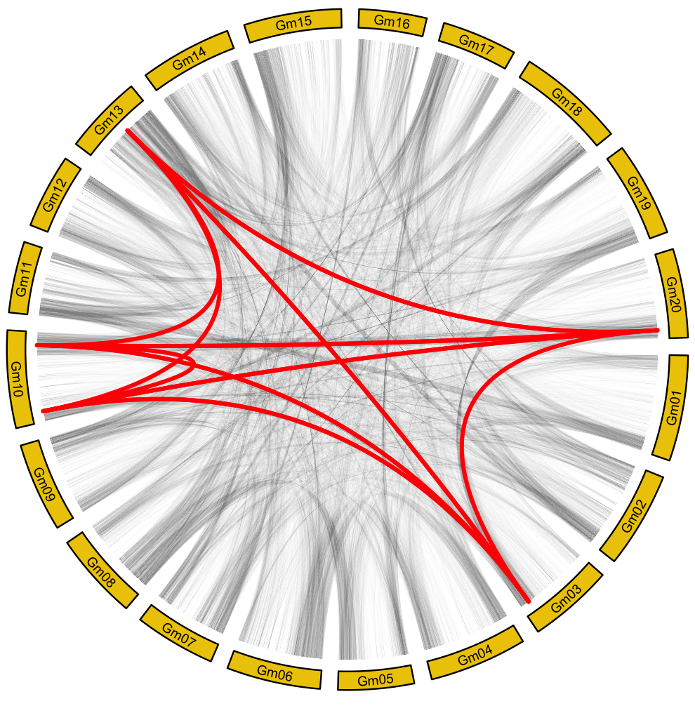
Figure S2: Gene Duplication Analysis of the five soybean dMTase genes. Yellow squares represent different chromosome locations. Red lines indicate syntenic lines between GmROS1 (Chr03), GmROS2-1 (Chr10), GmROS2-2 (Chr13), GmDME1-1 (Chr20), and GmDME1-2 (Chr10).
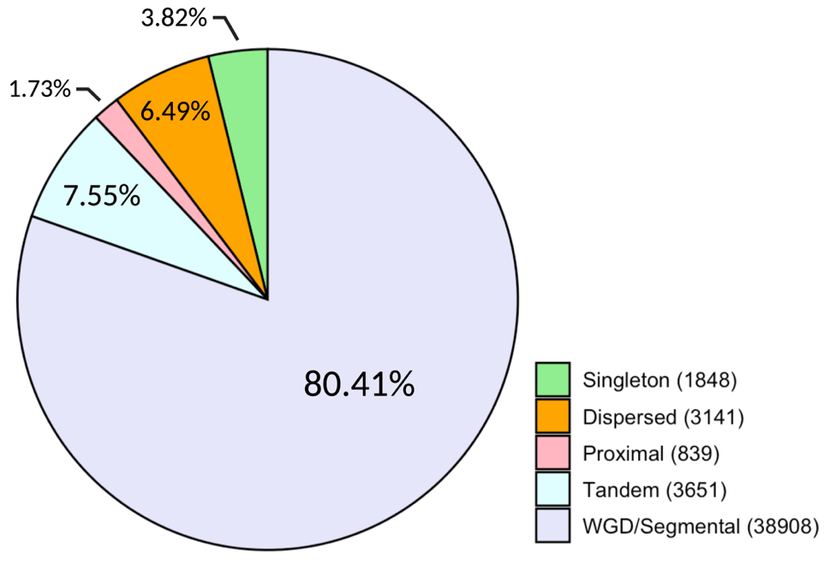
Figure S3: Proportion of all 48,387 identified soybean genes classified into duplication classes. Classes are color coded to the right.
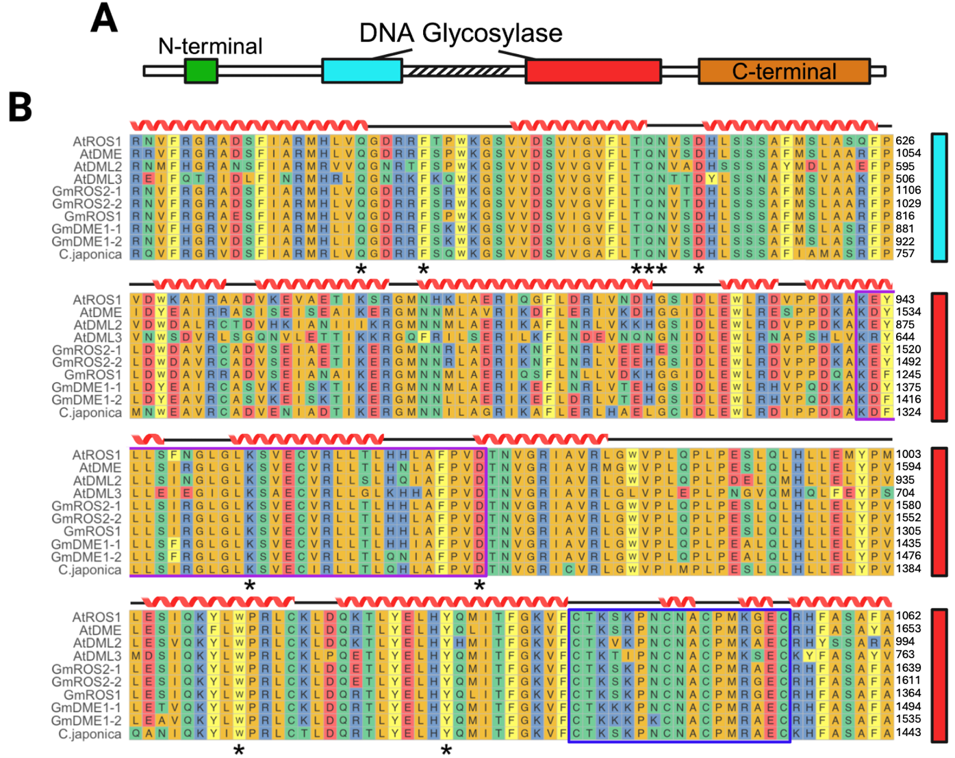
Figure S4: A. Diagram of a basic structure of a dMTase gene. B. Multiple sequence alignment of soybean (5), Arabidopsis (4), and C. japonica (1). First part of the DNA glycosylase domain is indicated by cyan; the second part of the domain is red. The purple and blue boxes represent the HhH-GPD motif and 4Fe-4S motif, respectively. All catalytic amino acid residues are identified with asterisks [31].
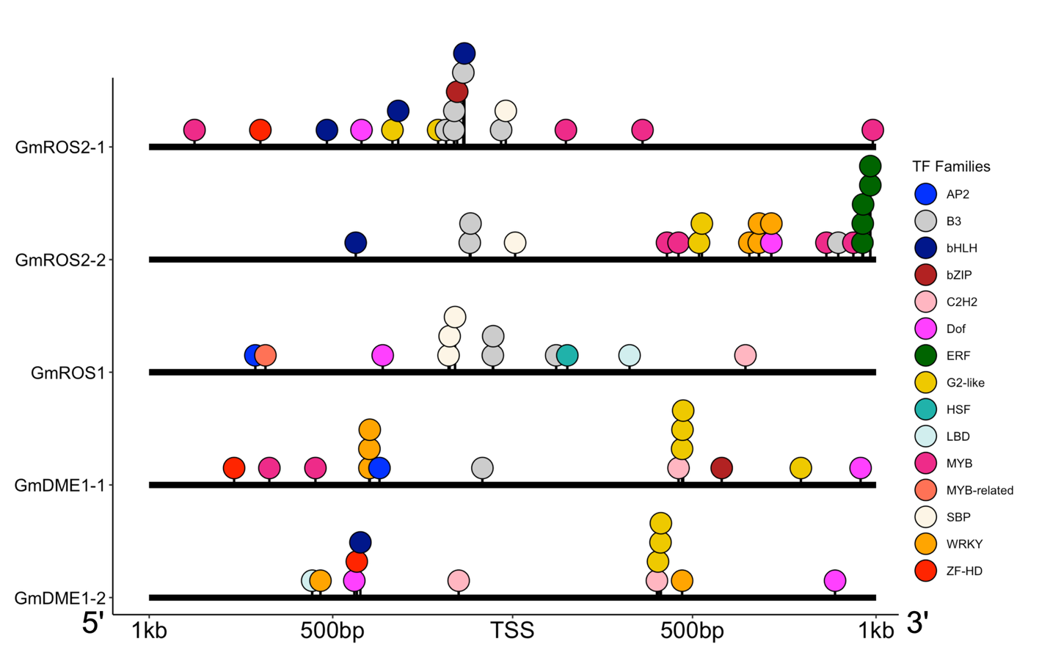
Figure S5: DAP-seq binding peaks of all TFs upstream of the transcription start site (TSS) in the promoter region and downstream in the untranslated region. X-axis scale length spans 1kb upstream and 1 kb downstream of TSS. All TF families are represented by different colored circles to the right.
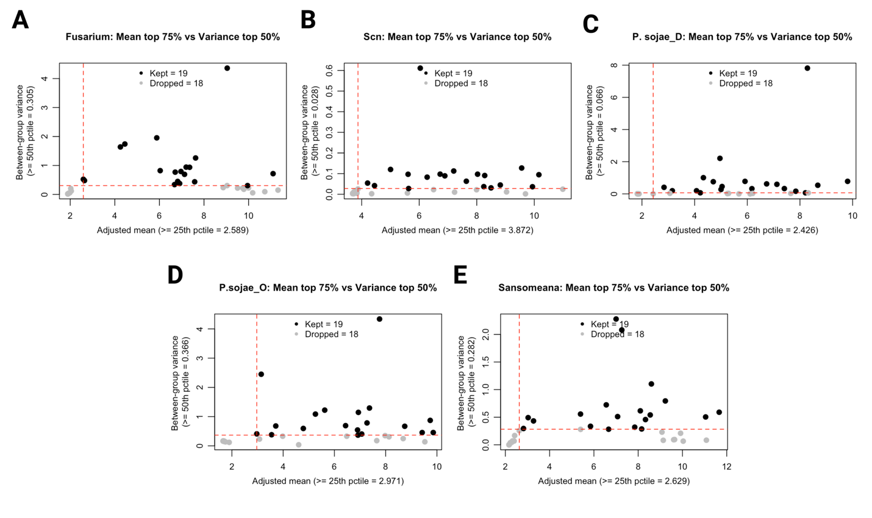
Figure S6: Filtered TFs based on average mean and between-condition variance in a studies examining A. Fusarium virguliforme, B. soybean cyst nematode, and C, D. Phytophthora sojae, and E. Phytophthora samsomeana. TFs that were above both thresholds (dashed red lines on the x- and y- axis) were represented as black dots. Anything TFs that fell below any of the threshold lines is represented as a grey dot.
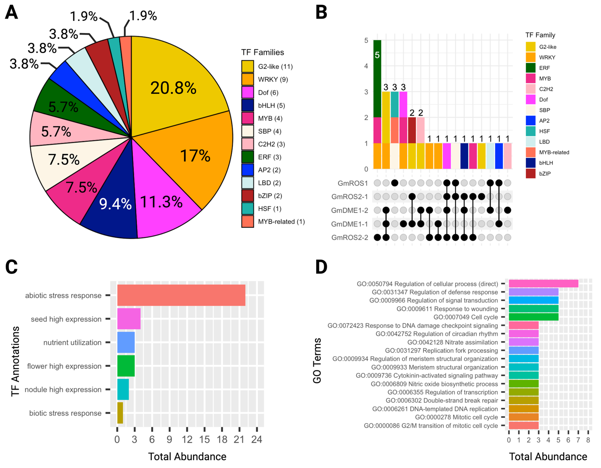
Figure S7: A. Percent proportion of filtered TF families predicted to interact with the five soybean dMTase genes. In the key is the exact number of TFs identified among all five soybean dMTase genes. B. Upset plot identifying filtered TF duplicates across all five soybean dMTase genes. The color-coded bar plot indicates what TF is in the gene(s). C. Total count of predicted gene annotation of all filtered TFs among all five soybean dMTase genes. D. Total abundance, across all identified filtered TF and 5 soybean dMTase genes, of GO biological processes identified in STRING. All plotted GOs had an abundance ≥3. TFs that are regulators in their protein-protein networks are marked with “direct”.
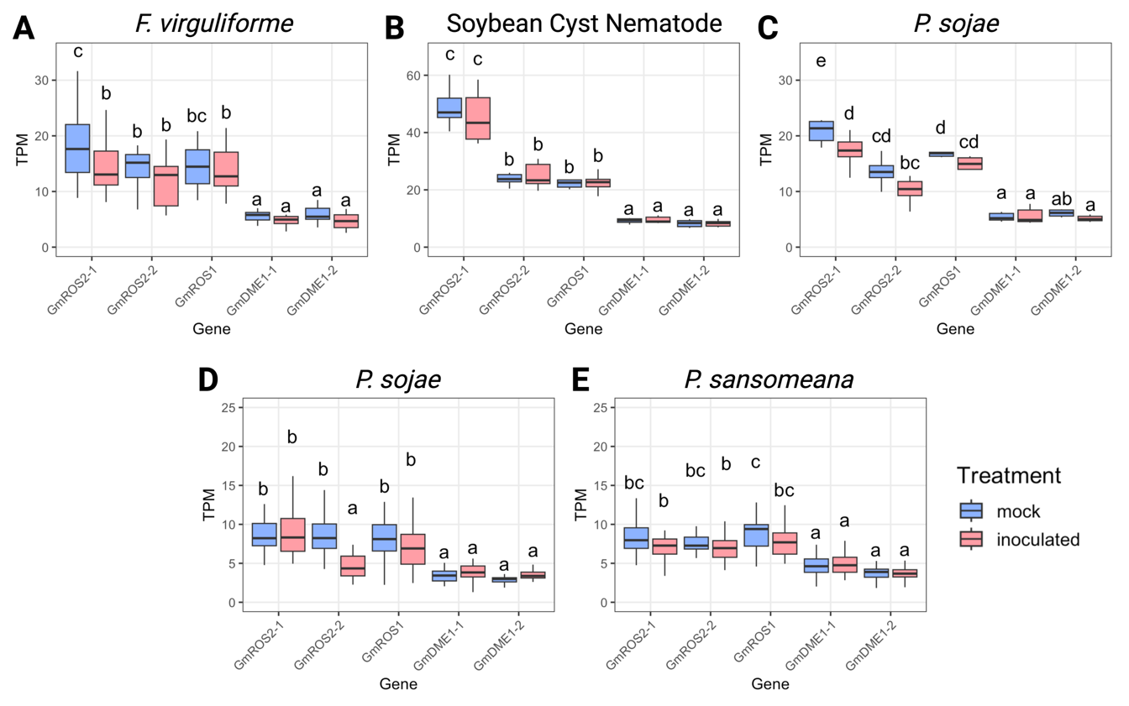
Figure S8: Expression of all five soybean dMTase genes under biotic stress. Different expression profiles of the genes in root tissue from different studies inoculated with A. Fusarium virguliforme, B. soybean cyst nematode, and C, D. Phytophthora sojae. E. Shoots infected with Phytophthora samsomeana. Mock is represented in light blue and inoculated is represented in light red. Statistical significance was determined with a two-way ANOVA test and post hoc Tukey’s test (p < 0.05).

