Appendix I

Policy Attributes and Rubrics

National security in AI policy addresses the protection of the United States from threats posed by adversaries leveraging AI for espionage, cyberwarfare, disinformation, and military advantage. It encompasses safeguarding critical infrastructure, ensuring technological sovereignty through export controls and supply chain resilience, and maintaining U.S. leadership in the global AI race. This category highlights the strategic dimension of AI as both a national defense tool and a geopolitical asset.

National Security Index Rubric
a. Defense & Military Applications (Weight: 20%) – Addresses AI in defense, autonomous weapons, and military decision-making.
b. Critical Infrastructure Protection (Weight: 20%) – Protects energy, transport, health, and communications against AI vulnerabilities.
c. Export Controls & Tech Sovereignty (Weight: 15%) – Imposes export controls, licensing requirements, or restrictions on the transfer of AI technologies to protect national security or strategic advantage.
d. Foreign Influence & Espionage (Weight: 15%) – Mitigates AI misuse for espionage, disinformation, and cyber warfare.
e. Cyber Defense & Resilience (Weight: 15%) – Addresses AI-enabled cyber threats to national security, including state-sponsored attacks, critical systems defense, and strategic cyber resilience.
f. Interagency & International Coordination (Weight: 15%) – Promotes coordination among national security agencies and with security alliances (e.g., NATO, defense partnerships) on AI-related threats and controls.

Safety & Security emphasize protecting people, systems, and the public from direct and indirect harm caused by AI deployment. It includes requirements for testing and evaluation (such as red teaming and safety benchmarks), incident reporting (where incidents are typically defined within the policy), human oversight, cybersecurity measures, and third-party audits. Policies in this domain focus on minimizing risks ranging from cybersecurity to catastrophic system failures, ensuring that AI adoption aligns with principles of robustness, transparency, and accountability.

Safety & Security Index Rubric
a. Testing & Evaluation Requirements (Weight: 25%) – Mandates pre-deployment testing (e.g., red teaming, safety benchmarks).
b. Incident Reporting & Transparency (Weight: 15%) – Requires timely reporting of AI malfunctions, security breaches, near-misses, or harmful outcomes to regulators or designated authorities.
c. Cybersecurity Provisions (Weight: 15%) – Addresses system robustness, adversarial attacks, and security vulnerabilities in AI systems, excluding state-sponsored or military cyber threats.
d. Human Oversight & Accountability (Weight: 15%) – Requires human-in-the-loop controls and clearly assigned organizational responsibility for AI system operation and risk management.
e. Whistleblower Protections (Weight 10%) - Protects individuals who report AI-related risks or noncompliance in good faith, including anti-retaliation safeguards and confidential reporting channels.
f. Third-Party Audits & Compliance (Weight: 10%) – Independent review, auditing, certification mechanisms.
g. Physical and Individual Safety Protections (Weight: 10%) – Addresses risks of physical injury or harm to individual well-being, including mental health impacts, arising from AI system operation.

Antitrust in AI policy seeks to prevent excessive market concentration through key anticompetitive practices such as vertical integration, self-preferencing, and anticompetitive discrimination. The goal of this policy area is to promote fair competition within the AI sector and ensure that AI does not facilitate market concentration in other sectors. It involves scrutiny of mergers and acquisitions, promoting interoperability and open standards, expanding fair access to datasets, allocating enforcement resources to regulators like the Federal Trade Commission (FTC) and Department of Justice (DOJ), and promoting small AI players in the AI sector. This category reflects concerns that unchecked dominance by a few large players could stifle innovation, limit consumer choice, and concentrate economic and political power within the technology industry and more broadly.

Antitrust Index Rubric
a. Market Concentration & Dominance (Weight: 30%) – Addresses market power, dominance, concentration metrics, and anticompetitive structural barriers to entry in AI markets.
b. Merger & Acquisition Scrutiny (Weight: 20%) - Strengthens review of mergers, acquisitions, and roll-up strategies in the AI sector, including foreclosure and killer-acquisition risks.
c. Competition Enforcement Capacity (Weight: 20%) - Allocates authority, staffing, funding, or tools to competition agencies (e.g., FTC, DOJ) for AI-related antitrust enforcement.
d. Interoperability & Open Standards (Weight: 15%) - Requires or promotes open APIs, data portability, or standards to reduce lock-in, switching costs, or gatekeeper control in AI markets.
e. Data Access & Mandatory Sharing (Weight: 10%) - Requires dominant platforms to provide fair, nondiscriminatory access to key datasets or inputs as a competition remedy, including court-ordered or regulator-imposed data-sharing obligations.
f. Exclusionary Conduct & Platform Neutrality (Weight: 5%) – Restricts exclusionary practices such as self-preferencing, tying, exclusive dealing, default settings, or discriminatory access that distort competition or foreclose rivals.

Note: Antitrust enforcement is treated differently from the other policy attributes in this framework in that enforcement capacity is included as an explicit variable in the rubric. Unlike safety, civil rights, national security, or industrial policy regimes, which rely primarily on ex ante rules, rights conferrals, or budgetary programs, antitrust law is largely ex-post and enforcement-driven. Enforcement depends heavily on prosecutorial discretion, investigatory authority, litigation resources, and institutional capacity within competition agencies.

The Civil & Human Rights category encompasses policies designed to safeguard civil liberties, consumer protections, equity, and transparency in the use of AI. It prioritizes privacy and data rights, algorithmic fairness, accessibility, explainability, and the protection of human rights and dignity. Civil society stakeholders emphasize trust, accountability, and inclusion as preconditions for AI adoption, urging governance structures that advance the broader public good while balancing innovation with democratic safeguards.

Civil & Human Rights Index Rubric
a. Consumer Protection (Weight 20%) – Prevents fraud, deception, and consumer harm from AI applications.
b. Privacy & Data Rights (Weight 20%) – Protects personal data, data ownership, consent, and lawful use.
c. Bias & Fairness (Weight 20%) – Prevents algorithmic discrimination and promotes equitable treatment across protected classes.
d. Accessibility & Inclusion (Weight 15%) – Ensures accessibility for people with disabilities consistent with the Americans with Disabilities Act (ADA) and promotes inclusive access for underserved groups.
e. Legal Protections & Due Process (Weight 15%) – Safeguards civil liberties, procedural due process, and legal rights of individuals subject to AI-enabled decisions.
f. Transparency & Explainability (Weight 10%) – Requires meaningful notice, explanation, or contestability for individuals affected by AI-driven decisions.

Industrial Policy (Economic Resilience) refers to strategic measures that strengthen U.S. competitiveness and economic resilience in the global AI economy. It includes investments in research & development (R&D), workforce development, domestic manufacturing, supply chain security, infrastructure such as public compute capacity, energy use requirements, and environmental impact. By fostering public-private partnerships and enabling small and medium enterprises (SMEs), this category seeks to position the U.S. as a global leader in AI while supporting job creation and innovation across industries.

Industrial Policy (Economic Resilience) Index Rubric

a. Workforce Development & Job Quality (Weight 25%) – Supports training, reskilling, apprenticeships, and workforce transition measures that promote sustainable, high-quality employment using, deploying, or creating AI, including job-quality standards linked to public investment.
b. R&D, Investment & Incentives (Weight 20%) – Funds grants, tax credits, procurement, and public-private programs that expand AI R&D and deployment capacity.
c. Domestic Manufacturing & Supply Chains (Weight 20%) – Builds domestic production capacity and supply chain resilience for chips, computing hardware, and critical inputs.
d. Infrastructure & Compute Capacity (Weight 15%) – Expands public-interest compute, clusters, and scalable compute infrastructure (including public compute initiatives).
e. Energy & Resource Capacity (Weight 10%) – Expands energy generation, grid capacity, and resource availability required for compute and infrastructure resilience.
f. Global Competitiveness (Weight 10%) – Strengthens national AI competitiveness through standards leadership and international market access, excluding export controls or trade restrictions.

Appendix II
Commercial LLM Benchmarking Model Prompt

You are an expert policy analyst. Evaluate the following legislative bill against granular policy criteria.

### RUBRIC DEFINITIONS:
#### SAFETY SECURITY
- **Testing & Evaluation Requirements** (Weight: 0.25)
Definition: Testing and Evaluation Requirements refers to legislative provisions that mandate systematic assessment of AI systems before deployment or during operation. This encompasses requirements for red teaming exercises where adversarial testing is conducted to identify vulnerabilities, safety benchmarks that establish minimum performance thresholds, pre-deployment audits conducted by internal teams or third parties, stress testing under various operational conditions, and validation of model behavior against intended use cases.
COMMON LEGISLATIVE PHRASING: 'shall conduct testing,' 'evaluation protocols,' 'safety assessment,' 'pre-release audit,' 'adversarial testing,' 'benchmark compliance,' 'validation requirements,' 'shall be tested prior to deployment,' 'safety evaluation framework,' 'pre-market testing,' 'conformity assessment.'
SYNONYMS AND RELATED TERMS: red team, red teaming, adversarial evaluation, safety benchmarks, model validation, stress testing, penetration testing, vulnerability assessment, safety audit, pre-deployment review, sandbox testing, simulation testing, alignment testing, capability evaluation, dangerous capability testing, model evaluation, safety testing protocol, evaluation criteria, test standards, validation protocol, conformance
... [FULL RUBRIC DEFINITIONS OMITTED FOR BREVITY] ...

### SCORING SCALE (0-100):
0: Not addressed.
25: Weak/Symbolic mention.
50: Moderate, explicit coverage.
75: Strong, detailed provisions.
100: Central focus, enforceable mandates.

### COMPOSITE SCORE CALCULATION:
Formula: Area_Score = SUM(Variable_Score * Weight)

### INPUT BILL TEXT:
[BILL TEXT INSERTED HERE (up to 35k chars)]

### OUTPUT INSTRUCTIONS:
Return ONLY valid JSON following this schema:
{
"safety_security": {
"Testing & Evaluation Requirements": {
"score": 0,
"justification": "string"
},
"Incident Reporting & Transparency": {
"score": 0,
"justification": "string"
},
"Cybersecurity Provisions": {
"score": 0,
"justification": "string"
},
"Human Oversight & Accountability": {
"score": 0,
"justification": "string"
},
"Whistleblower Protections": {
"score": 0,
"justification": "string"
},
"Third-Party Audits & Compliance": {
"score": 0,
"justification": "string"
},
"Physical and Individual Safety Protections": {
"score": 0,
"justification": "string"
},
"area_score": 0
},
... [FULL JSON FORMAT OMITTED FOR BREVITY] ...

Appendix III

Model Training Data Analysis: Summary Tables

Table 1 TF-IDF Top 5 Keywords per Attribute
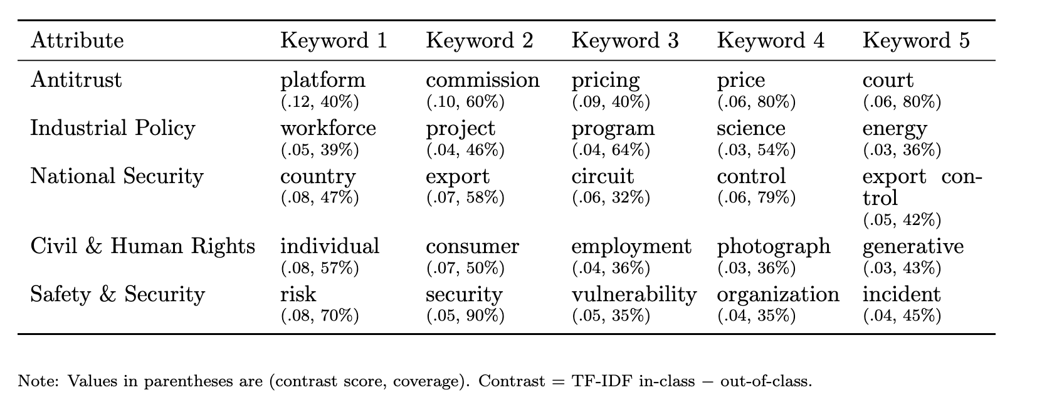\

Table 2 Topic Word Distribution (Antitrust)
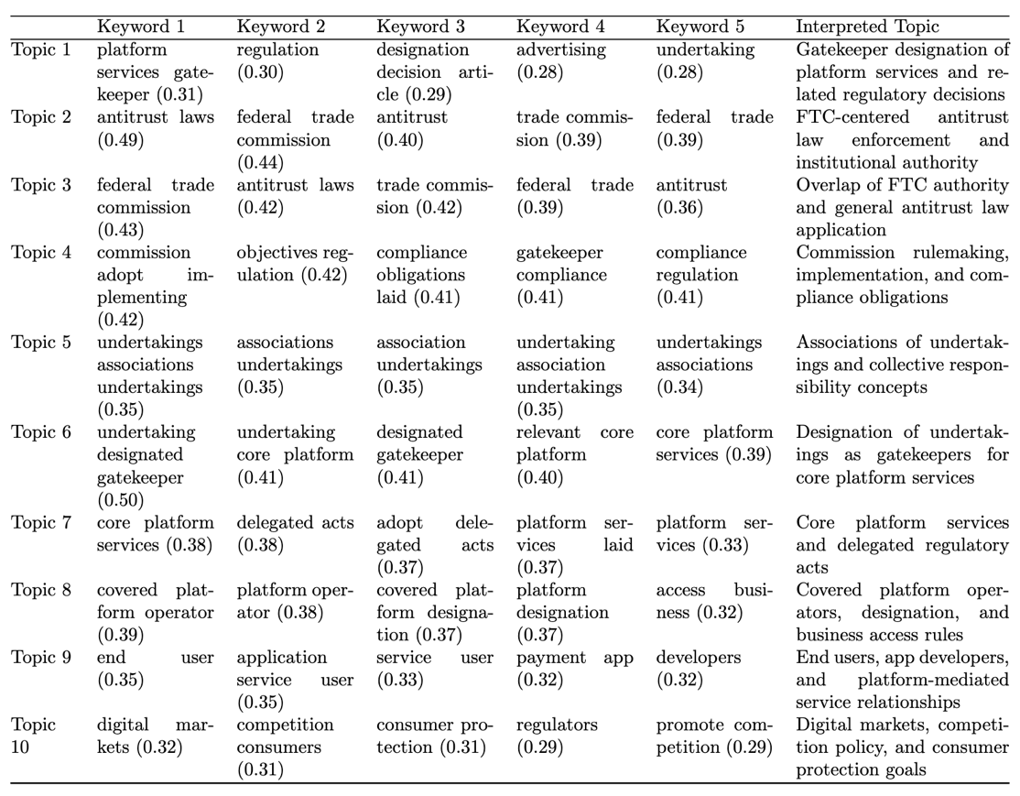

Table 3 Topic Word Distribution (Industrial Policy)
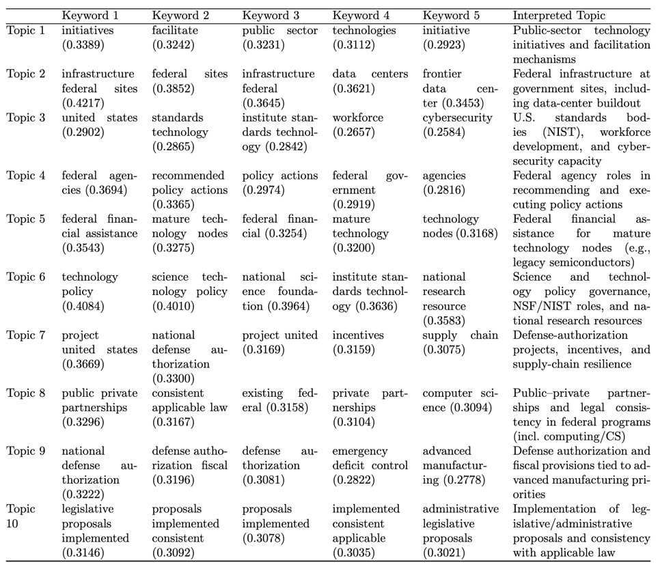

Table 4 Topic Word Distribution (National Security)
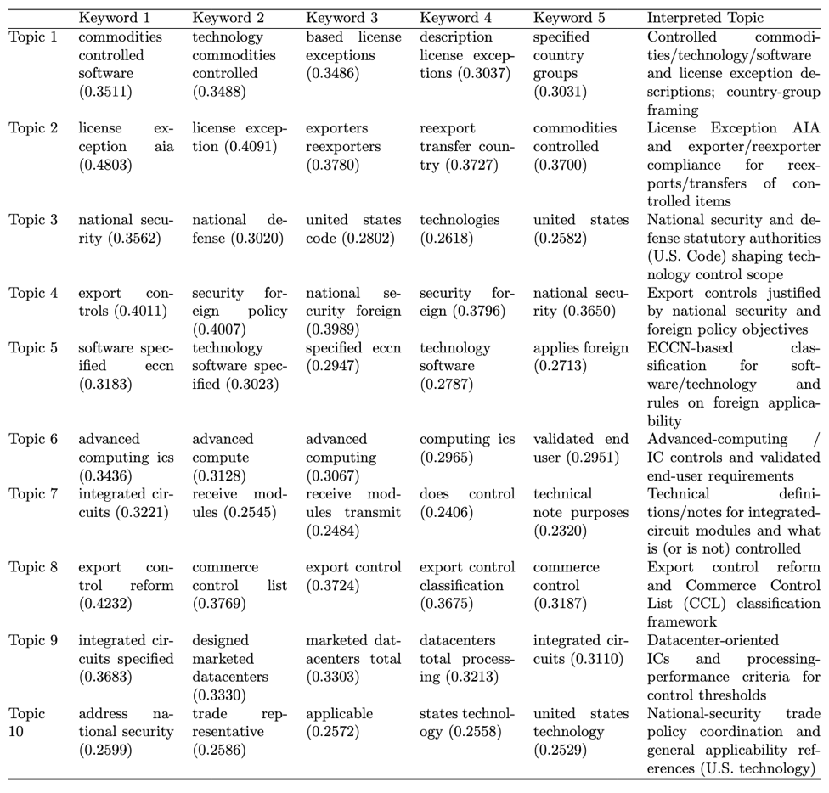
Table 5 Topic Word Distribution (Civil & human rights)
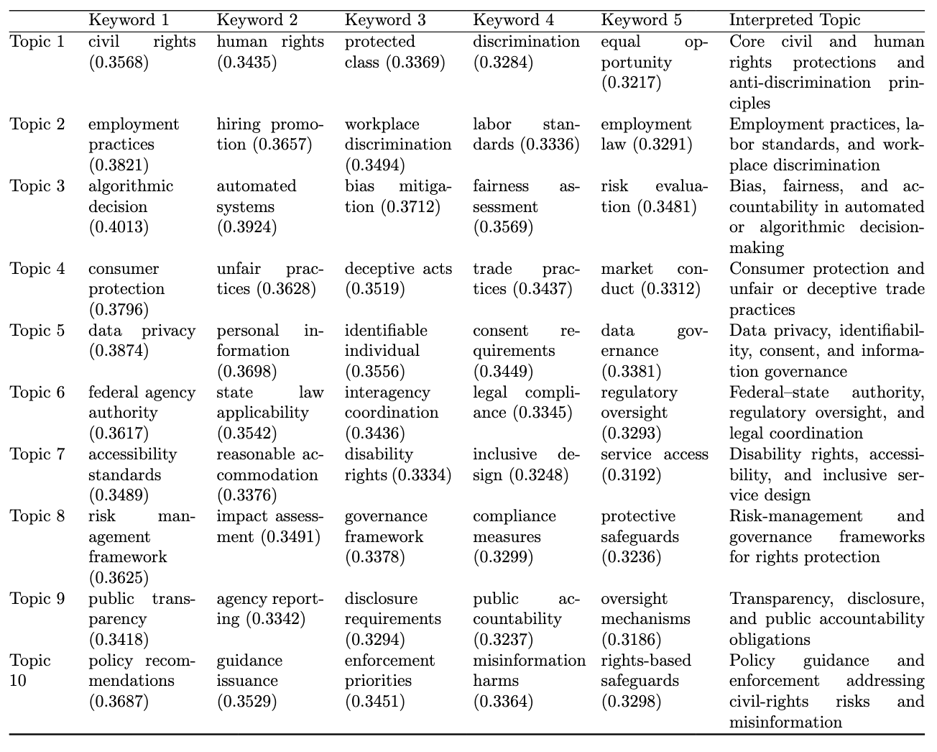
Table 6 Topic Word Distribution (Safety & security)
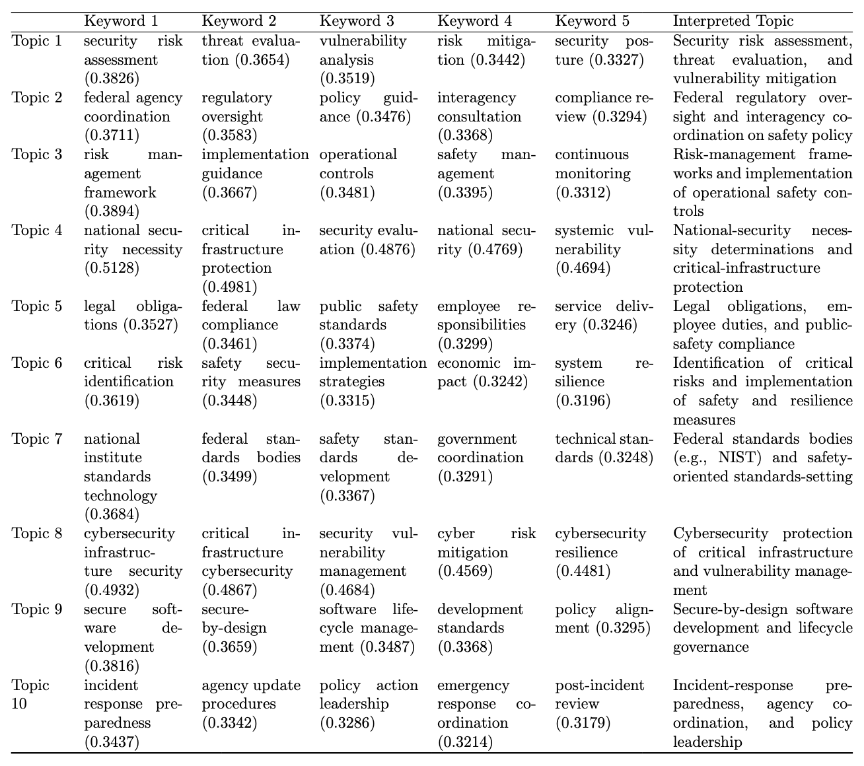

Table 7 Document Topic Distribution (Antitrust n=10)
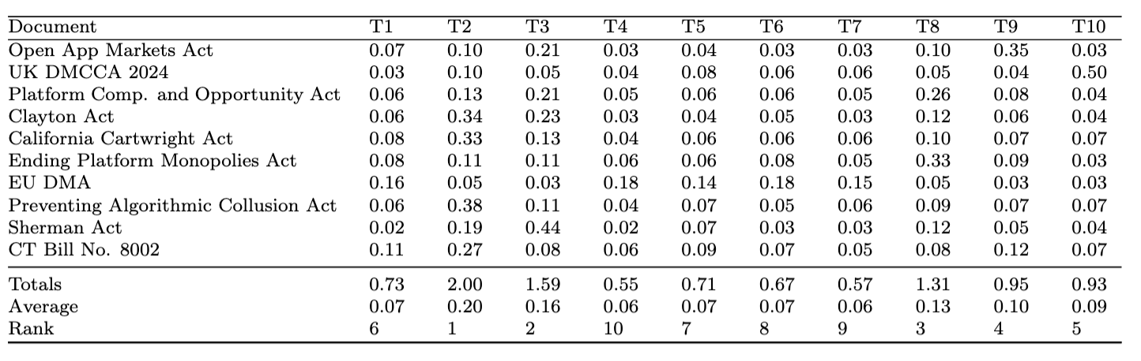

Table 8 Document Topic Distribution (Industrial Policy n =28)
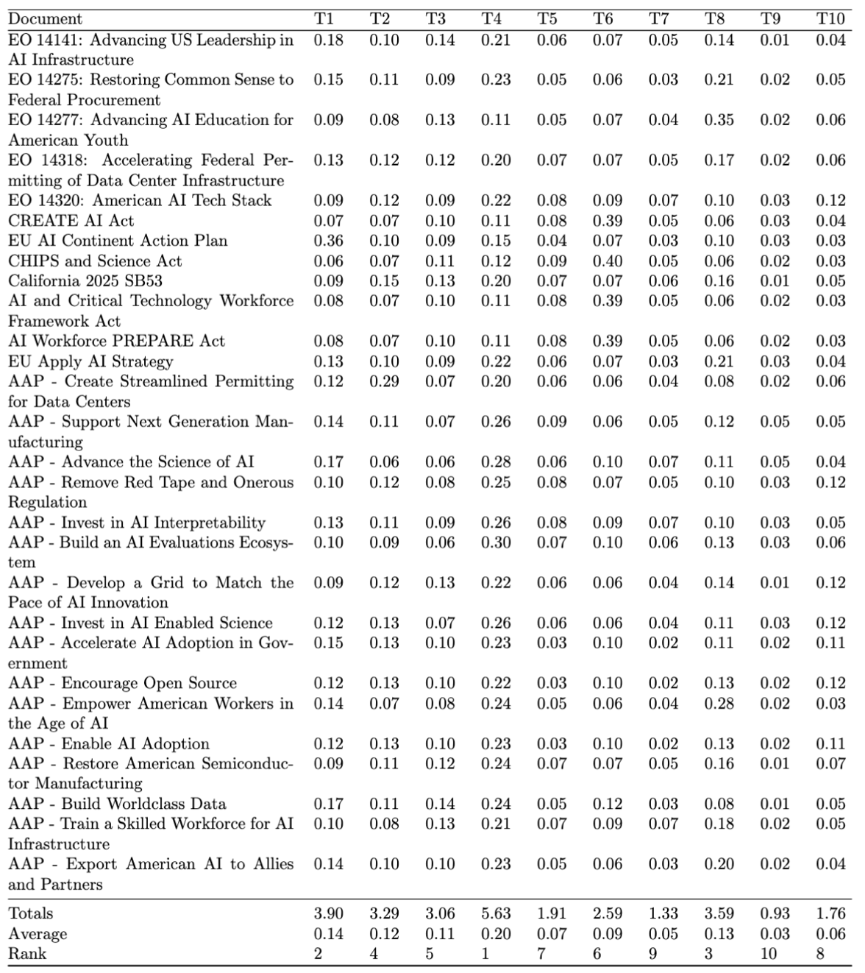
Note: AAP used for AI Action Plan.
Table 9 Document Topic Distribution (National Security n=19)
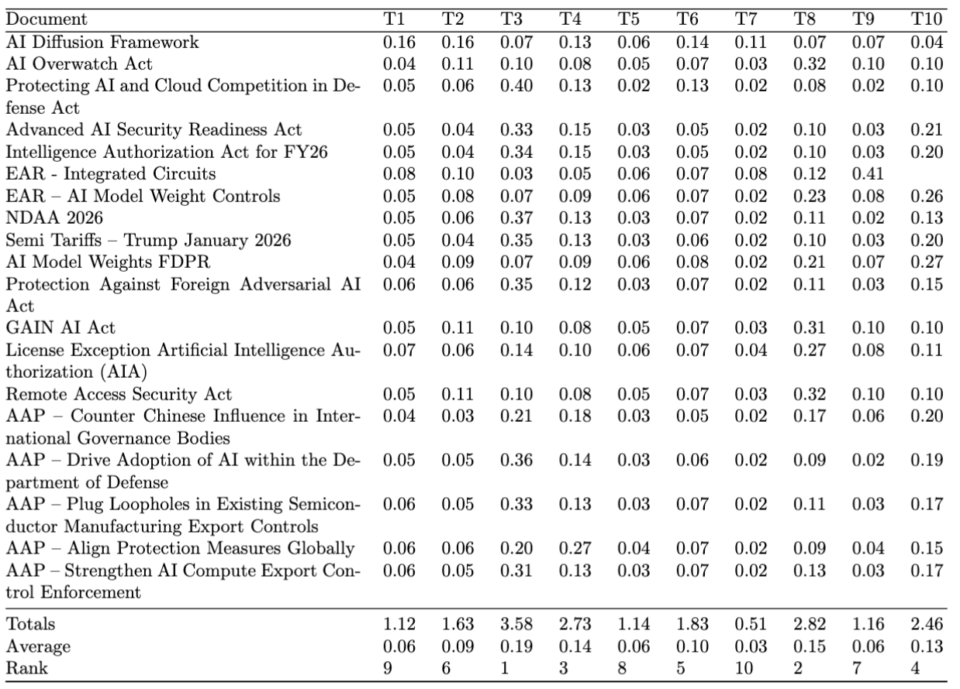

Table 10 Document Topic Distribution (Civil & human rights n=14)
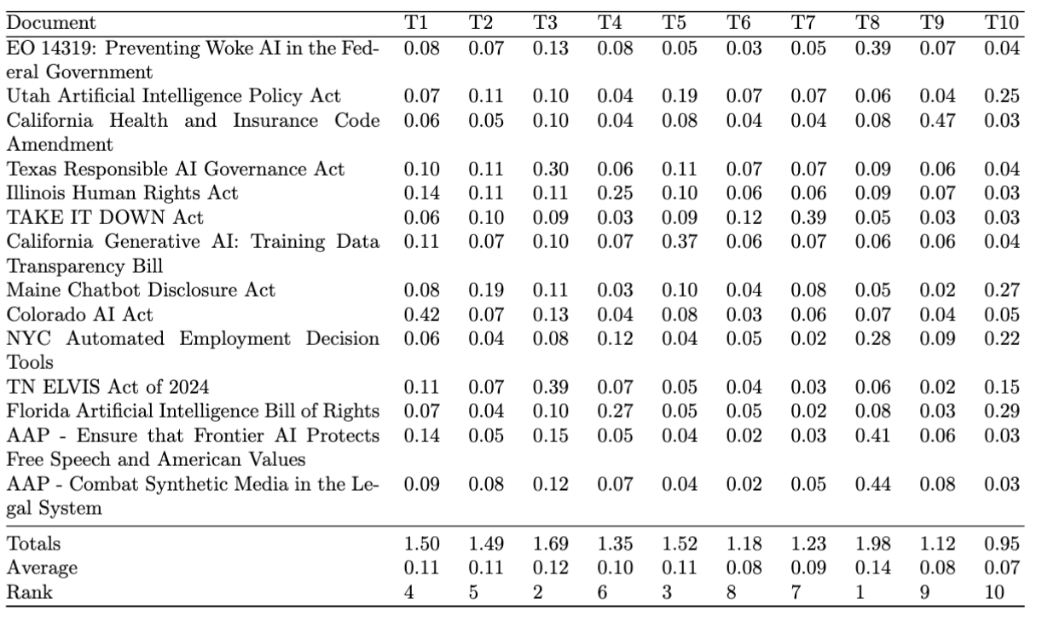

Table 11 Document Topic Distribution (Safety & Security n=20)
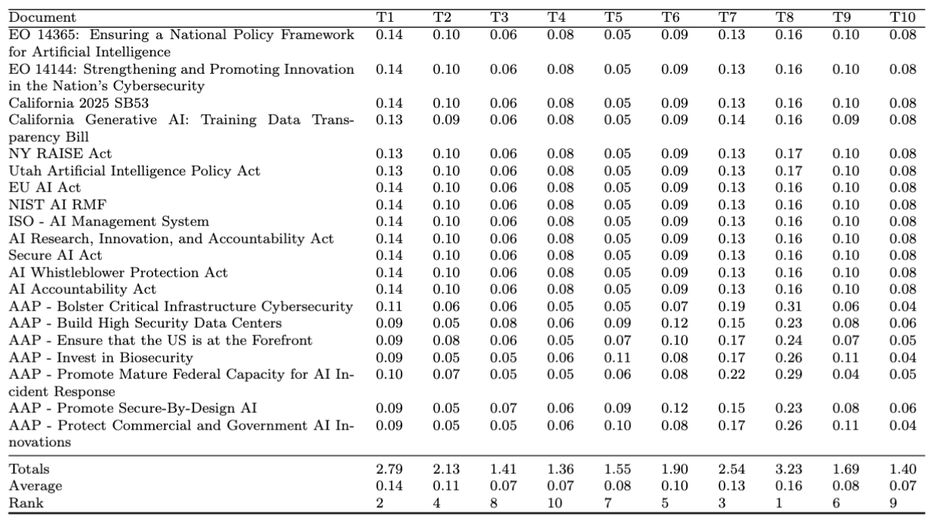

Note for Tables 12 to 16: Each cell is the cosine similarity between the policy in the line and the rubric variable (line item) in the column.

Table 12 Cosine Similarity – Policy vs Rubric Variables (Antitrust)
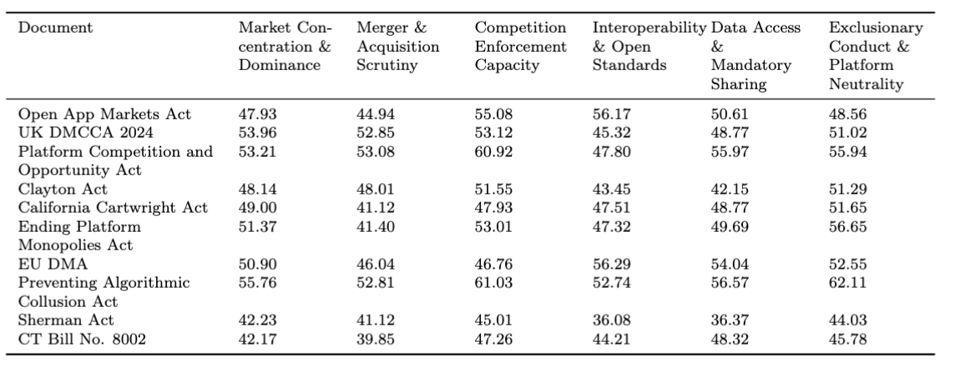

Table 13 Cosine Similarity – Policy vs Rubric Variables (Industrial Policy)
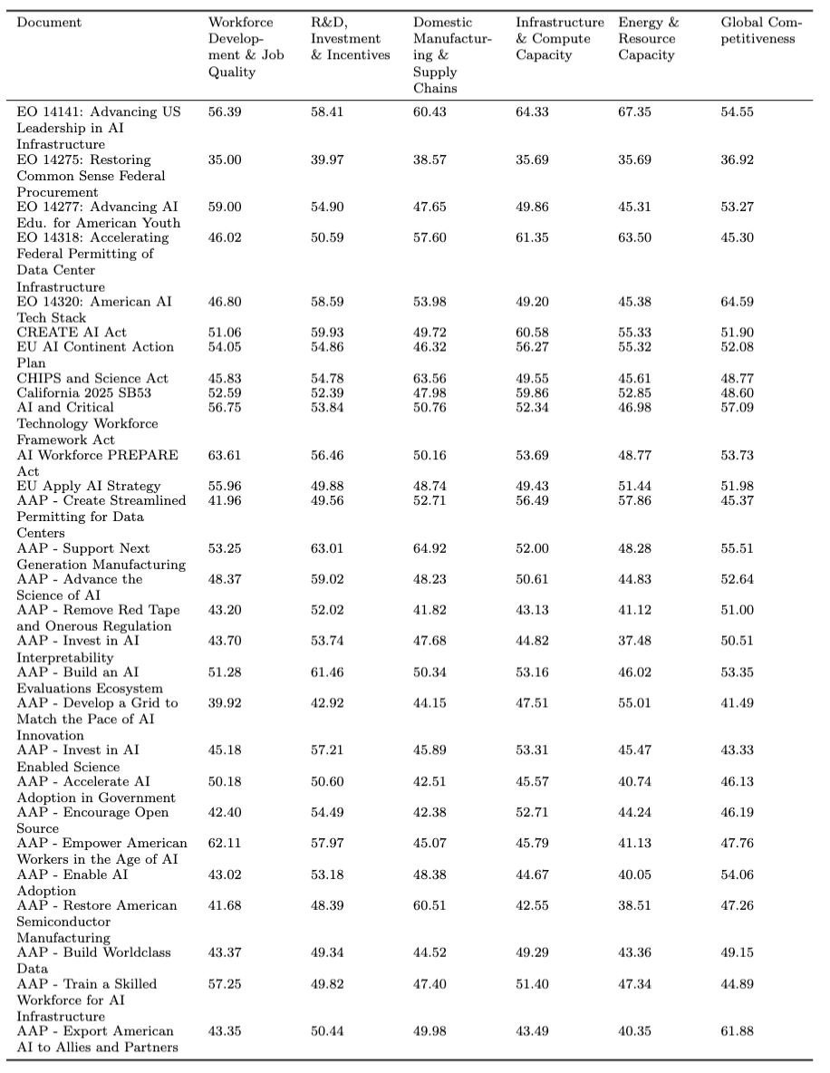

Table 14 Cosine Similarity – Policy vs Rubric Variables (National Security)

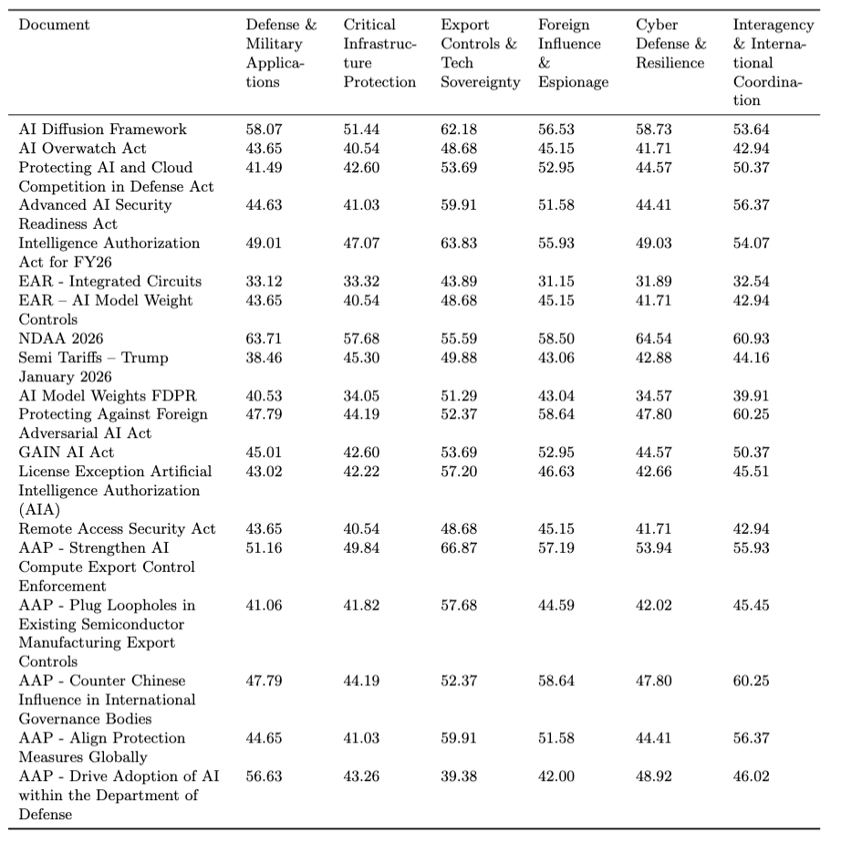

Table 15 Cosine Similarity – Policy vs Rubric Variables (Civil & human rights)

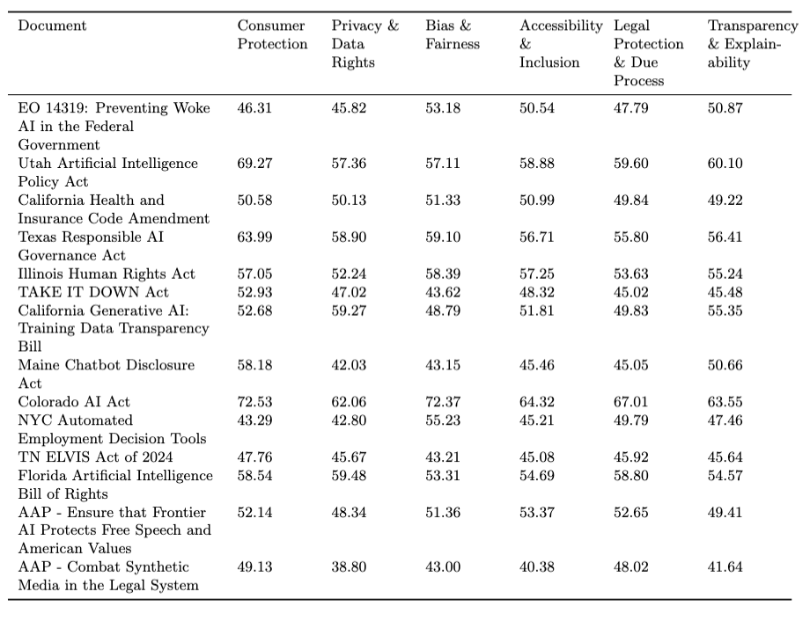

Table 16 Cosine Similarity – Policy vs Rubric Variables (Safety & security)

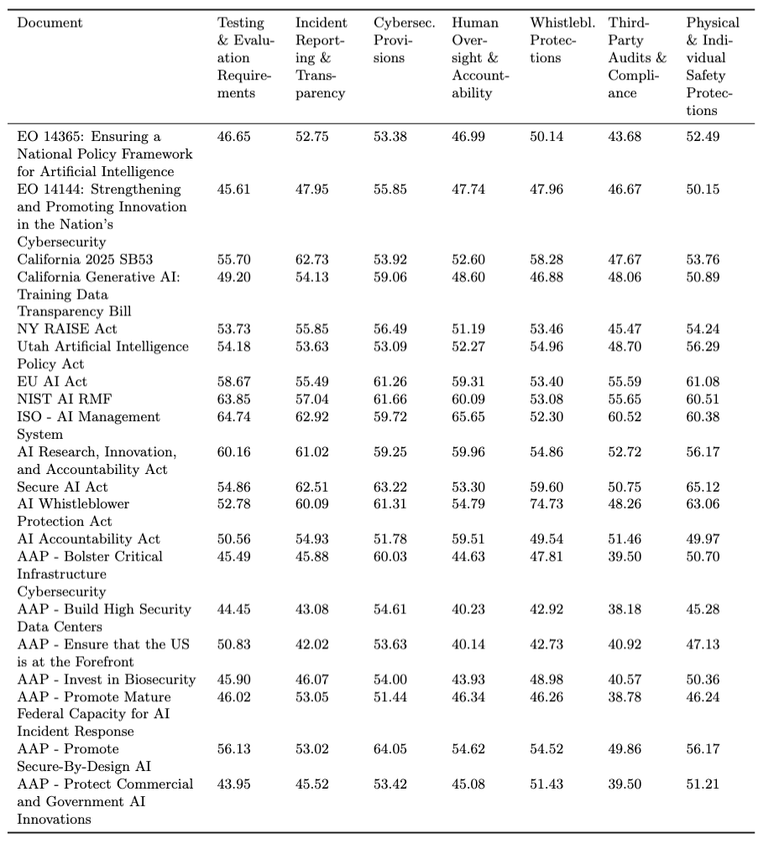

Table 17 Dominant Policy Attribute per Document
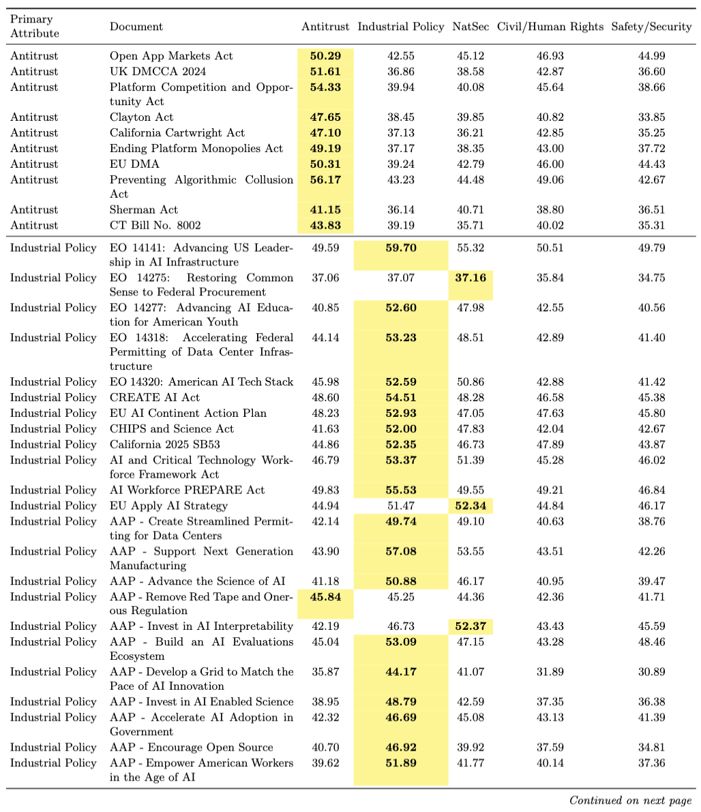

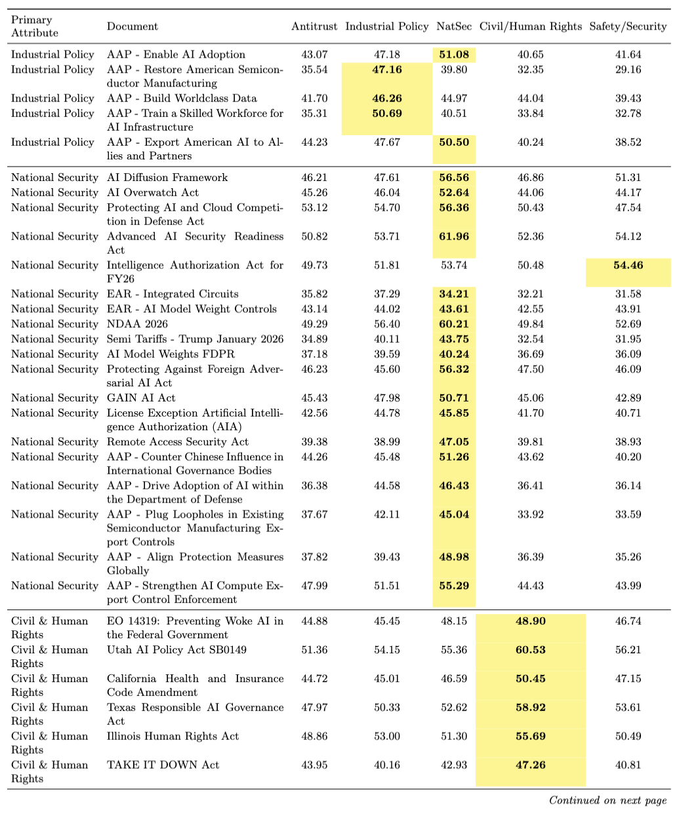

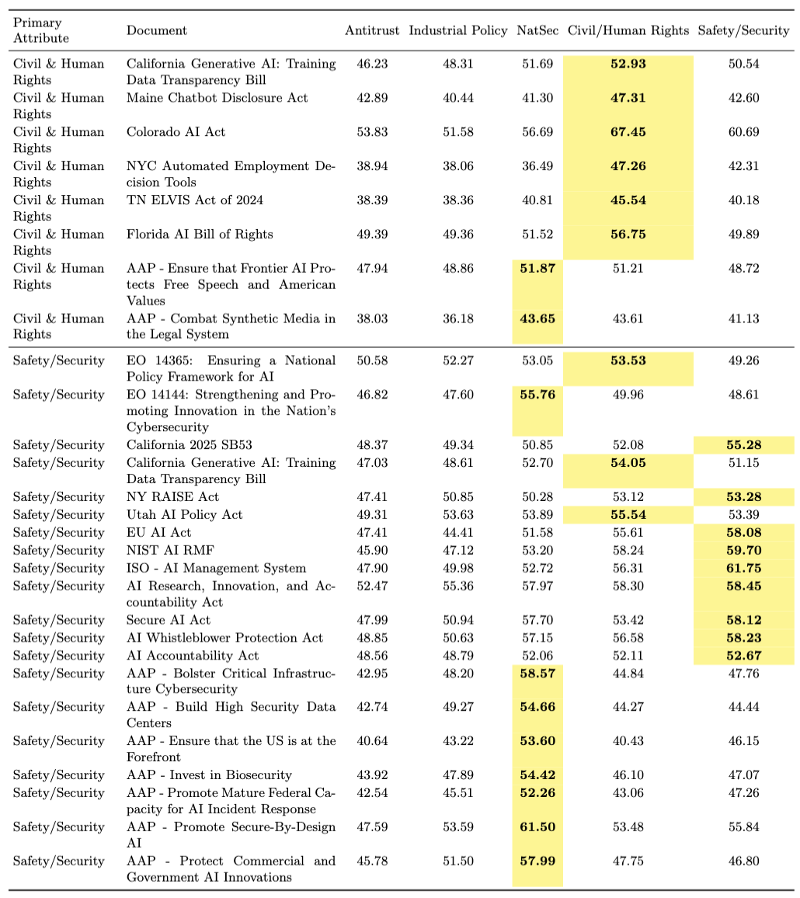

Table 18 LLM Benchmark – Antitrust - Policy from the Model Policy Data Set
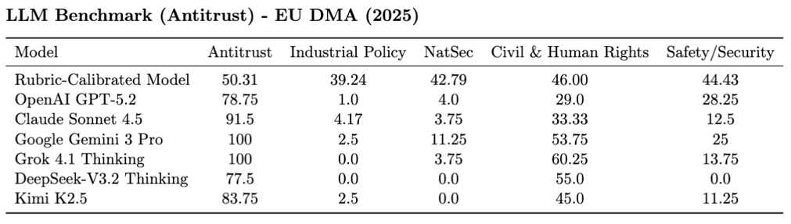

Table 19 LLM Benchmark - Industrial Policy - Policy from the Model Policy Dataset
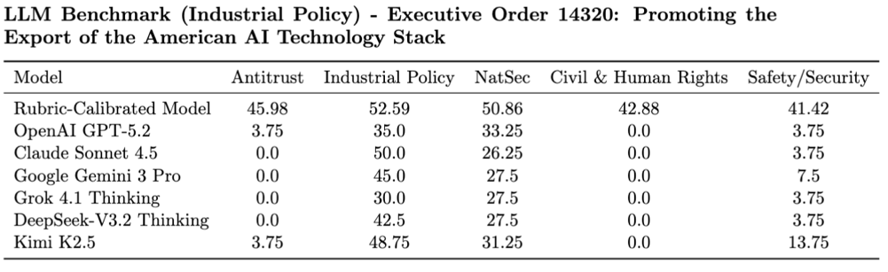

Table 20 LLM Benchmark – National Security - Policy from the Model Policy Dataset
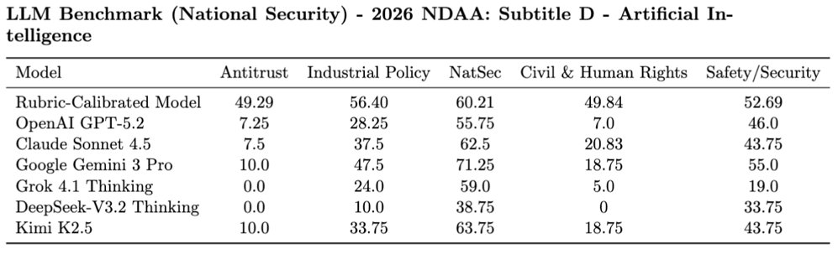

Table 21 LLM Benchmark – Civil & human rights – Policy from the Model Policy Dataset
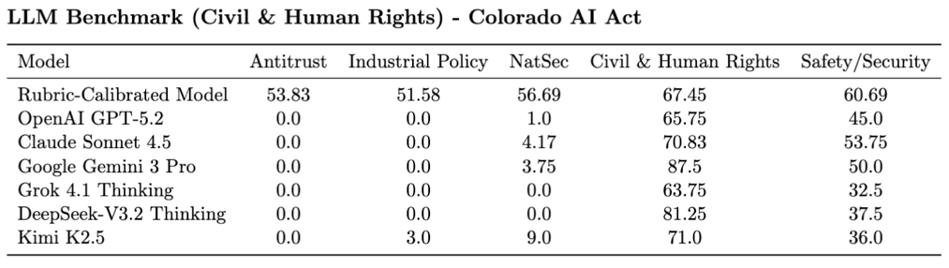

Table 22 LLM Benchmark – Safety & Security - Policy from the Model Policy Dataset
