APPENDIX A: FORECAST MODELLING
DATA ANALYSIS ON RSTUDIO
- Transform data into time series
Incidence.ts<-ts(Incidence,start=2018,frequency=4)
Incidence.ts

Année Trimestre Incidence
2018 Q1 2018 1 78
2018 Q2 2018 2 53
2018 Q3 2018 3 190
2018 Q4 2018 4 207
2019 Q1 2019 1 101
2019 Q2 2019 2 40
2019 Q3 2019 3 29
2019 Q4 2019 4 129
2020 Q1 2020 1 74
2020 Q2 2020 2 41
2020 Q3 2020 3 155
2020 Q4 2020 4 213
2021 Q1 2021 1 92
2021 Q2 2021 2 55
2021 Q3 2021 3 191
2021 Q4 2021 4 200
2022 Q1 2022 1 64
2022 Q2 2022 2 47
2022 Q3 2022 3 193
2022 Q4 2022 4 196
2023 Q1 2023 1 74
2023 Q2 2023 2 49
2023 Q3 2023 3 141
2023 Q4 2023 4 183
2024 Q1 2024 1 55
2024 Q2 2024 2 37
2024 Q3 2024 3 138
2024 Q4 2024 4 215
- Series graph
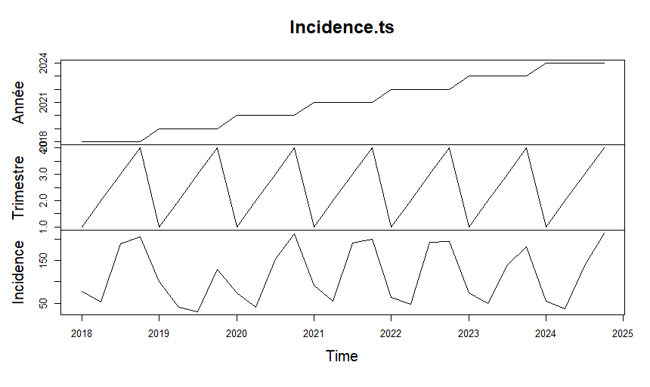

- Use of the TBATS model
model_tbats <- tbats(Incidence.ts[,3])
model_tbats
summary(model_tbats)

TBATS(1, {0,1}, -, {<4,1>})

Call: tbats(y = Incidence.ts[, 3])

Parameters
Alpha: -0.01000029
Gamma-1 Values: -6.525191e-05
Gamma-2 Values: 0.0001367682
MA coefficients: 0.577821

Seed States:
[,1]
[1,] 115.25281
[2,] -35.60676
[3,] -72.89247
[4,] 0.00000

Sigma: 27.33485
AIC: 294.5588

Length Class Mode
lambda 0 -none- NULL
alpha 1 -none- numeric
beta 0 -none- NULL
damping.parameter 0 -none- NULL
gamma.one.values 1 -none- numeric
gamma.two.values 1 -none- numeric
ar.coefficients 0 -none- NULL
ma.coefficients 1 -none- numeric
likelihood 1 -none- numeric
optim.return.code 1 -none- numeric
variance 1 -none- numeric
AIC 1 -none- numeric
parameters 2 -none- list
seed.states 4 -none- numeric
fitted.values 28 ts numeric
errors 28 ts numeric
x 112 -none- numeric
seasonal.periods 1 -none- numeric
k.vector 1 -none- numeric
y 28 ts numeric
p 1 -none- numeric
q 1 -none- numeric
call 2 -none- call
series 1 -none- character
method 1 -none- character

- Verification of residue stability
checkresiduals(model_tbats)

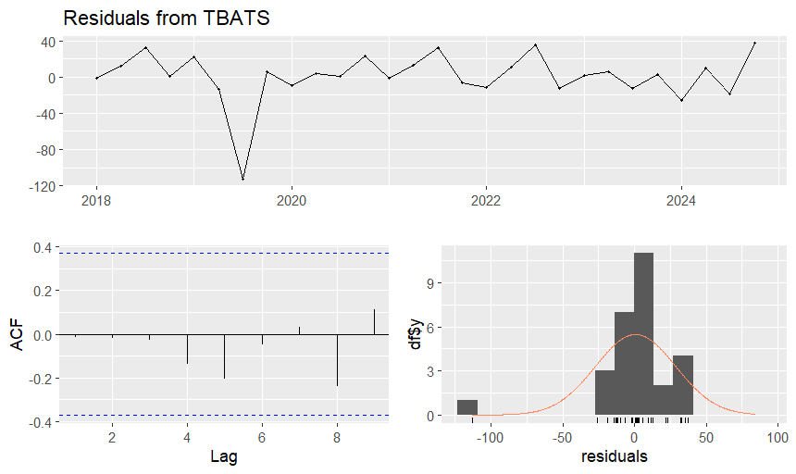

- Calculate residues
residuals_tbats <- residuals(model_tbats)
residuals_tbats
Qtr1 Qtr2 Qtr3 Qtr4
2018 -1.6460543 11.5742157 32.5433044 0.5338374
2019 21.7159432 -14.0149494 -112.8784644 5.7442111
2020 -9.8779775 3.3711964 1.1699743 23.1849025
2021 -1.7743422 13.0483788 32.0826218 -6.8023038
2022 -11.7009082 11.2580976 35.5264155 -12.3611044
2023 1.8940860 5.8935275 -12.8480415 2.5951785
2024 -25.8734813 9.6222598 -18.4403155 37.3532044

- Ljung-Box test
test_residus_tbats <- Box.test(residuals_tbats, lag = 27, type = "Ljung-Box" )
test_residus_tbats

Box-Ljung test

data: residuals_tbats
X-squared = 19.002, df = 27, p-value = 0.8699

- Normality test
qqnorm(residuals_tbats)
qqline(residuals_tbats)
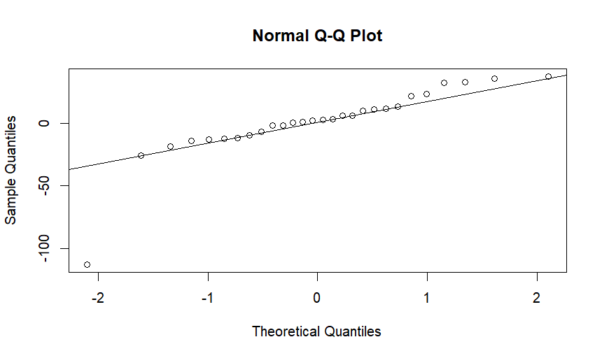
shapiro.test(residuals_tbats)

Shapiro-Wilk normality test

data: residuals_tbats
W = 0.77238, p-value = 3.612e-05

P value is < 5%, so the series is normally distributed.
- ACF and PACF of residuals to check for white noise
acf(residuals_tbats, main = "ACF of Residuals")
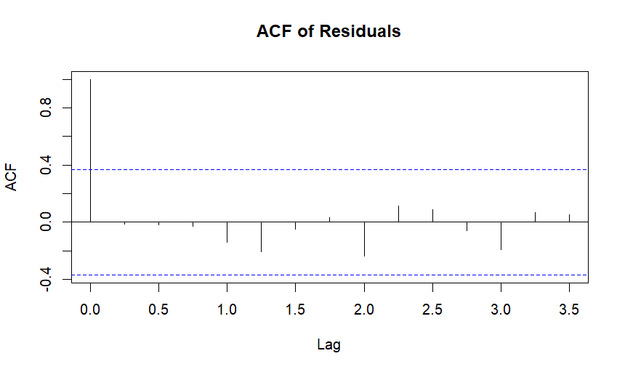
pacf(residuals_tbats, main = "PACF of Residuals")
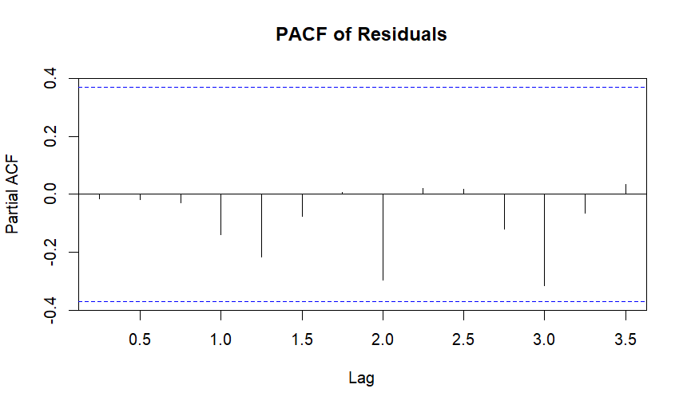

The residuals appear to follow white noise. Therefore, our model is statistically valid.
- 5-year forecast
forecost_tbats <- forecast(model_tbats, h=24)
forecost_tbats

Point Forecast Lo 80 Hi 80 Lo 95 Hi 95
2025 Q1 101.11571 66.084697 136.14673 47.54040 154.6910
2025 Q2 42.02936 1.746040 82.31268 -19.57866 103.6374
2025 Q3 150.53281 110.245743 190.81988 88.91906 212.1466
2025 Q4 187.81692 147.526129 228.10771 126.19747 249.4364
2026 Q1 79.31347 39.018842 119.60810 17.68815 140.9388
2026 Q2 42.02936 1.730874 82.32785 -19.60186 103.6606
2026 Q3 150.53281 110.230578 190.83504 88.89587 212.1698
2026 Q4 187.81692 147.510965 228.12287 126.17428 249.4596
2027 Q1 79.31347 39.003680 119.62326 17.66497 140.9620
2027 Q2 42.02936 1.715712 82.34301 -19.62504 103.6838
2027 Q3 150.53281 110.215418 190.85020 88.87268 212.1929
2027 Q4 187.81692 147.495807 228.13803 126.15110 249.4827
2028 Q1 79.31347 38.988523 119.63842 17.64178 140.9852
2028 Q2 42.02936 1.700557 82.35817 -19.64822 103.7069
2028 Q3 150.53281 110.200264 190.86536 88.84950 212.2161
2028 Q4 187.81692 147.480654 228.15318 126.12793 249.5059
2029 Q1 79.31347 38.973372 119.65357 17.61861 141.0083
2029 Q2 42.02936 1.685407 82.37332 -19.67139 103.7301
2029 Q3 150.53281 110.185116 190.88050 88.82634 212.2393
2029 Q4 187.81692 147.465507 228.16833 126.10476 249.5291
2030 Q1 79.31347 38.958226 119.66871 17.59545 141.0315
2030 Q2 42.02936 1.670263 82.38846 -19.69455 103.7533
2030 Q3 150.53281 110.169973 190.89565 88.80318 212.2624
2030 Q4 187.81692 147.450366 228.18347 126.08160 249.5522

plot(forecost_tbats)

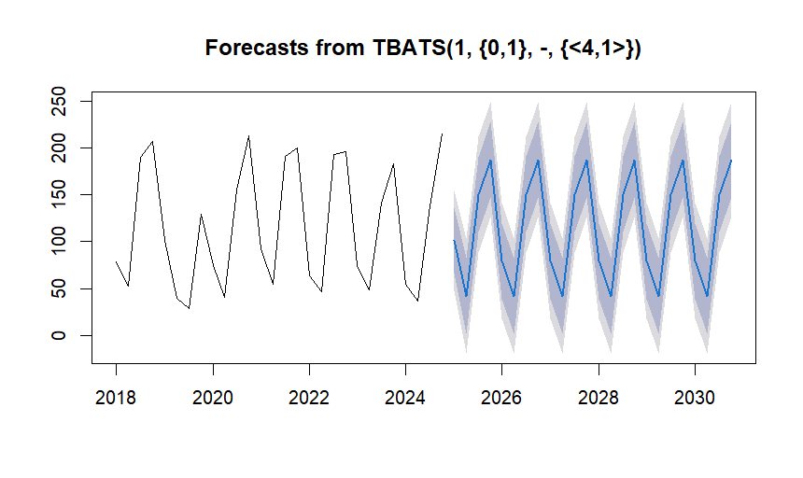
- 5-year forecast with confidence intervals
S <- forecost_tbats$upper[,"95%"] # prediction superieur à 95%
S

Qtr1 Qtr2 Qtr3 Qtr4
2025 154.6910 103.6374 212.1466 249.4364
2026 140.9388 103.6606 212.1698 249.4596
2027 140.9620 103.6838 212.1929 249.4827
2028 140.9852 103.7069 212.2161 249.5059
2029 141.0083 103.7301 212.2393 249.5291
2030 141.0315 103.7533 212.2624 249.5522

I <- forecost_tbats$lower[,"95%"] # prediction inferieur à 95%
I

Qtr1 Qtr2 Qtr3 Qtr4
2025 47.54040 -19.57866 88.91906 126.19747
2026 17.68815 -19.60186 88.89587 126.17428
2027 17.66497 -19.62504 88.87268 126.15110
2028 17.64178 -19.64822 88.84950 126.12793
2029 17.61861 -19.67139 88.82634 126.10476
2030 17.59545 -19.69455 88.80318 126.08160

ts.plot(Incidence.ts[,3], forecost_tbats$mean, S, I, xlab="Annee", ylab="Incidence 1000 habitants", col=c(1,2,4,4), lty=c(1,1,2,2))
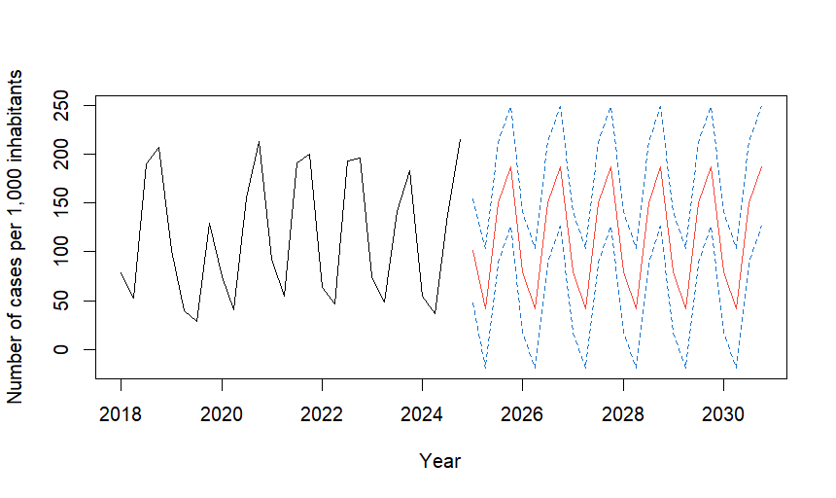

APPENDIX B: SPEAMAN'S LINEAR REGRESSION TEST
spearman Incidencecaspour1000hbts_E CouvertureenMILDAcheslesFE_E CouvertureenMILDAchezles01_E CouvertureenTPICPN_E CouvertureenCPS_E UtilisationdesMILDAchezlesF_E UtilisationdesMILDAchezles0_E UtiisationdesTDR_E UtilisationdesCTA_E DisponibilitéenMILDA_E DisponibilitéenTDRdansFS_E DisponibilitéenCTAdansFS_E Distancetravelledbypeopleto_E

APPENDIX C: CERTIFICATE FROM THE THESIS ETHICS COMMITTEE


