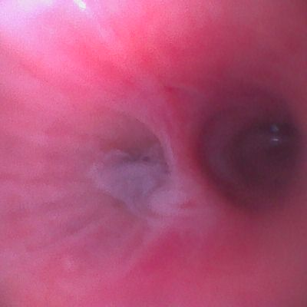
Supplement 1: Bronchoscopy images

Figure 1: Stenosed left upper bronchus lumen (yellow cross)

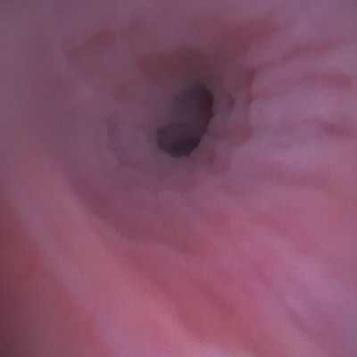
Figure 2: Luminal view of the left upper bronchus using paediatric bronchoscopy before biopsy was taken.

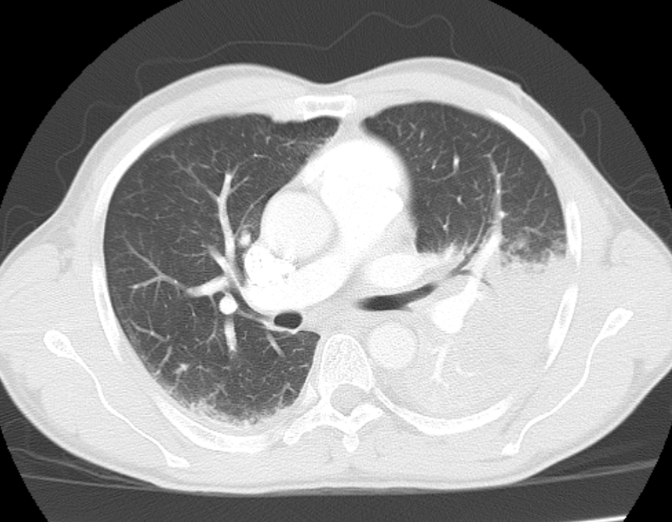
Supplement 2: Radiology images
Figure 3: Non-contrast chest CT scan axial view.

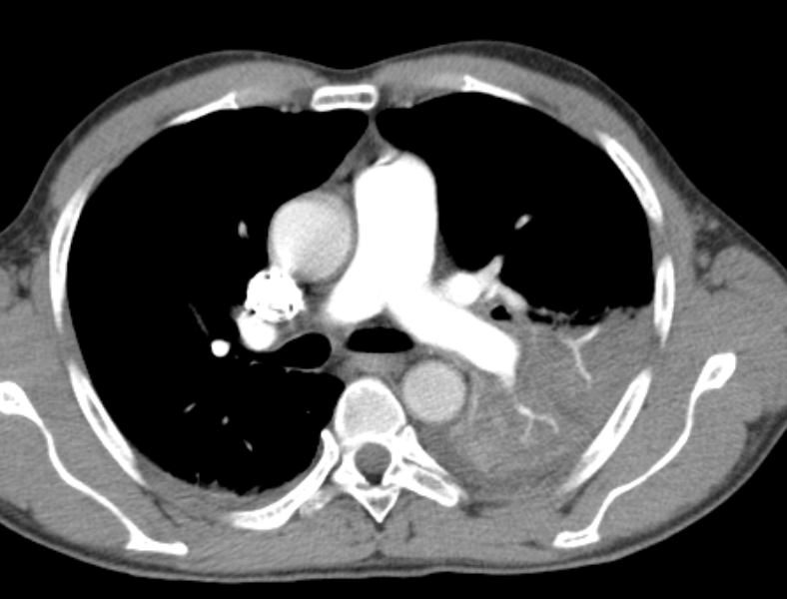
Figure 4: CTPA axial view.
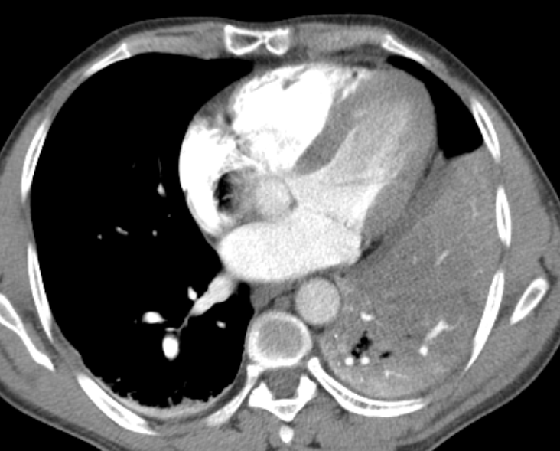
Figure 5: CTPA axial view.

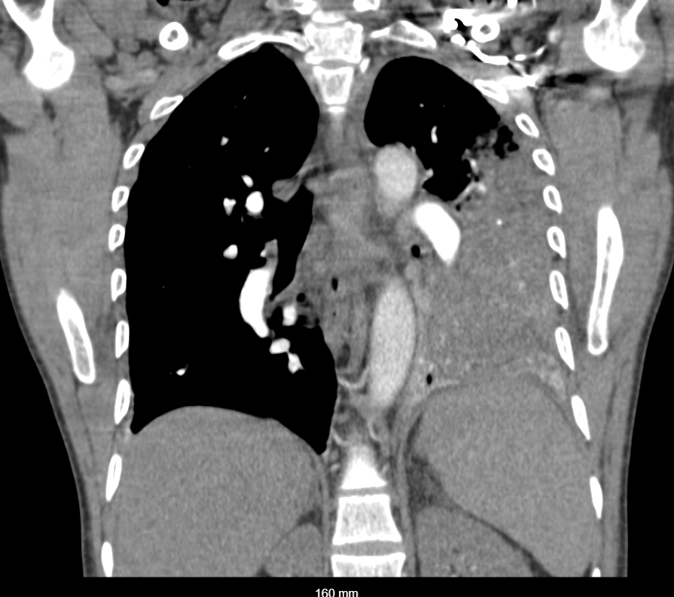
Figure 6: CTPA coronal view.

Key to supplement 2.
Figures 3-6: There is a consolidation opacity in the left lower lung lobe. The remaining lung parenchyma is normal. There is mild bilateral associated pleural effusion. No pericardial effusion. The superior mediastinum is normal. The rib cage is normal. No lytic or osseous lesions. The demonstrated abdomen is normal. Conclusion: The findings are consistent with left lower lobe consolidation and pneumonia, with minimal parapneumonic effusions. No Pulmonary embolism.

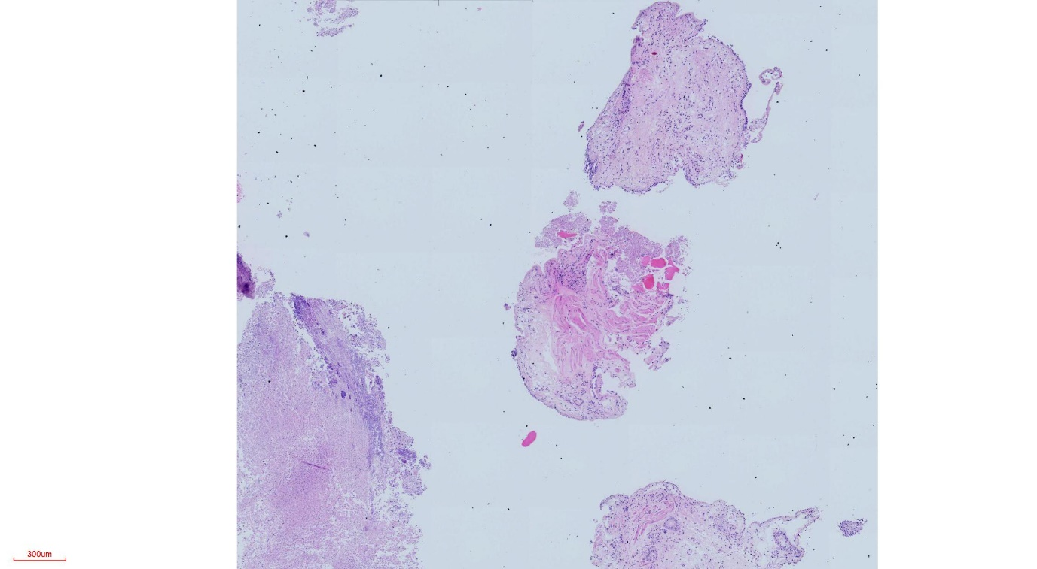
SUPPLEMENT 3. Photomicrographs

Figure 7: Photomicrograph of the bronchial biopsies. (Low-power X4)

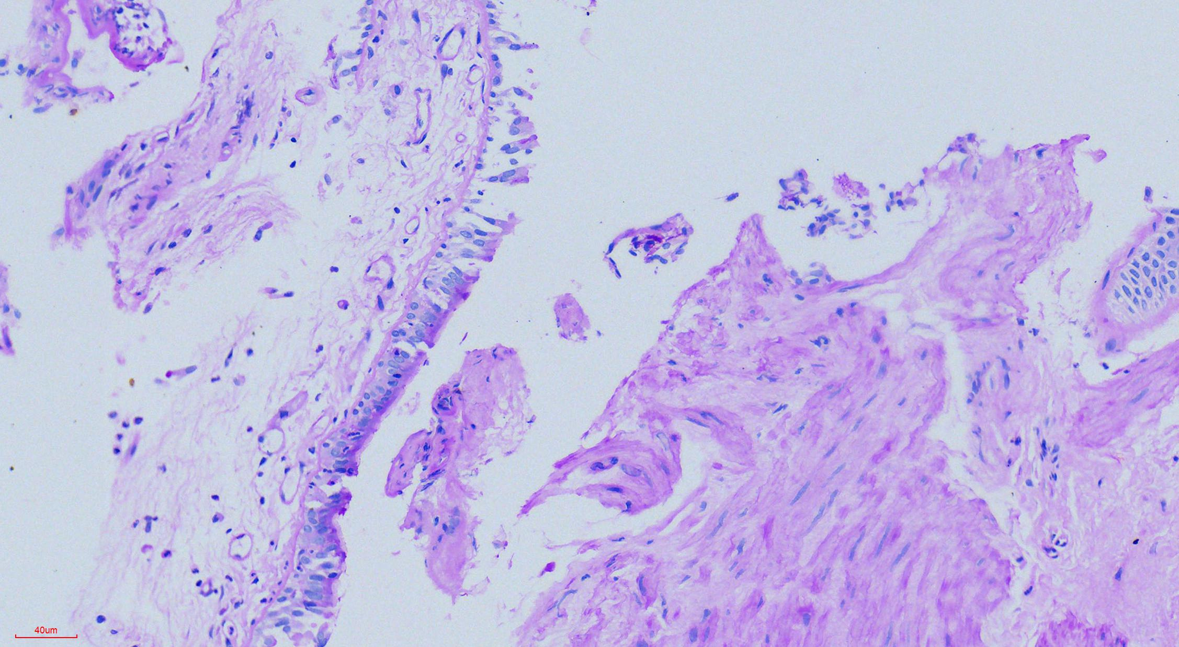
Figure 8: Photomicrograph of the bronchial tissue (H&E stain, X20)

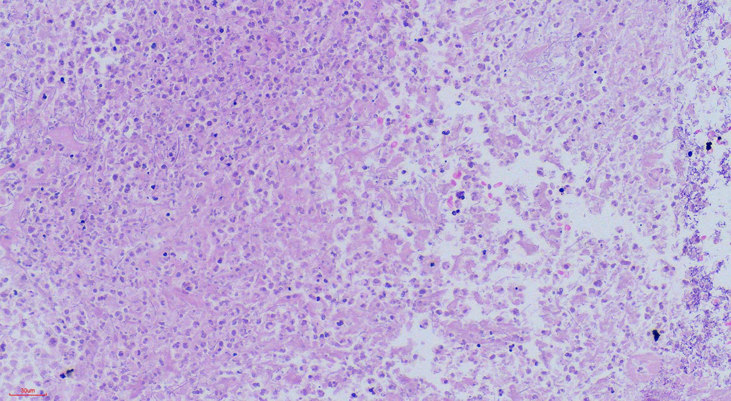
Figure 9: Photomicrograph of Lung tissue with neutrophil infiltrate and necrosis with filamentous fungal elements. (H&E stain, Magnification X20)

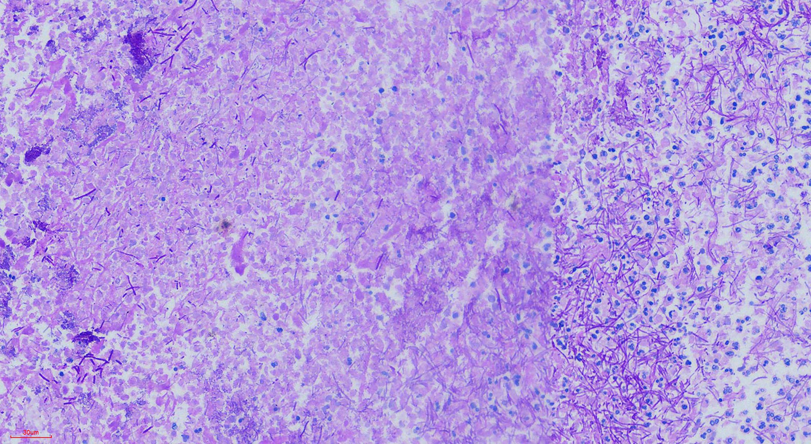
Figure 10: Photomicrograph of lung tissue invaded by filamentous pseudo-hyphae fungal elements. (PAS stain, Magnification X20)

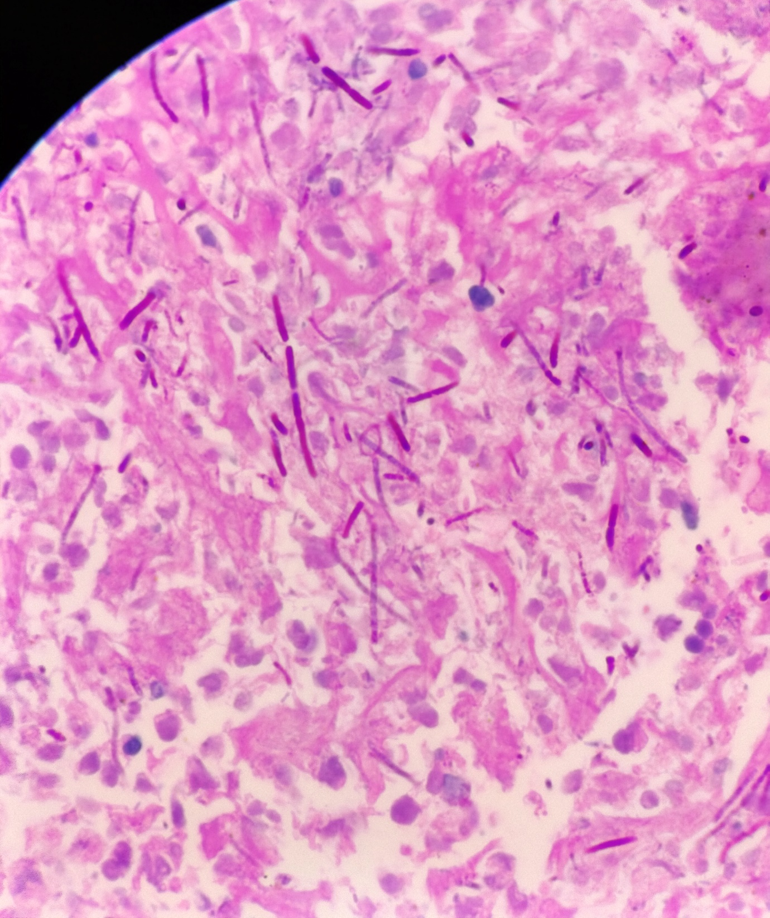
Figure 11: Photomicrograph of lung tissue invaded by filamentous pseudo-hyphae and intense inflammation as necrosis, consistent with invasive Candida species (PAS stain, X100)

