Supplementary Information
Table S1. Group-specific in- and exclusion criteria, across both study phases.
Groups | Inclusion | Exclusion
Optimization phase
Older adults without mobility impairments | - ≥ 65 years old | - Experiences a limitation in mobility (cfr. International Classification of Functioning, Disability and Health)
Chronic stroke survivors | - ≥ 18 years old  - ≥ 6 months after stroke  - Independent walking: FAC levels 3 (dependent on verbal supervision or the presence of an additional person without physical contact during walking), 4 (independent walking but only on level surfaces) or 5 (independent walking on all surfaces) | - Severe problems with speech or memory which prevents the participant to understand/follow instructions or to provide verbal input  - Fully dependent on a key walker or mobility scooter to navigate their life space
Older adults with mobility impairments | - ≥ 65 years old  - Experiences limitations in mobility (cfr. International Classification of Functioning, Disability and Health) | - Severe problems with speech or memory which prevents the participant to understand/follow instructions or to provide verbal input  - Fully dependent on a key walker or mobility scooter to navigate their life space
Validation phase
Older adults without mobility impairments | - ≥ 65 years old | - Experiences a limitation in mobility (cfr. International Classification of Functioning, Disability and Health)
Chronic stroke survivors | - ≥ 18 years old  - ≥ 6 months after stroke  - FAC levels 3 (dependent on verbal supervision or the presence of an additional person during walking) or 4 (independent walking but only on level surfaces) | - Severe problems with speech or memory which prevents the participant to understand/follow instructions or to provide verbal input  - Fully dependent on a key walker or mobility scooter to navigate their life space
Older adults with probable sarcopenia | - ≥ 65 years old  - Reduced muscle strength:  - 5 times sit-to-stand > 15 seconds (cfr. European Working Group on Sarcopenia in Older People)  - AND, maximal hand grip strength of the dominant hand: < 71 kPa (men) , < 41 kPa (women) (cfr. Belgian Society for Gerontology and Geriatrics) | - Severe problems with speech or memory which prevents the participant to understand/follow instructions or to provide verbal input  - Fully dependent on a key walker or mobility scooter to navigate their life space
FAC = Functional Ambulation Category; ICF = International Classification of Functioning, Disability and Health.

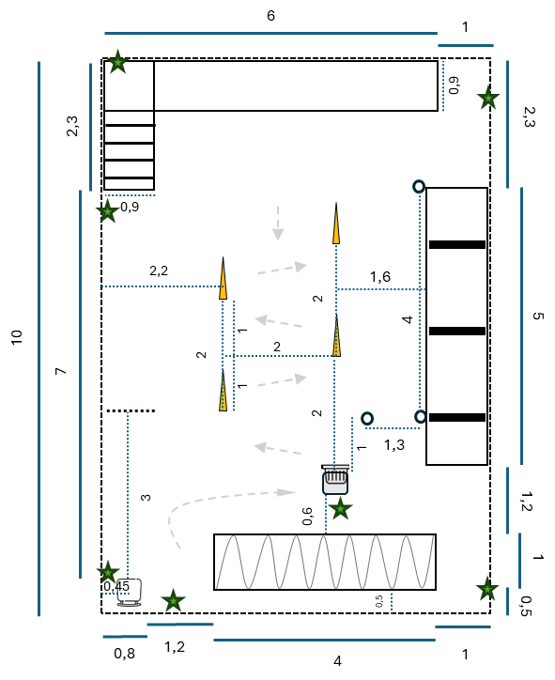
Figure S1. Detailed floorplan of the final FATIGU’AGE protocol with dimensions in meter.

