Supplementary Figure 1
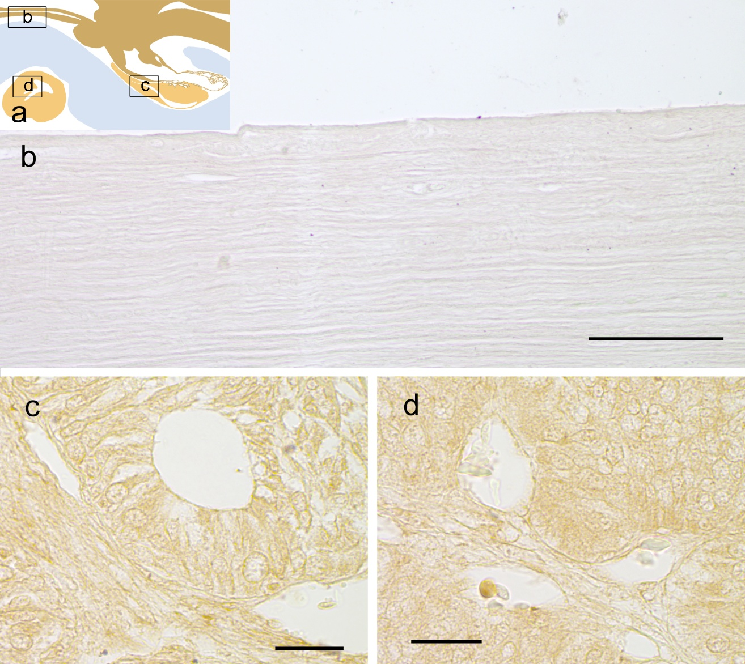

Supplementary Figure 2

Supplementary Figure 3
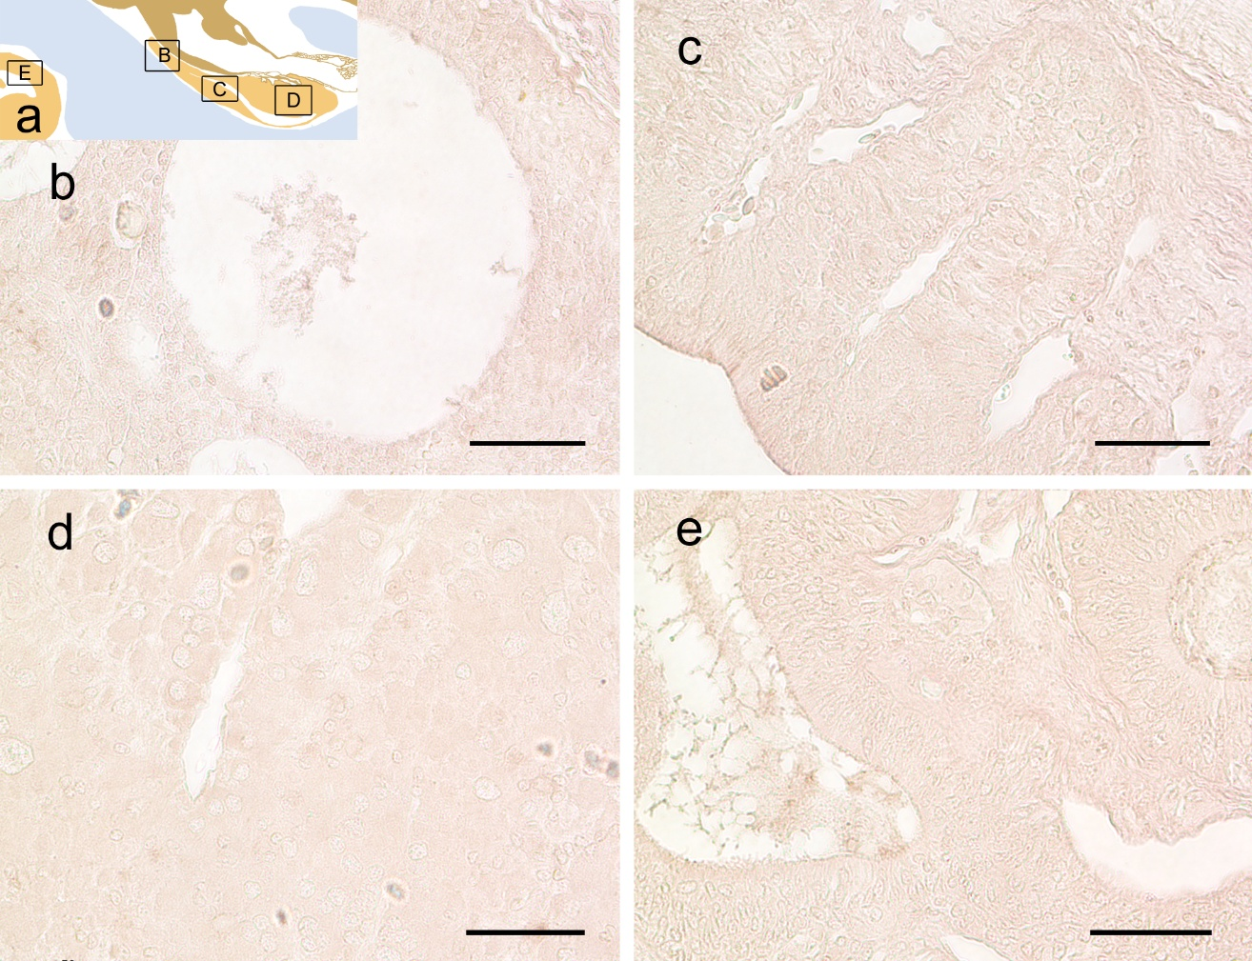

Supplementary Figure 4
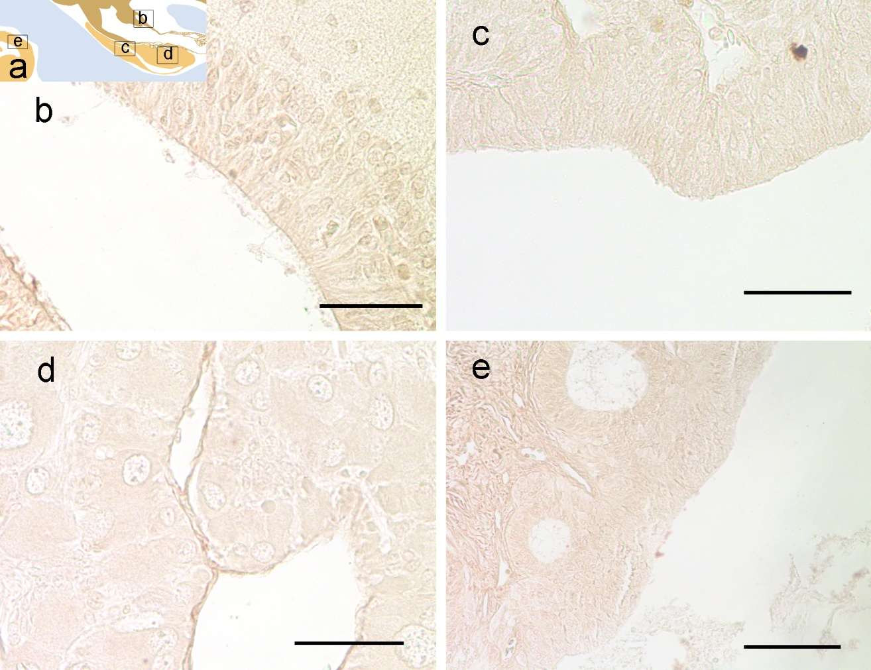

Supplementary Figure 5

Supplementary Figure 6

