Supplementary Figure
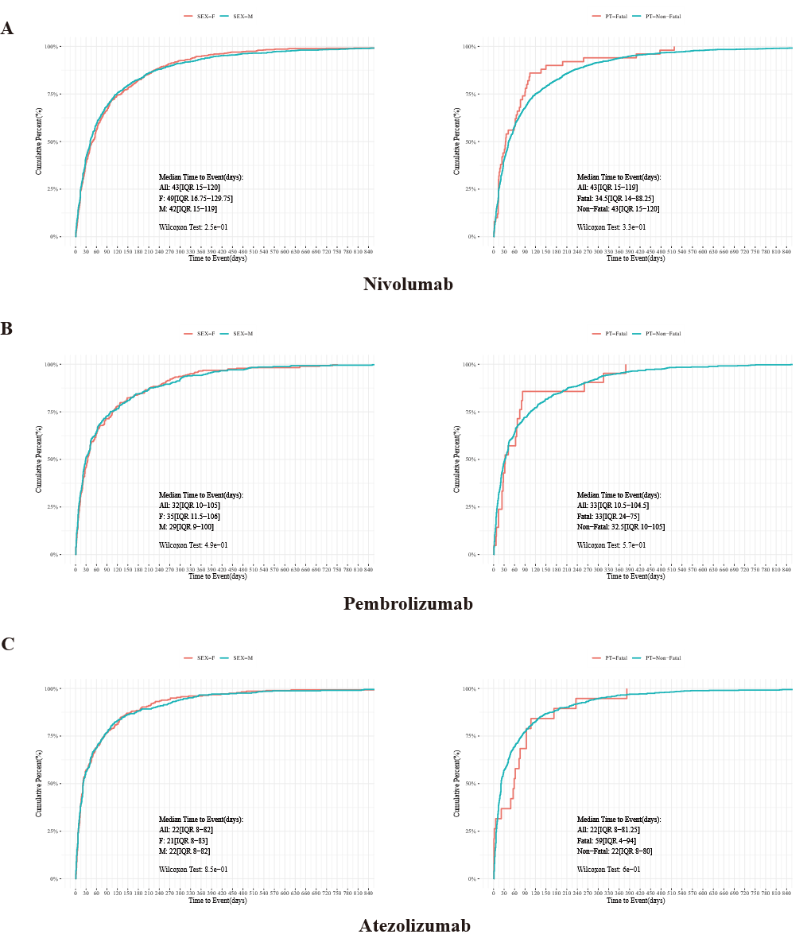
Figure S1. Kaplan-Meier curve analysis of factors associated with the TTO of the MNDs. (A-C) Time of the first MNDs in different sex and fatal outcome groups with nivolumab (A), pembrolizumab (B), atezolizumab (C).

