Additional File 2: Results of additional analyses

A2.1 Results of the correlation analysis between environmental indicators and contextual neighbourhood variables.
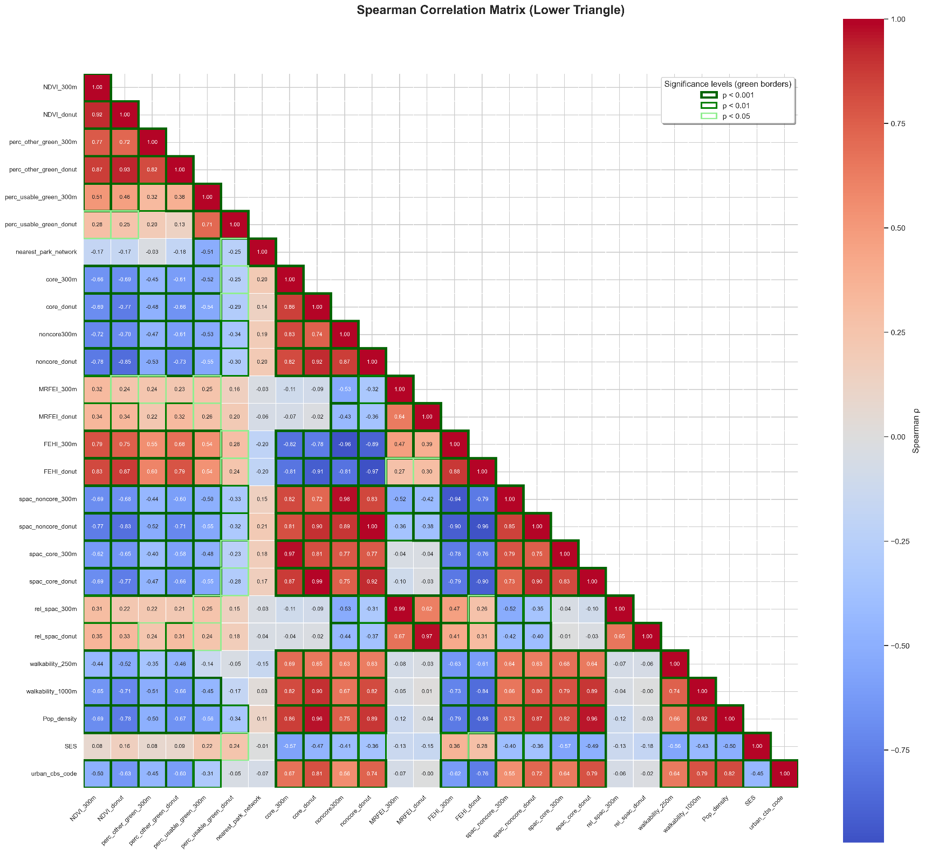
Figure A1. Correlation table between environmental indicators and contextual neighbourhood variables.

*For definition of the environmental indicators see Table 1. Pop_density (population density) defined as addresses per km². SES: Measure of socioeconomic status at the local level, based on a combination of data regarding financial prosperity, educational level and recent employment history of the households. [30]

A2.2 Results of the correlation analysis between principal components and contextual neighbourhood variables

Figure A2. Correlation table of correlation between principal components and contextual neighbourhood variables
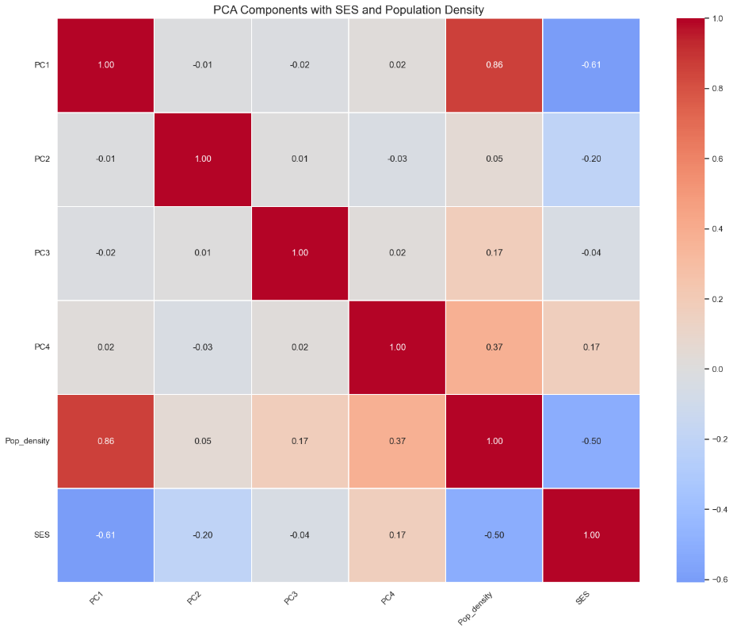
*For definition of the environmental indicators see Table 1. Pop_density (population density) defined as addresses per km². SES: Measure of socioeconomic status at the local level, based on a combination of data regarding financial prosperity, educational level and recent employment history of the households. [30]

A2.3 Additional analyses
The results of the additional analyses are presented below. The following outcomes were included:
- Fruit and vegetable diet quality: a subcomponent of the DHD-index was calculated as the sum of the fruit and vegetable scores (range: 0-20).
- Unhealthy choices: Another DHD-index subcomponent (range: 0-10) was dichotomized as ≥5 (more healthy) or <5 (more unhealthy), given the skewed distribution with many participants scoring either 0 or 10.
- Meeting the physical activity guideline: a binary outcome was derived from the SQUASH data indicating whether participants met the guideline of ≥150 minutes of moderate to vigorous physical activity per week.
- Effect modification by neighbourhood SES: Because the impact of the built environment may differ across different socioeconomic backgrounds as poor living environments are also more common in disadvantaged neighbourhoods with multiple health problems, effect modification between the principal components and the socioeconomic status of the neighbourhood was tested. An interaction term between the ordinal principal component and the continuous SES-WOA score was calculated and added to the main outcome models as a continuous variable. Effect modification was only tested in model 2.

Table S1. Result of univariate and multivariate regression analysis between varimax rotated principal components and DHD-subcomponent fruit and vegetable
Rotated Components |  | Univariate analyses |  | Multivariate model 1 |  | Multivariate model 2
 |  | β | 95% CI | β | 95% CI | β | 95% CI | P for trend
High food, low FEHI, high walkability | Q2  Q3  Q4 | 0.38  -0.09  -0.30 | -0.88, 1.63  -1.34, 1.16  -1.55, 0.95 | 0.29  -0.19  -0.15 | -1.05, 1.63  -1.56, 1.18  -1.50, 1.20 | 0.19  -0.70  -0.70 | -1.17, 1.55  -2.18, 0.77  -2.10, 0.70 | 0.24
Relative food environment advantage | Q2  Q3  Q4 | 0.24  0.21  -0.89 | -0.99, 1.47  -1.05, 1.48  -2.17, 0.39 | 0.07  -0.33  -1.51* | -1.19, 1.33  -1.62, 0.95  -2.86, -0.16 | -0.03  -0.57  -1.70* | -1.30, 1.24  -1.94, 0.80  -3.10, -0.31 | 0.01*
Low density and high distance to accessible green | Q2  Q3  Q4 | -0.48  -0.01  -0.55 | -1.72, 0.77  -1.25, 1.23  -1.82, 0.72 | -0.64  -0.29  -0.27 | -1.89, 0.62  -1.53, 0.96  -1.59, 1.05 | -0.40  -0.24  -0.14 | -1.74, 0.95  -1.49, 1.01  -1.47, 1.19 | 0.87
Low-quality, agricultural/inaccessible green | Q2  Q3  Q4 | -0.36  -0.21  -0.48 | -1.62, 0.89  -1.46, 1.05  -1.74, 0.77 | -0.67  -0.53  -0.49 | -2.01, 0.67  -1.89, 0.82  -1.83, 0.86 | -0.36  -0.37  -0.51 | -1.78, 1.06  -1.78, 1.05  -1.86, 0.83 | 0.52
*p<0.05. Multivariate model 1 included the individual principal components per model corrected for age, sex, educational level, migration background, SES-WOA score of the 4-digit postal code and population density. Multivariate model 2 included all principal components corrected for the aforementioned confounders.

Table S2. Result of univariate and multivariate logistic regression analysis between varimax rotated principal components and DHD-subcomponent unhealthy choices
Rotated Components |  | Univariate analyses |  | Multivariate model 1 |  | Multivariate model 2
 |  | OR | 95% CI | OR | 95% CI | OR | 95% CI | P for trend
High food, low FEHI, high walkability | Q2  Q3  Q4 | 1.07  0.77  0.79 | 0.64, 1.77  0.46, 1.27  0.48, 1.32 | 1.07  0.79  0.66 | 0.62, 1.83  0.45, 1.40  0.31, 1.39 | 0.94  0.69  0.70 | 0.53, 1.67  0.37, 1.28  0.39, 1.26 | 0.17
Relative food environment advantage | Q2  Q3  Q4 | 0.86  0.86  0.79 | 0.52, 1.41  0.51, 1.43  0.47, 1.33 | 0.92  0.85  0.73 | 0.55, 1.16  0.50, 1.46  0.41, 1.30 | 0.87  0.80  0.67 | 0.51, 1.48  0.45, 1.42  0.37, 1.21 | 0.17
Low density and high distance to accessible green | Q2  Q3  Q4 | 0.74  0.69  0.58* | 0.45, 1.23  0.41, 1.13  0.34, 0.97 | 0.76  0.68  0.56* | 0.45, 1.29  0.41, 1.15  0.33, 0.96 | 0.76  0.73  0.59 | 0.43, 1.32  0.43, 1.23  0.34, 1.04 | 0.07
Low-quality, agricultural/inaccessible green | Q2  Q3  Q4 | 1.19  1.43  1.19 | 0.71, 1.98  0.86, 2.39  0.71, 1.98 | 1.19  1.36  1.25 | 0.68, 2.06  0.77, 2.41  0.67, 2.33 | 1.07  1.21  1.05 | 0.59, 1.95  0.67, 2.20  0.59, 1.86 | 0.80

*p<0.05. Multivariate model 1 included the individual principal components per model corrected for age, sex, educational level, migration background, SES-WOA score of the 4 digit postal code and level of urbanicity. Multivariate model 2 included all principal components corrected for the aforementioned confounders.

Table S3. Result of univariate and multivariate logistic regression analysis between varimax rotated principal components and meeting the physical activity guideline.
Rotated Components |  | Univariate analyses |  | Multivariate model 1 |  | Multivariate model 2
 |  | OR | 95% CI | OR | 95% CI | OR | 95% CI | P for trend
High food, low FEHI, high walkability | Q2  Q3  Q4 | 0.92  0.68  0.93 | 0.55, 1.54  0.40, 1.16  0.55, 1.56 | 0.78  0.79  0.89 | 0.45, 1.37  0.44, 1.44  0.41, 1.95 | 0.77  0.87  1.15 | 0.43, 1.39  0.45, 1.67  0.63, 2.10 | 0.62
Relative food environment advantage | Q2  Q3  Q4 | 0.71  1.08  0.78 | 0.42, 1.20  0.64, 1.82  0.45, 1.33 | 0.91  1.41  1.10 | 0.52, 1.57  0.81, 2.45  0.61, 1.99 | 0.93  1.52  1.13 | 0.54, 1.62  0.84, 2.75  0.61, 2.09 | 0.48
Low density and high distance to accessible green | Q2  Q3  Q4 | 0.84  0.77  0.93 | 0.50, 1.41  0.46, 1.30  0.55, 1.58 | 1.00  0.71  0.97 | 0.58, 1.75  0.41, 1.22  0.55, 1.70 | 0.98  0.73  1.02 | 0.54, 1.77  0.42, 1.26  0.57, 1.83 | 0.87
Low-quality, agricultural/inaccessible green | Q2  Q3  Q4 | 1.04  1.72*  1.30 | 0.61, 1.78  1.01, 2.90  0.77, 2.20 | 1.05  1.32  1.07 | 0.58, 1.89  0.73, 2.37  0.56, 2.04 | 1.06  1.40  1.20 | 0.56. 2.00  0.76. 2.61  0.66. 2.18 | 0.39
*p<0.05. Multivariate model 1 included the individual principal components per model corrected for age, sex, educational level, migration background, SES-WOA score of the 4 digit postal code and population density. Multivariate model 2 included all principal components corrected for the aforementioned confounders.
Table S4. Interaction Effects of Socioeconomic Status and Principal Component on weight status
Weight status | Variables  Quartiles | Multivariate model 2
Overweight |  | OR | 95% CI
 | High food, low FEHI, high walkability  Q2  Q3  Q4  Socioeconomic status¹  Socioeconomic status * PC1 | 1.34  1.23  1.01  0.18  1.14 | 0.67, 2.71  0.51, 2.93  0.33, 3.11  0.02, 1.47  0.47, 2.75
 | Relative food environment advantage  Q2  Q3  Q4  Socioeconomic status¹  Socioeconomic status * PC2 | 0.91  0.49  0.72  0.11  1.47 | 0.45, 1.85  0.23, 1.05  0.35, 1.49  0.01, 1.25  0.57, 3.75
 | Low density and high distance to accessible green  Q2  Q3  Q4  Socioeconomic status¹  Socioeconomic status * PC3 | 1.05  1.60  0.91  0.24  0.98 | 0.52, 2.16  0.83, 3.08  0.43, 1.94  0.03, 2.41  0.47, 2.03
 | Low-quality, agricultural/inaccessible green  Q2  Q3  Q4  Socioeconomic status¹  Socioeconomic status * PC4 | 1.07  1.09  1.24  0.50  0.79 | 0.47, 2.46  0.44, 2.71  0.44, 3.48  0.05, 5.37  0.37, 1.17
Obese |  | OR | 95% CI
 | High food, low FEHI, high walkability  Q2  Q3  Q4  Socioeconomic status¹  Socioeconomic status * PC1 | 1.49  1.26  1.86  0.49  0.70 | 0.65, 3.42  0.47, 3.36  0.57, 6.10  0.06, 3.93  0.26, 1.86
 | Relative food environment advantage  Q2  Q3  Q4  Socioeconomic status¹  Socioeconomic status * PC2 | 0.53  0.60  0.71  0.02  3.47* | 0.31, 1.59  0.25, 1.42  0.22, 1.26  0.00, 0.23  1.22, 9.90
 | Low density and high distance to accessible green  Q2  Q3  Q4  Socioeconomic status¹  Socioeconomic status * PC3 | 1.32  1.55  0.94  0.14  1.29 | 0.60, 2.91  0.74, 3.23  0.39, 2.23  0.01, 1.41  0.59, 2.79
 | Low-quality, agricultural/ inaccessible green  Q2  Q3  Q4  Socioeconomic status¹  Socioeconomic status * PC4 | 1.37  1.73  2.06  0.36  0.90 | 0.52, 3.59  0.62, 4.82  0.68, 6.25  0.06, 3.93  0.26, 1.86

¹Measure of socioeconomic status at the local level, based on a combination of data regarding financial prosperity, educational level and recent employment history of the households.
Table S5. Interaction Effects of Socioeconomic Status and Principal Component on total DHD-index score
Variables | Multivariate model 2
 | β | 95% CI
High food, low FEHI, high walkability  Q2  Q3  Q4  Socioeconomic status¹  Socioeconomic status * PC1 | -1.21  -2.55  -2.18  -1.62  -0.69 | -5.91, 3.49  -7.69, 2.59  -7.04, 2.68  -21.04, 17.79  -6.59, 5.22
Relative food environment advantage  Q2  Q3  Q4  Socioeconomic status¹  Socioeconomic status * PC2 | -0.33  -1.12  -3.76  -7.51  1.53 | -5.10, 4.44  -6.10, 3.85  -8.69, 1.17  -25.64, 10.62  -4.69, 7.75
Low density and high distance to accessible green  Q2  Q3  Q4  Socioeconomic status¹  Socioeconomic status * PC3 | -0.91  -0.52  -1.36  -7.97  1.85 | -5.54, 3.72  -4.89, 3.85  -5.97, 3.24  -20.33, 4.39  -2.84, 6.54
Low-quality, agricultural/inaccessible green  Q2  Q3  Q4  Socioeconomic status¹  Socioeconomic status * PC4 | -3.44  -2.06  -3.03  -8.29  2.01 | -8.43, 1.55  -6.96, 2.84  -7.68, 1.63  -22.04, 5.46  -2.82, 6.84

¹Measure of socioeconomic status at the local level, based on a combination of data regarding financial prosperity, educational level and recent employment history of the households.

Table S6. Interaction Effects of Socioeconomic Status and Principal Component on Total Minutes of Weekly Physical Activity
Variables | Multivariate model 2
 | β | 95% CI
High food, low FEHI, high walkability  Q2  Q3  Q4  Socioeconomic status¹  Socioeconomic status * PC1 | -0.93  -0.49  2.61  2.38  1.95 | -4.55, 2.70  -4.45, 3.46  -1.14, 6.35  -12.56, 17.32  -2.62, 6.53
Relative food environment advantage  Q2  Q3  Q4  Socioeconomic status¹  Socioeconomic status * PC2 | -1.21  -0.05  -1.48  -3.05  4.10 | -4.87, 2.45  -3.87, 3.77  -5.31, 2.35  -17.24, 11.14  -0.75, 8.94
Low density and high distance to accessible green  Q2  Q3  Q4  Socioeconomic status¹  Socioeconomic status * PC3 | -1.65  -1.30  -2.00  8.90  -0.43 | -5.23, 1.94  -4.67, 2.07  -5.56, 1.56  -0.84, 18.64  -4.11, 3.24
Low-quality, agricultural/inaccessible green  Q2  Q3  Q4  Socioeconomic status¹  Socioeconomic status * PC4 | -0.94  -1.89  2.10  9.39  -0.19 | -4.77, 2.89  -5.65, 1.87  -1.47, 5.67  -1.39, 20.18  -3.94, 3.56

¹Measure of socioeconomic status at the local level, based on a combination of data regarding financial prosperity, educational level and recent employment history of the households.

