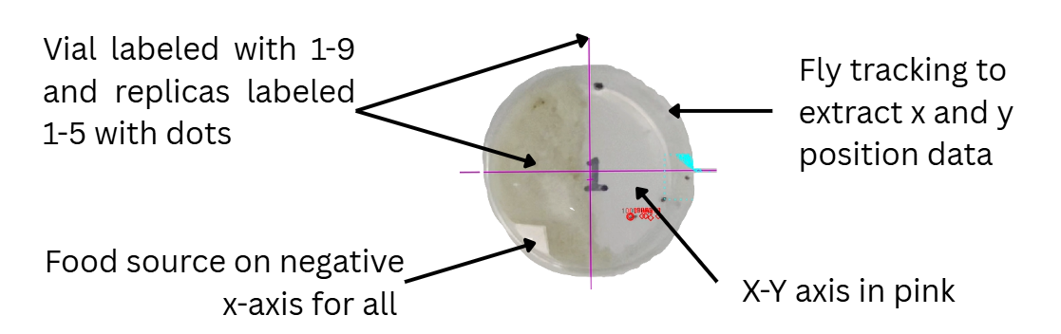
Illustration 1. Petri dish arrangement showing five flies per dish across nine experimental groups.
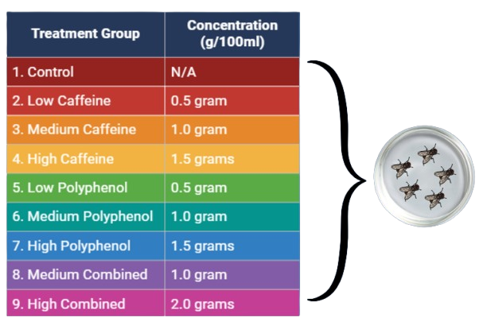
Illustration 2. Describes the nine treatment groups; all gram values are per 100ml of food medium; 5 Drosophila melanogaster in one petri dish.

