Supplementary Full Uncropped Blots
General notes
All Western blot signals were detected by X-ray film exposure.
Membranes were cut prior to antibody incubation as described in individual supplementary figure legends.
Supplementary Figure S1
Full uncropped film images corresponding to Figure 1A
After protein transfer, membranes were cut according to molecular weight and probed separately with different primary antibodies. Each membrane piece was independently exposed to X-ray film. The images shown here represent full, uncropped scans of the original films corresponding to the blots presented in Figure 1. Red boxes indicate the regions used in the main figure.

CD9

CD63

Calnexin
TSG101

GM130

Supplementary Figure S2
Full uncropped film images corresponding to Figure 5B
After protein transfer, membranes were cut according to molecular weight and probed separately with different primary antibodies. Each membrane piece was independently exposed to X-ray film. The images shown here represent full, uncropped scans of the original films corresponding to the blots presented in Figure 5. Red boxes indicate the regions used in the main figure.
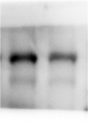

IκBα

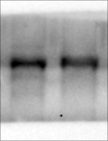

Supplementary Figure S2
Full uncropped film images corresponding to Figure 5C
After protein transfer, membranes were cut according to molecular weight and probed separately with different primary antibodies. Each membrane piece was independently exposed to X-ray film. The images shown here represent full, uncropped scans of the original films corresponding to the blots presented in Figure 5. Red boxes indicate the regions used in the main figure.
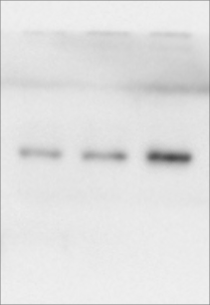

IκBα

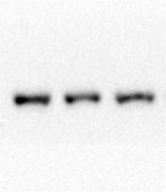

β-Actin
β-Actin

