Supporting Information

Particle-associated diazotrophs drive nitrogen fixation in Arctic subsurface waters

Mar Benavides, Arthur Coët, Marta Sebastián, Angela Vogts, Christian Furbo Reeder, Elena Cerdán-García, Ruth Hawley, Oliver Flanagan, Maeve C. Lohan, Joanne E. Hopkins, Claire Mahaffey

Mar Benavides
Email: mar.benavides@noc.ac.uk

Supplementary Methods

Biogeochemical and hydrographic data

The DY167 N-Arc GEOTRACES GApr19 cruise took place from 9 July to 13 August 2023 onboard the RRS Discovery. Water column profiles of pressure, temperature, salinity were obtained with a Seabird SBE 911plus CTD along with fluorescence, beam transmission, turbidity, oxygen and photosynthetic active radiation (PAR) sensors mounted on a 24-Niskin bottle stainless steel rosette frame.

Nutrient concentrations (nitrate plus nitrite = NN and phosphate = PO4 were determined onboard from triplicate fresh samples using a Bran and Luebbe QuAAtro 5-channel nutrient autoanalyzer ^{1,2}. The limit of detection of NN and PO4 was 0.1 µM. CTD fluorescence, oxygen and salinity profiles were calibrated against experimental values measured from seawater samples collected from stainless stell CTD casts as described in the DY167 cruise report ³. Dissolved and particulate iron (dFe and pFe, respectively) concentrations were obtained from seawater samples collected with Go-Flo bottles mounted on a titanium rosette frame following GEOTRACES protocols ^{3,4}. Stainless steel and titanium cast data are available in references ⁵ and ⁶, respectively.

An optimum multi-parameter (OMP) analysis was performed to identify the fractions of five key regional water masses present at sampling stations: Atlantic Water (AW), warm Atlantic Water (wAW), Arctic Water (AW), warm Arctic Water (wArW) and Glacial Water (GW). Both physical and biogeochemical tracers were used to constrain the results: conservative temperature, absolute salinity, nitrate+nitrite, silicate, and the meteoric and sea ice melt fractions derived from oxygen isotope samples (Ilyas et al., in prep.) For each station, the MSC sampling depths were matched to the nearest OMP result to provide an indication of the dominant water pass present.

DNA sampling, extraction, nifH gene sequencing and bioinformatics

Samples for DNA analyses were sequentially filtered through 3 µm Isopore polycarbonate filters (Millipore, Tullagreen, Carrightwohill, Ireland), and 0.2 µm Supor filters (Pall Corporation, Ann Arbor, MI, USA) to obtain particle-associated and free-living DNA fractions, respectively. Filters were transferred to 2 ml bead beater tubes containing sterile 0.1 mm and 0.5 mm silica beads and stored at -80ºC until DNA extractions ashore.

DNA was extracted from the particle-associated (3 µm) and free-living (0.2 µm) fractions using the DNeasy Plant Mini Kit (Qiagen, Courtaboeuf, France) with additional freeze-thaw bead beating and proteinase-K steps (Scientific Laboratory Supplies, Wilford, Nottingham, UK) before the kit purification step ⁷. Triplicate nested PCR reactions were conducted using the degenerate primers nifH3 (5’-ATRTTRTTNGCNGCRTA-3’) and nifH4 (5’-TTYTAYGGNAARGGNGG-3’) in the first PCR, followed by a second amplification with nifH1 (5’-TGYGAYCCNAARGCNGA-3’) and nifH2 (5’-ADNGCCATCATYTCNCC-3’) primers ^{8,9} (Eurofins Genomics, Nantes, France). The PCR mix was composed of 5 μl of 5X MyTaq red PCR buffer (Bioline, Memphis, TN, USA), 1.25 μl of 25 mM MgCl₂, 0.5 μl of 20 μM forward and reverse primers, 0.25 μl Platinum Taq, and 5 μl of DNA extract (1 μl on the second round). The reaction volume was adjusted to 25 μl with PCR grade water (Invitrogen, Carlsbad, CA, USA). All PCR reagents, Taq polymerase and buffers were purchased from Thermo Fisher (Ward Hill, MA, USA). Triplicate PCR products were pooled and purified using the GeneClean Turbo kit (MP Biomedicals, Santa Ana, CA, USA).

Partial adapters were added by ligation at the AZENTA/Genewiz sequencing facility (Leipzig, Germany) and llumina MiSeq 2 x 300 paired end sequenced. Demultiplexed paired-end sequences were dereplicated, denoised, assembled and chimeras discarded using the DADA2 pipeline ¹⁰. Between 1,966 and 227,863 reads were obtained per sample (mean ± SD: 46,745 ± 32,342 reads per sample). In total, 8,451,393 nifH gene sequences were obtained resulting in 494 amplicon sequence variants (ASVs; submitted to NCBI under project number PRJNA1412537). ASVs were annotated down to the genus level using a DADA2 formatted nifH gene database ¹¹. ASVs accounting for 1% or more of the reads for at least one of the samples were grouped into 44 genera according to the database (Table S2), and those sequences not identified to the genus level were grouped as ‘unknown’ betaproteobacteria, cyanobacteria or deltaproteobacteria. We obtained 8,451,393 sequences and 494 amplicon sequence variants (ASVs), annotated as 37 families and 49 genera (Table S3).

Nitrogenase antibody immunolabeling specificity

Nitrogenase (NifH) immunolabeling specificity was verified using complementary negative controls (Fig. S7). Full immunolabeling performed on a non-diazotrophic strain (Pseudomonas guineae; Fig. S7A) did not yield any detectable signal in the NifH (Alexa Fluor 594) channel. Similarly, omission of the primary antibody on the diazotrophic strain Vibrio diazotrophicus resulted in no detectable NifH signal (Fig. S7B). Finally, primary-antibody omission controls performed on marine snow particle samples collected on 3 µm filters also showed no detectable fluorescence in the NifH channel (Fig. S7C). Together, these controls confirm the absence of non-specific antibody binding and demonstrate that the secondary antibody alone does not generate detectable background signal.

Comparison of particle-associated diazotroph communities with lower latitude studies. To allow a direct comparison of particle-associated diazotroph communities across cruises and with lower-latitude studies, raw nifH amplicon sequences from the three campaigns (^{12,13} and this study) were reprocessed jointly using a unified bioinformatic pipeline based on DADA2 ¹⁰. All raw FASTQ files were pooled and treated together to infer a single, shared set of amplicon sequence variants (ASVs), thereby avoiding inconsistencies arising from independent denoising.
Both paired-end and forward-only reads were included. For paired-end reads, forward and reverse sequences were quality-filtered using filterAndTrim with truncation lengths of 230 bp (forward) and 150 bp (reverse), removal of reads containing ambiguous bases (maxN = 0), a maximum expected error threshold of 2 for each read (maxEE = c(2,2)), truncation at a quality score of 2 (truncQ = 2), primer trimming of 17 bp on both reads (trimLeft = c(17,17)), and removal of PhiX reads. Forward-only reads were processed separately using the same quality-filtering criteria, except for a truncation length of 180 bp and primer trimming of 17 bp on the forward read only. Error models were learned jointly across all filtered reads. Paired-end reads were denoised independently for forward and reverse directions and subsequently merged, while forward-only reads were denoised up to ASV inference. ASV tables derived from paired-end and forward-only datasets were then merged into a single sequence table. Chimeric sequences were removed using the consensus method implemented in DADA2.

ASVs were anotated using a curated nifH database ¹¹ Taxonomy was assigned using the DADA2 assignTaxonomy function with a minimum bootstrap confidence threshold of 80. This unified processing ensured that differences observed between cruises reflect biological variation rather than methodological biases. Family-level nifH ASVs were Hellinger-transformed and NMDS-ordained on Bray-Curtis dissimilarities using the microViz R package ¹⁴. Overlap of nifH ASVs among ocean basins was visualised using a three-way Venn diagram. ASV presence/absence was determined separately for each ocean basin (Pacific: NCDC cruise ¹²; Atlantic: e-IMPACT cruise ¹³; Arctic: NARC cruise: this study). ASVs were considered present in an ocean basin if they occurred in at least one sample from that cruise. Overlap sizes represent raw counts and percentages (relative to total ASVs across all three basins) and were generated using the VennDiagram R package ¹⁵.

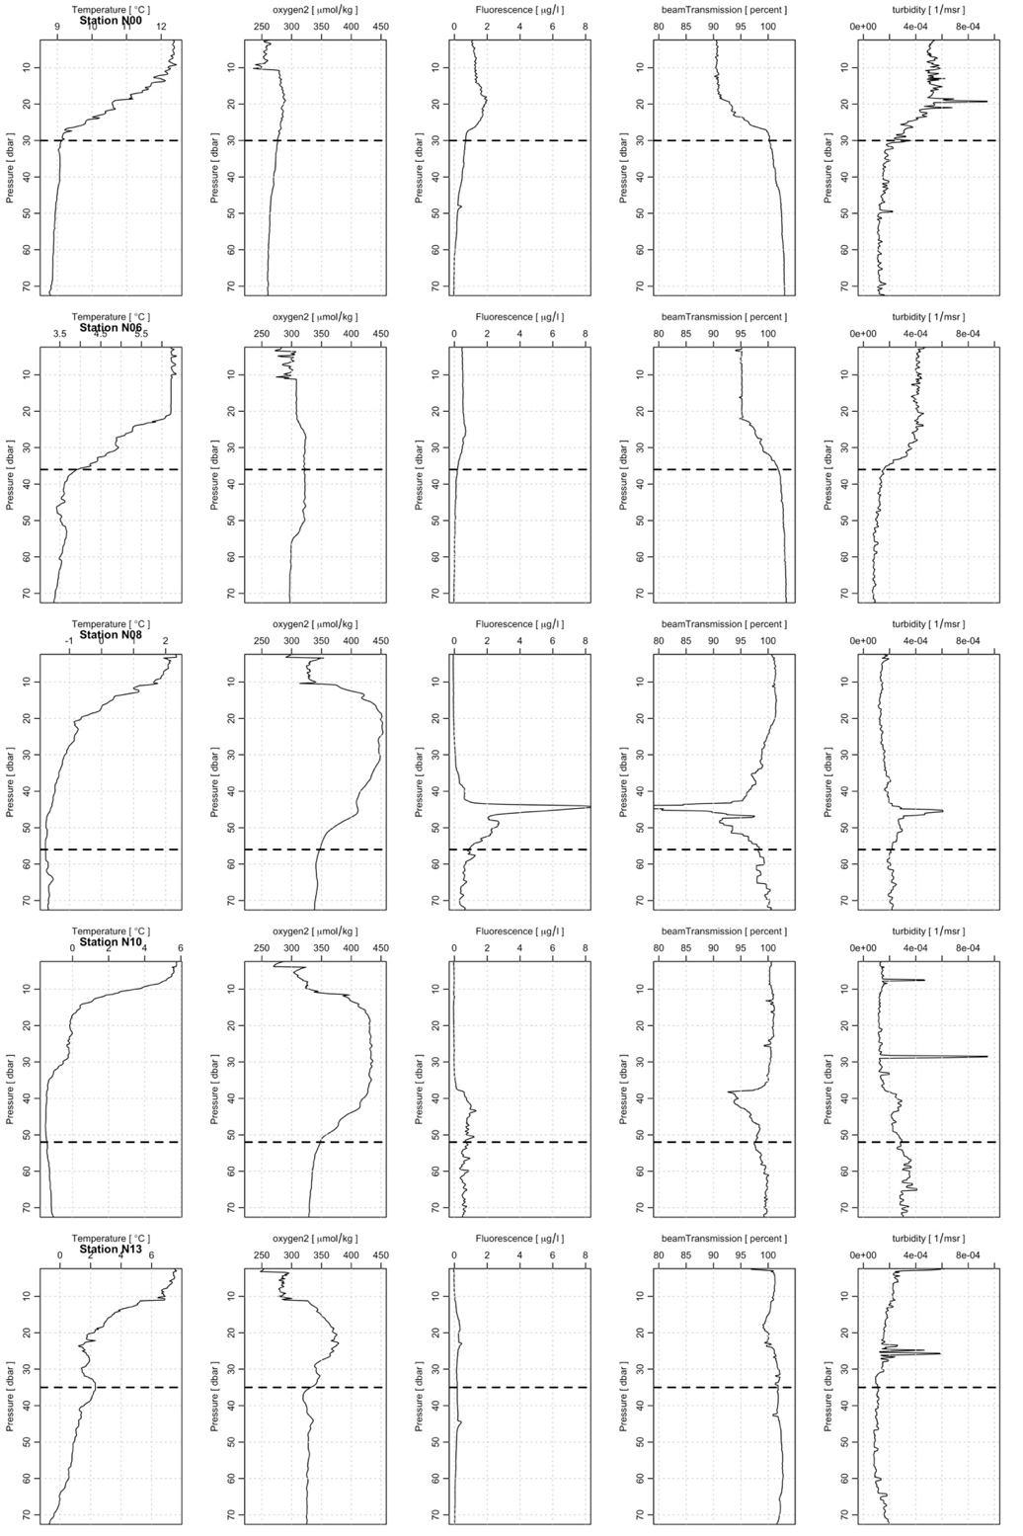
Fig. S1. Hydrographic profiles. Temperature, oxygen, fluorescence, beam transmission and turbidity profiles at stations where single-cell N₂ fixation measurements were performed (i.e., stations N00, N06, N08, N10 and 13). Dashed lines indicate the depth were the marine snow catcher (MSC) was deployed to.
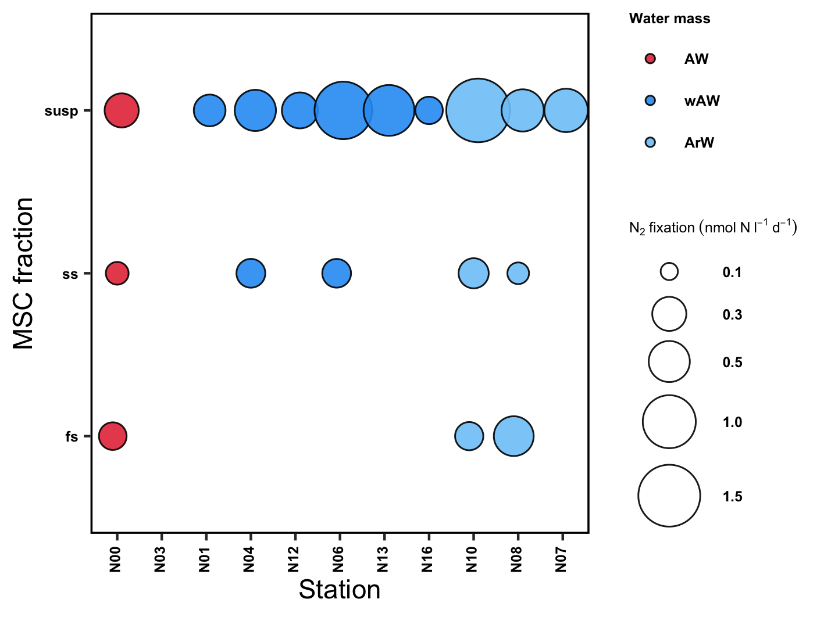Fig. S2. Bulk N₂ fixation rates in MSC fractions. Bulk N₂ fixation rates in the suspended (susp), slow sinking (ss) and fast sinking (fs) marine snow catcher (MSC) particle fractions, coloured by water mass (AW = Atlantic Water, wAW = warm Atlantic Water, ArW = Arctic Water). The size of the circles depicts the magnitude of the rate. Average and standard deviation values are shown in Table S5.
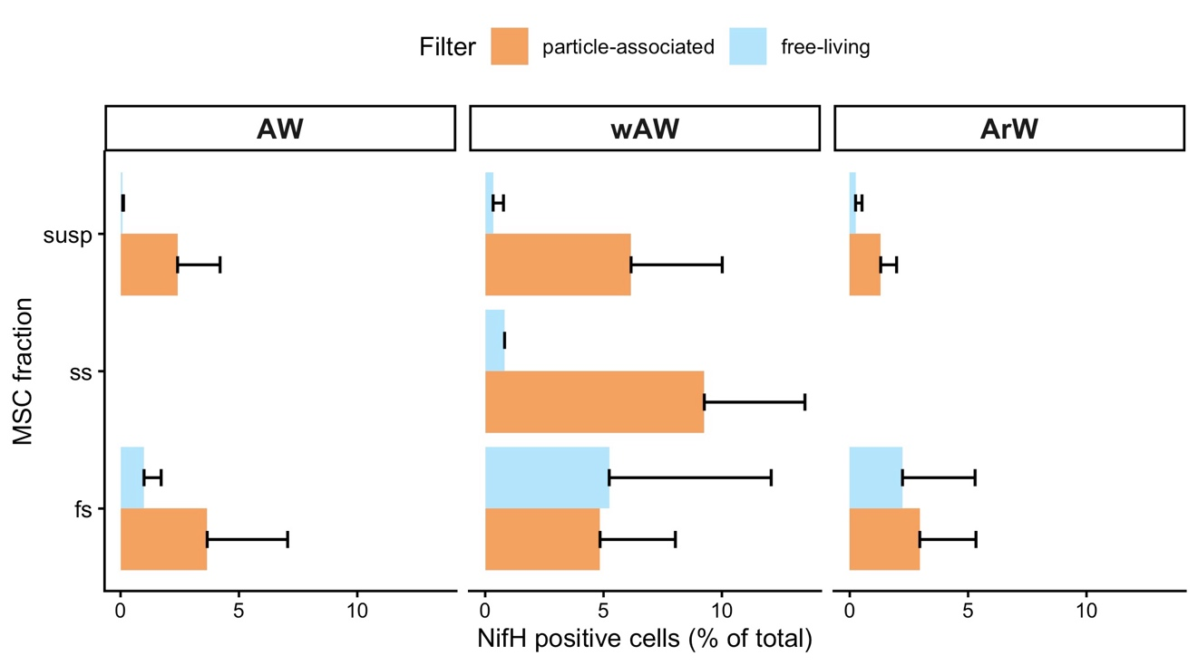
Fig. S3. Counts of particle-associated and free-living diazotrophs. Average percentage contribution of free-living (0.2 µm filters) and particle-associated (3 µm filters) diazotrophs (DAPI and NifH positive cells) to the total microbial community (DAPI positive cells). Percentage contributions are faceted by water mass (AW = Atlantic Water, wAW = warm Atlantic Water, ArW = Arctic Water) and marine snow catcher particle fraction (susp = suspended, ss = slow sinking, fs = fast sinking). NifH antibody positive cells in the ss fraction were only detected in wAW waters and were not further considered for nanoSIMS analyses (see Fig. 2).
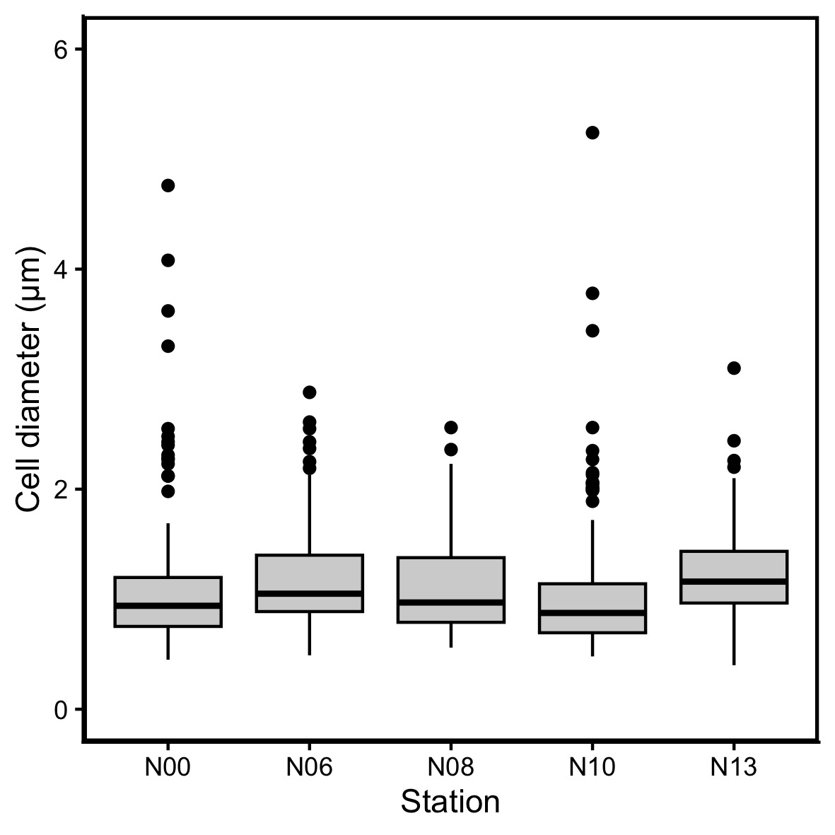
Fig. S4. Diameter of particle-associated cells. Diameter of particle-associated NifH and DAPI positive cells used for nanoSIMS analyses by station.
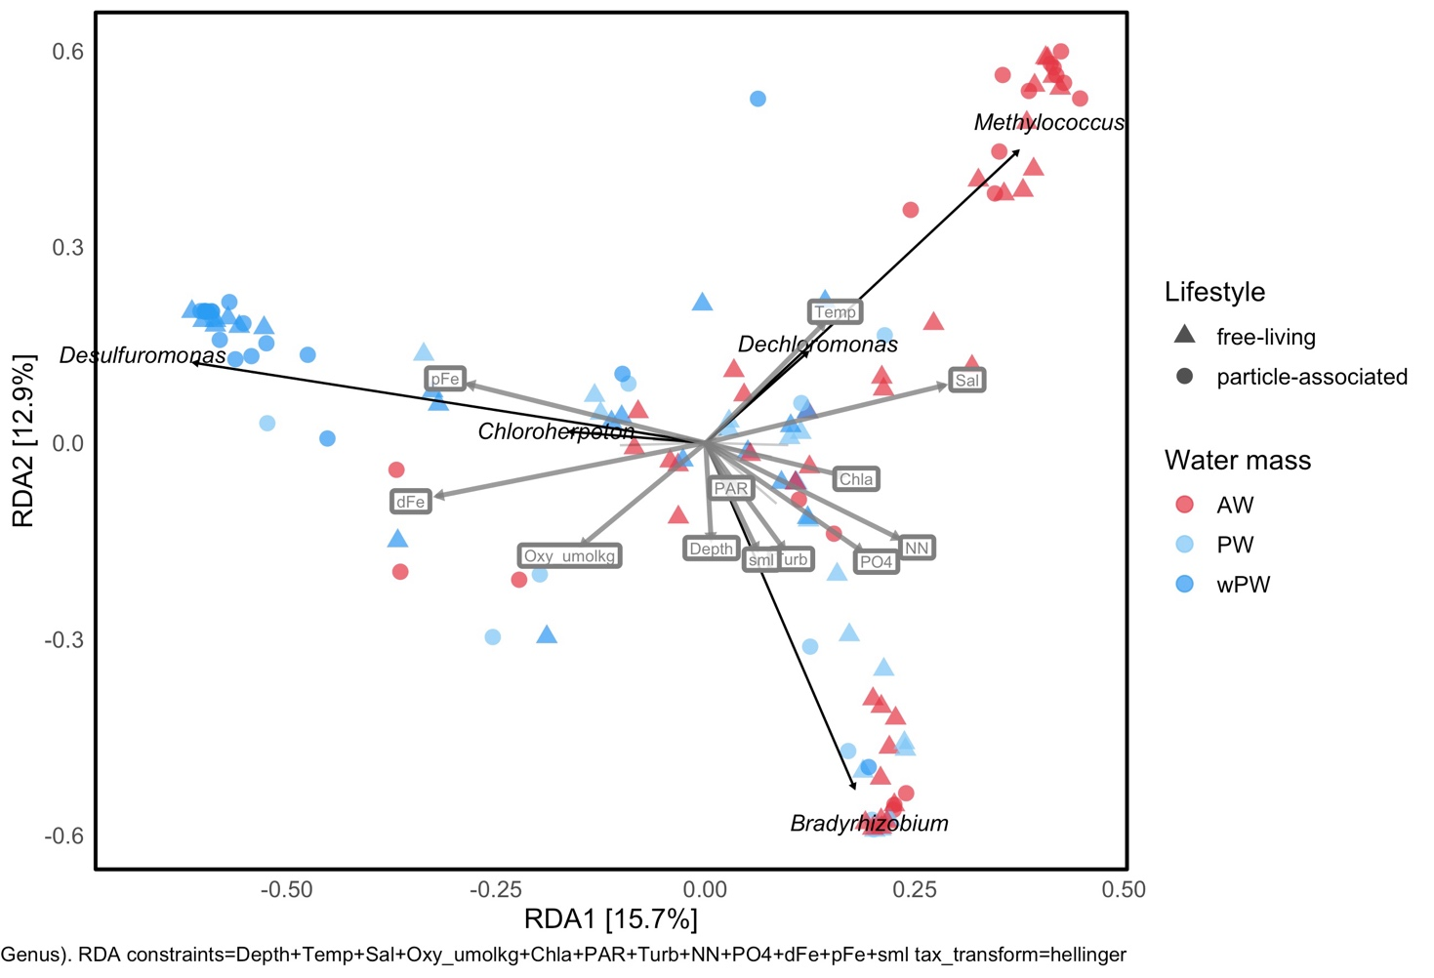
Fig. S5. Multivariate redundancy analyses of diazotroph communities and metadata. Multivariate redundancy analysis (RDA) biplot depicting the variance of nifH gene sequences explained by the environmental parameters and diazotroph genera grouped by water mass in colours (AW = Atlantic Water, wAW = warm Atlantic Water, ArW = Arctic Water). Explanatory variable vectors include depth = Depth, temperature = Temp, salinity = Sal, dissolved oxygen = Oxy_umolkg, chlorophyll a = Chla, photosynthetic active radiation = PAR, turbidity = Turb, nitrate + nitrite = NN, phosphate = PO4, dissolved iron = dFe, particulate iron = pFe, and surface mixed layer depth = SML.

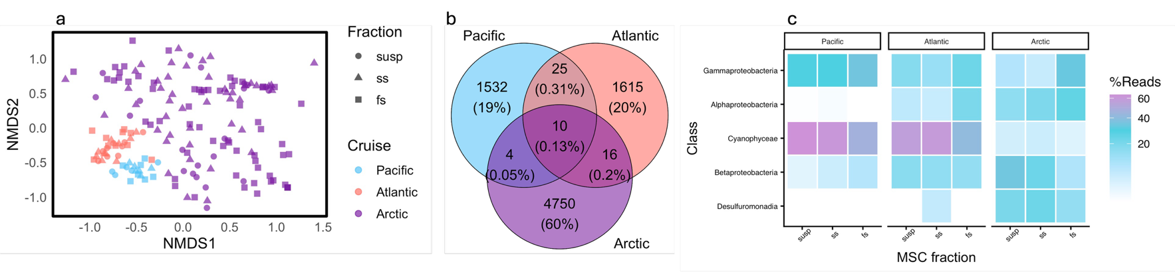Fig. S6. Comparison of Pacific, Atlantic and Arctic particle-associated diazotroph communities. (a) Non-metric multidimensional scaling (NMDS) analysis of particle-associated diazotroph communities collected in this study (Arctic, N-ARC cruise), and previously published studies in the subtropical North Pacific (NCDC cruise) ¹² and North Atlantic (eIMPACT cruise) ¹³; (b) Venn diagram showing percentage overlap of ASVs among the three studies; (c) Heatmap showing the log₁₀ nifH gene relative abundance of all the amplicon sequence variants (ASVs) annotated at the Class level, faceted by cruise marine snow catcher (MSC) fractions with susp = suspended, ss = slow sinking and fs = fast sinking.

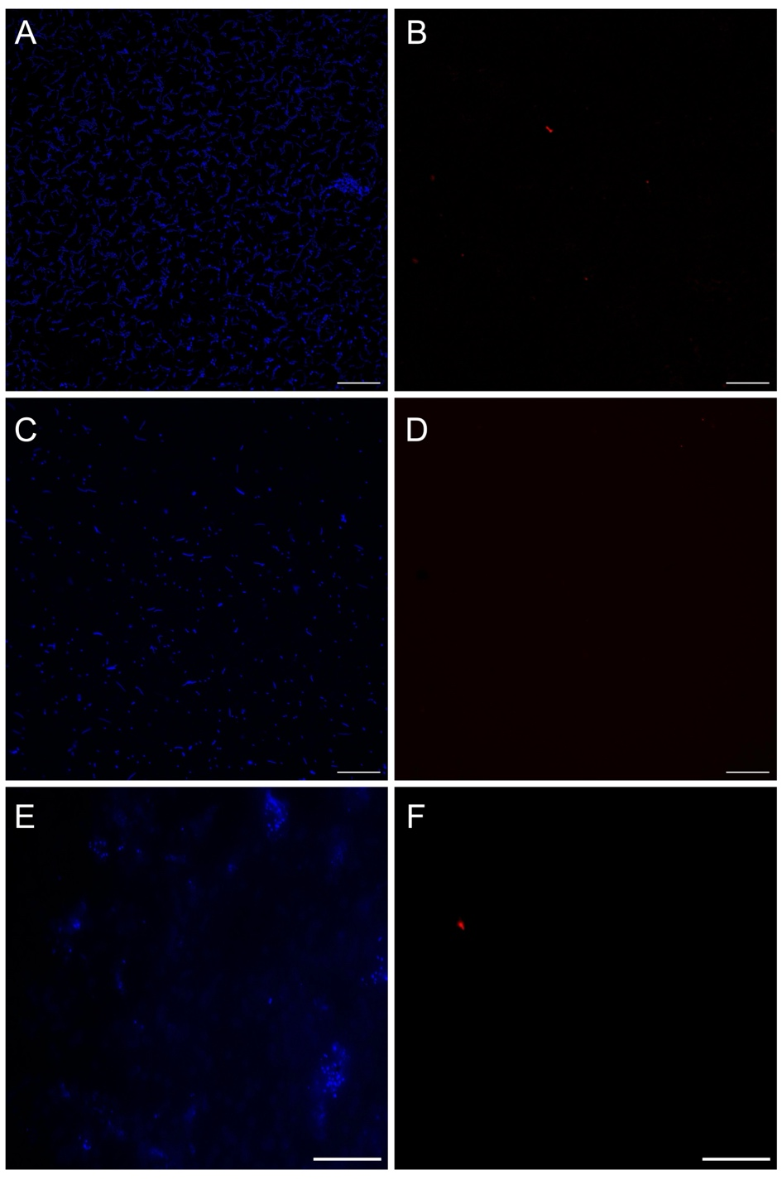
Fig. S7. Immunolabeling specificity tests. (A) DAPI-stained image of Pseudomonas guineae, showing all bacterial cells. (B) Fluorescence image of P. guineae following the complete nitrogenase immunolabeling protocol and acquired under excitation of the fluorochrome coupled to the anti-nitrogenase antibody. As P. guineae is a non-diazotrophic bacterium, no specific cellular fluorescence is detected, only sparse background artifacts are visible. (C) DAPI-stained image of Vibrio diazotrophicus, showing all bacterial cells. (D) Fluorescence image of V. diazotrophicus acquired under excitation of the secondary antibody-coupled fluorochrome, with omission of the primary anti-nitrogenase antibody. The absence of cellular fluorescence indicates that the secondary antibody does not bind non-specifically. (E) DAPI-stained image of the particle-attached fraction collected during the N-ARC cruise and retained on a 3 µm filter, showing aggregates of small bacterial cells associated with marine particles. (F) Fluorescence image of the same particle-attached fraction under NifH/Alexa excitation, with omission of the primary anti-nitrogenase antibody. No specific fluorescence is detected, confirming the absence of non-specific binding; only occasional imaging artifacts are observed.
Table S1. Sampling station metadata. List and classification of sampled stations and type of sampling conducted at each. Seawater mass classification was based on ref ¹⁶.
See TableS1.xlsx file attached.

Table S2. Bulk N₂ fixation rates. Bulk N₂ fixation rates by marine snow catcher (MSC) fractions, station number, and water mass (AW = Atlantic Water, wAW = warm Atlantic Water, ArW = Arctic Water).
See TableS2.xlsx file attached.
Table S3. Particle-associated N₂ fixation rates. ¹⁵N atom % enrichment, cell diameter, biovolume, particulate carbon (PC), particulate nitrogen (PN) and N₂ fixation rates of single-cells measured from 3 µm filters on suspended (susp) and fast sinking (fs) marine snow catcher (MSC) fractions.
See TableS3.xlsx file attached.
Table S4. Amplicon sequence variants. Taxonomic annotation of amplicon sequence variants (ASVs).
See TableS4.xlsx file attached.
Table S5. Metadata used in multivariate redundancy analysis. Environmental metadata used in redundancy analysis (RDA, Fig. S5).
See TableS5.xlsx file attached.
SI References

1. Brewer, P. G. & Riley, J. P. The automatic determination of nitrate in sea water. Deep Sea Res. Oceanogr. Abstr. 12, 765–772 (1965).
2. Methods of Sea-Water Analysis. (Wiley-VCH Verlag, Weinheim, Germany, 1999).
3. Hopkins, J. E. & Mahaffey, C. Nitrogen Fixation in the Arctic N-Arc DY167 Cruise Report GEOTRACES GApr19. https://www.bodc.ac.uk/resources/inventories/cruise_inventory/reports/dy167.pdf (2023).
4. Cutter, Gregory, Casciotti, Karen, Croot, Peter, Geibert, Walter, Heimbürger, Lars-Eric, Lohan, Maeve, Planquette, Hélène. Sampling and Sample-Handling Protocols for GEOTRACES Cruises. https://repository.oceanbestpractices.org/handle/11329/409 (2017).
5. Mahaffey, C. et al. Stainless Steel CTD water column samples (macronutrients, chlorophyll-a, particulate carbon, C-fixation, d18O) and upcast sensor measurements (temperature, salinity, oxygen, optical backscatter, beam transmittance and attenuation, PAR, fluorescence) from cruise DY167 (GApr19), July-August 2023. (2026).
6. Lohan, M. et al. Titanium CTD water column samples (macronutrients, chlorophyll-a, trace elements) and upcast sensor measurements (temperature, salinity, oxygen, optical backscatter, beam transmittance and attenuation, PAR, fluorescence) from the Norwegian and Barents Sea on cruise DY167 (GApr19), July-August 2023. https://doi.org/10.5285/48c1d94c-1647-8717-e063-7086abc0f520 (2026).
7. Moisander, P. H., Beinart, R. A., Voss, M. & Zehr, J. P. Diversity and abundance of diazotrophic microorganisms in the South China Sea during intermonsoon. ISME J. 2, 954–967 (2008).
8. Zehr, J. P., Mellon, M. T. & Zani, S. New nitrogen-fixing microorganisms detected in oligotrophic oceans by amplification of nitrogenase (nifH) genes. Appl. Environ. Microbiol. 64, 3444–3450 (1998).
9. Zehr, J. P. & Mcreynolds, L. a. Use of degenerate oligonucelotides for amplification of the nifH gene from the marine cyanobacterium Trichosdemium thiebautii. Appl. Environ. Microbiol. 55, 2522–2526 (1989).
10. Callahan, B. J. et al. DADA2: High-resolution sample inference from Illumina amplicon data. Nat. Methods 13, 581–583 (2016).
11. Morando, M. et al. Global biogeography of N₂-fixing microbes: nifH amplicon database and analytics workflow. Earth System Science Data Discussions 1–39 (2024) doi:10.5194/essd-2024-163.
12. Furbo Reeder, C. et al. Unveiling the contribution of particle-associated non-cyanobacterial diazotrophs to N₂ fixation in the upper mesopelagic North Pacific Gyre. Commun. Biol. (2025).
13. Cerdán-García, E., Álvarez-Salgado, X. A., Arístegui, J., Martínez-Marrero, A. & Benavides, M. Eddy-driven diazotroph distribution in the subtropical North Atlantic: horizontal variability prevails over particle sinking speed. Commun. Biol. 7, 929 (2024).
14. Barnett, D., Arts, I. & Penders, J. microViz: an R package for microbiome data visualization and statistics. J. Open Source Softw. 6, 3201 (2021).
15. Chen, H. & Boutros, P. C. VennDiagram: a package for the generation of highly-customizable Venn and Euler diagrams in R. BMC Bioinformatics 12, 35 (2011).
16. Sundfjord, A. et al. Suggested water mass definitions for the central and northern Barents Sea, and the adjacent Nansen Basin. The Nansen Legacy Report Series (2020) doi:10.7557/nlrs.5707.

