Supplementary material of : “Small event, big impact: Insights from Vallunaraju cascade event on April 28, 2025”
- Diego Cusicanqui^{1,2,}*, Edwin Loarte³, Wilson Gómez⁴, Hilbert Villafane⁵, Kristen L. Cook¹, Guillaume Piton⁶, Benjamin Lehmann¹, Florence Magnin⁷, Adina Racoviteanu⁶, Swann Zerathe¹, Pascal Lacroix¹, Simon Filhol⁸, Katy Medina^{3,7}, Rolando Cruz⁹, Ronald Concha¹, Juan Carlos Torrez⁵

- Affiliations:
- ¹ Institut des Sciences de la Terre (ISTerre) CNRS, IRD, Univ. Grenoble Alpes, Grenoble, France
- ² Centre national d’études spatiales (CNES), Paris, France
- ³ Universidad Nacional Santiago Antúnez de Mayolo (UNASAM), Huaraz, Perú
- ⁴ Instituto Geológico Minero y Metalúrgico (INGEMMET), Lima, Perú
- ⁵ Instituto Nacional de Investigación en Glaciares y Ecosistemas de Montaña (INAIGEM), Huaraz, Peru
- ⁶ Univ. Grenoble Alpes, INRAE, CNRS, IRD, Grenoble INP, IGE, 38000 Grenoble, France.
- ⁷ Laboratoire EDYTEM, CNRS, Univ. Savoie Mont-Blanc, Le Bourget-du-Lac, 73376, France
- ⁸ Météo-France, CNRS, Univ. Grenoble Alpes, Univ. Toulouse, CNRM, Centre d’Études de la Neige, Grenoble, France
- ⁹ Autoridad Nacional del Agua (ANA), Huaraz, Perú

- * Corresponding author: Diego Cusicanqui (diego.cusicanqui@univ-grenoble-alpes.fr)

Contents
- Table S1 to S4
- Figures S1 to S14

Table S1. Estimation of lake volume following different methods.
Lake | Surface (m²) | Avg. Depth (m) | Max depth (m) | Volume (m³) | Source
A | 11,199.42 | 3,84 | 6,43 | 42,747.61 ± 2,421.24 | This study
B | 7,245.49 | 4,45 | 8,03 | 32,483.9 ± 2,421.24 | This study
TOTAL |  |  |  | 75,231.51 ± 5,408.14 | This study
A | 10,899.87 | - | - | 50,000 | (INAIGEM & INGEMMET, 2025)
B | 7,225.63 | - | - | 30,000 | (INAIGEM & INGEMMET, 2025)
TOTAL |  |  |  | 80,000 | (INAIGEM & INGEMMET, 2025)
A | 11,199.42 |  | 13,05 | 47,182.42 | (Cael et al., 2017)
B | 7,245.49 |  | 10,75 | 24,616.33 | (Cael et al., 2017)
TOTAL |  |  |  | 71,798.75 | (Cael et al., 2017)
A | 11,199.42 |  | 5,22 | 58,464.33 | (Huggel et al., 2002)
B | 7,245.49 |  | 4,35 | 31,501.38 | (Huggel et al., 2002)
TOTAL |  |  |  | 89,965.71 | (Huggel et al., 2002)

Table S2. Volumetric assessment of all observed rockfalls.
 | Rockfall-1&2 | Rockfall-3 | Rockfall-4 | Accu-1 | Accu-2
Date  (yyy-mm-dd) | 2025-02-14* / 2025-03-05* | 2025-03-26* | 2025-04-28 | - | -
Area (m²) | 7,120 | 7,359 | 14,116 | 8,806 | 34,068
n pixels | 487 | 461 | 885 | 890 | 2,485
Sum | -3,759 | -6,342 | -16,827 | 5,557 | 26,489
Mean | Mean_{丄} | -7.7 | -6.2 | -13.8 | -11.1 | -19.0 | -14.7 | 6.2 | 10.7
Min | Min_{丄} | -17.2 | -13.2 | -40.5 | -26.3 | -60.8 | -42.5 | -1.1 | -0.5
Max | 1.0 | 2.5 | 5.5 | 16.5 | 29.1
Volume  (m³) | -60,139 | -101,472 | -269,233 | 88,915 | 423,825
Volume uncertainty (m³)** | 12,516 | 12,177 | 16,873 | 16,920 | 28.274
* known event dates with ±5 days of uncertainty; ** Accounting spatial correlation analysis high uncertainties (σ_{Δh} = 5 m); 丄 slope-normal thickness estimations

  - Table S3. Total flood volumetric assessment using different flood scenarios, lake volumes and watershed discharge. Text with grey background corresponds to the current scenario used in this study.
 |  | Volume of water from lakes (m³)
 |  | Lake A |  |  | Lake A +  1/3 of Lake B |  |  | Lake A +  2/3 of Lake B |  |  | Lake A + Lake B |  |  | Discharge background (m³)
Total solid volume (m³) |  | 42,748 |  |  | 53,468 |  |  | 64,187 |  |  | 75,232 |  |  | Discharge background (m³)
245,715.7 |  | Total flood volume (m³)  Relative contribution to the total flood volume of :  lake | Sediment | Basin discharge (%) |  |  |  |  |  |  |  |  |  |  |  | Discharge background (m³)
Length flood (hours) | 0,5 | 292,361 |  |  | 303,081 |  |  | 313,800 |  |  | 324,613 |  |  | 3,897
Length flood (hours) | 0,5 | 15 | 84 | 1 | 14 | 81 | 1 | 14 | 78 | 1 | 13 | 76 | 1 | 3,897
Length flood (hours) | 1 | 296,258 |  |  | 306,978 |  |  | 317,698 |  |  | 328,511 |  |  | 7,795
Length flood (hours) | 1 | 14 | 83 | 3 | 14 | 80 | 1 | 13 | 77 | 1 | 13 | 75 | 1 | 7,795
Length flood (hours) | 1,5 | 300 156 |  |  | 310,876 |  |  | 321,595 |  |  | 332,408 |  |  | 11,692
Length flood (hours) | 1,5 | 14 | 82 | 4 | 14 | 79 | 1 | 13 | 76 | 1 | 13 | 74 | 1 | 11,692
Length flood (hours) | 2 | 304,053 |  |  | 314,773 |  |  | 325,493 |  |  | 336,305 |  |  | 15,589
Length flood (hours) | 2 | 14 | 81 | 5 | 14 | 78 | 1 | 13 | 75 | 1 | 13 | 73 | 1 | 15,589

  - Table S4. Urban expansion of Huaraz and Independencia districts based on Villanueva & Del Valle, (2021) and updates until 2025.
Year | Source | Scale/resolution | Area (km²) | Reference
1948 | Aerial photos | 1:30,000 | 1.11* | Villanueva & Del Valle, (2021)
1962 | Aerial photos | 1:40,000 | 1.58 | Villanueva & Del Valle, (2021)
1977 | Corona KH | 6-9 m | 3.39 | Villanueva & Del Valle, (2021)
2001 | Aerial photo | 1:25,000 | 5.88 | Villanueva & Del Valle, (2021)
2018 | Google Earth imagery | 1 m | 7.74 | Villanueva & Del Valle, (2021)
2025 | Open Buildings / Pleiades image | 1- 2m | 8.40  ± 0.51 | This study
*does not include Independencia district which did not yet exist

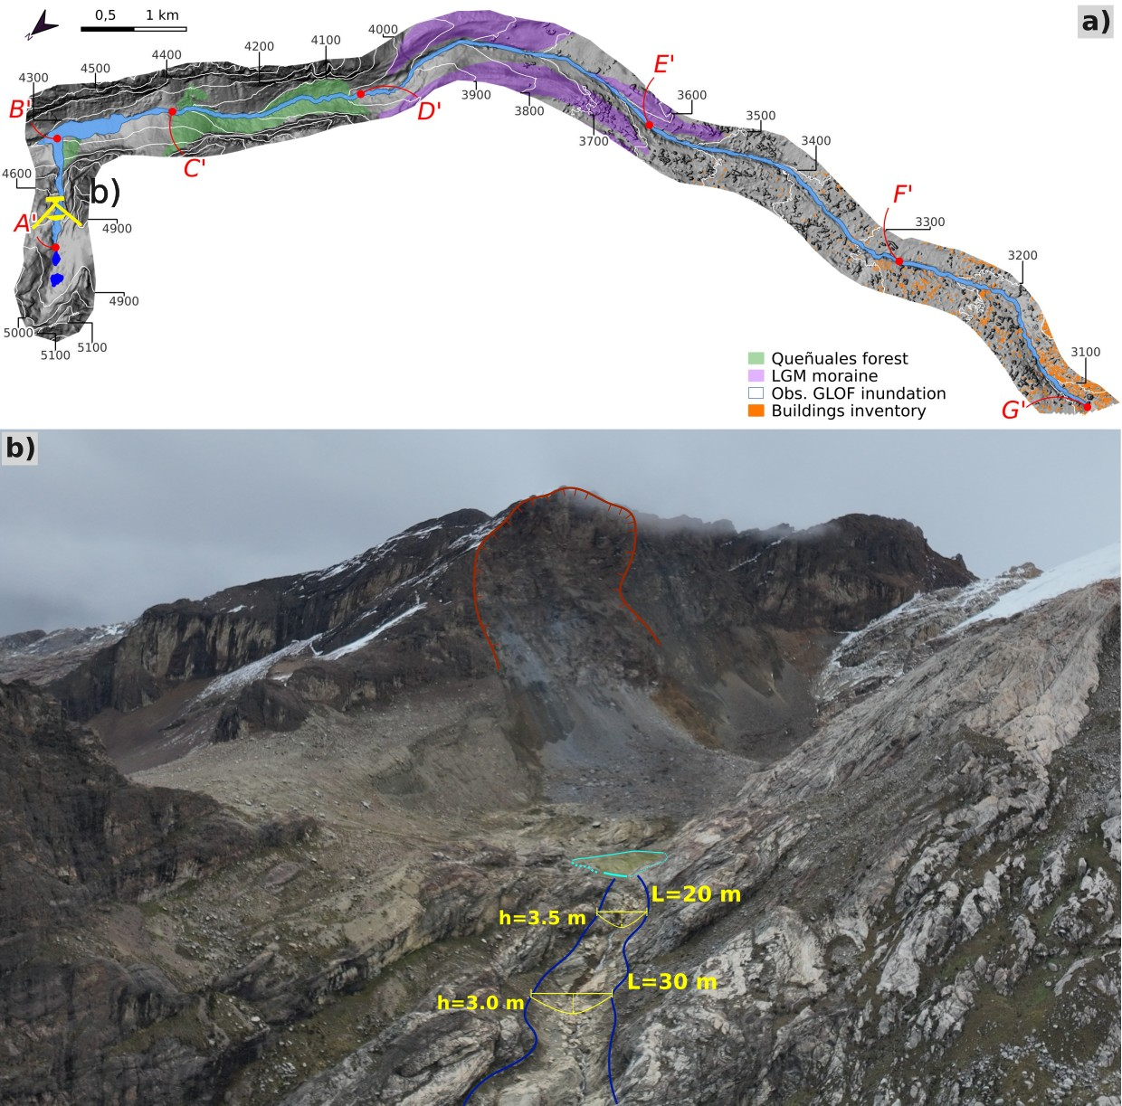
Figure S1. a) Show the context of the Vallunaraju flood and the approximate location of terrain photographs; b) UAV aerial photograph of the source zone (~5,000 m a.s.l.). GLOF traces are highlighted together with hydraulic sections interpreted from visual inspection and DoD from Pléiades DSM (Fig. 2). Photo credits: b) INAIGEM, 2025.

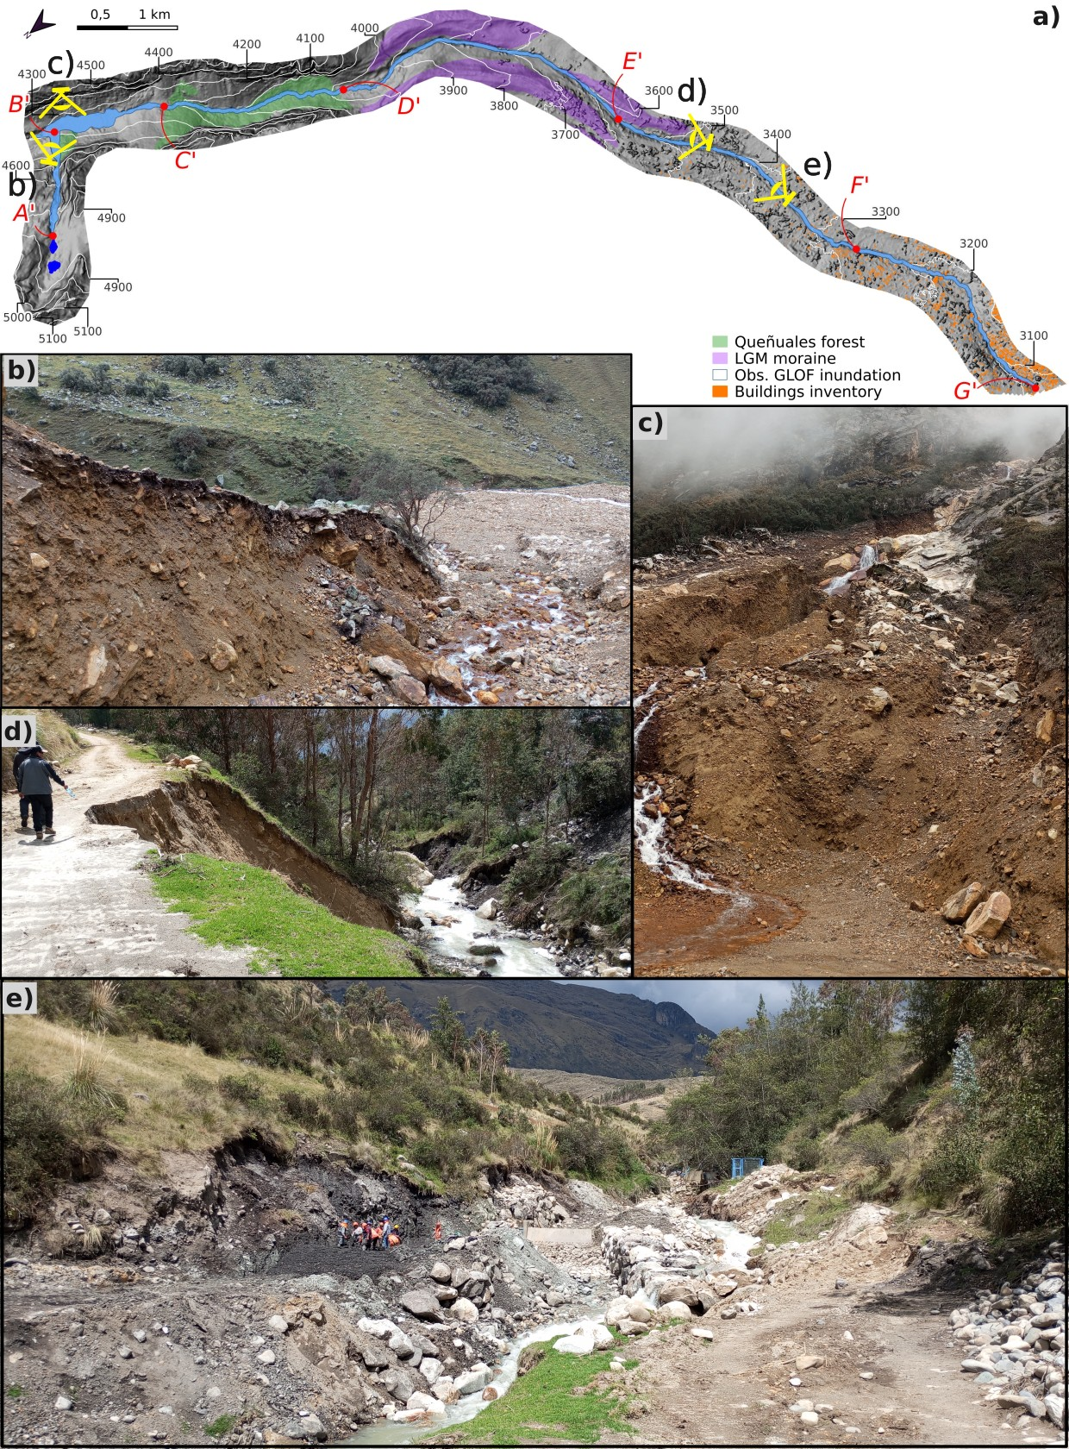
Figure S2. Terrain photographs after Vallunaraju GLOF. a) Show the context of the Vallunaraju flood and the approximative location of terrain photographs; b) and c) photographs of the LIA (4,290 m a.s.l.) moraine destroyed by the GLOF; d). Lateral erosion in the Casca river at the lowest edge of LGM moraine; e) lateral erosion in the section E’ーF’. Photo credits: b), c), d), e) P. Lacroix, 2025.

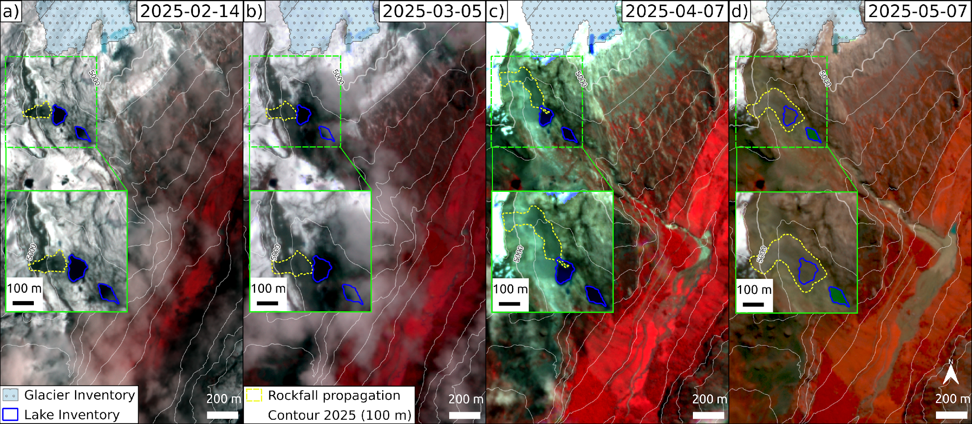
Figure S3: Chronology of different rockfall events in the left flank of Vallunaraju glacier. Image background from a) to d) correspond to ©PlanetScope orthoimages acquired on different dates. Image background is colored using a RGB combination: 4-3-2 for better visualization of material deposition.

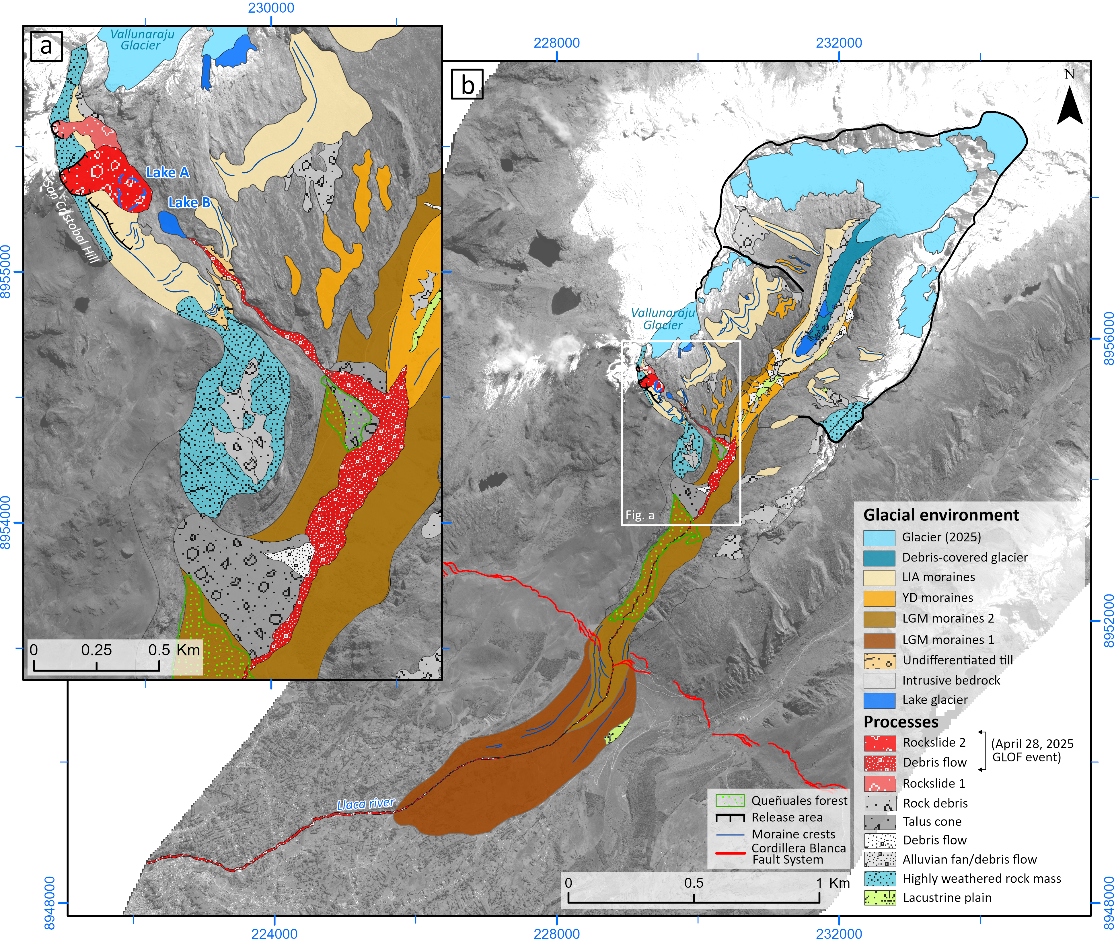
Figure S4: Geomorphological mapping of Casca sub-basin.

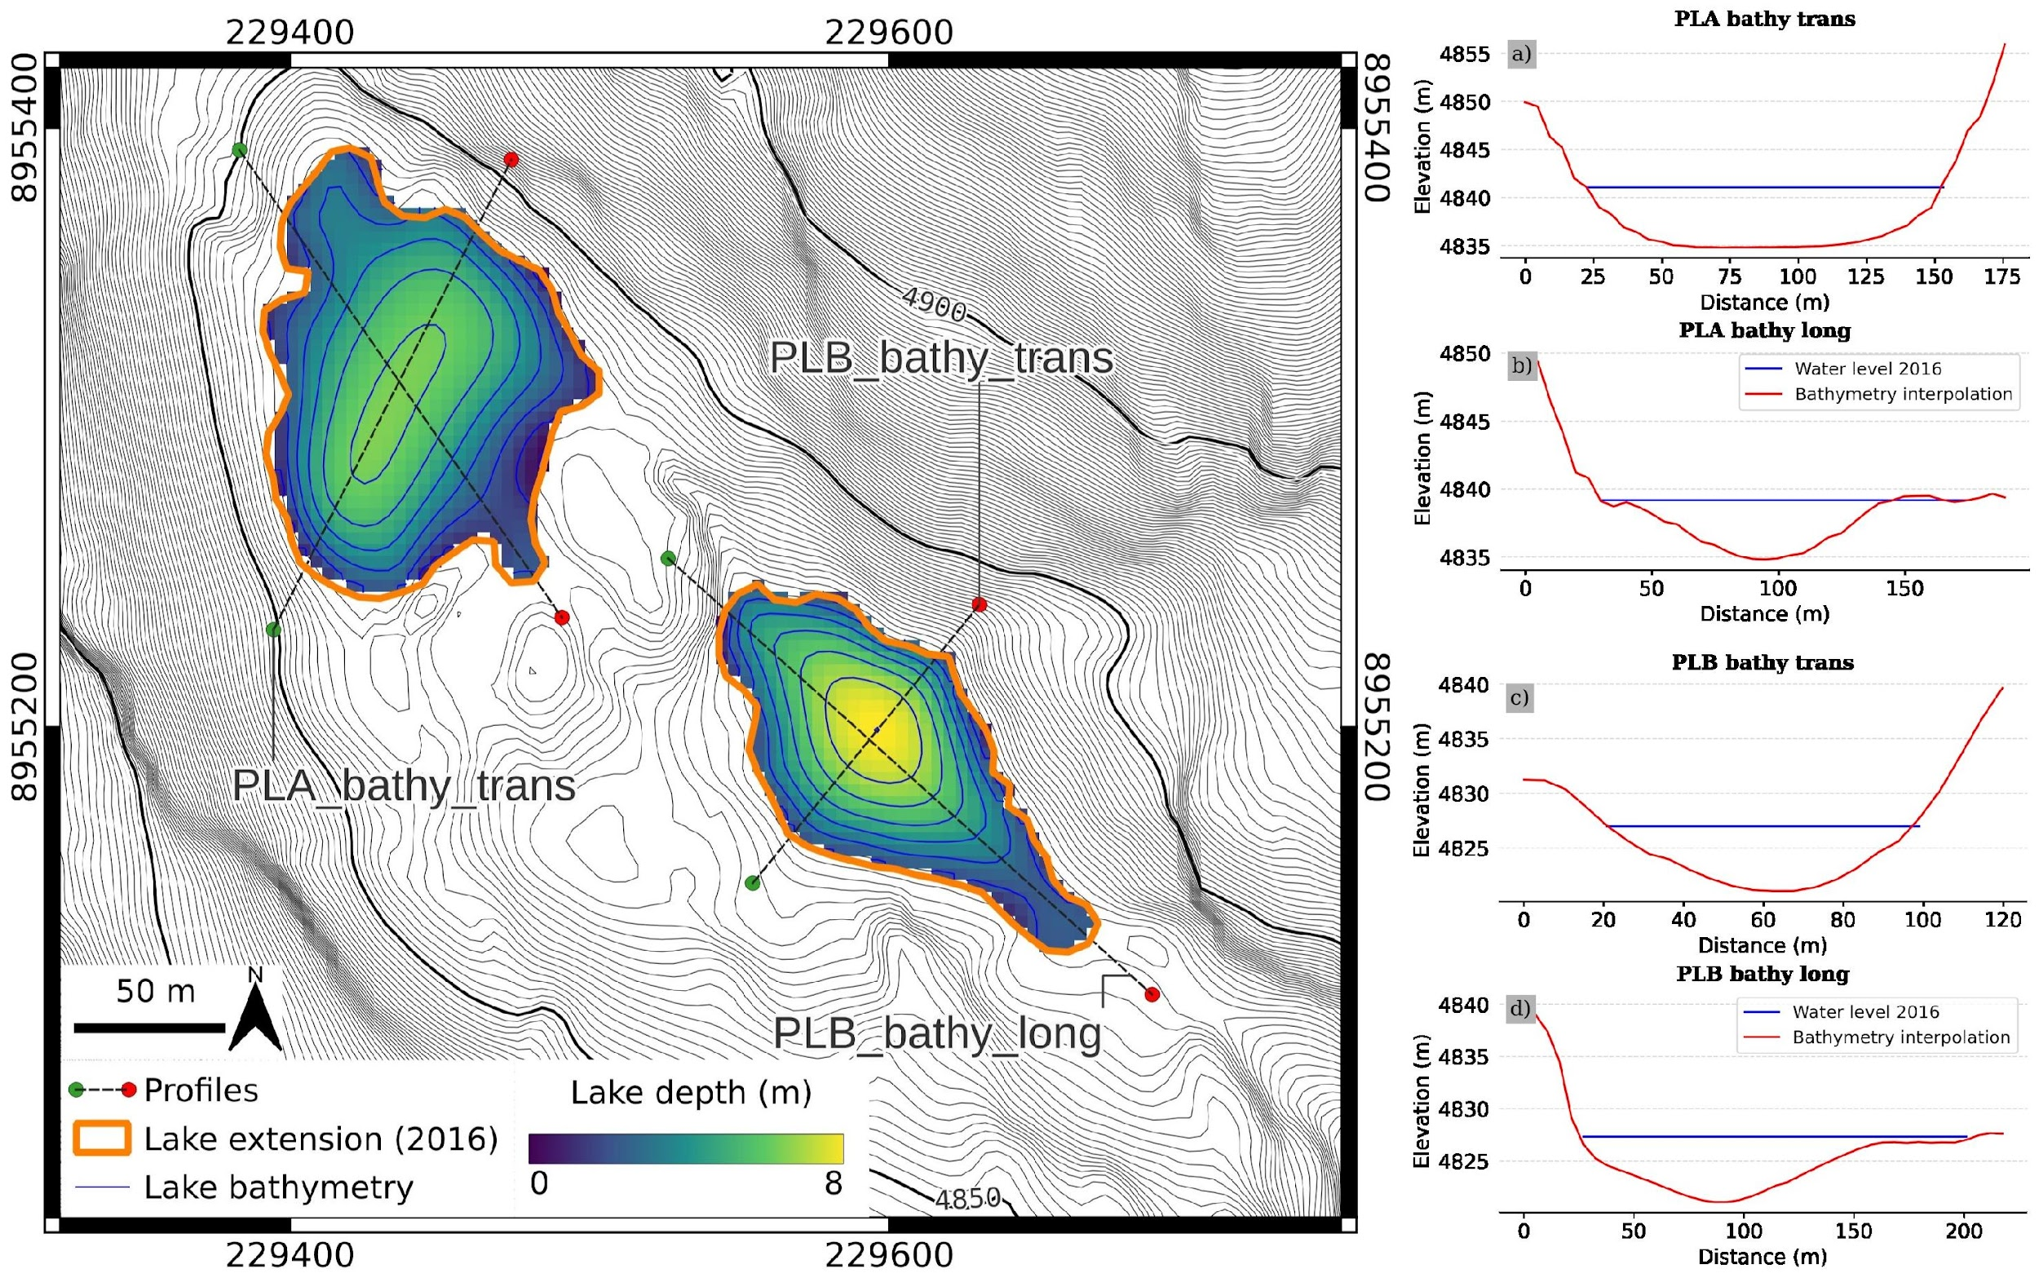
Figure S5: Lake depth estimation through shore-slope interpolation. Panels a), b), c) and d) show transversal and longitudinal profiles, respectively together with local surroundings used for interpolation.

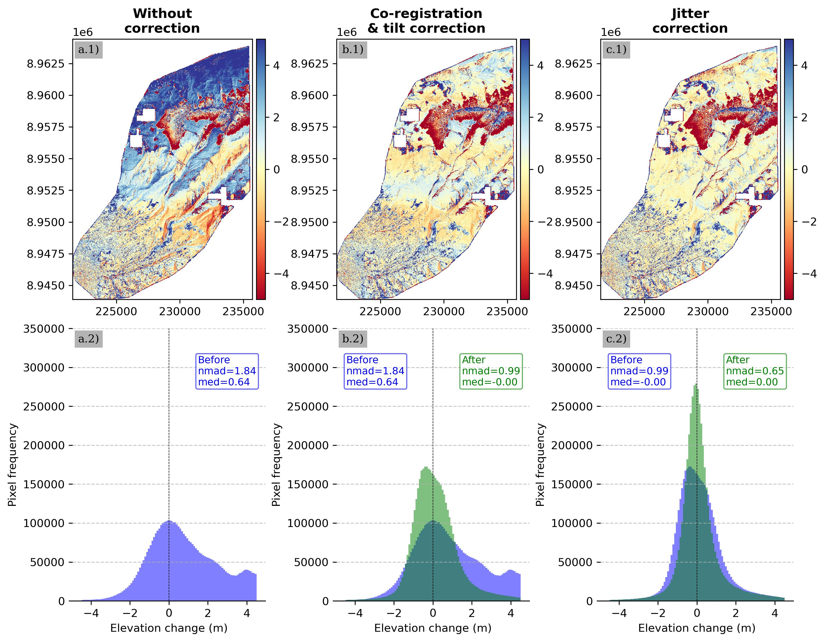
Figure S6: Figure 4. DSM bias-correction workflow based on Difference of DSMs (DoD). DoD were always computed using 2025 DSM as reference and considering pixels in stable area only (n pixels = 4,715,976) corresponding to 44.16% of intersected DSM. a) Raw DoD’s, b) DoD results after co-registration and tilt correction, c) DoD results after jitter correction. Lower panels refers to histograms showing median and NMAD values for each stage, based on stable terrain before (blue) and after (green) of each correction.

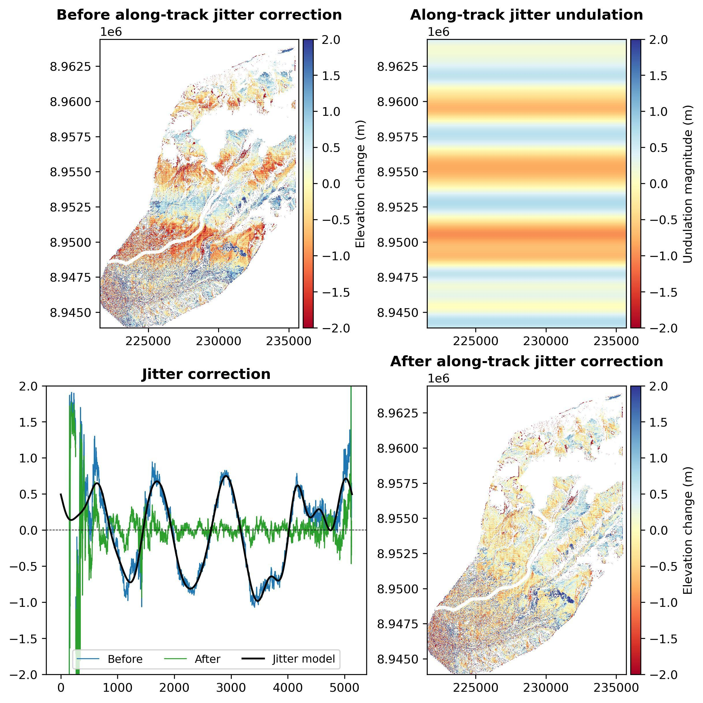
Figure S7: Along-track jitter correction summary.

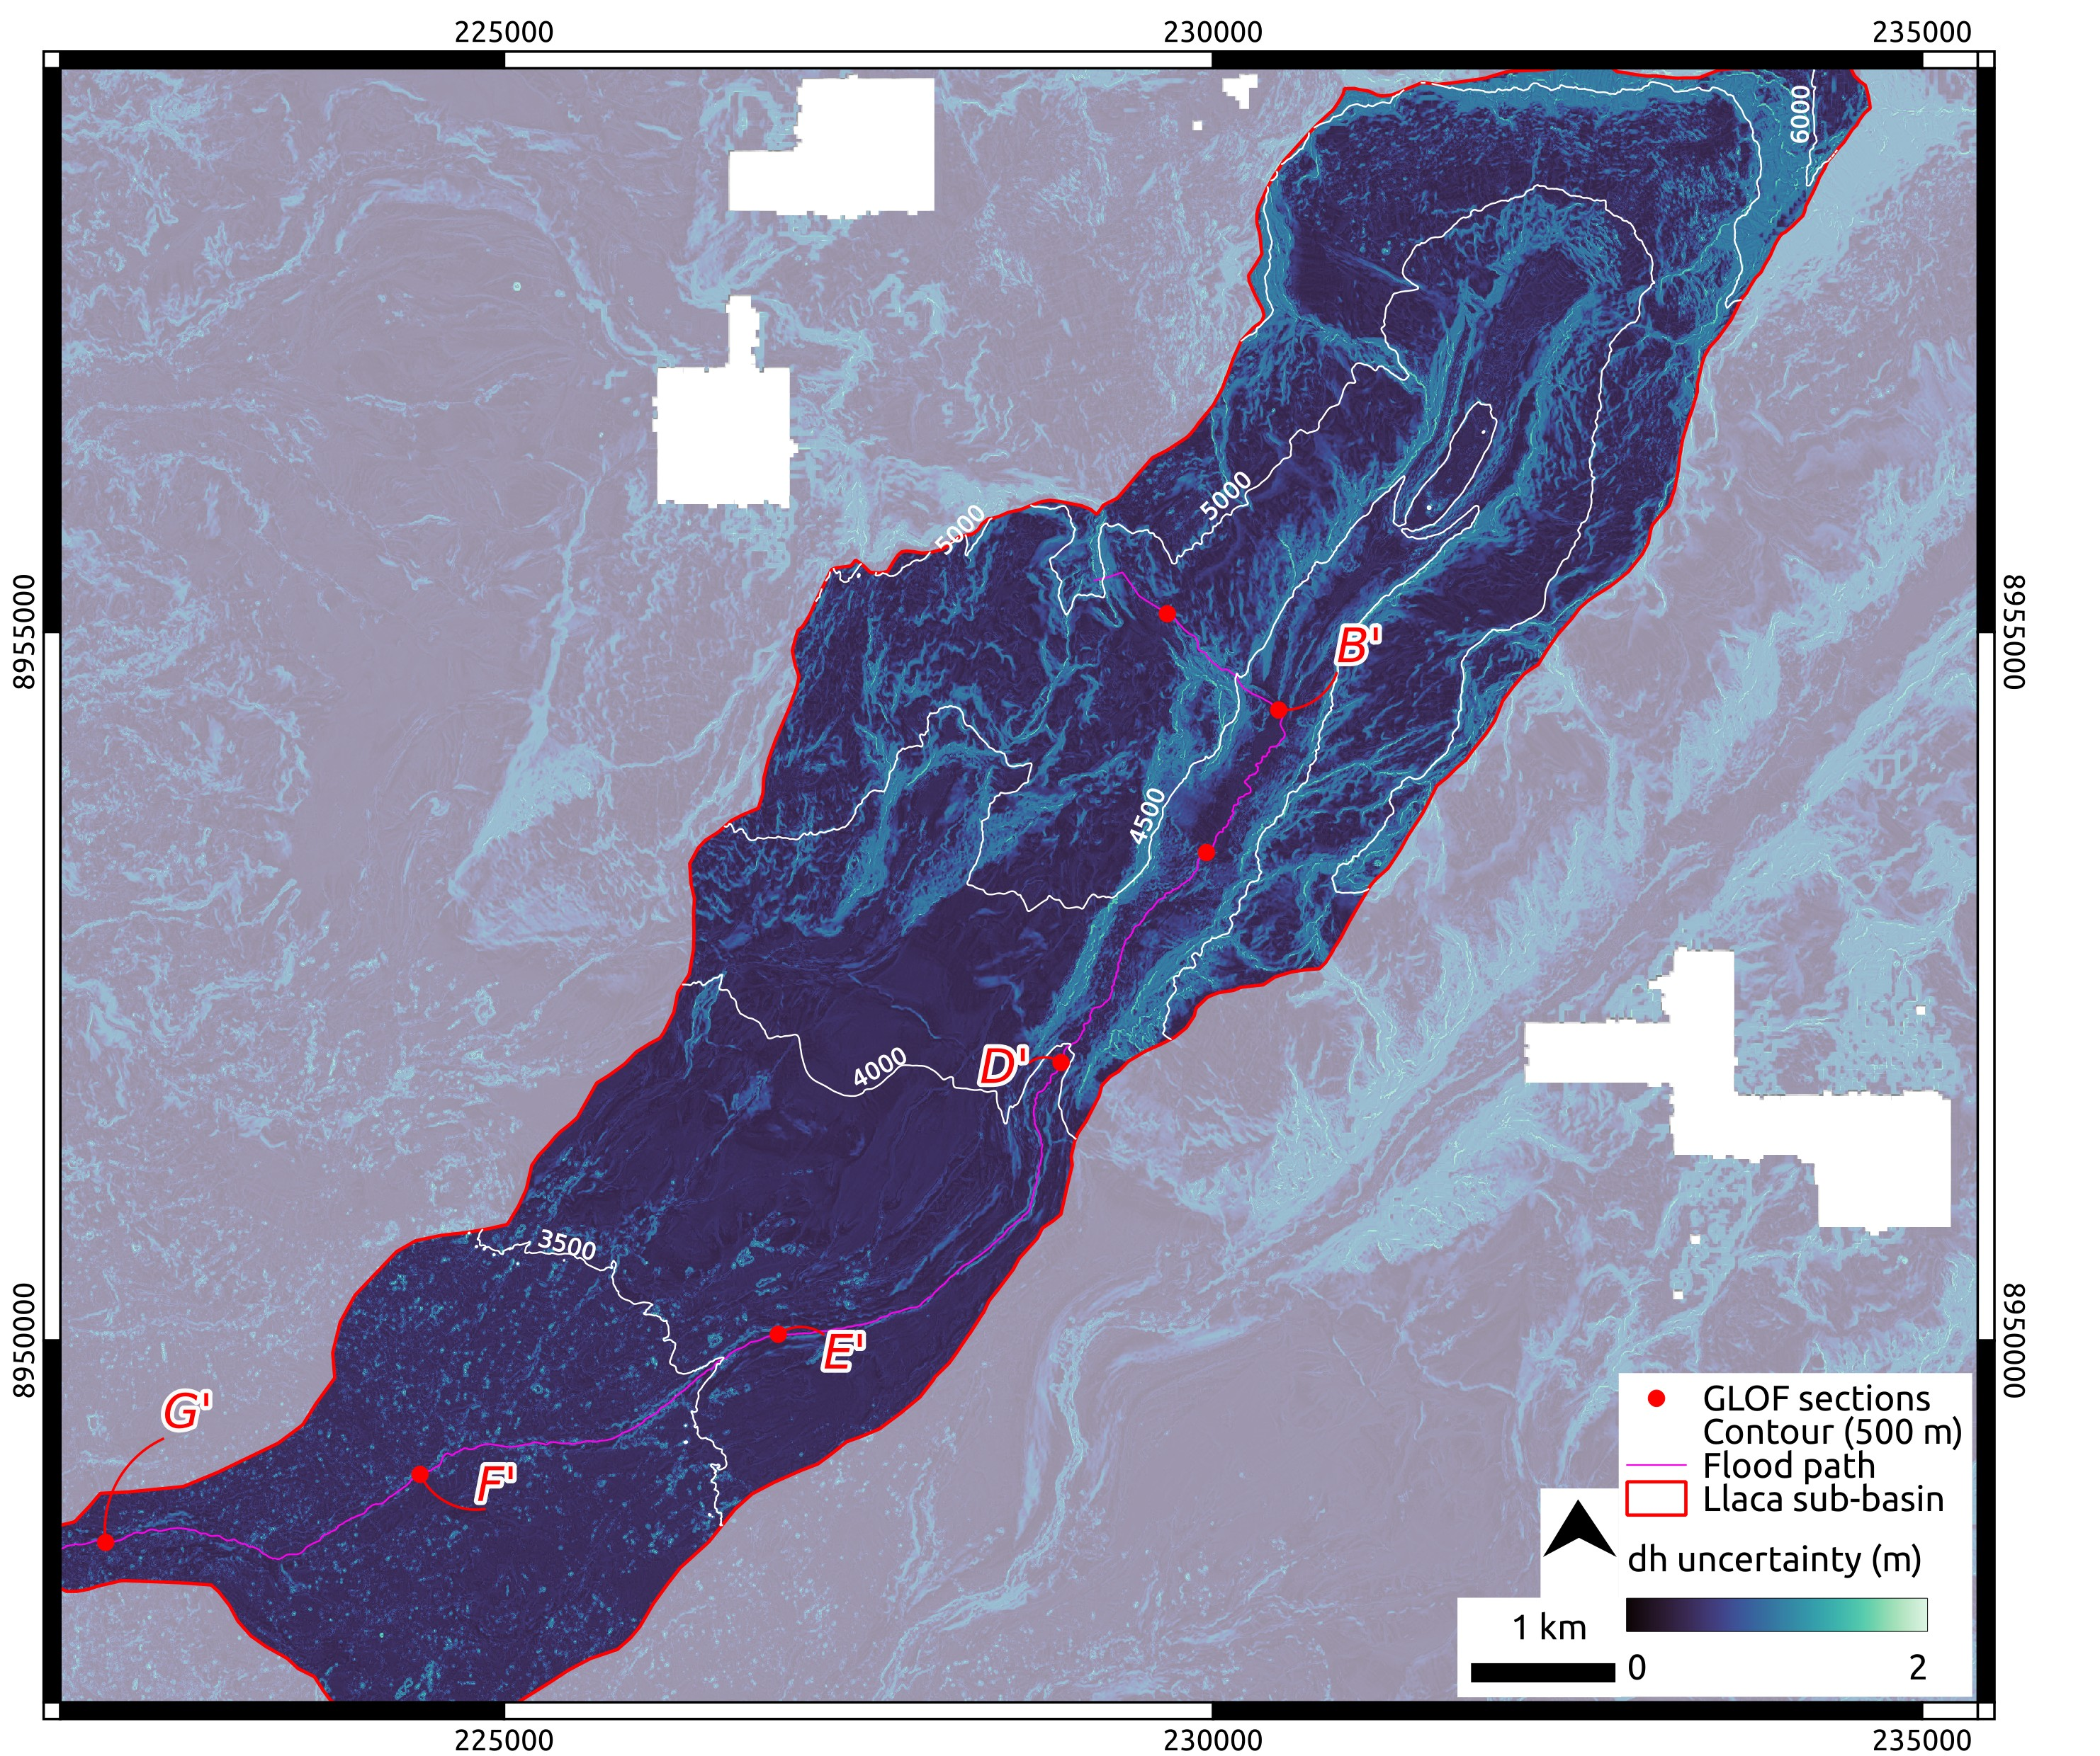
Figure S8: Estimation of DoD uncertainty accounting spatial correlation (Deschamps-Berger et al., 2020).

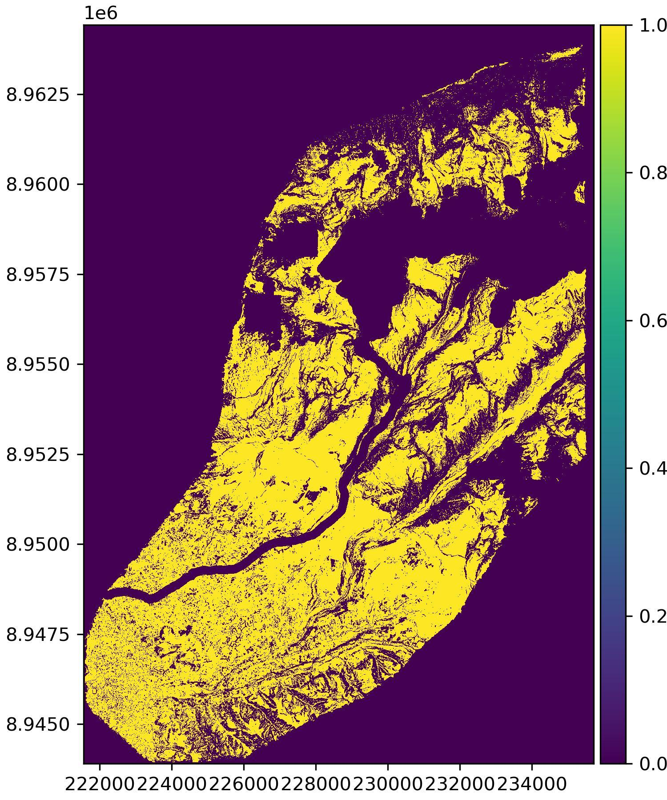
Figure S9: Mask of stable terrain used for bias correction. N of pixels = 7,494,743 corresponds to 44.16% of Pléiades common extent.

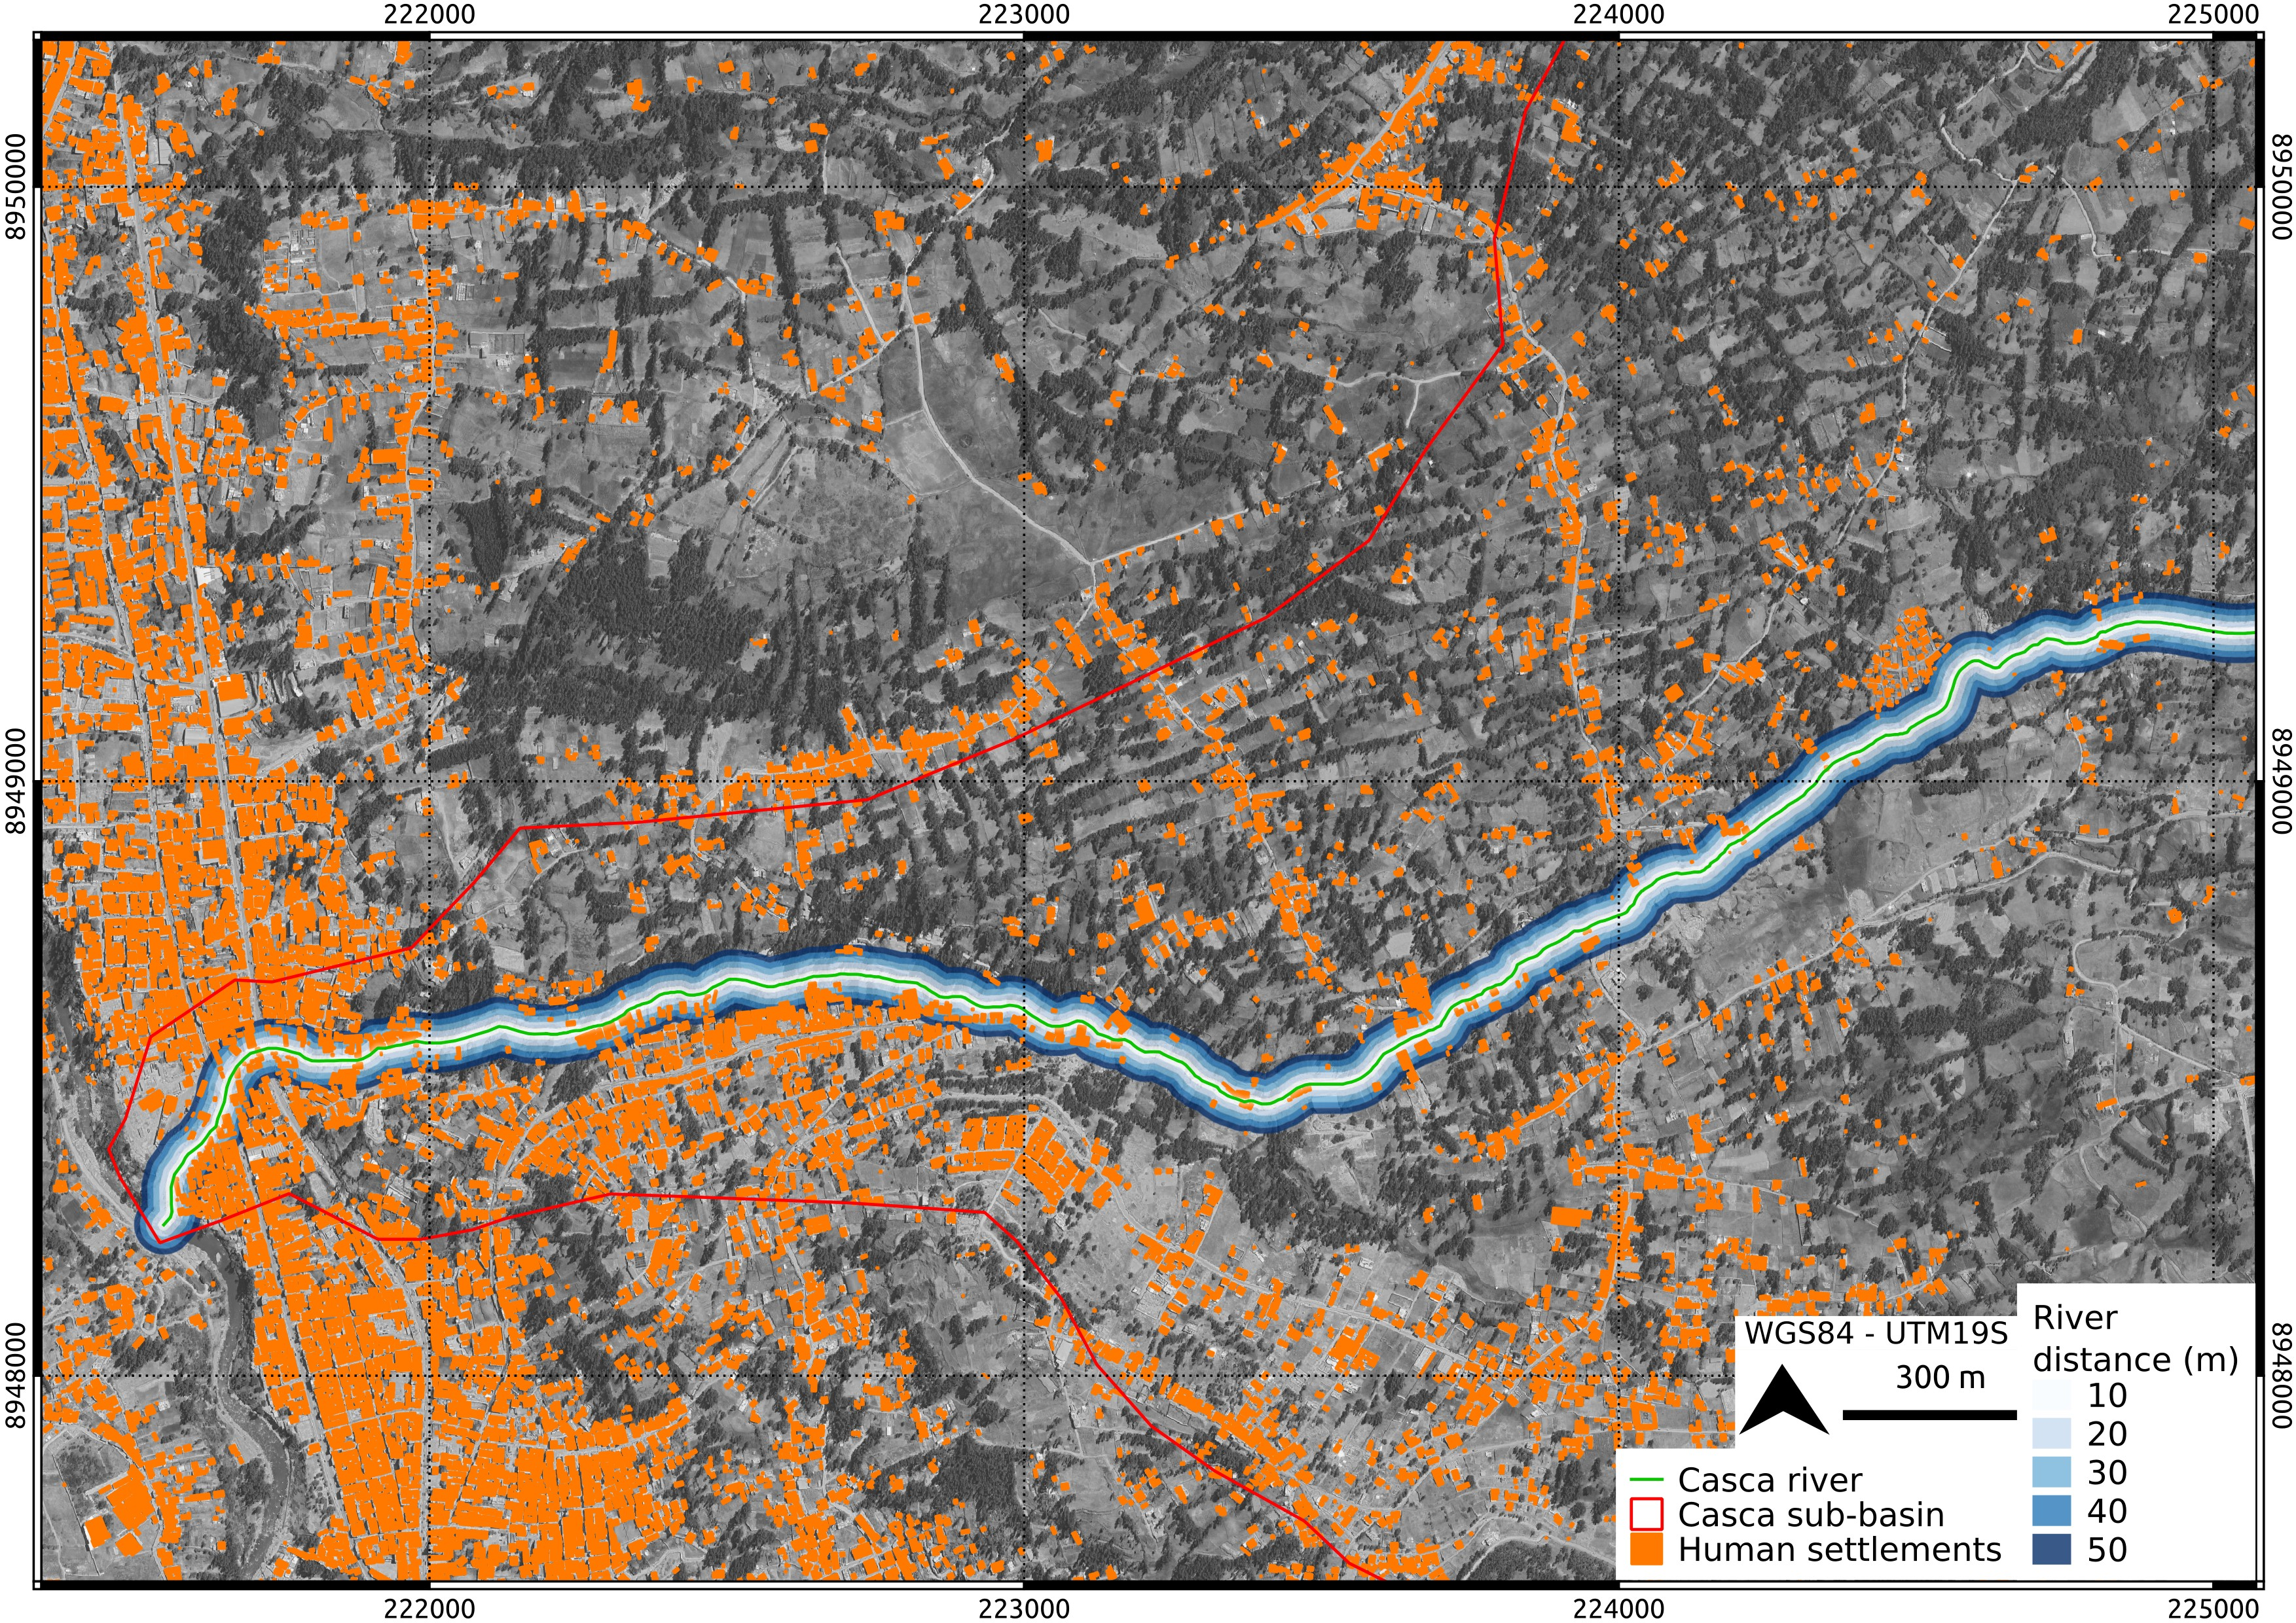
Figure S10: Assessment of building exposure.

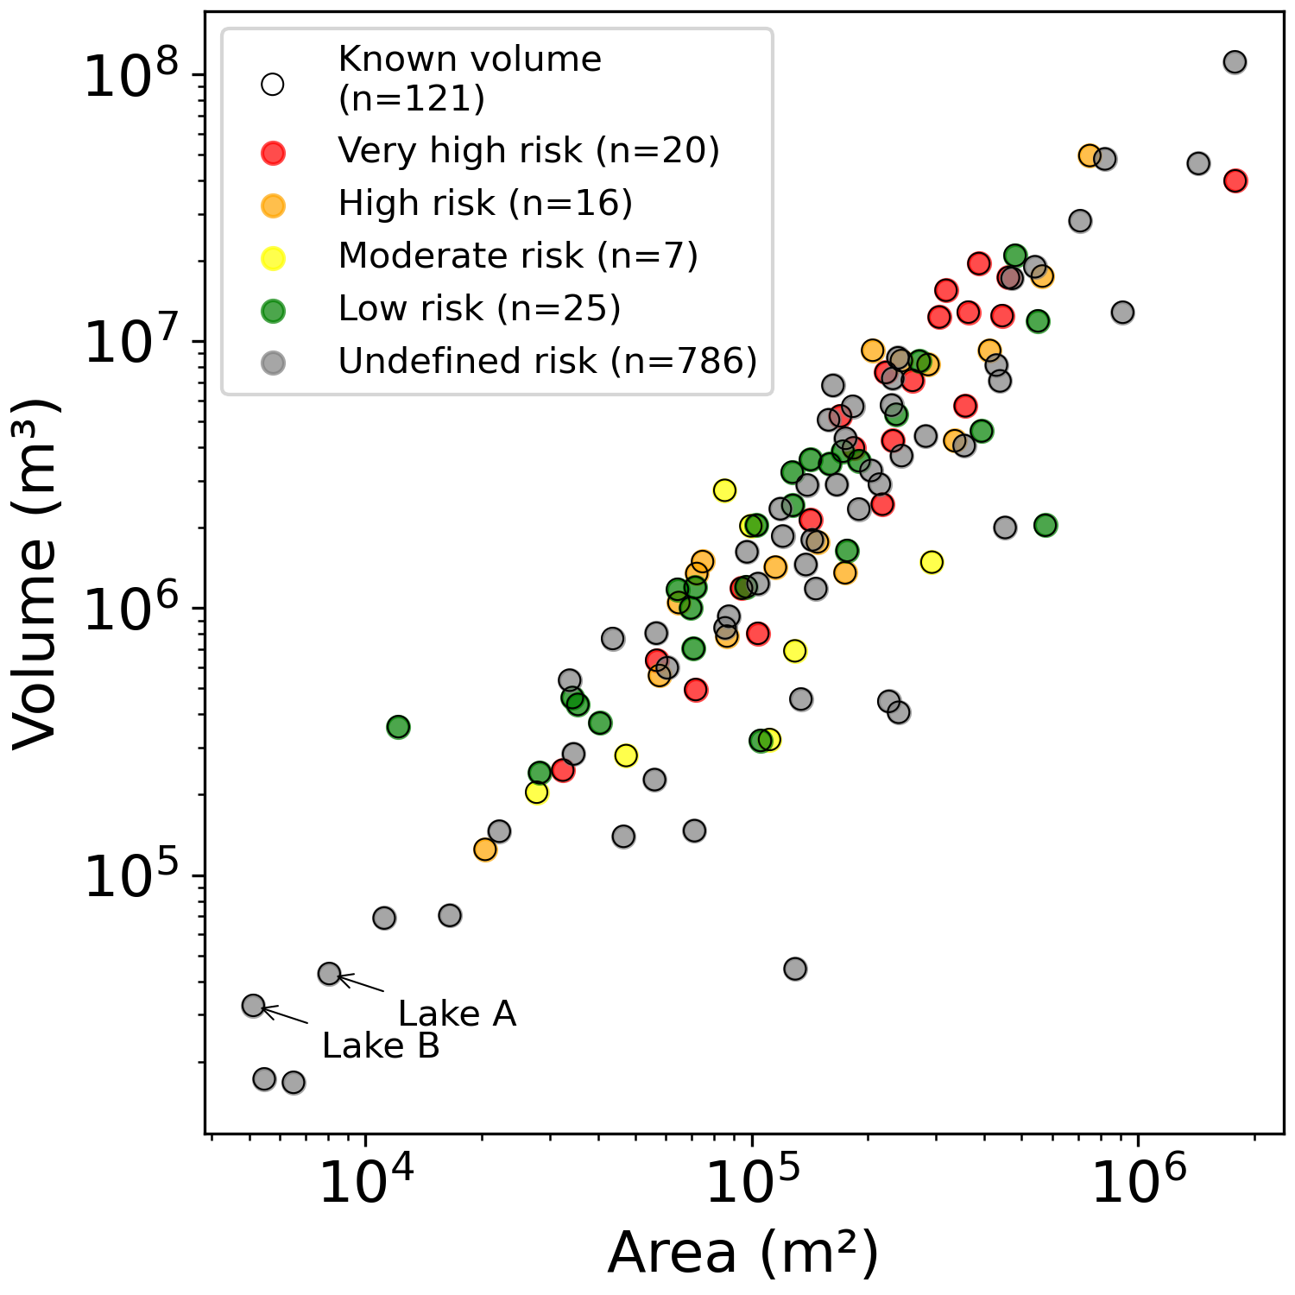
Figure S11: Current state of area-to-volume scaling .

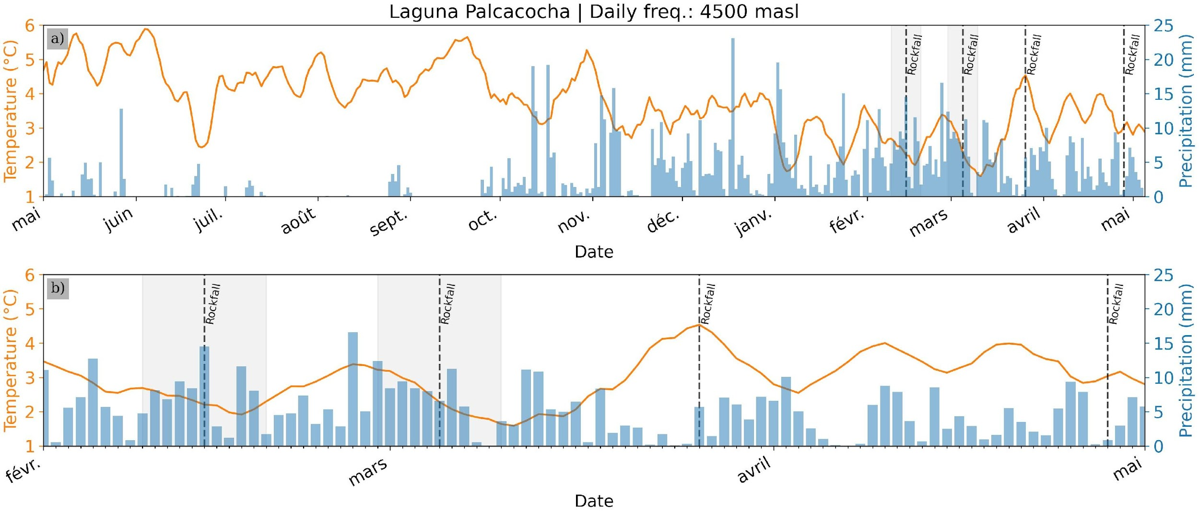
Figure S12: Meteorological context previous to the event based on In-situ instruments (Table 2). a) corresponds to records between May/2024 and May/2025. b) Corresponds to a zoom between Feb-May/2025. All identified rockfalls were by the dashed-line. Dashed-lines with incertitude (±5 days) bars correspond to those where the exact date is not known.

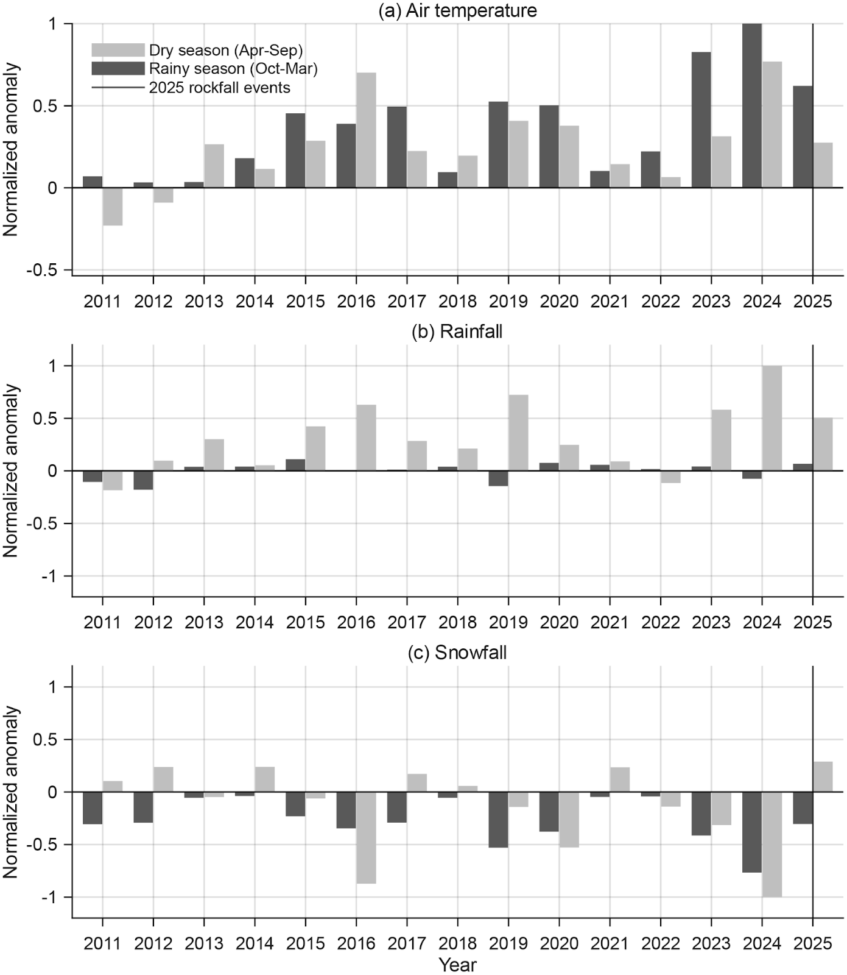
Figure S13: Long-term reconstruction of air temperature, rainfall and snowfall anomalies from dry (April to September) and rainy (October to March) seasons using ERA5 dataset. The ERA5 dataset was downscaled at the location of the rock fall and normalized using the median value of the 1980-2010 reference period.

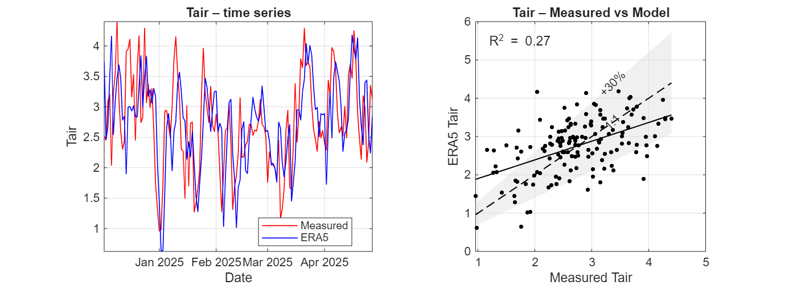
- 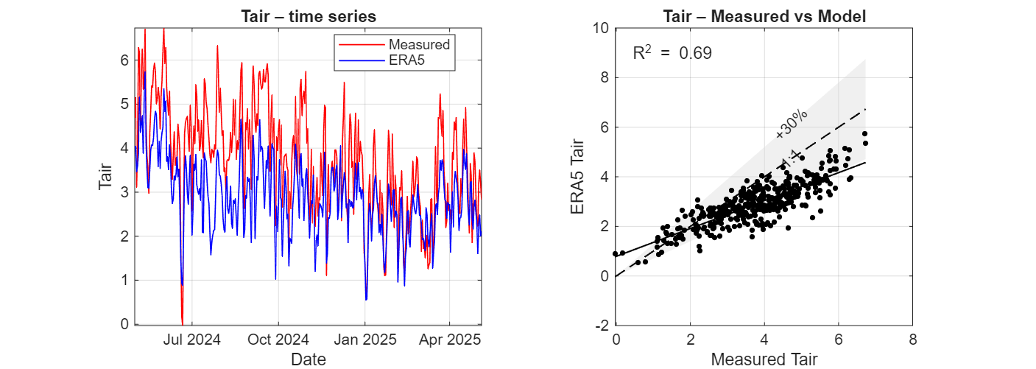
- 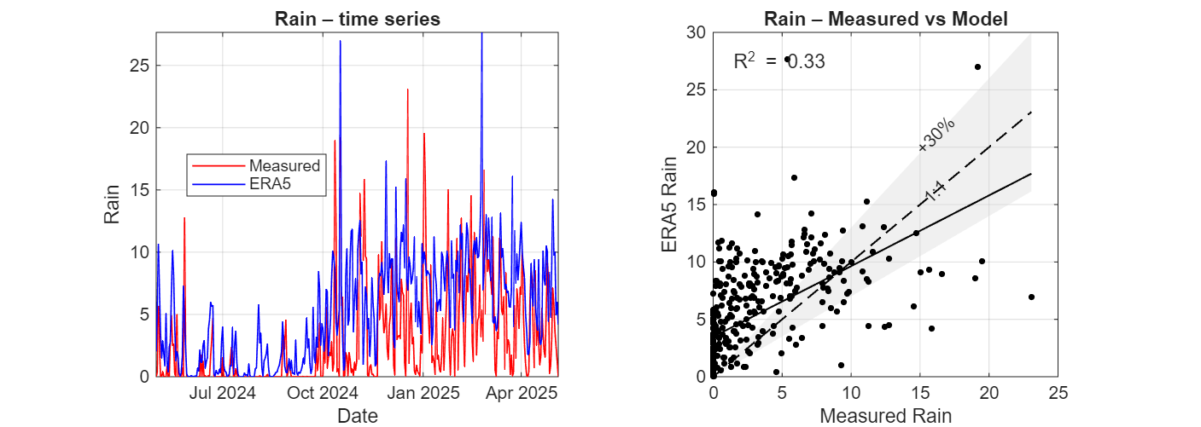
- Figure S14 Comparison between in-situ meteorological variables (INAIGEM, 2023) and downscaled ERA5 90 m dataset. Upper panels show the comparison of air temperature at the Llaca lake (lat: -9.4354°, long: -77.4408°, elevation: 4534 m a.s.l.. Middle panels show the comparison of air temperature at the Palcacocha lake (lat: -9.4004°, long: -77.3824°, elevation: 4558 m a.s.l.); and lower panels show the comparison of rain time series (mm/day) at the Palcacocha lake (lat: -9.4004°, long: -77.3824°, elevation: 4558 m a.s.l.).

