Supplementary Material Online

Title: Implementing a CYP2C19-guided approach for prescribing Dual Antiplatelet Therapy in Acute Coronary Syndrome for patients undergoing Percutaneous Coronary Intervention: a cost-effectiveness analysis

Supplementary Appendix 1: The CHEERS checklist

Supplementary Appendix 2: Model input parameters

Supplementary Appendix 3: Results from the technical verification process
Supplementary Appendix 4: Results from the deterministic sensitivity analysis
Supplementary Appendix 5: Results from the probabilistic sensitivity analysis (discounted)

Supplementary Appendix 6: Results from the probabilistic sensitivity analysis (undiscounted)

Supplementary Appendix 7: Results from scenario analyses

References

Supplementary Appendix 1: Consolidated Health Economic Evaluation Reporting Standards

This section, presents the completed CHEERS 2022 checklist for our manuscript, mapping each reporting item to the relevant section and page number. This checklist is provided to demonstrate adherence to current best-practice reporting standards for health economic evaluations and to support transparency and reproducibility. Items that were not applicable to this study are clearly indicated as “N/A”.

Table S1.1. The CHEERS 2022 checklist

Section/topic | Item No | Guidance for reporting | Reported in section
Title
Title | 1 | Identify the study as an economic evaluation and specify the interventions being compared. | Title Page
Abstract
Abstract | 2 | Provide a structured summary that highlights context, key methods, results, and alternative analyses. | Page 4
Introduction
Background and objectives | 3 | Give the context for the study, the study question, and its practical relevance for decision making in policy or practice. | Page 6
Methods
Health economic analysis plan | 4 | Indicate whether a health economic analysis plan was developed and where available. | N/A
Study population | 5 | Describe characteristics of the study population (such as age range, demographics, socioeconomic, or clinical characteristics). | Page 6, 7
Setting and location | 6 | Provide relevant contextual information that may influence findings. | Page 6
Comparators | 7 | Describe the interventions or strategies being compared and why chosen. | Page 7
Perspective | 8 | State the perspective(s) adopted by the study and why chosen. | Page 11
Time horizon | 9 | State the time horizon for the study and why appropriate. | Page 8
Discount rate | 10 | Report the discount rate(s) and reason chosen. | Page 11
Selection of outcomes | 11 | Describe what outcomes were used as the measure(s) of benefit(s) and harm(s). | Page 10, 11
Measurement of outcomes | 12 | Describe how outcomes used to capture benefit(s) and harm(s) were measured. | Page 10, 11
Valuation of outcomes | 13 | Describe the population and methods used to measure and value outcomes. | Page 9,10, 11
Measurement and valuation of resources and costs | 14 | Describe how costs were valued. | Page 11
Currency, price date, and conversion | 15 | Report the dates of the estimated resource quantities and unit costs, plus the currency and year of conversion. | Page 11, Table1
Rationale and description of model | 16 | If modelling is used, describe in detail and why used. Report if the model is publicly available and where it can be accessed. | Page 8,9
Analytics and assumptions | 17 | Describe any methods for analysing or statistically transforming data, any extrapolation methods, and approaches for validating any model used. | Page 11,12,13
Characterizing heterogeneity | 18 | Describe any methods used for estimating how the results of the study vary for subgroups. | Page 6
Characterizing distributional effects | 19 | Describe how impacts are distributed across different individuals or adjustments made to reflect priority populations. | N/A
Characterizing uncertainty | 20 | Describe methods to characterise any sources of uncertainty in the analysis. | Page 12,13
Approach to engagement with patients and others affected by the study | 21 | Describe any approaches to engage patients or service recipients, the general public, communities, or stakeholders (such as clinicians or payers) in the design of the study. | Page 8
Results
Study parameters | 22 | Report all analytic inputs (such as values, ranges, references) including uncertainty or distributional assumptions. | Page 9, Supplementary appendix 1
Summary of main results | 23 | Report the mean values for the main categories of costs and outcomes of interest and summarise them in the most appropriate overall measure. | Page 14, Table 2, Table 3
Effect of uncertainty | 24 | Describe how uncertainty about analytic judgments, inputs, or projections affect findings. Report the effect of choice of discount rate and time horizon, if applicable. | Page 14 , Table 4, Table 3, Supplementary Appendix 4, 5, 6
Effect of engagement with patients and others affected by the study | 25 | Report on any difference patient/service recipient, general public, community, or stakeholder involvement made to the approach or findings of the study | Supplementary Appendix 3
Discussion
Study findings, limitations, generalizability, and current knowledge | 26 | Report key findings, limitations, ethical or equity considerations not captured, and how these could affect patients, policy, or practice. | Page 16, 18, 19
Other relevant information
Source of funding | 27 | Describe how the study was funded and any role of the funder in the identification, design, conduct, and reporting of the analysis | Funding declaration
Conflicts of interest | 28 | Report authors conflicts of interest according to journal or International Committee of Medical Journal Editors requirements. | Author conflict of interest statement

Source: Consolidated Health Economic Evaluation Reporting Standards 2022 (CHEERS 2022) Statement: Updated Reporting Guidance for Health Economic Evaluations - PubMed.

Supplementary Appendix 2: Model input parameters
Table S2.1: Model input parameters
Input | value | probability distribution | Source
population characteristics
STEMI
size | 41690 | Not applicable | [1]
Mean age, Male (75%) | 62 years | Not applicable | [2]
Mean age, Female (25%) | 69 years | Not applicable | [2]
UA/NSTEMI
size | 61248 | Not applicable | [1]
Mean age, Male (72%) | 64 years | Not applicable | [2]
Mean age, Female (28%) | 69 years | Not applicable | [2]
prescribing breakdown, %
STEMI
Aspirin + clopidogrel | 21.9% | Not applicable | [3]
Aspirin + ticagrelor | 55.2% | Not applicable | [3]
Aspirin + prasugrel | 22.9% | Not applicable | [3]
UA/NSTEMI
Aspirin + clopidogrel (AC) | 50% | Not applicable | [3]
Aspirin + ticagrelor (AT) | 47% | Not applicable | [3]
Aspirin + prasugrel (AP) | 3% | Not applicable | [3]
genetic test uptake, %
Probability of ordering PoC test | 93% | β (α = 219, β=16) | [4]
Probability of following PoC test result | 93% | β (α = 219, β=16) | [4]
baseline risk of clinical events, %
STEMI
all-cause mortality with aspirin + clopidogrel | 9.72% | β (α = 4082, β=37892) | [5]
reinfarction with aspirin + clopidogrel | 6.55% | β (α = 108, β=1540) | [6]
stroke with aspirin + clopidogrel | 1.24% | β (α = 144, β=11509) | [7]
major bleeding with aspirin + clopidogrel | 2.2% | β (α = 23, β=1000) | [8]
minor bleeding with aspirin + clopidogrel | 6.1% | β (α = 62, β=961) | [8]
Dyspnoea with aspirin + clopidogrel | 7.85% | β (α = 344, β=4043) | [9]
UA/NSTEMI
all-cause mortality with aspirin + clopidogrel | 5.43% | β (α = 2962, β=51556) | [5]
reinfarction with aspirin + clopidogrel | 4.22% | β (α = 101, β=2291) | [6]
stroke with aspirin + clopidogrel | 0.63% | β (α = 1298, β=204664) | [7]
major bleeding with aspirin + clopidogrel | 2.38% | β (α = 24, β=999) | [8]
minor bleeding with aspirin + clopidogrel | 1.51% | β (α = 62, β=961) | [8]
dyspnoea with aspirin + clopidogrel | 7.85% | β (α = 15, β=1008) | [9]
Relative treatment effect
aspirin + ticagrelor versus aspirin + clopidogrel
OR all-cause mortality | 0.77 | Lognormal (μ= -0.26, σ=0.085) | [2]
OR reinfarction | 0.82 | Lognormal (μ= -0.2, σ=0.072) | [2]
OR stroke | 1.13 | Lognormal (μ= -0.11, σ=0.10) | [2]
OR major bleeding | 1.04 | Lognormal (μ= 0.038, σ=0.045) | [2]
OR minor bleeding | 1.37 | Lognormal (μ= 0.31, σ=0.051) | [2]
OR dyspnoea | 1.77 | Lognormal (μ= 0.57, σ=0.044) | [2]
aspirin + prasugrel versus aspirin + clopidogrel
OR all-cause mortality | 1 | Lognormal (μ= -0.005, σ=0.096) | [2]
OR reinfarction | 0.75 | Lognormal (μ= -0.29, σ=0.082) | [2]
OR stroke | 0.93 | Lognormal (μ=-0.087, σ=0.18) | [2]
OR major bleeding | 1.43 | Lognormal (μ= 0.35, σ=0.08) | [2]
OR minor bleeding | 2.07 | Lognormal (μ= 0.63, σ=0.20) | [2]
aspirin clopidogrel-no loss-of-function vs aspirin+ ticagrelor
HR all-cause mortality | 1 | Lognormal (μ= -0.006, σ=0.113) | [10]
HR reinfarction | 1 | Lognormal (μ= -0.006, σ=0.113) | [10]
HR stroke | 1 | Lognormal (μ= -0.006, σ=0.113) | [10]
HR major bleeding | 1 | Lognormal (μ= -0.006, σ=0.113) | [10]
HR minor bleeding | 1 | Lognormal (μ= -0.006, σ=0.113) | [10]
CYP2C19 loss-of-function allele frequency, % | 29.7% | β (α = 6, β=14) | [11] [12, 13]
Duration of adverse events, day
minor bleeding | 7.6 | NA | [14]
major bleeding | 45.38 | NA | [14]
dyspnoea | 30 | NA | [9]
Health state utilities
no further event | 0.842 | β (α = 28003, β=5255) | [15]
reinfarction | 0.779 | β (α = 1340, β=380) | [15]
post-reinfarction | 0.821 | β (α = 83, β=18) | [15]
stroke | 0.703 | β (α = 1467, β=620) | [15]
post-stroke | 0.703 | β (α = 101, β=43)
Utility decrements
minor bleeding | 0.026 | γ (α = 27; β = 0.00096) | [14]
major bleeding | 0.038 | γ (α = 40; β = 0.00094) | [14]
dyspnoea | 0.049 | γ (α = 100; β = 0.0005) | [2]
Standardised Mortality Ratios
no further event | 2 | Lognormal (μ= 0.693, σ=0.0025) | [16]
reinfarction | 4.5 | Lognormal (μ= 1.503, σ=0.0079) | [16]
post-reinfarction | 3 | Lognormal (μ= 1.098, σ=0.0085) | [16]
stroke | 4.73 | Lognormal (μ= 1.533, σ=0.0436) | [17]
post-stroke | 2.32 | Lognormal (μ= 0.838, σ=0.0351) | [17]
Post 1-year transition probabilities, %
STEMI
no further event to reinfarction | 4.3% | β (α = 182, β=4055) | [6]
no further event to stroke | 1.12% | β (α = 49, β=4338) | [7]
no further event to Death | age dependant |  | [18]
stroke to death | age dependant |  | [18]
reinfarction to death | age dependant |  | [18]
post-stroke to death | age dependant |  | [18]
post-reinfarction to death | age dependant |  | [18]
UA/NSTEMI
no further event to reinfarction | 3.62% | β (α = 153, β=4084) | [1]
no further event to stroke | 0.59% | β (α = 26, β=4361) | [7]
no further event to Death | age dependant |  | [18]
stroke to death | age dependant |  | [18]
reinfarction to death | age dependant |  | [18]
post-stroke to death | age dependant |  | [18]
post-reinfarction to death | age dependant |  | [18]
Daily cost of (£, 2025 values)
aspirin (ASA) | £0.03 | Not applicable | [19]
clopidogrel | £0.04 | Not applicable | [19]
prasugrel | £0.29 | Not applicable | [19]
ticagrelor | £1.95 | Not applicable | [19]
Cost elements decision tree (£, 2024/2025 values)
point-of-care test | £125 | Not applicable | Manufacturer
Index PCI | £3125 | γ (α = 25; β = 125) | [20]
no further event | £2004 | Not applicable | [2]
reinfarction | £6799 | Not applicable | [21]
stroke | £18576 | Not applicable | [22]
minor bleeding | £125 | Not applicable | [20]
major bleeding | £2389 | Not applicable | [20]
dyspnoea | £45 | Not applicable | [23]
Cost elements Markov (£, 2024/2025 values)
no further event | £1152 | Not applicable | [22]
reinfarction | £6237 | Not applicable | [21]
post-reinfarction | £1729 | Not applicable | [21]
stroke | £22632 | Not applicable | [22]
post- stroke | £8035 | Not applicable | [22]
Abbreviations: UA, unstable angina; NSTEMI, non-ST-elevation myocardial infarction; STEMI, ST-elevation myocardial infarction; PCI, percutaneous coronary intervention; OR, odds ratio; HR, hazard ratio; LoF, loss-of-function (allele of CYP2C19); BNF, British National Formulary; PSSRU, Personal Social Services Research Unit; MINAP, Myocardial Ischaemia National Audit Project, NA: not applicable.

Supplementary Appendix 3: The results from the technical verification process
3.1 Process of technical verification
The process of technical verification involves an independent programmer examining the model code and testing elements of it to identify potential errors and highlight areas for code improvement. The following report details the process of conducting a technical verification of the R code used to estimate the cost-effectiveness of a CYP2C19-guided DAPT for patients with acute coronary syndrome. This technical verification was conducted by Dr Stuart Wright, a Senior Research Fellow in Health Economics at the University of Manchester. While working in the same group as the model developers (Alireza Mahboub-Ahari, Joe Hilton, Katherine Payne), Dr Wright had no role in developing the code and had not seen any of the model code prior to commencing the verification process. This technical verification used the TECH-VER toolkit as a framework.
The first step in technical verification is to review the code, map the calculations performed at each stage, and assess their validity through manual inspection. To support this process, the authors provided a document summarising the decision criteria, model structure and pathway description, key assumptions, and the analytical approach, enabling the reviewer to become familiar with the overall workflow. The model comprises four stages that require examination: input calculations; event/state calculations; results calculations; and uncertainty analysis. The following section summarises the calculations that were manually checked at each stage, followed by recommendations for code revision and improvement.
3.2 Comments and recommendations from black box testing

For most black box tests[24], changes in input parameters resulted in logical changes in output values. It was noted that many of the values included in the input excel sheets did not impact the output parameters at al. It is hypothesised that these are legacy parameters from the excel based models and are not used in the R-based analysis, but it is critical for the research team to highlight which parameters are meant to be changeable. One key observation was that changing start age did not seem to affect the results.

In the analysis, only changes in the discount rate for costs had an impact on the results. Examination of the code showed that the same discount rate for both costs and outcomes is hard coded in the R script such that changes in the cost discount rate were also reflected in the outcome discount rate. While scenario analysis tests the use of differential discounting, it is recommended that the researchers uncouple the discount rates for future users. Changing the cost-effectiveness threshold also has no impact on the model results, although results are presented for different thresholds in the PSA.

Testing also identified one minor assumption that the researchers might want to address. Dyspnoea disutility appears to be linked to duration of illness, but the treatment cost it fixed. In reality this will not impact the results given the tiny effect of dyspnoea, but the researchers may wish to consider changing this.

When comparing the effects of changes between the model applications, it was noted that the effect of changes of parameters related to myocardial infarction had slightly different effects. There may be a mechanism by which this difference is relevant to the different model applications, but the researchers may wish to check in case this indicates an error. Detailed results of the code validation checks are presented in the tables 3.1 and 3.2 for the STEMI and UA/NSTEMI populations.

3.3 Adjustments to the code based on the recommendations from black box testing
Effect of changing starting age: Sex-stratified starting ages are read into our analysis code from the Excel workbook, but their values are not fully integrated into the analysis. The age-stratified utility formula in our Markov model uses the starting ages read from the Excel workbook, but the age-specific mortality cannot be updated to reflect changes to the starting age. This is because the limits of the mortality tables in our Excel workbook are chosen to precisely line up with the starting ages and time horizon and so there is no way to make the starting ages earlier or later without modifying these mortality tables. Given this limited range of age-specific mortalities in the Excel workbook, we have not updated the code’s handling of starting age.
Cost effectiveness threshold: The hardcoded value of 20,000 has been replaced with a variable ce_threshold which is extracted from the Excel workbook.
Cost of dyspnoea: as observed in the technical verification, in our code we calculate the disutility associated with dyspnoea by multiplying an annual disutility by the average duration of dyspnoea divided by 365, to give a per-episode disutility. The reviewer suggested adding a similar rescaling to the calculation of costs associated with dyspnoea. We have chosen not to add this rescaling because our parameter value for the cost of dyspnoea comes as a per-event cost rather than a per-unit-time cost, and so any rescaling would involve simply multiplying the cost by 1.
Independent cost/benefit discount rates: The single parameter discount_by_cycle has been replaced with independent parameters utility_discount and cost_discount which are extracted separately from the Excel workbook.
In addition to these changes, we inspected the code to for errors which might be causing the discrepancy in the effect of increased risk of reinfarction between the STEMI and NSTEMI and were unable to find an explanation in the code, suggesting that these discrepancies are genuine rather than artefactual.

Table 3.1 Black box tests for deterministic analysis - STEMI population

Check | Effect | Potential Error
Raise M and F start age to 70 | None | Not plugged in?
Raise proportion who are Male | Increase costs and benefits in both arms | No
Reduce prob of ordering test to 50% | Increase cost and reduce benefits in PC arm | No
Reduce prob of following test to 50% | Increase expected cost under PC and reduce benefits. | No
Increase prob of death with AC to 0.2 | Reduce costs and benefits of both strategies | No
Increase prob of MI with AC to 0.2 | Marginally reduced costs in both strategies and decreased benefits | No
Increase prob of major stroke with AC to 0.05 | Increase costs of both strategies and decrease benefits. PC now cost saving | No
Increase prob of major bleed with AC | Marginal increase in costs and reduction in benefits | No
Increase prob of major bleed with AC | Marginal increase in costs and reduction in benefits | No
Increase prob of death with AT | No effect | Not plugged in?
Increase prob of MI with AT | No effect | Not plugged in?
Increase prob of stroke with AT | No effect | Not plugged in?
Increase prob of major bleed with AT | No effect | Not plugged in?
Increase prob of minor bleed with AT | No effect | Not plugged in?
Increase prob of death with AP | No effect | Not plugged in?
Increase prob of MI with AP | No effect | Not plugged in?
Increase prob of stroke with AP | No effect | Not plugged in?
Increase prob of major bleed with AP | No effect | Not plugged in?
Increase prob of minor bleed with AP | No effect | Not plugged in?
Increase prevalence of LOF in the base case | Increase cost of PC and reduce benefits of PC | No
Decrease prevalence of LOF in base case | Reduce cost of PC and increase benefits of PC | No
Increase LOF prevalence sensitivity | Reduce benefits and increase costs in PC arm | No
Increase proportion AT in LOF | No effect
Increase prop_death_AC_noLOF to rate_min_bleed_AC_noLOF | No effect | Not plugged in?
Increase utility no event tree | Benefits increase in both arms | No
Increase utility reinfarction tree | Benefits increase in both arms | No
Increase utility stroke tree | Benefits increase in both arms | No
Increase major bleed disutility | Benefits decrease in both arms | No
Increase minor bleed disutility | Benefits decrease in both arms | No
Increase duration minor bleed | Benefits decrease in both arms | No
Increase duration major bleed | Benefits decrease in both arms | No
Increase SMR values | No effect
Increase POCT cost | Cost of PC goes up | No
Increase day costs aspirin | Cost of both arms goes up | No
Increase day costs of clopidogrel | Cost of both arms goes up | No
Increase day cost of prasugrel | Cost of both arms goes up | No
Increase day cost of ticagrelor | Cost of both arms goes up | No
Increase cost PCI | Cost of both arms goes up | No
Increase cost no event tree | Cost of both arms goes up | No
Increase cost MI tree | Cost of both arms goes up | No
Increase cost of stroke tree | Cost of both arms goes up | No
Increase cost of death tree | Cost of both arms goes up | No
Increase cost of minor bleed | Cost of both arms goes up | No
Increase cost of major bleed | Cost of both arms goes up | No
Increase cost of bleeding AC, AT, AP | No effect | Not plugged in?
Increase cost no event Markov | Costs of both arms go up | No
Cost stroke Markov | Costs of both arms go up | No
Increase cost stroke Markov | Costs of both arms go up | No
Increase cost post stroke Markov | Costs of both arms go up | No
Increase cost reinfarction Markov | Costs of both arms go up | No
Increase cost post-reinfarction Markov | Costs of both arms go up | No
Increase discount rate costs | No effect | Critical: Check
Increase discount rate QALYs | Discounted benefits decrease in both arms | No
Increase ce threshold | No effect on NMB | Critical: check
Reduce OR death tica vs clop | Increase costs and benefits in both arms | No
Reduce OR MI tica vs clop | Very marginal increase in costs and benefits in both arms | No
Reduce OR stroke tica vs clop | Decrease in costs and increase in benefits in both arms | No
Reduce OR maj bleed tica vs clop | Small decrease in costs in each arm (possible miniscule change in benefit) | No
Reduce OR min bleed tica vs clop | Small decrease in costs in each arm (possible miniscule change in benefit) | No
Reduce OR death pras vs clop | Increase costs and benefits in both arms | No
Reduce OR MI pras vs clop | Increase benefits in both arms and marginal increase in costs | No
Reduce OR stroke pras vs clop | Increase benefits in both arms but reduce costs | No
Reduce OR maj bleed pras vs clop | Small reduction in costs in both arms but no (or miniscule) impact on benefits | No
Reduce OR minor bleed pras vs clop | Small reduction in costs in both arms but no (or miniscule) impact on benefits | No
Reduce RR death AC no LOF vs AT standard | Increase benefits and costs in PC arm | No
Reduce RR MI no LOF vs AT standard | Small increase in benefits and costs in PC arm | No
Reduce RR stroke no LOF vs AT standard | Increase benefits and decrease costs in PC arm | No
Reduce RR maj bleed no LOF vs AT standard | Small decrease in costs in PC arm and no or insignificant impact on benefits | No
Reduce RR minor bleed no LOF vs AT standard | Small decrease in costs in PC arm and no or insignificant impact on benefits | No
Increase prob dyspnoea AC | Small reduction in benefits and increase in costs in both arms | No
Increase prob dyspnoea AP | Small reduction in benefits and increase in costs in both arms | No
Increase cost dyspnoea pp | Increase costs in both arms | No
Increase utility decrement dyspnoea | Reduce benefits in both arms | No
Increase duration of dyspnoea | Reduce benefits in both arms | No: but is there an assumption that dyspnoea treatment cost is not related to duration?

Table 3.2 Black box tests for deterministic analysis – UA/NSTEMI population

Check | Effect | Potential Error
Raise M and F start age to 70 | None | Not plugged in?
Raise proportion who are Male | Increase costs and benefits in both arms | No
Reduce prob of ordering test to 50% | Increase cost and reduce benefits in PC arm | No
Reduce prob of following test to 50% | Increase expected cost under PC and reduce benefits. | No
Increase prob of death with AC to 0.2 | Reduce costs and benefits of both strategies | No
Increase prob of MI with AC to 0.2 | Marginally increased costs and decreased benefits in both arms | Yes: different to STEMI analysis
Increase prob of major stroke with AC to 0.05 | Increase costs of both strategies and decrease benefits. | No
Increase prob of major bleed with AC | Marginal increase in costs and reduction in benefits | No
Increase prob of minor bleed with AC | Marginal increase in costs and reduction in benefits | No
Increase prob of death with AT | No effect | Not plugged in?
Increase prob of MI with AT | No effect | Not plugged in?
Increase prob of stroke with AT | No effect | Not plugged in?
Increase prob of major bleed with AT | No effect | Not plugged in?
Increase prob of minor bleed with AT | No effect | Not plugged in?
Increase prob of death with AP | No effect | Not plugged in?
Increase prob of MI with AP | No effect | Not plugged in?
Increase prob of stroke with AP | No effect | Not plugged in?
Increase prob of major bleed with AP | No effect | Not plugged in?
Increase prob of minor bleed with AP | No effect | Not plugged in?
Increase prevalence of LOF in the base case | Increase cost of PC and reduce benefits of PC | No
Decrease prevalence of LOF in base case | Reduce cost of PC and increase benefits of PC | No
Increase LOF prevalence sensitivity | Reduce benefits and increase costs in PC arm | No
Increase proportion AT in LOF | No effect
Increase prop_death_AC_noLOF to rate_min_bleed_AC_noLOF | No effect | Not plugged in?
Increase utility no event tree | Benefits increase in both arms | No
Increase utility reinfarction tree | Benefits increase in both arms | No
Increase utility stroke tree | Benefits increase in both arms | No
Increase major bleed disutility | Benefits decrease in both arms | No
Increase minor bleed disutility | Benefits decrease in both arms | No
Increase duration minor bleed | Benefits decrease in both arms | No
Increase duration major bleed | Benefits decrease in both arms | No
Increase SMR values | No effect
Increase POCT cost | Cost of PC goes up | No
Increase day costs aspirin | Cost of both arms goes up | No
Increase day costs of clopidogrel | Cost of both arms goes up | No
Increase day cost of prasugrel | Cost of both arms goes up | No
Increase day cost of ticagrelor | Cost of both arms goes up | No
Increase cost PCI | Cost of both arms goes up | No
Increase cost no event tree | Cost of both arms goes up | No
Increase cost MI tree | Cost of both arms goes up | No
Increase cost of stroke tree | Cost of both arms goes up | No
Increase cost of death tree | Cost of both arms goes up | No
Increase cost of minor bleed | Cost of both arms goes up | No
Increase cost of major bleed | Cost of both arms goes up | No
Increase cost of bleeding AC, AT, AP | No effect | Not plugged in?
Increase cost no event Markov | Costs of both arms go up | No
Cost stroke Markov | Costs of both arms go up | No
Increase cost stroke Markov | Costs of both arms go up | No
Increase cost post stroke Markov | Costs of both arms go up | No
Increase cost reinfarction Markov | Costs of both arms go up | No
Increase cost post-reinfarction Markov | Costs of both arms go up | No
Increase discount rate costs | No effect | Critical: Check
Increase discount rate QALYs | Discounted benefits decrease in both arms | No
Increase ce threshold | No effect on NMB | Critical: check
Reduce OR death tica vs clop | Increase costs and benefits in both arms | No
Reduce OR MI tica vs clop | Increase in benefits and decrease in costs in both arms | Yes: different to STEMI analysis
Reduce OR stroke tica vs clop | Decrease in costs and increase in benefits in both arms | No
Reduce OR maj bleed tica vs clop | Small decrease in costs in each arm (possible miniscule change in benefit) | No
Reduce OR min bleed tica vs clop | Small decrease in costs in each arm (possible miniscule change in benefit) | No
Reduce OR death pras vs clop | Increase costs and benefits in both arms | No
Reduce OR MI pras vs clop | Increase benefits in both arms and marginal decrease in costs | Yes: different to STEMI analysis
Reduce OR stroke pras vs clop | Reduce costs in both arms, imperceptible change in benefits | No
Reduce OR maj bleed pras vs clop | Small reduction in costs in both arms but no (or miniscule) impact on benefits | No
Reduce OR minor bleed pras vs clop | Small reduction in costs in both arms but no (or miniscule) impact on benefits | No
Reduce RR death AC no LOF vs AT standard | No effect | Not plugged in?
Reduce RR MI no LOF vs AT standard | No effect | Not plugged in?
Reduce RR stroke no LOF vs AT standard | Increase benefits and decrease costs in PC arm | No
Reduce RR maj bleed no LOF vs AT standard | Small decrease in costs in PC arm and no or insignificant impact on benefits | No
Reduce RR minor bleed no LOF vs AT standard | Small decrease in costs in PC arm and no or insignificant impact on benefits | No
Increase prob dyspnoea AC | Small reduction in benefits and increase in costs in both arms | No
Increase prob dyspnoea AP | No effect | Not plugged in?
Increase cost dyspnoea pp | Increase costs in both arms | No
Increase utility decrement dyspnoea | Reduce benefits in both arms | No
Increase duration of dyspnoea | Reduce benefits in both arms | No: but is there an assumption that dyspnoea treatment cost is not related to duration? Ok but just checking

Supplementary Appendix 4: Results from the deterministic sensitivity analysis
Deterministic (One-way) sensitivity analysis was conducted by varying the parameters including the prevalence of CYP2C19 LoF; baseline risks of reinfarction, stroke, minor and major bleeding and mortality; implementation assumptions (such as full uptake and follow-up of point-of-care testing); and treatment practice scenarios (alternative distributions of antiplatelet prescribing).

For the STEMI population, each parameter was varied across its low–high range with all other parameters fixed at their base-case values. Bars indicate the resulting change in net monetary benefit per patient when the baseline value is £853.

Figure S4.1: Tornado plot for the STEMI population

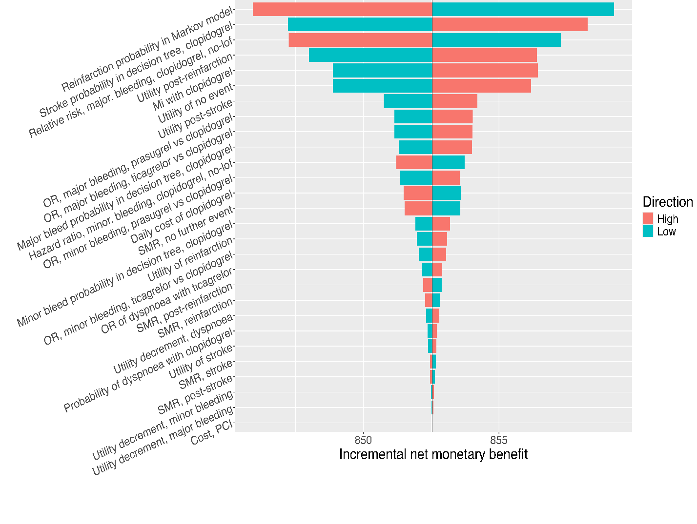

For the UA/NSTEMI population, each parameter was varied across its low–high range with all other parameters fixed at their base-case values. Bars indicate the resulting change in net monetary benefit per patient when the baseline value is £633.

Figure S4.2. Tornado plot for the UA/NSTEMI population

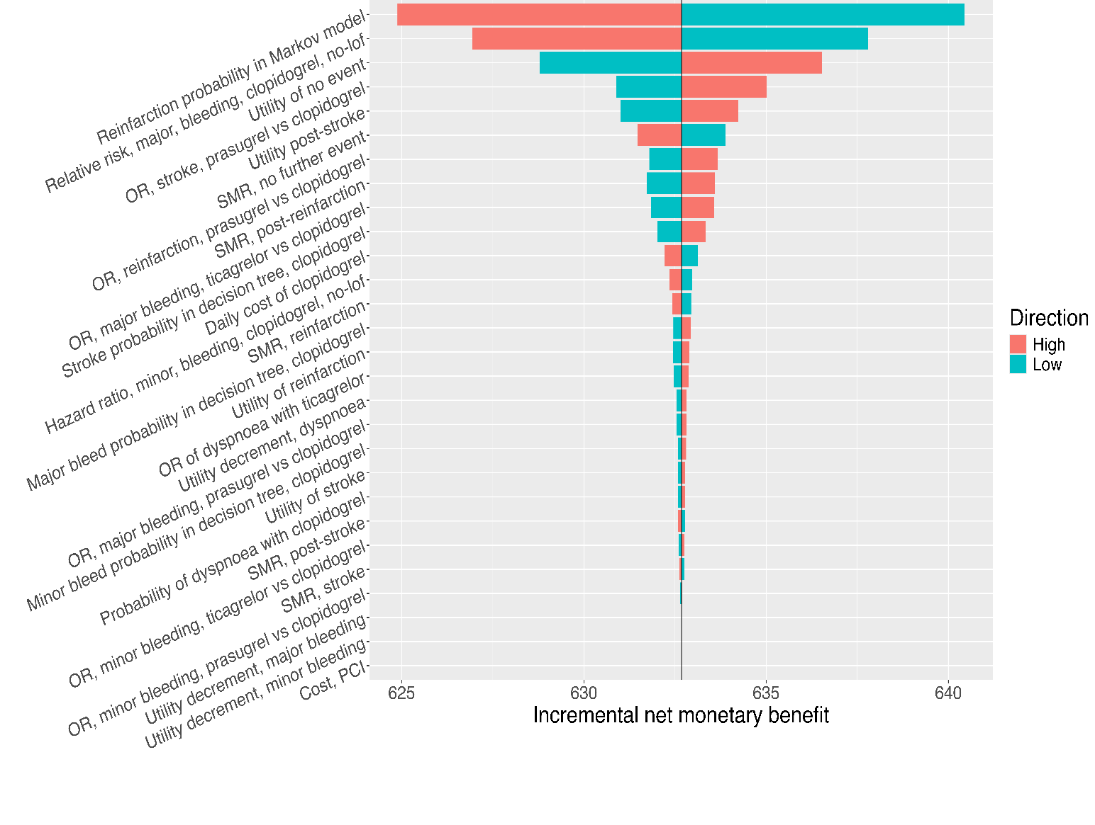

Supplementary Appendix 5: Results from the probabilistic sensitivity analysis
These figures present the cost-effectiveness plane and acceptability curve derived from the probabilistic sensitivity analysis (PSA) for the base-case model. Each point on the CEAC represents the proportion of PSA simulations in which CYP2C19-guided DAPT is cost-effective compared with current DAPT at a given willingness-to-pay (cost-effectiveness) threshold for a QALY. At the NICE reference threshold of £20,000 per QALY, CYP2C19-guided DAPT has a high probability of being cost-effective, indicating that the base-case conclusions are robust to joint parameter uncertainty.

Figure S5.1. cost-effectiveness plane and acceptability curve for STEMI population
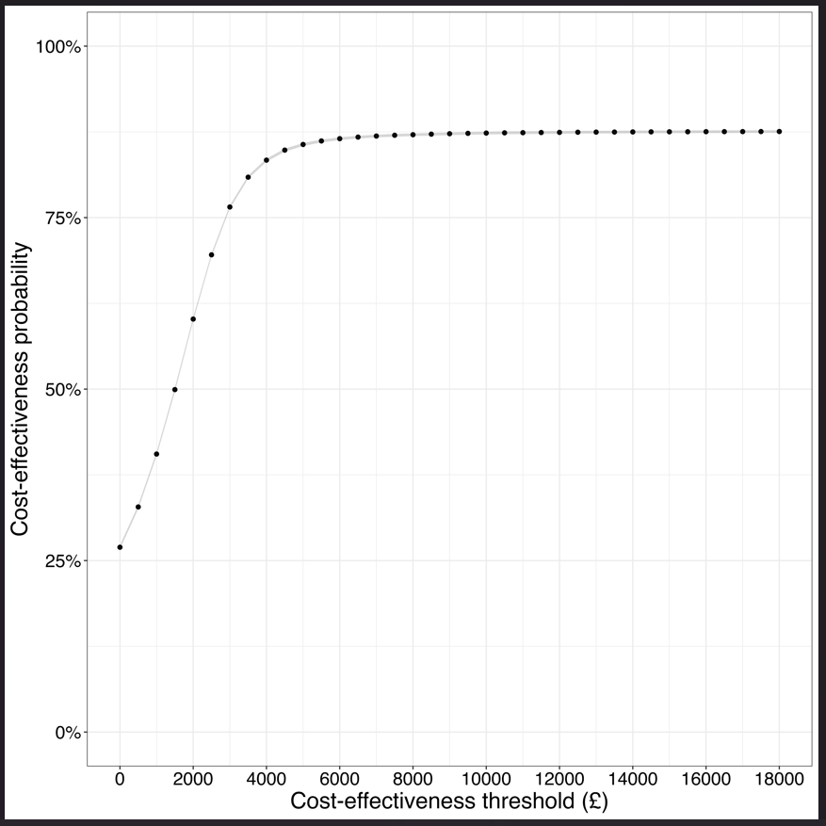
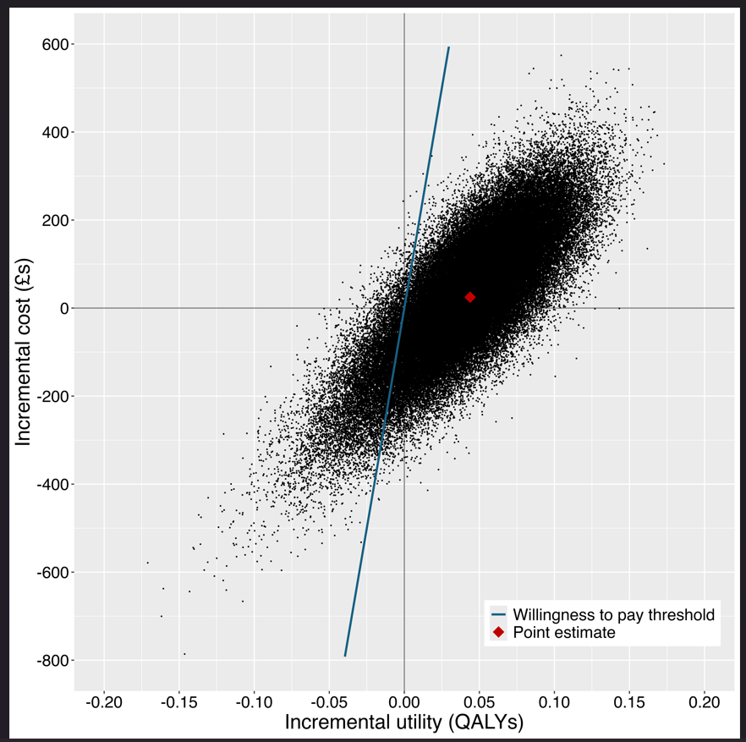
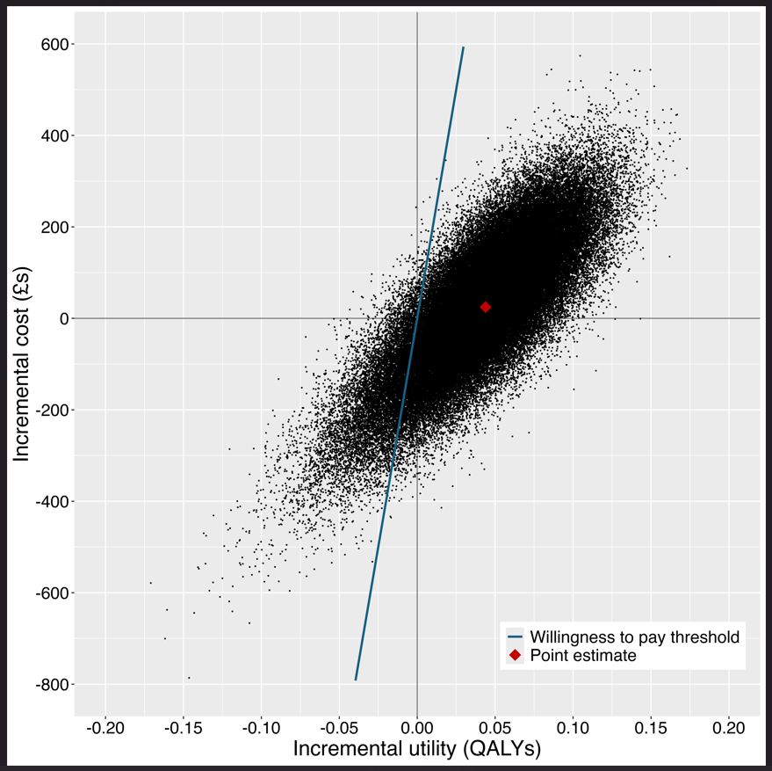
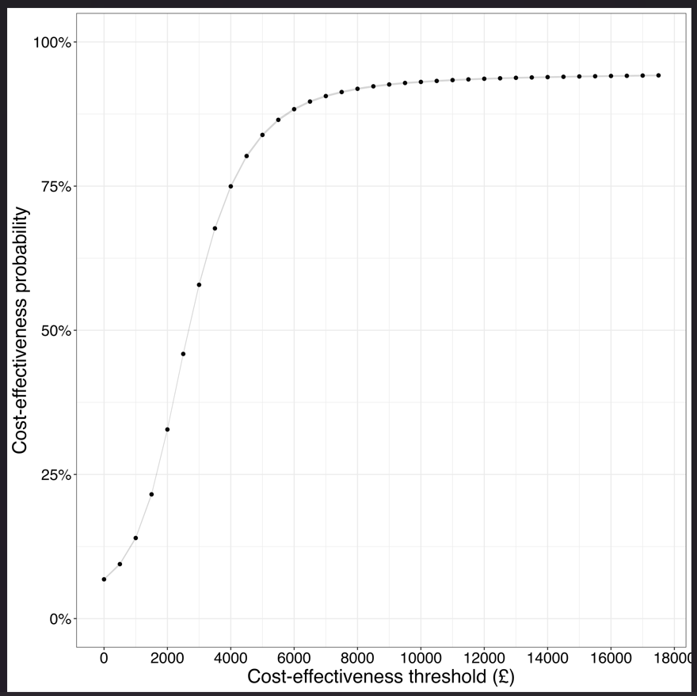

Figure S5.2. cost-effectiveness plane and acceptability curve for UA/NSTEMI population
Supplementary Appendix 6: Results from the probabilistic sensitivity analysis (undiscounted)
Results are based on a hypothetical annual cohort of 41,690 STEMI and 61,248 UA/NSTEMI patients in England. Values represent mean outcomes from the probabilistic sensitivity analysis under the base-case scenario, using undiscounted costs and QALYs. Uncertainty is summarised using 95% credible intervals derived from the distribution of model outputs across simulations.

Table S6.1: Results from the probabilistic sensitivity analysis results(undiscounted)
DAPT strategy | Mean cost  (95% credible interval) | Mean QALYs  (95% credible interval) | Incremental cost, £  (95% credible interval) | Incremental QALYs  (95% credible interval) | ICER  (95% credible interval) | Net Monetary Benefit  £,  (95% credible interval) | Incremental  Net Monetary Benefit  (95% credible interval)
STEMI
current DAPT | 31513 (29411, 33825) | 8.0731 (7.8451, 8.2739) | 76 (-309, 408) | 0.0557(-0.0462, 0.1423) | 711 (-16005, 18608) | 129949 (124703, 134719) | 1038 (-674, 2523)
CYP2C19-guided DAPT | 31589 (29441, 33947) | 8.1288 (7.8759, 8.3564) | 76 (-309, 408) | 0.0557(-0.0462, 0.1423) | 711 (-16005, 18608) | 130988 (125436, 136103) | 1038 (-674, 2523)
UA/NSTEMI
current DAPT | 26688 (24931, 28677) | 7.9426 (7.7615, 8.0982) | 126 (-66, 299) | 0.0460 (-0.0110, 0.0928) | 2769 (-3285, 9445) | 132163 (127877, 135991) | 793 (-192, 1627)
CYP2C19-guided DAPT | 26814 (25035, 28831) | 7.9885 (7.7979, 8.1561) | 126 (-66, 299) | 0.0460 (-0.0110, 0.0928) | 2769 (-3285, 9445) | 132956 (128544, 136949) | 793 (-192, 1627)
Ninety-five percent credible intervals are provided in the brackets. Since the ICER falls under NICE standard cost effectiveness threshold then the CYP2C19-guided treatment is preferred in both populations. Abbreviations: STEMI, ST-segment elevation myocardial infarction; NSTEMI, Non-ST-elevation myocardial infarction; UA, unstable angina. DAPT, dual antiplatelet therapy; pp, per person; CrI, credible interval; QALYs, quality-adjusted life years; ICER, incremental cost-effectiveness ratio; NMB, net monetary benefit; CE at £20k, probability of cost-effectiveness at a £20,000 per QALY threshold.

Supplementary Appendix 7: Results from scenario analyses
Table S7.1 and S7.2 reports the results of the scenario analyses exploring uncertainty around key structural and parameter assumptions. Values are reported per person, applying a 3.5% annual discount rate to both costs and QALYs, with mean estimates followed by 95% credible intervals (CrI) in parentheses. Incremental values represent differences between the CYP2C19-guided strategy and current DAPT. Net monetary benefit (NMB) is calculated at a willingness-to-pay threshold of £20,000 per QALY, and the probability of cost-effectiveness (%CE) is derived from the probabilistic analysis under each scenario.
Table S7.1: Scenario analyses for the STEMI population (per person)
DAPT strategy | per person  life years (CrI) | per person  lifetime costs (CrI) | per person lifetime QALYs (CrI) | incremental cost (CrI) | incremental QALYs (CrI) | ICER (CrI) | Per person NMB (CrI) | Incremental NMB (CrI) | %CE
SA1: proportion of DAPT: clopidogrel 10%, ticagrelor 45%, prasugrel 45%
current DAPT | 12.58  (12.41, 12.74) | 24686  (22979, 26579) | 6.29  (6.13, 6.44) | 36  (-277, 308) | 0.046  (-0.037, 0.119) | 9924  (-19335, 20511) | £101,128 (£97,336, £104,654) | £853 (-£561, £2,120) | 87.4
genotype-guided DAPT | 12.68  (12.44, 12.89) | 24748  (23027, 26660) | 6.34  (6.15, 6.50) | 36  (-277, 308) | 0.046  (-0.037, 0.119) | 9924  (-19335, 20511) | £101,981 (£97,962, £105,721) | £853 (-£561, £2,120) | 87.4
SA2: probability point-of-care test being ordered: 100%
current DAPT | 12.61  (12.46, 12.75) | 24781  (23081, 26657) | 6.30  (6.14, 6.44) | 26  (-288, 297) | 0.046  (-0.039, 0.118) | -1582  (-20999, 21934) | £101,250 (£97,445, £104,715) | £825 (-£510, £1,984) | 87.7
genotype-guided DAPT | 12.69  (12.46, 12.91) | 24807  (23076, 26715) | 6.35  (6.16, 6.51) | 26  (-288, 297) | 0.046  (-0.039, 0.118) | -1582  (-20999, 21934) | £102,075 (£98,013, £105,819) | £825 (-£510, £1,984) | 87.7
SA3: probability of point-of-care test result being followed: 100%
current DAPT | 12.61  (12.45, 12.75) | 24781  (23081, 26657) | 6.30  (6.14, 6.44) | 26  (-288, 297) | 0.046  (-0.039, 0.118) | -1582  (-20999, 21934) | £101,256 (£97,469, £104,751) | £708 (-£633, £1,873) | 87.8
genotype-guided DAPT | 12.69  (12.45, 12.91) | 24807  (23076, 26715) | 6.35  (6.17, 6.51) | 26  (-288, 297) | 0.046  (-0.039, 0.118) | -1582  (-20999, 21934) | £101,964 (£97,927, £105,721) | £708 (-£633, £1,873) | 87.8
SA4: prevalence of CYP2C19 loss-of-function allele: 56.8%
current DAPT | 12.61  (12.46, 12.75) | 24790  (23091, 26678) | 6.30  (6.14, 6.45) | 122  ( -55, 282) | 0.034  (-0.016, 0.076) | 2269  ( -4312, 12108) | £116,142 (£111,636, £120,288) | £940 (-£613, £2,274) | 91
genotype-guided DAPT | 12.68  (12.48, 12.86) | 24912  (23201, 26812) | 6.34  (6.17, 6.49) | 122  ( -55, 282) | 0.034  (-0.016, 0.076) | 2269  ( -4312, 12108) | £117,082 (£112,307, £121,526) | £940 (-£613, £2,274) | 91
SA5: baseline risk of stroke adjusted based on PLATO: 0.07
current DAPT | 12.61  (12.46, 12.75) | 24704  (23000, 26581) | 6.30  (6.14, 6.45) | -123  (-424, 128) | 0.045  (-0.035, 0.112) | 1365  (-48113, 45774) | £101,585 (£97,811, £105,296) | £660 (-£688, £1,809) | 88.6
genotype-guided DAPT | 12.69  (12.45, 12.91) | 24581  (22852, 26489) | 6.35  (6.17, 6.51) | -123  (-424, 128) | 0.045  (-0.035, 0.112) | 1365  (-48113, 45774) | £102,245 (£98,200, £106,003) | £660 (-£688, £1,809) | 88.6
SA6: baseline risk of reinfarction adjusted based on PLATO: 0.054
current DAPT | 12.61  (12.46, 12.75) | 24787  (23081, 26670) | 6.30  (6.14, 6.45) | 32  (-261, 285) | 0.041  (-0.037, 0.109) | 1960  (-19297, 21766) | £101,271 (£97,476, £104,739) | £888 (-£540, £2,132) | 87.0
genotype-guided DAPT | 12.70  (12.46, 12.91) | 24819  (23089, 26725) | 6.35  (6.16, 6.51) | 32  (-261, 285) | 0.041  (-0.037, 0.109) | 1960  (-19297, 21766) | £102,159 (£98,091, £105,933) | £888 (-£540, £2,132) | 87.0
SA7: baseline SMR for ACS/Reinfarction reduced by 20%
current DAPT | 13.78  (13.62, 13.94) | 26050  (24337, 27945) | 6.74  (6.55, 6.90) | 42  (-264, 305) | 0.046  (-0.039, 0.118) | -12898  (-17104, 19819) | £101,272 (£97,474, £104,708) | £892 (-£547, £2,139) | 87.7
genotype-guided DAPT | 13.88  (13.62, 14.11) | 26092  (24345, 28020) | 6.78  (6.58, 6.96) | 42  (-264, 305) | 0.046  (-0.039, 0.118) | -12898  (-17104, 19819) | £102,164 (£98,076, £105,901) | £892 (-£547, £2,139) | 87.7
SA8: Minor bleeding costs set to GI bleed: £893
current DAPT | 12.61  (12.46, 12.75) | 24842  (23137, 26736) | 6.30  (6.14, 6.45) | 25  (-269, 277) | 0.043  (-0.036, 0.109) | -220  (-21787, 22684) | £101,263 (£97,479, £104,738) | £568 (-£297, £1,287) | 87.7
genotype-guided DAPT | 12.70  (12.46, 12.91) | 24867  (23141, 26785) | 6.35  (6.16, 6.51) | 25  (-269, 277) | 0.043  (-0.036, 0.109) | -220  (-21787, 22684) | £101,831 (£97,925, £105,448) | £568 (-£297, £1,287) | 87.7
SA9: Major bleeding costs including intracranial bleeds (10%): £2502
current DAPT | 12.60  (12.46, 12.75) | 24792  (23093, 26668) | 6.30  (6.14, 6.44) | 33  (-258, 286) | 0.043  (-0.036, 0.110) | -2291  (-19307, 20894) | £101,364 (£97,564, £104,820) | £1,016 (-£322, £2,193) | 87.7
genotype-guided DAPT | 12.69  (12.46, 12.91) | 24825  (23096, 26739) | 6.35  (6.16, 6.51) | 33  (-258, 286) | 0.043  (-0.036, 0.110) | -2291  (-19307, 20894) | £102,380 (£98,331, £106,125) | £1,016 (-£322, £2,193) | 87.7
SA10: Major bleeding costs including intracranial bleeds (40%): £2843
current DAPT | 12.61  (12.46, 12.75) | 24800  (23089, 26676) | 6.30  (6.14, 6.44) | 33  (-261, 285) | 0.043  (-0.036, 0.110) | 1798  (-19431, 22059) | £101,297 (£97,529, £104,753) | £797 (-£538, £1,964) | 87.7
genotype-guided DAPT | 12.69  (12.46, 12.91) | 24833  (23103, 26748) | 6.35  (6.16, 6.51) | 33  (-261, 285) | 0.043  (-0.036, 0.110) | 1798  (-19431, 22059) | £102,094 (£98,042, £105,830) | £797 (-£538, £1,964) | 87.7
SA11: cost of point-of-care test doubled: £250
current DAPT | 12.61  (12.45, 12.75) | 24788  (23094, 26675) | 6.30  (6.14, 6.45) | 150  (-143, 403) | 0.043  (-0.036, 0.110) | 4536  ( -9474, 17153) | £108,671 (£104,482, £112,488) | £879 (-£560, £2,119) | 86.5
genotype-guided DAPT | 12.69  (12.45, 12.91) | 24938  (23212, 26849) | 6.35  (6.16, 6.51) | 150  (-143, 403) | 0.043  (-0.036, 0.110) | 4536  ( -9474, 17153) | £109,550 (£105,090, £113,660) | £879 (-£560, £2,119) | 86.5
SA12: Discount rate (costs and QALYs): 1.5%
current DAPT | 12.61  (12.46, 12.75) | 28250  (26331, 30384) | 7.22  (7.02, 7.39) | 56  (-286, 351) | 0.050  (-0.042, 0.127) | 3383  (-17854, 19542) | £101,210 (£97,441, £104,671) | £833 (-£502, £1,991) | 87.7
genotype-guided DAPT | 12.70  (12.45, 12.91) | 28306  (26348, 30476) | 7.27  (7.05, 7.47) | 56  (-286, 351) | 0.050  (-0.042, 0.127) | 3383  (-17854, 19542) | £102,043 (£98,004, £105,772) | £833 (-£502, £1,991) | 87.7
SA13: ticagrelor off-patent price assumption
current DAPT | 12.61  (12.46, 12.75) | 24462  (22760, 26342) | 6.30  (6.14, 6.45) | 202  ( -81, 460) | 0.043  (-0.036, 0.110) | 2036  (-10912, 20789) | £101,252 (£97,446, £104,718) | £825 (-£507, £1,989) | 85.5
genotype-guided DAPT | 12.70  (12.46, 12.91) | 24664  (22933, 26572) | 6.35  (6.16, 6.51) | 202  ( -81, 460) | 0.043  (-0.036, 0.110) | 2036  (-10912, 20789) | £102,077 (£98,015, £105,821) | £825 (-£507, £1,989) | 85.5

Abbreviations: ACS, acute coronary syndrome; CE, cost-effectiveness; CYP2C19, cytochrome P450 2C19; DAPT, dual antiplatelet therapy; GI, gastrointestinal; ICER, incremental cost-effectiveness ratio; NMB, net monetary benefit; PLATO, study of platelet inhibition and patient outcomes; QALY, quality-adjusted life year; SA, scenario analysis; SMR, standardised mortality ratio.

Table S7.2: Scenario analyses for the UA/NSTEMI population (per person)
DAPT strategy | per person  life years (CrI) | per person  lifetime costs (CrI) | per person lifetime QALYs (CrI) | incremental cost (CrI) | incremental QALYs (CrI) | ICER (CrI) | per person NMB (CrI) | Incremental NMB (CrI) | %CE
SA1: proportion of DAPT: clopidogrel 10%, ticagrelor 45%, prasugrel 45%
current DAPT | 12.44  (12.31, 12.56) | 21451  (19957, 23159) | 6.26  (6.14, 6.38) | -7  (-158, 124) | 0.025  (-0.020, 0.065) | 6294  (-24293, 24259) | £70,681 (£68,522, £72,628) | £345 (−£189, £830) | 88.2
genotype-guided DAPT | 12.49  (12.34, 12.63) | 21444  (19944, 23155) | 6.29  (6.15, 6.41) | -7  (-158, 124) | 0.025  (-0.020, 0.065) | 6294  (-24293, 24259) | £71,026 (£68,811, £73,027) | £345 (−£189, £830) | 88.2
SA2: probability point-of-care test being ordered: 100%
current DAPT | 12.43  (12.32, 12.54) | 21449  (19963, 23140) | 6.26 (6.14, 6.37) | 103  ( -63, 259) | 0.038  (-0.009, 0.077) | 2435  ( -4246, 10413) | £70,646 (£68,523, £72,582) | £419 (−£104, £865) | 94.4
genotype-guided DAPT | 12.51  (12.35, 12.66) | 21552  (20051, 23257) | 6.30 (6.16, 6.42) | 103  ( -63, 259) | 0.038  (-0.009, 0.077) | 2435  ( -4246, 10413) | £71,065 (£68,851, £73,081) | £419 (−£104, £865) | 94.4
SA3: probability of point-of-care test result being followed: 100%
current DAPT | 12.43  (12.32, 12.54) | 21450  (19961, 23156) | 6.26 (6.14, 6.37) | 93  ( -72, 250) | 0.038  (-0.009, 0.077) | 1464  ( -5035, 10302) | £70,657 (£68,517, £72,584) | £339 (−£183, £788) | 94.4
genotype-guided DAPT | 12.51  (12.35, 12.66) | 21544  (20038, 23266) | 6.30 (6.16, 6.42) | 93  ( -72, 250) | 0.038  (-0.009, 0.077) | 1464  ( -5035, 10302) | £70,996 (£68,784, £73,015) | £339 (−£183, £788) | 94.4
SA4: prevalence of CYP2C19 loss-of-function allele: 56.8%
current DAPT | 12.43  (12.33, 12.54) | 21449  (19955, 23149) | 6.26 (6.14, 6.37) | 231  (139, 316) | 0.034  (0.003, 0.061) | 9324  (4389, 21789) | £81,181 (£78,588, £83,597) | £481 (−£112, £994) | 95.4
genotype-guided DAPT | 12.51  (12.37, 12.64) | 21681  (20175, 23388) | 6.30 (6.16, 6.41) | 231  (139, 316) | 0.034  (0.003, 0.061) | 9324  (4389, 21789) | £70,853 (£68,714, £72,789) | £481 (−£112, £994) | 95.4
SA5: baseline risk of stroke adjusted based on PLATO: 0.07
current DAPT | 12.43  (12.33, 12.54) | 21489  (19996, 23196) | 6.26 (6.13, 6.37) | 105  ( -49, 249) | 0.035  (-0.009, 0.072) | 2635  ( -3871, 11620) | £70,853 (£68,714, £72,789) | £359 (−£162, £796) | 94
genotype-guided DAPT | 12.51  (12.35, 12.65) | 21594  (20089, 23313) | 6.30 (6.16, 6.42) | 105  ( -49, 249) | 0.035  (-0.009, 0.072) | 2635  ( -3871, 11620) | £71,212 (£69,002, £73,145) | £359 (−£162, £796) | 94
SA6: baseline risk of reinfarction adjusted based on PLATO: 0.054
current DAPT | 12.42  (12.32, 12.53) | 21468  (19988, 23148) | 6.26  (6.13, 6.37) | 82  ( -71, 228) | 0.039  (-0.005, 0.076) | 1850  ( -4943, 8400) | £70,658 (£68,520, £72,569) | £452 (−£110, £931) | 95.9
genotype-guided DAPT | 12.51  (12.35, 12.65) | 21550  (20057, 23249) | 6.30  (6.16, 6.42) | 82  ( -71, 228) | 0.039  (-0.005, 0.076) | 1850  ( -4943, 8400) | £71,110 (£68,879, £73,125) | £452 (−£110, £931) | 95.9
SA7: baseline SMR for ACS/Reinfarction reduced by 20%
current DAPT | 13.69  (13.57, 13.81) | 22703  (21200, 24407) | 6.73  (6.59, 6.86) | 102  ( -59, 251) | 0.038  (-0.010, 0.077) | 2681  ( -4065, 10173) | £70,661 (£68,502, £72,590) | £457 (−£104, £936) | 94.3
genotype-guided DAPT | 13.77  (13.60, 13.93) | 22804  (21283, 24523) | 6.77  (6.61, 6.90) | 102  ( -59, 251) | 0.038  (-0.010, 0.077) | 2681  ( -4065, 10173) | £71,118 (£68,878, £73,146) | £457 (−£104, £936) | 94.3
SA8: Minor bleeding costs set to GI bleed: £893
current DAPT | 12.43  (12.32, 12.54) | 21460  (19969, 23146) | 6.26  (6.14, 6.37) | 94  ( -59, 240) | 0.035  (-0.008, 0.072) | 2921  ( -4554, 10746) | £70,660 (£68,527, £72,588) | £311 (−£62, £627) | 94.3
genotype-guided DAPT | 12.51  (12.35, 12.65) | 21554  (20049, 23249) | 6.30  (6.16, 6.42) | 94  ( -59, 240) | 0.035  (-0.008, 0.072) | 2921  ( -4554, 10746) | £70,971 (£68,788, £72,953) | £311 (−£62, £627) | 94.3
SA9: Major bleeding costs including intracranial bleeds (10%): £2502
current DAPT | 12.43  (12.33, 12.54) | 21450  (19972, 23140) | 6.26  (6.14, 6.37) | 95  ( -58, 240) | 0.036  (-0.009, 0.072) | 1406  ( -4223, 10450) | £70,620 (£68,473, £72,558) | £410 (−£115, £860) | 94.4
genotype-guided DAPT | 12.51  (12.35, 12.65) | 21545  (20051, 23247) | 6.30  (6.16, 6.42) | 95  ( -58, 240) | 0.036  (-0.009, 0.072) | 1406  ( -4223, 10450) | £71,030 (£68,801, £73,058) | £410 (−£115, £860) | 94.4
SA10: Major bleeding costs including intracranial bleeds (40%): £2843
current DAPT | 12.43  (12.33, 12.54) | 21460  (19969, 23152) | 6.26  (6.14, 6.37) | 95  ( -59, 241) | 0.036  (-0.009, 0.072) | 2990  ( -4325, 10863) | £70,584 (£68,426, £72,532) | £480 (−£45, £930) | 94.3
genotype-guided DAPT | 12.51  (12.35, 12.65) | 21555  (20048, 23260) | 6.30  (6.16, 6.42) | 95  ( -59, 241) | 0.036  (-0.009, 0.072) | 2990  ( -4325, 10863) | £71,064 (£68,854, £73,083) | £480 (−£45, £930) | 94.3
SA11: cost of point-of-care test doubled: £250
current DAPT | 12.43  (12.33, 12.54) | 21448  (19962, 23152) | 6.26  (6.14, 6.37) | 211  (58, 357) | 0.035  (-0.009, 0.072) | 5079  (-10172, 26991) | £76,172 (£73,776, £78,315) | £448 (−£114, £929) | 91.1
genotype-guided DAPT | 12.51  (12.35, 12.65) | 21660  (20155, 23377) | 6.30  (6.16, 6.42) | 211  (58, 357) | 0.035  (-0.009, 0.072) | 5079  (-10172, 26991) | £76,619 (£74,144, £78,856) | £448 (−£114, £929) | 91.1
SA12: Discount rate (costs and QALYs): 1.5%
current DAPT | 12.43  (12.33, 12.54) | 24155  (22526, 25999) | 7.14  (6.98, 7.27) | 111  ( -62, 271) | 0.041  (-0.009, 0.083) | 3760  ( -3814, 10182) | £70,656 (£68,516, £72,575) | £419 (−£102, £866) | 94.4
genotype-guided DAPT | 12.51 (12.35, 12.65) | 24266 (22621, 26131) | 7.18 (7.01, 7.32) | 111  ( -62, 271) | 0.041  (-0.009, 0.083) | 3760  ( -3814, 10182) | £71,075 (£68,864, £73,096) | £419 (−£102, £866) | 94.4
SA13: ticagrelor off-patent price assumption
current DAPT | 12.43  (12.33, 12.54) | 21161  (19669, 22865) | 6.26  (6.14, 6.37) | 184  (49, 304) | 0.036  (-0.008, 0.072) | 5675  ( -7694, 20734) | £70,655 (£68,523, £72,582) | £419 (−£104, £865) | 92.4
genotype-guided DAPT | 12.51  (12.36, 12.65) | 21345  (19840, 23061) | 6.30  (6.16, 6.42) | 184  (49, 304) | 0.036  (-0.008, 0.072) | 5675  ( -7694, 20734) | £71,075 (£68,866, £73,083) | £419 (−£104, £865) | 92.4
Values are reported per person, discount rate 3.5% for costs and QALYs, with mean estimates followed by 95% credible intervals (CrI) in parentheses. Incremental values represent differences between CYP2C19-guided strategy and current DAPT. Cost-effectiveness is evaluated at a willingness-to-pay threshold of £20,000 per QALY. Abbreviations: ACS, acute coronary syndrome; CE, cost-effectiveness; CYP2C19, cytochrome P450 2C19; DAPT, dual antiplatelet therapy; GI, gastrointestinal; ICER, incremental cost-effectiveness ratio; NMB, net monetary benefit; PLATO, study of platelet inhibition and patient outcomes; QALY, quality-adjusted life year; SA, scenario analysis; SMR, standardised mortality ratio.

References
1. National Institute for Cardiovascular Outcomes, R., Myocardial Ischaemia National Audit Project (MINAP): 2021 Summary Report, in National Cardiac Audit Programme. 2021, Healthcare Quality Improvement Partnership (HQIP).
2. National Institute for, H. and E. Care, Acute coronary syndromes, in NICE guideline. 2020, National Institute for Health and Care Excellence (NICE): London.
3. Mohamed, M.O., et al., Impact of Society Guidelines on Trends in Use of Newer P2Y12 Inhibitors for Patients With Acute Coronary Syndromes Undergoing Percutaneous Coronary Intervention. Journal of the American Heart Association, 2024. 13(9): p. e034414.
4. McDermott, J.H., et al., Understanding general practitioner and pharmacist preferences for pharmacogenetic testing in primary care: a discrete choice experiment. The Pharmacogenomics Journal, 2024. 24(5): p. 25.
5. Hulme, W.J., et al., Temporal trends in relative survival following percutaneous coronary intervention. BMJ Open, 2019. 9(2): p. e024627.
6. Krishnamurthy, A., et al., Real-world comparison of clopidogrel, prasugrel and ticagrelor in patients undergoing primary percutaneous coronary intervention. Open Heart, 2019. 6(1): p. e000951.
7. Szummer, K., et al., Improved outcomes in patients with ST-elevation myocardial infarction during the last 20 years are related to implementation of evidence-based treatments: experiences from the SWEDEHEART registry 1995–2014. European Heart Journal, 2017. 38(41): p. 3056-3065.
8. Pufulete, M., et al., Real-world bleeding in patients with acute coronary syndrome (ACS) undergoing percutaneous coronary intervention (PCI) and prescribed different combinations of dual antiplatelet therapy (DAPT) in England: a population-based cohort study emulating a 'target trial'. Open Heart, 2022. 9(2).
9. Cannon, C.P., et al., Safety, tolerability, and initial efficacy of AZD6140, the first reversible oral adenosine diphosphate receptor antagonist, compared with clopidogrel, in patients with non–ST-segment elevation acute coronary syndrome: primary results of the DISPERSE-2 trial. Journal of the American College of Cardiology, 2007. 50(19): p. 1844-1851.
10. Pereira, N.L., et al., Effect of CYP2C19 Genotype on Ischemic Outcomes During Oral P2Y12 Inhibitor Therapy: A Meta-Analysis. JACC: Cardiovascular Interventions, 2021. 14(7): p. 739-750.
11. Ionova, Y., et al., CYP2C19 allele frequencies in over 2.2 million direct‐to‐consumer genetics research participants and the potential implication for prescriptions in a large health system. Clinical and translational science, 2020. 13(6): p. 1298-1306.
12. Wang, Y., et al., Effect of CYP2C19*2 and *3 on clinical outcome in ischemic stroke patients treated with clopidogrel. Journal of the Neurological Sciences, 2016. 369: p. 216-219.
13. Pilling, L.C., et al., Analysis of CYP2C19 genetic variants with ischaemic events in UK patients prescribed clopidogrel in primary care: a retrospective cohort study. BMJ open, 2021. 11(12): p. e053905.
14. Doble, B., et al., Health-related quality of life impact of minor and major bleeding events during dual antiplatelet therapy: a systematic literature review and patient preference elicitation study. Health Qual Life Outcomes, 2018. 16(1): p. 191.
15. National Institute for, H. and E. Clinical, Ticagrelor for the treatment of acute coronary syndromes, in NICE technology appraisal guidance. 2011, National Institute for Health and Clinical Excellence: London.
16. Smolina, K., et al., Long-Term Survival and Recurrence After Acute Myocardial Infarction in England, 2004 to 2010. Circulation: Cardiovascular Quality and Outcomes, 2012. 5(4): p. 532-540.
17. Brønnum-Hansen, H., M. Davidsen, and P. Thorvaldsen, Long-term survival and causes of death after stroke. Stroke, 2001. 32(9): p. 2131-2136.
18. Office for National, S., Single year life tables: England (1980 to 2023) — 2023 edition. 2024, Office for National Statistics.
19. Joint Formulary, C., British National Formulary (BNF). 2025.
20. England, N.H.S., Organisation level source data part 3 (2023/24 National Cost Collection). 2024.
21. Xu, X.-M., et al., The economic burden of stroke care in England, Wales and Northern Ireland: using a national stroke register to estimate and report patient-level health economic outcomes in stroke. European stroke journal, 2018. 3(1): p. 82-91.
22. Danese, M.D., et al., Estimating the economic burden of cardiovascular events in patients receiving lipid-modifying therapy in the UK. BMJ open, 2016. 6(8): p. e011805.
23. Jones, K., et al., Unit Costs of Health and Social Care 2024 Manual. 2025, Canterbury (Kent), UK; York, UK: Personal Social Services Research Unit (University of Kent) & Centre for Health Economics (University of York).
24. Büyükkaramikli, N.C., et al., TECH-VER: a verification checklist to reduce errors in models and improve their credibility. Pharmacoeconomics, 2019. 37(11): p. 1391-1408.

