Supplementary Material
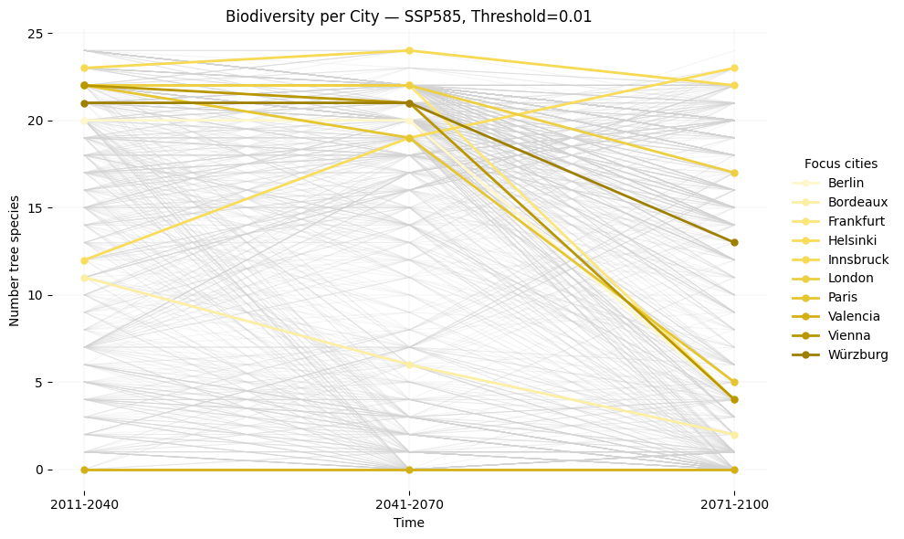
Figure S1 | Changes in number of projected tree species suitability considering the extended envelope under SSP5-8.5 across three future periods. The number of climatically suitable species is shown for all European cities (grey lines) and highlighted for ten focal cities (yellow lines). Values represent the number of species meeting the climatic space of the extended envelope per city within each period (2011–2040, 2041–2070, 2071–2100). The plot illustrates divergent trajectories in future climatic suitability, ranging from stable to strongly declining species richness depending on local climatic conditions.
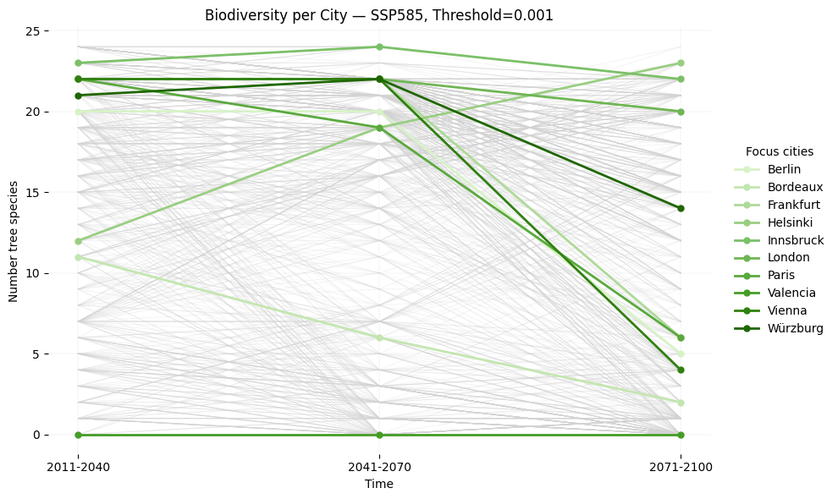
Figure S2 | Changes in number of projected tree species suitability considering the core envelope under SSP5-8.5 across three future periods. The number of climatically suitable species is shown for all European cities (grey lines) and highlighted for ten focal cities (green lines). Values represent the number of species meeting the climatic space of the core envelope per city within each period (2011–2040, 2041–2070, 2071–2100). The plot illustrates divergent trajectories in future climatic suitability, ranging from stable to strongly declining but also increasing species richness depending on local climatic conditions.

Table S3 | Climatic suitability thresholds for 30 common urban tree species based on published tolerance limits. Minimum and maximum values for mean annual temperature (tas_{min}, tas_{max}) and annual sum of precipitation (pr_{min} , pr_{max}) compiled from species profiles and reference works including EuForGen (2024), Forster et al. (2019), Kunz et al. (2020), San-Miguel-Ayanz et al. (2016), Schütt et al. (2006), and the Forestry Compendium of the Centre for Agriculture and Biosciences International (https://www.cabidigitallibrary.org/product/QF). These thresholds define the species-specific climatic limits based on published tolerance limits.
Species Name | Bot. name | tas_{min.} | tas_{ma}x | pr_{min.} | pr_{max}
Norway maple | Acer platanoides | 2 | 12.3 | 675 | 1275
Sycamore maple | Acer pseudoplatanus | 2.8 | 14.7 | 513 | 1550
Horse chestnut | Aesculus hippocastanum | 10 | 17 | 500 | 1100
Black alder | Alnus glutinosa | 1 | 16 | 450 | 1650
Silver birch | Betula pendula | -15 | 13.3 | 417 | 1767
Hornbeam | Carpinus betulus | 6.3 | 16 | 600 | 1767
Sweet chestnut | Castanea sativa | 8 | 14.3 | 575 | 1700
European beech | Fagus sylvatica | 3.5 | 13.3 | 483 | 1900
European Ash | Fraxinus excelsior | 5 | 14 | 500 | 1617
Ginkgo | Ginkgo biloba | 10 | 18 | 330 | 2000
Honey locust | Gleditsia triacanthos | 15 | 24 | 500 | 1800
Persian walnut | Juglans regia | 8.5 | 10 | 650 | 2000
Swedish whitebeam | Sorbus intermedia | - | - | - | -
Blue spruce | Picea pungens | 3.5 | 6 | 460 | 605
London plane | Platanus x acerifolia | 6.5 | 20 | 525 | 2170
Black pine | Pinus nigra | 5.3 | 14 | 538 | 1733
Black poplar | Populus nigra | 7.5 | 16.5 | 350 | 1250
European aspen | Populus tremula | -3 | 15 | 450 | 2500
Wild cherry | Prunus avium | 6 | 14.7 | 517 | 1667
Turkey oak | Quercus cerris | 6.3 | 15 | 467 | 1333
Sessile oak | Quercus petrae | 5 | 15 | 400 | 2500
Pedunculate oak | Quercus robur | 1.5 | 15.5 | 350 | 2000
Northern red oak | Quercus rubra | 3 | 17 | 707 | 1787
Black locust | Robinia pseudoacacia | 7.7 | 16.3 | 533 | 1700
Japanese pagoda tree | Styphnolobium japonicum | 10 | 16 | 600 | 1600
Small-leaved lime | Tilia cordata | 3.8 | 13.8 | 567 | 1933
Large-leaved lime | Tilia platyphyllos | 5.7 | 13.2 | 567 | 1283
Silver lime | Tilia tomentosa | 10 | 11.5 | 500 | 600
Wych elm | Ulmus glabra | 4 | 10 | 550 | 2000
European white elm | Ulmus laevis | 4 | 14 | 500 | 1475

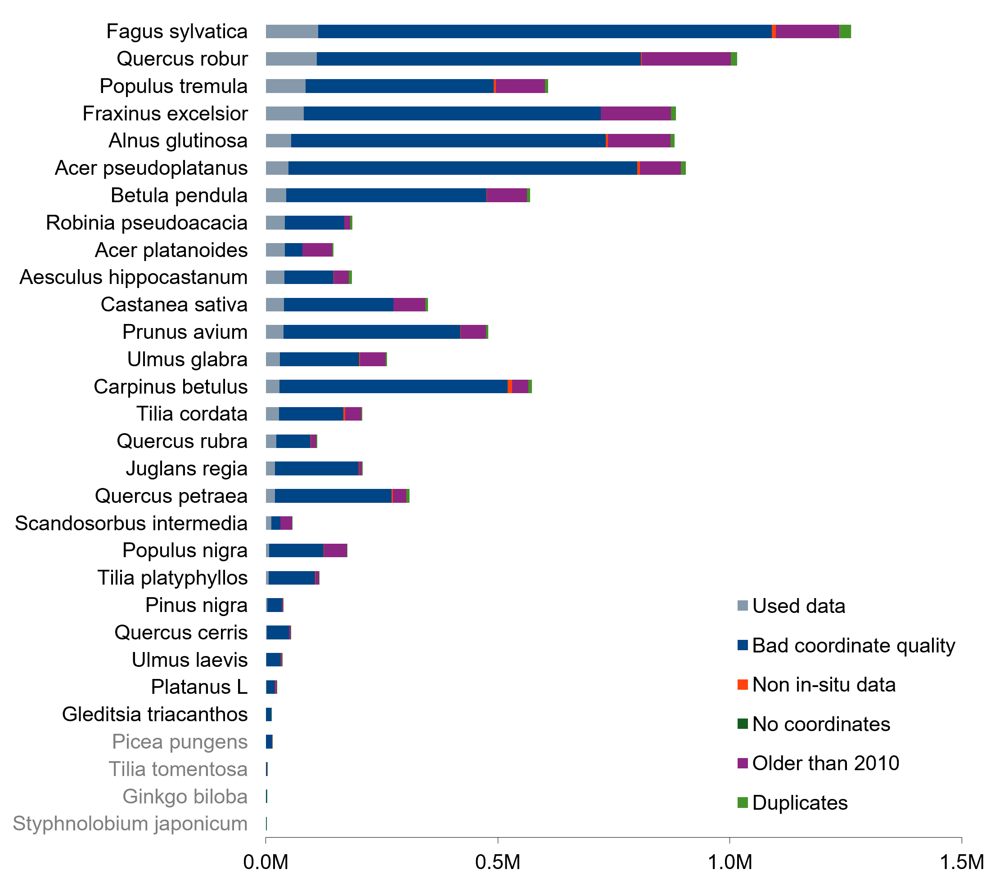
Figure S4 | Quality control results for occurrence records of the assessed tree species. Bar segments show the number of GBIF records retained for urban masking) and the number excluded due to bad coordinate quality, missing coordinates, non–in-situ observations, records older than 2010, or duplicates. Species shown in grey were excluded from further analyses because the remaining validated records were less than 1,000.
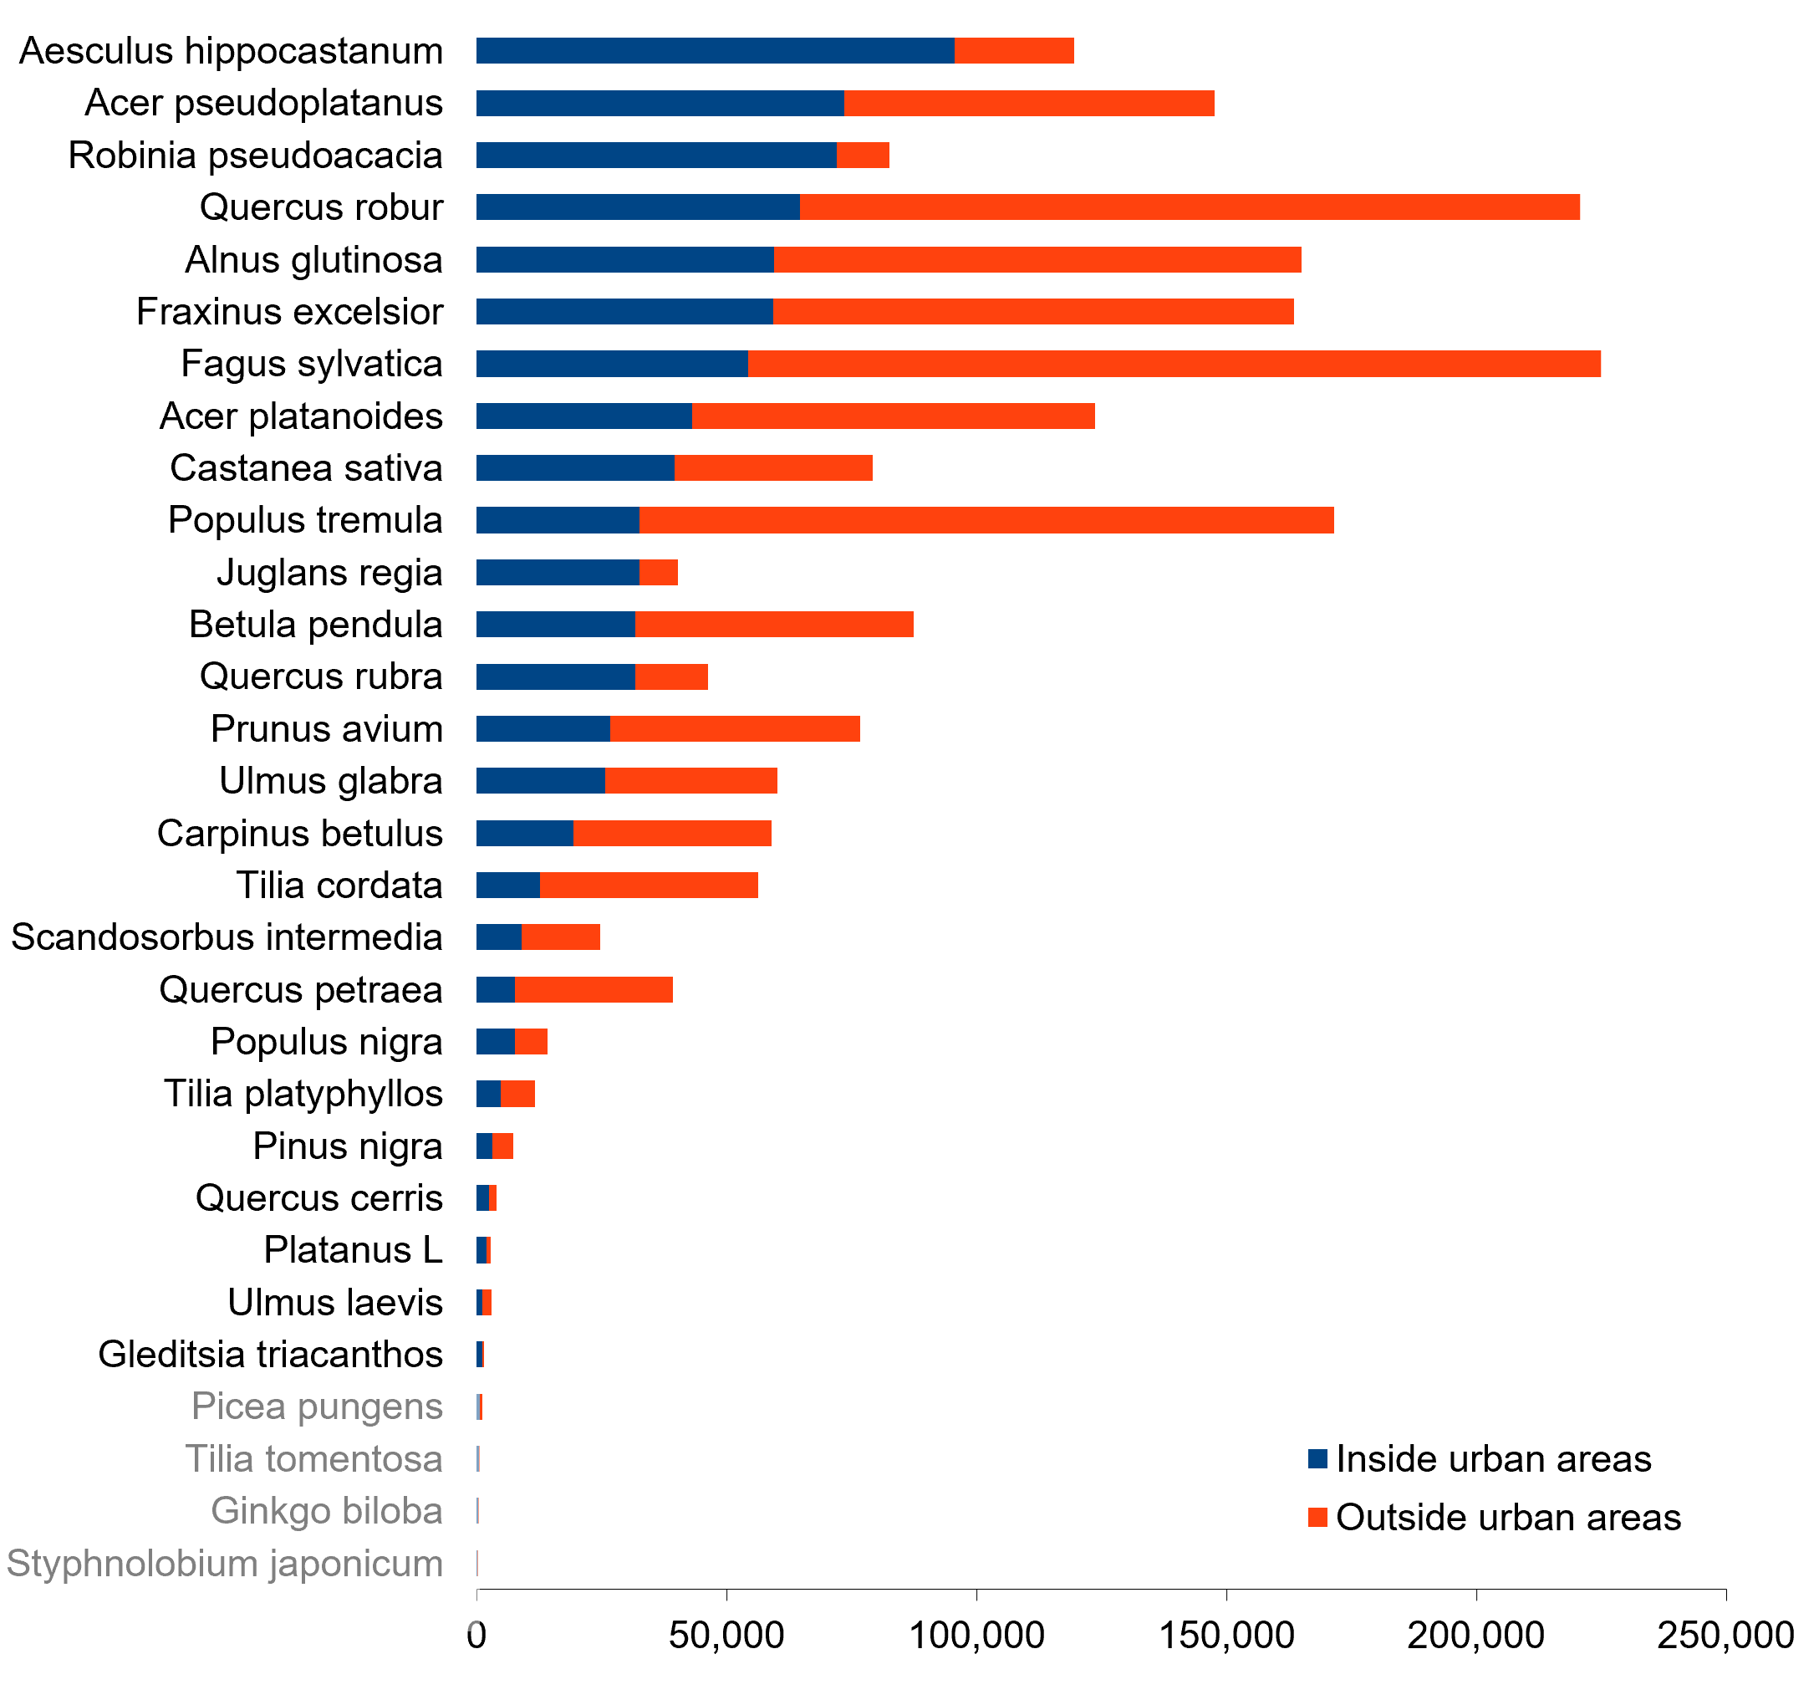
Figure S5 | Distribution of validated occurrence records inside and outside urban areas. For each tree species, the bars show the number of GBIF records located within urban areas (blue) and outside urban areas (orange) after the filtering procedure shown in Figure S2. Species shown in grey were excluded from further analyses because the remaining validated records were less than 1,000.
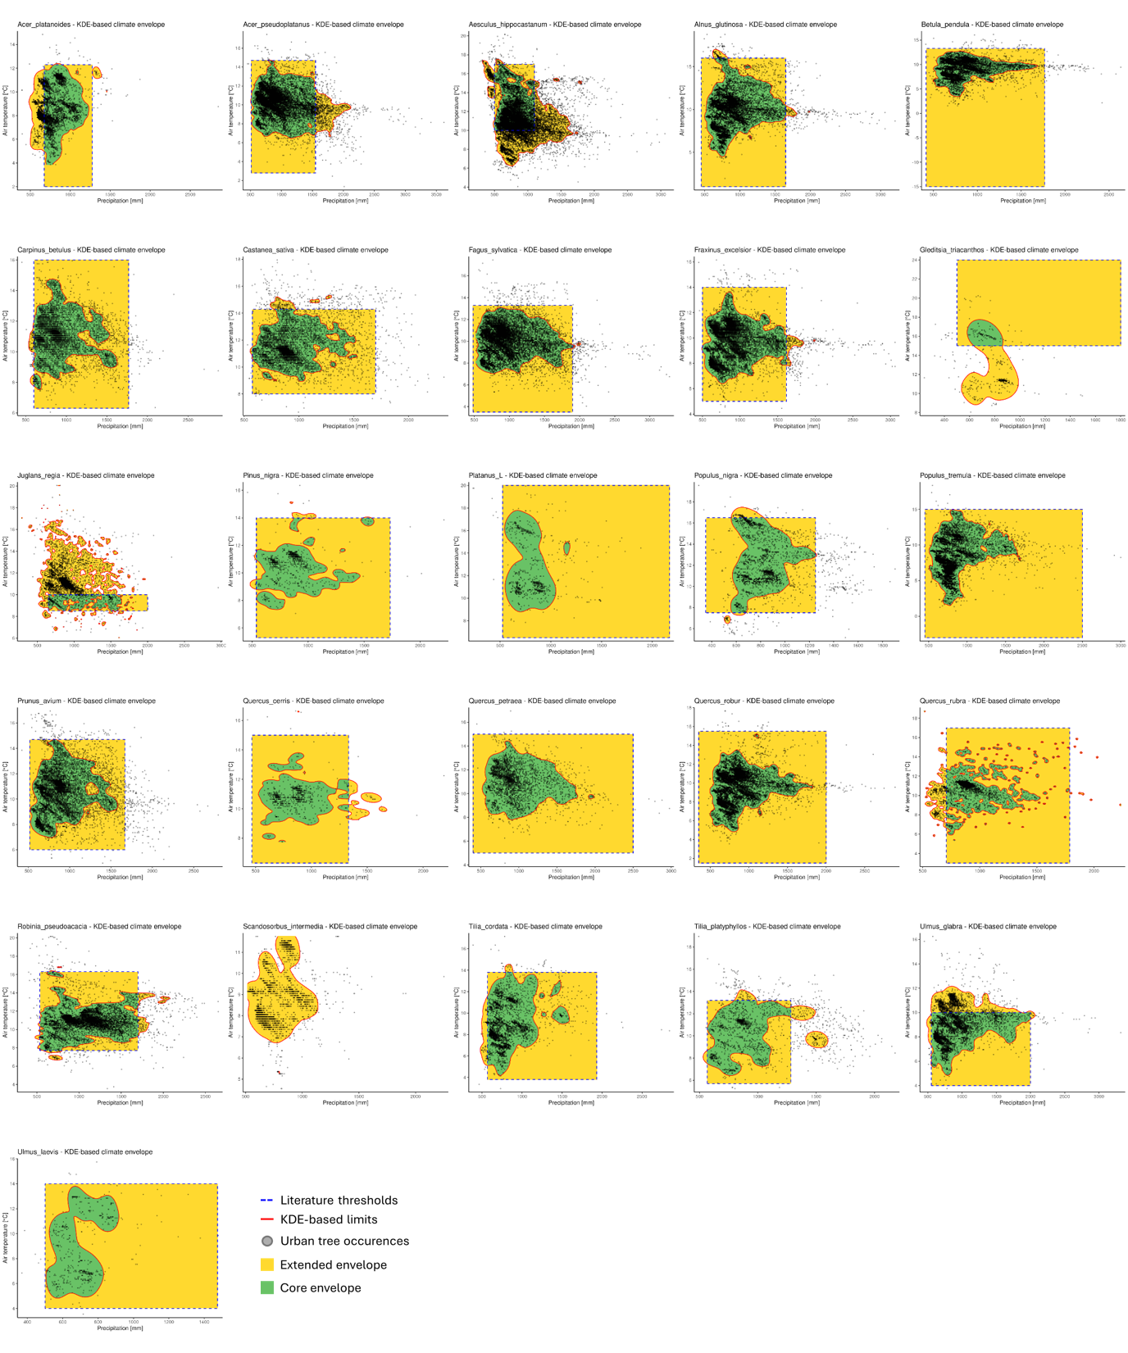
Figure S6 | Species-specific 2D climate envelopes based on temperature (tas) and precipitation (pr). Each panel shows the climatic envelope of one tree species derived from occurrence data and published tolerance limits. Black points represent occurrence records after quality control of the GBIF database. The red contour outlines the high-density region of the 2D kernel density estimation (KDE). The dashed rectangle shows the published climatic limits. Green areas indicate the core envelope where KDE and published tolerance ranges overlap. Yellow areas represent the extended envelope, defined as climatic space covered by either the KDE envelope and/or the published tolerance limits.
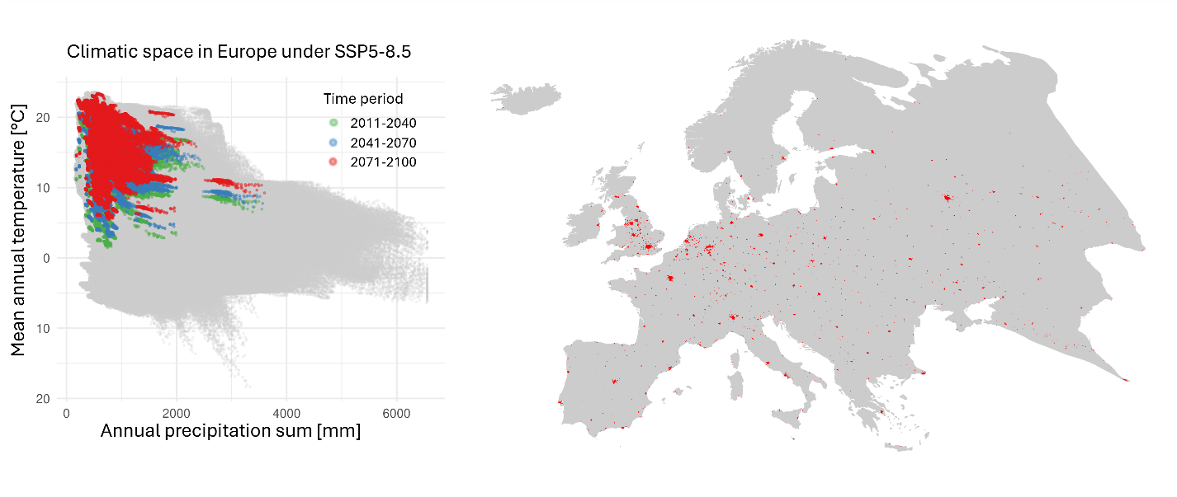
Figure S7 | Climatic space of European cities according to the Global human Human Settlement Layer under scenario SSP5-8.5 across the three surveyed time periods. Left: The grey background represents the full climatic space of Europe (CHELSA tas and pr). Coloured points show the climatic conditions of all European cities for the periods 2011–2040 (green), 2041–2070 (blue), and 2071–2100 (red). Right: Geographic locations of the analysed European cities (red points) shown against the outline of the European continent (grey).

Table S8 | Agreement between modeled core-envelope suitability (SSP5-8.5, 2011–2040) and municipal tree inventories for nine European cities. Values indicate whether a species present in the municipal tree inventory is also classified as climatically suitable by the core-envelope model (1 = agreement, 0 = disagreement).
 | Berlin | Bordeaux | Frankfurt | Helsinki | Innsbruck | London | Paris | Valencia | Vienna
Acer_platanoides | 0 | 0 | 1 | 1 | 1 | 1 | 1 | 0 | 1
Acer_pseudoplatanus | 1 | 1 | 1 | 1 | 1 | 1 | 1 | 0 | 1
Aesculus_hippocastanum | 1 | 1 | 1 | 0 | 1 | 1 | 1 | 0 | 1
Alnus_glutinosa | 1 | 1 | 1 | 1 | 1 | 1 | 1 | 1 | 1
Betula_pendula | 1 | 0 | 1 | 1 | 1 | 1 | 1 | 0 | 1
Carpinus_betulus | 1 | 1 | 1 | 0 | 1 | 1 | 1 | 0 | 1
Castanea_sativa | 1 | 0 | 1 | 1 | 1 | 1 | 1 | 1 | 1
Fagus_sylvatica | 1 | 0 | 1 | 0 | 1 | 1 | 1 | 1 | 1
Fraxinus_excelsior | 1 | 0 | 1 | 1 | 1 | 1 | 1 | 0 | 1
Gleditsia_triacanthos | 0 | 0 | 0 | 1 | 0 | 0 | 0 | 0 | 0
Juglans_regia | 0 | 0 | 0 | 0 | 1 | 0 | 0 | 0 | 0
Pinus_nigra | 1 | 0 | 1 | 0 | 1 | 1 | 1 | 0 | 1
Platanus_L | 1 | 1 | 1 | 1 | 1 | 1 | 1 | 0 | 1
Populus_nigra | 1 | 1 | 1 | 0 | 1 | 1 | 1 | 0 | 1
Populus_tremula | 1 | 1 | 1 | 1 | 1 | 1 | 1 | 0 | 1
Prunus_avium | 1 | 1 | 1 | 0 | 1 | 1 | 1 | 0 | 1
Quercus_cerris | 1 | 0 | 1 | 1 | 1 | 1 | 1 | 0 | 1
Quercus_petraea | 1 | 1 | 1 | 0 | 1 | 1 | 1 | 0 | 1
Quercus_robur | 1 | 0 | 1 | 1 | 1 | 1 | 1 | 0 | 1
Quercus_rubra | 0 | 1 | 1 | 1 | 1 | 1 | 1 | 1 | 1
Robinia_pseudoacacia | 1 | 1 | 1 | 1 | 1 | 1 | 1 | 0 | 1
Scandosorbus_intermedia | 1 | 1 | 1 | 1 | 1 | 1 | 1 | 1 | 1
Tilia_cordata | 1 | 0 | 1 | 1 | 1 | 1 | 1 | 0 | 1
Tilia_platyphyllos | 1 | 0 | 1 | 1 | 1 | 1 | 1 | 0 | 1
Ulmus_glabra | 0 | 0 | 0 | 1 | 1 | 0 | 0 | 0 | 0
Ulmus_laevis | 1 | 0 | 1 | 1 | 1 | 1 | 1 | 0 | 1

Table S9 | Agreement between modeled extended-envelope suitability (SSP1-2.6, 2011–2040) and municipal tree inventories for nine European cities. Values indicate whether a species present in the municipal tree inventory is also classified as climatically suitable by the core-envelope model (1 = agreement, 0 = disagreement).
model_name | Berlin | Bordeaux | Frankfurt | Helsinki | Innsbruck | London | Paris | Valencia | Vienna
Acer_platanoides | 1 | 0 | 1 | 1 | 1 | 1 | 1 | 0 | 1
Acer_pseudoplatanus | 1 | 1 | 1 | 1 | 1 | 1 | 1 | 0 | 1
Aesculus_hippocastanum | 1 | 1 | 1 | 1 | 1 | 1 | 1 | 0 | 1
Alnus_glutinosa | 1 | 1 | 1 | 1 | 1 | 1 | 1 | 1 | 1
Betula_pendula | 1 | 0 | 1 | 1 | 1 | 1 | 1 | 0 | 1
Carpinus_betulus | 1 | 1 | 1 | 1 | 1 | 1 | 1 | 0 | 1
Castanea_sativa | 1 | 1 | 1 | 1 | 1 | 1 | 1 | 1 | 1
Fagus_sylvatica | 1 | 0 | 1 | 1 | 1 | 1 | 1 | 1 | 1
Fraxinus_excelsior | 1 | 0 | 1 | 1 | 1 | 1 | 1 | 0 | 1
Gleditsia_triacanthos | 1 | 1 | 1 | 1 | 1 | 1 | 1 | 1 | 1
Juglans_regia | 1 | 1 | 1 | 1 | 1 | 1 | 1 | 0 | 1
Pinus_nigra | 1 | 1 | 1 | 1 | 1 | 1 | 1 | 0 | 1
Platanus_L | 1 | 1 | 1 | 0 | 1 | 1 | 1 | 1 | 1
Populus_nigra | 1 | 1 | 1 | 0 | 1 | 1 | 1 | 0 | 1
Populus_tremula | 1 | 1 | 1 | 1 | 1 | 1 | 1 | 0 | 1
Prunus_avium | 1 | 1 | 1 | 1 | 1 | 1 | 1 | 0 | 1
Quercus_cerris | 1 | 1 | 1 | 0 | 1 | 1 | 1 | 0 | 1
Quercus_petraea | 1 | 1 | 1 | 1 | 1 | 1 | 1 | 0 | 1
Quercus_robur | 1 | 1 | 1 | 1 | 1 | 1 | 1 | 0 | 1
Quercus_rubra | 1 | 1 | 1 | 1 | 1 | 1 | 1 | 1 | 1
Robinia_pseudoacacia | 1 | 1 | 1 | 0 | 1 | 1 | 1 | 0 | 1
Sorbus_intermedia | 0 | 0 | 1 | 1 | 1 | 1 | 0 | 1 | 1
Tilia_cordata | 1 | 1 | 1 | 1 | 1 | 1 | 1 | 0 | 1
Tilia_platyphyllos | 1 | 0 | 1 | 1 | 1 | 1 | 1 | 0 | 1
Ulmus_glabra | 1 | 0 | 1 | 1 | 1 | 1 | 1 | 0 | 1
Ulmus_laevis | 1 | 0 | 1 | 1 | 0 | 1 | 1 | 0 | 1

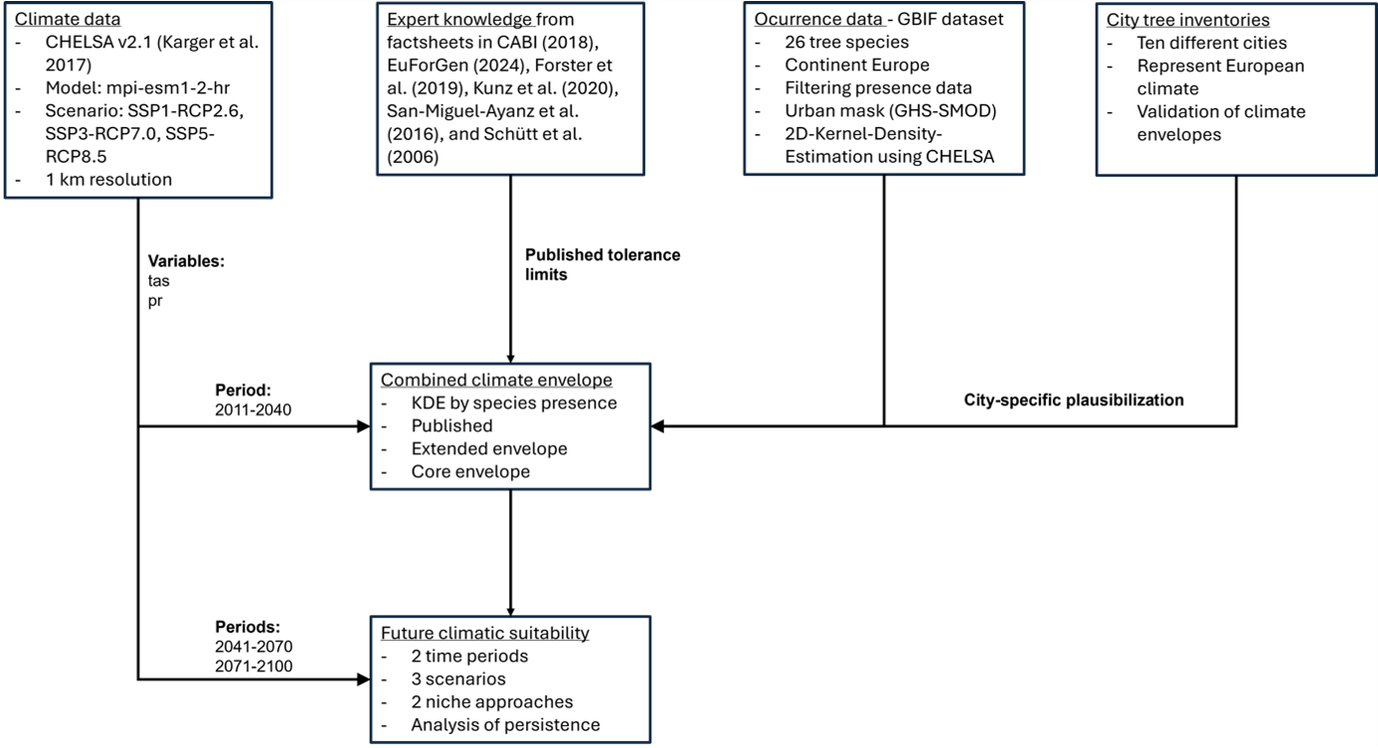Figure S10 | Workflow for deriving climate-based suitability estimates for 26 urban tree species. Overview of the data sources and analytical steps used in this study.

