Supplementary Figure 1
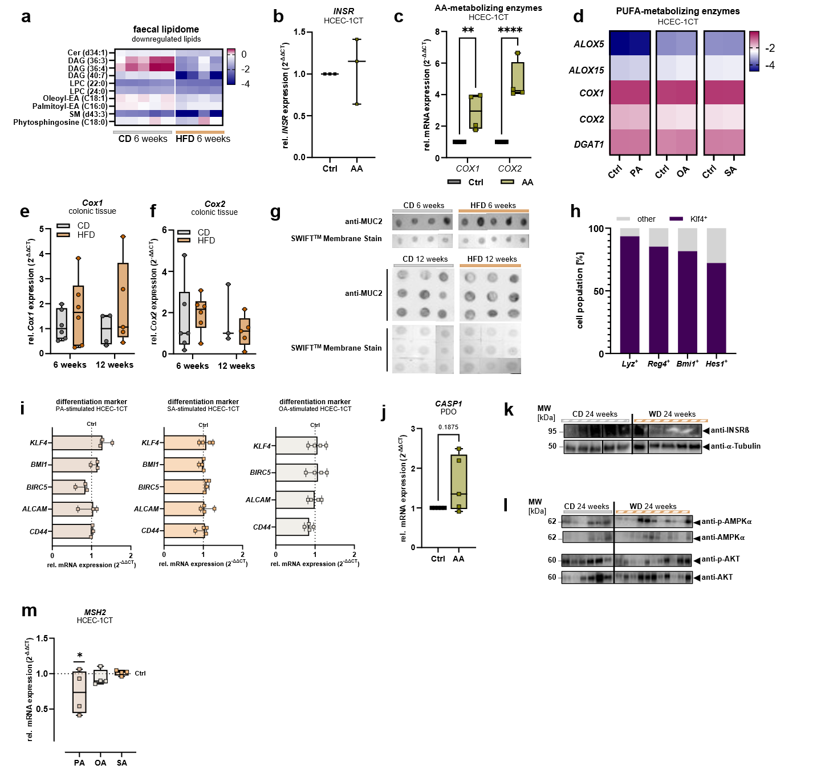
Supplementary Fig. 1 | Characterization of diet-induced alterations in cellular metabolism and differentiation. (a) Heatmap of significantly downregulated lipid molecules in faecal samples of mice after 6 weeks of HFD (n=4) in comparison to CD (n=5). (b) Expression of INSR in HCEC-1CT cells (n=3) stimulated with 10 µM AA (n=3) relative to DMSO-treated HCEC-1CT (Ctrl, n=3). (c) Relative expression of COX1 and COX2 in HCEC-1CT cells (n=4) stimulated with 10 µM AA (n=4) compared to DMSO-treated HCEC-1CT (Ctrl, n=4). (d) Expression of PUFA-metabolizing enzymes in PA, OA, or SA-treated HCEC-1CT (n=3-5 per group) relative to DMSO-, H₂O-, or EtOH-cultured HCEC-1CT (Ctrl, n=3-5 per control group) cells using RT-qPCR. Relative expression of (e) Cox1 and (f) Cox2 in murine colonic tissue of HFD-fed mice compared to CD-fed littermates (6 weeks: HFD n=6, CD n=6; 12 weeks: HFD n=5, CD n=3-4). (g) Top: Dot blot analysis using anti-MUC2 on colonic tissue from HFD- and CD-fed mice after 6 weeks (HFD n=5, CD n=4) and bottom: 12 weeks (each group n=9), with Swift Membrane Stain™ as loading control. (h) Percentage [%] of Klf4⁺ colonic ECs across mouse colonic epithelial cells positive for Lyz, Reg4, Bmi1, and Hes1. Single-cell transcriptomics dataset of colonic healthy mouse tissue publicly available at Tabula “Muris Senis, Large Intestine - A single-cell transcriptomic atlas characterizing ageing tissues in the mouse (10x)”⁴¹. (i) Left: Transcriptional differentiation profile of PA-stimulated HCEC-1CT cells (n=3) relative to DMSO-treated controls (Ctrl, n=3); Mid: SA-stimulated HCEC-1CT cells (n=4) relative to EtOH-treated controls (Ctrl, n=4); Right: OA-stimulated HCEC-1CT cells (n=4) relative to H₂O-treated controls (Ctrl, n=4). (j) CASP1 expression in human colonic organoids following stimulation with 10 µM AA (n=5), normalized to paired DMSO-treated control organoids (Ctrl, n=5). (k) INSRß detection (WD n=5, CD n=5) and (l) phosphorylation status of AKT and AMPKα (WD n=11, CD n=6) in murine colonic tissue after 24-week dietary-intervention, determined by Western blotting. (m) Relative MSH2 expression of FA-treated HCEC-1CT in comparison to the respective control treatment (each group n=4). (a), (c), (e)-(f), (i), (m) Two-way ANOVA with Fisher’s least significant difference (LSD) test. (b), (j) Wilcoxon test. (i) Multiple Mann-Whitney test with unadjusted P-values. (a) Data shown as log-transformed individual data point. (b)-(c), (e), (j)-(m) Box plots depict the median and IQR with whiskers indicating the range. (d) Data depicted as median of log-transformed 2^{-∆Ct}. (h) parts of a whole [%]. (b)-(c), (i), (j), (m) Relative values were calculated by normalizing to the paired control condition (set to 1) and (e), (f) relative values were determined by normalization to the median of the respective CD control group (set to 1). *P≤0.05, **P≤0.01, ****P≤0.0001. AA, arachidonic acid; EC, epithelial cell; FA, fatty acid; IQR, interquartile range; OA, oleic acid; PA, palmitic acid; PDO, patient-derived organoid; SA, steric acid; WD, western-style diet.

Supplementary Figure 2
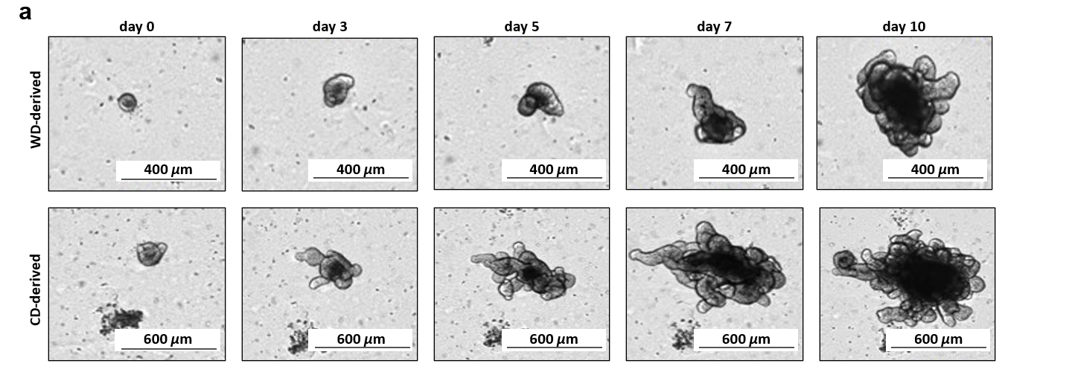
Supplementary Fig. 2 | Basal growth of colonic organoid derived from WD- and CD-fed mice.
(a) Representative brightfield microscopy image tracing of murine colonic organoid from WD- and CD-fed mice at day 0, day 3, day 5, day 7 and day 10 of basal cultivation.

Supplementary Tables
Supplementary Table 1. Diet composition as provided by the manufacturers.
Macronutrient | Autoclavable Rodent Diet 5010 | D12450B | D12492i | D12331 | Control (to Surwit)
Model | CD, 6 weeks | CD, 12 weeks | HFD, 6 and 12 weeks | Surwit, 24 weeks | CD to Surwit, 24 weeks
Physiological fuel value | 3.430 kcal/g | 3.430 kcal/g | 5.240 kcal/g | 5.400 kcal/g | 3.695 kcal/g
Protein | 30 kcal% | 20 kcal% | 20 kcal% | 15 kcal% | 22 kcal%
Fat | 10 kcal% | 10 kcal% | 60 kcal% | 59 kcal% | 13 kcal%
Carbohydrates | 60 kcal% | 70 kcal% | 20 kcal% | 25 kcal% | 65 kcal%

Supplementary Table 2. Results of statistical analysis serum 1H-NMR profiles (Multiple Mann-Whitney test, HFD vs. CD).
Metabolite | Below  threshold? | P-value | Mean rank  HFD | Mean rank  CD | Mean rank  diff. | Mann-Whitney U
Ethanol | Yes | 0.0065 | 3.75 | 9.25 | -5.50 | 1.50
Trimethylamine-N-oxide | No | 0.2489 | 5.25 | 7.75 | -2.50 | 10.50
Alanine | No | 0.6667 | 7.00 | 6.00 | 1.00 | 15.00
Creatine | No | 0.1472 | 4.92 | 8.08 | -3.17 | 8.50
Creatinine | No | 0.3593 | 7.58 | 5.42 | 2.17 | 11.50
Glutamic acid | No | 0.7381 | 6.08 | 6.92 | -0.83 | 15.50
Glutamine | No | 0.4589 | 5.67 | 7.33 | -1.67 | 13.00
Glycine | No | 0.9740 | 6.42 | 6.58 | -0.17 | 17.50
Histidine | No | 0.9784 | 6.58 | 6.42 | 0.17 | 17.50
Isoleucine | No | 0.8571 | 6.25 | 6.75 | -0.50 | 16.50
Leucine | No | 0.7251 | 6.08 | 6.92 | -0.83 | 15.50
Lysine | No | 0.9134 | 6.67 | 6.33 | 0.33 | 17.00
Methionine | No | 1.0000 | 6.50 | 6.50 | 0.00 | 18.00
Ornithine | No | 0.1385 | 8.08 | 4.92 | 3.17 | 8.50
Phenylalanine | No | 0.2035 | 5.08 | 7.92 | -2.83 | 9.50
Proline | No | 0.6970 | 6.83 | 6.17 | 0.67 | 16.00
Tyrosine | No | 0.3398 | 7.58 | 5.42 | 2.17 | 11.50
Valine | No | 0.9697 | 6.42 | 6.58 | -0.17 | 17.50
2-Hydroxybutyric acid | No | 0.4545 | 7.50 | 5.50 | 2.00 | 12.00
Acetic acid | Yes | 0.0022 | 3.50 | 9.50 | -6.00 | 0.00
Citric acid | No | 0.3312 | 7.58 | 5.42 | 2.17 | 11.50
Formic acid | No | 0.6926 | 7.17 | 5.83 | 1.33 | 14.00
Lactic acid | Yes | 0.0087 | 3.83 | 9.17 | -5.33 | 2.00
Succinic acid | No | 0.7879 | 6.83 | 6.17 | 0.67 | 16.00
Choline | No | 0.0909 | 8.33 | 4.67 | 3.67 | 7.00
2-Oxoglutaric acid | No | 1.0000 | 6.58 | 6.42 | 0.17 | 17.50
3-Hydroxybutyric acid | No | 0.9177 | 6.33 | 6.67 | -0.33 | 17.00
Acetone | No | 1.0000 | 6.33 | 6.67 | -0.33 | 17.00
Pyruvic acid | No | 0.5173 | 5.75 | 7.25 | -1.50 | 13.50
Glucose | Yes | 0.0065 | 9.33 | 3.67 | 5.67 | 1.00
Glycerol | No | 0.9372 | 6.33 | 6.67 | -0.33 | 17.00
TAG | No | 0.8182 | 6.83 | 6.17 | 0.67 | 16.00
Cholesterol | Yes | 0.0022 | 9.50 | 3.50 | 6.00 | 0.00

Supplementary Table 3. Results of statistical analysis of faecal lipidome (Multiple Mann-Whitney test; CD vs. HFD).
Lipid | Below  threshold? | P-value | Mean rank  CD | Mean rank  HFD | Mean rank  diff. | Mann-Whitney U
AcCa (16:0) | Yes | 0.0159 | 3.00 | 7.50 | -4.50 | 0.00
AcCa (18:0) | Yes | 0.0159 | 3.00 | 7.50 | -4.50 | 0.00
AcCa (18:1) | No | 0.1905 | 3.80 | 6.50 | -2.70 | 4.00
AcCa (24:0) | Yes | 0.0159 | 3.00 | 7.50 | -4.50 | 0.00
CE (18:1) | Yes | 0.0159 | 7.00 | 2.50 | 4.50 | 0.00
CE (20:4) | Yes | 0.0317 | 3.20 | 7.25 | -4.05 | 1.00
CE (22:6) | Yes | 0.0317 | 6.80 | 2.75 | 4.05 | 1.00
Cer (d32:0) | Yes | 0.0159 | 3.00 | 7.50 | -4.50 | 0.00
Cer (d34:0) | Yes | 0.0159 | 3.00 | 7.50 | -4.50 | 0.00
Cer (d34:1) | Yes | 0.0159 | 7.00 | 2.50 | 4.50 | 0.00
Cer (d36:0) | Yes | 0.0317 | 3.20 | 7.25 | -4.05 | 1.00
Cer (d36:1) | Yes | 0.0079 | 3.00 | 7.50 | -4.50 | 0.00
Cer (d38:0) | No | 0.2857 | 4.00 | 6.25 | -2.25 | 5.00
Cer (d40:0) | Yes | 0.0159 | 3.00 | 7.50 | -4.50 | 0.00
Cer (d41:0) | No | 0.1905 | 3.80 | 6.50 | -2.70 | 4.00
Cer (d44:0) | No | 0.4127 | 4.20 | 6.00 | -1.80 | 6.00
CerG (d36:2) | Yes | 0.0159 | 3.00 | 7.50 | -4.50 | 0.00
CerG (d40:0) | Yes | 0.0159 | 3.00 | 7.50 | -4.50 | 0.00
CerG (d40:2) | Yes | 0.0159 | 3.00 | 7.50 | -4.50 | 0.00
CerG (d41:2) | Yes | 0.0159 | 3.00 | 7.50 | -4.50 | 0.00
CerG (d42:2) | Yes | 0.0317 | 3.20 | 7.25 | -4.05 | 1.00
SA (C17:0) | No | 0.1111 | 6.40 | 3.25 | 3.15 | 3.00
SA (C18:0) | No | 0.9048 | 5.20 | 4.75 | 0.45 | 9.00
SA (C19:0) | Yes | 0.0159 | 7.00 | 2.50 | 4.50 | 0.00
DAG (34:1) | No | 0.9048 | 4.80 | 5.25 | -0.45 | 9.00
DAG (36:3) | Yes | 0.0159 | 7.00 | 2.50 | 4.50 | 0.00
DAG (36:4) | Yes | 0.0159 | 7.00 | 2.50 | 4.50 | 0.00
DAG (40:7) | Yes | 0.0159 | 7.00 | 2.50 | 4.50 | 0.00
FA (16:0) | Yes | 0.0159 | 3.00 | 7.50 | -4.50 | 0.00
FA (18:0) | Yes | 0.0159 | 3.00 | 7.50 | -4.50 | 0.00
FA (18:1) | Yes | 0.0159 | 3.00 | 7.50 | -4.50 | 0.00
FA (18:2) | No | 0.0635 | 3.40 | 7.00 | -3.60 | 2.00
FA (20:0) | Yes | 0.0159 | 3.00 | 7.50 | -4.50 | 0.00
FA (20:1) | Yes | 0.0159 | 3.00 | 7.50 | -4.50 | 0.00
FA (20:4) | Yes | 0.0159 | 3.00 | 7.50 | -4.50 | 0.00
FA (22:4) | No | 0.2857 | 4.20 | 6.00 | -1.80 | 6.00
FA (22:5) | No | 0.1905 | 3.80 | 6.50 | -2.70 | 4.00
FA (22:6) | No | 0.9048 | 5.20 | 4.75 | 0.45 | 9.00
FA (24:0) | No | 0.9048 | 4.80 | 5.25 | -0.45 | 9.00
FA (24:1) | Yes | 0.0079 | 3.00 | 7.50 | -4.50 | 0.00
LPC (16:0) | Yes | 0.0159 | 3.00 | 7.50 | -4.50 | 0.00
LPC (17:0) | Yes | 0.0159 | 3.00 | 7.50 | -4.50 | 0.00
LPC (18:0) | Yes | 0.0159 | 3.00 | 7.50 | -4.50 | 0.00
LPC (18:1) | No | 0.0635 | 3.40 | 7.00 | -3.60 | 2.00
LPC (18:2) | No | 0.9048 | 5.20 | 4.75 | 0.45 | 9.00
LPC (20:0) | Yes | 0.0159 | 3.00 | 7.50 | -4.50 | 0.00
LPC (20:4) | Yes | 0.0159 | 3.00 | 7.50 | -4.50 | 0.00
LPC (22:0) | Yes | 0.0159 | 7.00 | 2.50 | 4.50 | 0.00
LPC (22:1) | Yes | 0.0159 | 3.00 | 7.50 | -4.50 | 0.00
LPC (24:0) | Yes | 0.0159 | 7.00 | 2.50 | 4.50 | 0.00
LPC (24:1) | No | 0.9048 | 5.20 | 4.75 | 0.45 | 9.00
LPI (18:0) | Yes | 0.0159 | 3.00 | 7.50 | -4.50 | 0.00
DeoxySA (C18:0) | Yes | 0.0317 | 6.80 | 2.75 | 4.05 | 1.00
Deoxysphingosine (C18:1) | No | 1.0000 | 5.00 | 5.00 | 0.00 | 10.00
Oleoyl-EA (C18:1) | Yes | 0.0159 | 7.00 | 2.50 | 4.50 | 0.00
PC (30:0) | Yes | 0.0159 | 3.00 | 7.50 | -4.50 | 0.00
PC (31:0) | Yes | 0.0317 | 3.20 | 7.25 | -4.05 | 1.00
PC (32:1) | Yes | 0.0159 | 3.00 | 7.50 | -4.50 | 0.00
PC (33:0) | No | 0.2063 | 3.90 | 6.38 | -2.48 | 4.50
PC (34:1) | Yes | 0.0159 | 3.00 | 7.50 | -4.50 | 0.00
PC (34:2) | Yes | 0.0159 | 3.00 | 7.50 | -4.50 | 0.00
PC (36:1) | Yes | 0.0159 | 3.00 | 7.50 | -4.50 | 0.00
PC (36:2) | Yes | 0.0159 | 3.00 | 7.50 | -4.50 | 0.00
PC (36:4) | Yes | 0.0159 | 3.00 | 7.50 | -4.50 | 0.00
PC (38:4) | Yes | 0.0159 | 3.00 | 7.50 | -4.50 | 0.00
PC (38:5) | Yes | 0.0159 | 3.00 | 7.50 | -4.50 | 0.00
PC (38:6) | Yes | 0.0159 | 3.00 | 7.50 | -4.50 | 0.00
PC (40:6) | Yes | 0.0159 | 3.00 | 7.50 | -4.50 | 0.00
PC (40:8) | Yes | 0.0159 | 3.00 | 7.50 | -4.50 | 0.00
PE (31:0) | No | 0.1905 | 6.20 | 3.50 | 2.70 | 4.00
PE (32:0) | No | 0.9048 | 4.80 | 5.25 | -0.45 | 9.00
PE (32:1) | No | 0.5556 | 4.40 | 5.75 | -1.35 | 7.00
PE (34:1) | Yes | 0.0159 | 3.00 | 7.50 | -4.50 | 0.00
PE (36:2) | No | 0.5556 | 5.60 | 4.25 | 1.35 | 7.00
Palmitoyl-EA (C16:0) | Yes | 0.0159 | 7.00 | 2.50 | 4.50 | 0.00
SM (d32:0) | Yes | 0.0159 | 3.00 | 7.50 | -4.50 | 0.00
SM (d32:1) | Yes | 0.0159 | 3.00 | 7.50 | -4.50 | 0.00
SM (d34:0) | Yes | 0.0159 | 3.00 | 7.50 | -4.50 | 0.00
SM (d34:1) | Yes | 0.0159 | 3.00 | 7.50 | -4.50 | 0.00
SM (d34:2) | Yes | 0.0159 | 3.00 | 7.50 | -4.50 | 0.00
SM (d36:0) | Yes | 0.0159 | 3.00 | 7.50 | -4.50 | 0.00
SM (d36:1) | Yes | 0.0159 | 3.00 | 7.50 | -4.50 | 0.00
SM (d38:0) | Yes | 0.0159 | 3.00 | 7.50 | -4.50 | 0.00
SM (d38:1) | Yes | 0.0159 | 3.00 | 7.50 | -4.50 | 0.00
SM (d39:1) | Yes | 0.0159 | 3.00 | 7.50 | -4.50 | 0.00
SM (d40:0) | Yes | 0.0159 | 3.00 | 7.50 | -4.50 | 0.00
SM (d40:1) | Yes | 0.0159 | 3.00 | 7.50 | -4.50 | 0.00
SM (d40:2) | No | 0.2857 | 4.00 | 6.25 | -2.25 | 5.00
SM (d41:0) | Yes | 0.0159 | 3.00 | 7.50 | -4.50 | 0.00
SM (d41:1) | Yes | 0.0159 | 3.00 | 7.50 | -4.50 | 0.00
SM (d42:0) | Yes | 0.0159 | 3.00 | 7.50 | -4.50 | 0.00
SM (d42:1) | Yes | 0.0159 | 3.00 | 7.50 | -4.50 | 0.00
SM (d42:2) | No | 0.5556 | 4.40 | 5.75 | -1.35 | 7.00
SM (d42:3) | No | 0.1905 | 3.80 | 6.50 | -2.70 | 4.00
SM (d43:3) | No | 0.0556 | 6.60 | 3.00 | 3.60 | 2.00
Phytosphingosine (C18:0) | No | 0.9048 | 5.20 | 4.75 | 0.45 | 9.00
TAG (48:1) | No | 0.4127 | 4.20 | 6.00 | -1.80 | 6.00
TAG (51:1) | Yes | 0.0159 | 3.00 | 7.50 | -4.50 | 0.00
TAG (52:1) | Yes | 0.0159 | 3.00 | 7.50 | -4.50 | 0.00
TAG (54:1) | Yes | 0.0159 | 3.00 | 7.50 | -4.50 | 0.00
TAG (54:6) | Yes | 0.0317 | 6.80 | 2.75 | 4.05 | 1.00
TAG (54:7) | Yes | 0.0159 | 7.00 | 2.50 | 4.50 | 0.00
TAG (56:0) | Yes | 0.0159 | 3.00 | 7.50 | -4.50 | 0.00
TAG (56:3) | No | 0.2857 | 6.00 | 3.75 | 2.25 | 5.00

 | Tissue | Male (n) | Female  (n) | Sex  un-known (n) | Median age  (y) | TNM | Tumour  stage | Tumour grade (n) | Tumour cells
Paired samples from CRC patients for Figure 6g (OriGene) | normal | 5 | 5 | 0 | 74.5 | N.A. | N.A. | N.A. | N.A.
Paired samples from CRC patients for Figure 6g (OriGene) | tumour | 5 | 5 | 0 | 74.5 | pT3pN0pMX | IIA (10) | G1 (3)  G2 (7) | 60-89
Tissue Scan Colon Cancer tissue qPCR Panel III Matched pairs for Figure 6h (OriGene, #HCRT10303) | normal | 11 | 13 | 0 | 76 | N.A. | N.A. | N.A. | N.A.
 | tumour | 11 | 13 | 0 | 76 | pT2pN0pMX  pT1pN0pMX  pT3pN0pMX  pT4pN0pMX  pTXpN1pMX  pT1pN1pMX  pT3pN1pMX  pT4pN2pMX  pT3pNXpM1 | I (5),  II (7),  III (8),  IV (4) | N.A. (2)  G10 (10),  G2 (13),  G3 (1) | 40-95
Human colonic biopsies of hospitalized normal patients for qPCR  (Az-19-233; Az-2023-172; Az-05-112) | normal | 7 | 3 | 1 | 67.5 | N.A. | N.A. | N.A. | N.A.
Healthy colonic biopsy donors for organoid generation (Az-21-415) | normal | 2 | 3 | 0 | 34 | N.A. | N.A. | N.A. | N.A.
nonCRC serum donors  (Az-21-415) | N.A. | 22 | 39 | 0 | 45 | N.A. | N.A. | N.A. | N.A.
CRC serum donors  (Az-16-282) | N.A. | 40 | 24 | 0 | 70 | N.A. | I (11),  II (18),  III (14),  IV (2),  N.A. (38) | N.A. | N.A.
Supplementary Table 4. Patient characteristics of tissue and serum samples.

Supplementary Table 5. Sequences of the primer pairs used for RT-qPCR (produced by Metabion international AG, Planegg, Germany).
Target genes human: | Forward primer (5‘-3‘) | Reverse primer (5‘-3‘)
ACTB | ACATCCGCAAAGACCTGTACG | TTGCTGATCCACATCTGCTGG
ALCAM | CTTCTGCCTCTTGATCTCCG | AAATACTGGGGAGCCATCG
ALOX15 | TGGATGTCAAGGCCAAC | CATGTCAGAGACCAGCCCAG
ALOX5 | TGCCAACAAAACAGACCCCT | GAAGGTGGGTGATGGTCTGG
ALPI | CCCGCTTTAACCAGTGCAAC | GGAAACATGTACTTGCGGCC
ATOH1 | CCAGCTGCGCAATGTTATCC | TGCTGTTTTCCTCCTGCACT
BIRC5 | GGACCACCGCATCTCTACAT | GTCGTCATCTGGCTCCCA
BMI1 | ATGTGTGTGCTTTGTGGAGG | TCCGATCCAATCTGTTCTGG
CASP1 | CAAGACCTCTGACAGCACGT | GCATCTGCGCTCTACCATCT
CD36 | AAAACGGCTGCAGGTCAAC | TCACCACACCAACACTGAGT
CD44 | TGCCGCTTTGCAGGTGTATT | CCGATGCTCAGA GCTTTCTCC
COX1 | AGCCCTTCAATGAGTACCGC | ACTCCGGAGAACAGATGGGA
COX2 | ATGATTGCCCGACTCCCTTG | AACTGATGCGTGAAGTGCTG
DGAT1 | GAGCTACCCGGACAATCTGA | GCGTGAGTAGTCCATGTCCT
DLL1 | ACTGAGAAGCTAGAGGGCCA | AGTCCGCCTTCTTGTTGGT
EGF | ACTTGTTTCCTGTCCACGCA | TGGTTGTGGTCCTGAAGCTG
HES1 | GAAGAAAGATAGCTCGCGGCA | GGAAAGCAAACTGGCCATCG
HMGCS1 | GCACAGTACTCACCTCAGCA | CGAAGACATCTGGTGCCACA
HOPX | CTTCAACAAGGTCGACAAGC | GTGACGGATCTGCACTCTGA
INSR | CGCTCTGGTGTCACTTTCCT | ATGTCGTTTCTCTCCTGGCG
KLF4 | CCATCTTTCTCCACGTTCG | ATCGGATAGGTGAAGCTGCA
LDHA | GCACCCAGTTTCCACCATGA | GCACTCTTCTTCAAACGGGC
LGR5 | CACACACTG TCATTGCGAG | GCTTCTGTGGGTACGTGTCTT
LRP5 | CTGCATGGACTGAGGAACG | CGGCTGTAGATGTCGATGC
LRP6 | ATCTCGACAGTCAGGGTGGA | CGGGGCTCTGTTGTTCATC
LYZ | GCCTAGCAAACTGGATGTGT | ATGCCTTGTGGATCACGGAC
MLH1 | CCTACTTCCAGCAACCCCAG | TGAGGATTCACACAGCCCAC
MSH2 | AGTGCAGCCAGAGATCTTGG | GGCATCCTGGGCTTCAT
MSI1 | AGCCAAAGGAGGTGATGTCG | GCAGTGAGAGGAATGGCTGT
MUC2 | GACGGAGCTGAAGTTGGAAG | GGACACGGAGATGTTGGAGT
PMS2 | ATCTCGCAACCCCAAACACA | GAGTCTGAGGTGCTATGAGCC
RARRES2 | GTGCAAAGTCAGGCCCAATG | GCGAACTGTCCAGGGAAGTA
REG4 | TCCTATTGCTGAGCTGCCTG | CGGCATCAGACCAGTTCCTC
SLC2A1 | TGGCATCAACGCTGTCTTCT | CTAGCGCGATGGTCATGAGT
SLC2A3 | GGCTGCTTTATGGGACTGTG | CAAAATGGAAGGGCTGCACT
SLC2A4 | TAGGCTCCGAAGATGGGGAA | GGAAAAGATGGCCACGGAGA
SLC5A1 | TGCTGGTGGGGTCTTTAATC | GGATGGACATCCCAAAGATG
SPDEF | GATTCACTACTGTGCCTCGAC | ATGTCTGGCTTCCGGATGAT
UBC | CCGGGATTTGGGTCGCAG | TCACGAAGATCTGCATTGTCAAG
Target genes mouse: | Forward primer (5‘-3‘) | Reverse primer (5‘-3‘)
Rn18S | GCAAATTACCCACTCCCGAC | CCGCTCCCAAGATCCAACTA
Alpi | GGACATCGCCACTCAACTCA | TGGTCAATACGACCCCCTTC
Alox12 | GCCTGCTGA GAATCCCAA GT | GGTGAGGAA ATGGCAGAGCT
Alox15 | ATGGTGCTGAAGCGGTCTAC | ATCCGCTTCAAACAGAGTGC
Alox5 | GCGCAAATACTGGCTCCAT | TACGTCTGTGCTGCTTGAGG
Atoh1 | GTGGGGTTGTAGTGGACGAG | GTTGCTCTCCGACATTGGG
Bmi1 | GCTCCAATGAAGACCGAGGA | CAGCTCTCCAGCATTCGTCA
Casp1 | CTTCAATCAGCTCCATCAGC | CACGGCATGCCTGAATAATG
Cd44 | CGGCGCTAAAGATGCAAGAA | TTCTGCCCACACCTTCTCCT
Cox1 | AGTCGAAGGAGTCTCTCGCT | CCAGGTCCAGATCTCAGGGA
Cox2 | ATGACTGCCCAACTCCCATG | ACTGATGGGTGAAGTGCTGG
Daglβ | GGTGGCCGCTCTACATCTAC | GGGCAGCTCATACACCTTGT
Dgat1 | TCTCTTAAAGCTGGCGGTCC | CCACTTGTGCACGGGGATA
Hes1 | CAAACCAAAGACGGCCTCT | GTCACCTCGTTCATGCACTC
Hopx | TCAACAAGGTCAACAAGCACC | CCGTAACAGATCTGCATTCCG
Insr | CAGCAACTTGATGTGCACCC | CATAGGAGCGGCGGATCTTT
Klf4 | GGGAAGGGAGAAGACACTGC | GGTGGGTTAGCGAGTTGGA
Ldha | TTGCCCTTGTTGACGTCATG | GCCACTGATTTTCCAAGCCA
Lgr5 | CGGCAACAGTGTGGACGACCT | GCGAGCACTGCACCGAGTGA
Lpl | TTCAGAGTTTGACCGCCTTC | AAGGTCTTGCTGCTGTGGTT
Lyz | GCCAAGGTCTACAATCGTTGTGAGTTG | CAGTCAGCCAGCTTGACACCACG
Mki67 | CCTGCCCGACCCTACAAAAT | TTGCTCACACTCGATGCAGT
Mlh1 | TTCACCCAGACCTTGCTTCC | AGCTGTCATTTCCTTCCCGG
Msh2 | ATGGGGAAACTGAGGCAGG | TTGAGGGCTCTAACTGCTGC
Msi1 | GAGCAGTTCGGAAAGGTGGA | ACATCACCTCCTTTGGCTGG
Pdh | GCTGCTGAAGAGGCGTTTT | TCAGAGATGGGCTTTGCTG
Pkm | TGAAGAAGGGAGCCACTCTG | CCAACATCCATGGCCAAG
Pms2 | TGTGTTTGGCCAGAAGCAGT | AGTGGCTGCTGGTTGACATT
Reg4 | CCCGAAGTCCTGAGCGATAT | CCACACAGGCAGGTTTCTCT
Rarres2 | GCCTTCCAAGAGATCGGTGT | ATTTCCGCCTTCTCCCGTTT
Rn18S | GCAAATTACCCACTCCCGAC | CCGCTCCCAAGATCCAACTA
Spdef | GGAGAAGGCAGCATCAGGA | CCAGGGTCTGCTGTGATGT
Tert | ACTCCGTTGTCATCGAGCAG | GTAAAAGCAACCCATCCCGC

Supplementary Table 6. Applied primary and secondary antibodies.
Primary antibodies | Species | Company | Working concentration
Anti-α-TUBULIN (#2125) | rabbit | Cell Signaling Technology, Danvers, Massachusetts, USA | 1:1000 (WB)ª
Anti-PROCASPASE-1 +p10 +p12 (#ab179515) | rabbit | Abcam, Cambridge, United Kingdom | 1:1000 (WB)ª
Anti-KI67 (D3B5) (#12202) | rabbit | Cell Signaling Technology, Danvers, Massachusetts, USA | 1:400 (IHC)ª
Anti-MSH2 (#2017) | rabbit | Cell Signaling Technology, Danvers, Massachusetts, USA | 1 µg/ml (WB)
Anti-PHOSPHO-AKT (Ser473) (D9E) XP (#4025) | rabbit | Cell Signaling Technology, Danvers, Massachusetts, USA | 1:1000 (WB)ª
Anti-AKT (#9272) | rabbit | Cell Signaling Technology, Danvers, Massachusetts, USA | 1:1000 (WB)ª
Anti-p44/42 MAPK (Erk1/2) (137F5) (#4695) | rabbit | Cell Signaling Technology, Danvers, Massachusetts, USA | 1:1000 (WB)ª
Anti-PHOSPHO-p44/42 MAPK (Erk1/2) (Thr202/Tyr204) (D13.14.4E) XP (#4370) | rabbit | Cell Signaling Technology, Danvers, Massachusetts, USA | 1:1000 (WB)ª
Anti-AMPKα (#2532) | rabbit | Cell Signaling Technology, Danvers, Massachusetts, USA | 1:1000 (WB)ª
Anti-PHOSPHO-AMPKα (Thr172) (40H9) (#2535) | rabbit | Cell Signaling Technology, Danvers, Massachusetts, USA | 1:1000 (WB)ª
Anti-MUC2 (#GTX63560) | rabbit | GeneTex, California, USA | 1:1000 (WB)ª
Anti-INSR ß (E9L5V) (#23413) | rabbit | Cell Signaling Technology, Danvers, Massachusetts, USA | 1:1000 (WB)ª
Secondary antibodies/  labelled polymers |  | Company | Working concentration
Anti-rabbit IgG HRP |  | Cell Signaling Technology, Danvers, Massachusetts, USA | 1:4000 (WB)ª
EnVision anti-rabbit HRP system |  | Agilent, Santa Clara, California, USA | N.A.
EnVision anti-mouse HRP system |  | Agilent, Santa Clara, California, USA | N.A.
ª If stock concentration was not provided by the manufacturer, dilution from stock solution was listed.

