Supplementary Materials

3D SYNCHROTRON CT SEGMENTATION AND THRESHOLDS

Segmenting of porous materials in in high resolution of micro or nano X-ray CT images is a recognized challenge [1]. Although advanced machine-learning methods such as the Trainable WEKA Segmentation protocol exist to automate multiphase segmentation, they require users to define numerous input parameters and to interpret voxel classification outputs for different material phases [2]. High-resolution synchrotron-based X-ray tomography has therefore been widely adopted for quantitative three-dimensional analysis of complex porous materials, where threshold-based segmentation remains a reliable and transparent approach for resolving pore–solid interfaces at the nanoscale [3]. In this study, the authors performed manual segmentation on synchrotron-based nano-CT datasets of Posidonia fibres, using a grayscale intensity thresholding approach to distinguish the dense fibre cell walls from the low-density lumen channels (internal pores), as illustrated in Figure S1 a,c. The threshold value was determined from the average solid fibre intensities measured in air-dry (AD) and presoaked (PS) fibre datasets (43642.32 and 43865.90, respectively, in 16-bit grayscale) (Figure S1 b,d). The authors adopted the mean of these values (43754.11, on a 0–65535 intensity scale) as a global threshold to delineate the lumen (pore volume, Vv) from the surrounding solid fibre material (solid volume, Vs).

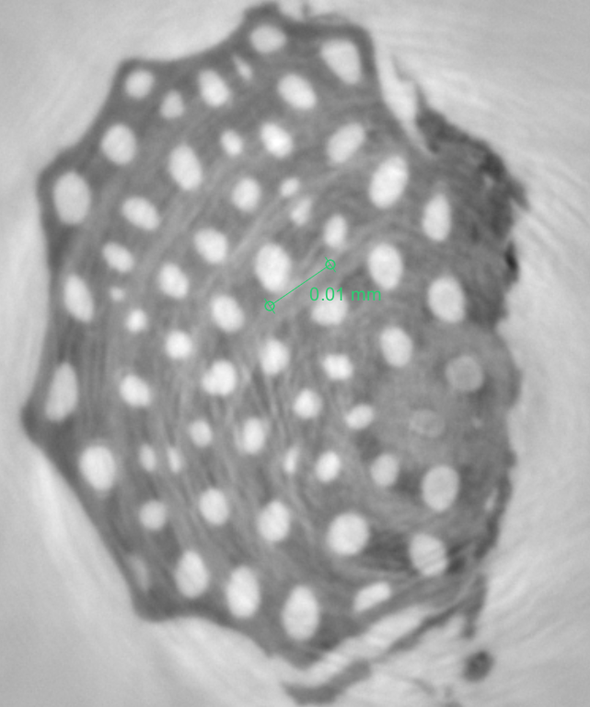  a) | 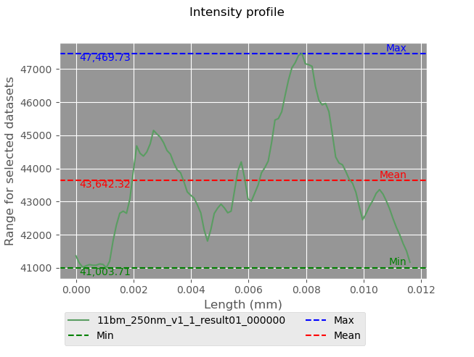  b)
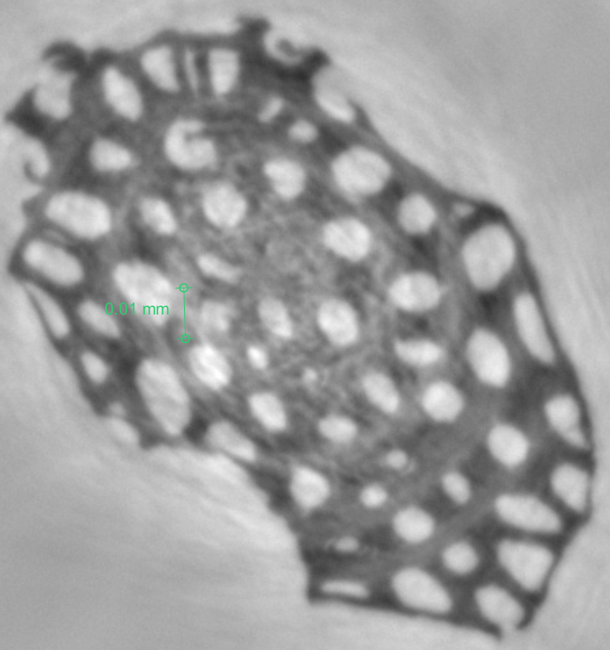  c) | 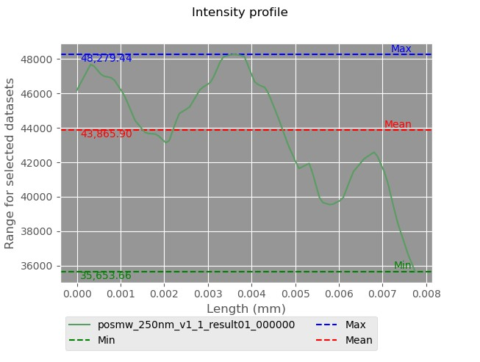  d)
Figure S1: Synchrotron nano-CT (Syn-nCT) reconstructed images: (a) air-dried (AD) fibres; (b) grayscale intensity profile of a selected region in the base image of AD fibres; (c) pre-soaked (PS) fibres; (d) grayscale intensity profile of a selected region in the base image of PS fibres.
Cracks within the air-dried (AD) fibres are clearly visible in the raw base images (SF1-See slice 1-100 in the video AD fibres). These cracks appear more frequently and distinctly in AD fibres compared to the pre-soaked (PS) ones (SF1-see the video).

POROSITY CALCULATIONS

Some classical formula in porous materials for calculation the void ratio (e) and porosity (n) are shown in the following equations:
To evaluate the void ratio and porosity of the fibre network, classical formulae in porous materials were employed as outlined in Equations 1 through 7. The void ratio, e, was calculated using the (Equation S1), where ρ_{s} represents the solid densities of the cell wall material and ρ, the bulk material, and w is the moisture content. Porosity, n, was then derived from the void ratio using the transformation n=e/(1+e) (Equation S2). These values were computed to provide a theoretical benchmark for comparison with porosity measurements obtained through synchrotron-based 3D imaging. This dual approach enables validation of the imaging results against traditional methods grounded in fundamental physical relationships. The combination of classical porosity relationships with three-dimensional synchrotron X-ray imaging enables validation of pore metrics obtained from image-based segmentation and provides a robust framework for quantifying pore connectivity in heterogeneous geomaterials [4].

e = (ρ_{s}(1+w)/ρ)-1 | Equation S1

n =e/(1+e) | Equation S2

$υ=\frac{v}{v_{s}}=\frac{v_{v+ }v_{s}}{v_{s}}=\frac{v_{v+ }v_{s}}{v_{s}}=\frac{v_{v}}{v_{s}}+1=e+1$ | Equation S3

$υ=\frac{v_{v}}{v}=\frac{v_{v }}{v_{v+ }v_{s}}=\frac{v_{v}}{v_{s}}. \frac{1}{\frac{v_{v+ }v_{s}}{v_{s}}} =e.\frac{1}{e+1}=\frac{e}{1+e}$ | Equation S4

$$γ_{d}=\frac{ρ_{s}}{v}=\frac{ρ-ρ_{w}}{v}=γ-\frac{ρ_{w}}{v} =γ-\frac{ρ_{w}}{ρ_{s}}.\frac{ρ_{s}}{v}=γ-ω.γ_{d}, γ_{d}= \frac{γ}{1+ω}$$ | Equation S5

$$e=\frac{v_{v}}{v_{s}}= \frac{v_{v}}{ρ_{s}}.\frac{ρ_{s}}{v_{s}}=(\frac{v_{- }v_{s}}{ρ_{s}}{)γ}_{s}=\left(\frac{υ}{ρ_{s}}-\frac{v_{s}}{ρ_{s}}\right)=γ_{s}\left(\frac{1}{γ_{d}}-\frac{1}{γ_{s}}\right)=γ_{s}\left(\frac{{γ_{s}-γ}_{d}}{{γ_{s}.γ}_{d}}\right)=\frac{γ_{s}}{γ_{d}}-1$$ | Equation S6

$$Sr=\frac{v_{w}}{v_{v}}=\frac{v_{w}}{ρ_{w}}.\frac{ρ_{w}}{v_{v}}= \frac{1}{γ_{ω}}\left(\frac{{ρ-ρ}_{s}}{v_{v}}\right)=\frac{1}{γ_{ω}}.\frac{v_{s}}{v_{s}}\left(\frac{{ρ-ρ}_{s}}{v_{v}}\right)=\frac{1}{γ_{ω }.e}\left(γ_{s}.\frac{ρ}{ρ_{s}}-γ_{s}\right)=\frac{γ_{s}}{γ_{ω }.e}\left(\frac{ρ-ρ_{s}}{ρ_{s}}\right)=\frac{γ_{s}}{γ_{ω }}.\frac{1}{e}\left(\frac{ρ_{w}}{ρ_{s}}\right)=\frac{G_{s }.ω}{e}, G_{s }.ω=Sr.e$$ | Equation S7

TENSILE TEST
All the statistical analysis can be found in the supplementary files with excel file [refer to supplementary materials 2].

CT TOMOGRAPHY SEGMENTATION:

The fibre samples, including both air-dried and pre-soaked conditions, were segmented from the reconstructed images using manual thresholding in Dragonfly software (Figure S2 a, c). A grayscale intensity threshold was applied to distinguish the fibre structures from the surrounding glass holder (Figure S2 b,d). Based on visual assessment and intensity analysis, average threshold values of 120.02/255 for air-dried fibres and 98.11/255 for pre-soaked fibres were used. This intensity range (98–120 on a normalized 8-bit scale) effectively isolated the fibre material.

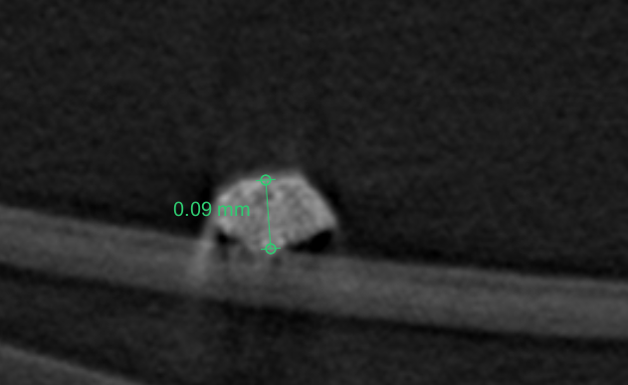  a) | 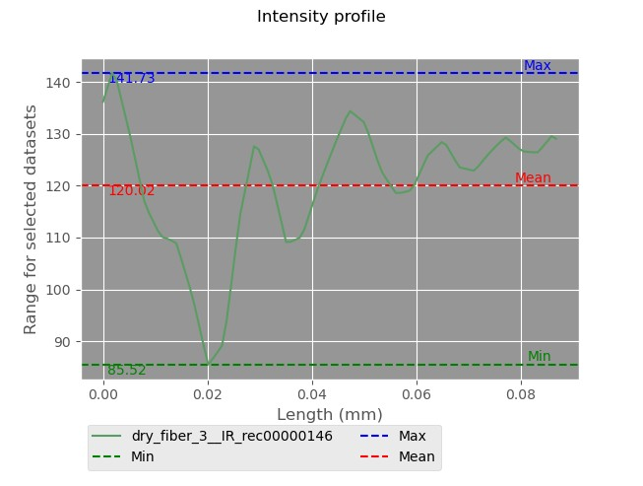  b)
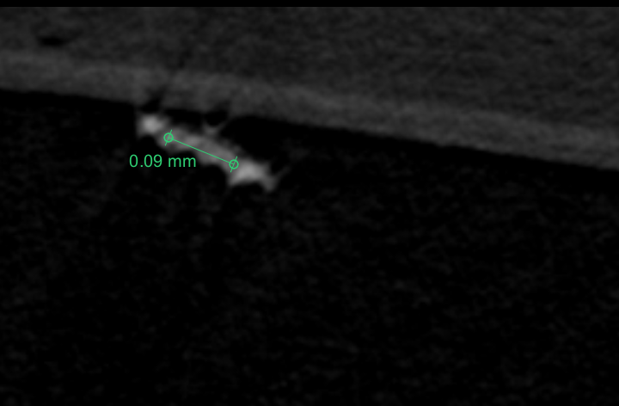  c) | 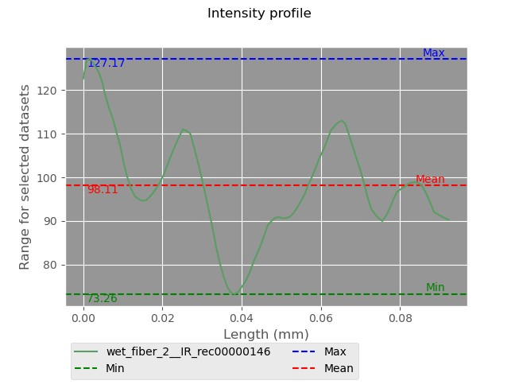  d)
Figure S2: CT tomography reconstructed images: (a) air-dried (AD) fibres; (b) grayscale intensity profile of a selected region in the AD base image; (c) pre-soaked (PS) fibres; (d) grayscale intensity profile of a selected region in the PS base image.

TORTUOSITY MEASUREMENT
Tortuosity was measured in MATLAB, following a structured approach. Initially, each 2D cross-section was binarized and segmented (average threshold values of 120/255 for air-dried fibres and 98/255 for pre-soaked fibres were used). After segmentation (Figure S4,4 a), some fibres showed small branches in their geometry (black pixels in Figure S4,4 b). The skeleton path (main branch with the longest path length) in 3D was identified with centroids of the fibres (red pixels in (Figure S4,4 b,c), and the small branches were pruned (Figure S4 c). Therefore, the longest connected red path was used to represent the main length. In the case of fibres without any bifurcations (Figure S4) the naturally curved or “snake-like” shape was directly selected as the main path in 3D. For all fibres, tortuosity was calculated as the ratio of the actual fibre length (main path) to the straight-line distance between its endpoints.
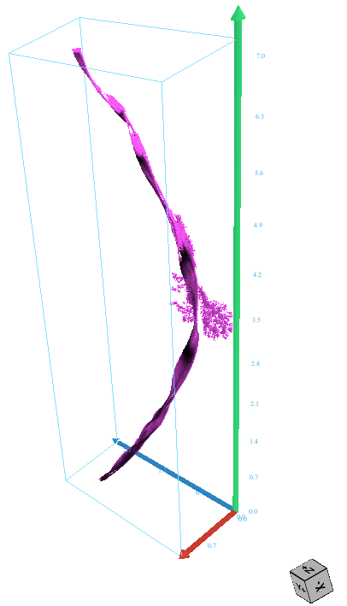  a) | 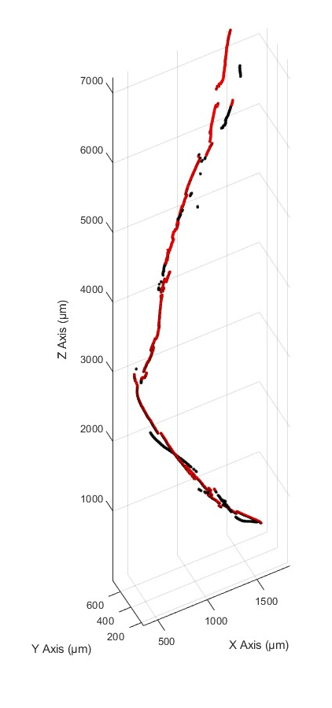  b) | 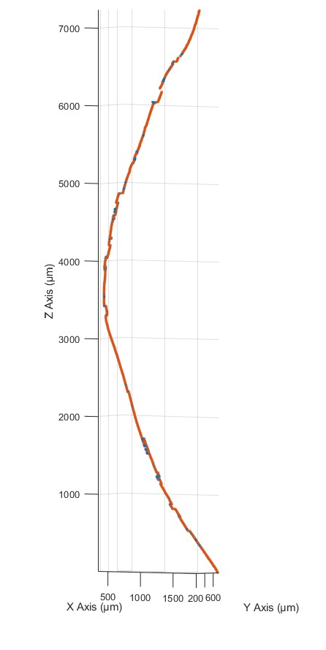  c)
Figure S3: (a) Segmented pre-soaked fibres (PS-S1) showing visible bifurcations; (b) corresponding reconstructed images in MATLAB, including noise and bifurcation artifacts; (c) extracted centroids of the fibres after removal of noise and bifurcations, where the center of mass along the longest 3D skeleton path is used to define the fibre length.
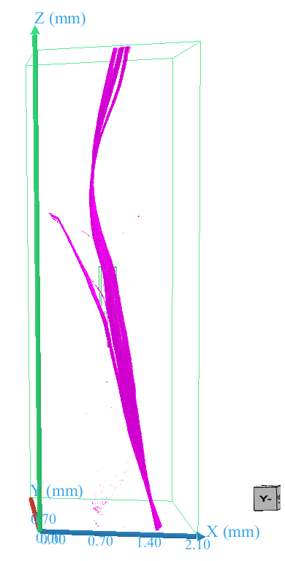  Branches  a) | 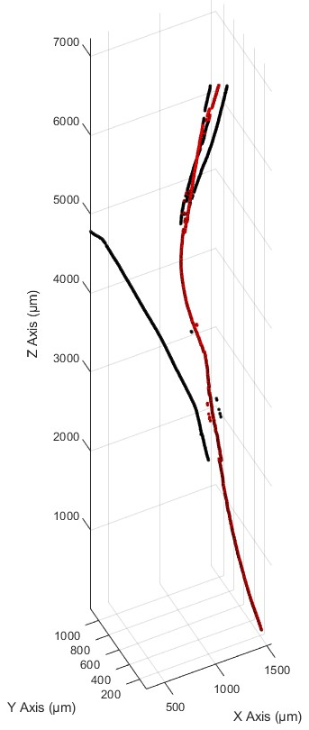  Branches (black pixels)  Main branch (red pixels)  b) | 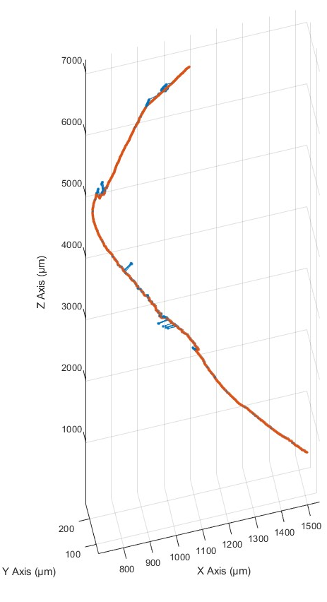  Main branch (red pixels)  b)  c)
Figure S4: (a) Segmented pre-soaked fibres (PS-S2) showing visible bifurcations; (b) corresponding reconstructed images in MATLAB, including noise and bifurcation artifacts; (c) extracted centroids of the fibres after removal of noise and bifurcations, where the center of mass along the longest 3D skeleton path is used to define the fibre length.
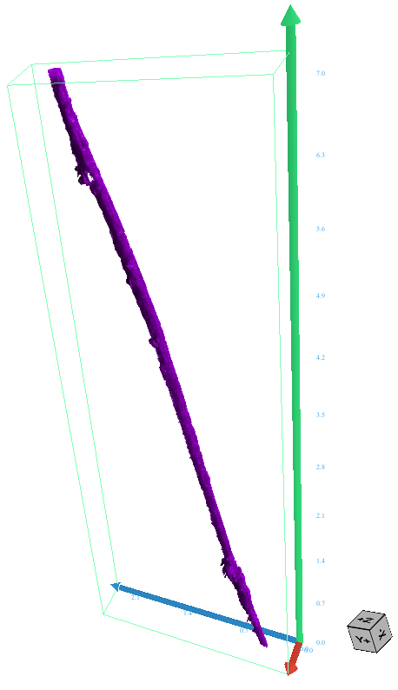 | 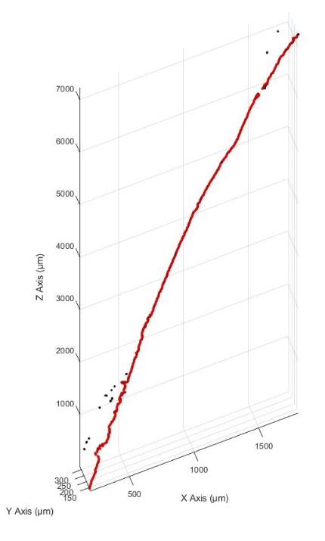 | 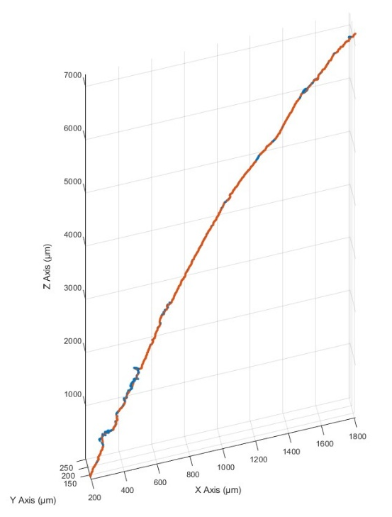
Figure S5: (a) Segmented air-dried fibres (AD-S1) with noises; (b) corresponding reconstructed images in MATLAB (c) extracted centroids of the fibres, after deleting the noises, where the centre of mass along the longest 3D skeleton path is used to define the fibre length.
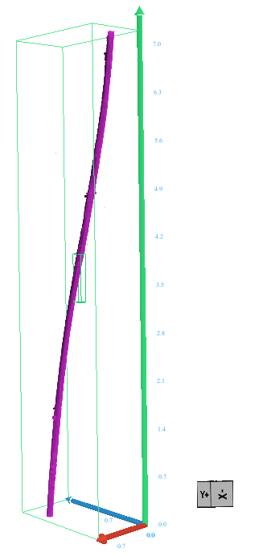 | 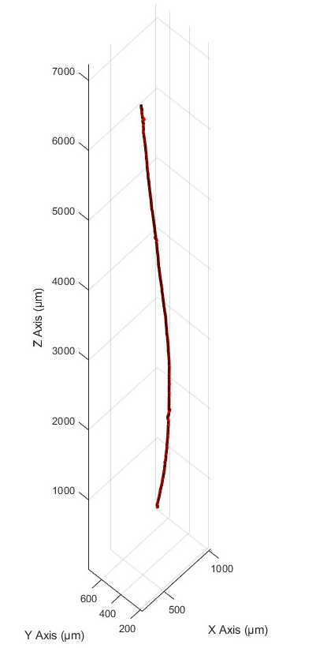 | 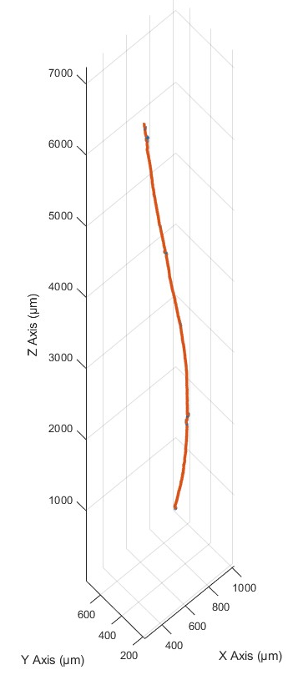
Figure S6: (a) Segmented air-dried fibres (AD-S2) without any bifurcations; (b) corresponding reconstructed images in MATLAB (c) extracted centroids of the fibres, where the centre of mass along the longest 3D skeleton path is used to define the fibre length.
References

1. Schlüter, S., et al., Image processing of multiphase images obtained via X‐ray microtomography: a review. Water Resources Research, 2014. 50(4): p. 3615-3639.
2. Koebernick, N., et al., High‐resolution synchrotron imaging shows that root hairs influence rhizosphere soil structure formation. New Phytologist, 2017. 216(1): p. 124-135.
3. Górecki, R., et al., Ptychographic X-ray computed tomography of porous membranes with nanoscale resolution. Communications Materials, 2023. 4(1): p. 68.
4. Zhang, Z., Y. Yan, and G. Geng, A review of micro-resolved crystochemical and mechanical probes for sustainable cement-based material studies. npj Materials Sustainability 3,(2025). 1. Deng, B., Eddy, L., Wyss, KM, Tiwary, CS & Tour, JM Flash Joule heating for synthesis, upcycling and remediation. Nature Reviews Clean Technology, 2025. 1: p. 32-54.

