APPENDIX
Table A1: Classification of Sampled Countries by Digitalisation Intensity
Group | Countries | Empirical Indicators
High-Digitalisation | Ghana, Kenya, Nigeria, Rwanda, Namibia, Zambia | Internet users >50%; Mobile broadband >80 per 100; EGDI ≈0.45–0.60; GII ICT subindex high; Strong digital policies
Low-Digitalisation | Burundi, Cameroon, Eritrea, Ethiopia, Gambia, Liberia, Sudan | Internet users <40%; Mobile broadband <60 per 100; EGDI ≈0.30–0.40; GII ICT subindex low; Weak policy infrastructure
Note: This classification draws on the latest (2023–2024) cross-country data from the ITU, World Bank, UNDESA EGDI, GSMA Mobile Connectivity Index, and WIPO Global Innovation Index, harmonised into a conceptual Digitalisation Intensity Index (DII), combining infrastructure, connectivity, e-governance, and innovation capacity dimensions.

Table A2: Firm Sectoral Classification by Digital Intensity
Category | Sectors Included | Core Digital Characteristics
High Tech-Intensive (1) | Information & Communication Technology (ICT); Finance & Insurance; Manufacturing & Industrial Processing; Transportation & Logistics; Energy & Utilities | High automation, real-time data analytics, ERP, and IoT integration, digital supply-chain linkages
Low Tech-Intensive (0) | Agriculture & Agribusiness; Retail & Wholesale; Construction; Tourism & Hospitality; Education & Training; Health & Social Services; Community & Cooperative Enterprises; Other Public or Non-profit Services | Limited automation; digital tools primarily support marketing, record-keeping, payments, or customer management

Table A3: Measurement model invariance testing using permutation (MICOM approach)
Construct | Configural invariance | Compositional Invariance Assessment |  |  | Full Measurement Model  Invariance Assessment
Construct | Configural invariance | Original Correlation | 0.05 (5.0%) | Partial  Measurement  Invariance  Established | Equality of Means |  | Equality of Variances |  | Full Measurement  Invariance  Established
 |  |  |  |  | Differences | CIs | Differences | CIs | Full Measurement  Invariance  Established
Digitalisation
DM | Established | 1.000 | 1.000 | Yes | -0.017 | [-0.038; 0.039] | -0.033 | [-0.057; 0.060] | Yes
IP | Established | 1.000 | 1.000 | Yes | -0.020 | [-0.041; 0.040] | 0.021 | [-0.060; 0.063] | Yes
IRB | Established | 1.000 | 1.000 | Yes | -0.028 | [-0.040; 0.038] | -0.019 | [-0.054; 0.060] | Yes
KMC | Established | 1.000 | 1.000 | Yes | -0.010 | [-0.041; 0.042] | 0.016 | [-0.057; 0.058] | Yes
OA | Established | 1.000 | 1.000 | Yes | -0.022 | [-0.040; 0.041] | 0.030 | [-0.064; 0.063] | Yes
OE | Established | 1.000 | 1.000 | Yes | -0.010 | [-0.040; 0.040] | -0.001 | [-0.057; 0.063] | Yes
OIC | Established | 1.000 | 1.000 | Yes | -0.026 | [-0.041; 0.042] | -0.037 | [-0.057; 0.061] | Yes
OR | Established | 1.000 | 1.000 | Yes | -0.018 | [-0.041; 0.039] | -0.005 | [-0.058; 0.058] | Yes
PU | Established | 1.000 | 1.000 | Yes | -0.020 | [-0.040; 0.040] | -0.024 | [-0.058; 0.062] | Yes
SA | Established | 1.000 | 1.000 | Yes | -0.017 | [-0.044; 0.041] | 0.006 | [-0.061; 0.060] | Yes
TMS | Established | 1.000 | 1.000 | Yes | -0.010 | [-0.044; 0.040] | 0.005 | [-0.058; 0.060] | Yes
Tech-Intensity
DM | Established | 1.000 | 1.000 | Yes | 0.006 | [-0.038; 0.042] | 0.032 | [-0.060; 0.059] | Yes
IP | Established | 1.000 | 1.000 | Yes | 0.003 | [-0.039; 0.041] | 0.037 | [-0.059; 0.056] | Yes
IRB | Established | 1.000 | 1.000 | Yes | 0.020 | [-0.038; 0.041] | -0.028 | [-0.060; 0.058] | Yes
KMC | Established | 1.000 | 1.000 | Yes | -0.023 | [-0.041; 0.038] | 0.048 | [-0.058; 0.057] | Yes
OA | Established | 1.000 | 1.000 | Yes | -0.006 | [-0.040; 0.036] | -0.009 | [-0.067; 0.060] | Yes
OE | Established | 1.000 | 1.000 | Yes | 0.021 | [-0.038; 0.041] | -0.002 | [-0.060; 0.054] | Yes
OIC | Established | 1.000 | 1.000 | Yes | 0.007 | [-0.041; 0.038] | -0.007 | [-0.061; 0.058] | Yes
OR | Established | 1.000 | 1.000 | Yes | 0.005 | [-0.043; 0.039] | 0.016 | [-0.056; 0.055] | Yes
PU | Established | 1.000 | 1.000 | Yes | -0.017 | [-0.043; 0.042] | 0.021 | [-0.062; 0.059] | Yes
SA | Established | 1.000 | 1.000 | Yes | -0.004 | [-0.040; 0.037] | -0.016 | [-0.064; 0.056] | Yes
TMS | Established | 1.000 | 1.000 | Yes | 0.023 | [-0.041; 0.039] | -0.053 | [-0.058; 0.060] | Yes

Table A4: Hypotheses testing results - high vs low digitalised countries
Paths (Hypotheses) | High digitalised countries |  |  |  |  | Low digitalised countries |  |  |  |  | Path Differences | p-value
Paths (Hypotheses) | β | SE | t-value | p-value | f² | β | SE | t-value | p-value | f² | Path Differences | p-value
Direct Effects (H1-H6)
H1: DM→OE | 0.109 | 0.013 | 8.473 | 0.000 | 0.012 | 0.158 | 0.016 | 10.005 | 0.000 | 0.025 | -0.049 | 0.015
H2: IRB→OE | 0.155 | 0.013 | 11.815 | 0.000 | 0.024 | 0.141 | 0.016 | 8.847 | 0.000 | 0.021 | 0.014 | 0.507
H3: IRB→DM | 0.185 | 0.013 | 14.748 | 0.000 | 0.035 | 0.146 | 0.016 | 9.347 | 0.000 | 0.022 | 0.039 | 0.053
H4: OR→DM | 0.141 | 0.013 | 10.899 | 0.000 | 0.021 | 0.183 | 0.015 | 12.276 | 0.000 | 0.036 | -0.041 | 0.038
H5: PU→DM | 0.144 | 0.013 | 11.042 | 0.000 | 0.021 | 0.135 | 0.015 | 8.781 | 0.000 | 0.019 | 0.009 | 0.675
H6: IP→DM | 0.177 | 0.013 | 13.755 | 0.000 | 0.032 | 0.165 | 0.015 | 11.058 | 0.000 | 0.028 | 0.011 | 0.565
Mediating Effects (H7-H9)
H7: DM→OIC→OE | 0.069 | 0.006 | 11.653 | 0.000 | n/a | 0.073 | 0.008 | 9.688 | 0.000 | n/a | -0.004 | 0.681
H8: DM→KMC→OE | 0.062 | 0.006 | 11.090 | 0.000 | n/a | 0.053 | 0.007 | 7.464 | 0.000 | n/a | 0.010 | 0.271
H9: DM→SA→OE | 0.052 | 0.006 | 9.347 | 0.000 | n/a | 0.046 | 0.007 | 7.015 | 0.000 | n/a | 0.006 | 0.496
Moderating Effects (H10 - H13)
H10: IRB×DM→OE | -0.003 | 0.011 | 0.317 | 0.751 | 0.000 | 0.008 | 0.013 | 0.576 | 0.565 | 0.000 | -0.011 | 0.520
H11: OA×DM→OE | 0.029 | 0.011 | 2.683 | 0.007 | 0.001 | 0.010 | 0.012 | 0.809 | 0.418 | 0.000 | 0.019 | 0.255
H12: TMS×IRB→DM | 0.003 | 0.011 | 0.298 | 0.765 | 0.000 | 0.011 | 0.014 | 0.751 | 0.453 | 0.000 | -0.007 | 0.684
H13: IP×IRB → DM | 0.021 | 0.011 | 1.892 | 0.059 | 0.001 | 0.018 | 0.013 | 1.329 | 0.184 | 0.000 | 0.003 | 0.849
Control Variables
Firm age←DM | 0.008 | 0.010 | 0.804 | 0.421 | n/a | 0.000 | 0.013 | 0.001 | 0.999 | n/a | n/a | n/a
Firm age←KMC | -0.009 | 0.011 | 0.771 | 0.441 | n/a | 0.001 | 0.015 | 0.042 | 0.967 | n/a | n/a | n/a
Firm age←OE | -0.006 | 0.010 | 0.596 | 0.551 | n/a | -0.004 | 0.013 | 0.270 | 0.787 | n/a | n/a | n/a
Firm age←OIC | 0.001 | 0.012 | 0.073 | 0.942 | n/a | 0.011 | 0.014 | 0.764 | 0.445 | n/a | n/a | n/a
Firm age←SA | -0.014 | 0.012 | 1.227 | 0.220 | n/a | 0.007 | 0.014 | 0.521 | 0.602 | n/a | n/a | n/a
Firm size←DM | -0.005 | 0.011 | 0.433 | 0.665 | n/a | -0.007 | 0.013 | 0.540 | 0.589 | n/a | n/a | n/a
Firm size←KMC | -0.001 | 0.012 | 0.062 | 0.950 | n/a | 0.030 | 0.015 | 2.044 | 0.041 | n/a | n/a | n/a
Firm size←OE | -0.010 | 0.011 | 0.951 | 0.342 | n/a | 0.023 | 0.013 | 1.731 | 0.083 | n/a | n/a | n/a
Firm size←OIC | -0.004 | 0.012 | 0.303 | 0.762 | n/a | 0.005 | 0.015 | 0.319 | 0.750 | n/a | n/a | n/a
Firm size←SA | -0.002 | 0.012 | 0.165 | 0.869 | n/a | 0.012 | 0.014 | 0.838 | 0.402 | n/a | n/a | n/a
Industry←DM | 0.010 | 0.010 | 0.919 | 0.358 | n/a | -0.014 | 0.013 | 1.086 | 0.277 | n/a | n/a | n/a
Industry←KMC | -0.002 | 0.012 | 0.202 | 0.840 | n/a | 0.006 | 0.014 | 0.390 | 0.697 | n/a | n/a | n/a
Industry←OE | -0.004 | 0.010 | 0.359 | 0.719 | n/a | -0.030 | 0.013 | 2.265 | 0.024 | n/a | n/a | n/a
Industry←OIC | -0.016 | 0.011 | 1.396 | 0.163 | n/a | 0.027 | 0.014 | 1.944 | 0.052 | n/a | n/a | n/a
Industry←SA | 0.007 | 0.012 | 0.608 | 0.543 | n/a | 0.013 | 0.015 | 0.906 | 0.365 | n/a | n/a | n/a

Table A5: Hypotheses testing results - high vs low tech intensity
Paths (Hypotheses) | High Tech-Intensity |  |  |  |  | Low Tech-Intensity |  |  |  |  | Path Differences | p-value
Paths (Hypotheses) | β | SE | t-value | p-value | f² | β | SE | t-value | p-value | f² | Path Differences | p-value
Direct Effects (H1-H6)
H1: DM→OE | 0.138 | 0.015 | 9.334 | 0.000 | 0.019 | 0.122 | 0.013 | 9.456 | 0.000 | 0.015 | 0.015 | 0.431
H2: IRB→OE | 0.127 | 0.015 | 8.378 | 0.000 | 0.017 | 0.166 | 0.013 | 12.474 | 0.000 | 0.028 | -0.039 | 0.051
H3: IRB→DM | 0.183 | 0.015 | 12.020 | 0.000 | 0.036 | 0.159 | 0.013 | 12.271 | 0.000 | 0.026 | 0.025 | 0.219
H4: OR→DM | 0.156 | 0.015 | 10.499 | 0.000 | 0.026 | 0.160 | 0.013 | 12.390 | 0.000 | 0.027 | -0.004 | 0.833
H5: PU→DM | 0.136 | 0.015 | 9.001 | 0.000 | 0.019 | 0.143 | 0.013 | 11.012 | 0.000 | 0.021 | -0.007 | 0.729
H6: IP→DM | 0.165 | 0.015 | 11.280 | 0.000 | 0.028 | 0.178 | 0.013 | 13.643 | 0.000 | 0.033 | -0.013 | 0.523
Mediating Effects (H7-H9)
H7: DM→OIC→OE | 0.079 | 0.007 | 11.356 | 0.000 | n/a | 0.065 | 0.006 | 10.296 | 0.000 | n/a | 0.014 | 0.150
H8: DM→KMC→OE | 0.057 | 0.007 | 8.404 | 0.000 | n/a | 0.059 | 0.006 | 10.270 | 0.000 | n/a | -0.002 | 0.827
H9: DM→SA→OE | 0.047 | 0.007 | 7.263 | 0.000 | n/a | 0.051 | 0.006 | 9.007 | 0.000 | n/a | -0.004 | 0.635
Moderating Effects (H10 - H13)
H10: IRB×DM→OE | -0.013 | 0.013 | 1.023 | 0.306 | 0.000 | 0.012 | 0.011 | 1.050 | 0.294 | 0.000 | -0.025 | 0.142
H11: OA×DM→OE | 0.025 | 0.013 | 1.952 | 0.051 | 0.001 | 0.018 | 0.011 | 1.688 | 0.091 | 0.000 | 0.007 | 0.676
H12: TMS×IRB→DM | 0.023 | 0.014 | 1.624 | 0.104 | 0.001 | -0.004 | 0.012 | 0.357 | 0.721 | 0.000 | 0.027 | 0.141
H13: IP×IRB→DM | 0.010 | 0.013 | 0.751 | 0.453 | 0.000 | 0.026 | 0.011 | 2.276 | 0.023 | 0.001 | -0.016 | 0.347
Control Variables
Firm age← DM | 0.006 | 0.013 | 0.510 | 0.610 | n/a | 0.005 | 0.011 | 0.454 | 0.650 | n/a | n/a | n/a
Firm age← KMC | -0.006 | 0.014 | 0.452 | 0.651 | n/a | -0.005 | 0.012 | 0.418 | 0.676 | n/a | n/a | n/a
Firm age←OE | -0.003 | 0.013 | 0.248 | 0.804 | n/a | -0.008 | 0.011 | 0.767 | 0.443 | n/a | n/a | n/a
Firm age←OIC | 0.001 | 0.014 | 0.050 | 0.960 | n/a | 0.008 | 0.012 | 0.655 | 0.513 | n/a | n/a | n/a
Firm age←SA | -0.029 | 0.014 | 2.093 | 0.036 | n/a | 0.011 | 0.012 | 0.954 | 0.340 | n/a | n/a | n/a
Firm size←DM | -0.008 | 0.013 | 0.663 | 0.507 | n/a | -0.003 | 0.011 | 0.277 | 0.782 | n/a | n/a | n/a
Firm size←KMC | 0.011 | 0.014 | 0.805 | 0.421 | n/a | 0.011 | 0.012 | 0.916 | 0.360 | n/a | n/a | n/a
Firm size←OE | -0.003 | 0.013 | 0.261 | 0.794 | n/a | 0.008 | 0.011 | 0.749 | 0.454 | n/a | n/a | n/a
Firm size←OIC | -0.004 | 0.014 | 0.271 | 0.786 | n/a | 0.002 | 0.012 | 0.204 | 0.839 | n/a | n/a | n/a
Firm size←SA | 0.021 | 0.014 | 1.519 | 0.129 | n/a | -0.010 | 0.012 | 0.835 | 0.404 | n/a | n/a | n/a
Industry←DM | 0.000 | 0.012 | 0.013 | 0.990 | n/a | 0.000 | 0.011 | 0.020 | 0.984 | n/a | n/a | n/a
Industry←KMC | 0.008 | 0.014 | 0.548 | 0.584 | n/a | -0.007 | 0.012 | 0.562 | 0.574 | n/a | n/a | n/a
Industry←OE | -0.016 | 0.012 | 1.321 | 0.187 | n/a | -0.010 | 0.011 | 0.896 | 0.370 | n/a | n/a | n/a
Industry←OIC | 0.003 | 0.014 | 0.220 | 0.826 | n/a | 0.001 | 0.012 | 0.061 | 0.952 | n/a | n/a | n/a
Industry←SA | 0.024 | 0.014 | 1.688 | 0.091 | n/a | 0.000 | 0.012 | 0.035 | 0.972 | n/a | n/a | n/a

High Digitalised Countries  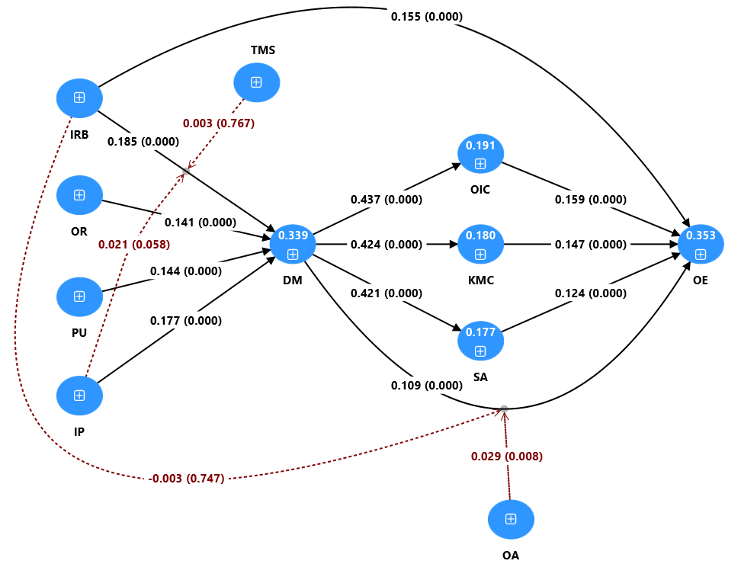 | Low Digitalised Countries  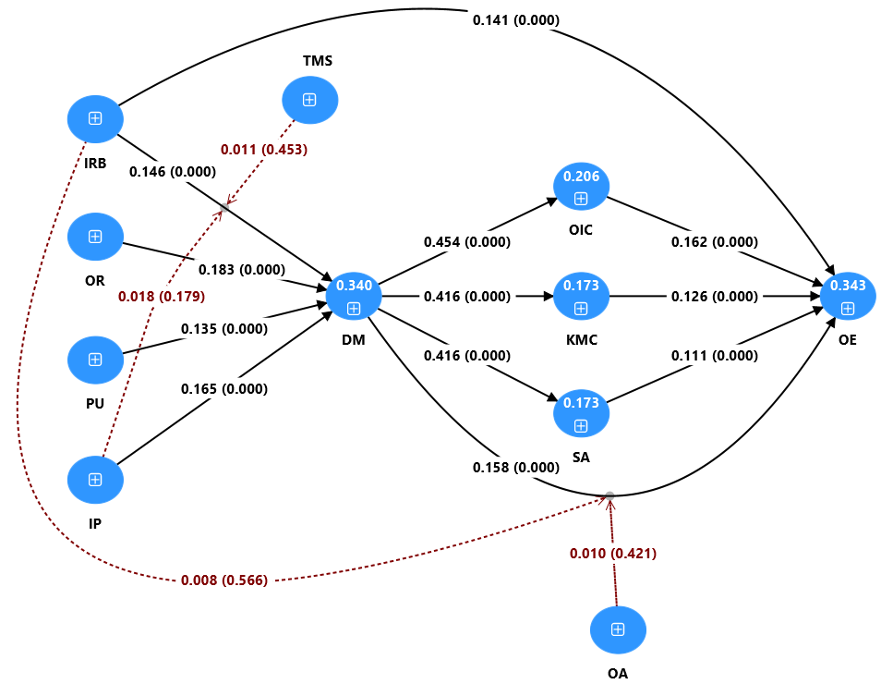
Figure A1: Structural model results for high vs low digitalised countries

High Tech-Intensity  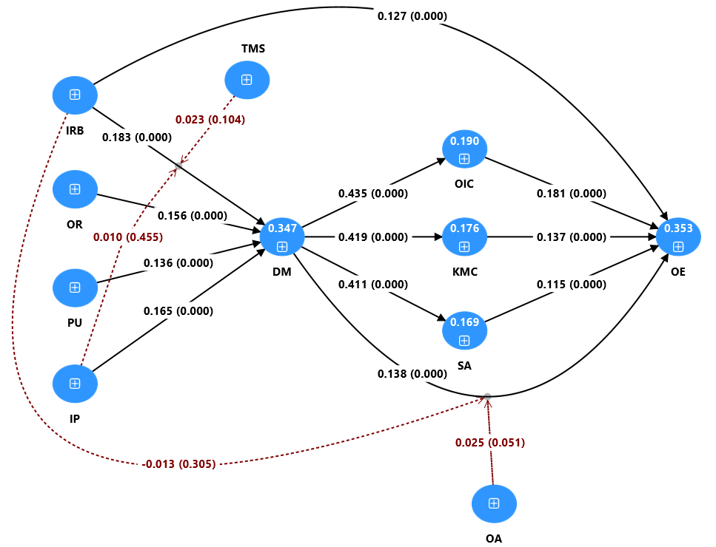 | Low Tech-Intensity  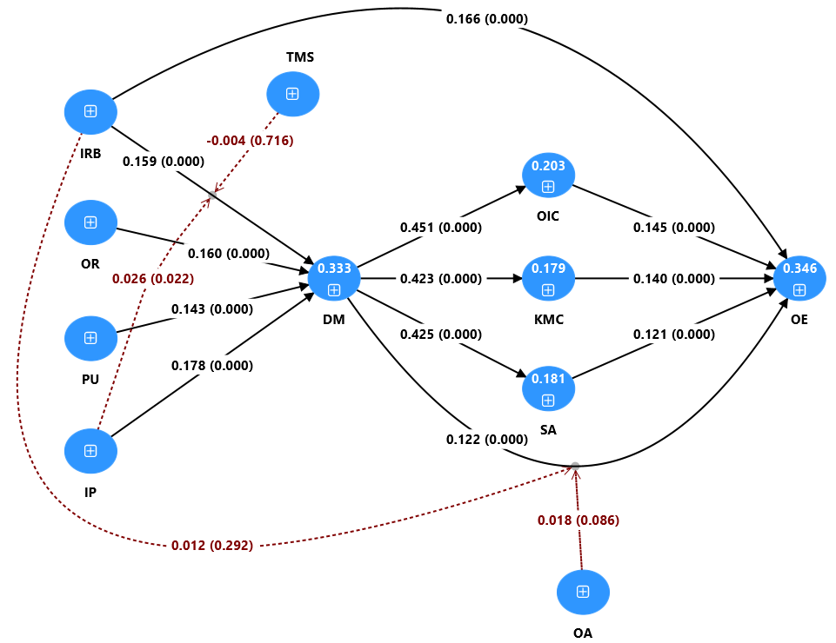
Figure A2: Structural model results for high vs low-tech intensity

