Supplementary Materials for
Three-Dimensional Dispersive Excitons in Metallic TbNiC₂

Zihan Lin^{1†}, Tian Shang^{2†}, Siyan Liu^{3†}, Xingkai Cheng^{3†}, Sailong Ju⁴, Xin Liang¹, Wenlong Lu¹, Shiyu Feng¹, Dariusz Jakub Gawryluk⁵, Ekaterina Pomjakushina⁵, Nicholas C. Plumb⁴, Milan Radovic⁴, Bastien Michon^{1,6}, Wei Bao¹, Hanbin Deng⁷, Jiaxin Yin⁷, Ming Shi^{8,9,10}*, Junwei Liu³*, Junzhang Ma¹*

* Conrresponding authors: Ming SHI (shi20001231@zju.edu.cn), Junwei LIU (liuj@ust.hk), Junzhang MA (junzhama@cityu.edu.hk)

The PDF File includes：
Supplementary Text
Figs. S1 to S13

Model theory of exciton induced spectra in ARPES results
I. Exciton in semiconductor under ARPES detection
1.1 Hamiltonian with electron-hole interaction
In a semiconductor two band model, the conduction band (CB) is above the Fermi energy and the valence band (VB) is below the Fermi energy. When there is notable electron-hole interaction, this system can be described by the Hamiltonian:
$$\begin{aligned}H =H_{0}+W\#(1) \\ H_{0} =\sum_{k_{1}}{ } ϵ_{v,k_{1}}a^{†}\left(k_{1}\right)a\left(k_{1}\right)+\sum_{k_{2}}{ } ϵ_{c,k_{2}}b^{†}\left(k_{2}\right)b\left(k_{2}\right)\#(2) \\ W =\sum_{k_{1},k_{2},q≠0}{ } V(q)b^{†}\left(k_{1}+q\right)a^{†}\left(k_{2}-q\right)a\left(k_{2}\right)b\left(k_{1}\right),\#(3)\end{aligned}$$
where $b^{†}\left(k_{2}\right)/b\left(k_{2}\right)$ is the creation/annihilation operator for the electron in the CB and $a^{†}\left(k_{1}\right)/a\left(k_{1}\right)$ is the creation/annihilation operator for an electron in the VB.
By fitting the energy band with quadratic function, we could get the effective mass of the $CB$ as $m_{c}$.
1.2 The exciton creation operator and the energy of exciton
Exciton creation operator with exciton center-of-mass (COM) momentum $Q$ and state $λ$ can be described as shown below (30):
$$\begin{aligned}A_{λ}^{†}(Q,w)=\sum_{p}{ } ϕ_{λ}^{w}(p)b^{†}\left(p+\frac{m_{c}}{m_{c}+m_{v}}Q\right)a\left(p-\frac{m_{v}}{m_{c}+m_{v}}Q\right),\#(4)\end{aligned}$$
where $ϕ_{λ}^{w}(p)$ is the envelope wave function satisfying the eigenvalue equation:
$$\begin{aligned}\left[\frac{p^{2}}{2μ}-E_{λ}\right]ϕ_{λ}^{w}(p)=\sum_{p^{'}}{ } V\left(p-p^{'}\right)ϕ_{λ}^{w}\left(p^{'}\right).\#(5)\end{aligned}$$
In this equation, $w$ is the wave vector separation between the conduction band minima and the valence band maxima.
After rearranging the Coulomb interaction terms, we could get the equation:
$$\begin{aligned}i\frac{∂}{∂t}A^{†}(Q,w)=\left[-E_{g}-E_{λ}-\frac{Q^{2}}{2M}\right]A^{†}(Q,w).\#(6)\end{aligned}$$
Therefore, an exciton with COM momentum $Q$ in state $λ$ has energy:
$$\begin{aligned}E_{λ,Q}=E_{g}-E_{λ}^{B}+\frac{Q^{2}}{2M}.\#(7)\end{aligned}$$
In this equation we define the energy of ground state as $0 eV$. Therefore, this equation illustrates an electron being excited to the CB and creating one exciton with binding energy $E_{λ}^{B}$ and with center of mass momentum energy $\frac{Q^{2}}{2M}$.
1.3 ARPES photoemission spectra
According to semi perturbative theory (31), ARPES process can be viewed as a perturbation, while the exciton creation process is the main process. In this instance, we can define the probe Hamiltonian term using a probe pulse with energy $ω_{0}$ and a temporal profile $s(t)$ as shown below:
$$\begin{aligned}H_{\text{probe }}=s(t)e^{-iω_{0}t}M_{k,k^{'}}^{fc}f^{†}(k)b\left(k^{'}-w\right).\#(8)\end{aligned}$$
This equation demonstrates that the electron excited to the conduction band annihilates, and $f^{†}(k)$ denotes the creation operator of a free electron which is the photoelectron during ARPES process. We use a Gaussian distribution as the temporal profile $s(t).M_{k,k^{'}}^{fc}$ represents the matrix element that shows the connection between momentum $k$ and $k^{'}$.
We define the ground-state wave function of the system as $\left|Ψ_{n}\right\rangle$, the exciton wave function as $\left|Ψ_{n}^{I}\right\rangle$, and the post-probe wave function as $\left|Ψ_{n}^{F}\right\rangle$. The final state after the action of the probe Hamiltonian denoted by $\left|Ψ_{m}^{1<};k\right\rangle ≜\left|Ψ_{m}^{1<}\right\rangle ⨂|k⟩$.
ARPES results can be computed by calculating the probability:
$$\begin{aligned}P(t)=\sum_{n,m}{ } ρ_{n}{\left|\left\langle Ψ_{m}^{1<};k∣Ψ_{n}^{F}(t)\right\rangle \right|}^{2}.\#(9)\end{aligned}$$
Solving the above equations yields the probability: $\begin{aligned}P≃2πσ^{2}{\left|M_{k,k^{'}}^{fc}\right|}^{2}\sum_{λ,Q}{ } ρ_{λ,Q}{\left|ϕ_{λ}^{w}\left(k^{'}-w-\frac{m_{c}}{m_{c}+m_{v}}Q\right)\right|}^{2}exp⁡\left(-σ^{2}{\left[-ω+E_{λ,Q}+ϵ_{v,k^{'}-w-Q}\right]}^{2}\right).\#(10)\end{aligned}$
Equation (10) shows that for a single energy state $λ$, the probability is given by the sum over all possible center-of-mass momentum $Q$.
II. Exciton in conductors during photoemission process
2.1 Microscopic mechanism
In conductive systems, electronic states from CB predominantly reside near the Fermi energy. In the model under consideration, a finite band gap separates the Fermi-level-crossing CB from its closest lower-lying VB. Figure S10 provides an idealized visualization of this electronic structure.
While ARPES detects the electrons from the VB band, it creates valence band holes. The lower energy of final excitonic binding between one VB hole and one CB electron results in higher energy of the emitted electron into the vacuum, leading to distinct spectral contributions as replica valence band above the main valence band.
In this model, we denote the momentum of electron which is excited in Figure S10 and Figure S11 as $k_{h}$, so the momentum of hole is ${-k}_{h}$.
We discuss the system using classical central momentum system. When electron-hole pairs have coinciding momenta ( $k_{e}=k_{h}$ ), the excitonic center-of-mass wavevector becomes zero. Conversely, when the electron and hole have different momenta, the exciton has center-of-mass wavevector $Q=k_{e}-k_{h}$. Figure S11 shows excitons in direct and indirect band gap systems with identical ARPES results. Their distinguishing feature is the center-of-mass wavevector Q. The influence of indirect band gap would be discussed later.
2.2 Exciton creation process
The electron-hole pair operator can be expressed as:
$$\begin{aligned}A_{λ}^{†}(Q,w)=\sum_{p}{ } ϕ_{λ}^{w}(p)c^{†}a\left(p-\frac{m_{v}}{m_{c}+m_{v}}Q\right).\#(11)\end{aligned}$$
In this equation, $a$ is the annihilation operator of the lower energy VB and $c^{†}$ is the creation operator of a virtual energy band that is nearly detached from the material edge. If the hole forms exciton with an electron in the CB with wavevector $k_{e}$, we obtain the following equation:
$$\begin{aligned}p+\frac{m_{c}}{m_{c}+m_{v}}Q=k_{e}≜0.\#(12)\end{aligned}$$
For conciseness of the final expression, we define $k_{e}≜0$. In this case, the electron with wavevector $k_{e}=p+\frac{m_{c}}{m_{c}+m_{v}}$ form exciton with photo-hole with wavevector $k_{h}=p-\frac{m_{v}}{m_{c}+m_{v}}$. We could calculate the relationship between $p$ and $Q$. By considering the sum term of center-of-mass momentum $Q$ :
$$\begin{aligned}A_{λ}^{†}(w)=\sum_{Q}{ } ϕ_{λ}^{w}(-\frac{m_{c}}{m_{c}+m_{v}}Q)c^{†}a(-Q).\#(13)\end{aligned}$$
By applying effective mass approximation, the Schrödinger equation of the exciton system can be written as:
$$\begin{aligned}\left(-\frac{ℏ^{2}}{2m_{e}^{*}}∇_{e}^{2}-\frac{ℏ^{2}}{2m_{h}^{*}}∇_{h}^{2}-\frac{e^{2}}{ϵ\left|r_{e}-r_{h}\right|}\right)Ψ=\left(E-E_{Δ}\right)Ψ.\#(14)\end{aligned}$$
We define the energy of the electron in Fermi-level-crossing CB as 0 eV. So the total energy of electron is $-\frac{ℏ^{2}}{2m_{e}^{*}}∇_{e}^{2}$, the total energy of photo-hole is $-\frac{ℏ^{2}}{2m_{h}^{*}}∇_{h}^{2}-E_{Δ}$, the interaction of electron and hole is $-\frac{e^{2}}{ϵ\left|r_{e}-r_{h}\right|}$.
Then we define center-of-mass coordinate $X$ and relative coordinates $x$ :
$$\begin{aligned}X =\frac{m_{e}^{*}r_{e}+m_{h}^{*}r_{h}}{m_{e}^{*}+m_{h}^{*}}\#(15) \\ x =r_{e}-r_{h}.\#(16)\end{aligned}$$
Assume that:
$$\begin{aligned}Ψ=g(X)f(x).\#(17)\end{aligned}$$
We could obtain two equations:
$$\begin{aligned}-\frac{ℏ^{2}}{2M}∇_{X}^{2}g(X) =\frac{Q^{2}}{2M}g(Q)\#(18) \\ \left(-\frac{ℏ^{2}}{2μ}∇_{x}^{2}-\frac{e^{2}}{ϵx}\right)f(x) =\left(E-E_{Δ}-\frac{Q^{2}}{2M}\right)f(x).\#(19)\end{aligned}$$
Here $M=m_{e}+m_{h}$ and $μ^{-1}=m_{c}^{-1}+m_{v}^{-1}$. By solving this equation, we could get the energy eigenvalue of exciton:
$$\begin{aligned}E_{λ,Q}=E_{Δ}-E_{λ}^{B}+\frac{Q^{2}}{2M}.\#(20)\end{aligned}$$
By solving equation (19), we could also estimate the exciton binding energy $E_{λ}^{B}$ :
$$\begin{aligned}E_{λ}^{B}=\frac{μe^{4}}{2ℏ^{2}ϵ^{2}n^{2}}.\#(21)\end{aligned}$$
2.3 ARPES detection process
The detection Hamiltonian can be expressed as:
$$\begin{aligned}H_{\text{probe }}=s(t)e^{-iω_{0}t}M_{k,k^{'}}^{fc}f^{†}(k)c.\#(22)\end{aligned}$$
We define $ω$ as the difference in energy of the material before and after photoemission:
$$\begin{aligned}ω=ω_{e}+W-ω_{0},\#(23)\end{aligned}$$
where $ω_{e}$ is the kinetic energy of photoemitted electron, $W$ is the work function of material, $ω_{0}$ is the energy of probe pulse.
We also assume that:
$$\begin{aligned}s(t)=e^{-\frac{{\left(t-t_{d}\right)}^{2}}{2σ^{2}}},\#(24)\end{aligned}$$
where $σ$ means the width of probe temporal.
2.4 Calculation of spectral function
The photoemission process is described by $H$ in equation (1) and $H_{\text{probe }}$ in equation (22):
$$\begin{aligned}\left|Ψ_{n}^{F}(t)\right\rangle =\overset{‾}{U}\left(t,t_{0}\right)\left|Ψ_{n}^{I}\left(t_{0}\right)\right\rangle .\#(25)\end{aligned}$$
Here the time-evolution operator $\overset{‾}{U}\left(t,t_{0}\right)$ is:
$$\begin{aligned}\overset{‾}{U}\left(t,t_{0}\right)={\overset{ˆ}{T}}_{t}exp⁡\left(-i\int_{t_{0}}^{t}{ } dt_{1}\left[H+H_{\text{probe }}\left(t_{1}\right)\right]\right).\#(26)\end{aligned}$$
We could also define time-evolution operator $U\left(t,t_{0}\right)$ as:
$$\begin{aligned}U\left(t,t_{0}\right)={\overset{ˆ}{T}}_{t}exp⁡\left(-i\int_{t_{0}}^{t}{ } dt_{1}H\right).\#(27)\end{aligned}$$
As the photoelectron gain the energy of exciton, so the energy of initial state is:
$$\begin{aligned}H\left|Ψ_{n}^{I}\left(t_{0}\right)\right\rangle =\left(Ω_{0}-E_{λ,Q}+\frac{Q^{2}}{2M}\right)\left|Ψ_{n}^{I}\left(t_{0}\right)\right\rangle .\#(28)\end{aligned}$$
So the eigenvalue of $\left|Ψ_{n}^{I}\left(t_{0}\right)\right\rangle$ is $\left(Ω_{0}-E_{λ,Q}+\frac{Q^{2}}{2M}\right).$
$$\begin{aligned}U\left(t_{0},t_{1}\right)\left|Ψ_{n}^{I}\left(t_{1}\right)\right\rangle =e^{-i\left(Ω_{0}-E_{λ,Q}+\frac{Q^{2}}{2M}\right)\left(t_{0}-t_{1}\right)}\left|Ψ_{n}^{I}\left(t_{1}\right)\right\rangle .\#(29)\end{aligned}$$
When view probe-process as perturbation, Taylor expansion can be performed on the time evolution operator $\overset{‾}{U}\left(t,t_{0}\right)$, retaining only the first-order term:
$$\begin{aligned}\overset{‾}{U}\left(t,t_{0}\right)≈U\left(t,t_{0}\right)-i\int_{t_{0}}^{t}{ } dt_{1}U\left(t,t_{1}\right)H_{\text{probe }}\left(t_{1}\right)U\left(t_{1},t_{0}\right).\#(30)\end{aligned}$$
By defining:
$$\begin{aligned}\left|Ψ_{m}^{1<};k\right\rangle ≡\left|Ψ_{m}^{1<}\right\rangle ⊗|k⟩,\#(31)\end{aligned}$$
we could calculate the spectral function:
$$\begin{aligned}P(t)=\sum_{n,m}{ } ρ_{n}{\left|\left\langle Ψ_{m}^{1<};k∣Ψ_{n}^{F}(t)\right\rangle \right|}^{2}.\#(32)\end{aligned}$$
Here $\left|Ψ_{m}^{1<}\right\rangle$ is the state of system after photoemission of an electron and $|k⟩$ is the state of a free photoemitted electron.
Adopting the theoretical framework outlined in second part of ref. (32), we could compute the spectral function:
$$\begin{aligned}P\left(t_{d}\right)∝ρ_{Q}(-k){\left|ψ_{λ}^{w}(αk)\right|}^{2}exp⁡\left(-σ^{2}{\left[-ω-E_{λ,Q}+\frac{Q^{2}}{2M}+ϵ_{v,k}\right]}^{2}\right).\#(33)\end{aligned}$$
The spectral function calculation allows us to determine how exciton formation affects ARPES spectra. For Figure S10, we calculated the electron spectrum considering one single electron in the Fermi-level-crossing CB. Assuming the exciton creation processes are independent for different electrons in the CB, we obtain the final result by summing the spectral functions of multiple electrons. This approach provides a realistic representation of the actual system.
III. Comparison with experimental results
The spectral function can be derived from experimentally obtained band data. We then compute the spectral function of the side band induced by exciton formation. By fitting the energy band with parabolic dispersion, we could get the effective mass $m_{e}^{*}$ and $m_{h}^{*}$. We could assume the wave function as:
$$\begin{aligned}ϕ_{1}^{w}(k)∝\frac{1}{{\left[1+k^{2}a_{ex}^{2}/4\right]}^{2}}.\#(34)\end{aligned}$$
Here $a_{ex}=0.529ϵ/μ\text{Å}$ which depends on the effective dielectric constant and $μ$ is defined in equation (19).
To fit the side band of experiment result, we mainly modified two parameters: $E_{λ}^{B}$ and $ρ(Q)$. $ρ(Q)$ is the distribution of center of mass momentum $Q$.
3.1 Different exciton binding energy under different $k$
By fitting the band of experimental data, we found that the spectral function in different $k_{h}$ has different exciton binding energy. Considering the crystal symmetry, the dielectric constant tensor can be written as:
$$\begin{aligned}ϵ=\left(\begin{matrix}ϵ_{xx} & 0 & 0 \\ 0 & ϵ_{yy} & 0 \\ 0 & 0 & ϵ_{zz}\end{matrix}\right).\#(35)\end{aligned}$$
When the momentum of electron and hole are non-colinear, the interaction between electron and hole are restricted in a specific plane depends on the momentum vectors of electron and hole. We define the momentum of electron as $k_{e}$ and the momentum occupied by the hole in the energy band as $k_{h}$. Therefore, the normal vector of the plane could be calculated by:
$$\begin{aligned}\overset{ˆ}{n}=\frac{k_{e}×k_{h}}{\left|k_{e}×k_{h}\right|}.\#(36)\end{aligned}$$
In this case, we could define average dielectric constant:
$$\begin{aligned}⟨ϵ_{//}⟩=\frac{1}{2}\left[Tr(ϵ)-\left({\overset{ˆ}{n}}^{T}⋅ϵ⋅\overset{ˆ}{n}\right)\right].\#(37)\end{aligned}$$
When the momentum of electron and hole are colinear, coulomb-mediated electron-hole interactions exhibit no directional restriction in the material.
Considering equation (21), the exciton binding energy $E_{λ}^{B}$ could be defined by:
$$\begin{aligned}E_{λ}^{B}=\frac{μe^{4}}{2ℏ^{2}{\left\langle ϵ_{//}\right\rangle }^{2}n^{2}}.\#(38)\end{aligned}$$
The ARPES result of different high-symmetry path shows different energy separation of side band from the main band, which is induced by momentum dependent exciton binding energy.
3.2 The definition of distribution of Q
We assume that the distribution of center-of-mass momentum is:
$$\begin{aligned}ρ(Q)=\frac{1}{\sqrt{2πσ^{2}}}exp⁡\left(-\frac{(x-w)^{2}}{2σ^{2}}\right).\#(39)\end{aligned}$$
Here $w=\left|k_{e}-k_{h}\right|$, where $k_{e}$ and $k_{h}$ are the wavevectors of electron and photo-hole which are more likely to form exciton. $σ$ describes the maximum interaction range between different $k_{e}$ and $k_{h}$. Figure S12 and S13 shows the influence of parameter $σ$ which modify the distribution range of sideband and $w$ which modify the position of sideband to the exciton induced spectra in ARPES results. Comparing with the ARPES data as shown in main text, the excitons have a wide center-of-mass momentum range spanning from around -0.4 to 0.4 ${\dot{A}}^{-1}$. Moreover, we calculate the excitons induced spectra along high symmetry lines according to both DFT band structure and experimental ARPES results as shown in Fig.5 in the main text which agree well with our observations.

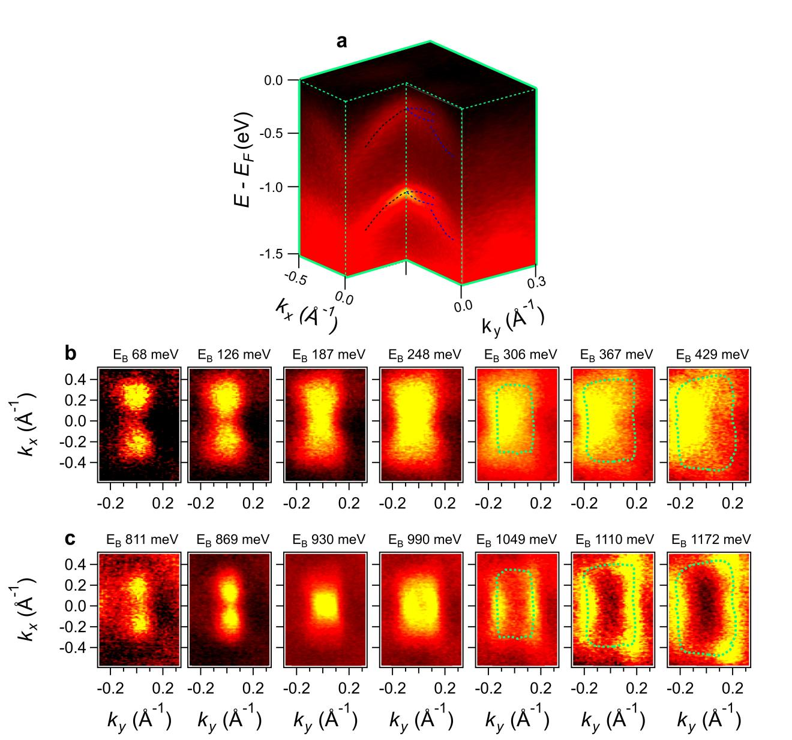
Fig. S1. Detailed comparison between the replica bands and main valence bands in TbNiC₂. a, The ARPES spectrum showing the dispersions of the main valence bands and their replica bands in the k_{z} = π/c plane. b,c, Series of constant-energy contours at various E_{b} values (b) and E_{b} + 0.74 eV (c), showing the similarity between the replica bands and valence bands.

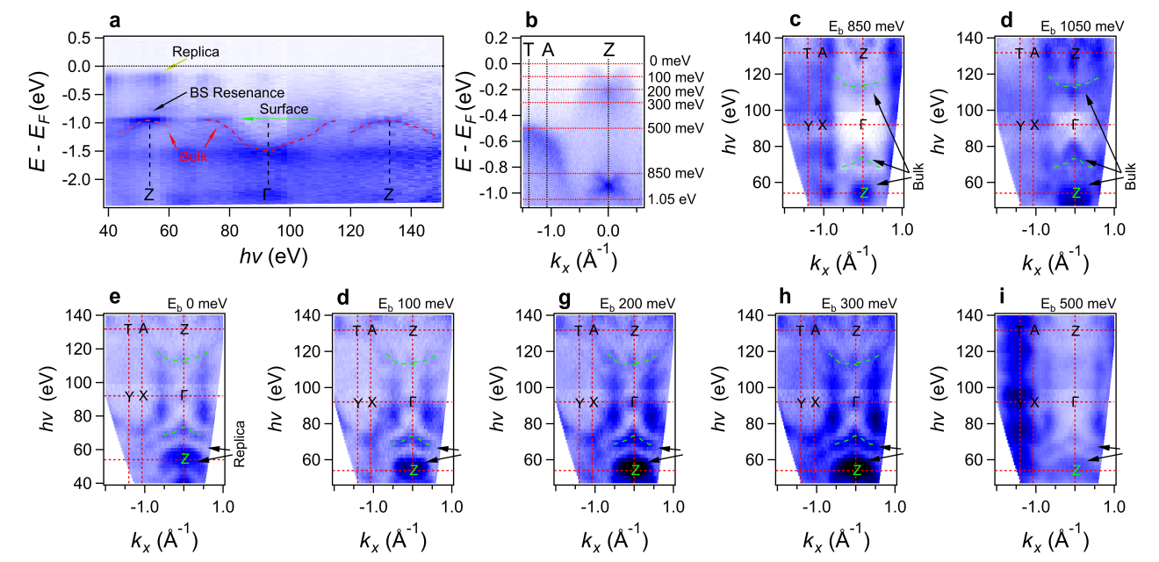
Fig. S2. Photon-energy-dependent ARPES spectra of TbNiC₂. a, The ARPES spectrum along the Γ–Z direction line, acquired by varying photon energy. The red dotted lines trace the dispersive bulk bands. The bands indicated by the green double arrow show no noticeable k_{z} dispersion, which is attributed to surface state. “BS resonance” denotes the bulk–surface resonance feature. b, The ARPES spectrum along the T–A–Z momentum cut, acquired with photon energy hν = 54 eV. c–i, Constant-energy contours at different binding energies, as marked in (b), illustrating the evolution of the main valence bands and the replica bands as a function of k_{z}, showing their bulk state character.

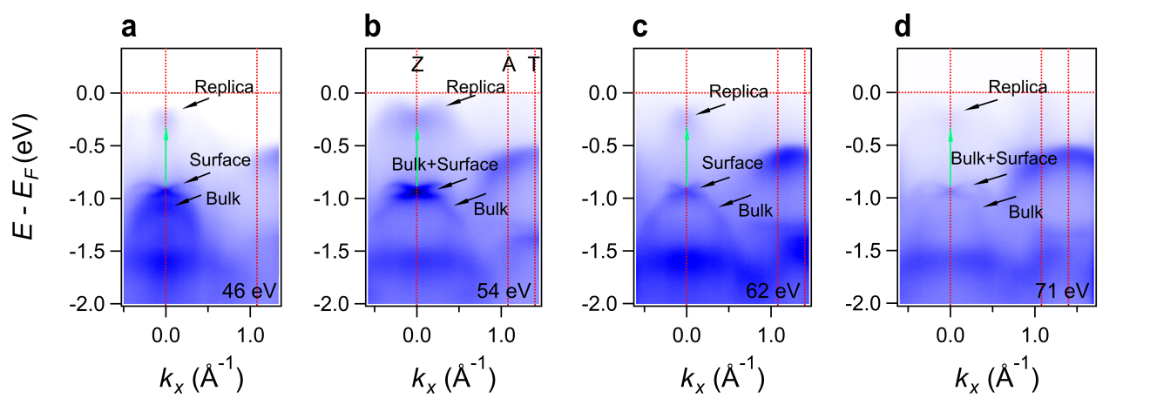
Fig. S3. The ARPES spectra of TbNiC₂ along a momentum cut in the Γ–Z–A plane and parallel to the Z–A line, acquired with different photon energies indicated in panels (a - d), showing the evolution of the band structure and the variation of the spectral weight with k_{z}.

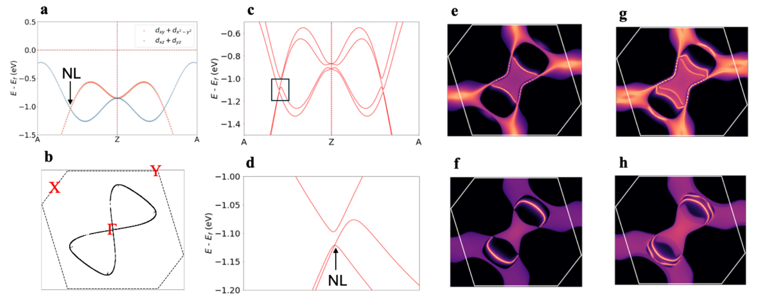
Fig. S4. Topological nodal line (NL) and the related surface Fermi arcs (dream head surface). a, orbital projection along A-Z direction showing nodal line crossings, which is formed by orbitals with opposite mirror eigenvalues without considering SOC. b, the position of nodal line crossings in the k_{z} = π plane. c,d, Nodal line band crossings along Z-Z direction when considering SOC. e,f, Tb-termination and Ni-C termination drum head surface states at binding energy of 1 eV without considering SOC. g,h, Tb-termination and Ni-C termination drum head surface states at binding energy of 1 eV with considering SOC.
Topology analysis: TbNiC₂ belongs to the space group Amm2 (SG #38), which contains a mirror symmetry $M_{z}$ perpendicular to the [001] direction. The Hamiltonian satisfies the relation $M_{z}H(k_{x},k_{y},k_{z})M_{z}^{-1}=H(k_{x},k_{y},-k_{z})$ under the mirror operation. Consequently, in a mirror-invariant plane such as $k_{z}=π$ plane, the Hamiltonian commutes with $M_{z}$, $[H,M_{z}]=0$. All bands within this plane can therefore be labeled by the eigenvalue $m$ of $M_{z}$. In the spinless case (without SOC), the corresponding bands can be labeled by the eigenvalues $m=±1$. A crossing between bands of opposite mirror eigenvalues is symmetry-protected against hybridization, which can result in the formation of nodal rings. Our calculations identify such a crossing near –0.8 eV as shown in (a), consisting of the bands from Ni $d_{xy}$ and $d_{x^{2}-y^{2}}$ orbitals $(m=+1)$, and Ni $d_{xz}$ and $d_{yz}$ orbitals $(m=-1)$. The crossing generates a pair of nodal rings in the $k_{z}=π$ plane, as shown in (b). We further compute the (001) surface spectral function using the Green’s function method (c-f). The calculated surface states connect the projections of the bulk nodal rings, revealing topological nodal-line drum head surface states.

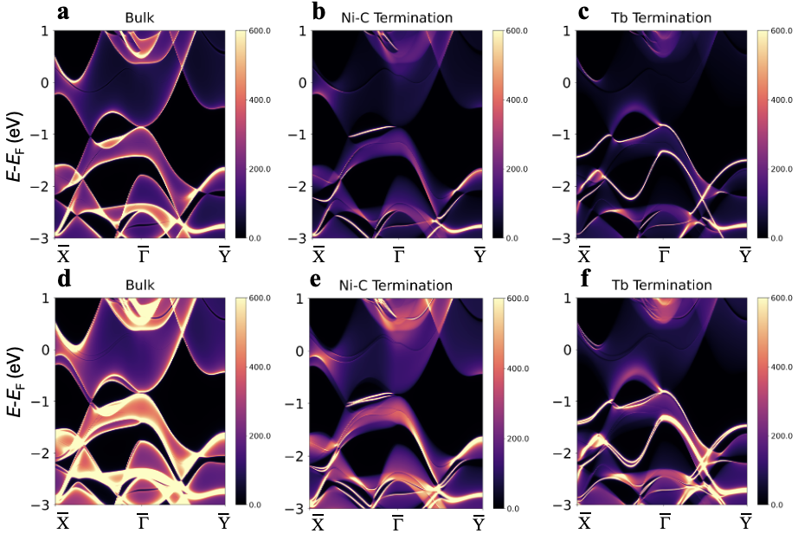
Fig. S5. The calculated projection of the bulk bands and surface states on the Ni-C termination and Tb-termination, without SOC (a-c) and with SOC (d-f), respectively.

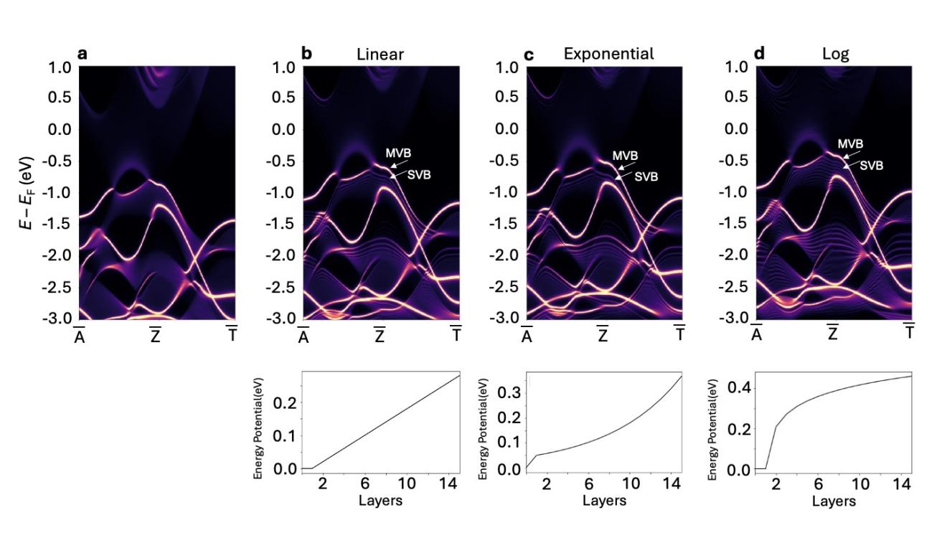
Fig. S6. The surface constrained states from model calculations by applying various surface potentials. The distributions of the surface potential, as a function of layers from surface to bulk, are given in the lower panels, they are Nil (a), Linear (b), Exponential (c), and Logarithmic (d). These surface state bands exhibit a two-dimensional character.

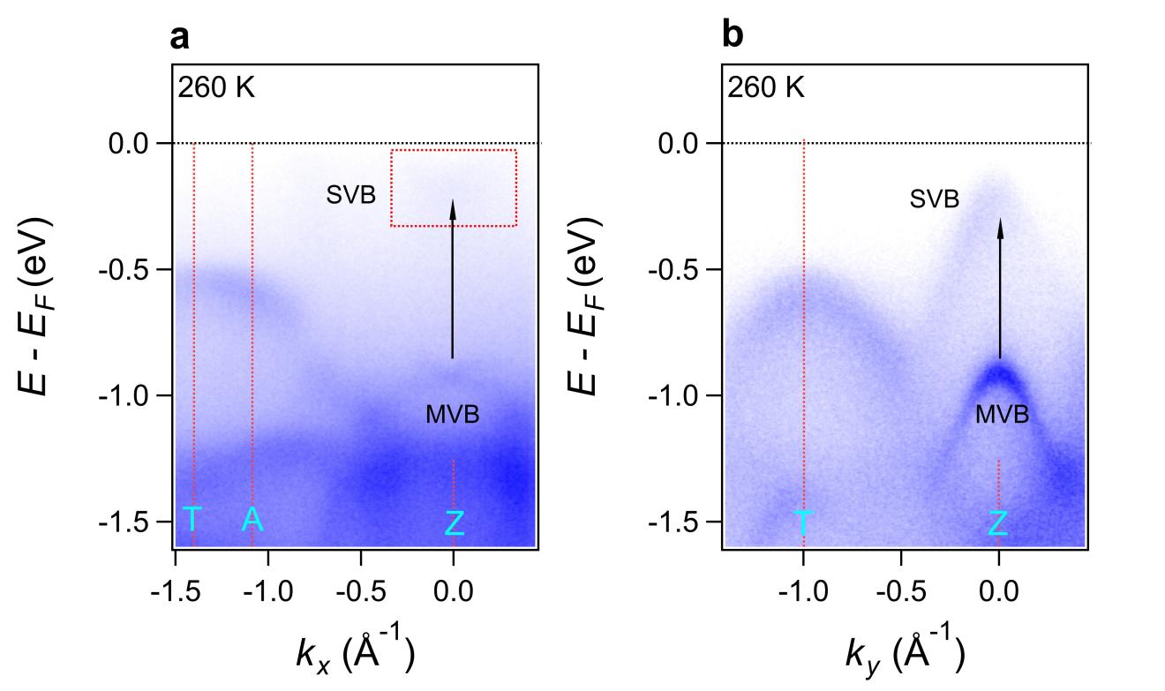
Fig. S7. The ARPES spectra of TbNiC₂ along the T-A-Z (a) and T-Z (b) lines in the BZ, acquired at 260 K. The replica bands persist above the CDW transition temperature.

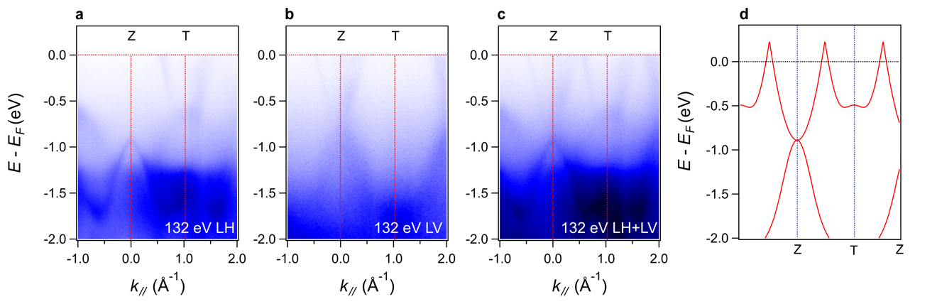
Fig. S8. a,b, The band dispersions measured along the Z-T line by using the photon energy of 132 eV with linear horizontal (LH) (a) and linear vertical (LV) (b) light. c, The superposition of (a) + (b), which agrees well with the electronic structure from the LDA calculations (d). The conduction band is not visible in Fig. 3j due to its low cross section at lower photon energies.

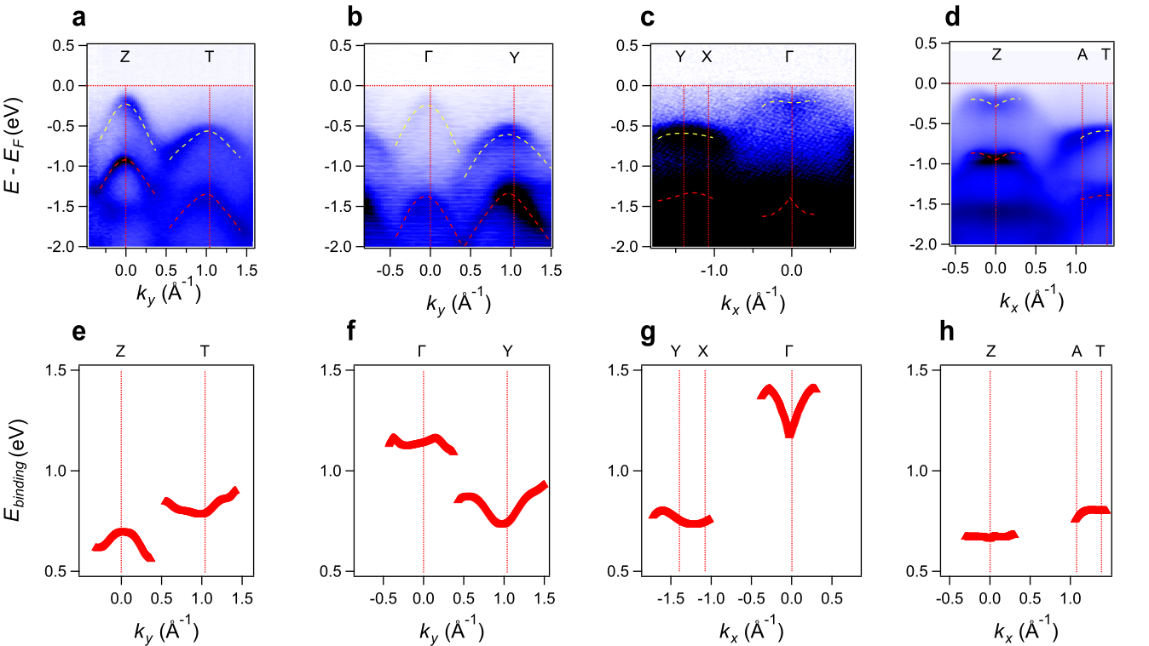
Fig. S9. Extracted energy dispersion of excitons. a-d, APRES Band structure spectra along Z-T, F-Y, Y-X-G, and Z-A-T directions, respectively. The yellow dotted lines indicate the extracted replica bands, and the red dotted lines indicate the extracted main VB. e-h, Extracted energy offset between replica bands and the relevant main VBs.

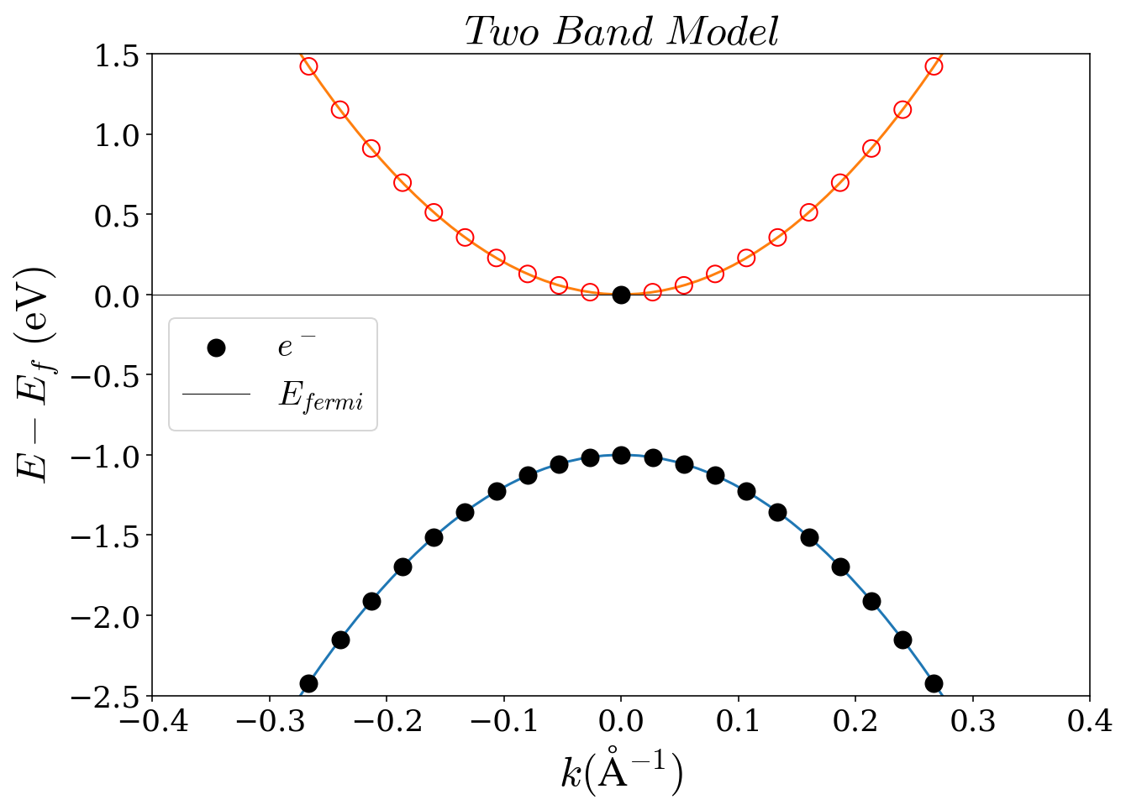
Fig. S10: Idealized model: The Fermi energy lies slightly above the bottom of the conduction band. At $T=0K$, only the electronic state at $k=0$ in this band is occupied.

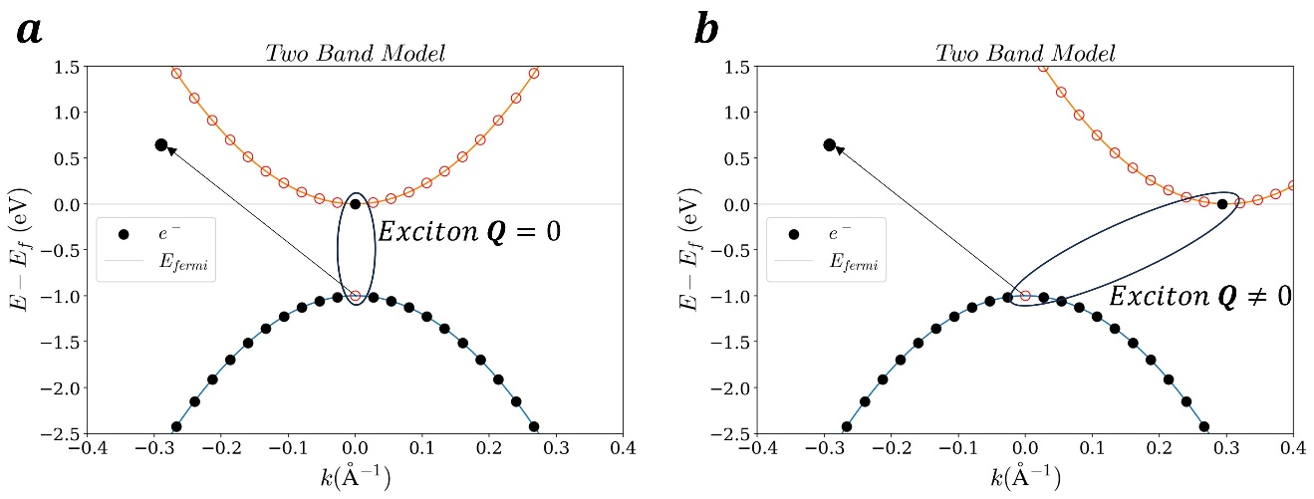
Fig. S11. a, Exciton with zero center-of-mass momentum ($Q=0$) in a direct band gap system; b, Exciton with non-zero center-of-mass momentum ($Q≠0$) in an indirect band gap system. Despite their differing origins, both excitons exhibit identical ARPES results, as shown in Figure S12.

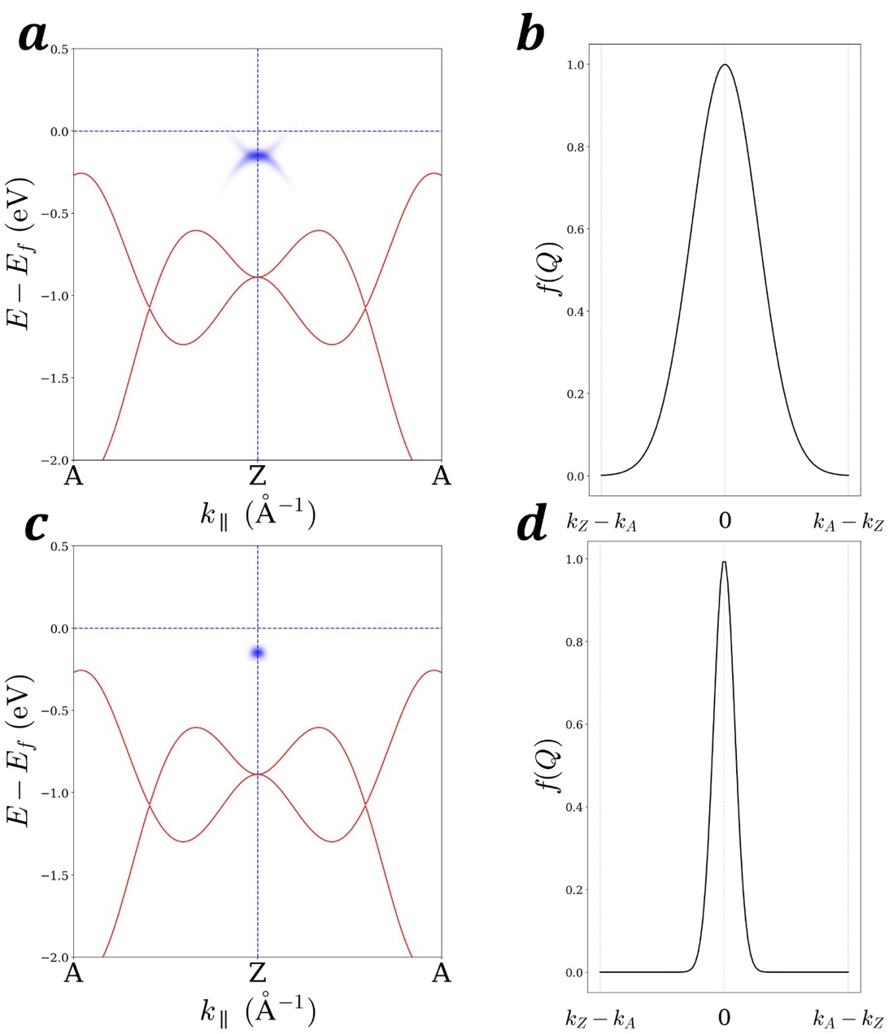
Fig. S12. a, the spectrum function under distribution function of $Q$ in b. c, the spectrum function under distribution function of $Q$ in d. The k-space distribution of the electron spectral function is modulated by the parameter $σ$.

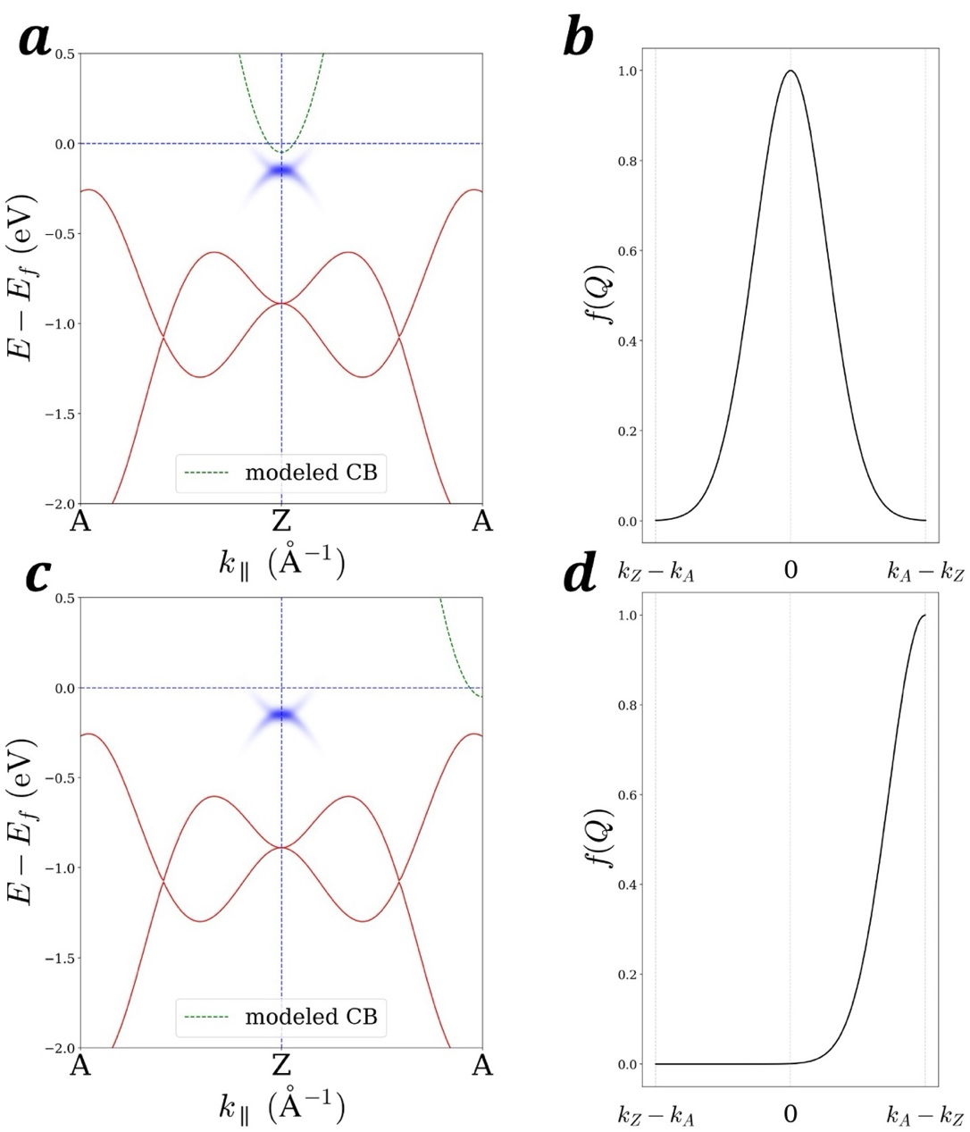
Fig. S13. a, show us the spectrum function under distribution function of $Q$ in b. c, show us the spectrum function under distribution function of $Q$ in d. The mean value of distribution of center-of-mass momentum is the key parameter which modify the position of sideband in k-space.

