Table S1 Item analysis of the scale.
Item | CR | P | Cronbach’s α if item  deleted | Correlation coefficient with the total score | Retained or not
A1 | -17.05 | P＜0.001 | 0.917(↓) | 0.813** | retained
A2 | -7.52 | P＜0.001 | 0.921(↓) | 0.639** | retained
A3 | -7.47 | P＜0.001 | 0.921(↓) | 0.605** | retained
A4 | -11.04 | P＜0.001 | 0.917(↓) | 0.777** | retained
B1 | -6.89 | P＜0.001 | 0.921(↓) | 0.580** | retained
B2 | -6.79 | P＜0.001 | 0.921(↓) | 0.586** | retained
B3 | -7.71 | P＜0.001 | 0.920(↓) | 0.659** | retained
B4 | -13.89 | P＜0.001 | 0.919(↓) | 0.737** | retained
B5 | -4.97 | P＜0.001 | 0.923(↓) | 0.468** | retained
B6 | -4.73 | P＜0.001 | 0.923(↓) | 0.452** | retained
B7 | -7.09 | P＜0.001 | 0.922(↓) | 0.570** | retained
B8 | -2.43 | P＜0.05 | 0.926(↑) | 0.214* | not retained
C1 | -5.97 | P＜0.001 | 0.921(↓) | 0.540** | retained
C2 | -9.29 | P＜0.001 | 0.920(↓) | 0.688** | retained
C3 | -5.74 | P＜0.001 | 0.922(↓) | 0.549** | retained
C4 | -11.36 | P＜0.001 | 0.918(↓) | 0.795** | retained
C5 | -7.09 | P＜0.001 | 0.921(↓) | 0.587** | retained
D1 | -7.52 | P＜0.001 | 0.920(↓) | 0.644** | retained
D2 | -7.66 | P＜0.001 | 0.920(↓) | 0.640** | retained
D3 | -6.57 | P＜0.001 | 0.922(↓) | 0.569** | retained
E1 | -4.71 | P＜0.001 | 0.923(↓) | 0.440** | retained
E2 | -8.30 | P＜0.001 | 0.921(↓) | 0.591** | retained
E3 | -8.58 | P＜0.001 | 0.920(↓) | 0.630** | retained
E4 | -4.73 | P＜0.001 | 0.924(↓) | 0.419** | retained
Note: **represented P <0.001, *represented P <0.05

Item | Factor 1 | Factor 2 | Factor 3 | Factor 4 | Factor 5
A1 | 0.657 | 0.282 | 0.406 | 0.151 | 0.224
A2 | 0.804 | 0.146 | 0.186 | 0.007 | 0.112
A3 | 0.786 | 0.034 | 0.107 | 0.109 | 0.250
A4 | 0.627 | 0.347 | 0.212 | 0.243 | 0.296
B1 | 0.479 | -0.034 | 0.259 | 0.385 | 0.232
B2 | 0.156 | 0.059 | 0.751 | 0.184 | 0.222
B3 | 0.252 | 0.251 | 0.791 | 0.092 | 0.022
B4 | 0.337 | 0.198 | 0.653 | 0.142 | 0.268
B5 | 0.045 | 0.018 | 0.692 | 0.342 | -0.064
B6 | 0.226 | 0.795 | 0.056 | -0.003 | -0.087
B7 | 0.364 | -0.086 | 0.249 | 0.221 | 0.522
B8 | 0.081 | -0.217 | 0.427 | -0.077 | 0.288
C1 | 0.087 | 0.820 | 0.049 | 0.219 | 0.166
C2 | 0.122 | 0.376 | 0.361 | 0.383 | 0.320
C3 | 0.032 | 0.621 | 0.156 | 0.103 | 0.394
C4 | 0.510 | 0.254 | 0.202 | 0.491 | 0.275
C5 | 0.120 | 0.729 | 0.078 | 0.139 | 0.301
D1 | 0.282 | 0.252 | 0.097 | 0.317 | 0.574
D2 | 0.328 | 0.265 | 0.043 | 0.258 | 0.584
D3 | 0.161 | 0.263 | 0.172 | -0.015 | 0.683
E1 | -0.002 | -0.017 | 0.327 | 0.603 | 0.264
E2 | 0.140 | 0.176 | 0.375 | 0.631 | 0.060
E3 | 0.304 | 0.344 | -0.009 | 0.717 | 0.090
E4 | 0.425 | 0.411 | -0.086 | 0.362 | -0.173
Eigenvalues | 8.95 | 2.26 | 1.49 | 1.19 | 1.1
Explained variance (%) | 37.3 | 9.4 | 6.22 | 4.94 | 4.57
Cumulative explained variance (%) | 37.3 | 46.7 | 52.92 | 57.86 | 62.43
Table S2 Factor loadings of first EFA
Note: items with unreasonable factor loadings were removed (B1, B6, B7, B8, C2, C4, E4)

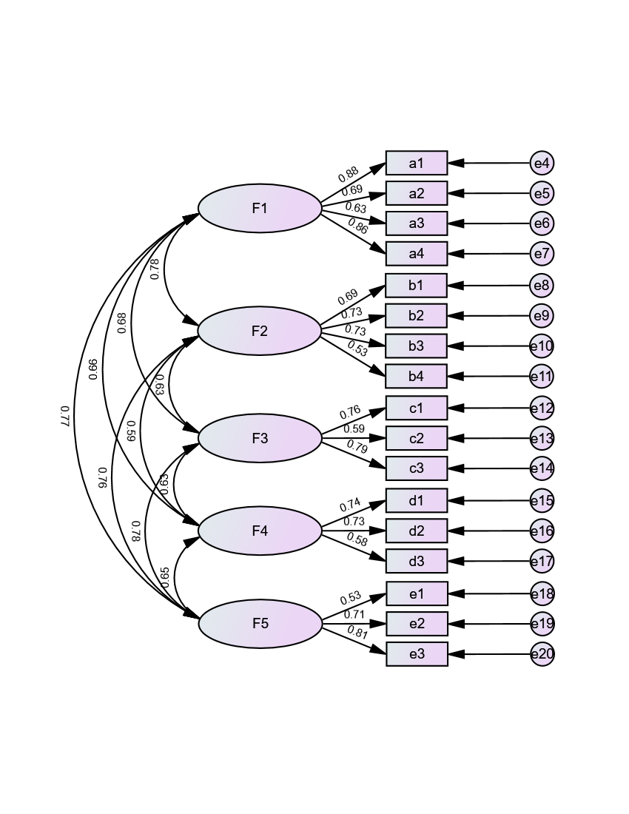
Figure S1 Model Fit of the CFA

Pulmonary Rehabilitation Kinesiophobia Scale for Patients with COPD
Please tick (√) the box that best describes your situation. Be sure to only select one response for each question.
Item | Strongly Disagree | Disagree | Neutral | Agree | Strongly Disagree
Item | 1 | 2 | 3 | 4 | 5
1: I avoid exercise for fear of shortness of breath
2: I worry about coughing while exercising
3: I worry about falling or injuring myself while exercising
4: I worry that my condition will worsen after exercise
5: I usually can’t walk fast during walking exercise
6: I have difficulty with strength training
7: I get out of breath with slight exertion in daily life
8: Shortness of breath during exercise means I need a break
9 Exercise is enjoyable for me
10: Exercise no longer helps with my illness
11: I’m confident that consistent exercise will improve my physical condition
12: I’m worried about exercising without family or friends around
13: I am concerned about exercising without guidance from a healthcare professional
14: I lack appropriate venues for physical exercise
15: I will avoid activities or movements that cause shortness of breath as much as possible
16: Rest is the best I can do for now
17: I should rest properly instead of exercising
Note: Item 9 and Item 11 are reverse scored.
□ Grade 0 I only get breathless with strenuous exercise
□ Grade 1 I get short of breath when hurrying on the level or walking up a slight hill
□ Grade 2 I walk slower than people of the same age on the level because of breathlessness, or I have to stop for breath when walking on my own pace on the level
□ Grade 3 I stop for breath after walking about 100 meters or after a few minutes on the level
□ Grade 4 I am too breathless to leave the house or I am breathless when dressing or undressing
Modified Medical Research Council Dyspnea Scale (mMRC)
please tick in the box that applies to you | one box only | grades 0 - 4

I never cough | □0 □1 □2 □3 □4 □5 | I cough all the time
I have no phlegm (mucus) in my chest at all | □0 □1 □2 □3 □4 □5 | My chest is completely full of phlegm (mucus)
My chest does not feel tight at all | □0 □1 □2 □3 □4 □5 | My chest feels very tight
When I walk up a hill or one flight of stairs I am not breathless | □0 □1 □2 □3 □4 □5 | When I walk up a hill or one flight of stairs I am very breathless
I am not limited doing any activities at home | □0 □1 □2 □3 □4 □5 | I am very limited doing activities at home
I am confident leaving my home despite my lung condition | □0 □1 □2 □3 □4 □5 | I am not at all confident leaving my home because of my lung condition
I sleep soundly | □0 □1 □2 □3 □4 □5 | I don't sleep soundly because of my lung condition
I have lots of energy | □0 □1 □2 □3 □4 □5 | I have no energy at all

COPD Assessment Test
For each item below, place a mark (√) in the box that best describes you currently. Be sure to only select one response for each question.

