TABLE 1
Basis characteristics.
 | All  n=2405 | Spontaneous onset of labor  n=1962 |  |  | Induction of labor  n=443
 | Mean±SD |  | Mean±SD | Mean±SD |  | p-value
Maternal age (years)ª | 30.2±4.5 |  | 30.1±4.5 | 30.6±4.6 |  | 0.087
BMI (kg/m²)ª | 24.2±4.4 |  | 23.9±4.1 | 25.8±5.4 |  | <0.001
Gestational age at birthª | 40+2± 7 |  | 40+1±7 | 40+4±9 |  | <0.001
 | n (%) |  | n (%) | n (%)
Primiparous^{b} | 1116 |  | 871 | 245 |  | <0.001
Smoking (yes) | 376 |  | 304 (15.5) | 72(16.3) |  | 0.749
Method of induction of labor^{c}
Prostaglandin | - |  | NA | 135
Balloon catheter | - |  | NA | 104
Artificial rupture of membrane | - |  | NA | 81
Oxytocin | - |  | NA | 96
Mode of delivery^{c} |  |  |  |  |  | <0.001
Vaginal birth | 1878 (78.1) |  | 1591 (81.1) | 287 (64.8) |  | <0.001
Vacuum extraction | 309 (12.8) |  | 240 (12.2) | 69 (15.6) |  | 0.069
Urgent cesarean section | 193 (8.0) |  | 113 (5.8) | 80 (18.1) |  | <0.001
Emergency cesarean section | 25 (1.0) |  | 18 (0.9) | 7 (1.6) |  | 0.202
Lenght of labor (mean minutes±SD)ª | 493±309 |  | 504±305 | 439±321 |  | <0.001
Experience of labor (positive^{d})^{b} | 953 (39.6) |  | 821 (41.8) | 132 (29.8) |  | <0.001
Newborn characteristics | Mean±SD |  | Mean±SD | Mean±SD
Birthweight (grams)ª | 3637±441 |  | 3619±427 | 3717±488 |  | <0.001
Newborn's uApHª | 7.27±0.1 |  | 7.27±0.1 | 7.25±0.1 |  | <0.001
Newborn's uVpHª | 7.35±0.1 |  | 7.35±0.1 | 7.35±0.1 |  | 0.757
Apgar < 7 (15min)^{b} n | 41 |  | 32 | 9 |  | 0.693
ªp-value from Mann-Whitney U-test.
^{b}p-value from Chi-square test.
^{c}The first used method of induction of labor. Missing data of the method n=27. Elective cesarean sections were excluded from the study.
^{d}The options in the question of experience of labor (‘very positive’/‘quite positive’/’quite negative/’very negative) were dichotomized in analysis as ‘positive’ (’very positive’ and ‘quite positive’ combined) and ‘negative’ (‘quite negative’ and ‘very negative’ combined). Of all experience of labor questions, 666 (27.7 %; 27.8 in SOL group and 27.1 % in IOL group) answers were missing.
One sudden fetus mortus occurred after induction of labor has started, no other serious complications related to induction of labor. Parity information was missing for 201 (8,4%) women.
Abbreviations: BMI, body mass index; uApH, umbilical artery pH; uVpH, umbilical venous pH.

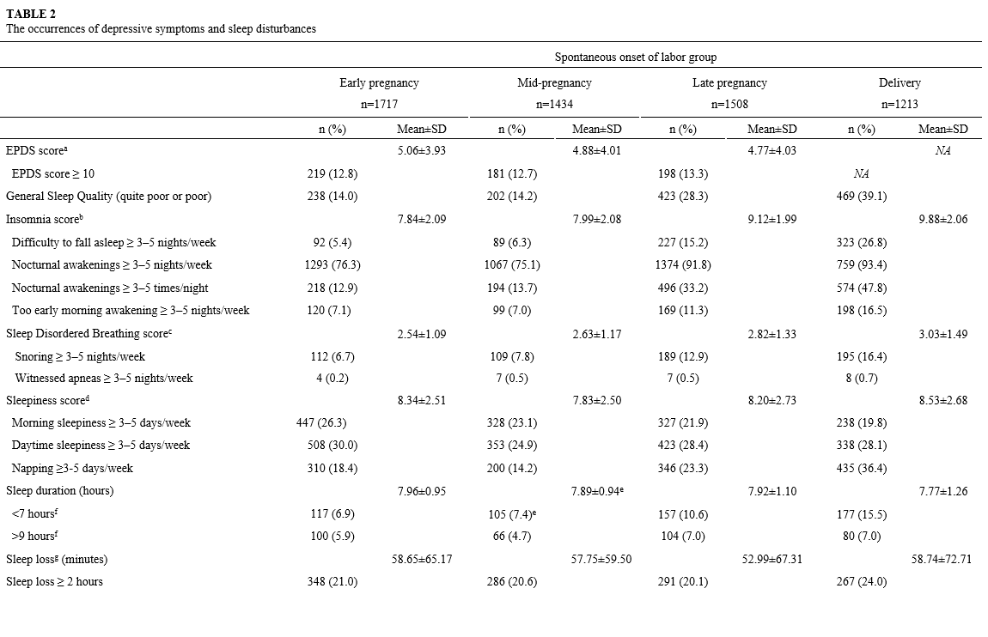
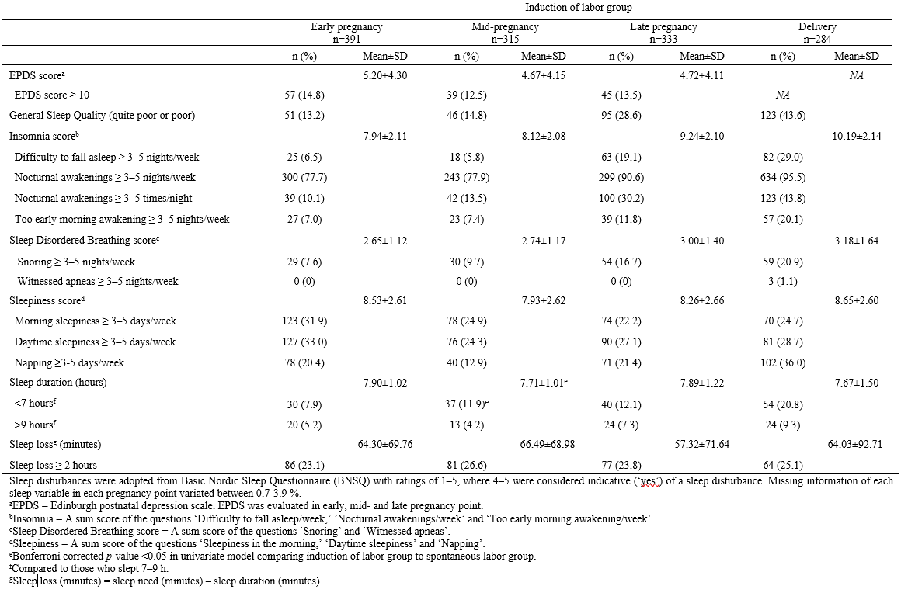
TABLE 3
Associations between negative experience of labor and depressive symptoms and sleep disturbances in early, mid- and late pregnancy point and at delivery.
 | AOR |  | 95% CI | p-value
Higher EPDS scoreª | 1.05^{pp1}  1.04^{pp2}  1.05^{pp3} |  | 1.02-1.08^{pp1}  1.01-1.08^{pp2}  1.02-1.08^{pp3} | 0.004^{pp1}  0.026 ^{pp2}  0.003^{pp3}
EPDS score ≥ 10 | 1.68^{pp3} |  | 1.24-2.27^{pp3} | 0.003^{pp3}
General Sleep Quality (quite poor or poor) | 1.49^{pp4} |  | 1.17-1.89^{pp4} | 0.005^{pp4}
Higher Insomnia score^{b} | 1.08^{pp2}  1.10^{pp4} |  | 1.02-1.15^{pp2}  1.04-1.16^{pp4} | 0.042^{pp2}  0.007^{pp4}
Difficulty to fall asleep ≥ 3–5 nights/week | 1.57^{pp4} |  | 1.21-2.03^{pp4} | 0.003^{pp4}
Nocturnal awakenings ≥ 3–5 nights/week | 1.87^{pp3} |  | 1.20-2.94^{pp3} | 0.025^{pp3}
Nocturnal awakenings ≥ 3–5 times/night | - |  | - | -
Too early morning awakening ≥ 3–5 nights/week | - |  | - | -
Higher Sleep Disordered Breathing score^{c} |  | - | - | -
Snoring ≥ 3–5 nights/week | - |  | - | -
Higher Sleepiness score^{d} | 1.10^{pp2}  1.06^{pp3}  1.06^{pp4} |  | 1.04-1.16^{pp2}  1.02-1.11^{pp3}  1.02-1.11^{pp4} | 0.001^{pp2}  0.028^{pp3}  0.034^{pp4}
Morning sleepiness ≥ 3–5 days/week | 1.48^{pp3}  1.82^{pp4} |  | 1.10-1.98^{pp3}  1.36-2.45^{pp4} | 0.034^{pp3}  <0.001^{pp4}
Daytime sleepiness ≥ 3–5 days/week | 1.47^{pp2} |  | 1.11-1.96^{pp2} | 0.031^{pp2}
Napping ≥ 3–5 days/week | - |  | - | -
Sleep duration (hours) | - |  | - | -
< 7 hours^{e} | - |  | - | -
Higher sleep loss^{f} | - |  | - | -
Sleep loss ≥ 2 hours | - |  | - | -
In the table, p-values are Bonferroni corrected, and only statistically significant findings (P<0.05) are reported.
Sleep disturbances were adopted from Basic Nordic Sleep Questionnaire (BNSQ) with ratings of 1–5, where 4–5 were considered indicative (‘yes’) of a sleep disturbance. No associations found in early pregnancy point.
Positive experience of labor was used as a reference level.
ªEPDS = Edinburgh postnatal depression scale. EPDS was evaluated in early, mid- and late pregnancy point.
^{b}Insomnia = A sum score of the questions ‘Difficulty to fall asleep/week,’ ’Nocturnal awakenings/week’ and ‘Too early morning awakening/week’.
^{c}Sleep Disordered Breathing score = A sum score of the questions ‘Snoring’ and ‘Witnessed apneas’.
^{d}Sleepiness score = A sum score of the questions ‘Sleepiness in the morning,’ ‘Daytime sleepiness’ and ‘Napping’.
^{e}Compared to those who slept 7–9 h.
^{f}Sleep loss (minutes) = sleep need (minutes) – sleep duration (minutes).
AOR= Adjusted for age, BMI, parity, smoking, and the Edinburgh postnatal depression scale (EPDS) in early pregnancy (binary logistic regression analysis), except EPDS scores were not adjusted with EPDS in early pregnancy.
Abbreviations: pp1, early pregnancy point; pp2, mid-pregnancy point; pp3, late pregnancy point; pp4, delivery point.

