Appendix 1: Reliability of NECO Technical drawing from 2017- 2021
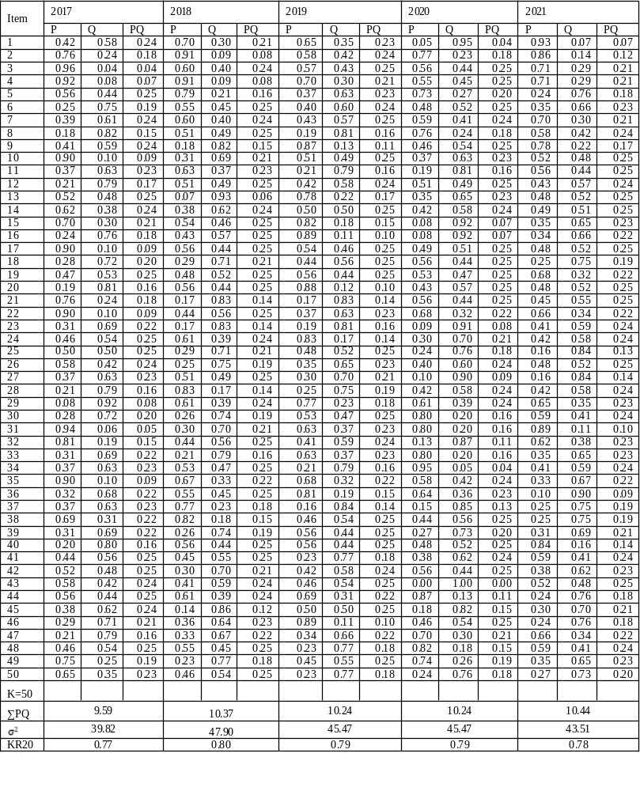P= proportion of respondents that got items correctly, Q= proportion of respondents that failed the items, K= number test items, $σ^{2}=varaince,$KR20 = reliability of test.

Appendix 2: Difficulty Indices of NECO Technical drawing MCQs from 2017-2021
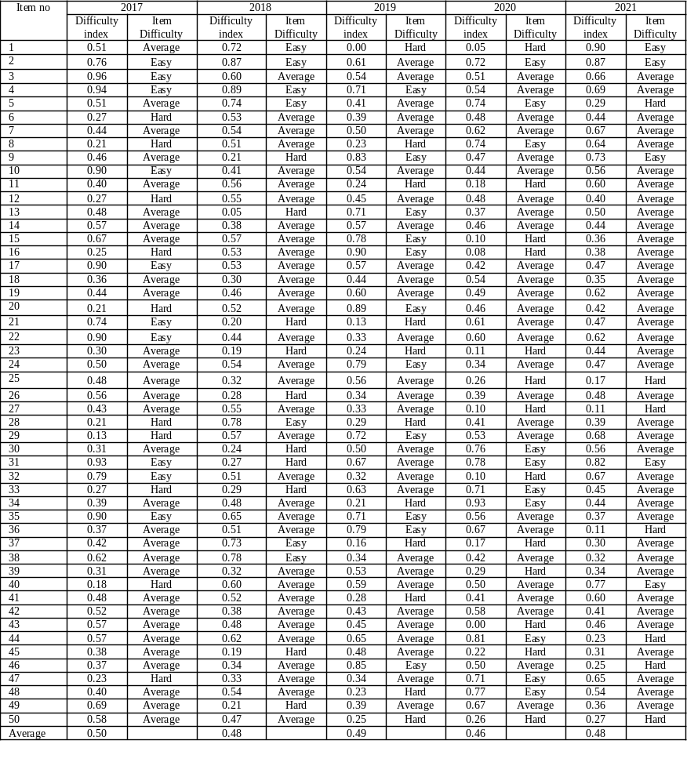2017: Easy items =10, Average items=30, Difficult items= 10, 2018: Easy items =7, Average items=33, Hard items= 10, 2019: Easy items =11, Average items=28, Hard items= 11, 2020: Easy items =10, Average items=27, Hard items= 13, 2021: Easy items =5, Average items=38, Hard items= 7. Total number of easy items=43(17.2%), total number of average items = 156(62.4%) and total number of hard items =51(20.4%)
Appendix 3: Discrimination Indices of NECO Technical drawing MCQs from 2017-2021

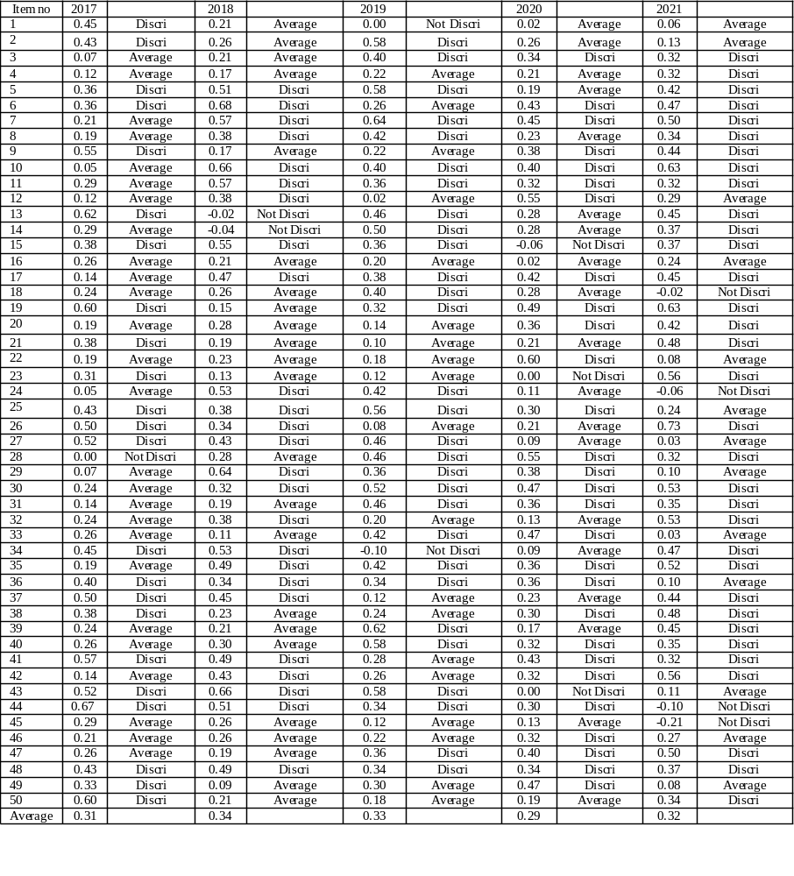2017: Discriminating item =23, Average items=26, Not Discriminating items=1. 2018: Discriminating item =25, Average items=23, Not Discriminating items=2. 2019: Discriminating item =29, Average items= 19, Not Discriminating items=2. 2020: Discriminating item =28, Average items=19, Not Discriminating items=3 2021: Discriminating item =33, Average items=13, Not Discriminating items=4. Total number of discriminating items =138(55.2%), total number of average items =100(40%) and total number of Not discriminating items=12(4.8%)

