Supporting Information
for
Intrinsic Flame Retardancy in Flexible Polyurethane Foams Enabled by a Bio-Based P–N Reactive Polyol and a Silicon-Functionalized Triazine Charring Agent
Lugui Lan^{a,b,c}, Yanping Mo^{a,b,c}, Yuhui Xie^{a,b,c*}, Feng Wu^{a,b,c}, Dong Feng^{a,b,c}, Yang Meng^{a,b,c}, Yi Mei^{a,b,c}, Delong Xie^{a,b,c*}
ªFaculty of Chemical Engineering, Kunming University of Science and Technology, Kunming 650500, China
^{b}Yunnan Provincial Key Laboratory of Energy Saving in Phosphorus Chemical Engineering and New Phosphorus Materials, Kunming 650500, China
^{c}The International Joint Laboratory for Sustainable Polymers of Yunnan Province, Kunming 650500, China
*Corresponding authors.
E-mail addresses: yuhuixie@kust.edu.cn (Y. Xie), cedlxie@kust.edu.cn (D. Xie)

S1. Synthesis of PMESO
S1.1. Synthesis of the phosphorus-containing polyester polyol (PM)
PA (94.29 g, 0.10 mol) was charged into a 500 mL three-neck round-bottom flask and preheated in an oil bath at 60 °C for 0.5 h under nitrogen (N₂, 40 mL/min). MEA (21.3 g, 0.35 mol) was then added dropwise into the flask within 20 min using a peristaltic pump under reflux. The mixture was allowed to react at 60 °C for 3 h. After pre-polymerization, the temperature was increased to 120 °C while the N₂ flow rate was raised to 60 mL/min, and the reaction was continued for 4 h to increase the degree of polymerization and reduce the hydroxyl value. A dark-brown viscous product (PM) was obtained. The hydroxyl value of PM was 134 mg KOH/g; Mn = 861, Mw = 963, and Mw/Mn = 1.12.
S1.2. Synthesis of P–N functional epoxidized soybean oil-based polyether polyol (PMESO)
ESO (150 g) and triphenylphosphine (0.775 g) were placed into a 500 mL three-neck flask and preheated under magnetic stirring in an oil bath at 120 °C for 10 min. In parallel, PM (22.5 g, corresponding to 15 wt% of ESO) was dissolved in DMSO (70 mL) in a 250 mL single-neck flask by vigorous shaking until a homogeneous solution was obtained.
After ESO preheating, nitrogen was introduced (40 mL/min), and the PM/DMSO solution was added to the ESO mixture via a peristaltic pump within 40 min. The reaction proceeded at 120 °C for 1 h. Subsequently, the temperature was increased to 170 °C and maintained under reflux for 2 h, during which the N₂ flow rate was increased to 100 mL/min to ensure sufficient DMSO reflux and completion of the reaction, aiming to increase polymerization degree and decrease the hydroxyl value of PMESO. The resulting dark-brown intermediate was then subjected to rotary evaporation at 145 °C under −0.1 MPa for 0.5 h until no DMSO distillate was observed. A dark-brown viscous PMESO product was obtained. The hydroxyl value of PMESO was 246 mg KOH/g; Mn = 73,208, Mw = 165,381, and Mw/Mn = 2.26.
S2. Synthesis of silicon-modified triazine charring agent (KHT)
Acetonitrile (50 mL) was added into a three-neck flask and stirred in an ice bath at 0 °C for 20 min. KH554 was dissolved in acetonitrile under stirring, while nitrogen was introduced at 100 mL/min to prevent hydrolysis of KH554 by exposure to air. In a separate vessel, TCT (0.10 mol, 18.4 g) was dissolved in acetonitrile (200 mL), and the solution was ultrasonicated for 5 min to ensure complete dissolution. The TCT solution was then added dropwise into the KH554 solution within 30 min using a peristaltic pump. The reaction was maintained at 0 °C for 6 h. After reaction, most of the solvent was removed by rotary evaporation, followed by washing the solid several times with ethanol and water. The product was dried in a vacuum oven at 50 °C for 12 h, yielding a white powder designated as KHT.
S3. Preparation of FPUFs (foaming procedure)
S3.1. Preparation of FPUF/PMESO
Pristine FPUF and PMESO-modified foams were prepared using a one-pot free-rise process. The formulations of the FPUFs expressed as four components are summarized in Table S1. The preparation consisted of three key steps:
(i) The “white component” mixture was prepared and mixed at 4500 r/min. Due to the high viscosity of PMESO, the mixing time was adjusted to ~3.5 min.
(ii) The mold was lined with aluminum foil while the “black component” was weighed according to the formulation. The black component was poured rapidly into the white component under stirring at 4500 r/min, and the mixture was further stirred for ~2.4 min.
(iii) The reactive mixture was poured into the foil-lined mold and immediately placed in a forced-air oven at 45 °C for free-rise foaming for ~5 min. When the foam growth rate suddenly accelerated, the mold was removed from the oven and cured at room temperature for 48 h; otherwise, excessive foaming speed could lead to collapse.
S3.2. Preparation of FPUF/40P@K series
Pristine FPUF and KHT-containing foams were prepared similarly, following the formulation shown in Table S1. The white component was first mixed at high speed for 2 min and then left aside; KHT was added as the last component into the white component system. The mold was lined with aluminum foil, and the black component was weighed. The mixed system was stirred at high speed for 2.4 min and then placed in a 45 °C forced-air oven for 5 min free-rise foaming, followed by room-temperature curing for 48 h before demolding and cutting.
Table S1. Formulations of FPUFs expressed as four components.
Sample ID | White component¹  (g) | Black component²  (g) | PMESO  (g) | KHT  (g)
Pristine FPUF | 120.95 | 72.00 | 0 | 0
FPUF/10P | 120.95 | 74.00 | 10 | 0
FPUF/20P | 110.95 | 76.00 | 20 | 0
FPUF/30P | 100.95 | 78.00 | 30 | 0
FPUF/40P | 90.95 | 80.00 | 40 | 0
FPUF/40P@0.5K | 90.95 | 80.00 | 40 | 1.06
FPUF/40P@1.5K | 90.95 | 80.00 | 40 | 3.18
FPUF/40P@3.0K | 90.95 | 80.00 | 40 | 6.36
Notes (Table footnotes):
- White component refers to the polyol-side mixture used in the one-shot foaming process, including industrial polyether polyols, water, catalysts, crosslinker, silicone stabilizer, cell opener, physical blowing agent.
- Black component refers to the isocyanate-side component used in the foaming process.
- PMESO and KHT are listed separately to highlight their individual contributions to the flame-retardant system.
- Sample codes follow the nomenclature used throughout the main text: “P” denotes the PMESO content, and “K” denotes the KHT content.

Figure S1. (a) FTIR spectra of phytic acid (PA), monoethanolamine (MEA), and the intermediate polyester polyol (PM); (b) XRD patterns of trichlorotriazine (TCT) and the silicon-modified triazine charring agent (KHT); High-resolution C 1s XPS spectra of (c) TCT and (d) KHT.
Figure S1a presents additional FTIR spectra of phytic acid (PA), monoethanolamine (MEA), and the intermediate polyester polyol (PM), providing supplementary evidence for the successful esterification reaction between PA and MEA. Compared with PA and MEA, PM exhibits characteristic ester-related absorption bands, confirming the formation of polyester structures prior to the ring-opening reaction of epoxidized soybean oil.
Figure S1b shows the XRD patterns of trichlorotriazine (TCT) and the silicon-modified triazine charring agent (KHT). The disappearance of the characteristic diffraction peaks of crystalline TCT and the emergence of a broad amorphous halo in KHT indicate the disruption of the original crystalline structure after silicon modification, suggesting successful chemical functionalization. High-resolution C 1s XPS spectra of TCT and KHT are presented in Figure S1 (c-d). Compared with TCT, KHT exhibits additional carbon environments associated with C–O and C–Si bonds, further confirming the incorporation of silicon-containing moieties into the triazine framework. These results provide complementary structural evidence for the successful synthesis of the reactive flame-retardant components.
Figure S2. Photographs of FPUFs with different PMESO contents, showing the influence of excessive PMESO loading on the foaming process and macroscopic foam integrity.
Macroscopic photographs of FPUFs with different PMESO contents are shown in Figure S2, clearly illustrating that PMESO contents exceeding 40 php adversely affect the foaming process and lead to irregular foam structures. Based on these results, FPUF/40P was selected as the optimal base formulation for subsequent incorporation of silicon-containing charring agents.

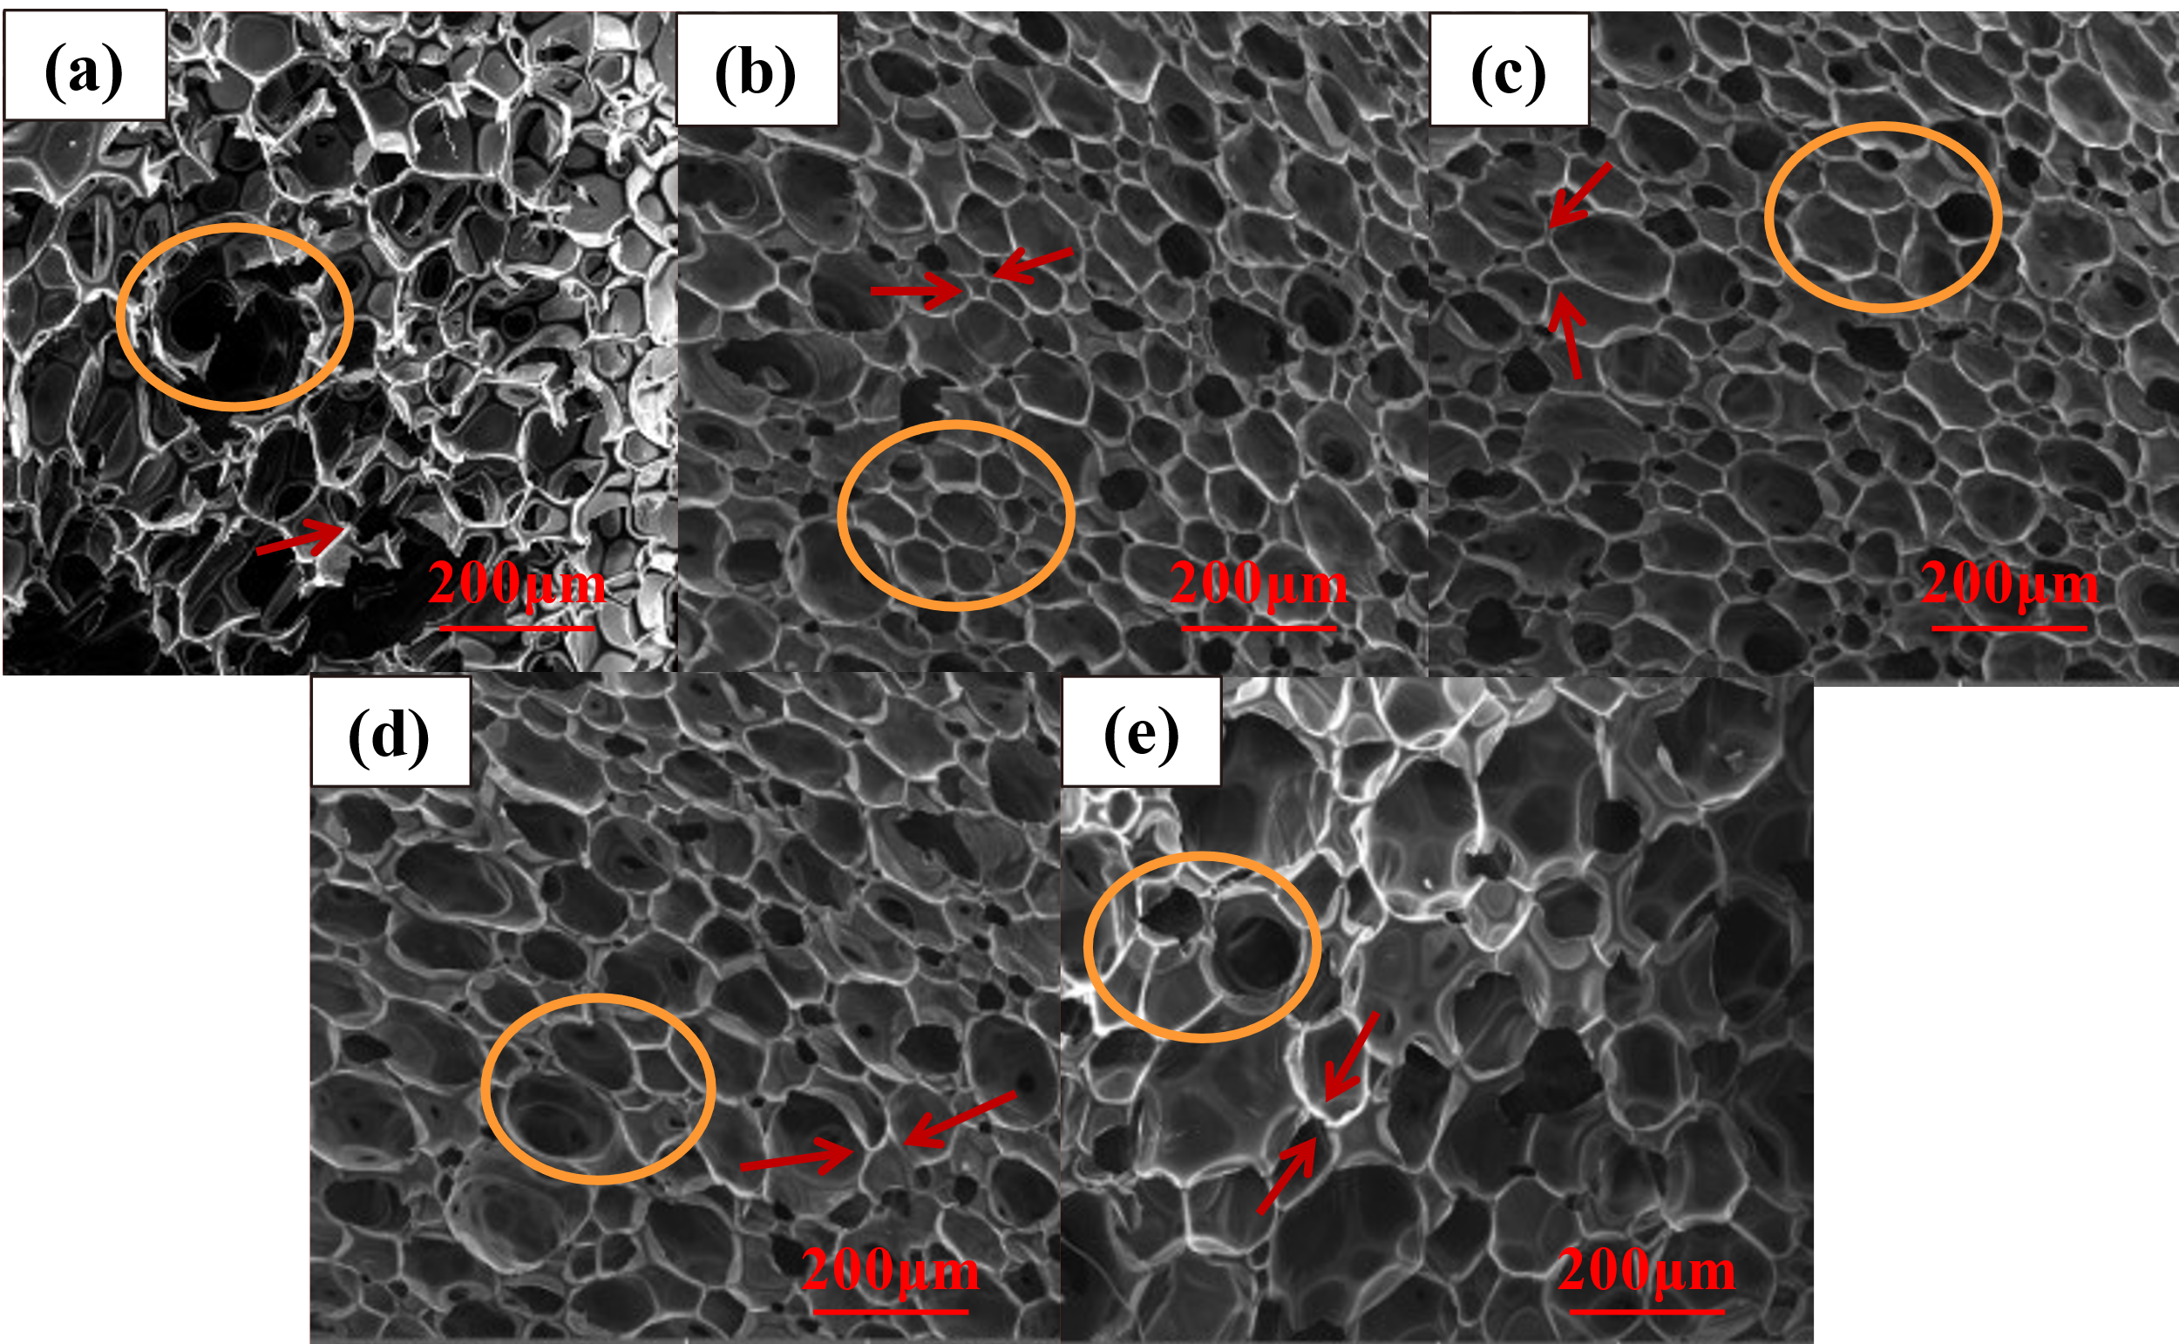
Figure S3. SEM images of cellular morphology of (a) Pristine FPUF, (b) FPUF/10P, (c) FPUF/20P, (d) FPUF/30P, and (e) FPUF/40P.
Figure S3 displays SEM images of the cellular morphology of pristine FPUF and FPUFs containing different PMESO contents (FPUF/10P, FPUF/20P, FPUF/30P, and FPUF/40P). With increasing PMESO content, the cellular structure gradually becomes more uniform, indicating improved foam stabilization during the foaming process. However, excessive PMESO content leads to increased viscosity and deteriorated foaming behavior.

Figure S4. Mechanical properties of pristine FPUF and FPUF/P composites with different PMESO contents: (a) tensile stress–strain curves and (b) cyclic compression–unloading behavior.
The corresponding mechanical properties are shown in Figure S4, including tensile stress–strain curves and cyclic compression–unloading behavior. Foams containing PMESO up to 40 php maintain acceptable mechanical performance comparable to pristine FPUF, whereas further increases in PMESO content result in reduced elasticity and structural instability.

Figure S5. FTIR spectra of residual char after CC test of Pristine FPUF, FPUF/40P and FPUF/40P@3.0K.
Figure S5 presents FTIR spectra of residual char obtained after cone calorimetry tests for pristine FPUF, FPUF/40P, and FPUF/40P@3.0K. Compared with pristine FPUF, the char residues of PMESO- and KHT-modified foams exhibit stronger absorption bands associated with phosphorus- and silicon-containing structures, confirming their participation in condensed-phase char formation.

Table S2. Results of Py-GC/MS analysis of various pyrolysis products of pristine FPUF.
Peak | Retention time (min) | Molecular weight | Structural formula
1 | 1.584 | 44 | 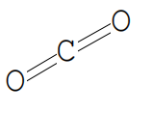
2 | 1.652 | 42 | 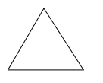
3 | 1.882 | 58 | 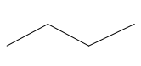
4 | 2.103 | 60 | 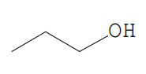
5 | 3.169 | 100 | 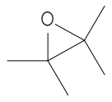
6 | 5.349 | 146 | 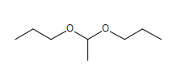
7 | 5.801 | 116 | 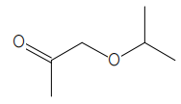
8 | 7.437 | 104 | 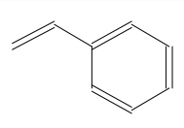
9 | 9.556 | 118 | 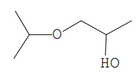
10 | 21.108 | 198 | 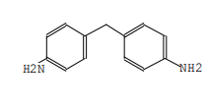
11 | 22.148 | 335 | 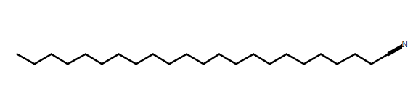

Table S3. Results of Py-GC/MS analysis of various pyrolysis products of FPUF/40P.
Peak | Retention time (min) | Molecular weight |  | Structural formula
1 | 1.600 | 44
2 | 1.860 | 58 | 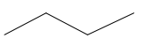
3 | 2.083 | 58 | 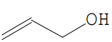
4 | 7.277 | 124 | 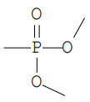
5 | 19.933 | 256 | 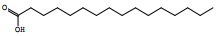
6 | 20.917 | 282 | 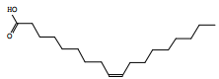
7 | 21.973 | 310 | 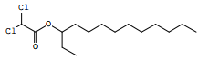
8 | 24.603 | 410 | 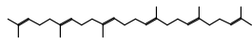
9 | 25.470 | 592

Table S4. Results of Py-GC/MS analysis of various pyrolysis products of FPUF/40P@3.0KHT.
Peak | Retention time (min) | Molecular weight | Structural formula
1 | 1.313 | 44
2 | 1.380 | 42 | 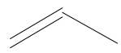
3 | 1.430 | 44 | 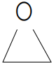
4 | 1.577 | 58 | 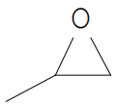
5 | 9.447 | 127 | 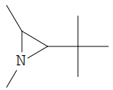
6 | 20.167 | 198 | 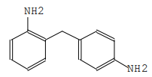
7 | 20.500 | 198 | 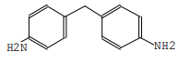
8 | 20.880 | 306
9 | 20.980 | 238 | 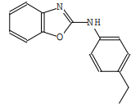
10 | 22.067 | 144
11 | 23.373 | 174 | 