Improving Radar Rainfall Estimate with Kalman Filter Based Bias Adjustment Methods
Feiyang Lv¹
Alan Seed²
Yong Wang^{1,3,4*}
Correspondence: yong.wang@nuist.edu.cn
Author details
1 School of Atmospheric Sciences, Nanjing University of Information Science and Technology, 219 Ningliu Road, Pukou District, Nanjing, Jiangsu, 210044, China
2 Visiting Professor at NUIST, and Weather Radar New Zealand Limited, 101 Pakenham Street West, Auckland Central, Auckland, 1010, New Zealand.
3 Earth System Modeling and Prediction Centre, China Meteorological Administration, Beijing, 100081, China.
4 State Key Laboratory of Severe Weather Meteorological Science and Technology, Beijing, 100080, China.

Abstract
This study evaluates three real-time Kalman filter (KF) approaches—Mean Field (MKF), Site-Specific (SKF), and a novel Lagrangian (LKF)—to correct radar rainfall estimation biases. While the SKF addresses spatial heterogeneity by applying independent filters per gauge, the LKF uniquely utilizes optical flow to advect the bias correction field alongside moving storms. This prevents the erroneous spatial propagation of large correction factors into trailing light rain areas. Evaluated using a dense gauge network in northern China, the LKF demonstrates superior performance, reducing the raw radar’s systemic bias from -35.0% to -3.5% while minimizing overall errors. However, these performance improvements diminish rapidly beyond a 10 km distance from the training gauges. Furthermore, an analysis of optimized filter parameters reveals a fundamental physical constraint: the KF breaks down when radar measurement variance (S) exceeds the intrinsic process variance (Q). Because these errors are independent, the filter remains effective only when the observed residual variance is less than 2Q. This demonstrates that dynamic algorithmic corrections cannot compensate for fundamentally degraded radar observations.

Keywords
Radar rainfall estimation, Kalman filter, Bias correction, Optical flow

Statements and Declarations
Competing interests
The authors declare that they have no competing interests.

Data and Method

Data
The radar and rain gauge data used in this study were all from the China Meteorological Administration (CMA), and the analysis period was from June 1 to August 31, 2022. The base radar data underwent rigorous operational quality control procedures by the CMA before analysis. Since CINRAD/SA is a single-polarization system, the operational QC algorithm relies on Doppler radial velocity, spectral width, and fuzzy logic classification to identify and suppress non-meteorological echoes, such as ground clutter, anomalous propagation, and biological targets.
Furthermore, to ensure the reliability of quantitative precipitation estimation, a strict reflectance threshold of 15 to 53 dBZ was used. The lower limit effectively filtered out residual clear-sky echoes and drizzle that typically evaporates before reaching the ground. The upper limit played a crucial role in suppressing hail contamination; reflectance exceeding this threshold is primarily associated with hail, which severely violates the physical assumptions of the standard liquid water Z-R relationship (Fulton et al., 1998).
To minimize uncertainties associated with the vertical reflectivity profile (VPR) and beam overshoot, the spatial scope of this study was limited to a maximum radius of 150 km around the Beijing SA radar station. At a distance of 150 km, the center of the 0.5° elevation beam is located approximately 2.5 km above the ground. Given that the wet-bulb zero-degree altitude in northern China during the summer monsoon typically exceeds 4.5 km above the ground (HUANG Xiaoyan, WANG Xiaoping, WANG Jinsong, et al, 2017), radar measurements at this distance primarily detect liquid precipitation. Therefore, the chosen 150 km radius effectively avoids bright bands and solid condensate regions, allowing the assumption that the VPR effect is negligible in this study to hold. The reflectivity of the lowest elevation scan was interpolated to a Cartesian grid with a spatial resolution of 1 km × 1 km using standard geographic projection techniques. To match the 1-minute resolution of the rain gauge observations, the temporal resolution of the radar reflectivity field was interpolated to 1 minute using the optical flow-based advection interpolation technique in the pysteps library (Pulkkinen et al. 2019).
The training set was specifically used to optimize the climatological Z-R relationship coefficients and to estimate station-specific Kalman filter parameters. The validation set was reserved for independent spatial evaluation. Real-time correction factors calculated at the training stations were interpolated to the locations of the validation stations using inverse distance weighting. Performance metrics were calculated only at these validation stations to demonstrate the true out-of-sample predictive power of the proposed method.

Parameter estimation
The performance of the proposed Kalman filter framework hinges on the precise determination of three core parameters: the autoregressive coefficient ($ϕ$), the process noise variance ($Q$), and the measurement error variance ($S$). These parameters are not pre-set but are independently optimized for each rain gauge using historical observation datasets to ensure spatial representativeness and temporal stability. According to optimal filtering theory, if a Kalman filter can optimally extract the true signal from noisy observations, the resulting innovative sequence (the residual between the observed and predicted states) should exhibit white noise. Therefore, we employ the Nelder-Mead simplex algorithm to minimize the first-order autocorrelation of each rain gauge residual sequence. A common challenge in such parameter calibration is the equivalence problem, where multiple combinations of strongly coupled parameters especially $S$ and $Q$ can produce similar filtering performance, potentially leading to mathematically valid but physically impractical or ill-conditioned solutions. To mitigate this identifiability problem and ensure parameter robustness, strict physical constraints are imposed on the parameter space during optimization. For example, the measurement error variance $S$ is bounded within 0.01 < $S$ < 0.30. These boundaries guarantee that the estimated parameters retain their physical meaning: S represents the inherent uncertainty and signal-to-noise ratio of local radar observations, while $Q$ and $ϕ$ characterize the temporal memory and inherent natural variability of potential precipitation microphysical processes.

References
Huang XY, Wang XP, Wang JS, et al (2017) Spatio-temporal changes of 0℃ isotherm height in China during summer half year of 1970-2012. Meteorol Mon 43:286–293. doi:10.7519/j.issn.1000-0526.2017.03.004.
Pulkkinen S, Nerini D, Perez Hortal A, Foresti L, Seed A, Berenguer A (2019) Pysteps: An open-source Python library for probabilistic precipitation nowcasting (v1.0). Geosci Model Dev 12:4185–4219. doi:10.5194/gmd-12-4185-2019.
Fulton RA, Breidenbach JP, Seo D-J, Miller DA, O'Bannon T (1998) The WSR-88D rainfall algorithm. Wea Forecasting 13:377–395.

Figure Legends
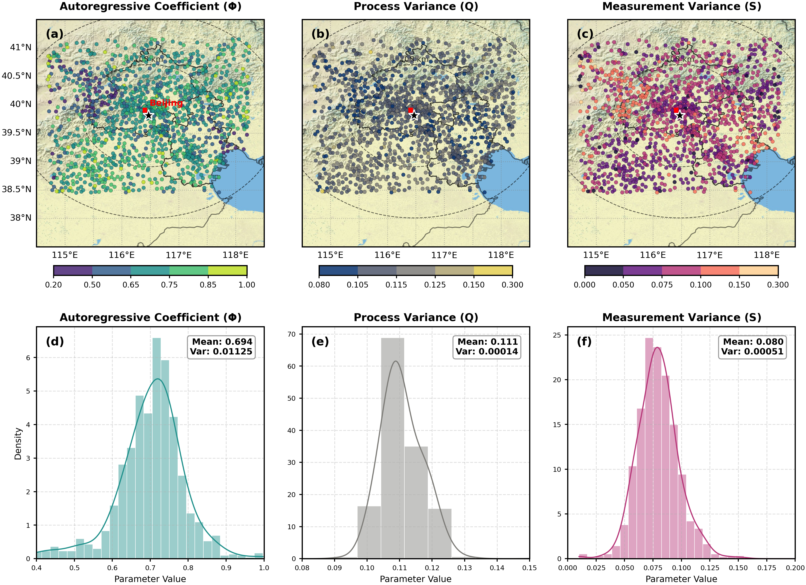
Fig. S1 Spatial distributions (a,b,c) and the corresponding probability density functions (d,e,f) of the optimized Kalman filter parameters: (a, d) the autoregressive coefficient ($ϕ$), (b, e) the process variance (Q), and (c, f) the measurement variance (S). The parameter values are mapped using physically-based discrete color bins to highlight regional variabilities over the complex terrain.

Tables
Table S1: Number of validation gauges and data observations categorized by distance to the nearest training gauge.
Distance (km) | Num Gauges | Num Observations
0-2 | 53 | 21751
2-4 | 127 | 53358
4-6 | 160 | 62355
6-8 | 73 | 27458
8-10 | 26 | 8401
10-12 | 7 | 1840
12-14 | 3 | 845

Table S2: Number of validation gauges and data observations categorized by unadjusted radar rainfall intensity.
Rain Intensity (mm/h) | Num Observations
0-5 | 20483
5-10 | 11893
10-15 | 3925
15-20 | 2240
20-25 | 1303
25-30 | 823
>30 | 2627

