This supplementary appendix (‘Additional File 2’) contains supplementary figures accompanying the following manuscript:

Title: Epigenome-Wide Association Study in Asian Cohort Identifies Novel DNA Methylation Markers for Carotid Intima-Media Thickness

Journal: Clinical Epigenetics
Authors: Konstanze Tan, Sarah E Harris, Jane Maddock, Darwin Tay, Pritesh R Jain, The HELIOS Study Team, Shi Qi Mok, Maxime Herbrard, Ulf Schminke, Can Can Xue, Liuh Ling Goh, Theresia Mina, Alexander Teumer, Weng Khong Lim, Khai Pang Leong, Khung Keong Yeo, Ching-Yu Cheng, Xueling Sim, Lee Eng Sing, Joanna M Wardlaw, Henry Völzke, Andrew Wong, Simon R Cox, Rinkoo Dalan, Abbas Dehghan, Marie Loh
Corresponding Author: Marie Loh
Affiliation: Lee Kong Chian School of Medicine, Nanyang Technological University Singapore, Singapore
Email: marie_loh@ntu.edu.sg

Supplementary Figure 1 Quantile–quantile (QQ) plots of test statistics for EWAS of cIMT_{mean}. Test statistics are signed Z-statistics (from two-sided p-values, sign taken from β). Points show empirical Z quantiles against theoretical N(0,1) quantiles; the dashed line is the null expectation. BACON inflation (σ) is reported per panel; values around 0.95-1.10 indicate adequate calibration for EWAS. (A) Strata/Cohort-specific (pre-meta-analysis). (B) Ancestry-specific (post within-ancestry meta-analysis).

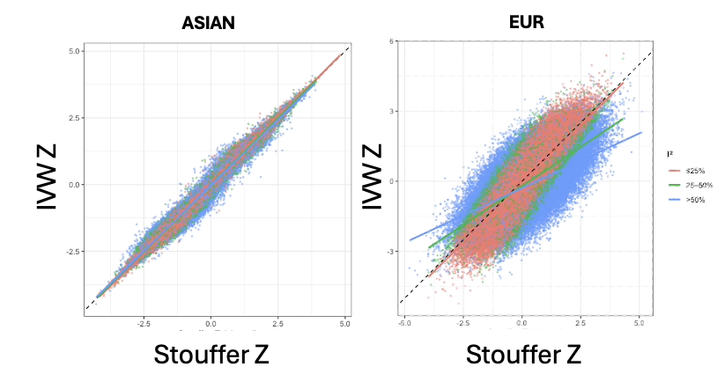

Supplementary Figure 2. Concordance of fixed-effects meta-analytic Z statistics across methods. Each point is a CpG marker analysed across all cohorts of the ancestry-specific meta-analysis (Asians: N=833,743; Europeans: N=419,262; one European cohort used the 450K array). Points are colored by effect-size heterogeneity across cohorts, quantified by I² (≤25%, 25–50%, >50%), with smooth lines showing trends within I² (heterogeneity) strata.

Supplementary Figure 3 Ethnic-stratified MRS analysis. (a) Distribution of MRS across ethnicities. P-values from one-way ANOVA testing differences in mean MRS values across the three ethnic groups. (b) Distribution of MRS by cIMT status within each ethnicity. MRS values were normalised within each group for visualisation purposes. P-values calculated from two-sample t-tests using unnormalised values.

Supplementary Figure 4 Methylation risk score of cIMT developed and evaluated with comprehensive covariate adjustment. The MRS was constructed from sentinel CpGs, weighting each CpG by its Stouffer-combined z-score estimated in the training set (model: log-transformed cIMT_{mean} ~sentinel CpG methylation β + age + sex + smoking status + estimated proportion of six white blood cell subpopulations + methylation array control probe PC). Models were fit separately by ethnicity, and the per-ethnicity association z-scores were combined using Stouffer’s method to obtain the final CpG weight. (a) Distribution of MRS by cIMT status. MRS values were normalised within each group for visualisation purposes. P-values are from two-sample t-tests using the original (unnormalised) scores. (b) Discriminatory ability of MRS. ROC analysis compared models with and without the MRS; AUCs are plotted (c) Stratification by MRS quartiles. Participants were grouped by MRS quartile; relative odds of clinically concerning cIMT elevation are reported relative to Q1 (lowest MRS). Odds ratios and 95% CI were obtained from logistic regression (cIMT_{elevated} ~ MRS quartile + Age + Sex + Ethnicity + [smoking + white blood cell composition + PC1-30_{control-probes}]) by exponentiating the MRS quartile coefficients. Abbreviations: AUC, Area Under Curve; CHN, Chinese; IND, Indian; MLY, Malay; MRS, methylation risk score; ROC, Receiver Operating Characteristic

