Supplementary materials for Comparative transmissibility of SARS-CoV-2, influenza virus, and common human coronaviruses in the post-pandemic era: a community- and household-based prospective cohort study in China

Contents

Supplementary Methods 2
Definitions of household contacts and ARI 2
Estimation of Transmission Heterogeneity 2
Individual Hazard Model 2
Analysis of Viral Shedding and Infectivity 3
Temporal Trend Estimation Using Generalized Additive Models (GAMs) 4
Multivariable Analysis of Factors Influencing Viral Burden 4
Estimation of Key Epidemiological Parameters 5
Data Inputs and Structure 5
Latent Period 5
Serial Interval 6
Generation Time 6
Infectiousness Profile 6
Model Implementation and Inference 6
Supplementary Tables 7
Supplementary Figures 19

Supplementary Methods

Definitions of household contacts and ARI
Household contacts were individuals who stayed overnight in the same house at least once during two days before to seven days after index case symptom onset.

An ARI was defined as at least one systemic symptom (feeling feverish or a measured axillary temperature ≥37.0 °C, chills, headache, or general malaise) plus at least one respiratory symptom (sore throat, cough lasting ≥24 hours, runny nose, shortness of breath, difficulty breathing or chest pain, phlegm production); or at least two respiratory symptoms during one or more days of follow-up. For children under two years of age or those unable to report symptoms, an ARI was defined as an axillary temperature ≥37.0 °C, cough, or difficulty breathing.

Estimation of Transmission Heterogeneity
To quantify the degree of individual-level variation in transmission for each pathogen, we analyzed the distribution of secondary acute respiratory infection (ARI) cases caused by each index case within households. Transmission heterogeneity was modeled using a negative binomial (NB) distribution, which allows for overdispersion relative to Poisson models and is widely used to characterize “superspreading” patterns in infectious disease transmission.

For each household, the number of secondary ARI cases was aggregated based on unique household identifiers. Secondary ARI cases were defined as ARI episodes among household contacts that occurred within 14 days after the index case's illness onset. For each pathogen, the offspring distribution (i.e., number of secondary ARI cases per infector) was fitted to a negative binomial distribution (NB) using the fitdistr () function from the MASS package in R. The NB model is parameterized by the mean (μ) and the dispersion parameter (k), where smaller k values indicate greater heterogeneity (a heavier right tail and a greater propensity for superspreading). To visualize the goodness of fit, we simulated 100,000 random draws from the fitted NB distribution using the rnbinom () function, and plotted histograms of the observed offspring distribution overlaid with the theoretical NB density curve.

To quantify the concentration of transmission events among a small fraction of infectious individuals, we ranked all simulated secondary case counts in descending order and identified the smallest proportion of infectors responsible for 80% of all secondary infections.

Individual Hazard Model
To evaluate the potential for community-acquired infections and tertiary (third-generation) transmission within households, and to identify factors influencing infectivity and susceptibility for each pathogen, we conducted a sensitivity analysis using an individual hazard model. The model was implemented using the `household_dynamics()` function from the hhdynamics R package (Tsang, 2023; available at https://github.com/timktsang/hhdynamics) ¹. Analyses were performed separately for SARS-CoV-2, IFV, and HCoV.

The dataset created for the analysis included individual-level records for all household members, with variables representing the household identifier, infection status (secondary case or not), age group, sex, and the timing of symptom onset. Data preprocessing was conducted in R. Index cases were defined as the first laboratory-confirmed positive individual within each household, and subsequent acute respiratory infection (ARI) cases within the same household were treated as potential secondary ARI cases.

The individual hazard model describes the probability that a susceptible household contact becomes infected at a given time, conditioned on exposure to an infectious household member and potential community exposure. The hazard of infection for individual j in household h at time t is expressed as the sum of two components:

$$λ_{hjt}=λ_{0t}+\sum_{i∈I_{h}}{β_{i}ω(t-t_{i})}$$
where λ₀ₜ represents the baseline community hazard, βᵢ the relative infectivity of infector i, and w(t - tᵢ) the infectivity kernel derived from the serial interval distribution of the corresponding pathogen. This formulation accounts for both within-household and external transmission. Separate models were fitted for SARS-CoV-2, IFV, and HCoV using their respective serial interval distributions, parameterized as lognormal distributions based on results of transmission dynamics from our study:

SARS-CoV-2: meanlog = 1.17, sdlog = 0.70
IFV: meanlog = 1.20, sdlog = 0.74
HCoV: meanlog = 1.25, sdlog = 0.64
These serial interval distributions were incorporated into the model as w(t), representing the generation-time-dependent infectiousness function. Individual hazard models were fitted with 15,000 iterations, including a 5,000 iteration burn-in, and a thinning interval of 1 to reduce autocorrelation. Infectivity and susceptibility were modeled as functions of demographic covariates. Covariates included in the model were identical to those in the primary mixed-effects multiple logistic regression model. To model index case infectiousness, we included: age group (0–14, 15–59, and ≥60 years; reference: 15–59 years), number of symptoms at onset (≥3 vs. <3; reference: <3), presence of cough (yes vs. no; reference: no), and household size (2–4 vs. ≥5 members; reference: 2–4). To model the risk of infection for household contacts, we included the age group in the susceptibility group. Posterior samples were generated through Markov Chain Monte Carlo (MCMC) sampling to estimate the posterior means and 95% credible intervals (CrI) of all parameters.

Analysis of Viral Shedding and Infectivity
To investigate viral shedding kinetics and factors influencing viral burden, we analyzed the temporal dynamics of cycle threshold (Ct) values obtained from symptomatic index cases for SARS-CoV-2, IFV, and HCoV. Ct values were treated as inverse indicators of viral load, with lower values corresponding to higher viral burden. Nasopharyngeal and oropharyngeal swab specimens were obtained from index cases on different days following symptom onset, and Ct values were plotted against the interval between symptom onset and sampling date.

Temporal Trend Estimation Using Generalized Additive Models (GAMs)
To characterize the overall viral RNA shedding trajectory for each pathogen, we fitted generalized additive models (GAMs) using the `mgcv` package. The models took the form:

$$Ct_value \sim s(t, k = 3)$$
where `$s()$` represents a smooth spline function with three knots to capture non-linear relationships between $t$ and Ct values, and $t$ represents the sampling time since illness onset. Pathogen-specific datasets were fitted separately. Model predictions were generated with 95% confidence intervals, producing fitted viral RNA shedding curves that were overlaid with observed Ct values. From the GAM analysis, we estimated that for all three pathogens, viral loads peaked around the day of symptom onset and declined monotonically thereafter.

Multivariable Analysis of Factors Influencing Viral Burden
To identify demographic and clinical predictors of viral burden, we constructed Generalized Linear Models (GLM) with and without interaction terms between covariates and $t$, separately for each pathogen. We assumed that viral load in symptomatic cases declines monotonically after illness onset—a pattern supported by our exploratory generalized additive models (GAMs)—and used the Ct value at onset as a proxy for peak viral load. The dependent variable was the Ct value for each specimen. Independent variables analyzed in this study included days since onset ($t$), age group, sex, number of symptoms at onset (≥3 vs. <3), presence of fever, presence of cough, underlying medical conditions, medical occupation, healthcare-seeking behavior, and illness onset dates of the index cases.

We first fit base models including only $t$ as a fixed effect. To account for potential non-linear temporal trends, a quadratic term ($t^{2}$) was also evaluated in the model based on the Akaike Information Criterion (AIC). Subsequently, we explored the effect of covariates of interest on peak viral load (i.e., the intercept). Each candidate covariate was then added to the model one at a time, with and without an interaction term with $t$. The inclusion of interaction terms between $t$ and each covariate allows both the peak viral load (intercept at interval = 0) and the rate of viral load change over time (slope of Ct against interval) to vary across subgroups. At each step, model fit was evaluated using AIC. A covariate was retained if it led to a meaningful improvement in model fit, defined as a reduction in AIC of at least 2 units (ΔAIC ≥ 2). Analyses were performed separately for SARS-CoV-2, IFV, and HCoVs. The best-fitting model for each pathogen was selected based on the lowest AIC:
For SARS-CoV-2:
$$ct_valueᵢ = β₀ + β₁ tᵢ + β₂ (tᵢ²) + β₃ ageᵢ + β₄ symp_numᵢ + εᵢ$$

For IFV:
$$ct_valueᵢ = β₀ + β₁ tᵢ + β₂(tᵢ²) + β₃ageᵢ + β₄symp_numᵢ + β₅(tᵢ* symp_numᵢ) + β₆medical_staffᵢ + εᵢ$$
For HCoV:
$$ct_valueᵢ = β₀ + β₁tᵢ + β₂ageᵢ + β₃ (tᵢ × ageᵢ) + β₄symp_numᵢ + εᵢ$$

where:
- $ct_valueᵢ$: Ct value for individual i;
- ti​: Number of days from illness onset to sampling;
- ${ti}^{2}$: Quadratic term to capture non-linear changes in viral load;
- $ageᵢ$ : Age group of the index case (categorical: e.g., 0–14, 15–59, ≥60);
- $symp_num$ : Number of symptoms at onset (e.g., <3 vs. ≥3; coded as a binary factor);
- $medical_staff$: Occupation status (binary: medical staff vs. non-medical staff; reference: non-medical staff);
- $εᵢ$∼N(0, σ2): Independent error term assumed to be normally distributed;
- $β_{0}$​ is the intercept and $β_{k}$ are regression coefficients estimating the effect of each covariate on Ct value.

Model fitting was performed using the `lm()` function from the `stats` package, and statistical significance was evaluated at the α = 0.05 level.

Estimation of Key Epidemiological Parameters
Household contact-tracing data were used to reconstruct transmission chains between index cases (infectors) and household secondary ARI cases (infectees) to estimate key epidemiological parameters for SARS-CoV-2, influenza virus (IFV), and common human coronaviruses (HCoVs). Bayesian statistical models implemented in Stan were fit using the Hamiltonian Monte Carlo (HMC) algorithm to estimate four principal parameters: latent period, serial interval, generation time, and infectiousness profile. The latent period distribution was estimated separately for each pathogen, and serial interval distribution, generation time distribution, and infectiousness profile were jointly estimated for each pathogen.

Data Inputs and Structure
The input dataset used for latent period estimation included individual-level household follow-up data, consisting of symptom onset date and sampling date for the first positive PCR test for each index case. Literature-based incubation period parameters for each pathogen were incorporated as fixed priors to anchor infection time estimation and constrain model identifiability. The input dataset used for serial interval, generation time, and infectiousness profile estimation included symptom onset dates for both infectors and infectees. Literature-based incubation period parameters for each pathogen were incorporated as fixed priors to anchor infection time estimation and constrain model identifiability. For SARS-CoV-2, the literature-based incubation period distribution follows a Gamma distribution with shape = 8.38 and rate = 2.20. For IFV, the literature-based incubation period distribution follows a Log-normal distribution with meanlog = 0.3364722 and sdlog = 0.4121097. For HCoV, the literature-based incubation period distribution follows a Log-normal distribution with meanlog = 1.1690094 and sdlog = 0.2419385 ^{2,3}.

Latent Period
The latent period was defined as the duration between infection and the onset of detectable viral shedding. For each infector, a time window was established to estimate the onset of viral shedding: the lower bound corresponded to the inferred infection time, and the upper bound corresponded to the sampling date of the first positive PCR test. A lognormal distribution was used to model the latent period, with weakly informative priors on the log-scale mean (μ_log) and standard deviation (σ_log). Interval censoring was incorporated to account for uncertainty in the start of shedding.

Serial Interval
The serial interval was defined as the time difference between symptom onset in the infector and in the infectee. For each linked infector-infectee pair, the serial interval was modeled as a lognormal distribution, parameterized by the estimated mean and standard deviation on the log scale. Bayesian inference was used to derive posterior estimates of the median and 95th percentile of the serial interval for each pathogen.

Generation Time
The generation time, defined as the time difference between infection of an infector and infection of the corresponding infectee, was calculated from inferred infection times derived from constructed transmission chains. Generation time was assumed to follow a lognormal distribution, with priors informed by existing epidemiological evidence. The model jointly inferred infection times for infectors and infectees by integrating over the uncertainty in incubation periods and the observed symptom onset intervals.

Infectiousness Profile
Infectiousness profiles describe the relative transmission risk as a function of time since symptom onset in the infector. A Gamma distribution was used to model the profile, parameterized by shape and rate parameters that determine the timing and magnitude of peak infectiousness. The model estimated the mode of the infectiousness distribution (relative to symptom onset), the proportion of pre-symptomatic transmission (infection occurring before onset), the proportion of transmission occurring on the day of onset, and the cumulative proportion within 3 days post-onset.

Model Implementation and Inference
All models were implemented in Stan and run via the `rstan` interface in R. Each model was fitted with four independent Markov chains, each containing 4,000 iterations (2,000 warm-up iterations). Convergence was assessed using R-hat statistics (<1.01) and effective sample size (ESS > 1,000). Posterior summaries were derived using the median and 95% credible intervals (CrI). Model fit was evaluated using log-likelihood-based criteria and visual posterior predictive checks.

Supplementary Tables
Supplementary Table 1: Variables analyzed in the mixed effects multiple logistic regression model
Variable | Definition | Category | Reference group or not
Household size | Number of members in each household | Continuous variable
Type of pathogen | Type of pathogen included in this study | SARS-CoV-2
Type of pathogen | Type of pathogen included in this study | IFV
Type of pathogen | Type of pathogen included in this study | HCoV | Reference group
Characteristics of index cases
Age | Age group of index cases | ＜15 years
Age | Age group of index cases | 15-59 years | Reference group
Age | Age group of index cases | ≥60 years
Sex | Sex of index cases | Male
Sex | Sex of index cases | Female | Reference group
Education | Education level of the index cases | Below college degree
Education | Education level of the index cases | College degree and above | Reference group
Rural area | Living in rural area or not, if not, means they live in urban area | No | Reference group
Rural area |  | Yes
With underlying conditions | With or without underlying conditions. Underlying conditions included diabetes mellitus, hypertension, heart disease, asthma, chronic bronchitis, chronic obstructive pulmonary disease, chronic kidney disease, myocardial infarction, stroke, cancers, and others. | No | Reference group
With underlying conditions |  | Yes
Medical staff or not | If their occupation is medical staff. Medical staff includes doctors, nurses, and other clinical personnel | No | Reference group
Medical staff or not |  | Yes
With fever | If they developed fever (≥37.0 °C) at onset | No | Reference group
With fever | If they developed fever (≥37.0 °C) at onset | Yes
With cough | If they developed cough at onset | No | Reference group
With cough | If they developed cough at onset | Yes
Number of symptoms at illness onset | The number of clinical symptoms developed at illness onset, including fever, chills, headache, fatigue, sore throat, cough, phlegm, runny nose, shortness of breath, difficulty breathing or chest pain | Continuous variable
Sought healthcare services | If subject sought medical service after developing ARI | No | Reference group
Sought healthcare services | If subject sought medical service after developing ARI | Yes
Characteristics of household contacts
Age | Age group of household contacts | ＜15 years
Age | Age group of household contacts | 15-59 years | Reference group
Age | Age group of household contacts | ≥60 years
Sex | Sex of household contacts | Male
Sex | Sex of household contacts | Female | Reference group
Education | Education level of the household contacts | Below college degree
Education | Education level of the household contacts | College degree and above | Reference group
Rural area | Living in rural area or not, if not, means they live in urban area | No | Reference group
Rural area |  | Yes
With underlying conditions | With or without underlying conditions. | No | Reference group
With underlying conditions | With or without underlying conditions. | Yes
Medical staff or not | If their occupation if medical staff. | No | Reference group
Medical staff or not | If their occupation if medical staff. | Yes

Supplementary Table 2: Baseline characteristics of participating households followed in the cohort and included in this study
Characteristic | No. of households followed in the cohort (%) |  | No. of households included in this study (%)
Characteristic | No. of households followed in the cohort (%) |  | Overall | SARS-CoV-2 | IFV | HCoV
No. of households | 1764 |  | 704 | 289 | 171 | 244
Follow up period
Nov 2023-Oct 2024 | 1764 |  | 254 (36.1) | 113 (39.1) | 77 (45.0) | 64 (26.2)
Nov 2024-Oct 2025 | 1764 |  | 450 (63.9) | 176 (60.9) | 94 (55.0) | 180 (73.8)
Rural households | 415 (23.5) |  | 213 (30.3) | 102 (35.3) | 40 (23.4) | 71 (29.1)
Households size (No. of members) ª
2 | 552 (31.3) |  | 132 (18.8) | 65 (22.5) | 31 (18.1) | 36 (14.8)
3 | 328 (18.6) |  | 123 (17.5) | 46 (15.9) | 40 (23.4) | 37 (15.2)
4 | 230 (13.0) |  | 93 (13.2) | 35 (12.1) | 23 (13.5) | 35 (14.3)
5 | 216 (12.2) |  | 139 (19.7) | 48 (16.6) | 31 (18.1) | 60 (24.6)
6 | 144 (8.2) |  | 61 (8.7) | 24 (8.3) | 13 (7.6) | 24 (9.8)
≥7 | 294 (16.7) |  | 156 (22.2) | 71 (24.6) | 33 (19.3) | 52 (21.3)
Households with ≥1 child aged <15 years | 775 (43.9) |  | 384 (54.5) | 152 (52.6) | 98 (57.3) | 134 (54.9)
Households with ≥1 old adult aged ≥ 60 years | 1405 (79.6) |  | 539 (76.6) | 224 (77.5) | 118 (69.0) | 197 (80.7)
Abbreviations: SARS-CoV-2, Severe Acute Respiratory Syndrome Coronavirus 2; IFV, Influenza Virus; HCoV, Human Common Coronaviruses.
ª Household size includes the index case and all enrolled household members.

Supplementary Table 3: Parameters of the negative binomial distribution for the number of household secondary ARI infections per index case by pathogen
Pathogen | Parameter |  | Proportion of index cases causing 80% of secondary ARI infections (%)
Pathogen | mu | k
SARS-CoV-2 | 0.30 | 0.80 | 16.7
IFV | 0.25 | 0.76 | 14.7
HCoV | 0.17 | 1.06 | 11.3
mu = mean number of secondary ARI cases per index case; k = dispersion parameter (smaller k indicates greater overdispersion)

Supplementary Table 4: Crude estimates of household secondary attack risk (HSAR) by age group of index cases and household contacts, by pathogen
HSAR by age of index case | SARS-CoV-2 | IFV | HCoV
Any age | 7.9 (6.3–9.5) ª | 7.0 (5.1–9.2) | 4.4 (3.1–5.8)
＜15 years | 6.7 (2.5–10.8) | 10.9 (5.0–17.8) | 5.0 (2.2–8.3)
15-59 years | 6.7 (5.0–8.5) | 6.9 (4.6–9.8) | 2.9 (1.5–4.4)
≥60 years | 11.1 (7.8–14.9) | 4.9 (1.8–8.5) | 7.1 (4.3–10.2)
HSAR by age of household contacts
Any age | 7.9 (6.3–9.5) | 7.0 (5.1–9.2) | 4.4 (3.1–5.8)
＜15 years | 8.8 (5.3–13.5) | 8.0 (2.3–14.8) | 5.5 (2.1–9.6)
15-59 years | 10.0 (7.1–12.9) | 10.8 (7.2–14.7) | 5.4 (3.1–8.0)
≥60 years | 6.2 (4.2–8.3) | 3.3 (1.5–5.5) | 3.3 (1.8–5.0)
ª HSAR are presented as % (95% CI) based on bootstrap resampling at the household level.

Supplementary Table 5: Multivariable GLMM-logit analysis of factors associated with transmissibility and susceptibility based on household secondary attack risk (HSAR) for SARS-CoV-2
Characteristic | Household  contacts | ARI  infections | HSAR (%) | Adjusted OR  (95% CI)
Household size | – | – | – | 0.74 (0.58–0.94)
Characteristics of index cases
Age group
＜15 years | 120 | 8 | 6.7 | 1.07 (0.36–3.21)
15-59 years | 702 | 47 | 6.7 | Reference
≥60 years | 296 | 33 | 11.1 | 2.22 (1.07–4.58)
Date of illness onset | – | – | – | 0.99 (0.70–1.38)
Number of symptoms at illness onset | – | – | – | 1.20 (0.83–1.73)
With cough
No | 562 | 51 | 9.1 | Reference
Yes | 556 | 37 | 6.7 | 0.45 (0.20–0.98)
Characteristics of household contacts
Age group
＜15 years | 171 | 15 | 8.8 | 0.91 (0.44–1.88)
15-59 years | 381 | 38 | 10.0 | Reference
≥60 years | 566 | 35 | 6.2 | 0.49 (0.27–0.86)

Supplementary Table 6: Multivariable GLMM-logit analysis of factors associated with transmissibility and susceptibility based on household secondary attack risk (HSAR) for IFV
Characteristic | Household  contacts | ARI  infections | HSAR (%) | Adjusted OR  (95% CI)
Household size | – | – | – | 0.61 (0.34–1.10)
Characteristics of index cases
Age group
＜15 years | 101 | 11 | 10.9 | 1.54 (0.46–5.17)
15-59 years | 347 | 24 | 6.9 | Reference
≥60 years | 164 | 8 | 4.9 | 1.12 (0.33–3.79)
Date of illness onset | – | – | – | 1.02 (0.62–1.68)
Number of symptoms at illness onset | – | – | – | 1.22 (0.73–2.03)
With cough
No | 182 | 10 | 5.5 | Reference
Yes | 430 | 33 | 7.7 | 1.15 (0.35–3.77)
Characteristics of household contacts
Age group
＜15 years | 88 | 7 | 8.0 | 0.64 (0.22–1.84)
15-59 years | 251 | 27 | 10.8 | Reference
≥60 years | 273 | 9 | 3.3 | 0.29 (0.11–0.72)

Supplementary Table 7: Multivariable GLMM-logit analysis of factors associated with transmissibility and susceptibility based on household secondary attack risk (HSAR) for HCoV
Characteristic | Household  contacts | ARI  infections | HSAR (%) | Adjusted OR  (95% CI)
Household size | – | – | – | 0.94 (0.59–1.51)
Characteristics of index cases
Age group
＜15 years | 181 | 9 | 5.0 | 1.50 (0.45–5.04)
15-59 years | 519 | 15 | 2.9 | Reference
≥60 years | 254 | 18 | 7.1 | 3.12 (1.15–8.46)
Date of illness onset | – | – | – | 0.83 (0.56–1.24)
Number of symptoms at illness onset | – | – | – | 0.86 (0.54–1.37)
With cough
No | 451 | 14 | 3.1 | Reference
Yes | 503 | 28 | 5.6 | 1.83 (0.70–4.80)
Characteristics of household contacts
Age group
＜15 years | 146 | 8 | 5.5 | 2.01 (0.64–6.33)
15-59 years | 351 | 19 | 5.4 | Reference
≥60 years | 457 | 15 | 3.3 | 0.98 (0.36–2.67)

Supplementary Table 8: Multivariable GLMM-logit analysis of comparison of overall transmissibility between post-pandemic period SARS-CoV-2 and pandemic period ancestor strain, pandemic period Delta variant, and pandemic period Omicron, and comparison of age-specific transmissibility and susceptibility within each strain
Characteristic | Household  contacts | ARI  infections | HSAR (%) | Adjusted OR  (95% CI)
Household size | – | – | – | 0.73 (0.63–0.85)
Type of pathogen
Post pandemic period SARS-CoV-2 | 1118 | 88 | 7.9 | Reference
Pandemic period Omicron variant | 160 | 44 | 27.5 | 3.30 (1.82–5.98)
Pandemic period Delta variant | 173 | 37 | 21.4 | 2.46 (1.27–4.79)
Pandemic period Ancestral strain | 1020 | 110 | 10.8 | 0.66 (0.40–1.10)
Characteristics of index cases
Age group for Post pandemic period SARS-CoV-2
＜15 years | 120 | 8 | 6.7 | 1.02 (0.47–2.23)
15-59 years | 702 | 47 | 6.7 | Reference
≥60 years | 296 | 33 | 11.1 | 1.91 (1.18–3.09)
Age group for Pandemic period Omicron variant
＜15 years | 20 | 4 | 20.0 | 0.68 (0.14–3.43)
15-59 years | 136 | 38 | 27.9 | Reference
≥60 years | 4 | 2 | 50.0 | 2.00 (0.21–19.44)
Age group for Pandemic period Delta variant
＜15 years | 10 | 2 | 20.0 | 0.65 (0.09–4.75)
15-59 years | 114 | 24 | 21.1 | Reference
≥60 years | 49 | 11 | 22.4 | 1.01 (0.35–2.95)
Age group for Pandemic period Ancestral strain
＜15 years | 30 | 0 | 0.0 | –
15-59 years | 713 | 55 | 7.7 | Reference
≥60 years | 277 | 55 | 19.9 | 2.59 (1.17–5.76)
Characteristics of household contacts
Age group for Post pandemic period SARS-CoV-2
＜15 years | 171 | 15 | 8.8 | 0.88 (0.47–1.65)
15-59 years | 381 | 38 | 10.0 | Reference
≥60 years | 566 | 35 | 6.2 | 0.55 (0.34–0.90)
Age group for Pandemic period Omicron variant
＜15 years | 31 | 10 | 32.3 | 1.40 (0.40–4.91)
15-59 years | 112 | 29 | 25.9 | Reference
≥60 years | 17 | 5 | 29.4 | 1.08 (0.26–4.48)
Age group for Pandemic period Delta variant
＜15 years | 31 | 6 | 19.4 | 1.07 (0.28–4.15)
15-59 years | 117 | 22 | 18.8 | Reference
≥60 years | 25 | 9 | 36.0 | 2.62 (0.81–8.54)
Age group for Pandemic period Ancestral strain
＜15 years | 139 | 8 | 5.8 | 0.71 (0.22–2.31)
15-59 years | 613 | 54 | 8.8 | Reference
≥60 years | 268 | 48 | 17.9 | 1.88 (0.83–4.26)

Supplementary Table 9: Estimated parameter values for latent period, incubation period, serial interval, and generation time for each pathogen
Parameter | SARS-CoV-2
Parameter | Latent period (days) | Incubation period (days) | Serial interval (days) | Generation time (days)
Median | 2.9 (2.7–3.1) | 3.6 (3.4–3.8) | 3.6 (3.6–3.7) | 3.7 (3.1–4.2)
25th percentile | 2.7 (2.5–2.9) | 2.9 (2.6–3.0) | 2.1 (2.0–2.2) | 2.7 (2.2–3.2)
75th percentile | 3.1 (3.0–3.3) | 4.6 (4.3–4.8) | 6.3 (6.3–6.3) | 5.0 (4.2–5.9)
95th percentile | 3.5 (3.3–3.7) | 6.2 (5.8–6.6) | 13.9 (13.7–14.1) | 7.9 (5.9–10.1)
 | IFV
Median | 1.2 (1.1–1.4) | 1.4 (1.3–1.5) | 3.6 (3.5–3.6) | 3.3 (2.8–3.9)
25th percentile | 1.1 (1.0–1.3) | 1.1 (1.0–1.2) | 2.1 (2.1–2.2) | 2.2 (1.8–2.7)
75th percentile | 1.4 (1.2–1.5) | 1.8 (1.7–2.0) | 6.0 (5.9–6.0) | 5.0 (4.2–5.9)
95th percentile | 1.6 (1.4–1.8) | 2.8 (2.5–3.0) | 12.6 (12.3–12.8) | 8.9 (7.3–11.3)
 | HCoV
Median | 2.8 (2.6–3.0) | 3.2 (3.1–3.3) | 3.8 (3.7–3.8) | 4.1 (3.3–4.9)
25th percentile | 2.6 (2.5–2.8) | 2.7 (2.6–2.9) | 2.2 (2.2–2.3) | 2.7 (2.1–3.4)
75th percentile | 3.0 (2.9–3.2) | 3.8 (3.6–3.9) | 6.3 (6.3–6.4) | 6.1 (5.0–7.5)
95th percentile | 3.4 (3.2–3.6) | 4.8 (4.5–5.1) | 13.4 (13.1–13.6) | 10.8 (8.5–14.8)
Values are posterior medians (95% CrI).

Supplementary Table 10: Estimated parameters of the infectiousness profile relative to symptom onset for each pathogen
Parameter | SARS-CoV-2 | IFV | HCoV
Infectiousness peak relative to symptom onset (days) | -0.2 (-0.5–0.1) | 0.5 (0.0–0.9) | 0.8 (0.4–1.3)
Proportion of pre-symptomatic transmission (%) | 35.7 (26.7–46.2) | 20.1 (13.9–26.8) | 17.7 (10.1–26.6)
Proportion of transmission onset day (%) | 26.5 (22.3–33.0) | 18.6 (15.1–22.4) | 21.8 (17.8–25.9)
Proportion of transmission within 3 days after onset (%) | 54.0 (47.1–61.8) | 49.0 (41.3–57.2) | 58.1 (51.5–65.5)
Values are posterior medians (95% CrI).

Supplementary Figures

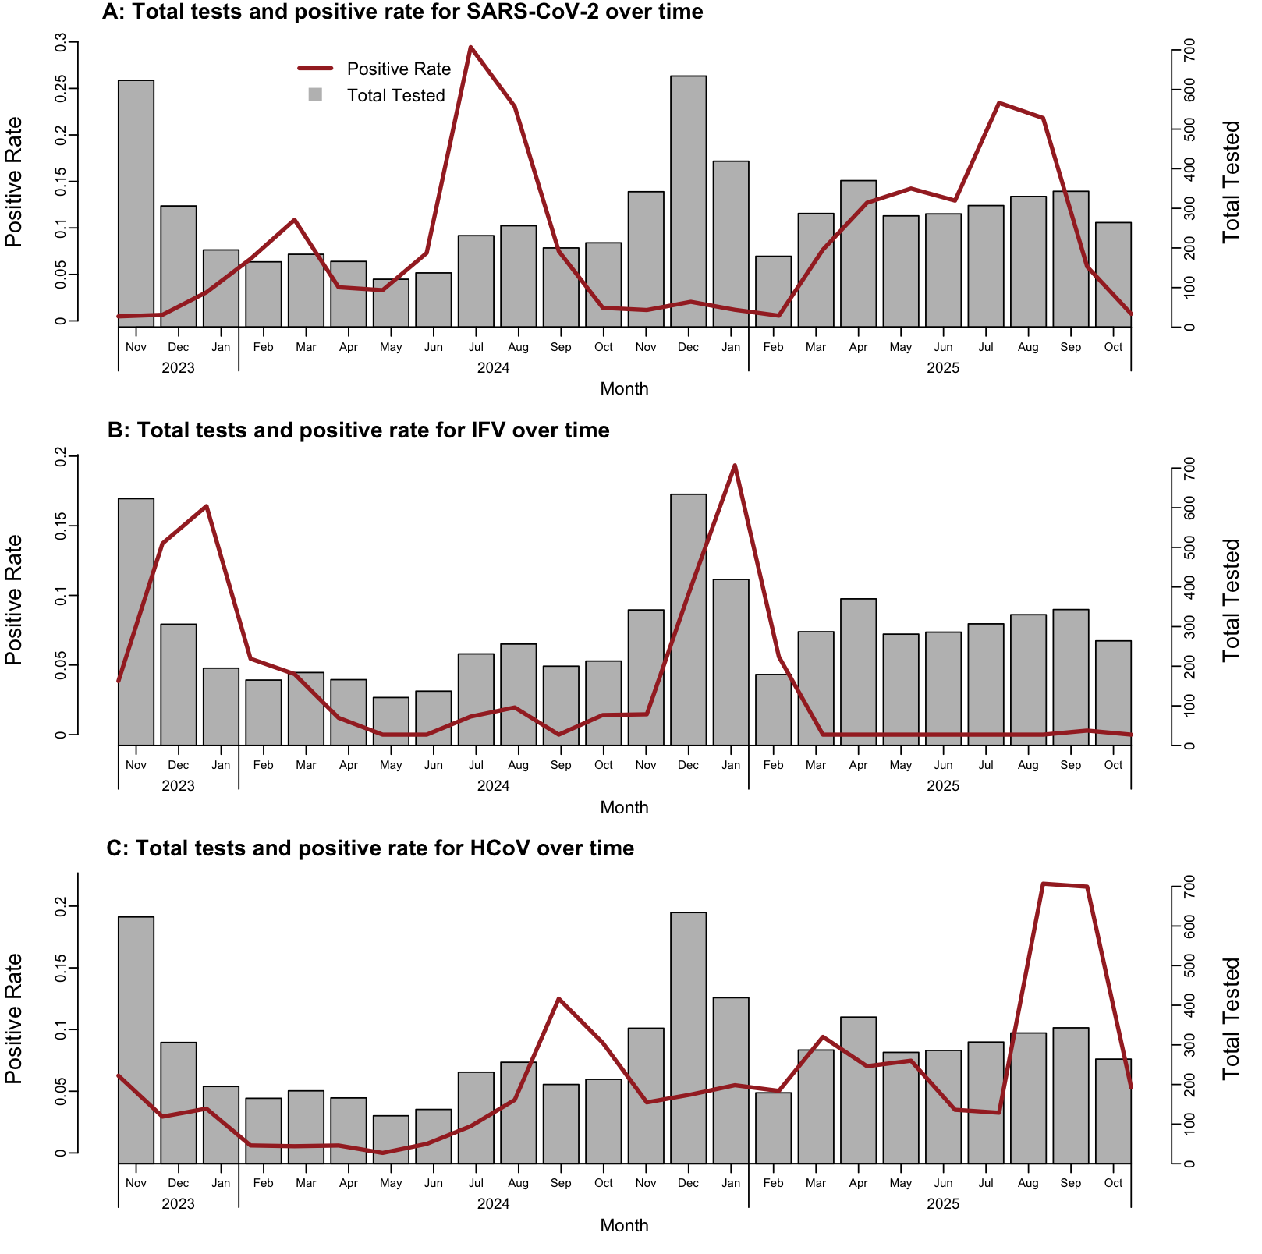
Supplementary Figure 1: Monthly number of tests performed and positivity rates in the cohort for SARS-CoV-2 (A), IFV (B), and HCoV (C), November 2023 to October 2025 Bars show the number of tests; lines show positivity (%) among tested participants.

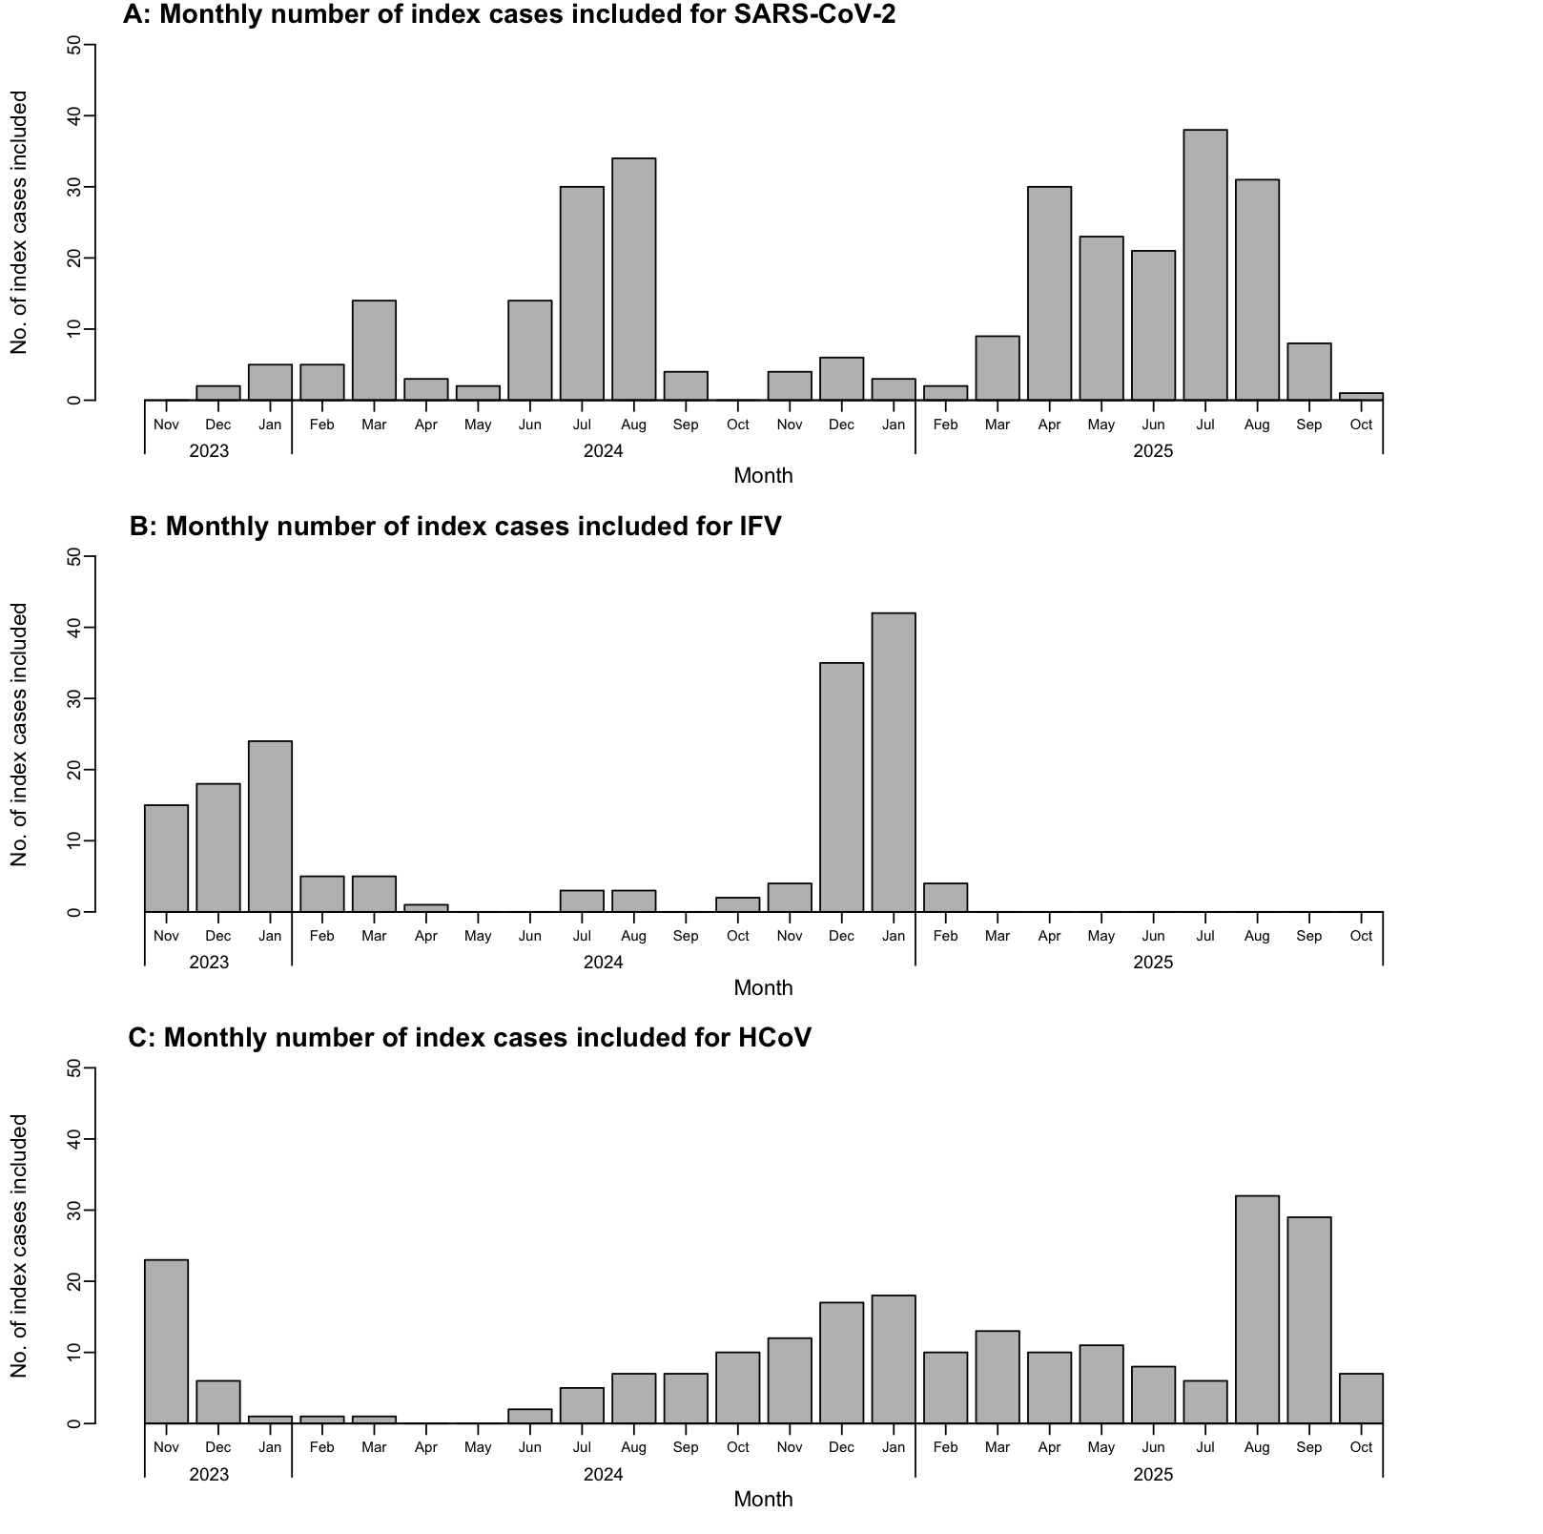
Supplementary Figure 2: Monthly number of index cases included for SARS-CoV-2 (A), IFV (B), and HCoV (C), November 2023 to October 2025

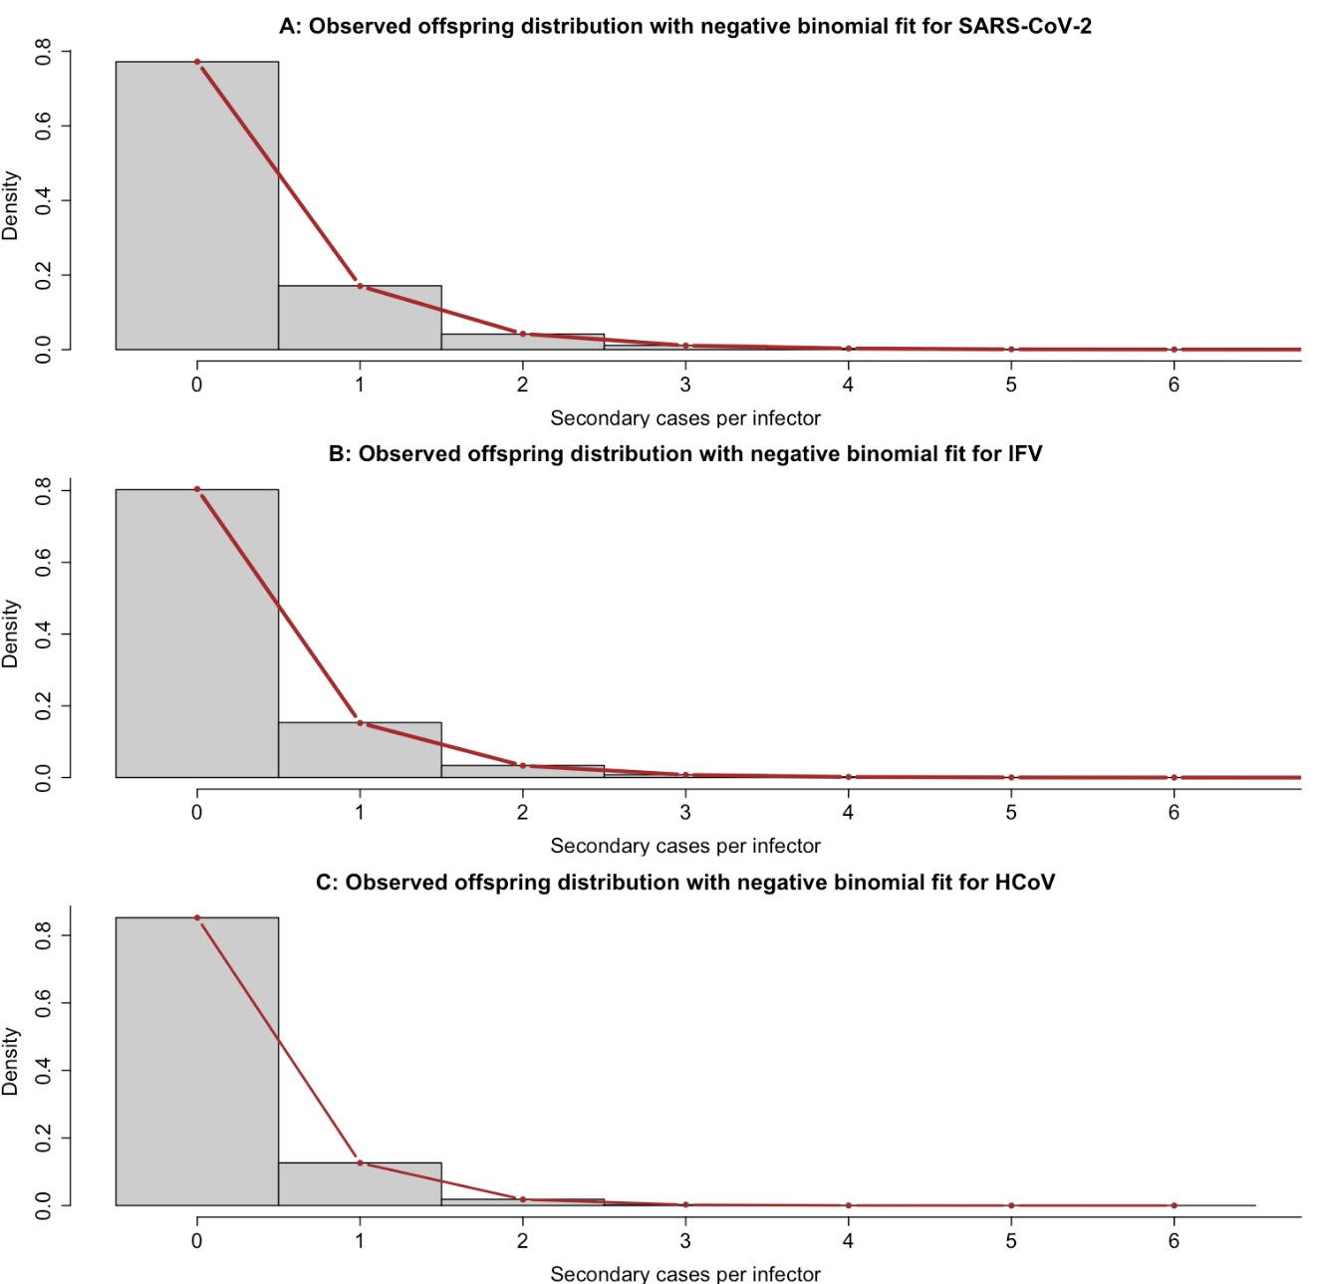
Supplementary Figure 3: Observed distribution (bars) and fitted negative binomial probability mass function (red line) for the number of household secondary ARI cases per index case for each pathogen

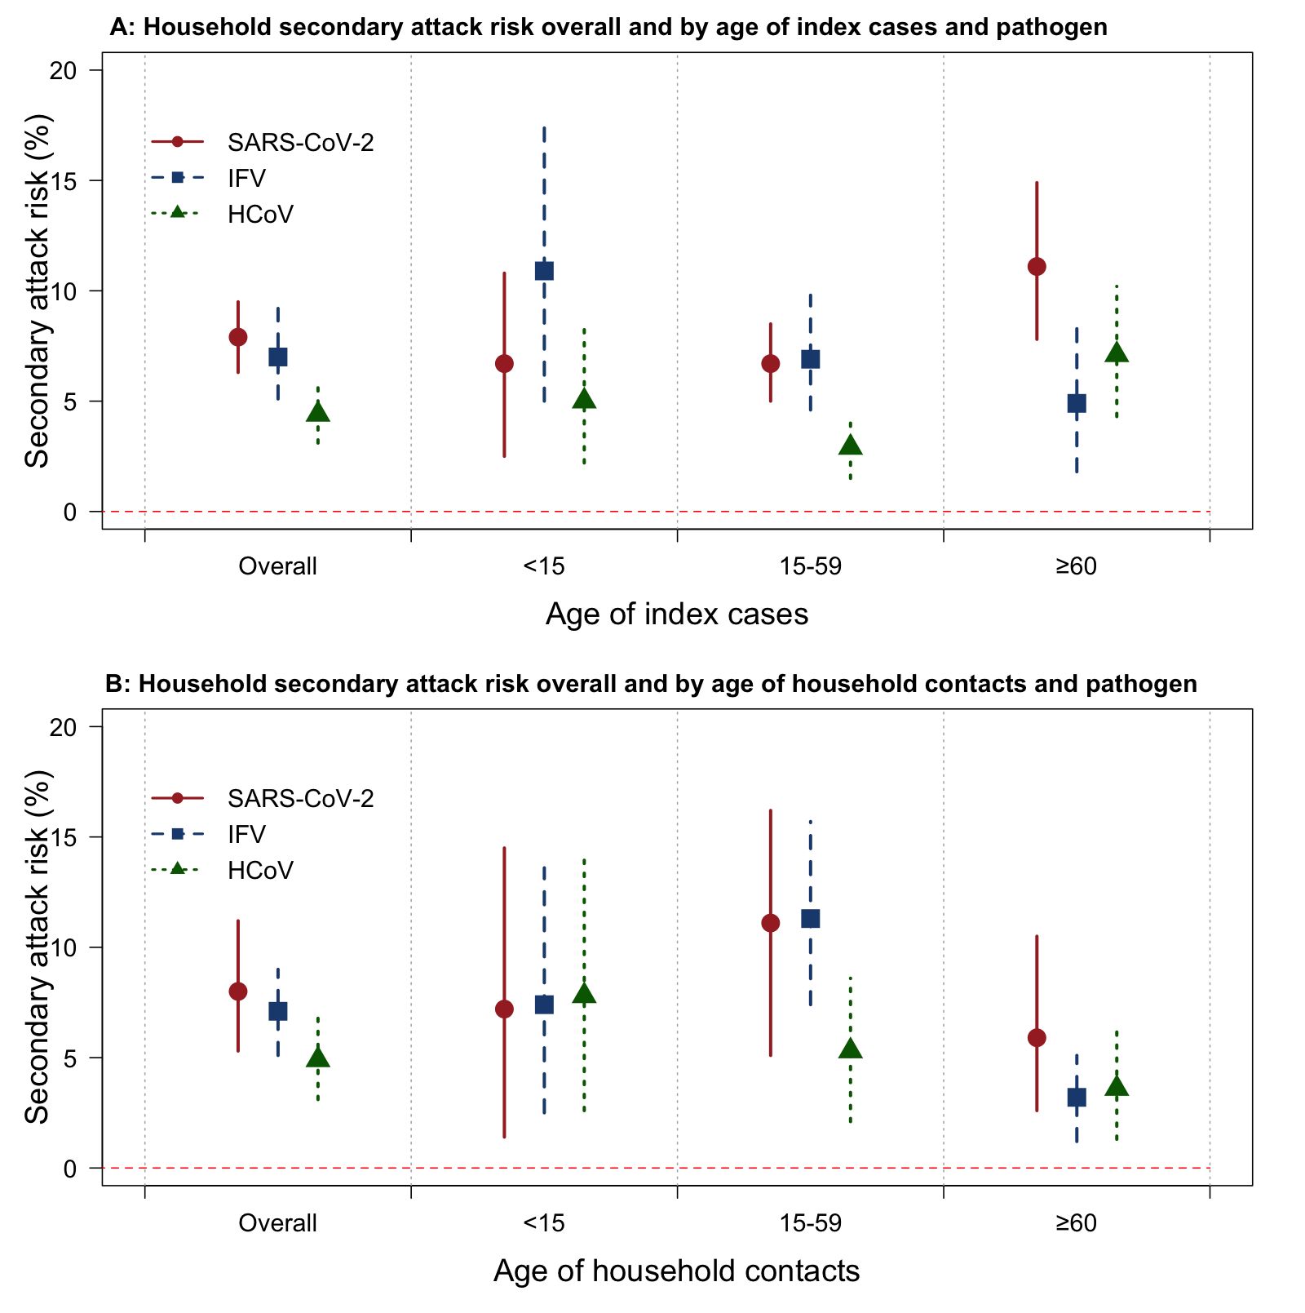Supplementary Figure 4: Crude household secondary attack risk (HSAR) overall and by age group of index cases (A) and household contacts (B) for each pathogen Points represent attack risks; error bars represent 95% CIs.
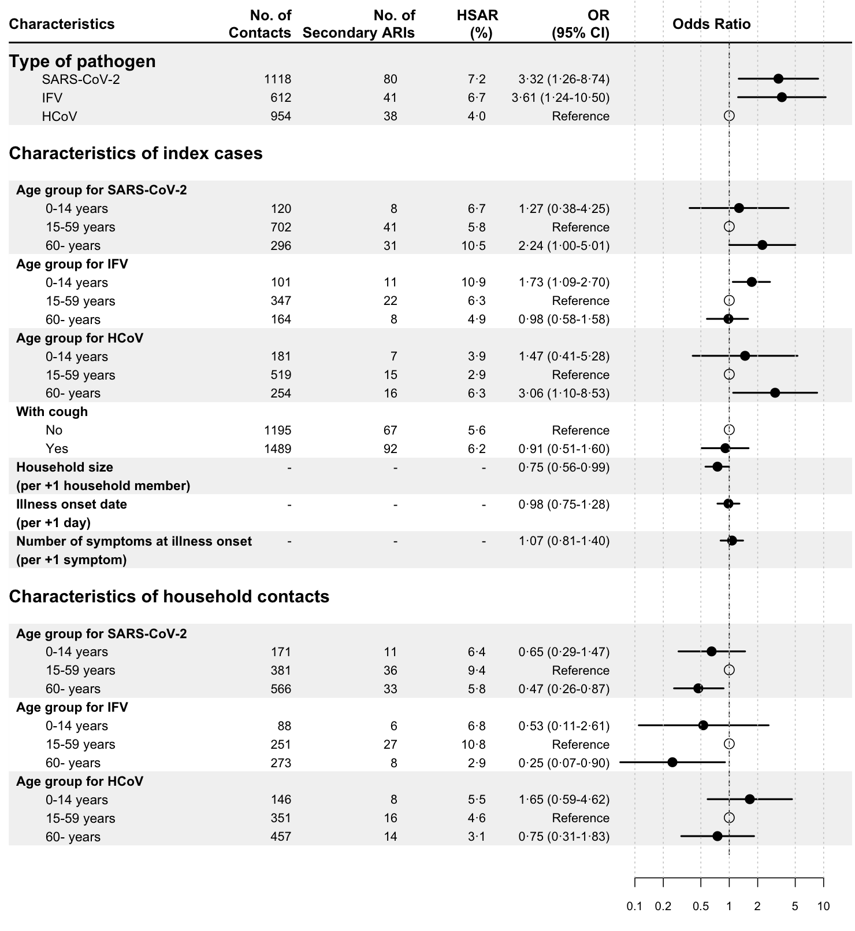
Supplementary Figure 5: Adjusted odds ratios from a mixed-effects logistic regression model of pathogen- and population-specific transmissibility and susceptibility based on household secondary attack risks (HSAR) estimated as the proportion of contacts with ARI within 7 days after index-case onset Models include index-case and contact characteristics with a random intercept for the household. Hollow points represent the reference group; black points represent adjusted ORs; horizontal lines represent 95% confidence intervals.

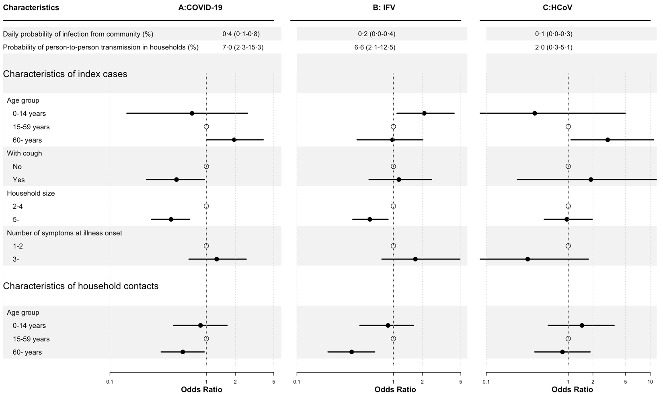
Supplementary Figure 6: Daily probability of infection from community, probability of person-to-person transmission in households, and estimated relative transmissibility and susceptibility by subgroup, with points and lines indicating posterior means and 95% credible intervals from Markov chain Monte Carlo–based individual hazard model fit
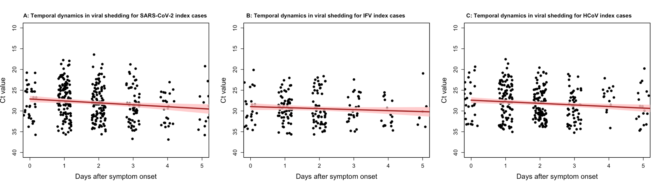
Supplementary Figure 7: Temporal trends in cycle threshold (Ct) values relative to symptom onset for each pathogen Points represent observed individual specimens; solid lines represent GAM-fitted mean Ct and shaded bands 95% confidence intervals.

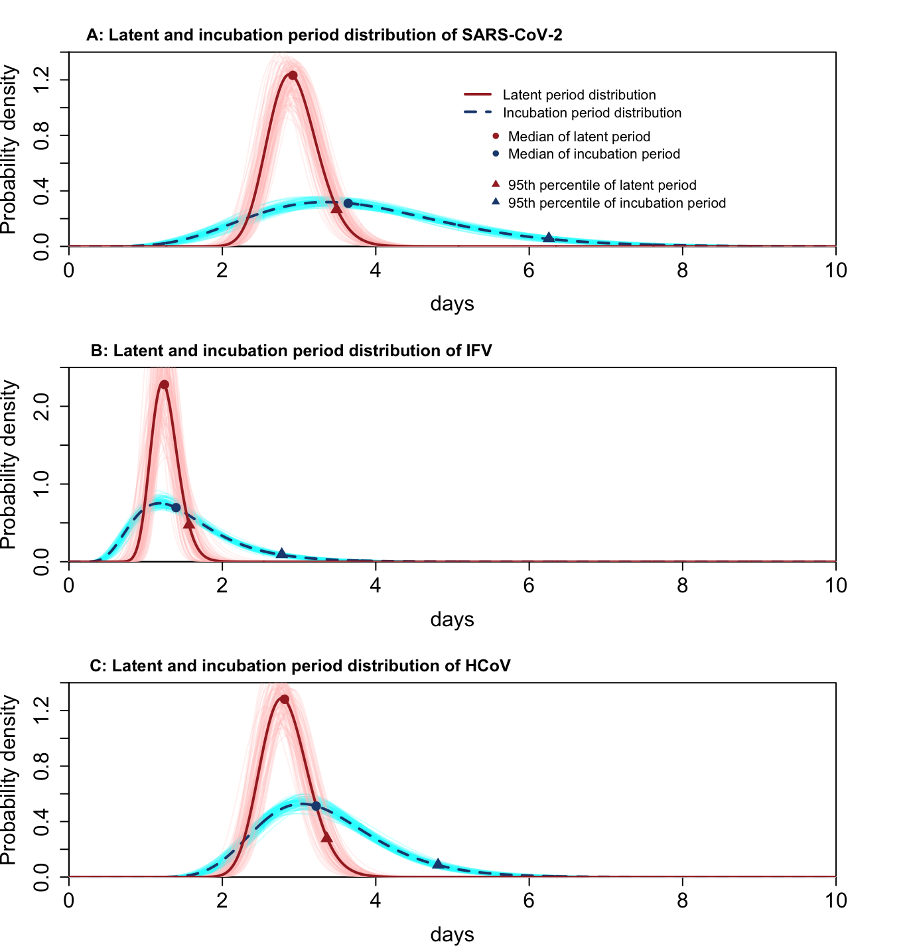
Supplementary Figure 8: Probability density distributions of the latent period (dark red) and incubation period (dark blue) for each pathogen
References

1. Tsang TK, Cauchemez S, Perera RA, et al. Association between antibody titers and protection against influenza virus infection within households. J Infect Dis 2014; 210(5): 684-92.
2. Lessler J, Reich NG, Brookmeyer R, Perl TM, Nelson KE, Cummings DA. Incubation periods of acute respiratory viral infections: a systematic review. Lancet Infect Dis 2009; 9(5): 291-300.
3. Xin H, Wang Z, Feng S, et al. Transmission dynamics of SARS-CoV-2 Omicron variant infections in Hangzhou, Zhejiang, China, January-February 2022. Int J Infect Dis 2023; 126: 132-5.

