Supporting Information
In situ electrochemical activation converts carbon disulfide into an organosulfide cathode material for rechargeable lithium-organosulfide batteries

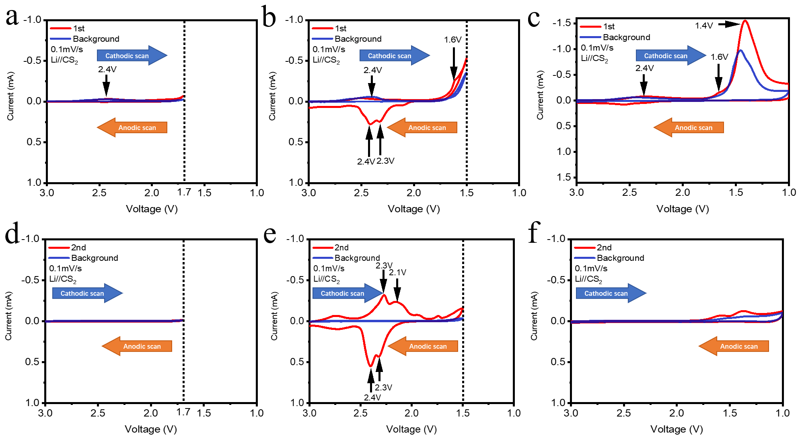
Figure S1. The first-cycle CV in a Li//CS₂ battery under different scanning ranges. (a) scanning range 3.0-1.7 V vs Li/Li⁺; (b) scanning range 3.0-1.5 V vs Li/Li⁺; (c) scanning range 3.0-1.0 V vs Li/Li⁺; the second cycle cyclic voltammetry of the Li//CS₂ battery in different scanning ranges: (d) scanning range 3.0-1.7 V vs Li/Li⁺; (e) scanning range 3.0-1.5 V vs Li/Li⁺; (f) scanning range 3.0-1.0 V vs Li/Li⁺. (The background curve is obtained from control batteries using electrolyte without CS₂, while maintaining identical electrode configurations to those in the Li//CS₂ battery)

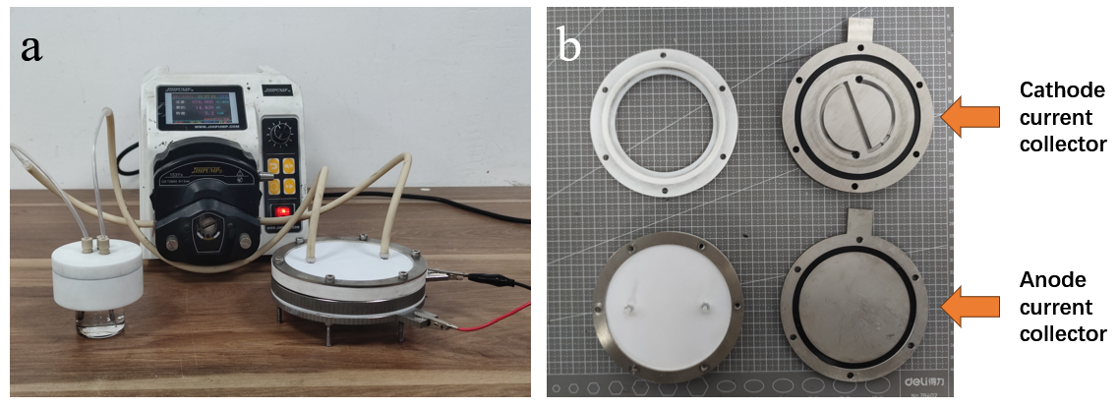
Figure S2. (a) Graphic of a collection device; (b) Internal structure of collection device.

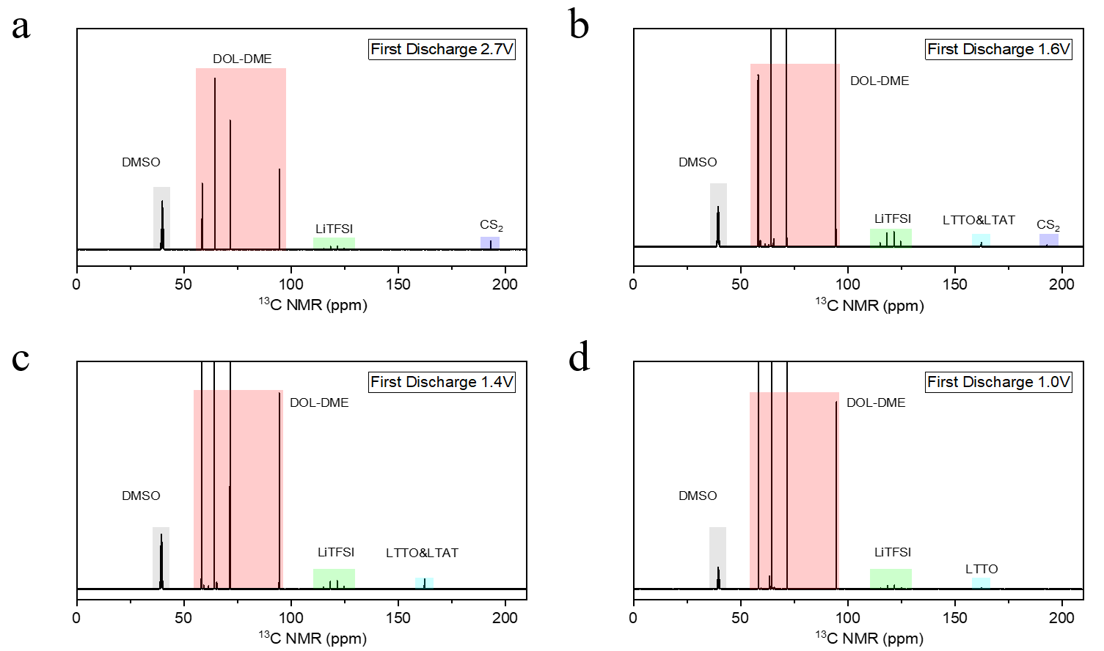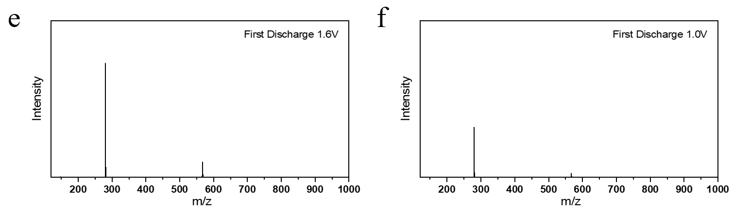
Figure S3. ¹³C NMR spectra of electrolyte during the first discharge process: (a) 2.7 V; (b) 1.6 V; (c) 1.4 V; (d) 1.0 V; HRMS spectra of electrolyte at first discharge: (e) 1.6 V; (f) 1.0 V.

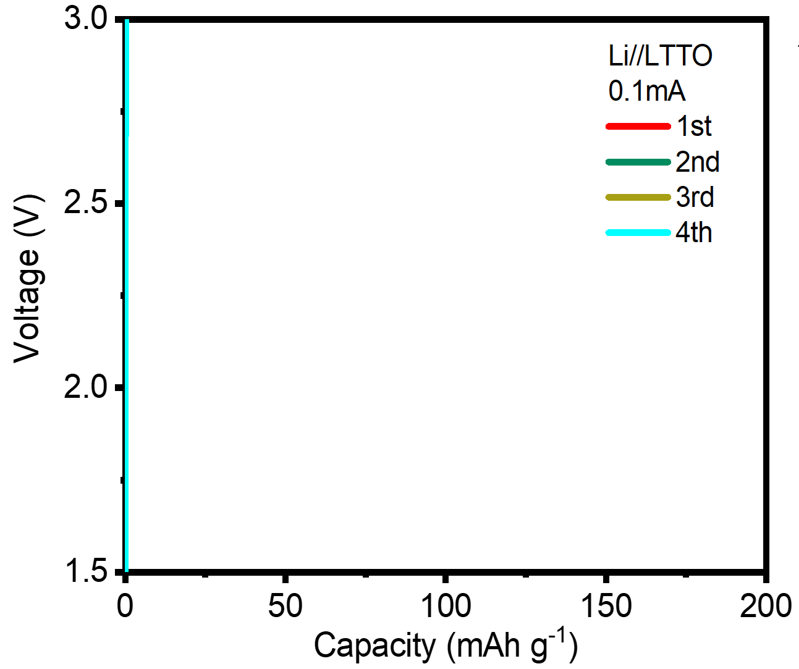
Figure S4. The charge/discharge curves of LTTO. (Preparation method: First synthesize LTTO by chemical method, then disperse LTTO in DME, and drop the mixed solution onto carbon paper to obtain the electrode with LTTO. Subsequently, assemble a coin battery using the Li//CS₂ battery preparation method and perform charge/discharge tests. The specific capacities mentioned above are calculated based on the mass of LTTO.)

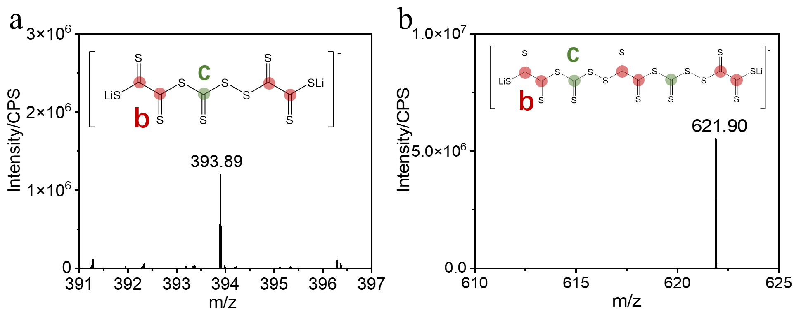
Figure S5. HRMS and molecular structure of different substances: (c) Li₂C₅S₁₀; (d) Li₂C₈S₁₆.

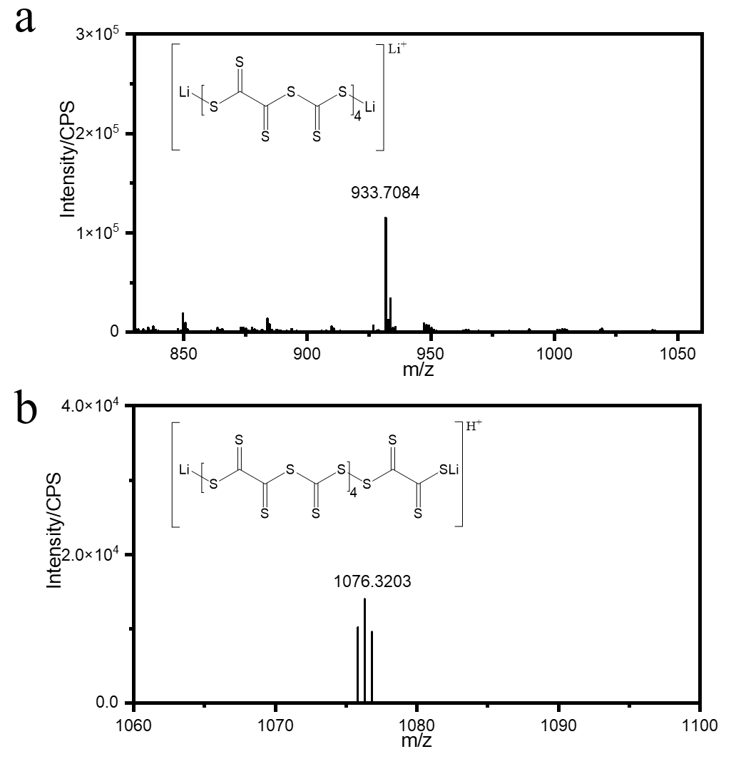
Figure S6. HRMS and molecular structure of different Li₂C_{x}S_{y}: (a) Li₂C₁₂S₂₄; (b) Li₂C₁₄S₂₈.

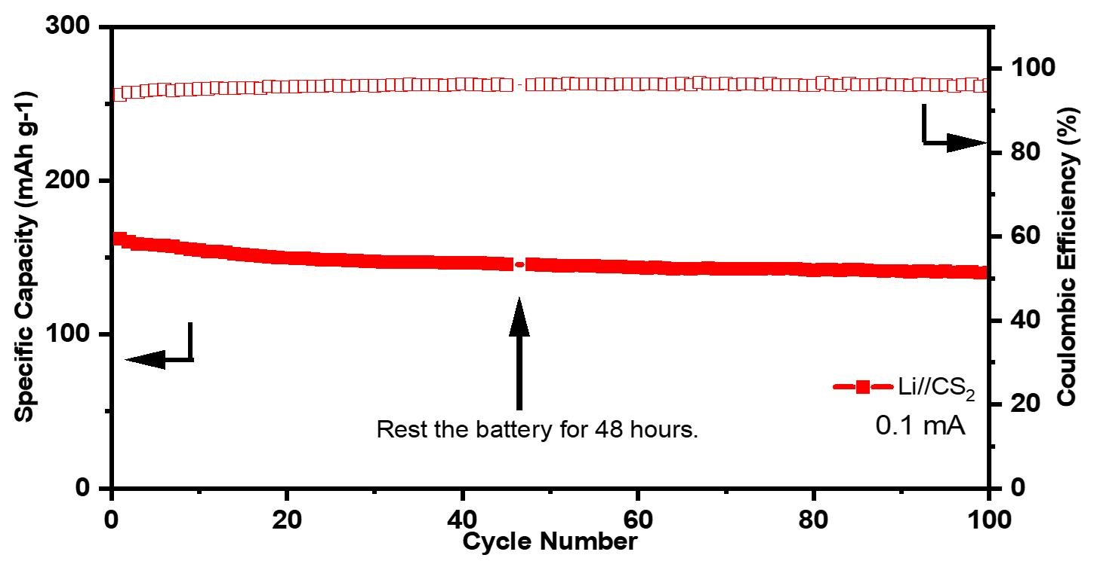
Figure S7. Cycle Performance of the Li//CS₂ Battery with a 48-Hour Rest Period at the 45th Cycle.

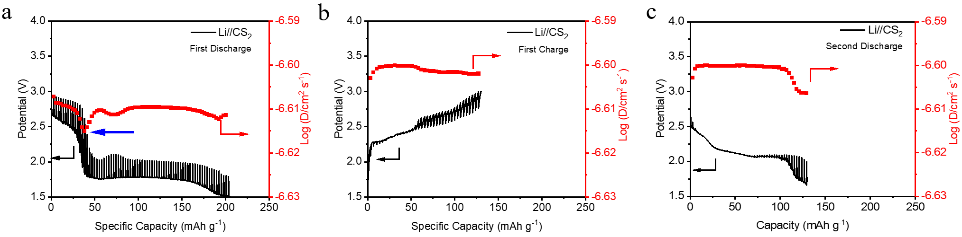
Figure S8. (a) Temporal voltage evolution in GITT studies during the first discharge with the corresponding Li-ion diﬀusion coeﬃcients; (b) Temporal voltage evolution in GITT studies during the first charge with the corresponding Li-ion diﬀusion coeﬃcients; (c) Temporal voltage evolution in GITT studies during the second discharge with the corresponding Li-ion diﬀusion coeﬃcients. (The specific capacity of the battery is calculated based on the mass of CS₂)

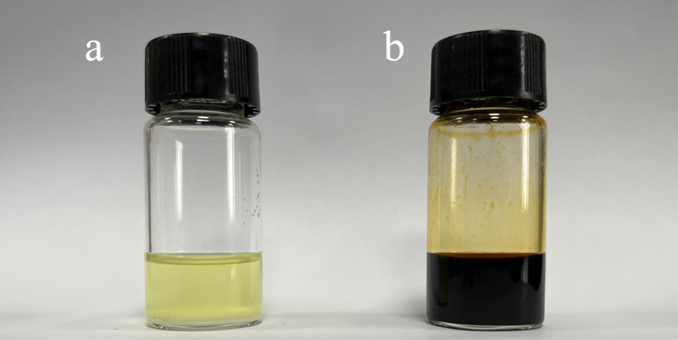
Figure S9. Solubility tests of LTTO and LTAT:(a) Dissolution behavior of 10 wt% LTTO in DME/DOL solvent;（b）Dissolution behavior of LTAT in DME/DOL solvent. (The LTAT solution is obtained through the reaction of 5 wt% LTTO with 5 wt% CS₂ catalyzed by lithium metal)

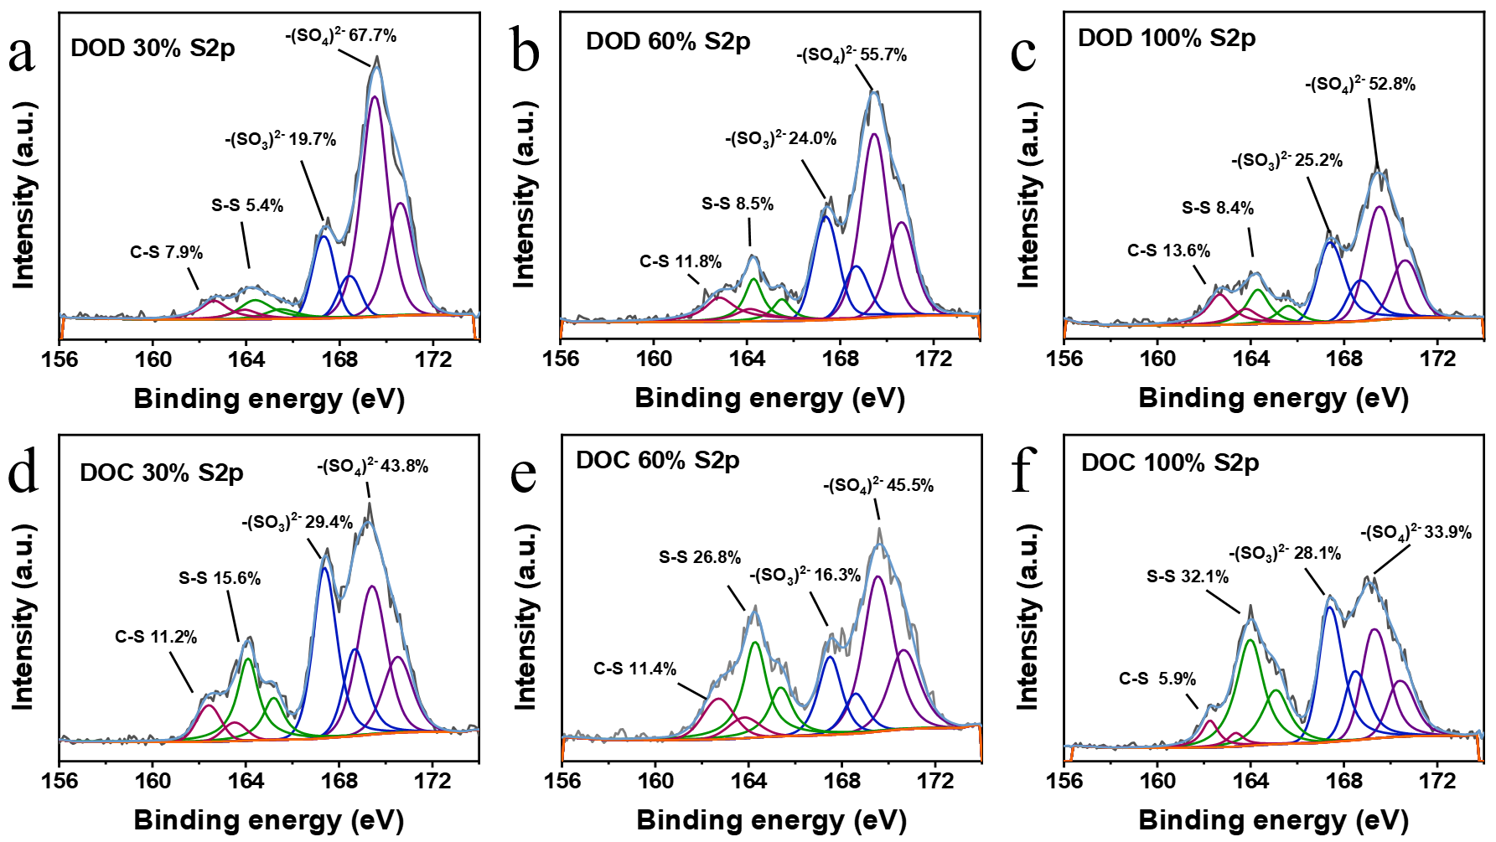
Figure S10. High-resolution XPS spectra of S 2p at different first discharge states: (a) DOD 30%; (b) DOD 60%; (c) DOD 100% and first charge potentials: (d) DOC 30%; (e) DOC 60%; (f) DOC 100%.

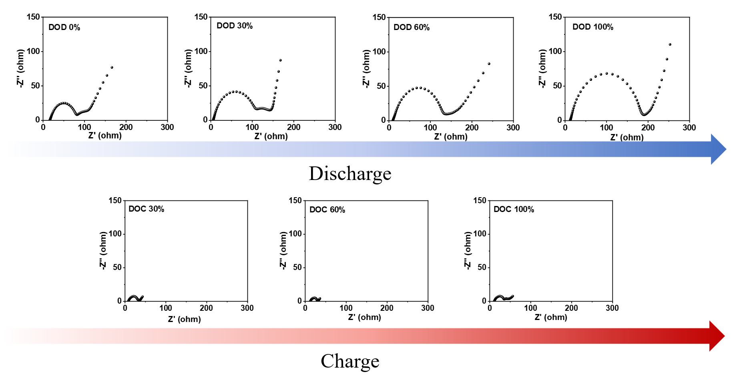
Figure S11. Results of in-situ EIS testing of the Li//CS₂ battery during the first cycle of charge and discharge.

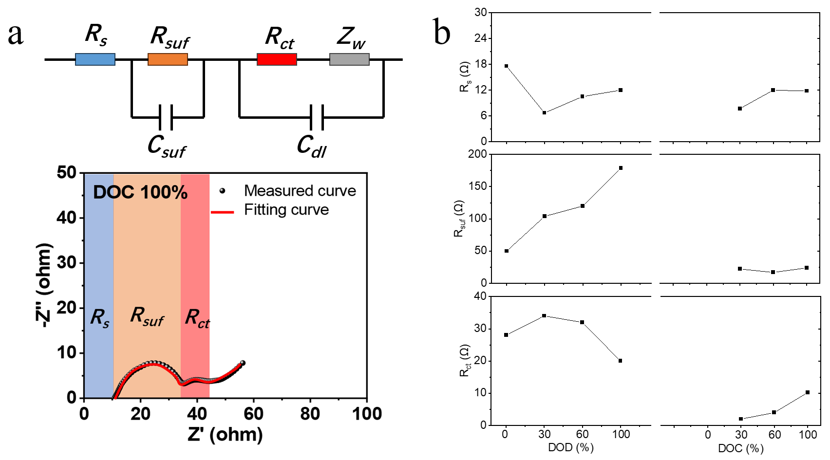
Figure S12. (a) EIS curve and equivalent circuit diagram of Li//CS₂ battery at 100% DOC; (b) Plots of electrolyte solution resistance (R_{s}), R_{suf} and R_{ct} against different extent of discharge/charge (DOD/DOC) states.

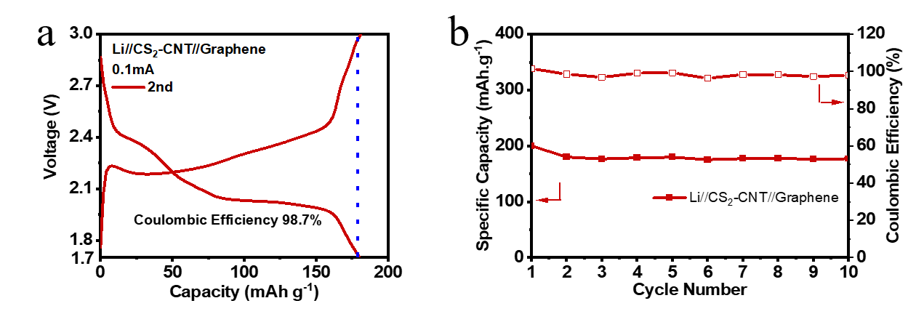
Figure S13. (a) The second-cycle charge/discharge curves of the Li//CS₂ battery; (b) The cycling performance of the Li//CS₂ battery.

Material | State of matter | Can it be dissolved in electrolyte? | Mass fraction of sulfur element that can be lithiated | Theoretical capacity (mAh g⁻¹) | Loading (mg cm⁻²) | Cycling performance (Initial capacity (mAh g⁻¹)) | Number of cycles (Capacity retention) | Ref
Tetramethyl thiuram monosulfide | Solid | Yes | - | - | 2.0 | 125 (10C) | 8000 (70%) | ¹
C6S6 | Solid | No | 72.7% | 609.0 | 0.8-1.2 | 125 (0.1C) | 200 (-60%) | ²
Phenyl disulfide | Solid | No | 27.8% | 245.5 | 5.0 | 218 (1C) | 150 (70%) | ³
1,2-benzenedithiol | Solid | Yes | 45.7% | 347.8 | 2.0 | 336.8 (1C) | 150 (70%) | ⁴
Phenyl selenosulfide | Solid | Yes | 43.5% | 202.1 | 2.7 | 152 (0.2) | 200 (52%) | ⁵
2,2’-dipyridyl disulfide | Solid | Yes | 29.1% | 243 | 1.1 | 237 (0.5C) | 500 (69%) | ⁶
Tetramethylthiuram disulfide | Solid | No | 29.6% | 496.3 | 1.8 | ~300 (0.2C) | 200 (75%) | ⁷
Diphenyl trisulﬁde | Solid | Yes | 53.9% | 428.8 | 3.9 | 330 (0.5C) | 100 (79%) | ⁸
Carbon disulfide | Liquid | Yes | 42.1% | 235 | 5.8 | 163 (1.0 mA cm-2) | 6000 (60%) | This work

(1) Chen, Q.; Li, L.; Wang, W.; Li, X.; Guo, W.; Fu, Y. Thiuram Monosulfide with Ultrahigh Redox Activity Triggered by Electrochemical Oxidation. Journal of the American Chemical Society 2022, 144 (41), 18918.
(2) Preefer, M. B.; Oschmann, B.; Hawker, C. J.; Seshadri, R.; Wudl, F. High Sulfur Content Material with Stable Cycling in Lithium-Sulfur Batteries. Angew. Chem., Int. Ed. 2017, 56 (47), 15118.
(3) Bhargav, A.; Patil, S. V.; Fu, Y. A phenyl disulfide@CNT composite cathode for rechargeable lithium batteries. Sustainable Energy & Fuels 2017, 1 (5), 1007.
(4) Li, F.; Si, Y.; Liu, B.; Li, Z.; Fu, Y. Lithium Benzenedithiolate Catholytes for Rechargeable Lithium Batteries. Advanced Functional Materials 2019, 29 (32).
(5) Guo, W.; Bhargav, A.; Ackerson, J. D.; Cui, Y.; Ma, Y.; Fu, Y. Mixture is better: enhanced electrochemical performance of phenyl selenosulfide in rechargeable lithium batteries. Chem Commun (Camb) 2018, 54 (64), 8873.
(6) Wang, D.-Y.; Si, Y.; Li, J.; Fu, Y. Tuning the electrochemical behavior of organodisulfides in rechargeable lithium batteries using N-containing heterocycles. Journal of Materials Chemistry A 2019, 7 (13), 7423.
(7) Xu, H.; Shi, Y.; Yang, S.; Li, B. A linear molecule sulfur-rich organic cathode material for high performance lithium–sulfur batteries. Journal of Power Sources 2019, 430, 210.
(8) Wu, M.; Bhargav, A.; Cui, Y.; Siegel, A.; Agarwal, M.; Ma, Y.; Fu, Y. Highly Reversible Diphenyl Trisulfide Catholyte for Rechargeable Lithium Batteries. ACS Energy Letters 2016, 1 (6), 1221.

