Supplementary Data

Supplementary Table 1. List of pneumococcal isolates used in this study.
Sample ID | Serotype | Country of Origin | Reference
PMP1668 | 1 | Mongolia | ¹
PMP1669 | 7F | Mongolia | ¹
PMP296 | 9V | Fiji | ²
PMP1670 | 14 | Somaliland | ⁵
PMP1671 | 16F | Vietnam | ³
PMP1672 | 8 | Mongolia | ⁴
PMP1673 | 10A | Mongolia | ⁴
PMP1674 | 12F | Somaliland | ⁵
PMP1675 | 18C | Somaliland | ⁵
PMP1676 | 22F | Vietnam | ³
PMP788 | 33F | Denmark | ⁶
PMP1677 | Non-encapsulated pneumococci (NT2) | Vietnam | ³
PMP1678 | 34 | Vietnam | ³
PMP1679 | 15A | Vietnam | ³
PMP1680 | 35B | Mongolia | ⁴
PMP22 | 23F | Fiji | ²
PMP591 | 6B | Fiji | ²
PMP812 | 5 | Bangladesh | ⁷
PMP292 | 19A | Fiji | ²
PMP278 | 3 | Fiji | ²
All isolated from the nasopharynx except PMP812, which was an invasive isolate.

Supplementary Table 2. Mean density of samples at 28 days post storage calculated using traditional culture techniques.
 | Mean Density (log₁₀ CFU/ml) for Low Load (10² ⁻ 10³ CFU) Samples ± SD | Mean Density (log₁₀ CFU/ml) for Medium Load (10⁴ ⁻ 10⁵ CFU) Samples ± SD
-80°C in STGG | 2.84 ± 0.71 | 5.08 ± 0.63
-20°C in STGG | 2.67 ± 0.54 | 3.53 ± 0.89
4°C in STGG | 1.99 ± 0.57 | 2.31 ± 0.61
4°C in SDPs | 1.67 ± 0.55 | 2.20 ± 0.65
30°C in SDPs | Non-recoverable | Non-recoverable

Supplementary Table 3. Difference in combined mean density (log₁₀ CFU/ml) between baseline and 28 days post-storage.
 | 2 Days Post-Storage | 7 Days Post-Storage | 14 Days Post-Storage | 21 Days Post-Storage | 28 Days Post-Storage
Low Density Samples
4°C in SDPs | -1.32 | -1.64 | -1.70 | -1.84 | -1.91
30°C in SDPs | -2.28 | -1.28 | Non-recoverable | -2.28 | Non-recoverable
-20°C in STGG | -0.44 | -0.62 | -0.56 | -0.96 | -0.90
4°C in STGG | -0.81 | -1.03 | -1.17 | -1.60 | -1.59
Medium Density Samples
4°C in SDPs | -2.00 | -2.16 | -2.58 | -2.52 | -2.75
30°C in SDPs | -3.15 | -2.60 | Non-recoverable | Non-recoverable | Non-recoverable
-20°C in STGG | -0.63 | -0.99 | -1.19 | -1.25 | -1.41
4°C in STGG | -1.00 | -1.51 | -2.08 | -2.06 | -2.63

Supplementary Table 4. Difference in the mean density of samples between assessed alternative methods and baseline inoculum.
 | Mean Density ± SD log10 GE/ml, 95% CI | P-Value
Low Load Samples
30°C in SDPs | 5.26 ± 0.52 log₁₀ GE/ml [4.96, 5.56] | p = 0.22
-20°C in STGG | 5.76 ± 0.44 log₁₀ GE/ml [5.51, 5.60] | p = 0.06
-80°C in STGG | 5.58 ± 0.58 log₁₀ GE/ml [ 5.26, 5.90] | p = 0.53
Medium Load Samples
30°C in SDPs | 5.76 ± 0.65 log₁₀ GE/ml [5.40, 6.12] | p = 0.0006
-20°C in STGG | 6.65 ± 0.44 log₁₀ GE/ml [6.41, 6.90] | p = 0.42
-80°C in STGG | 6.74 ± 0.52log₁₀ GE/ml [6.46, 7.03] | p = 0.21

Supplementary Table 5. Difference in the mean density of samples between assessed alternative methods and the gold standard storage condition (-80°C in STGG).
 | Difference in Mean Density ± log10 GE/ml, 95% CI | P-Value
Low Load Samples
30°C in SDPs | -0.32 [-0.74, 0.10], | 0.13
-20°C in STGG | +0.18 [-0.21, 0.56] | 0.36
Medium Load Samples
30°C in SDPs | -0.98 [-1.42, -0.55] | <0.0001
-20°C in STGG | -0.09 [-0.45, 0.27] | 0.61

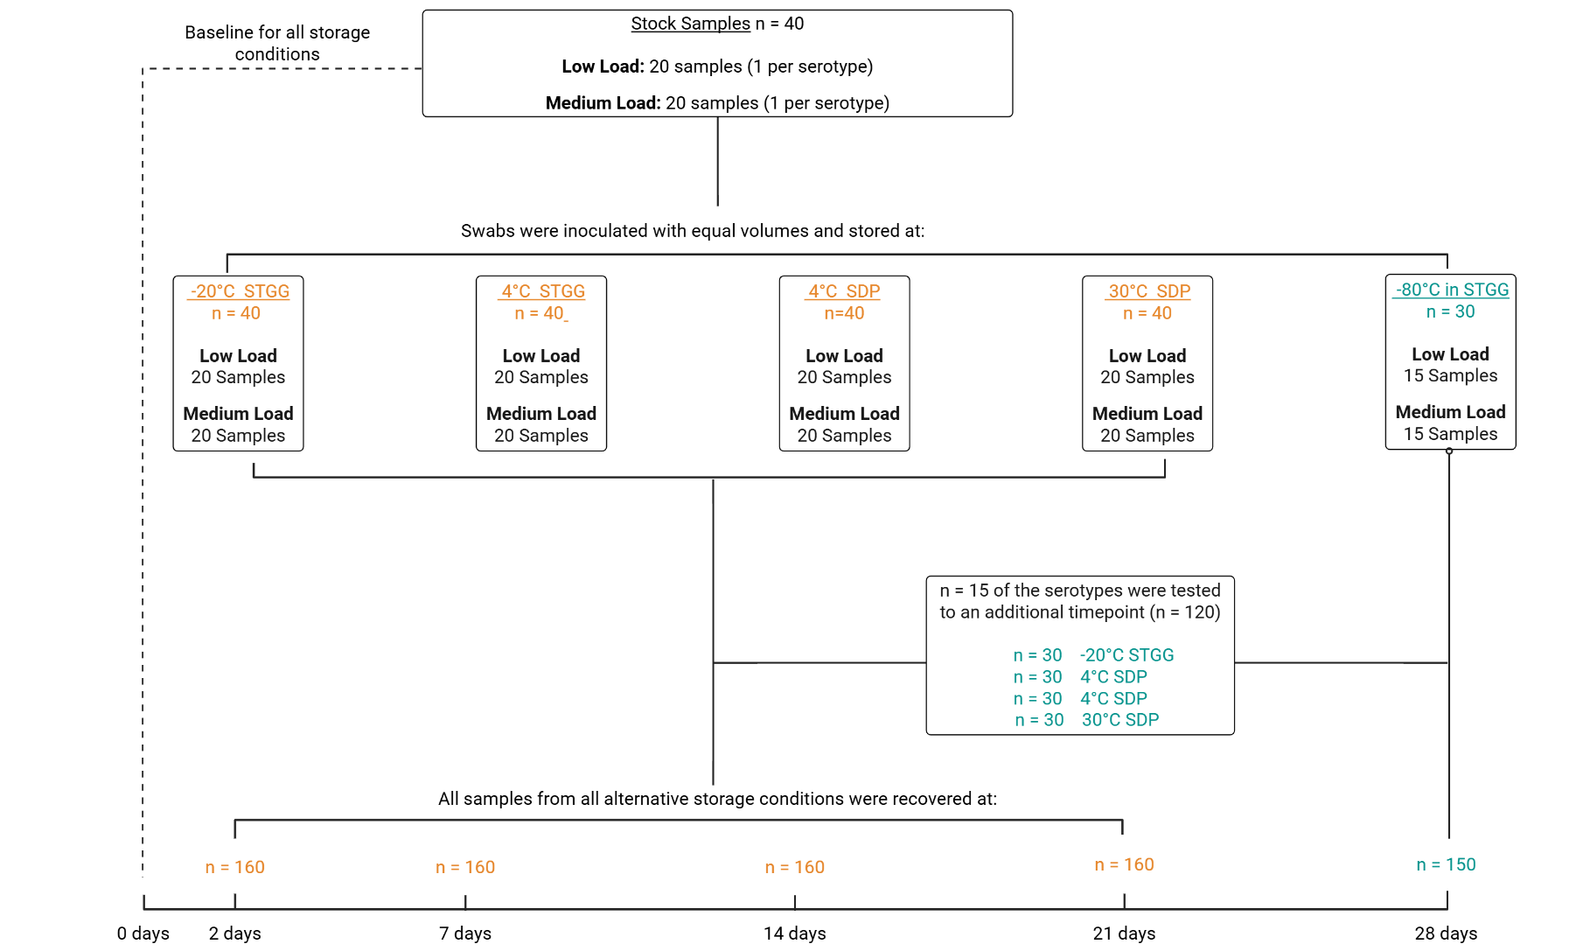
Figure 1 - Flow chart of sample processing. N = 40 stock samples were created including 20 low bacterial load and 20 medium bacterial load (1 per serotype) and were plated for viability on day 0. Stock samples were used to create n = 160 samples per storage condition including 80 low bacterial load and 80 medium bacterial loads and recovered at 2, 7, 14, 21 days. 28 days. Additionally, the stock samples were recovered at 28 days to check viability.
References:
1. von Mollendorf C, Ulziibayar M, Gessner BD, et al. Evaluation of the impact of childhood 13-valent pneumococcal conjugate vaccine introduction on adult pneumonia in Ulaanbaatar, Mongolia: study protocol for an observational study. BMC Public Health. 2021;21(1):1731.
2. Russell FM, Carapetis JR, Satzke C, Tikoduadua L, Waqatakirewa L, Chandra R, et al. Pneumococcal nasopharyngeal carriage following reduced doses of a 7-valent pneumococcal conjugate vaccine and a 23-valent pneumococcal polysaccharide vaccine booster. Clin Vaccine Immunol. 2010;17(12):1970–6.
3. Temple B, Tran HP, Dai VTT, Smith-Vaughan H, Group V-IC, Licciardi PV, et al. Efficacy against pneumococcal carriage and the immunogenicity of reduced-dose (0 + 1 and 1 + 1) PCV10 and PCV13 schedules in Ho Chi Minh City, Viet Nam: a parallel, single-blind, randomised controlled trial. Lancet Infect Dis. 2023;23(8):933–44.
4. von Mollendorf C, Mungun T, Ulziibayar M, Nguyen CD, Batsaikhan P, Suuri B, et al. Effect of pneumococcal conjugate vaccination on pneumococcal carriage in hospitalised children aged 2-59 months in Mongolia: an active pneumonia surveillance programme. The Lancet Microbe. 2024;5(12).
5. van Zandvoort K, Hassan AI, Bobe MO, Pell CL, Ahmed MS, Ortika BD, et al. Pre-vaccination carriage prevalence of Streptococcus pneumoniae serotypes among internally displaced people in Somaliland: a cross-sectional study. Pneumonia. 2024;16(1):25.
6. SSI Diagnostica. Instructions for use: Bacterial strains [Internet]. 3rd ed. Hillerød (Denmark): SSI Diagnostica; 2024 [cited 2025 Aug 19]. Available from: https://ssid.vps.webdock.cloud/wp-content/uploads/2024/04/IFU-Bacterial-strains-10560-3.pdf
7. Satzke C, Dunne EM, Porter BD, Klugman KP, Mulholland EK. The PneuCarriage Project: A Multi-Centre Comparative Study to Identify the Best Serotyping Methods for Examining Pneumococcal Carriage in Vaccine Evaluation Studies. PLoS Med. 2015;12(11):e1001903.

