Supply material
Table S1
 | [ALL] N=900 | Non-PIS  N=759 | PIS N=141 | p.overall
Sex: |  |  |  | 0.143
Female | 366 (40.67%) | 317 (41.77%) | 49 (34.75%)
Male | 534 (59.33%) | 442 (58.23%) | 92 (65.25%)
HTN: |  |  |  | 0.001
NO | 500 (55.56%) | 440 (57.97%) | 60 (42.55%)
YES | 400 (44.44%) | 319 (42.03%) | 81 (57.45%)
DM: |  |  |  | 0.958
NO | 723 (80.33%) | 609 (80.24%) | 114 (80.85%)
YES | 177 (19.67%) | 150 (19.76%) | 27 (19.15%)
AF: |  |  |  | 0.152
NO | 641 (71.22%) | 533 (70.22%) | 108 (76.60%)
YES | 259 (28.78%) | 226 (29.78%) | 33 (23.40%)
Smoke: |  |  |  | 0.548
NO | 547 (60.78%) | 465 (61.26%) | 82 (58.16%)
YES | 353 (39.22%) | 294 (38.74%) | 59 (41.84%)
Drink: |  |  |  | 0.463
NO | 810 (90.00%) | 686 (90.38%) | 124 (87.94%)
YES | 90 (10.00%) | 73 (9.62%) | 17 (12.06%)
TACI: |  |  |  | <0.001
NO | 747 (83.00%) | 663 (87.35%) | 84 (59.57%)
YES | 153 (17.00%) | 96 (12.65%) | 57 (40.43%)
PACI: |  |  |  | 0.436
NO | 751 (83.44%) | 637 (83.93%) | 114 (80.85%)
YES | 149 (16.56%) | 122 (16.07%) | 27 (19.15%)
POCI: |  |  |  | 0.699
NO | 668 (74.22%) | 561 (73.91%) | 107 (75.89%)
YES | 232 (25.78%) | 198 (26.09%) | 34 (24.11%)
LACI: |  |  |  | <0.001
NO | 534 (59.33%) | 416 (54.81%) | 118 (83.69%)
YES | 366 (40.67%) | 343 (45.19%) | 23 (16.31%)
Age | 63.00 [54.00;72.00] | 63.00 [54.00;72.00] | 63.00 [55.00;73.00] | 0.548
SBP | 133.00 [123.00;146.00] | 132.00 [123.00;145.50] | 136.00 [123.00;148.00] | 0.354
DBP | 79.00 [70.00;86.00] | 79.00 [71.00;86.00] | 78.00 [70.00;87.00] | 0.312
Hb | 135.00 [124.00;148.00] | 135.00 [124.00;148.00] | 135.00 [122.00;148.00] | 0.698
WBC | 7.64 [5.98;9.46] | 7.64 [5.95;9.40] | 7.80 [6.15;9.74] | 0.512
Neut | 5.88 [4.16;9.20] | 5.79 [4.00;9.34] | 6.54 [5.19;8.78] | 0.080
Lym | 1.56 [1.23;1.98] | 1.56 [1.25;1.98] | 1.53 [1.20;1.96] | 0.429
Mono | 0.56 [0.41;0.75] | 0.55 [0.41;0.75] | 0.57 [0.41;0.75] | 0.874
PLT | 179.00 [149.75;221.25] | 180.00 [149.00;222.00] | 176.00 [152.00;216.00] | 0.679
SII_100 | 6.75 [4.37;10.58] | 6.62 [4.28;10.38] | 7.86 [4.89;12.40] | 0.005
Glu | 5.80 [5.00;6.96] | 5.64 [4.95;6.88] | 6.50 [5.62;7.78] | <0.001
HbA1c | 5.70 [5.30;6.40] | 5.60 [5.30;6.40] | 5.90 [5.50;6.50] | 0.044
ARC | 0.89 [0.76;1.05] | 0.88 [0.74;1.03] | 0.97 [0.85;1.21] | <0.001
TG | 1.84 [1.28;2.92] | 1.79 [1.25;2.90] | 2.14 [1.43;3.11] | 0.052
TC | 4.38 [3.61;5.06] | 4.38 [3.61;5.06] | 4.36 [3.63;5.10] | 0.508
HDL | 1.08 [0.90;1.35] | 1.10 [0.90;1.38] | 1.00 [0.81;1.17] | <0.001
LDL | 2.86 [2.14;3.64] | 2.77 [2.05;3.59] | 3.30 [2.71;3.73] | <0.001
LPA | 183.05 [104.57;309.75] | 171.20 [99.20;293.65] | 235.70 [143.70;389.30] | <0.001
apoA1 | 1.25 [1.11;1.45] | 1.26 [1.11;1.46] | 1.24 [1.10;1.41] | 0.339
apoB | 0.93 [0.75;1.12] | 0.92 [0.74;1.11] | 0.96 [0.77;1.20] | 0.040
ALB | 41.10 [38.10;44.40] | 41.50 [38.50;45.10] | 38.80 [36.00;40.90] | <0.001
ALT | 28.00 [20.00;42.00] | 26.00 [19.00;41.00] | 36.00 [23.00;45.00] | <0.001
AST | 30.00 [24.00;47.00] | 29.00 [23.00;47.00] | 40.00 [26.00;47.00] | 0.001
K | 3.97 [3.70;4.25] | 3.99 [3.71;4.27] | 3.87 [3.62;4.13] | 0.006
UA | 342.45 [279.00;405.55] | 342.00 [280.50;404.00] | 344.50 [271.00;420.00] | 0.807
Cr | 74.00 [61.00;86.00] | 74.00 [60.50;85.00] | 76.00 [65.50;91.00] | 0.027
NHISS | 10.00 [8.00;12.00] | 9.00 [8.00;12.00] | 13.00 [10.00;17.00] | <0.001

Table S2

Variables | VIF
HTN | 1.026901477955867
TACI | 1.617023530890083
LACI | 1.266168662758668
SII_100 | 1.056127225925204
ARC | 1.066992530846188
HDL | 1.062263843080581
LDL | 1.103498651563411
ALB | 1.016412561303645
NHISS | 1.754751934835021

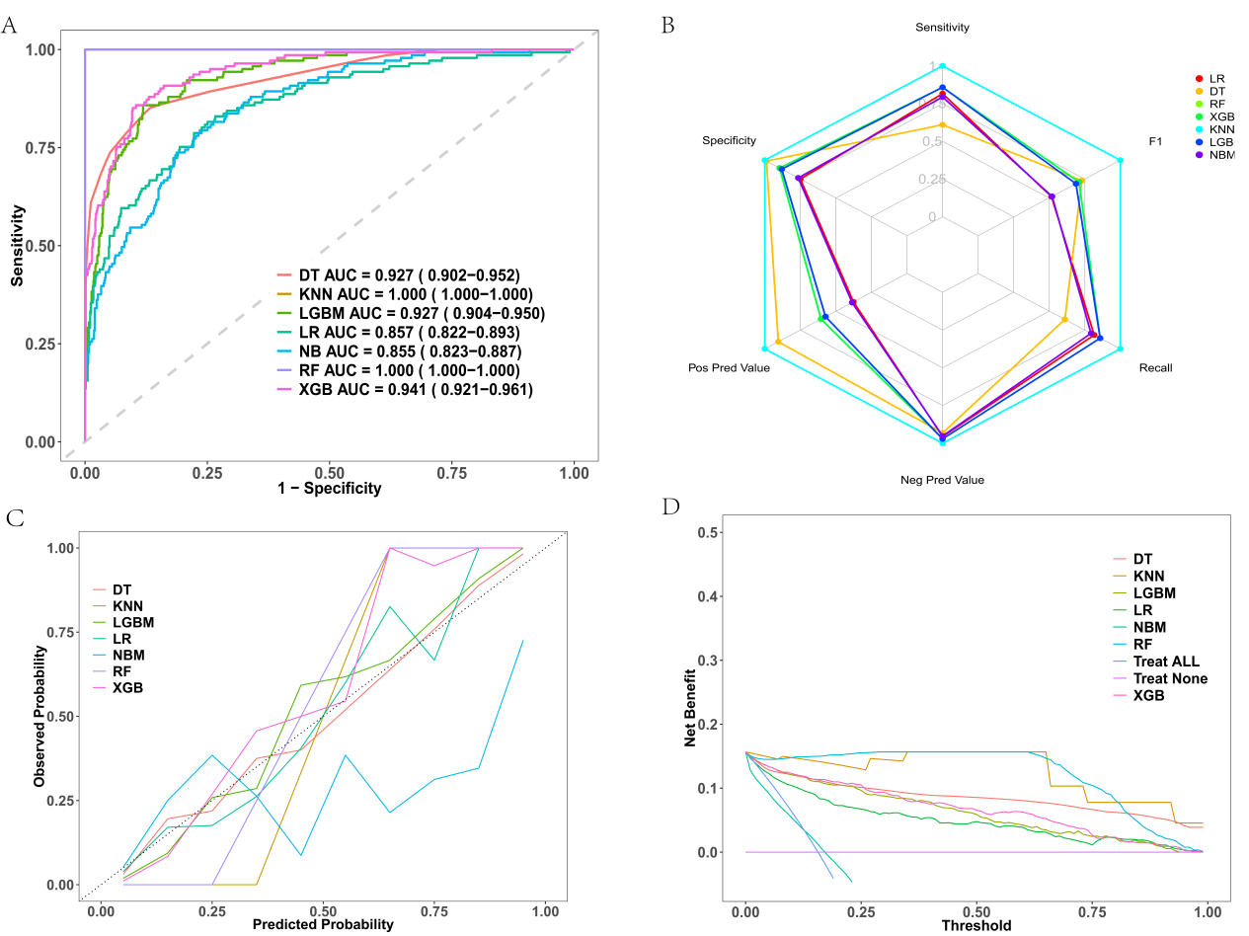

Figure S2: Evaluation of predictive models in the training set (where A, B, C, and D correspond to the ROC curves of various machine learning models in the validation set, radar chart of predictive ability, DCA curve, and decision curve, respectively).

The NIHSS (National Institutes of Health Stroke Scale) is a tool used by healthcare professionals to assess the severity of stroke symptoms in patients. It evaluates several aspects of neurological function, including consciousness, language, motor skills, coordination, and sensory perception. Here’s the English version of the NIHSS scoring system:
1.Level of Consciousness (LOC):
0: Alert
1: Not alert, but arousable by minor stimulation
2: Not alert, requires repeated stimulation to awaken
3: Responds only to pain
4: Unresponsive

2.LOC Questions (Orientation to year, month, age, and location):
0: Answers all questions correctly
1: One incorrect answer
2: Two or more incorrect answers

3.LOC Commands (Ability to follow simple commands):
0: Performs both tasks correctly
1: Performs one task correctly
2: Performs neither task correctly

4.Best Gaze:
0: Normal
1: Partial gaze palsy
2: Forced gaze deviation

5.Visual Fields (Checks for visual field defects):
0: No visual field defect
1: Partial hemianopia
2: Complete hemianopia
3: Bilateral hemianopia or cortical blindness

6.Facial Paralysis:
0: Normal
1: Minor paralysis (asymmetry visible)
2: Partial paralysis
3: Complete paralysis

7.Motor Arm (Assessing strength of arms):
0: No drift (normal)
1: Drift (arm drifts down or sidewards)
2: Some effort against gravity, but no movement against resistance
3: No movement

8.Motor Leg (Assessing strength of legs):
0: No drift (normal)
1: Drift (leg drifts down or sidewards)
2: Some effort against gravity, but no movement against resistance
3: No movement

9.Limb Ataxia (Coordination in arms and legs):
0: No ataxia
1: Present in one limb
2: Present in two or more limbs

10.Sensory (Ability to feel touch, pain, temperature):
0: Normal sensation
1: Mild or moderate loss
2: Severe or total loss

11.Best Language (Speech function):
0: Normal
1: Mild aphasia
2: Moderate aphasia
3: Severe aphasia
4: Mute

12.Dysarthria (Speech clarity):
0: Normal
1: Mild dysarthria
2: Severe dysarthria
3: Unable to understand

13.Extinction and Inattention (Neglect):
0: No neglect
1: Mild or moderate neglect
2: Severe neglect

The NIHSS score is the sum of individual scores, with a higher score indicating more severe stroke symptoms. The total score ranges from 0 to 42.

