Supplementary Information

In silico QSAR and design of chalcone derivatives for HT-29 colorectal cancer: MLR and ANN approaches
Tony Nyo^{1*}, Dr.rer.nat. Liling Triyasmono¹, Dr. Uripto Trisno Santoso²

¹Department of Pharmacy, Faculty of Mathematics and Natural Sciences, Lambung Mangkurat University
Jalan A. Yani Km 35.8 Banjarbaru 70714, South Kalimantan, Indonesia
²Department of Chemistry, Faculty of Mathematics and Natural Sciences, Lambung Mangkurat University
Jalan A. Yani Km 35.8 Banjarbaru 70714, South Kalimantan, Indonesia

*Corresponding author: tonynyo012@gmail.com

Journal: Discover Chemistry

- Data Accessibility and Digital Resources
All raw data, large-scale tables, and detailed calculation workflows supporting the findings of this study are hosted on Zenodo to ensure transparency and reproducibility.
Repository Details:
- Repository Name: Zenodo
- Digital Object Identifier (DOI): https://doi.org/10.5281/zenodo.18708203
- Access Instructions: Scan the QR code below or use the DOI link to access the full Excel datasets (Table S1, S3 – S7) and methodology files (File S1 & S2).


- Supplementary Figures
- Figure S1. ANN Architecture (13i – 8N – 1O). This figure illustrates the optimized feed-forward multilayer perceptron configuration used for benchmarking.
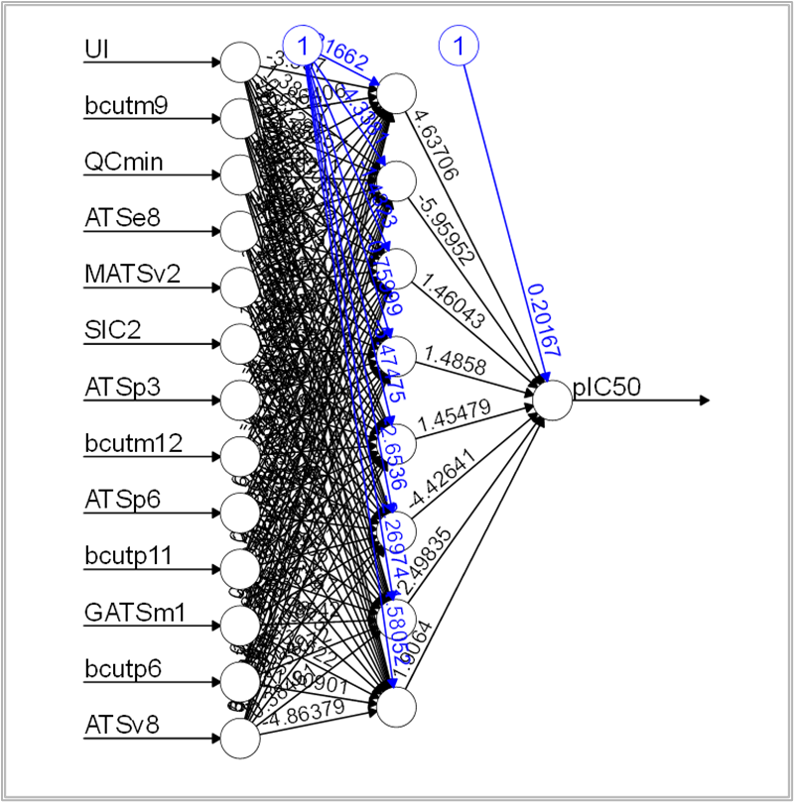

- Figure S2. Full ProTox-III Toxicity Prediction Profiles. Comprehensive toxicological assessments for the lead candidate Modifikasi_W_136.
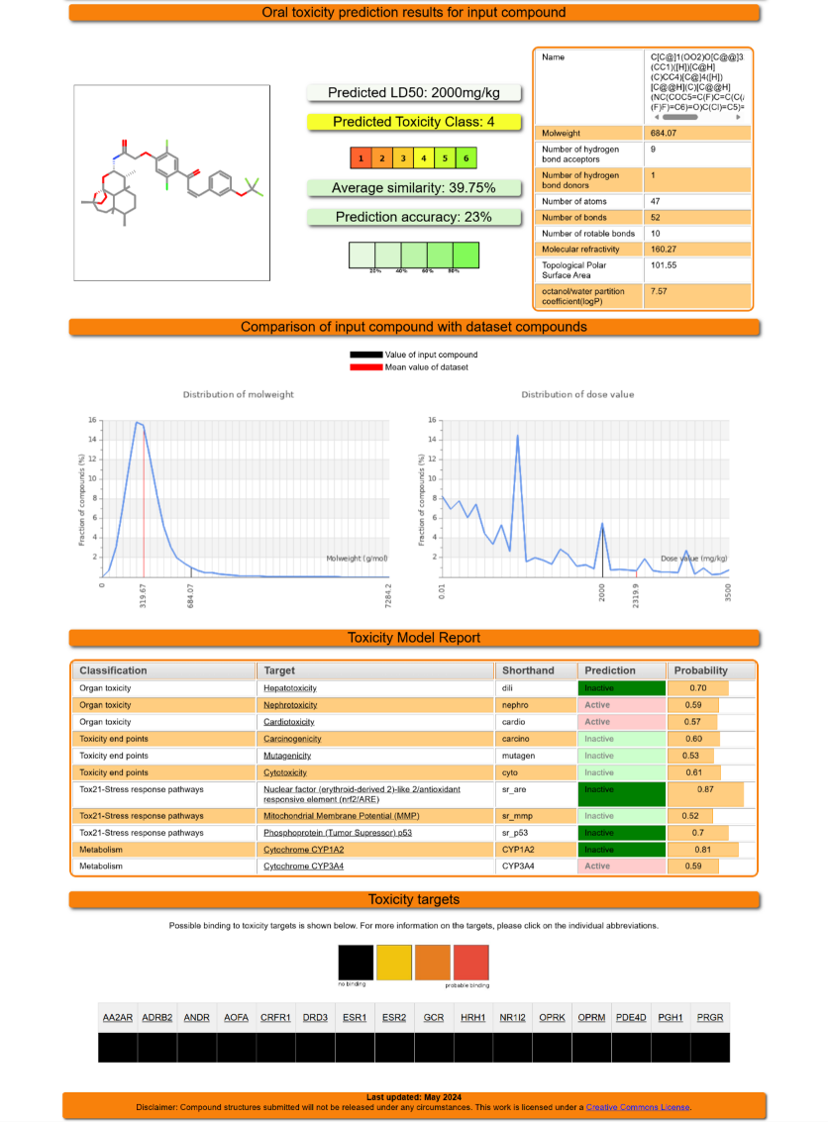

- Supplementary Tables
Supplementary Tables (Integrated in this Document)
- Table S2. Chemical Structures of the Full Dataset. Visual representation of all 193 chalcone derivatives, encompassing structural types A through AA, used for QSAR modeling.
Table S2a. Chemical structures and substituent patterns of the Scaffold A.

Scaffold A
No. | R | R₁ | R₂ | R₃ | R₄ | R₅ | R₆ | pIC₅₀ exp.
1 | H | H | NH₂ | H | Cl | H | Cl | 4,40
2 | H | H | OCH₃ | H | Cl | H | Cl | 4,72
3 | OH | H | H | H | Cl | H | Cl | 4,37
4 | H | H | NH₂ | H | Cl | H | H | 4,53
5 | H | H | H | H | H | H | OCH₃ | 4,62
6 | H | H | NH₂ | H | H | H | OCH₃ | 4,25
7 | H | NH₂ | H | H | H | H | OCH₃ | 4,37
8 | H | H | OCH₃ | H | H | H | OCH₃ | 4,31
9 | OH | H | H | H | H | H | OCH₃ | 4,23
10 | H | F | H | F | H | H | OCH₃ | 4,00
11 | H | H | NH₂ | H | F | H | H | 4,32
12 | H | H | OCH₃ | H | F | H | H | 4,72
13 | H | H | H | H | H | H | OH | 4,61
14 | H | H | OCH₃ | H | H | H | OH | 4,73
15 | H | H | H | H | OCH₃ | H | OCH₃ | 3,88
16 | H | H | F | F | H | OCH₃ | H | 4,27
17 | H | H | NH₂ | H | OCH₃ | OCH₃ | H | 4,16
18 | H | NH₂ | H | H | OCH₃ | OCH₃ | H | 4,36
19 | H | H | OCH₃ | H | OCH₃ | OCH₃ | H | 4,38
20 | H | H | H | H | CF₃ | H | H | 4,37
21 | H | H | OCH₃ | H | CF₃ | H | H | 4,44
22 | H | H | NH₂ | H | Br | H | H | 4,45
23 | H | H | OCH₃ | H | Br | H | H | 4,59
24 | H | H | OCH₃ | H | F | H | F | 4,95
25 | H | OCH₃ | OCH₃ | H | Cl | H | Cl | 4,73
26 | H | OCH₃ | OCH₃ | H | H | H | N(CH₃)₂ | 4,30
27 | H | OCH₃ | OCH₃ | H | Cl | H | H | 4,81
28 | H | OCH₃ | OCH₃ | H | H | H | OCH₃ | 4,26
29 | H | OCH₃ | OCH₃ | H | OCH₃ | H | OCH₃ | 4,18
30 | H | OCH₃ | OCH₃ | H | OCH₃ | OCH₃ | H | 4,45
31 | H | OCH₃ | OCH₃ | H | Br | H | H | 4,86

Table S2b. Chemical structures and substituent patterns of the Scaffold B.

Scaffold B
No. | R₁ | R₂ | R₃ | R₄ | pIC₅₀ exp.
32 | H | H | H | H | 4,31
33 | CH₃ | H | H | H | 4,07
34 | OCH₃ | H | H | H | 3,81
35 | H | H | H | Cl | 4,26
36 | OH | H | H | Cl | 4,22
37 | H | H | CH₃ | H | 4,07
38 | OH | H | CH₃ | H | 4,29
39 | CH₃ | H | CH₃ | H | 4,16
40 | OCH₃ | H | CH₃ | H | 4,20
41 | CH₃ | OCH₃ | H | H | 3,93
42 | H | N(CH₃)₂ | H | H | 3,59
43 | CH₃ | N(CH₃)₂ | H | H | 3,58
44 | H | H | H | OH | 4,05
45 | CH₃ | H | H | OH | 4,26
46 | OCH₃ | H | H | OH | 4,35
47 | H | H | Cl | H | 4,49

Table S2c. Chemical structures and substituent patterns of the Scaffold C.

Scaffold C
No. | R₁ | R₂ | R₃ | R₄ | pIC50 exp.
48 | OH | H | H | OC₂H₅ | 4,36
49 | OC₂H₅ | H | H | OC₂H₅ | 5,50
50 | OH | H | H | OC₃H₇ | 3,90
51 | OH | H | H | OCH(CH₃)₂ | 4,52
52 | OH | H | H | OC₄H₉ | 4,15
53 | OH | H | H | OCH₂CH(CH₃)₂ | 4,51
54 | OH | H | H | OC₅H₁₁ | 4,06
55 | OH | H | H | OCH₃ | 4,15
56 | OC₂H₅ | H | H | OCH₃ | 7,00
57 | OC₃H₇ | H | H | OCH₃ | 4,06
58 | OC₄H₉ | H | H | OCH₃ | 4,21
59 | OH | OH | OCH₃ | H | 4,27
60 | OH | OH | OH | H | 4,45

Table S2d. Chemical structures and substituent patterns of the Scaffold D.

Scaffold D
No. | R₁ | R₂ | R₃ | pIC₅₀ exp.
61 | H | H | H | 5,82
62 | H | H | F | 4,92
63 | H | H | Cl | 5,22
64 | H | H | NO | 5,06
65 | H | H | OCH₃ | 5,47
66 | H | H | OCF₃ | 5,96
67 | H | H | CF₃ | 5,43
68 | H | H | CH₃ | 5,68
69 | H | H | OC₂H₅ | 5,62
70 | CH₃ | H | H | 5,22
71 | H | CH₃ | CH₃ | 5,23

Table S2e. Chemical structures and substituent patterns of the Scaffold E.

Scaffold E
No. | R | pIC₅₀ exp.
72 | H | 5,08
73 | CH₃ | 5,02

Table S2f. Chemical structures and substituent patterns of the Scaffold F.

Scaffold F
No. | pIC₅₀ exp.
74 | 5,72

Table S2g. Chemical structures and substituent patterns of the Scaffold G.

Scaffold G
No. | pIC₅₀ exp.
75 | 4,64

Table S2h. Chemical structures and substituent patterns of the Scaffold H.

Scaffold H
No. | pIC₅₀ exp.
76 | 4,96

Table S2i. Chemical structures and substituent patterns of the Scaffold I.

Scaffold I
No. | pIC₅₀ exp.
77 | 4,94

Table S2j. Chemical structures and substituent patterns of the Scaffold J.
Scaffold J
No. | pIC₅₀ exp.
78 | 4,71

Table S2k. Chemical structures and substituent patterns of the Scaffold K.
Scaffold K
No. | pIC₅₀ exp.
79 | 4,79

Table S2m. Chemical structures and substituent patterns of the Scaffold M.

Scaffold M
No. | R₁ | R₂ | X | Z | pIC₅₀ exp.
80 | H | H | O | - | 4,61
81 | - |  |  | O | 4,67
82 | H | H | S | - | 4,88
83 | - |  |  | S | 5,28
84 | CH₃ | H | O | - | 4,37
85 | CH₃ | H | S | - | 5,75
86 | H | CH₃ | S | - | 4,71
87 | Br | H | O | - | 4,82

Table S2l. Chemical structures and substituent patterns of the Scaffold L.

Scaffold L
No. | pIC₅₀ exp.
88 | 4,58

Table S2n. Chemical structures and substituent patterns of the Scaffold N.

Scaffold N
No. | R₁ | R₂ | R₃ | pIC₅₀ exp.
89 | H | CH₃ | H | 4,79
90 | H | OCH₃ | H | 4,64
91 | OCH₃ | OCH₃ | OCH₃ | 4,62

Table S2o. Chemical structures and substituent patterns of the Scaffold O.

Scaffold O
No. | R₁ | R₂ | R₃ | R₄ | pIC₅₀ exp.
92 | H | OCH₃ | OCH₃ | OCH₃ | 4,82
93 | OCH₃ | OCH₃ | H | H | 4,92
94 | OCH₃ | H | OCH₃ | H | 4,79
95 | OCH₃ | NO | H | H | 5,06
96 | OCH₃ | OCH₃ | OCH₃ | OCH₃ | 4,92
97 | OCH₃ | H | F | H | 4,93

Table S2p. Chemical structures and substituent patterns of the Scaffold P.

Scaffold P
No. | R₁ | R₂ | R₃ | R₄ | pIC₅₀ exp.
98 | H | OCH₃ | OCH₃ | OCH₃ | 4,68
99 | OCH₃ | OCH₃ | OCH₃ | OCH₃ | 5,19

Table S2q. Chemical structures and substituent patterns of the Scaffold Q.

Scaffold Q
No. | R1 | R₂ | R₃ | R₄ | pIC₅₀ exp.
100 | H | OCH₃ | OCH₃ | OCH₃ | 4,91
101 | OCH₃ | OCH₃ | H | H | 5,09
102 | OCH₃ | H | OCH₃ | H | 4,77
103 | OCH₃ | NO | H | H | 5,08
104 | OCH₃ | OCH₃ | OCH₃ | OCH₃ | 5,02
105 | OCH₃ | H | F | H | 4,67

Table S2r. Chemical structures and substituent patterns of the Scaffold R.

Scaffold R
No. | R₁ | R₂ | R₃ | R₄ | pIC₅₀ exp.
106 | H | OCH₃ | OCH₃ | OCH₃ | 4,81
107 | OCH₃ | OCH₃ | OCH₃ | OCH₃ | 5,22

Table S2s. Chemical structures and substituent patterns of the Scaffold S.

Scaffold S
No. | R₁ | pIC₅₀ exp.
108 | CH₃ | 4,91
109 | Ph | 5,11

Table S2t. Chemical structures and substituent patterns of the Scaffold T.

Scaffold T
No. | R₁ | pIC₅₀ exp.
110 | CH₃ | 4,93
111 | Ph | 5,05

Table S2u. Chemical structures and substituent patterns of the Scaffold U.
Scaffold U
No. | R₁ | R₂ | R₃ | pIC₅₀ exp.
112 | H | H | H | 5,63
113 | H | F | H | 5,15
114 | H | Cl | H | 4,94
115 | H | Br | H | 4,72
116 | H | OCH₃ | H | 4,75
117 | H | OCF₃ | H | 6,43
118 | H | NO | H | 4,74
119 | Cl | Cl | H | 4,68
120 | OCH₃ | OCH₃ | OCH₃ | 5,08

Table S2v. Chemical structures and substituent patterns of the Scaffold V.

Scaffold V
No. | R₁ | pIC₅₀ exp.
121 | 4-(Dimethylamino)phenyl | 5,73
122 | Naphthalen-2-yl | 5,35
123 | 4-(Diethylamino)phenyl | 6,26
124 | 4-(Pyrrolidin-1-yl)phenyl | 5,08
125 | 4-(1H-Imidazol-1-yl)phenyl | 5,18
126 | Quinolin-2-yl | 5,42
127 | 4-Nitrophenyl | 5,43
128 | 3-Nitrophenyl | 5,37
129 | 3-(Trifluoromethyl)phenyl | 5,04
130 | Pyridin-2-yl | 5,67
131 | 3.4-Dichlorophenyl | 5,12
132 | 2-(4-Chloro)phenyl | 5,30

Table S2w. Chemical structures and substituent patterns of the Scaffold W.

Scaffold W
No. | R₁ | pIC₅₀ exp.
133 | 2.4-Difluorophenyl | 6,03
134 | 3.4.5-Trimethoxyphenyl | 6,62
135 | 4-Triflouromethoxyphenyl | 6,44
136 | 3-Triflouromethoxyphenyl | 6,59
137 | 4-Fluorophenyl | 6,16
138 | 4-Chlorophenyl | 6,30
139 | 2.6-Dichlorophenyl | 6,85
140 | 3-Methoxyphenyl | 6,14
141 | Phenyl | 6,19
142 | 2-Furyl | 5,64
143 | 2-Thienyl | 5,80
144 | 1.3-Benzodioxo-5-yl | 5,92

Table S2x. Chemical structures and substituent patterns of the Scaffold X.

Scaffold X
No. | R₁ | pIC₅₀ exp.
145 | 2.4-Difluorophenyl | 5,59
146 | 3.4.5-Trimethoxyphenyl | 6,16
147 | 4-Triflouromethoxyphenyl | 6,41
148 | 3-Triflouromethoxyphenyl | 6,62
149 | 4-Fluorophenyl | 6,12
150 | 4-Chlorophenyl | 6,17
151 | 2.6-Dichlorophenyl | 6,30
152 | 3-Methoxyphenyl | 6,17
153 | Phenyl | 6,13
154 | 2-Furyl | 5,85
155 | 2-Thienyl | 5,68
156 | 1.3-Benzodioxo-5-yl | 5,77

Table S2y. Chemical structures and substituent patterns of the Scaffold Y.
Scaffold Y
No. | R | R₁ | R₂ | R₃ | pIC₅₀ exp.
157 | H | OCH₃ | OH | 3, 4 OCH₂OH | 3,84
158 | Double bond | OCH₃ | OH | 3 OCH₃ | 4,34
159 | Double bond | OH | OH | 3 OCH₃ | 4,67
160 | Double bond | OH | OH | 3, 4 OCH₂OH | 4,68
161 | Double bond | OCH₂CH=CH₂ | OCH₂CH=CH₂ | 3 OCH₃ | 4,55

Table S2z. Chemical structures and substituent patterns of the Scaffold Z.

Scaffold Z
No. | R₁ | R₂ | R₃ | R₄ | R₅ | R₆ | In Vitro pIC₅₀(µM)
162 | OCH₃ | OCH₃ | OCH₃ | H | NO₂ | H | 4,32
163 | OCH₃ | OCH₃ | OCH₃ | H | NH₂ | H | 4,26
164 | H | F | OCH₃ | H | OCH₃ | H | 4,22

Table S2aa. Chemical structures and substituent patterns of the Scaffold AA.

Scaffold AA
No. | R | R₁ | R₂ | R₃ | R₄ | pIC₅₀(µM)
165 | OMe | H | OMe | OMe | OMe | 4,69
166 | OMe | H | OMe | H | OMe | 4,91
167 | OMe | H | OMe | OMe | H | 4,59
168 | OMe | H | OH | OMe | H | 4,92
169 | OMe | Br | OMe | OMe | OMe | 4,46
170 | OEt | H | OMe | OMe | OMe | 4,42
171 | OEt | H | OMe | H | OMe | 4,54
172 | OEt | H | OMe | OMe | H | 4,47
173 | OEt | H | OH | OMe | H | 4,93
174 | OEt | H | H | OMe | H | 4,91
175 | OEt | Br | OMe | OMe | OMe | 4,69
176 | Me | H | OMe | OMe | OMe | 4,74
177 | Me | H | OMe | H | OMe | 4,56
178 | Me | H | OMe | OMe | H | 5,02
179 | Me | H | H | OMe | H | 4,97
180 | Me | Br | OMe | OMe | OMe | 4,67
181 | H | H | OMe | OMe | OMe | 4,61
182 | H | H | OMe | H | OMe | 4,61
183 | H | H | OMe | OMe | H | 5,35
184 | H | H | OH | OMe | H | 5,15
185 | H | H | H | OMe | H | 5,66
186 | H | Br | OMe | OMe | OMe | 5,04
187 | F | H | OMe | OMe | OMe | 5,13
188 | F | H | OMe | H | OMe | 4,97
189 | F | H | OMe | OMe | H | 4,81
190 | F | H | H | OMe | H | 5,32
191 | F | Br | OMe | OMe | OMe | 5,09

Table S2y. Chemical structures and substituent patterns of the Scaffold Y.
Scaffold Y
No. | pIC₅₀ exp.
192 | 4,62

Table S2z. Chemical structures and substituent patterns of the Scaffold Z.
Scaffold Z
No. | pIC₅₀ exp.
193 | 4,64

Supplementary Tables (Available via Zenodo Repository)
- Table S1. Complete dataset of 193 chalcone derivatives with SMILES notations and experimental pIC₅₀ values.
- Table S3. ANOVA statistics for the Stepwise MLR model.
- Table S4. Correlation matrices showing the inter-correlation between the 27 selected molecular descriptors.
- Table S5. Comparative performance data for all tested ANN architectures (13i – 4N – 1O to 13i – 10N – 1O).
- Table S6. Standardized regression coefficients and statistical significance for all 27 descriptors.
- Table S7. Detailed Wilcoxon Signed-Rank Test results comparing absolute errors (AE) of MLR and ANN models.

- Supplementary Files (Available via Zenodo Repository)
- File S1. Full library of designed compounds with their calculated descriptors and predicted activities.
- File S2. Full statistical calculation workflows for all validation parameters.

- Mandatory Statements
Funding: This research received no specific external grant funding. Software licenses were provided through institutional resources at Lambung Mangkurat University.

Author Contributions: Conceptualization, Methodology, Software, Formal analysis, Data curation, Writing (original draft); Dr.rer.nat. L.T.: Conceptualization, Resources, Writing (review & editing), Supervision, Project administration; Dr. U.T.S.: Conceptualization, Methodology, Validation, Writing (review & editing), Supervision.

Competing Interests: The authors declare no competing financial or non-financial interests.

Ethics Approval: Not applicable. This study involved computational analysis of published data and did not involve human or animal subjects.

Acknowledgements: The authors thank the Department of Pharmacy and Department of Chemistry, Faculty of Mathematics and Natural Sciences, Lambung Mangkurat University, for providing institutional support and research facilities. The authors gratefully acknowledge Normaidah, B.Pharm., M.Pharm.Sci and Dr. Samsul Hadi for their critical suggestions during thesis examination. Computational resources and software licensing were coordinated through institutional channels at Lambung Mangkurat University

