Supporting Information

Competitive Adsorption Stabilizes Metallic Copper for Anodic H₂ Evolution from $α$-H Aliphatic Aldehydes
Obaida Zeno¹, Saroj Kumari¹, Amirhossein Farzi¹, Sathishkumar Nadaraj¹, Hamed Heidarpour¹, Mahdi Salehi¹, Chris Akl¹, Jiayin Zhang¹, Félix Pelletier¹, Sina Pourebrahimi¹, Alaleh Esfandiari¹, Freddy E. Oropeza², Victor de la Peña O'Shea², Alexis T. Bell^{3, 4, *}, Ali Seifitokaldani^{1, *}

¹ Department of Chemical Engineering, McGill University, 3610 Rue University, Montreal, Québec H3A 0C5, Canada
² Photoactivated Processes Unit, IMDEA Energy Institute, Technological Park of Mostoles, Avda. Ramón de la Sagra 3, Madrid, Spain
³ Lawrence Berkeley National Laboratory, Berkeley, California 94720, United States
⁴ Department of Chemical and Biomolecular Engineering, University of California, Berkeley, Berkeley, California 94720, United States
* Corresponding author: alexbell@berkeley.edu
* Corresponding author: ali.seifitokaldani@mcgill.ca

The Faradaic efficiency (FE) for hydrogen gas and acetate was evaluated using the equation:

$$FE(\%)=\frac{mole of produced product}{{total charge passed}/{(n×F)}}×100\%$$
Where F : Faraday constant = 96485 C mol⁻¹

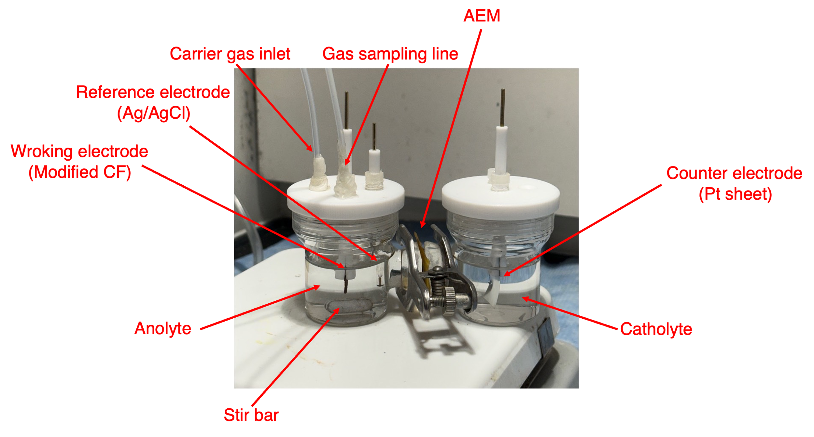
Figure S1. The 50 mL H-cell used for electrochemical experiments and its components. The AEM used is a Fumasep FAA−3−PK−75 is a 70-80 microns thick membrane that is stable in the pH range and with a specific area resistance of 1.2−2.0 (in Cl– form) Ω•cm^{–1}. In a typical experiment, 40 mL aldehyde-containing anolyte and 40 mL aldehyde-free catholyte solutions were used.
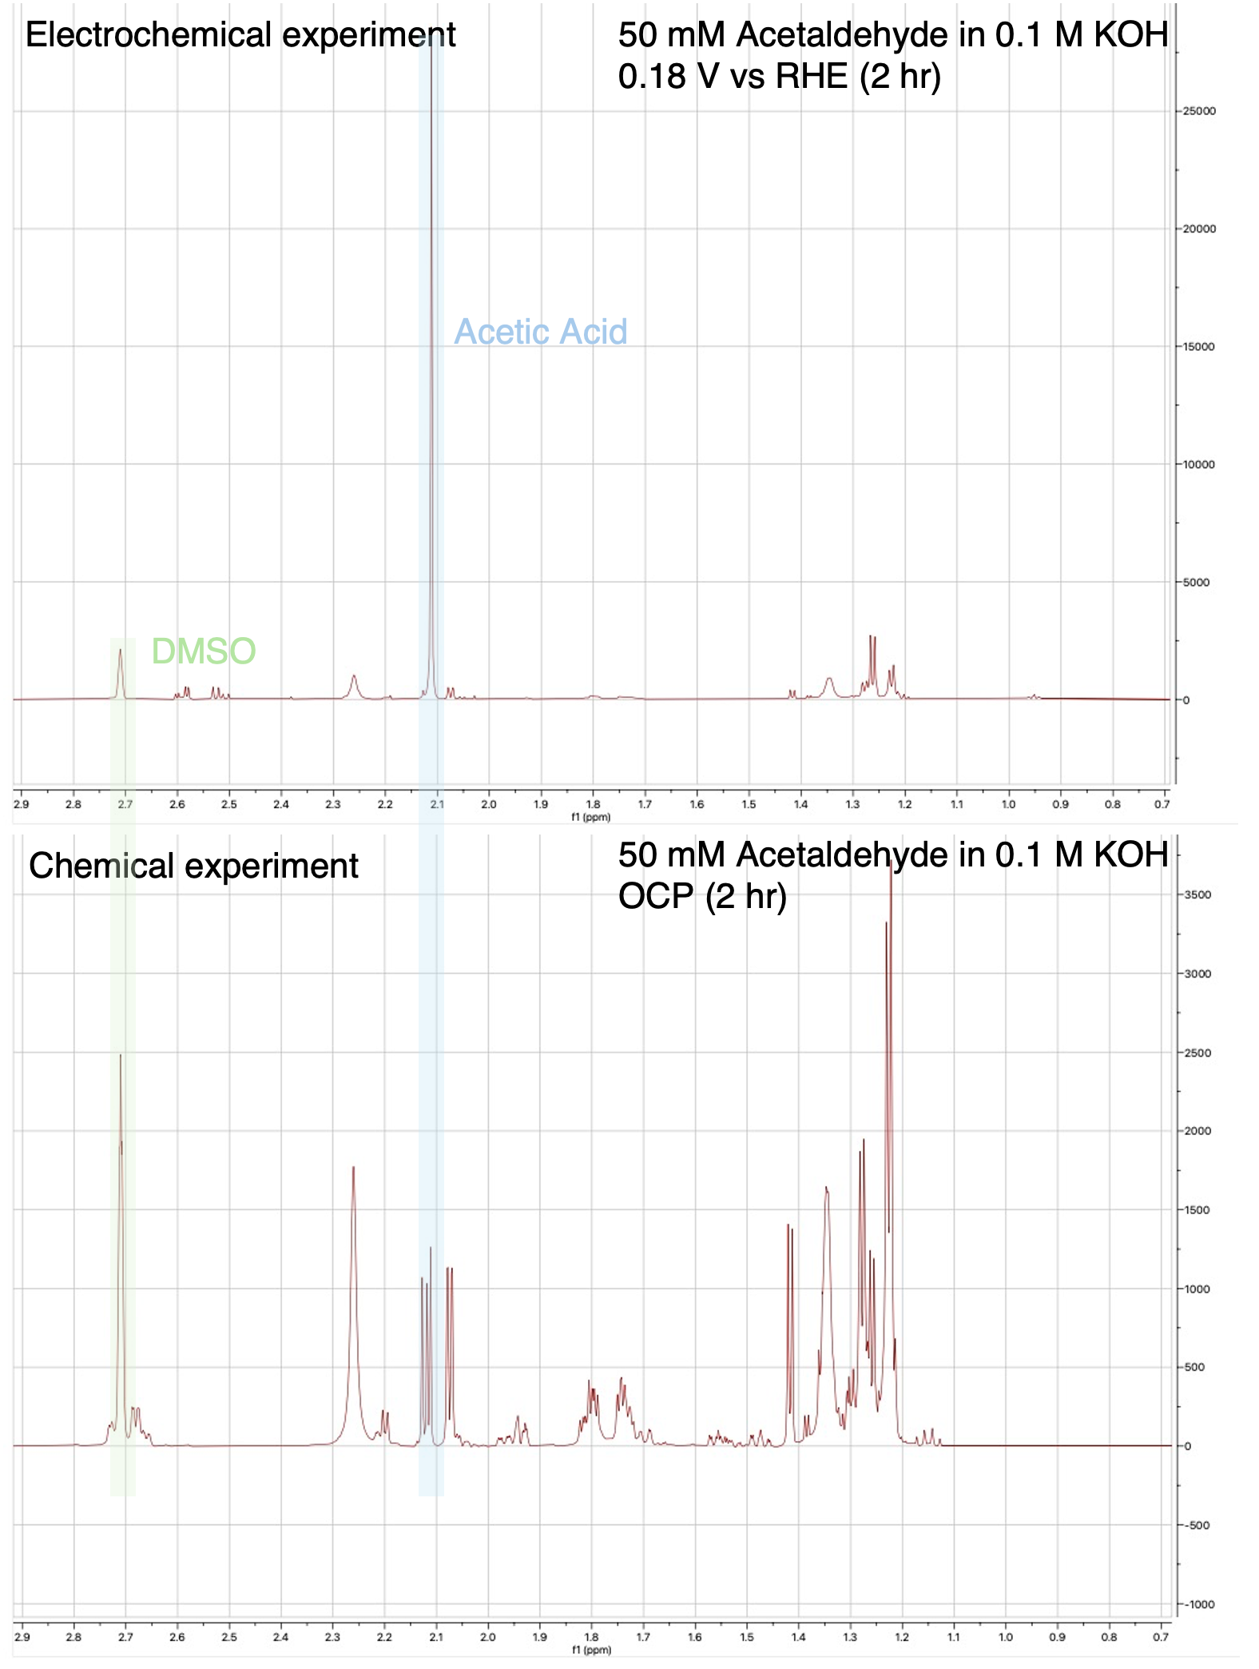
Figure S2. Electrochemical and chemical ¹H NMR spectra for a 2-hour electrolysis experiment at 0.18 V vs RHE. From the analysis, it was clear that some product is forming chemically, having the same chemical shift as acetic acid. This was accounted for in the quantification of the liquid product’s FE.

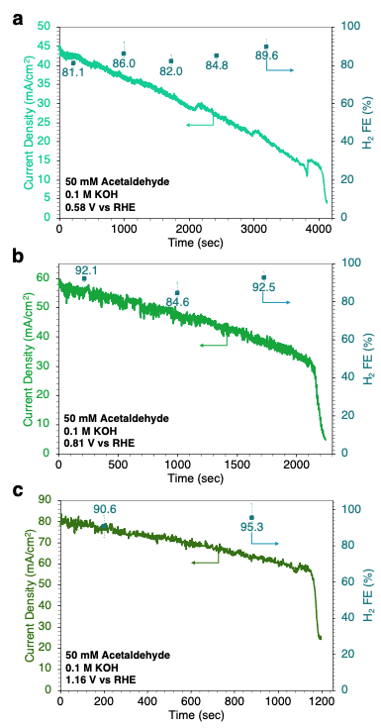
Figure S3. CA test results for (a) 0.58, (b) 0.81 and (c) 1.16 V vs RHE showing the respective recorded H₂ FE values.
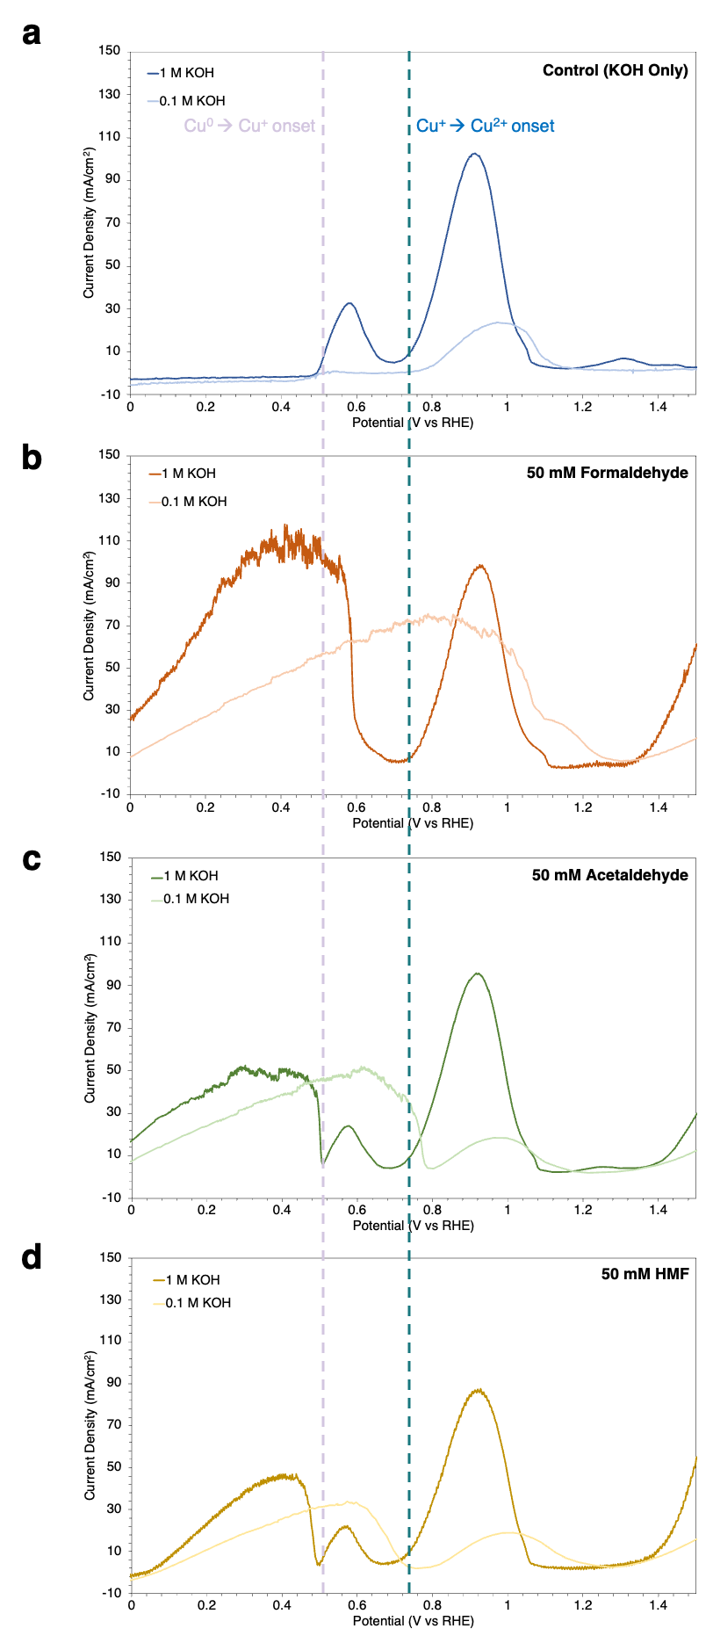
Figure S4. LSVs of (a) KOH only, (b) formaldehyde, (c) acetaldehyde and (d) HMF in 0.1 and 1.0 M KOH demonstrating the effect of aldehyde oxidation on the copper oxidation peak (competition).
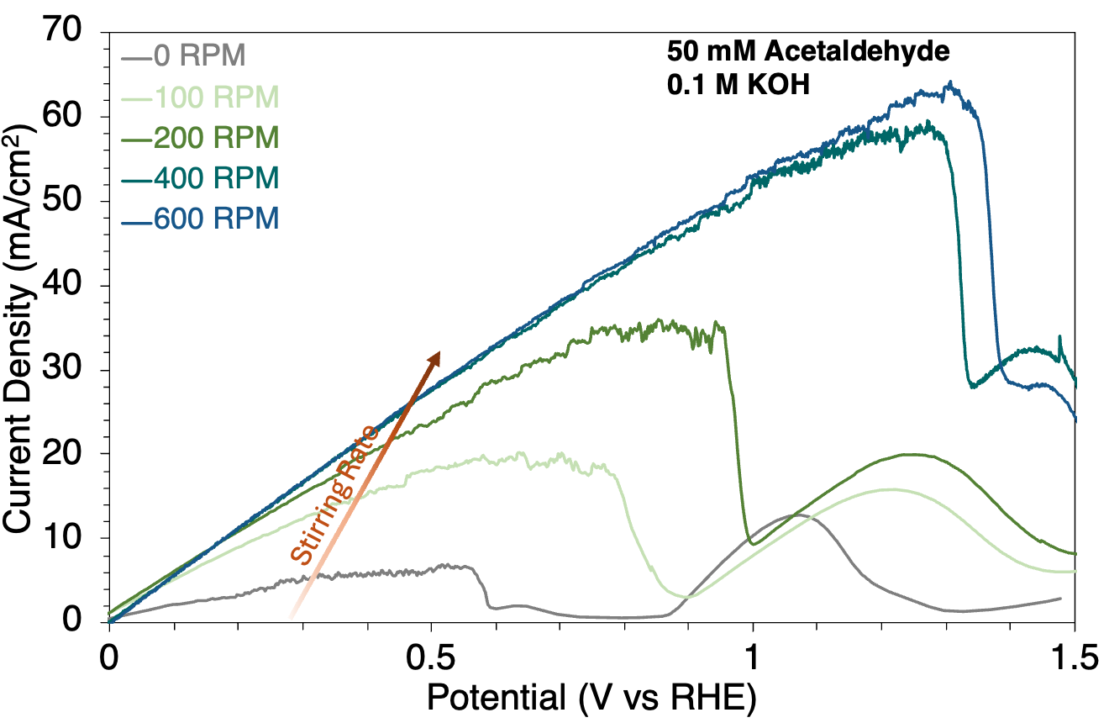
Figure S5. LSVs for 50 mM acetaldehyde in 0.1 M KOH at different stirring rates.

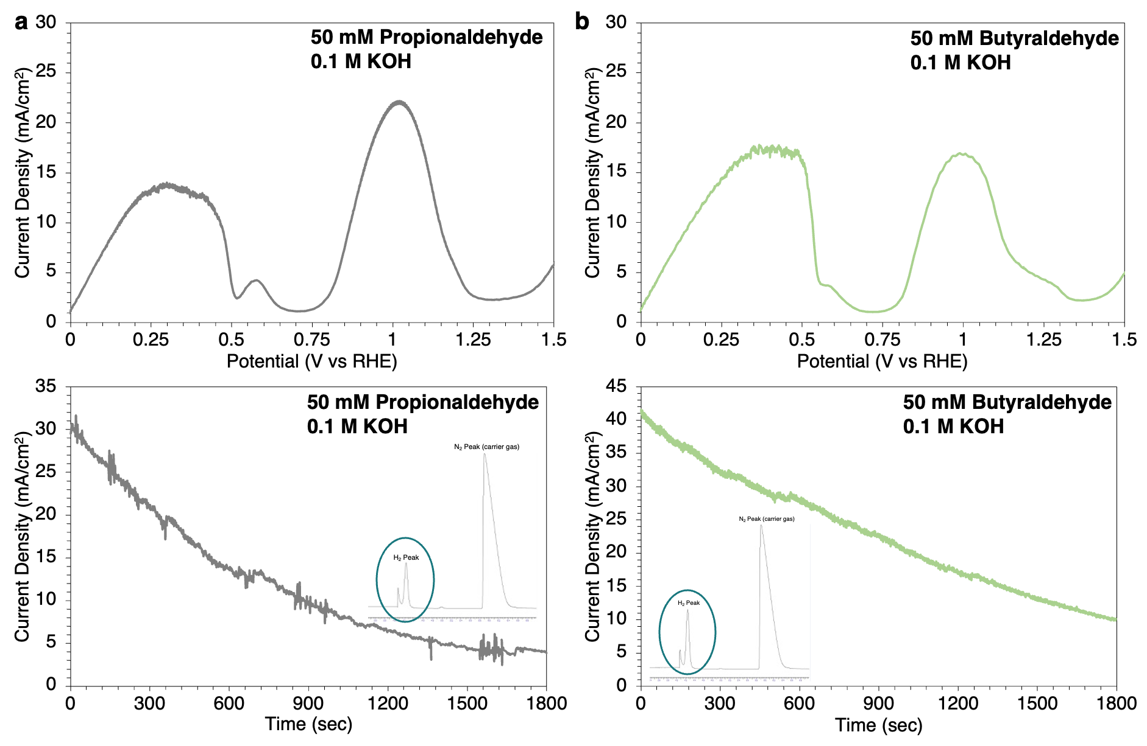
Figure S6. LSV and CA test results and GC signal showing H₂ detection during the electrolysis of (a) propionaldehyde and (b) butyraldehyde (50 mM) in 0.1 M KOH.

Table S1. Charge transfer resistance (R_{ct}) and solution resistance R_{s} values corresponding to Figure 2f.
Acetaldehyde Concentration (mM) | R_{ct} (Ω) | R_{s} (Ω)
0 | 12.435 | 12.471
50 | 5.5508 | 12.607
100 | 3.6089 | 13.186
200 | 2.4820 | 14.107

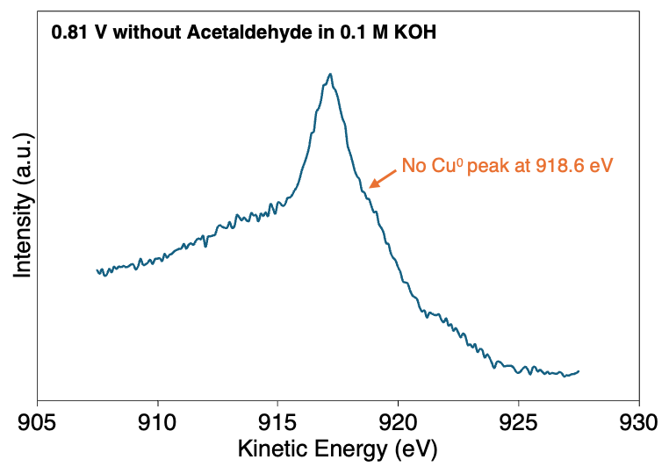
Figure S7. XPS Cu LMM results for catalysts subjected to 0.81 V vs RHE for 4 minutes without acetaldehyde.

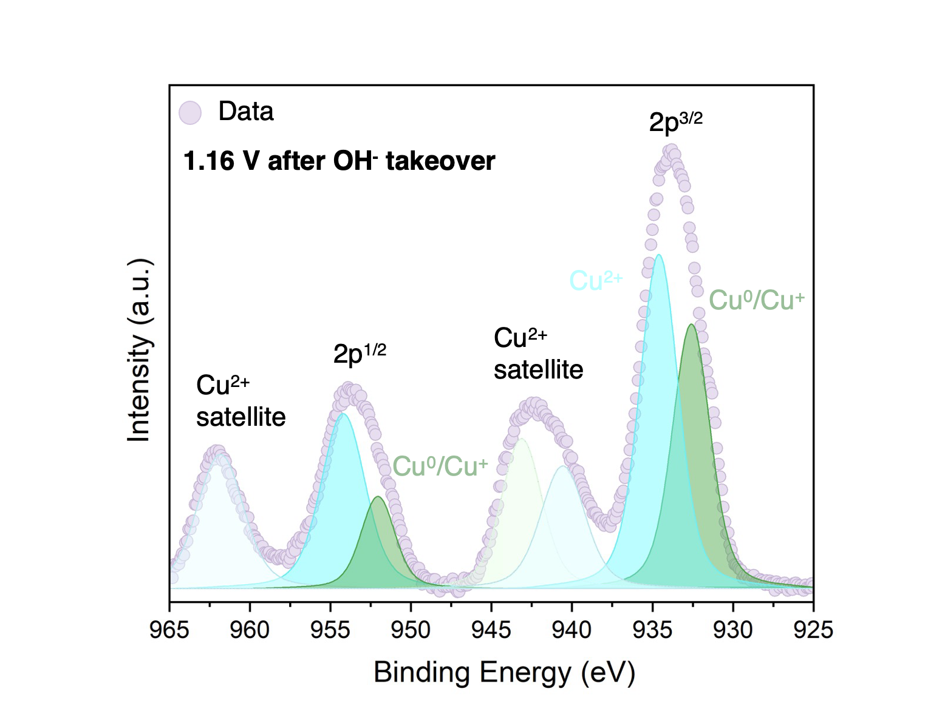
Figure S8. XPS Cu 2p results for catalysts subjected to and 1.16 V for 4 min vs RHE without acetaldehyde.

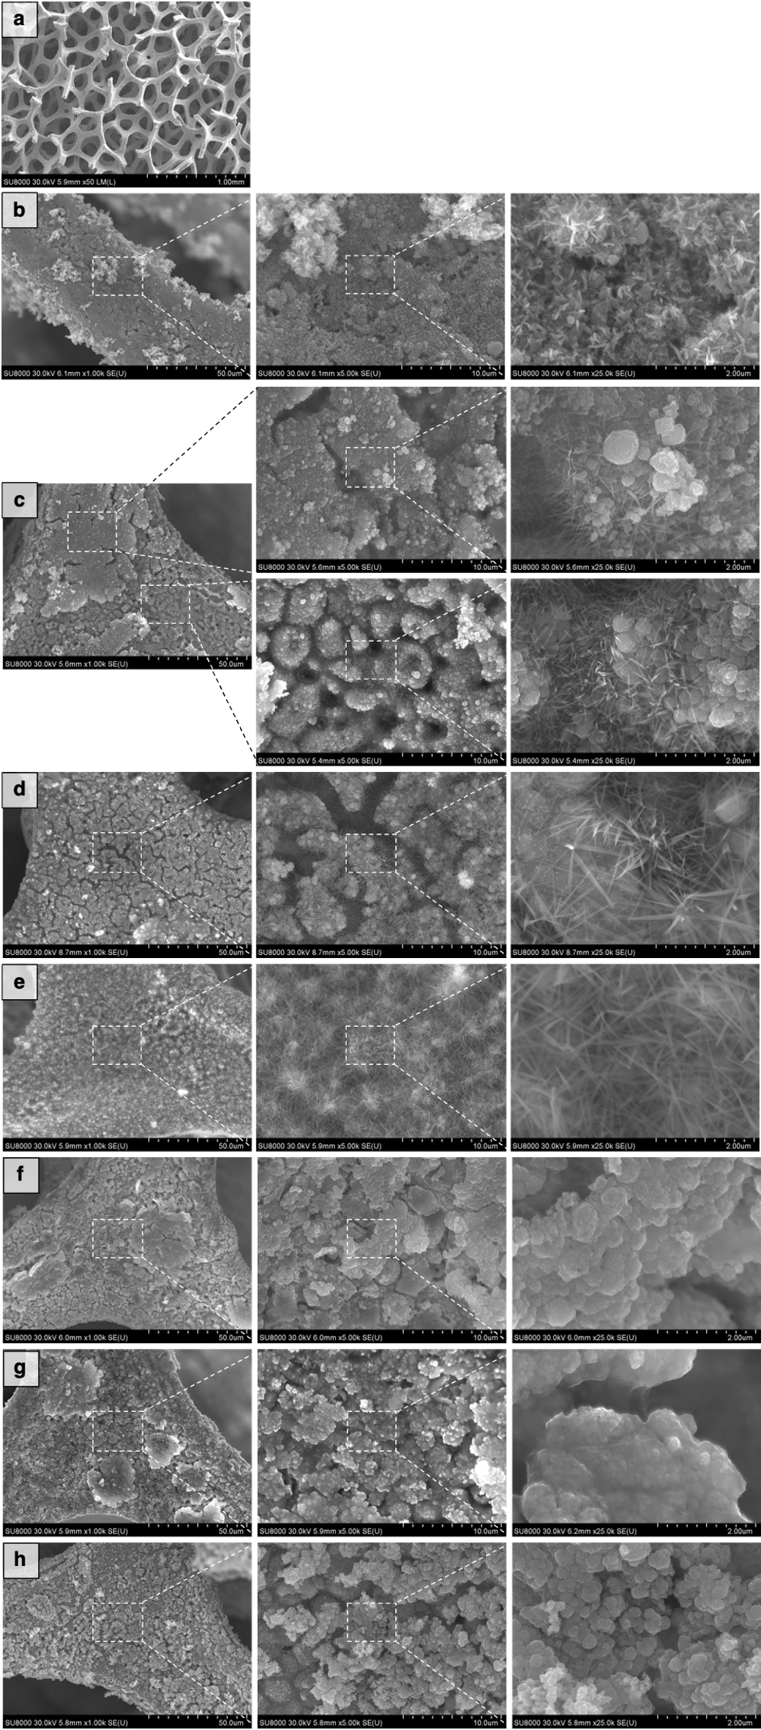
Figure S9. Morphological characterization by SEM imaging. (a) Low magnification image showing the foam structure. (b) A fresh catalyst. (c) The catalyst in 0.1 M KOH under 1.16 V vs RHE applied potential and no acetaldehyde, for a short period of 90 s. (d) The catalyst in 0.1 M KOH under 1.16 V vs RHE applied potential and no acetaldehyde, for a longer period of 240 s. (e) The catalyst in 0.1 M KOH and 50 mM acetaldehyde under 1.16 V vs RHE applied for a long period of time. (f) The catalyst in 0.1 M KOH under 0.73 V vs RHE applied potential and no acetaldehyde. (g) The catalyst after being exposed to 500 mM acetaldehyde in RO water. (h) The catalyst after being exposed to 500 mM acetaldehyde in 1 M KOH.
Table S2. Cu⁰, Cu⁺, and Cu²⁺ fraction values (%) during LSV derived from linear combination fitting (LCF). The values in parentheses represent the fitting standard deviation. These data were normalized to their initial values for Figure 5c. Data points associated with large fitting uncertainties were excluded from Figure 5.
Potential  (V vs RHE) | KOH |  |  | KOH + Acetaldehyde
Potential  (V vs RHE) | Cu⁰ | Cu⁺ | Cu²⁺ | Cu⁰ | Cu⁺ | Cu²⁺
0.05 | 87.9 (1.0) | 9.3 (1.1) | 2.8 (1.5) | 71.8 (1.0) | 8.4 (1.1) | 19.8 (1.4)
0.14 | 84.7 (0.9) | 12.2 (1.0) | 3.1 (1.4) | 42.2 (3.0) | 38.2 (3.1) | 19.6 (4.3)
0.23 | 85.6 (1.0) | 11.3 (1.1) | 3.1 (1.5) | 71.8 (0.9) | 12.0 (0.9) | 16.2 (1.3)
0.32 | 83.2 (0.9) | 13.7 (1.0) | 3.1 (1.4) | 75.5 (0.9) | 9.3 (1.0) | 15.2 (1.4)
0.41 | 83.6 (1.0) | 13.2 (1.0) | 3.2 (1.4) | 71.2 (1.0) | 13.0 (1.0) | 15.8 (1.4)
0.5 | 84.6 (0.9) | 11.7 (1.0) | 3.7 (1.4) | 76.3 (0.9) | 8.2 (1.0) | 15.5 (1.4)
0.59 | 86.1 (1.1) | 9.2 (1.1) | 4.7 (1.6) | 74.9 (0.9) | 8.2 (1.0) | 16.9 (1.3)
0.68 | 46.3 (2.1) | 45.7 (2.2) | 8.0 (3.0) | 65.3 (1.1) | 15.0 (1.1) | 19.7 (1.6)
0.77 | 38.0 (2.5) | 52.9 (2.7) | 9.1 (3.7) | 63.5 (1.1) | 14.5 (1.1) | 22.0 (1.6)
0.86 | 34.8 (2.5) | 51.1 (2.7) | 14.0 (3.7) | 57.8 (1.1) | 13.7 (1.1) | 28.4 (1.6)
0.95 | 39.4 (2.5) | 39.2 (2.7) | 21.4 (3.7) | 48.1 (1.2) | 19.2 (1.3) | 32.7 (1.7)
1.04 | 38.4 (2.8) | 35.1 (2.9) | 26.5 (4.0) | 17.5 (3.5) | 42.0 (3.7) | 40.5 (5.1)
1.13 | 36.5 (2.8) | 31.8 (3.0) | 31.7 (4.1) | 31.9 (2.2) | 27.2 (2.3) | 40.9 (3.1)
1.22 | 34.7 (2.8) | 29.4 (3.0) | 35.9 (4.1) | 33.6 (2.0) | 25.1 (2.2) | 41.3 (3.0)
1.31 | 30.7 (2.7) | 28.7 (2.9) | 40.7 (4.0) | 46.1 (1.5) | 11.9 (1.6) | 42.0 (2.2)
1.40 | 29.2 (2.8) | 27.2 (2.9) | 43.5 (4.0) | 27.2 (2.5) | 25.4 (2.6) | 47.4 (3.6)

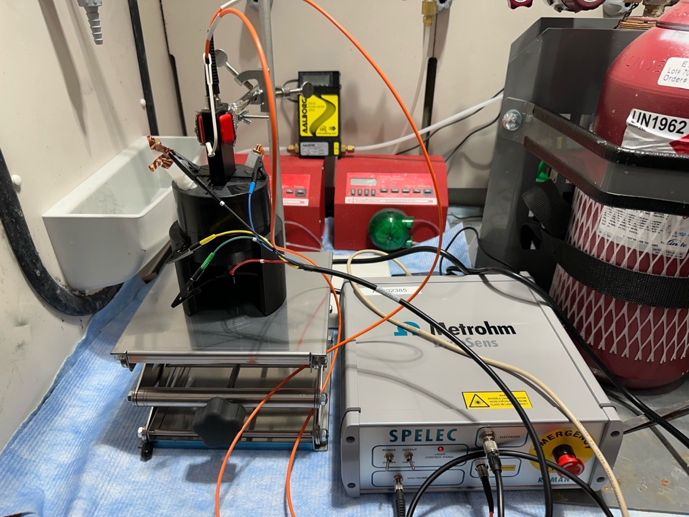
Figure S10. In situ Raman setup used for scanning surface species under electro-oxidation of acetaldehyde in Figure 5.

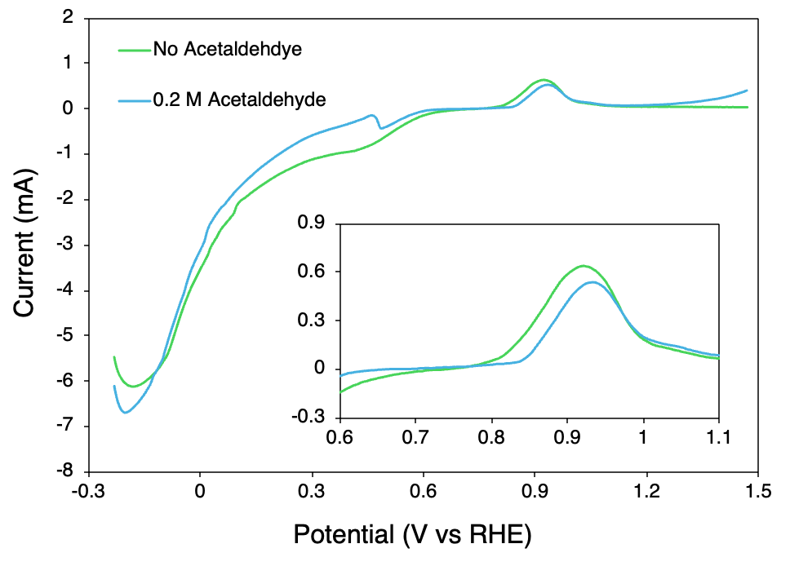
Figure S11. LSV curves corresponding to the in situ Raman results in Figure 5. A delay in copper oxidation is noted in the presence of acetaldehyde.

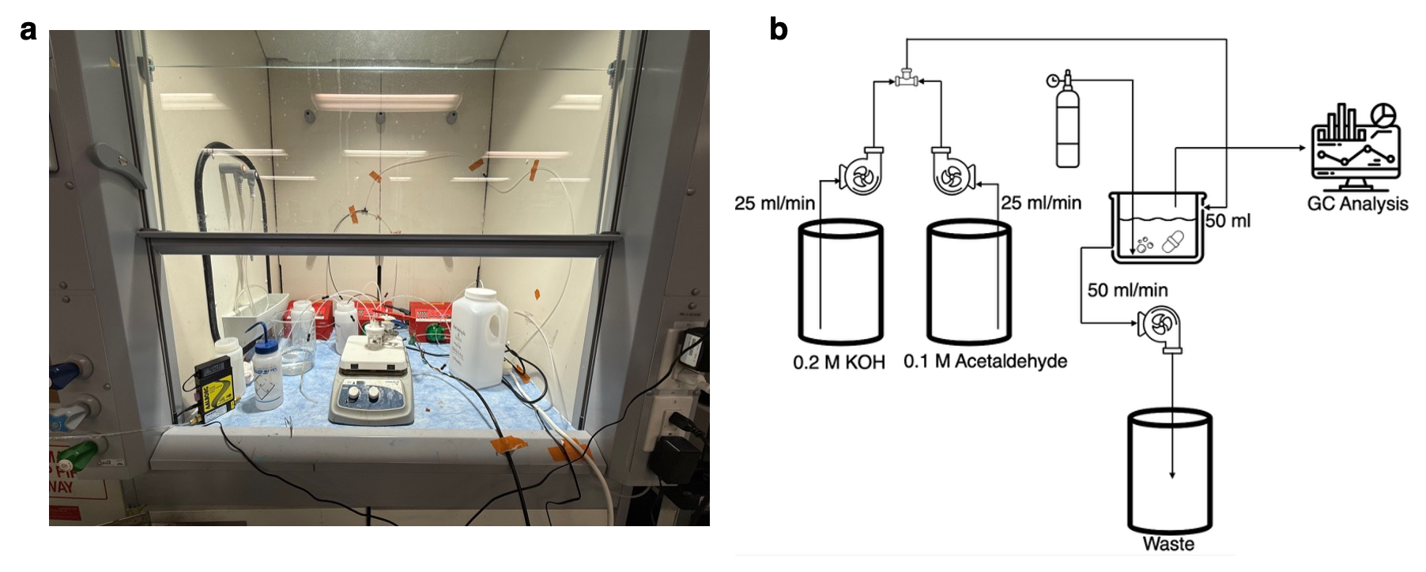
Figure S12. (a) Picture and (b) schematic of the continuous stability experimental system.

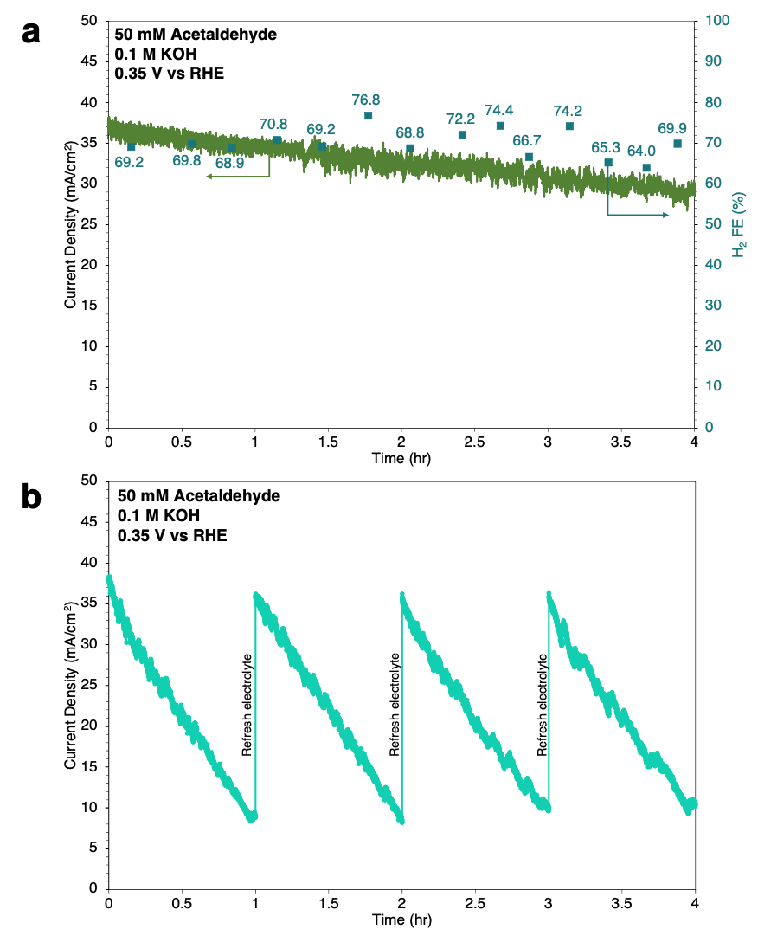
Figure S13. 4-hour (a) continuous and (b) cyclic stability experimental results showing the difference in performance. The measured H₂ FE values for the continuous system are reported in (a).

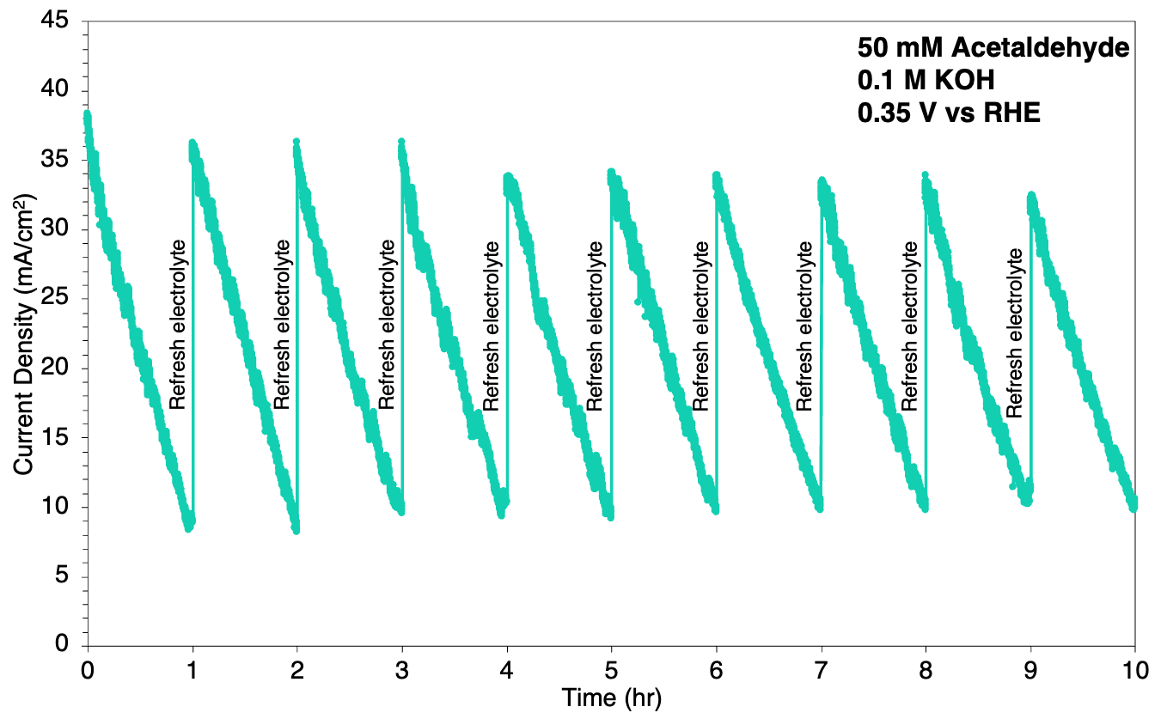
Figure S14. Cyclic stability results using the same catalyst for 10-cycles (each lasting one hour) with electrolyte replenishment.

Note S1. Techno-economic Analysis (TEA)
Potassium acetate is a high-value, versatile chemical as it is used in the pharmaceutical and the food and beverage industries, and its market presents good growth potential with a projected compounded annual growth rate of 5.2% over the next 10 years according to market research [1]. As such, investigating other ways to produce potassium acetate, including the electrochemical approach, may be worthwhile due to its significant market size, as well as the global efforts in transitioning from thermochemical to electrochemical processes to support sustainability endeavors [2], [3].
Acetaldehyde, which is the proposed precursor of the electrochemical production of potassium acetate, can be sourced from petrochemical wastewater, but since the concentration is usually low, for the sake of reliability, acetaldehyde will be assumed to come from a bioethanol oxidative dehydrogenation plant, with a reported minimum selling price (MSP) of 887 USD/ton [4]. By employing acetaldehyde as the anodic reactant in a low-potential oxidation reaction, acetate production can be coupled with hydrogen generation, offering opportunities for reduced energy consumption and improved environmental performance. Potassium acetate is assumed to have a selling price of 750 USD/ton, which is within the lower range of market standard price in accordance with bulk listings by chemical providers [5] via Made in China network. Hydrogen that is produced from the process is valued at a price of 7,570 USD/ton which is in the price range suggested by PWC [6] as it is considered green hydrogen. Electricity is priced at 0.056 USD/kWh based on North American pricing and according to the market exchange rate for the local currency. Potassium hydroxide is priced at 500 USD/ton based on lower-end bulk chemical listings for potassium hydroxide flakes on Made in China network [7], with an area-based pricing of electrolyzer priced at 1,000 USD/m² [8]. Table S3 below lists the prices (in USD) of relevant chemicals for the low-potential acetaldehyde-enabled aldehyde oxidation reaction (AOR) and alkaline water electrolysis (AWE) for comparison.
Table S3. Summarized relevant material costs (USD/kg)
Chemical | AOR | AWE
Potassium Hydroxide | 0.500 | 0.500
Acetaldehyde | 0.887
Hydrogen | 7.570 | 7.570
Oxygen |  | 0.12
Potassium Acetate | 0.75

Using a heuristics-based TEA model [8], we are able to estimate the cost of operation based on experimental electrochemical parameters. To better align model with a realistic market, we will provide results for a plant with a production basis of 1 daily ton of hydrogen as well as analyze profit margins compared to AWE system modelled with the same method. In this study, AOR refers to a system where the low-potential anodic reaction is powered by acetaldehyde and potassium acetate, and coupled with the HER at the cathode.
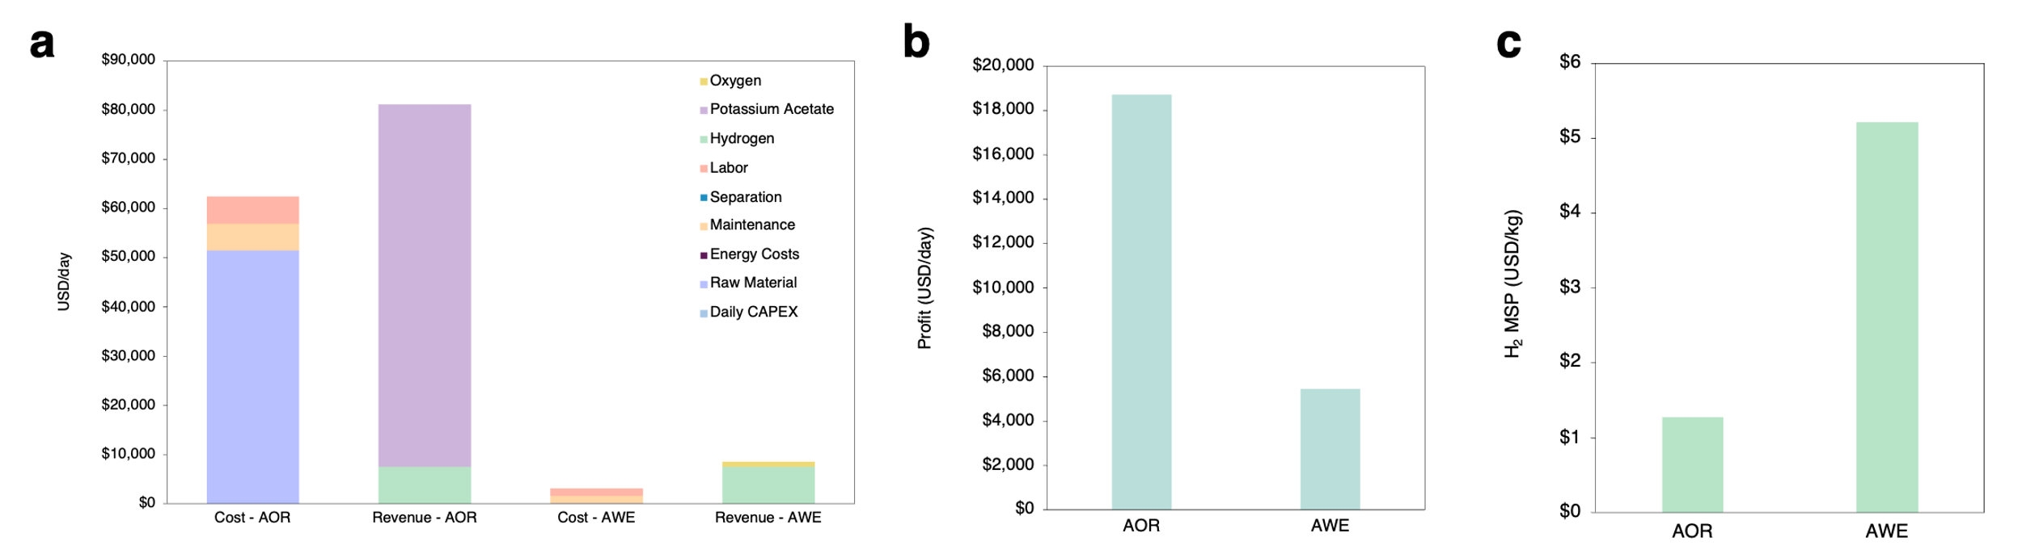
Figure S15. (a) Daily cost and revenue breakdown for AOR and AWE systems. (b) Economic performance comparison of AOR and AWE systems in terms of daily profit. (c) Hydrogen minimum selling price (MSP) comparison between conventional AWE and AOR systems.
Based on the aforementioned scenario, Figure S14 depicts and compares multiple economical aspects for a system that works with AOR coupled with the hydrogen evolution reaction (HER) and one that works with AWE, where HER is coupled with the oxygen evolution reaction (OER). Both plants are taken to produce one ton of hydrogen per day.
A detailed breakdown of the cost and revenue structures in Figure S14a reveals that while the AOR system incurs higher costs than the AWE system, it also generates a significantly greater daily revenue. By comparing the data, and as illustrated in Figure S14b, the total profit of the AOR system is more than threefold higher than that of the AWE system.
As 1 ton of daily hydrogen is used as a basis for the AOR and AWE systems, the revenue generated from hydrogen production is identical for both. However, the role of hydrogen in the overall revenue structure differs substantially between the two configurations. In the AWE case, hydrogen represents the primary profit-generating product relative to the co-produced oxygen. In contrast, in the AOR system, the revenue attributed to hydrogen accounts for only approximately 10% of the revenue generated by the co-product potassium acetate, implying that potassium acetate is the major product in this system from a revenue standpoint. This provides flexibility in the way hydrogen can be priced in a competitive market. While keeping the selling price of potassium acetate and oxygen for the AOR and AWE systems, respectively, at the market prices reported in Table S3, the minimum hydrogen selling price is 1.27 USD/kg and 5.21 USD/kg for AOR and AWE, respectively as shown in Figure S14c. This is due to potassium acetate being able to absorb the cost with its higher value compared to oxygen. Overall, this positions the AOR system more competitively pertaining to the green hydrogen market.
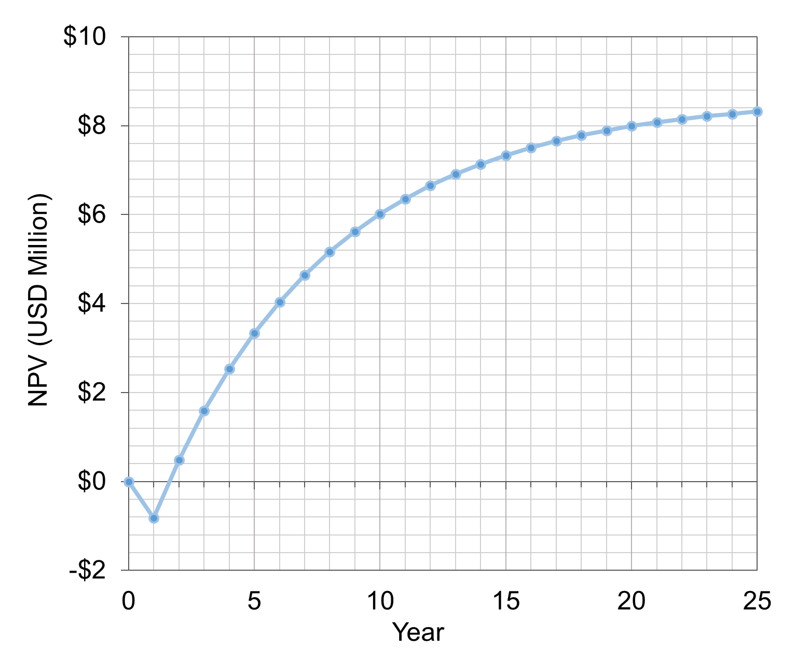
Figure S16. Discounted cashflow diagram of net present value (NPV) for the AOR system
To assess the economic viability of the AOR-enabled system, a net present value (NPV) analysis was conducted over the project’s lifetime of 25 years. Figure S15 shows the evolution of the NPV of the system with applied heuristics related to the scaleup of an initial capital investment of 818,000 USD (ten times the total capital cost). An internal rate of return of 15% is assumed as it is a relatively standard value according to McKinsey [9]. Profits are assumed to be taxed at a flat 40% with 35% declining balance depreciation with a 10% of initial costs as salvage value after an assumed 25 plant operating life. The system shows very low payback period which would suggest more room for making the products more affordable. Detailed calculations are listed below in Table S4.

Table S4. NPV calculations
Year  A | Annual Profits  B | Others  C | Investment  D | Depreciation Deduction  E = Remaining value x Depreciation rate | Taxable Profits  F = B + C -E | Taxes  G = F x tax rate | Net Cash Flow  H = B + C -D - G | NPV  I = sum + NPV (I)
0 |  |  |  |  |  |  |  | 0
1 | $0 | $0 | $818,000 | $0 | $0 | $0 | ($818,000) | ($818,000)
2 | $2,306,756 | $0 | n/a | $286,300 | $2,020,456 | $808,182 | $1,498,574 | $485,107
3 | $2,306,756 | $0 | n/a | $186,095 | $2,120,661 | $848,264 | $1,458,492 | $1,587,937
4 | $2,306,756 | $0 | n/a | $120,962 | $2,185,794 | $874,318 | $1,432,438 | $2,529,788
5 | $2,306,756 | $0 | n/a | $78,625 | $2,228,131 | $891,252 | $1,415,504 | $3,339,107
6 | $2,306,756 | $0 | n/a | $51,106 | $2,255,650 | $902,260 | $1,404,496 | $4,037,390
7 | $2,306,756 | $0 | n/a | $33,219 | $2,273,537 | $909,415 | $1,397,341 | $4,641,499
8 | $2,306,756 | $0 | n/a | $21,592 | $2,285,164 | $914,065 | $1,392,691 | $5,165,063
9 | $2,306,756 | $0 | n/a | $14,035 | $2,292,721 | $917,088 | $1,389,668 | $5,619,348
10 | $2,306,756 | $0 | n/a | $9,123 | $2,297,633 | $919,053 | $1,387,703 | $6,013,819
11 | $2,306,756 | $0 | n/a | $5,930 | $2,300,826 | $920,330 | $1,386,426 | $6,356,523
12 | $2,306,756 | $0 | n/a | $3,854 | $2,302,902 | $921,161 | $1,385,595 | $6,654,347
13 | $2,306,756 | $0 | n/a | $2,505 | $2,304,251 | $921,700 | $1,385,056 | $6,913,224
14 | $2,306,756 | $0 | n/a | $1,628 | $2,305,128 | $922,051 | $1,384,705 | $7,138,277
15 | $2,306,756 | $0 | n/a | $1,059 | $2,305,697 | $922,279 | $1,384,477 | $7,333,943
16 | $2,306,756 | $0 | n/a | $688 | $2,306,068 | $922,427 | $1,384,329 | $7,504,070
17 | $2,306,756 | $0 | n/a | $447 | $2,306,309 | $922,524 | $1,384,232 | $7,651,995
18 | $2,306,756 | $0 | n/a | $291 | $2,306,465 | $922,586 | $1,384,170 | $7,780,621
19 | $2,306,756 | $0 | n/a | $189 | $2,306,567 | $922,627 | $1,384,129 | $7,892,465
20 | $2,306,756 | $0 | n/a | $123 | $2,306,633 | $922,653 | $1,384,103 | $7,989,720
21 | $2,306,756 | $0 | n/a | $80 | $2,306,676 | $922,670 | $1,384,086 | $8,074,288
22 | $2,306,756 | $0 | n/a | $52 | $2,306,704 | $922,682 | $1,384,074 | $8,147,825
23 | $2,306,756 | $0 | n/a | $34 | $2,306,722 | $922,689 | $1,384,067 | $8,211,769
24 | $2,306,756 | $0 | n/a | $22 | $2,306,734 | $922,694 | $1,384,062 | $8,267,373
25 | $2,306,756 | $0 | n/a | $14 | $2,306,742 | $922,697 | $1,384,059 | $8,315,724
 | $2,306,756 | $40,900 | n/a | $9 | $2,347,647 | $939,059 | $1,408,597 | $8,358,514

Overall, the results of the TEA indicate that a co-production of hydrogen with potassium acetate, even with a higher capital cost due to the transition of the major product from hydrogen to potassium acetate, would be a value-adding platform compared to standard AWE system in the green hydrogen sphere.

TEA Methodology [8]:
Daily CAPEX (Capital cost):
The cost (USD) of cells, membrane and catalyst, balance of plant (BoP) and installation are the four components of the capital cost. The daily CAPEX is acquired from breaking the sum of the capital cost into 25 years, and each year has to 340 operative days.
$$Cost of cells (USD/m^{2})=\frac{1000 x Charge}{Time x Current density}$$
$$Membrane and catalyst=5\% x Cell cost$$
$$Electrolyzer cost=cost of cells+membrane and catalyst$$
$$BoP=30\% x Electrolyzer cost$$
$$Installation cost=\frac{Electrolyzer cost}{Lang Factor^{*}}$$
*$: Lang Factor=5, as a typical value for a fluid processing plant$
Daily OPEX (Operational cost):
Operational cost (USD per day) consists of labor, separation, maintenance, energy cost and raw materials. Raw materials cost can be estimated by finding online listings for chemicals and applying those to the material inputs. As for the other costs, since the scope of this study focuses on the electrolyzer unit, the cost of the electrolyzer is assumed to be the capital cost used in accordance with the following guidelines:
$$Labor=10\% x Electrolyzer cost$$
$$Maintenance=10\% x Electrolyzer cost$$
$$Energy cost=Energy consumption x Electricity price$$
$$Separation=20\% x Energy cost$$
MSP Calculations:
The MSP was calculated using a discounted cashflow excel-based NPV model, where the selling price was adjusted to achieve NPV = 0 at the end of a 25-year project lifetime. The resulting value represents an average MSP for the total product output. For the dual-product system, the hydrogen MSP was derived by subtracting the revenue generated by the co-product (assumed to be sold at market price) from the minimum required annual revenue and normalizing the remainder by the hydrogen production rate. The following guidelines were used:

$$NPV(i)=\sum_{n=0}^{i}{\frac{Cash Flow}{{\left(1+IRR\right)}^{i}}}$$
$$Depreciation\left(i\right)=\left(Initial investment-\sum_{n=1}^{i-1}{Depreciation}\right)*Rate$$
$$Investment=10 x Total CAPEX$$
$$Salvage value of the plant=5\% x Investment$$
Internal rate of return (IRR): 15%
Profit increase rate: 0
Tax rate on profits: 40%
1st year depreciation rate: 35%
Subsequent years depreciation rate: 35%
Production rate: Sum of the production rate of both hydrogen and potassium acetate

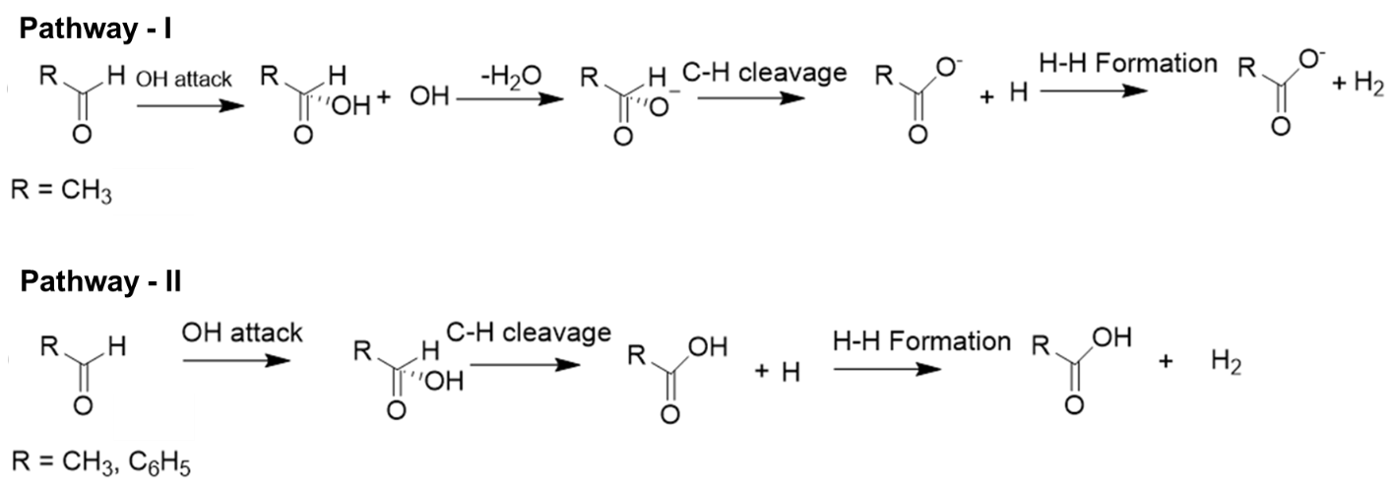
Figure S17. Schematic illustration of acetaldehyde oxidation on Cu (111) surface depicting two reaction pathways: Pathway-I leading to acetate and H₂ formation, related to Figure 6a, and pathway-II yielding acetic acid and H₂, related to Figure S19.

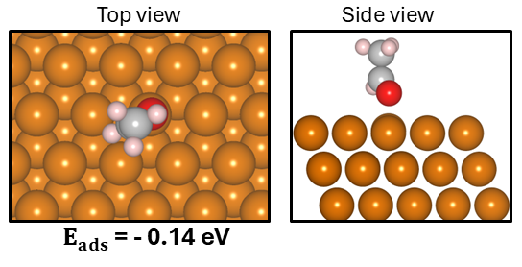
Figure S18. The views of DFT optimized structure of the CH₃CHO over Cu surface and its adsorption energy. Atomic color code: Copper (brown), oxygen (red), hydrogen (pink), and carbon (grey).

Table S5. DFT computed adsorption energetics for different configurations of CH₃CHO over Cu (111) surface.
Parameter  Adsorption site | Adsorption Energy  (E_{ads} (eV)) | Cu-O bond (Å) | C-H bond (Å) | C-O bond (Å) | HCO Angle  θ_{H−C−O} (deg)
Prep_Top | -0.11 | 2.2 | 1.12 | 1.24 | 119.0
Prep_Bridge | -0.12 | 2.19 | 1.12 | 1.24 | 119.2
Tilted_Top | -0.14 | 2.14 | 1.11 | 1.24 | 119.0
Prep_Bridge | -0.13 | 2.14 | 1.11 | 1.24 | 119.0
HCP | -0.12 | 2.17 | 1.11 | 1.24 | 119.1
FCC | -0.05 | 2.23 | 1.12 | 1.24 | 118.9
Bridge | -0.11 | 2.23 | 1.12 | 1.24 | 118.9

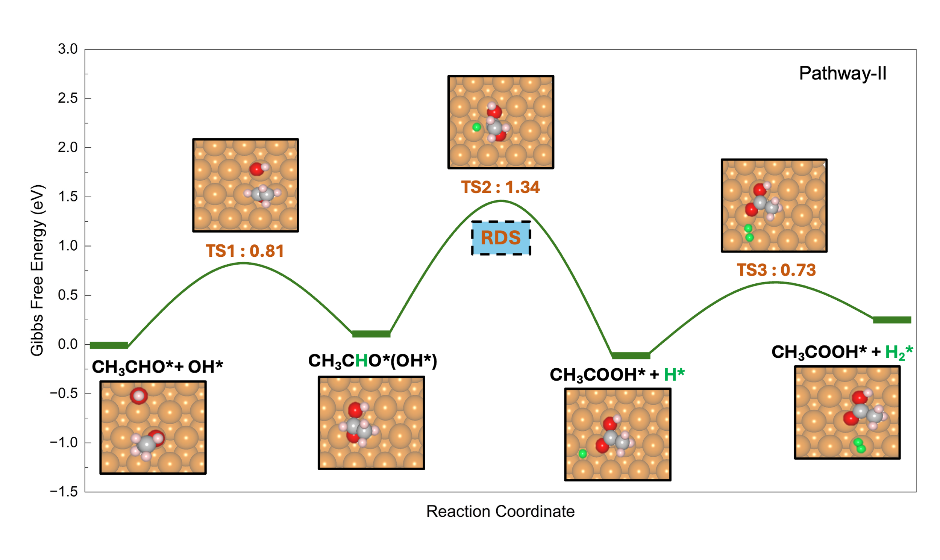
Figure S19. Gibbs free energy diagram for the acetaldehyde oxidation (pathway-II) over Cu surface. Atomic color code: Copper (brown), oxygen (red), hydrogen (pink), and carbon (grey).

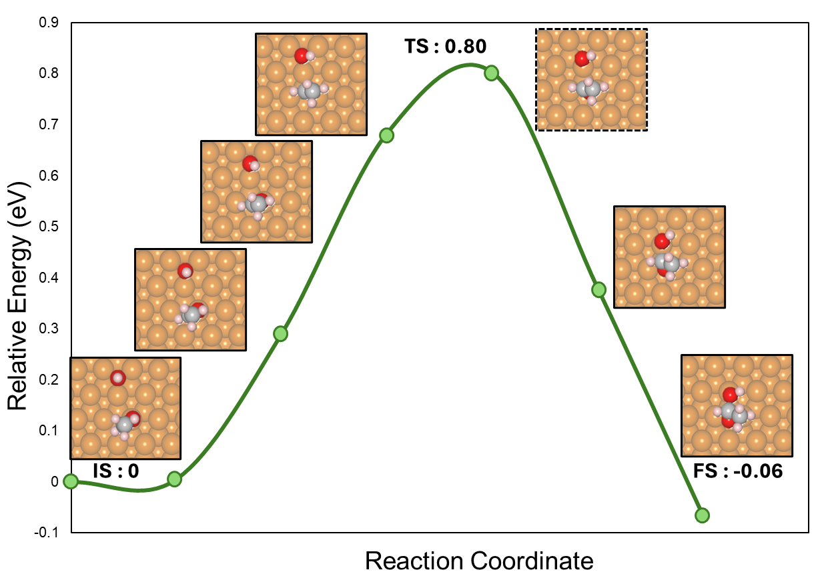
Figure S20. DFT-optimized initial (IS), transition (TS), and final (FS) states from NEB calculations for the OH attack on CH₃CHO to form CH₃CHO(OH) during acetaldehyde oxidation (pathway-I and pathway-II) on the Cu (111) surface, related to Figure 6a. Atomic color code: Copper (brown), oxygen (red), hydrogen (pink), and carbon (grey).

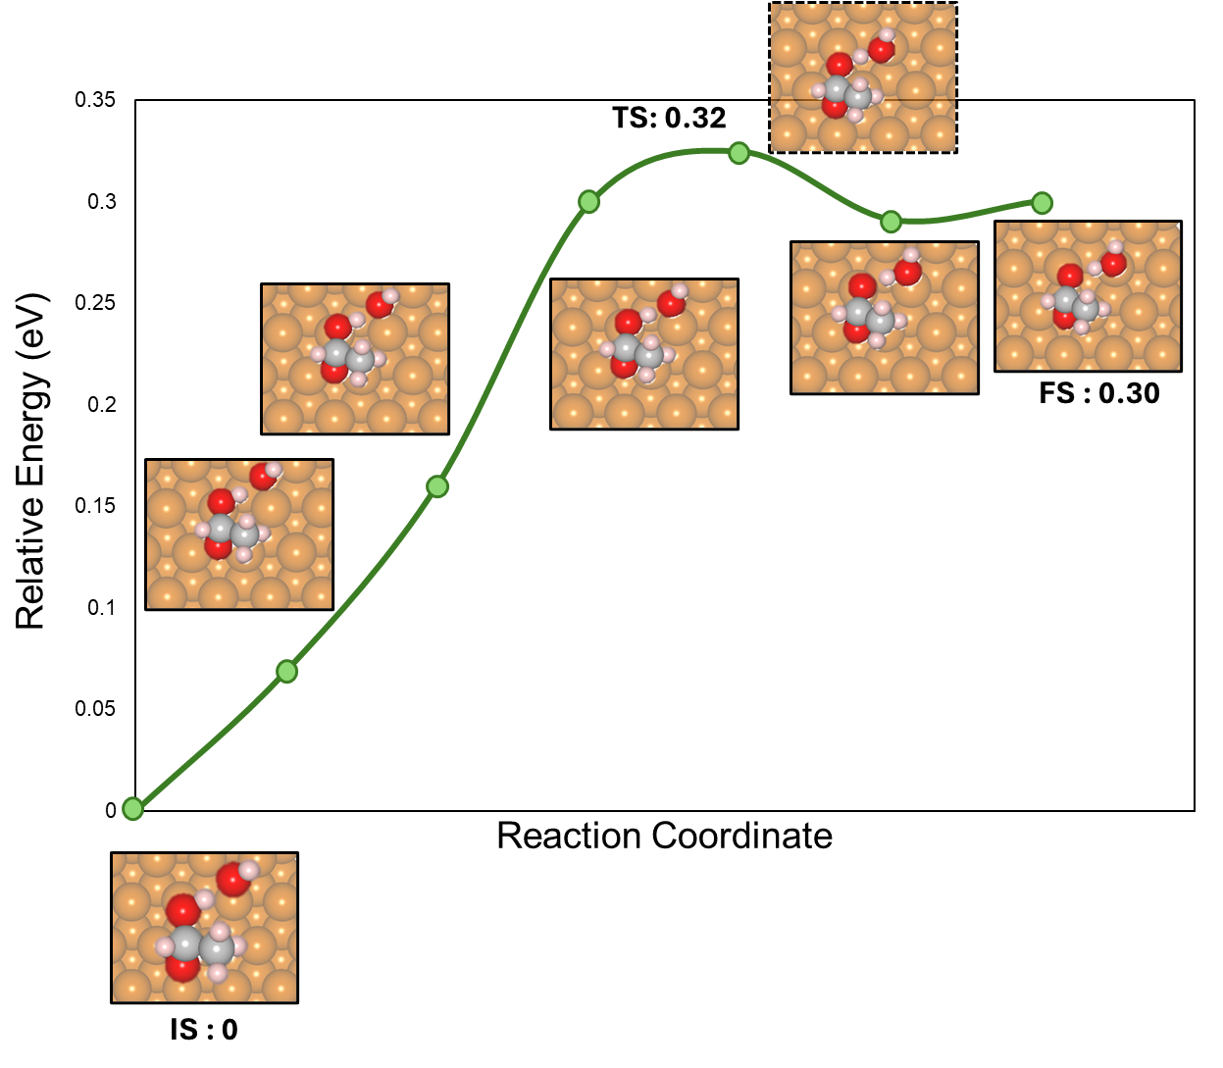
Figure S21. The second OH-assisted deprotonation, CH₃CHO(OH) to form CH₃CHO(O) and H₂O during acetaldehyde oxidation (pathway-I) on the Cu (111) surface, related to Figure 6a. Atomic color code: Copper (brown), oxygen (red), hydrogen (pink), and carbon (grey).

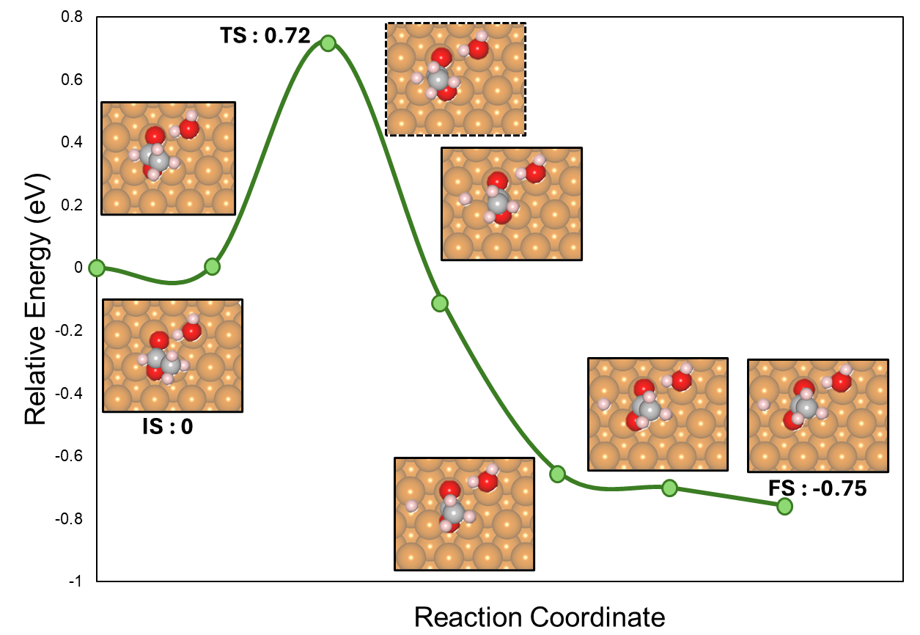
Figure S22. The C–H cleavage, from CH₃CHO(O) to form CH₃COO and H during acetaldehyde oxidation (pathway-I) on the Cu (111) surface, related to Figure 6a. Atomic color code: Copper (brown), oxygen (red), hydrogen (pink), and carbon (grey).

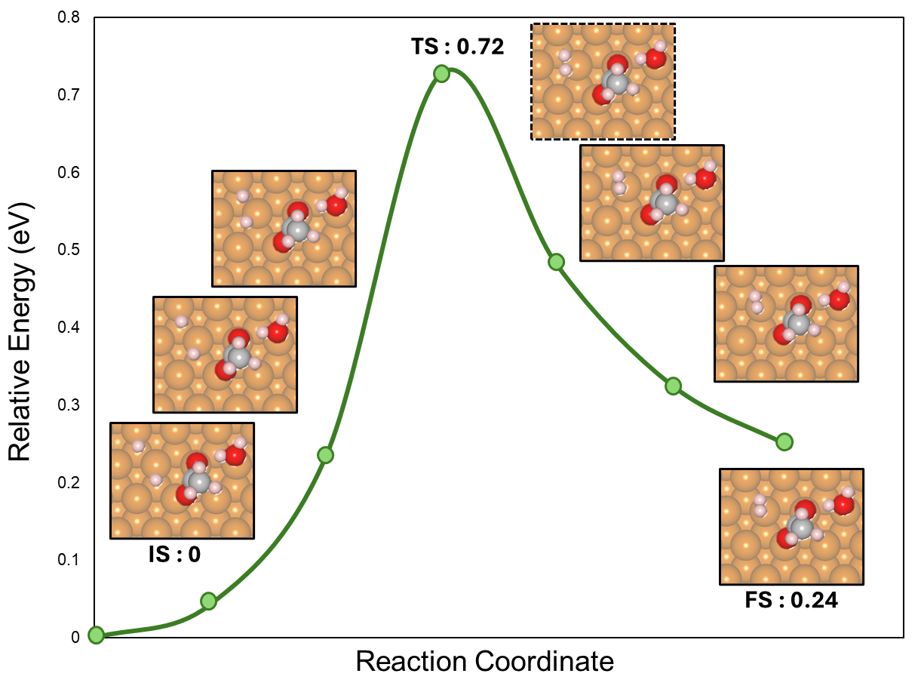
Figure S23. The H–H coupling on to CH₃COO and H to form CH₃COO and H₂ during acetaldehyde oxidation (pathway-I) on the Cu (111) surface, related to Figure 6a. Atomic color code: Copper (brown), oxygen (red), hydrogen (pink), and carbon (grey).

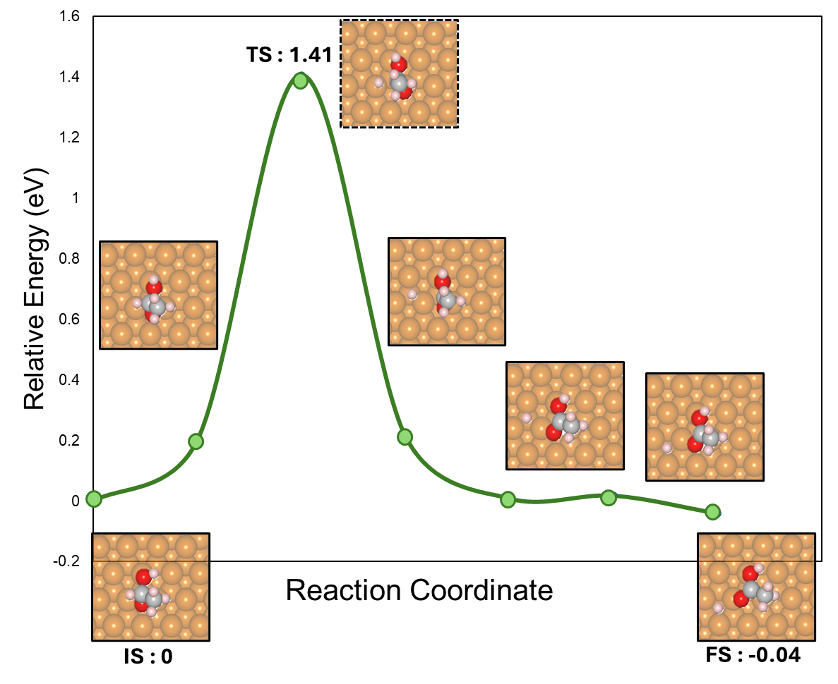
Figure S24. The C–H cleavage, from CH₃CHO(OH) to form CH₃COOH and H during acetaldehyde oxidation (pathway-II) on the Cu (111) surface, related to Figure S19. Atomic color code: Copper (brown), oxygen (red), hydrogen (pink), and carbon (grey).

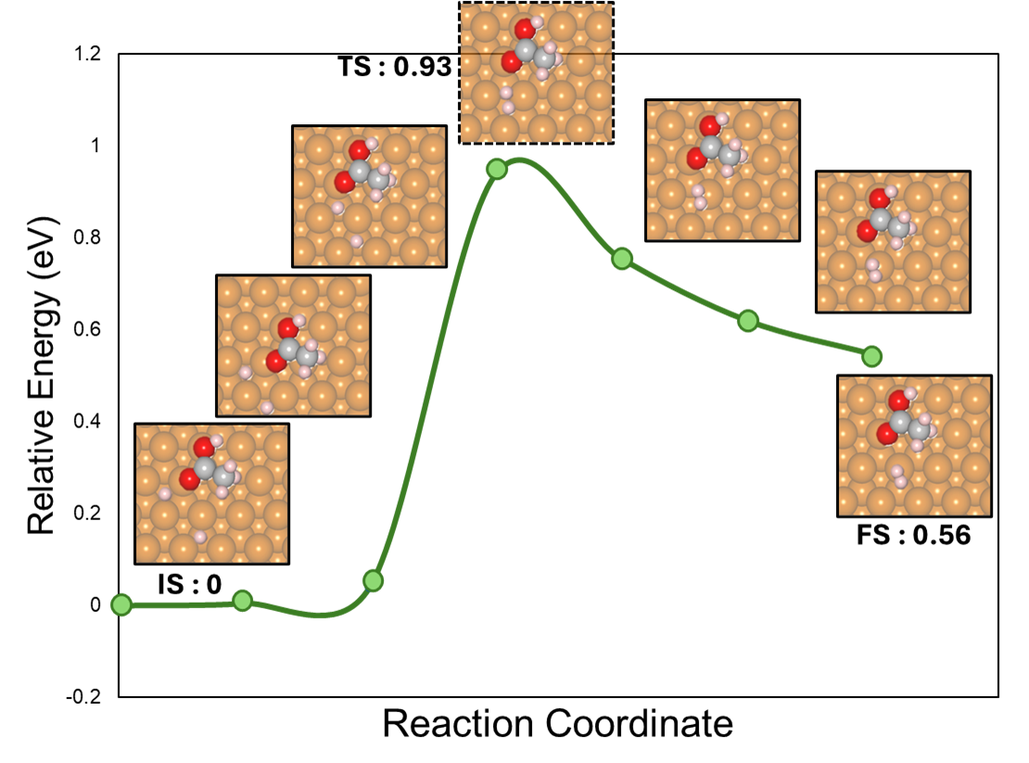
Figure S25. The H–H coupling on to CH₃COOH and H to form CH₃COOH and H₂ during acetaldehyde oxidation (pathway-II) on the Cu (111) surface, related to Figure S19. Atomic color code: Copper (brown), oxygen (red), hydrogen (pink), and carbon (grey).
Table S6. Reaction free energies (ΔG_{rxn}) and activation energy barriers (ΔG_{act}) for the elementary steps involved in the acetaldehyde oxidation reactions to form acetate and H₂ (pathway-I) on Cu surface.
Reaction | Elementary Steps | Cu (111)
Reaction | Elementary Steps | ΔG_{rxn} | ΔG_{act}
R1 | CH₃CHO* + OH* → CH₃CHO(OH)* | 0.11 | 0.81
R2 | CH₃CHO(OH)* + OH* → CH₃CHO(O)* + H₂O* | 0.26 | 0.17
R3 | CH₃CHO(O)* + H₂O* → CH₃COO* + H₂O+ H* | -0.72 | 0.46
R4 | CH₃COO* + H₂O* + 2H* → CH₃COO* + H₂ | 0.10 | 0.55

Table S7. Reaction free energies (ΔG_{rxn}) and activation energy barriers (ΔG_{act}) for the elementary steps involved in the acetaldehyde oxidation reactions to form acetic acid and H₂ (pathway-II) on Cu surface.
Reaction | Elementary Steps | Cu (111)
Reaction | Elementary Steps | ΔG_{rxn} | ΔG_{act}
R1 | CH₃CHO* + OH* → CH₃CHO(OH)* | 0.11 | 0.81
R2 | CH₃CHO(OH)* → CH₃COOH* + H* | -0.23 | 1.34
R3 | CH3COOH* + 2H* → CH₃COOH* + H₂ | 0.39 | 0.73

Table S8. Reaction intermediates, computed electronic energies, zero-point energies (ZPE) and entropic contributions (TS) for acetaldehyde oxidation to form acetate and H₂ (pathway-I) on Cu surface at 298.15 K.
Reaction Intermediates | Energy (eV) | ZPE (eV) | TS (eV)
Reaction Intermediates | Energy (eV) | ZPE (eV) | 298.15 K
CH₃CHO* + OH* | -399.468 | 1.855 | 0.341
CH₃CHO* + OH* → CH₃CHO(OH)* | -399.535 | 1.958 | 0.260
CH₃CHO(OH)* + OH* | -410.602 | 2.310 | 0.345
CH₃CHO(OH)* + OH* → CH₃CHO(O)* + H₂O* | -410.301 | 2.280 | 0.350
CH₃CHO(O)* + H₂O* → CH₃COO* + H₂O* + H* | -411.061 | 2.310 | 0.392
CH₃COO* + H₂O* + 2H* → CH₃COO* + H₂ | -414.394 | 2.320 | 0.482

Table S9. Reaction intermediates, computed electronic energies, zero-point energies (ZPE) and entropic contributions (TS) for acetaldehyde oxidation to form acetic acid and H₂ (pathway-II) on Cu surface at 298.15 K.
Reaction Intermediates | Energy (eV) | ZPE (eV) | TS (eV)
Reaction Intermediates | Energy (eV) | ZPE (eV) | 298.15 K
CH₃CHO* + OH* | -399.468 | 1.855 | 0.341
CH₃CHO* + OH* → CH₃CHO(OH)* | -399.535 | 1.958 | 0.260
CH₃CHO(OH)* → CH₃COOH* + H* | -399.576 | 1.806 | 0.306
CH₃COOH* + 2H* → CH₃COOH* + H₂ | -402.679 | 1.931 | 0.407

References

[1] “Potassium Acetate Market | Global Market Analysis Report - 2035.” Accessed: Feb. 05, 2026. [Online]. Available: https://www.futuremarketinsights.com/reports/potassium-acetate-market
[2] D. S. Mallapragada et al., “Decarbonization of the chemical industry through electrification: Barriers and opportunities,” Joule, vol. 7, no. 1, pp. 23–41, Jan. 2023, doi: 10.1016/j.joule.2022.12.008.
[3] P. M. Maitlis, A. Haynes, G. J. Sunley, and M. J. Howard, “Methanol carbonylation revisited: thirty years on,” J. Chem. Soc. Dalton Trans., no. 11, p. 2187, 1996, doi: 10.1039/dt9960002187.
[4] G. Li, S. Ma, F. Liu, Z. Wang, and Y. Zhang, “Economic assessment of acetaldehyde production from oxidative dehydrogenation of bioethanol through chemical looping air separation,” Sustain. Energy Technol. Assess., vol. 70, p. 103967, Oct. 2024, doi: 10.1016/j.seta.2024.103967.
[5] “[Hot Item] Best Price Potassium Acetate/ Acetic Acid Potassium Salt CAS 127-08-2,” Made-in-China.com. Accessed: Feb. 05, 2026. [Online]. Available: https://hbkenbin.en.made-in-china.com/product/lORaLKsvLjfc/China-Best-Price-Potassium-Acetate-Acetic-Acid-Potassium-Salt-CAS-127-08-2.html
[6] PricewaterhouseCoopers, “Green hydrogen economy - predicted development of tomorrow,” PwC. Accessed: Feb. 05, 2026. [Online]. Available: https://www.pwc.com/gx/en/industries/energy-utilities-resources/green-hydrogen-cost.html
[7] “[Hot Item] Factory Supplier 1310-58-3 Liquid Solid Flake 90% Price KOH Potassium Hydroxide,” Made-in-China.com. Accessed: Feb. 05, 2026. [Online]. Available: https://fengdachem.en.made-in-china.com/product/JmjRzWXhgiUK/China-Factory-Supplier-1310-58-3-Liquid-Solid-Flake-90-Price-KOH-Potassium-Hydroxide.html
[8] J. Li, W. Xie, H. Zhou, Z. Li, and M. Shao, “Techno-economic analysis of electrochemical hydrogen production coupled with alternative oxidation,” Chem. Eng. Sci., vol. 298, p. 120322, Oct. 2024, doi: 10.1016/j.ces.2024.120322.
[9] “Chemical innovation: An investment for the ages | McKinsey.” Accessed: Feb. 05, 2026. [Online]. Available: https://www.mckinsey.com/industries/chemicals/our-insights/chemical-innovation-an-investment-for-the-ages

