Biocrust belt below the edge of a dying glacier in the Tropical Andes

Alejandro Salazar¹*, Maria E. Gutiérrez-Lagoueyte², Ingibjörg S. Jónsdóttir³, Isabel C. Barrio¹, Heiðrún I. Guðmundsdóttir³, Emilio Rodriguez-Caballero^{4,5}, Adriana Sanchez⁶

Affiliations
- Agricultural University of Iceland, Keldnaholt, Árleynir 22, 112 Reykjavík, Iceland. AS: https://orcid.org/0000-0002-0798-882X; ICB: https://orcid.org/0000-0002-8120-5248
- School of Engineering and Basic Sciences, Universidad EIA, Envigado, Colombia. https://orcid.org/0000-0001-7984-3139
- Faculty of Life and Environmental Sciences, University of Iceland, 102 Reykjavík, Iceland. ISJ: https://orcid.org/0000-0003-3804-7077
- Agronomy Department, University of Almería, 04120 Almería, Spain. https://orcid.org/0000-0002-5934-3214
- Center for Research on Scientific Collections of the University of Almeria (CECOUAL), 04120 Almeria, Spain.
- Biology Department, School of Sciences and Engineering, Universidad del Rosario, Bogotá, Colombia. https://orcid.org/0000-0003-2334-5741

Supplementary material

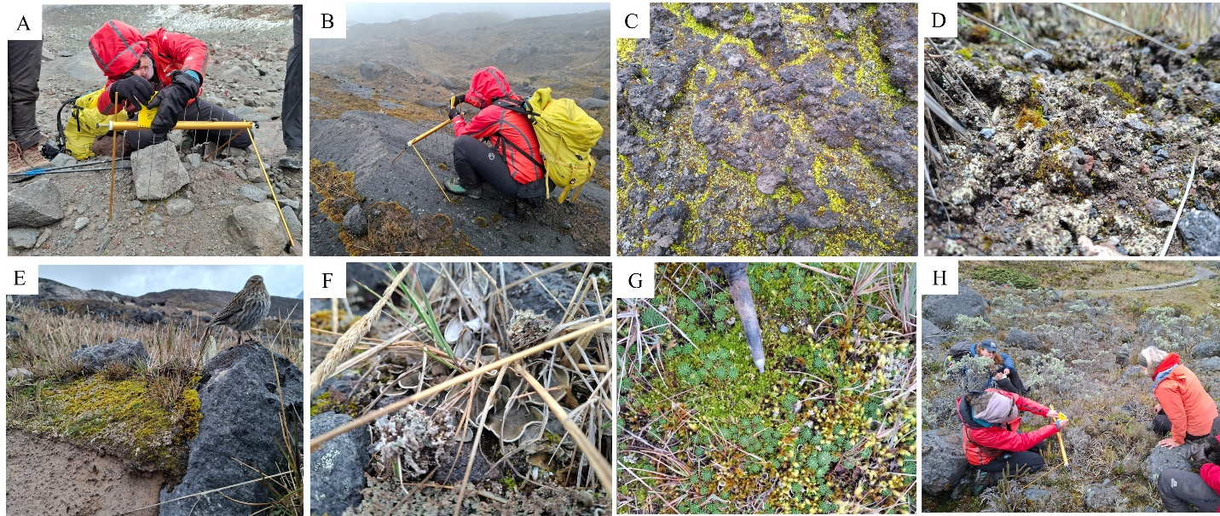

Figure S1. Illustrative pictures of main surface covers at the Conejeras chronosequence. A) Bare ground in the highest point of the chronosequence, at 4698 m.a.s.l., corresponding to the location of the edge of the glacier in 2020, B) Large rocks, particularly abundant 4648 m.a.s.l., corresponding to the location of the glacier’s edge in 1960, C) cyanobacteria-dominated biocrust, characterized by dark pigmentation (small, light-green bryophyte growing in microdepressions), D) Light-pigmented, lichen-dominated biocrust, E) Bryophyte-dominated biocrust, with patches of lichen- and cyanobacterial-biocrust on the edges, F) Non-crusted (foliose) lichen structure, G) Non-crusted bryophyte structure, H) Vascular plant community near the glacier moraine.

Table S1. Locations of PNN signs along the glacier forefield chronosequence at Nevado Santa Isabel, Colombia. Coordinates provided by PNN.
Elevation (m.a.s.l.) | Year of glacial edge | Latitude | Longitude
4359 | Ca. 1850 | 4,831758 | -75,375756
4648 | 1960 | 4,821181 | -75,375414
4660 | 1990 | 4,819253 | -75,373198
4690 | 2010 | 4,816333 | -75,373198
4698 | 2020 | 4,813613 | -75,37218

Table S2. Statistical results of vascular plant cover across the glacier forefield chronosequence. LMM with quadratic term: lmer(Vascular plant cover ~ poly(Elevation, 2) + (1|grid)), AIC=112. Statistical results include significance of linear [Poly(Elevation, 2)1] and non-linear [Poly(Elevation, 2)2] variation of cover with elevation. AIC of LMM without quadratic term=130. P values < 0.05 are in bold. Significance codes: * P < 0.05, **, *** P < 0.001.
 | Estimate | Std. Error | df | t value | P value
Intercept | 21.5 | 4.1 | 2 | 5.2 | 0.035 *
Poly(Elevation, 2)1 | -116.2 | 15.2 | 10 | -7.6 | < 0.001 ***
Poly(Elevation, 2)2 | 8.4 | 15.2 | 10 | 0.6 | 0.592

Table S3. Statistical results of biocrust cover across the glacier forefield chronosequence. LMM with quadratic term: lmer(Vascular plant cover ~ poly(Elevation, 2) + (1|grid)), AIC=123. Statistical results include significance of linear [Poly(Elevation, 2)1] and non-linear [Poly(Elevation, 2)2] variation of cover with elevation. AIC of LMM without quadratic term=144. Significance codes: + P < 0.1 (marginal).
 | Estimate | Std. Error | df | t value | P value
Intercept | 19.3 | 9.0 | 2 | 2.1 | 0.166
Poly(Elevation, 2)1 | 24.6 | 22.3 | 10 | 1.1 | 0.296
Poly(Elevation, 2)2 | -41.4 | 22.3 | 10 | -1.8 | 0.093 +

Table S4. Statistical results of bryophyte cover across the glacier forefield chronosequence. LMM with quadratic term: lmer(Vascular plant cover ~ poly(Elevation, 2) + (1|grid)), AIC=124. Statistical results include significance of linear [Poly(Elevation, 2)1] and non-linear [Poly(Elevation, 2)2] variation of cover with elevation. AIC of LMM without quadratic term=144. P values < 0.05 are in bold. Significance codes: * P < 0.05.
 | Estimate | Std. Error | df | t value | P value
Intercept | 18.5 | 6.5 | 12 | 2.9 | 0.014 *
Poly(Elevation, 2)1 | -11.5 | 25.0 | 12 | -0.5 | 0.655
Poly(Elevation, 2)2 | -30.0 | 25.0 | 12 | -1.2 | 0.254

Table S5. Statistical results of lichen cover across the glacier forefield chronosequence. LMM with quadratic term: lmer(Vascular plant cover ~ poly(Elevation, 2) + (1|grid)), AIC=119. Statistical results include significance of linear [Poly(Elevation, 2)1] and non-linear [Poly(Elevation, 2)2] variation of cover with elevation. AIC of LMM without quadratic term=139. P values < 0.05 are in bold. Significance codes: * P < 0.05.
 | Estimate | Std. Error | df | t value | P value
Intercept | 13.3 | 5.3 | 12 | 2.5 | 0.027 *
Poly(Elevation, 2)1 | -35.2 | 20.4 | 12 | -1.7 | 0.111
Poly(Elevation, 2)2 | -21.8 | 20.4 | 12 | -1.1 | 0.307

Table S6. Statistical results of bare ground cover across the glacier forefield chronosequence. LMM with quadratic term: lmer(Vascular plant cover ~ poly(Elevation, 2) + (1|grid)), AIC=122. Statistical results include significance of linear [Poly(Elevation, 2)1] and non-linear [Poly(Elevation, 2)2] variation of cover with elevation. AIC of LMM without quadratic term=150. P values < 0.05 are in bold. Significance codes: ** P < 0.01, *** P < 0.001.
 | Estimate | Std. Error | df | t value | P value
Intercept | 42.2 | 6.1 | 12 | 7.0 | < 0.001 ***
Poly(Elevation, 2)1 | 94.6 | 23.5 | 12 | 4.0 | 0.002 **
Poly(Elevation, 2)2 | 83.5 | 23.5 | 12 | 3.6 | 0.004 **

Table S7. Species or surface structures recorded with the point-intercept method. Data in excel file attached.

Table S8. Statistical results of surface roughness along the glacier forefield chronosequence. LMM with quadratic term: lmer(Roughness ~ poly(Elevation, 2) + (1|grid)), AIC=722. Statistical results include significance of linear [Poly(Elevation, 2)1] and non-linear [Poly(Elevation, 2)2] variation of cover with elevation. AIC of LMM without quadratic term=742. P values < 0.05 are in bold. Significance codes: + P < 0.1 (marginal), * P < 0.05.
 | Estimate | Std. Error | df | t value | P value
Intercept | 6.5 | 0.8 | 2 | 7.6 | 0.017 *
Poly(Elevation, 2)1 | -5.3 | 3.5 | 130 | -1.5 | 0.132
Poly(Elevation, 2)2 | -6.2 | 3.5 | 130 | -1.8 | 0.074 +

Table S9. Statistical results of surface stability along the glacier forefield chronosequence. LMM with quadratic term: lmer(Stability ~ poly(Elevation, 2) + (1|grid)), AIC=84. Statistical results include significance of linear [Poly(Elevation, 2)1] and non-linear [Poly(Elevation, 2)2] variation of cover with elevation. AIC of LMM without quadratic term=111. P values < 0.05 are in bold. Significance codes: *** P < 0.001.
 | Estimate | Std. Error | df | t value | P value
Intercept | 4.7 | 0.6 | 4.1 | 8.5 | < 0.001 ***
Poly(Elevation, 2)1 | -5.2 | 4.6 | 18.4 | -1.1 | 0.270
Poly(Elevation, 2)2 | -11.4 | 2.9 | 17.6 | -4.0 | < 0.001 ***

