SUPPLEMENTARY MATERIAL FOR:
Amyloid-linked versus age-driven copathologies in Alzheimer’s dementia: differential associations with APOE ε4

SUPPLEMENTARY METHODS
Statistical Analyses
General Approach
The general statistical approach, including variable summarization, regression modeling strategies, adjustment levels, and APOE grouping rationale, is described in the main text (Section 4.5). All analyses were performed using R (version 4.2.2) with two-sided tests and p-value < 0.05 considered statistically significant.
Cohort Characterization and Amyloid-Positive Selection Rationale
We characterized the cohort by examining distributions of cognitive status, clinical diagnoses, and amyloid pathology across APOE haplotypes and age groups (Supplementary Figure 1A-B). Binary logistic regression models assessed associations between APOE haplotype (with ε3/ε3 as reference) and: (1) clinical diagnosis of AD versus non-AD, (2) amyloid positivity at autopsy (moderate or frequent neuritic plaques). Unadjusted results were visualized as forest plots (Supplementary Figure 1C; Supplementary Table 1A-B). For the concordant clinicopathological AD outcome, models were fit across three adjustment levels: unadjusted, adjusted for sex and education, and adjusted for sex, education, and age at dementia diagnosis, with odds ratios and 95% confidence intervals reported (Supplementary Table 2).
Braak Neurofibrillary Tangle Stage Analyses
We examined the association between age (as a continuous variable per 10-year increase) and ordinal Braak stage using proportional odds regression, adjusted for sex and education, within each APOE haplotype and diagnostic stratum (Supplementary Table 3). Visual representations of Braak stage distributions by age are shown in Supplementary Figure 2.
APOE × Age Interaction Testing for Copathologies
For regional Lewy body pathology, regional TDP-43 pathology, and vascular pathologies, we tested whether age effects on pathology prevalence or severity differed by APOE haplotype. Models included an APOE × age interaction term, and the interaction was formally tested using likelihood ratio tests. Test statistics (LR χ²) and p-values are reported in Supplementary Figures 3, 4, and 5.
Sex-Stratified Sensitivity Analyses
For each pathology and APOE haplotype combination, we first examined unadjusted distributions using chi-squared tests (or Fisher's exact test when cell counts were <5). We then fitted regression models comparing males versus females adjusted for age at death, education, and ADNC. For pathologies with ordered severity levels, we used proportional odds ordinal regression. When ordinal models failed to converge, the outcome was dichotomized at the median and analyzed using binary logistic regression. Odds ratios with 95% CIs were estimated for the male versus female comparison (Supplementary Table 10).
TDP-43 Pathology Across Diagnostic Groups
To examine whether APOE haplotype associations with TDP-43 pathology differed by diagnostic specificity, we fitted binary logistic regression models across three progressively restricted diagnostic strata: all-cause dementia, AD dementia (clinical diagnosis), and amyloid-positive AD dementia. For each stratum, models were fit at three adjustment levels: (1) unadjusted, (2) adjusted for sex, education, and age at death, and (3) additionally adjusted for ADNC stage. The reference group was ε3/ε3 carriers. Chi-squared statistics for unadjusted analyses and likelihood ratio χ² statistics for adjusted models are reported alongside odds ratios with 95% confidence intervals and p-values (Supplementary Table 11).

SUPPLEMENTARY RESULTS
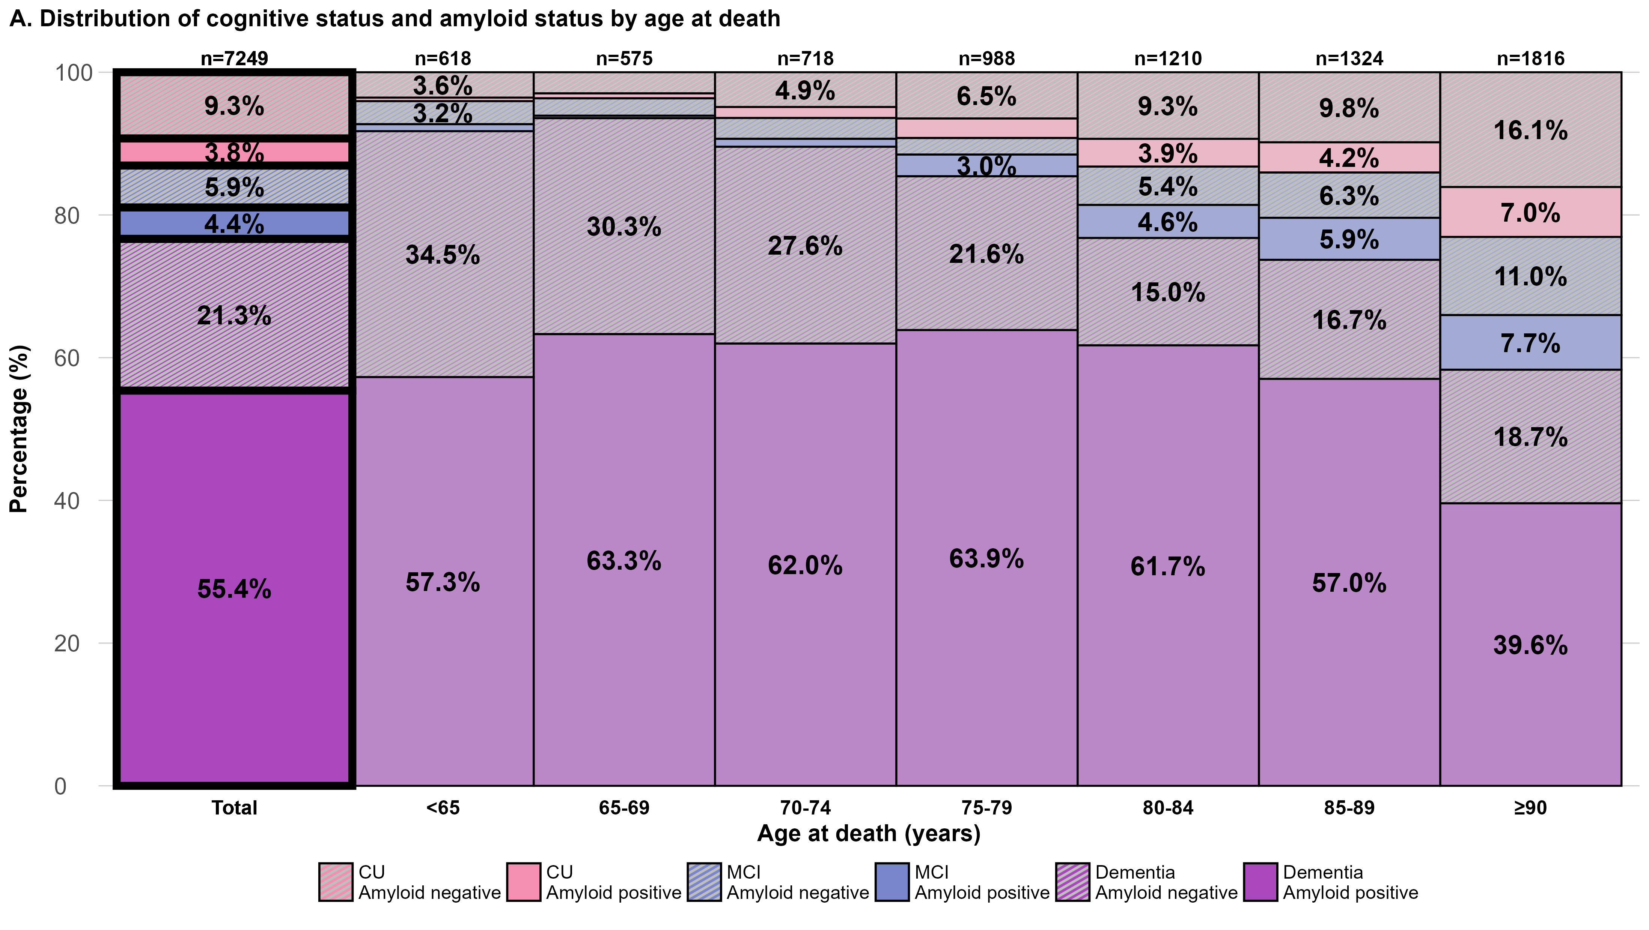
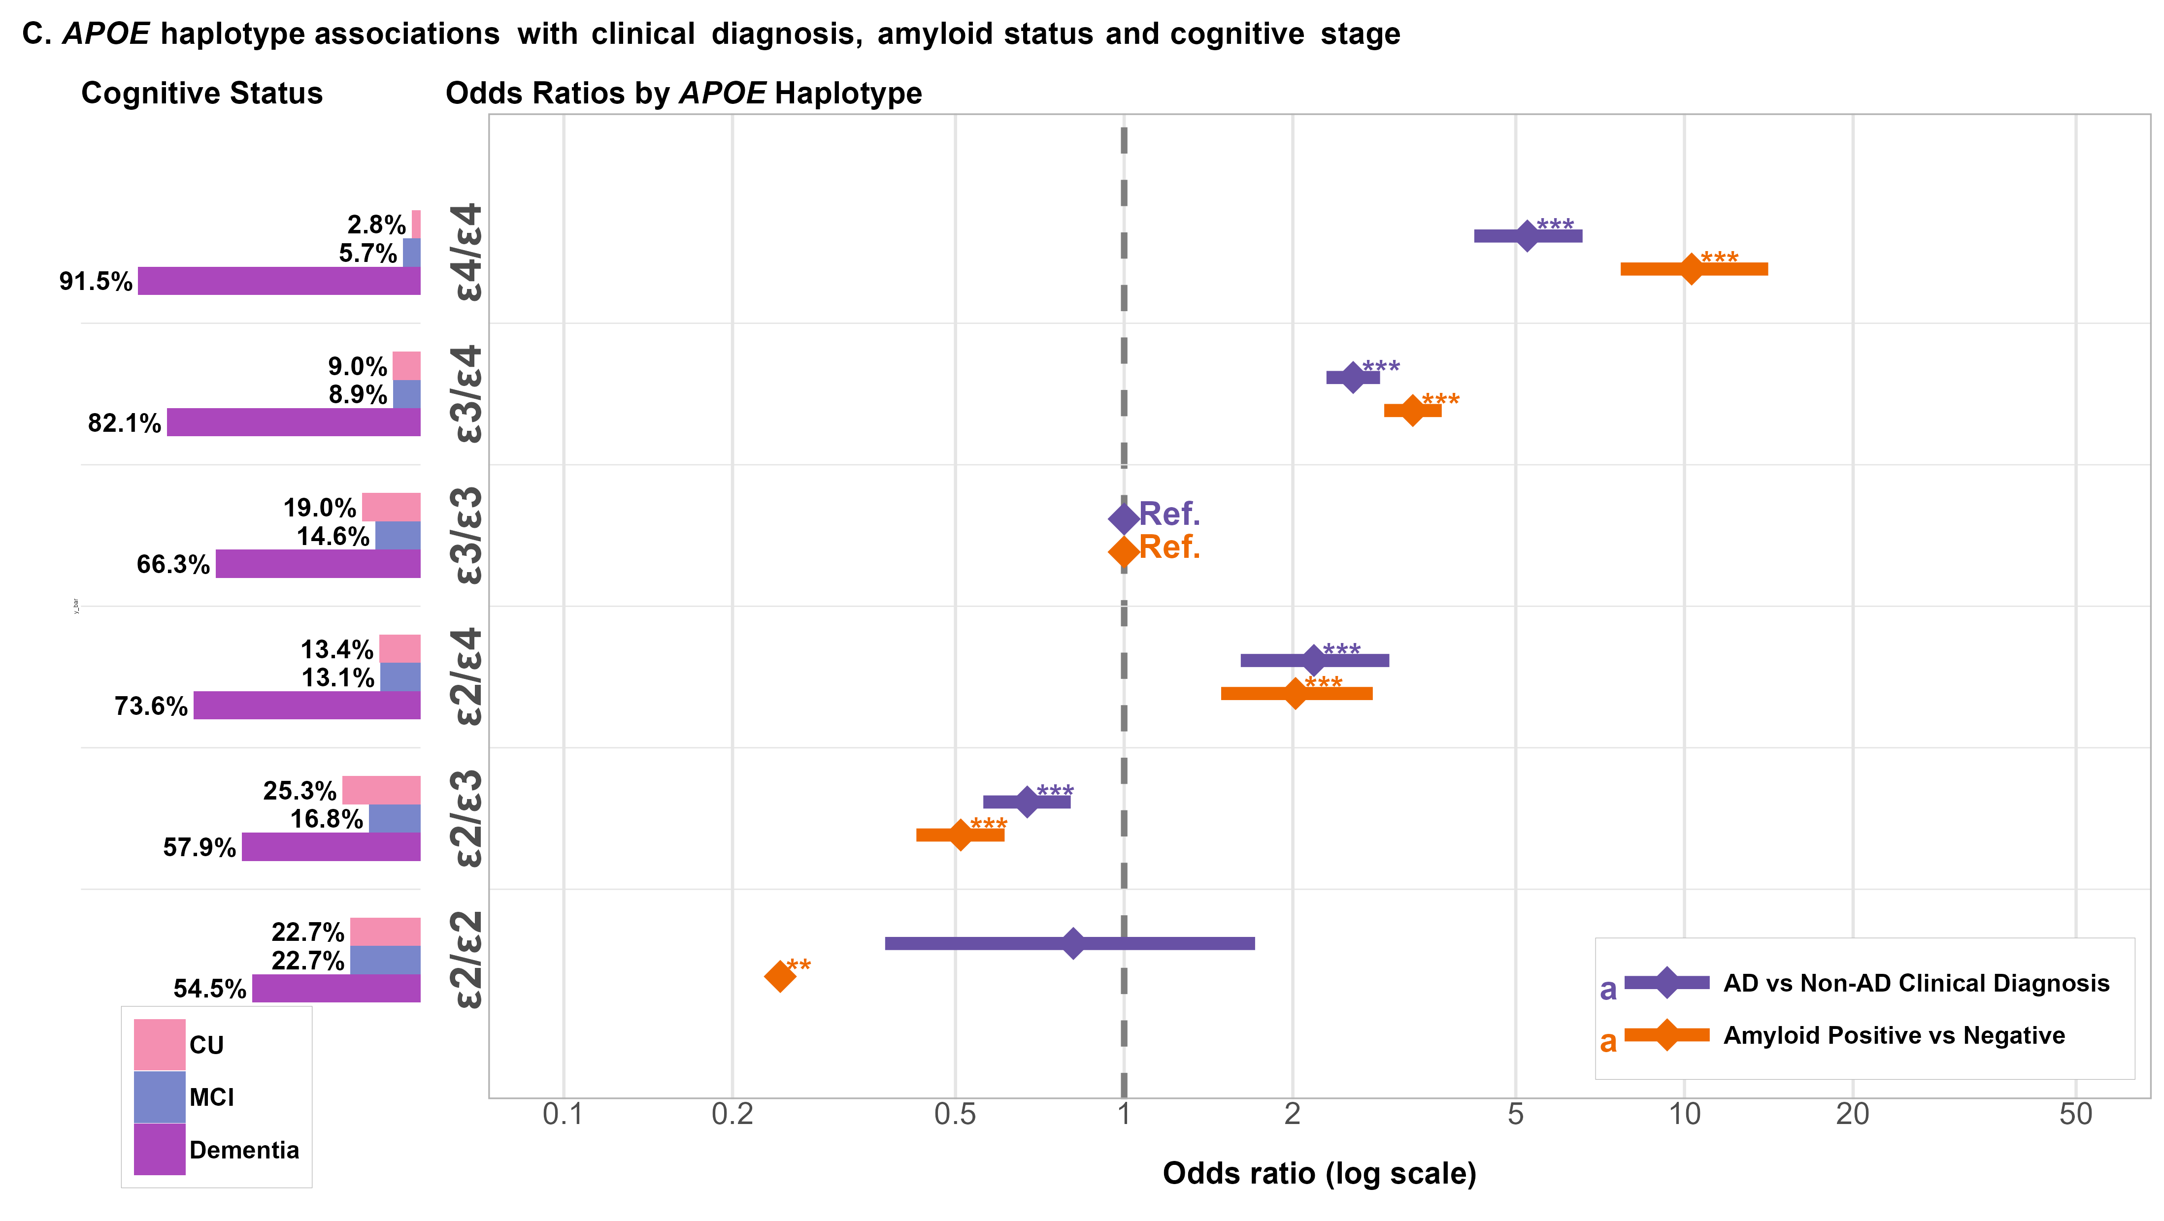
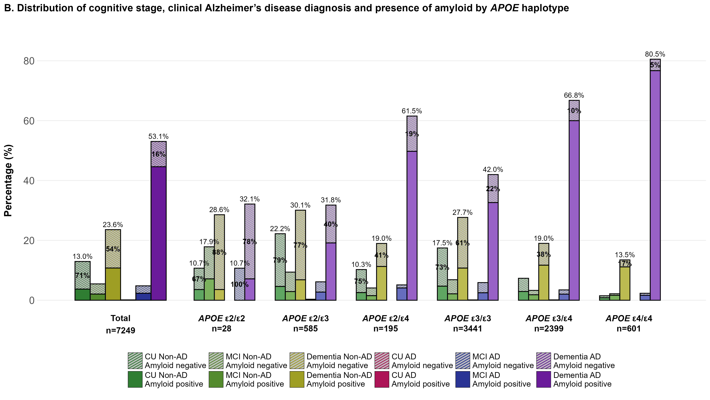
Supplementary Figure 1. Cognitive, clinical, and amyloid status by APOE haplotype and age. (A) Distribution of cognitive/clinical status at death within each APOE haplotype (and total cohort): cognitively unimpaired, MCI or dementia, each classified as primary AD or primary non-AD; striped segments indicate amyloid-negative and solid segments amyloid-positive cases. Labels show total percentage per bar and, when ≥10% of the APOE group, the proportion that is amyloid-negative. (B) Distribution of cognitive status by age-at-death group and amyloid status (leftmost bar: total cohort), with striped vs solid segments indicating amyloid-negative vs amyloid-positive, respectively; percentage labels are shown for categories ≥3% of the corresponding age group. The total number of individuals for each haplotype group is shown. (C) Odds ratios (log scale) for diagnosis of AD vs non-AD clinical etiology and amyloid positivity, across APOE haplotypes (reference: APOE ε3/ε3). Points indicate odds ratios and horizontal lines 95% CIs; asterisks denote *p < 0.05, **p < 0.01, ***p < 0.001. Abbreviations: AD, Alzheimer’s disease; APOE, apolipoprotein E; CI, confidence interval; MCI, mild cognitive impairment; CU, cognitively unimpaired; Ref., Reference.
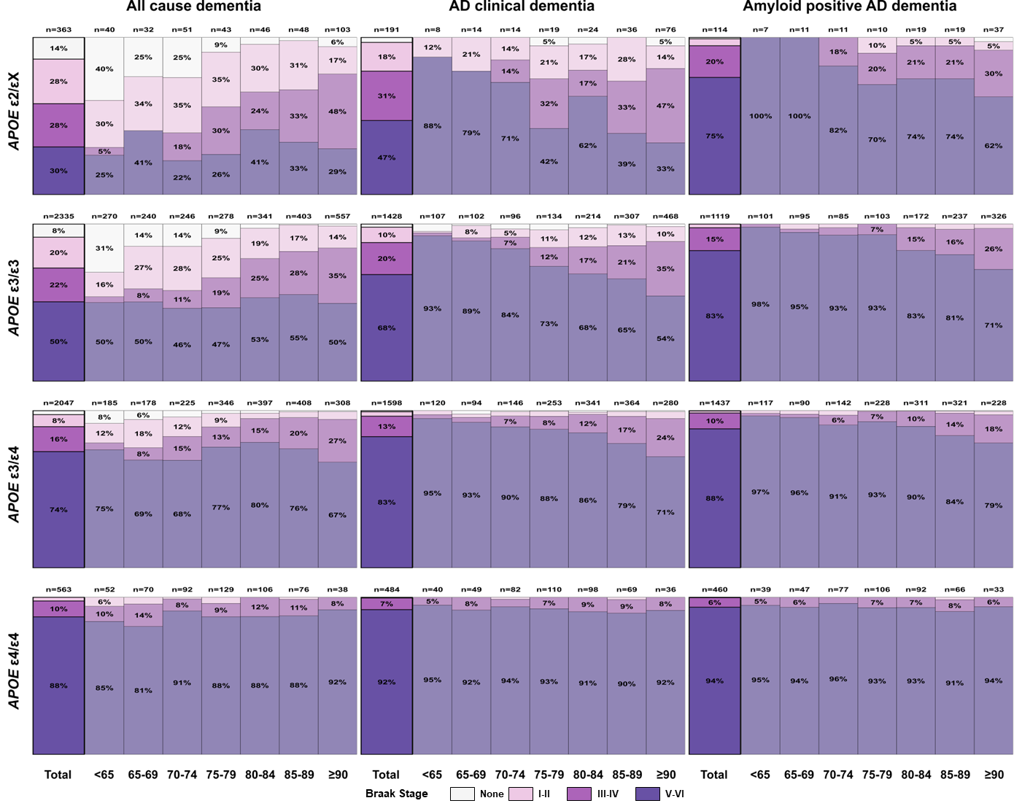
Supplementary Figure 2. Distribution of Braak neurofibrillary tangle stages by age at death and APOE haplotype in dementia cases. Stacked bar charts show the proportion of individuals with no, I–II, III–IV, and V–VI Braak stages across age-at-death categories for ε2/εX ε3/ε3, ε3/ε4 and ε4/ε4 carriers who died with dementia of any cause (left panels), with a clinical diagnosis of AD dementia (middle panels), or with AD dementia and neuritic-plaque–confirmed amyloid positivity (right panels). For each bar, the total number of individuals in that age and haplotype stratum is shown above, and the thick black outline indicates the total (all ages combined) within each diagnostic stratum. AD, Alzheimer's disease; APOE, apolipoprotein E.

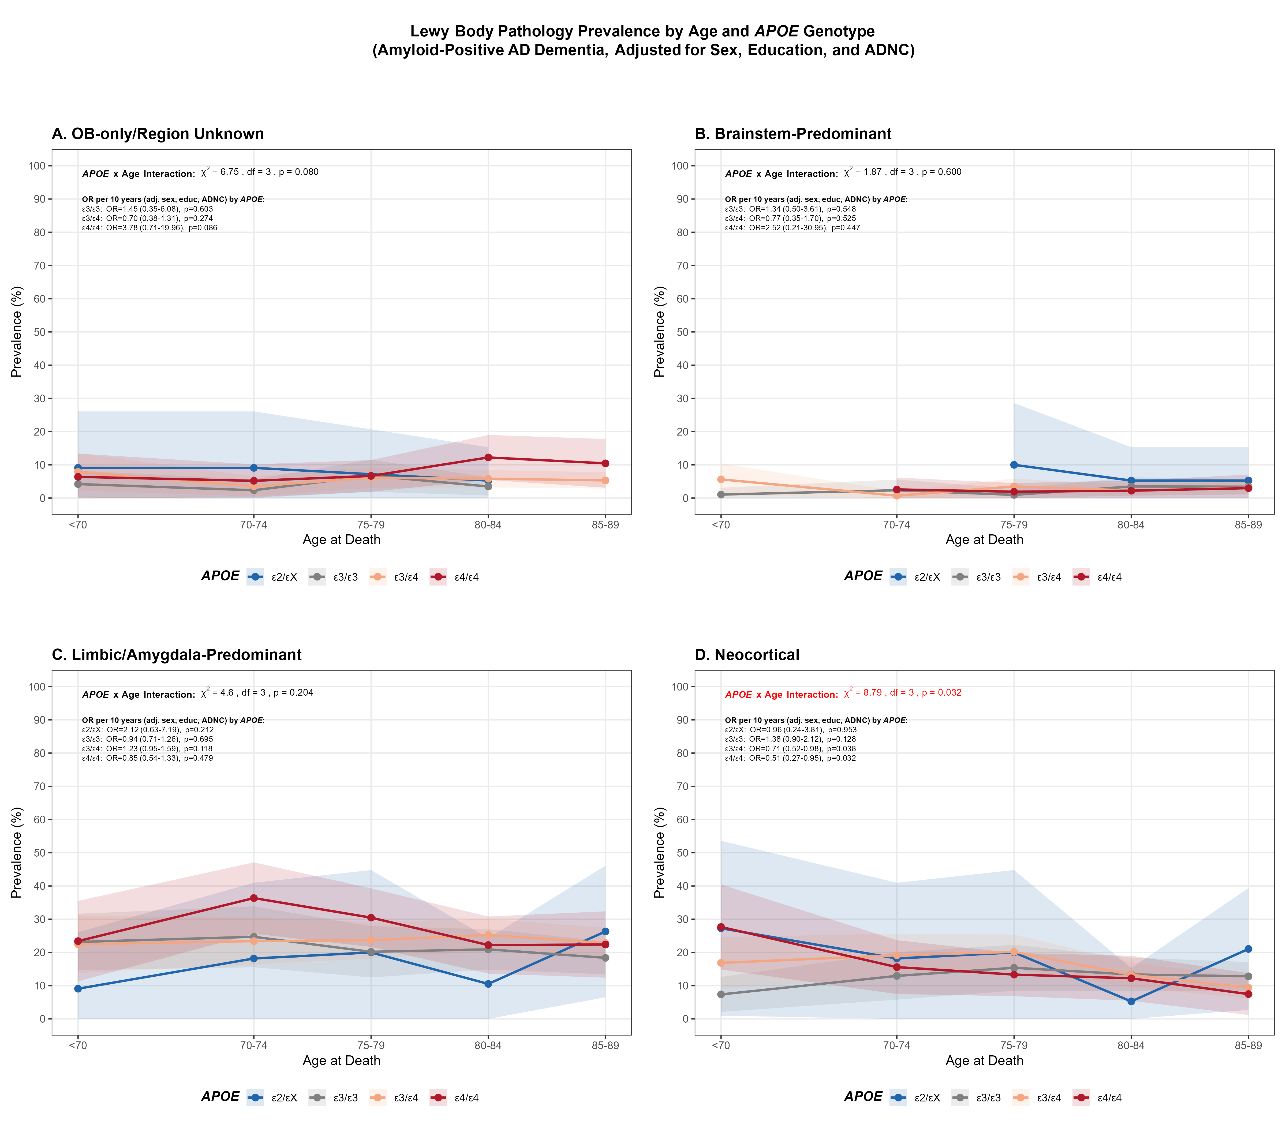
Supplementary Figure 3. Lewy Body pathology prevalence by age at death and APOE haplotype in amyloid-positive Alzheimer’s disease dementia. Line plots show the prevalence (%) of Lewy body pathology across age-at-death categories, stratified by APOE haplotype, for four regional patterns: (A) olfactory bulb–only/region unknown, (B) brainstem-predominant, (C) limbic/amygdala-predominant, and (D) neocortical. Shaded areas represent 95% confidence intervals. Odds ratios are estimated per 10-year increase in age using models adjusted for sex, education, and ADNC. APOE × age interaction terms were tested for each regional pattern, with corresponding χ² statistics and p-values shown in each panel. Interaction labels shown in red indicate statistical significance (p < 0.05). AD, Alzheimer's disease; ADNC, Alzheimer's disease neuropathologic change; APOE, apolipoprotein E; educ, education; OB, olfactory bulb; OR, odds ratio.

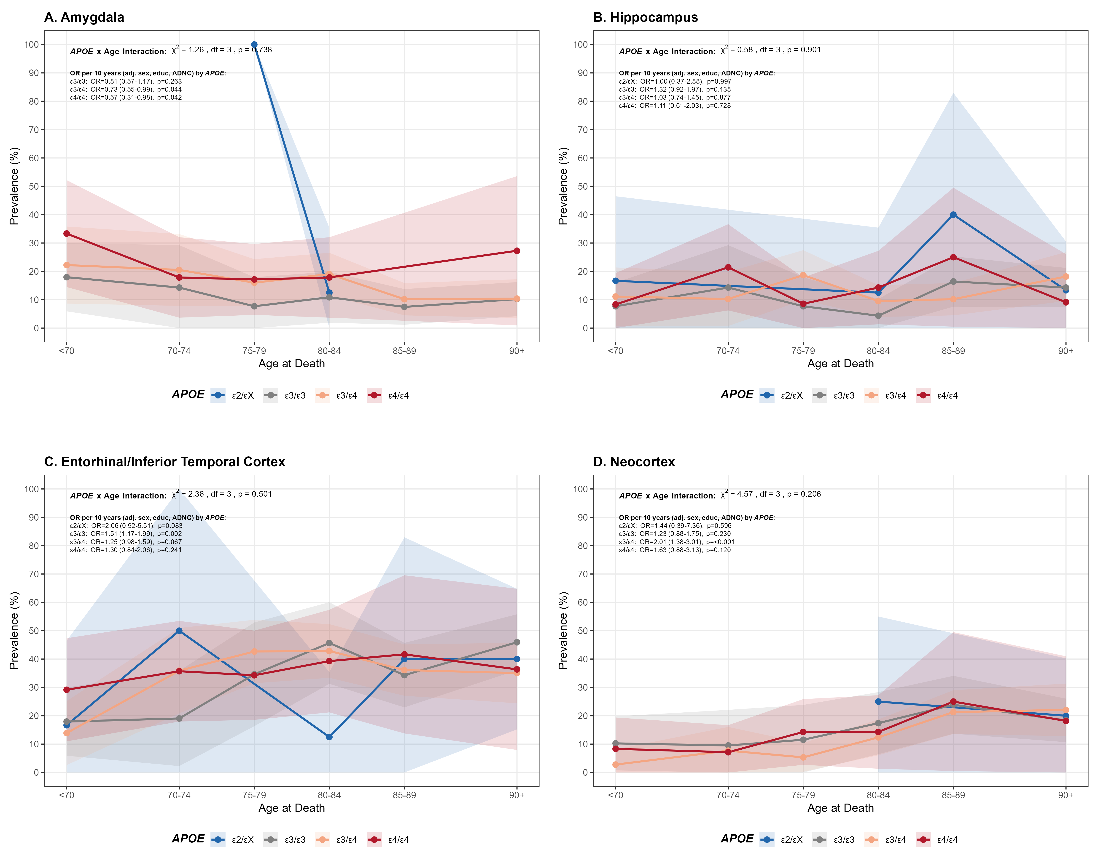
Supplementary Figure 4. TDP-43 pathology prevalence by age at death and APOE haplotype in amyloid-positive Alzheimer’s disease dementia. Line plots show the prevalence (%) of TDP-43 pathology across age-at-death categories, stratified by APOE haplotype, for four brain regions: (A) amygdala, (B) hippocampus, (C) entorhinal/inferior temporal cortex, and (D) neocortex. Shaded areas represent 95% confidence intervals. Odds ratios are estimated per 10-year increase in age using models adjusted for sex, education, and ADNC. APOE × age interaction terms were tested for each region, with corresponding χ² statistics and p-values shown in each panel. AD, Alzheimer's disease; ADNC, Alzheimer's disease neuropathologic change; APOE, apolipoprotein E; educ, education; OB, olfactory bulb; OR, odds ratio; TDP-43, TAR DNA-binding protein 43.

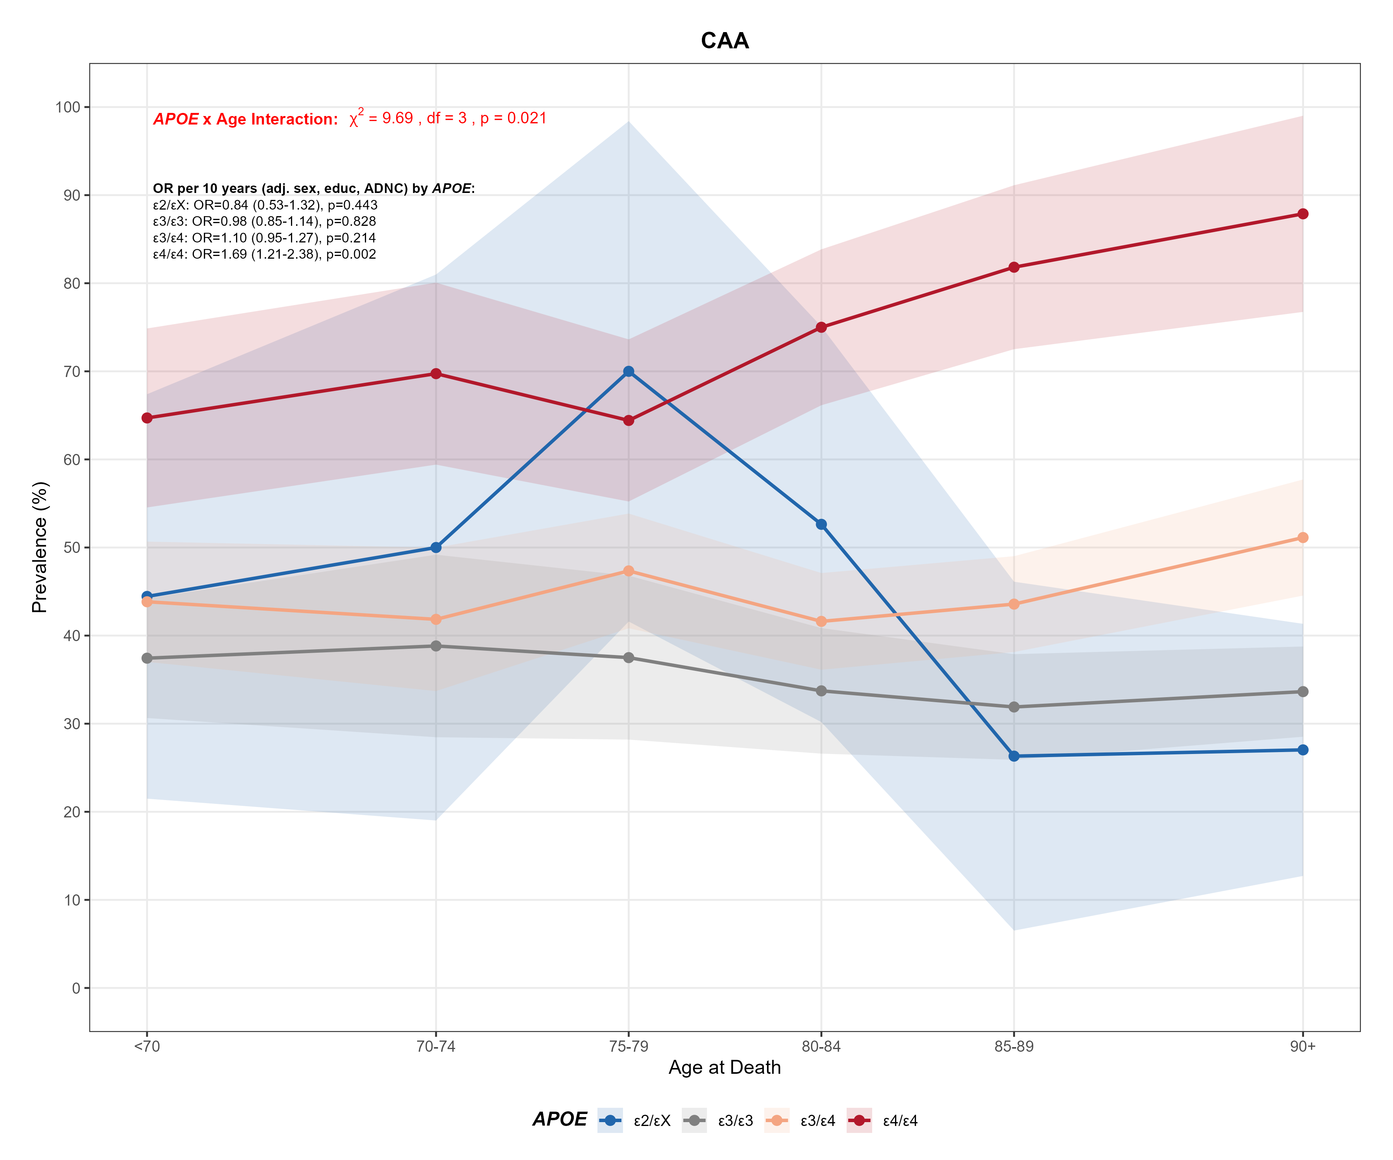
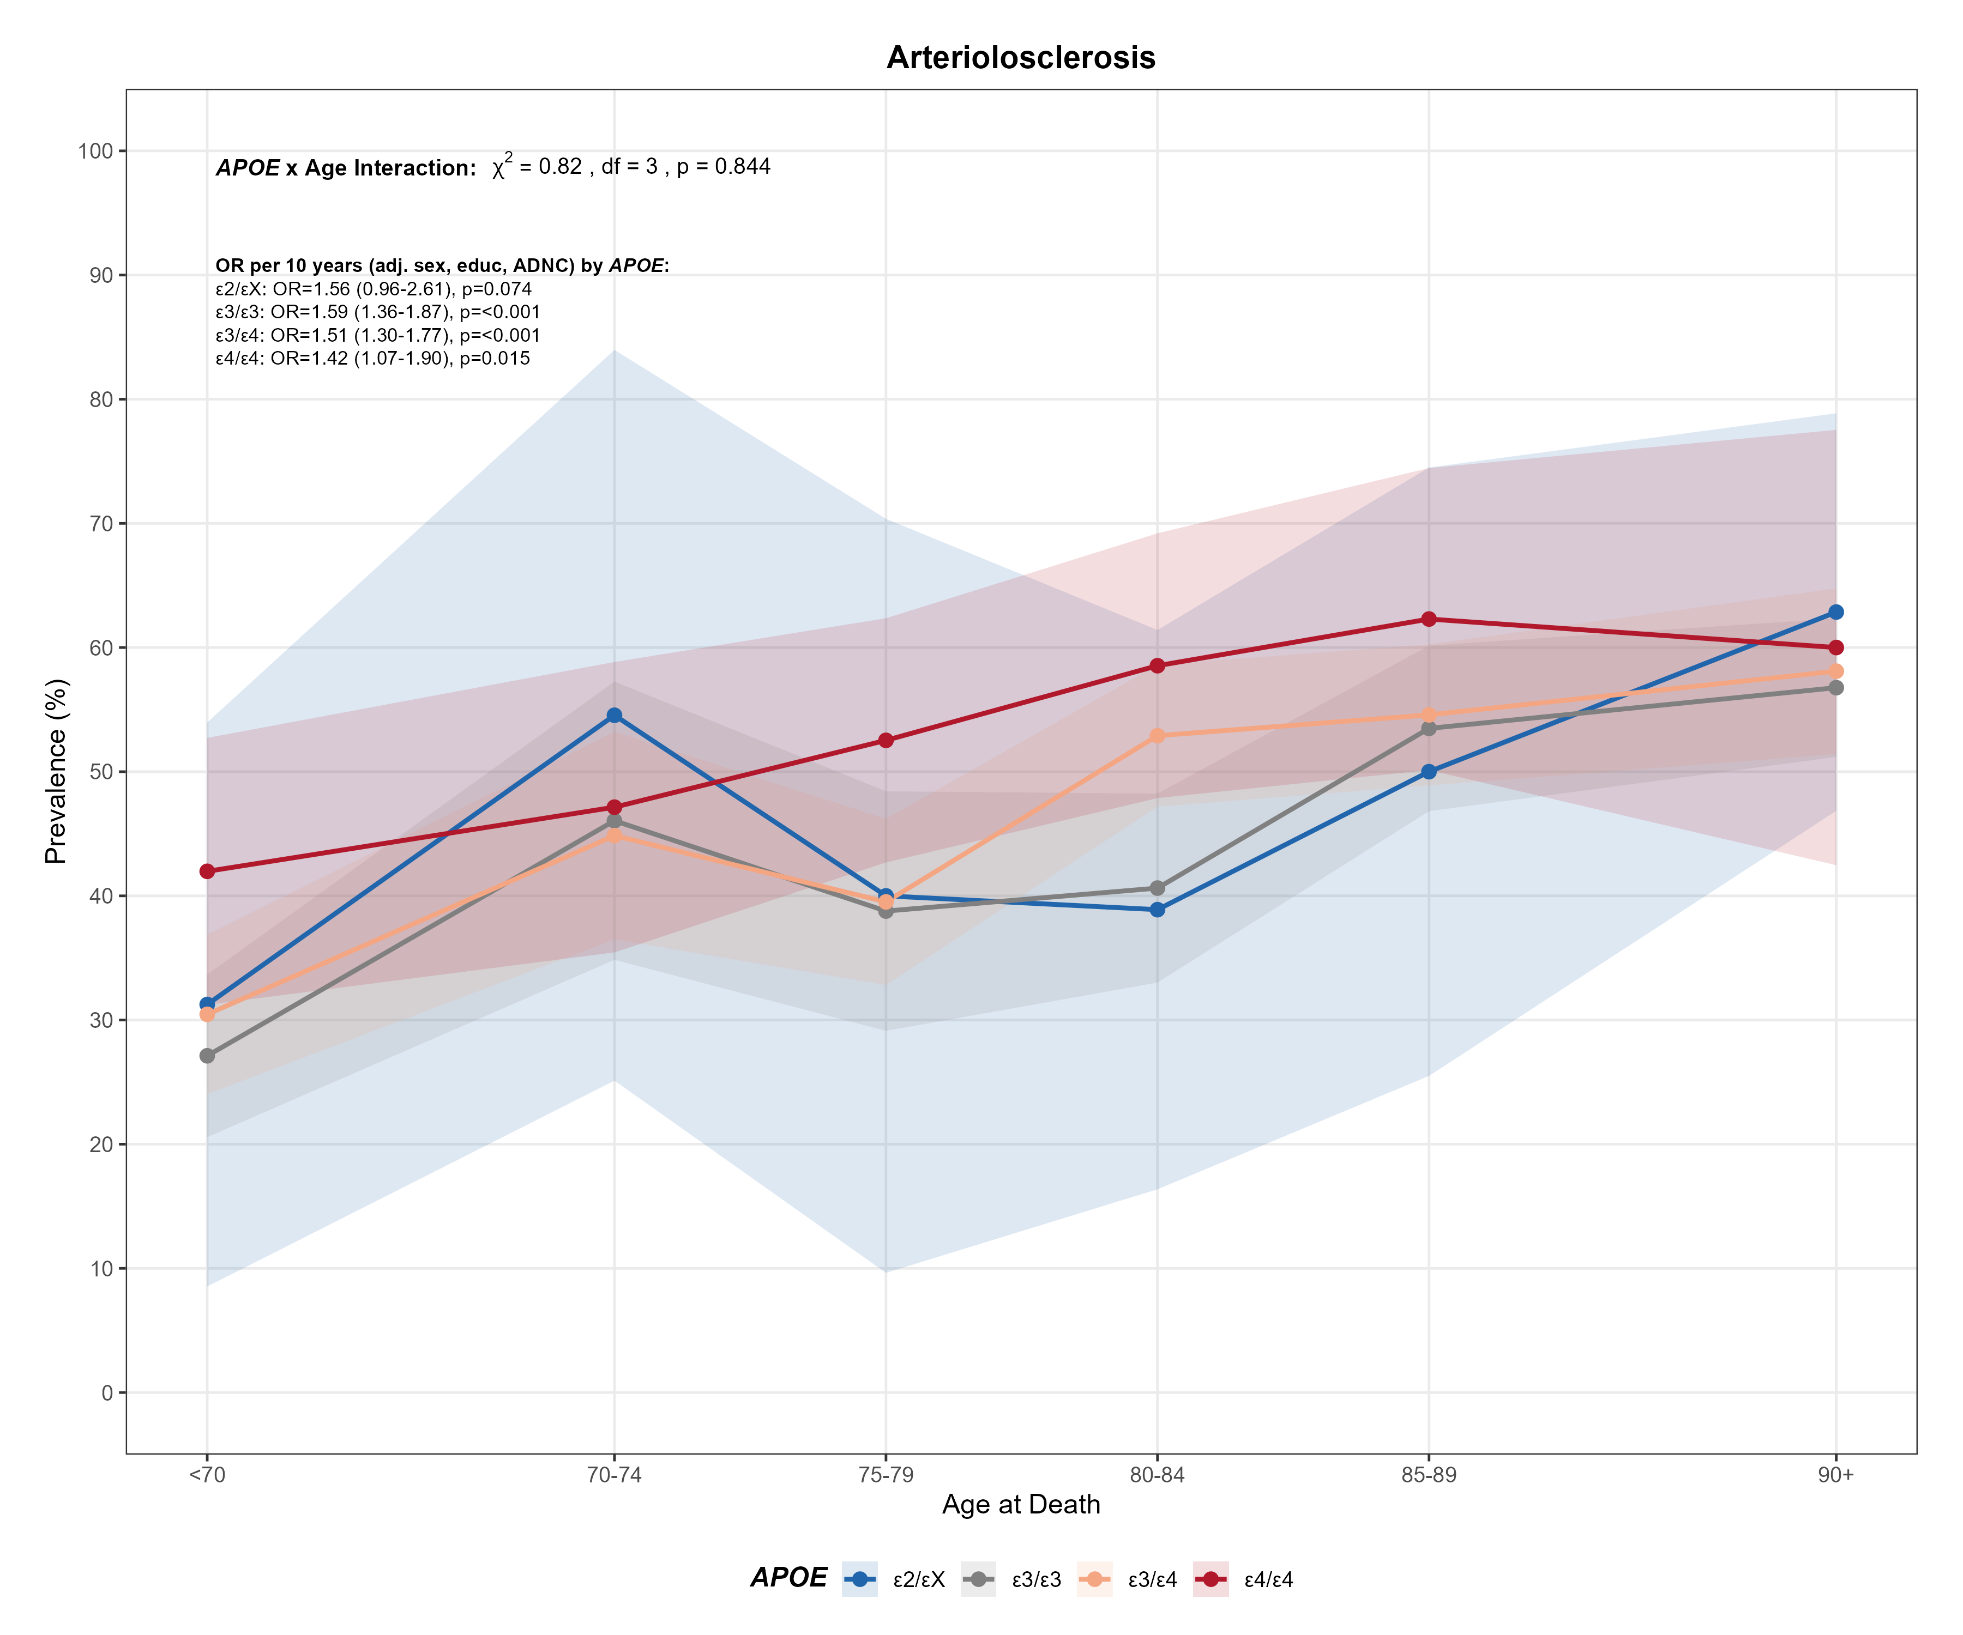
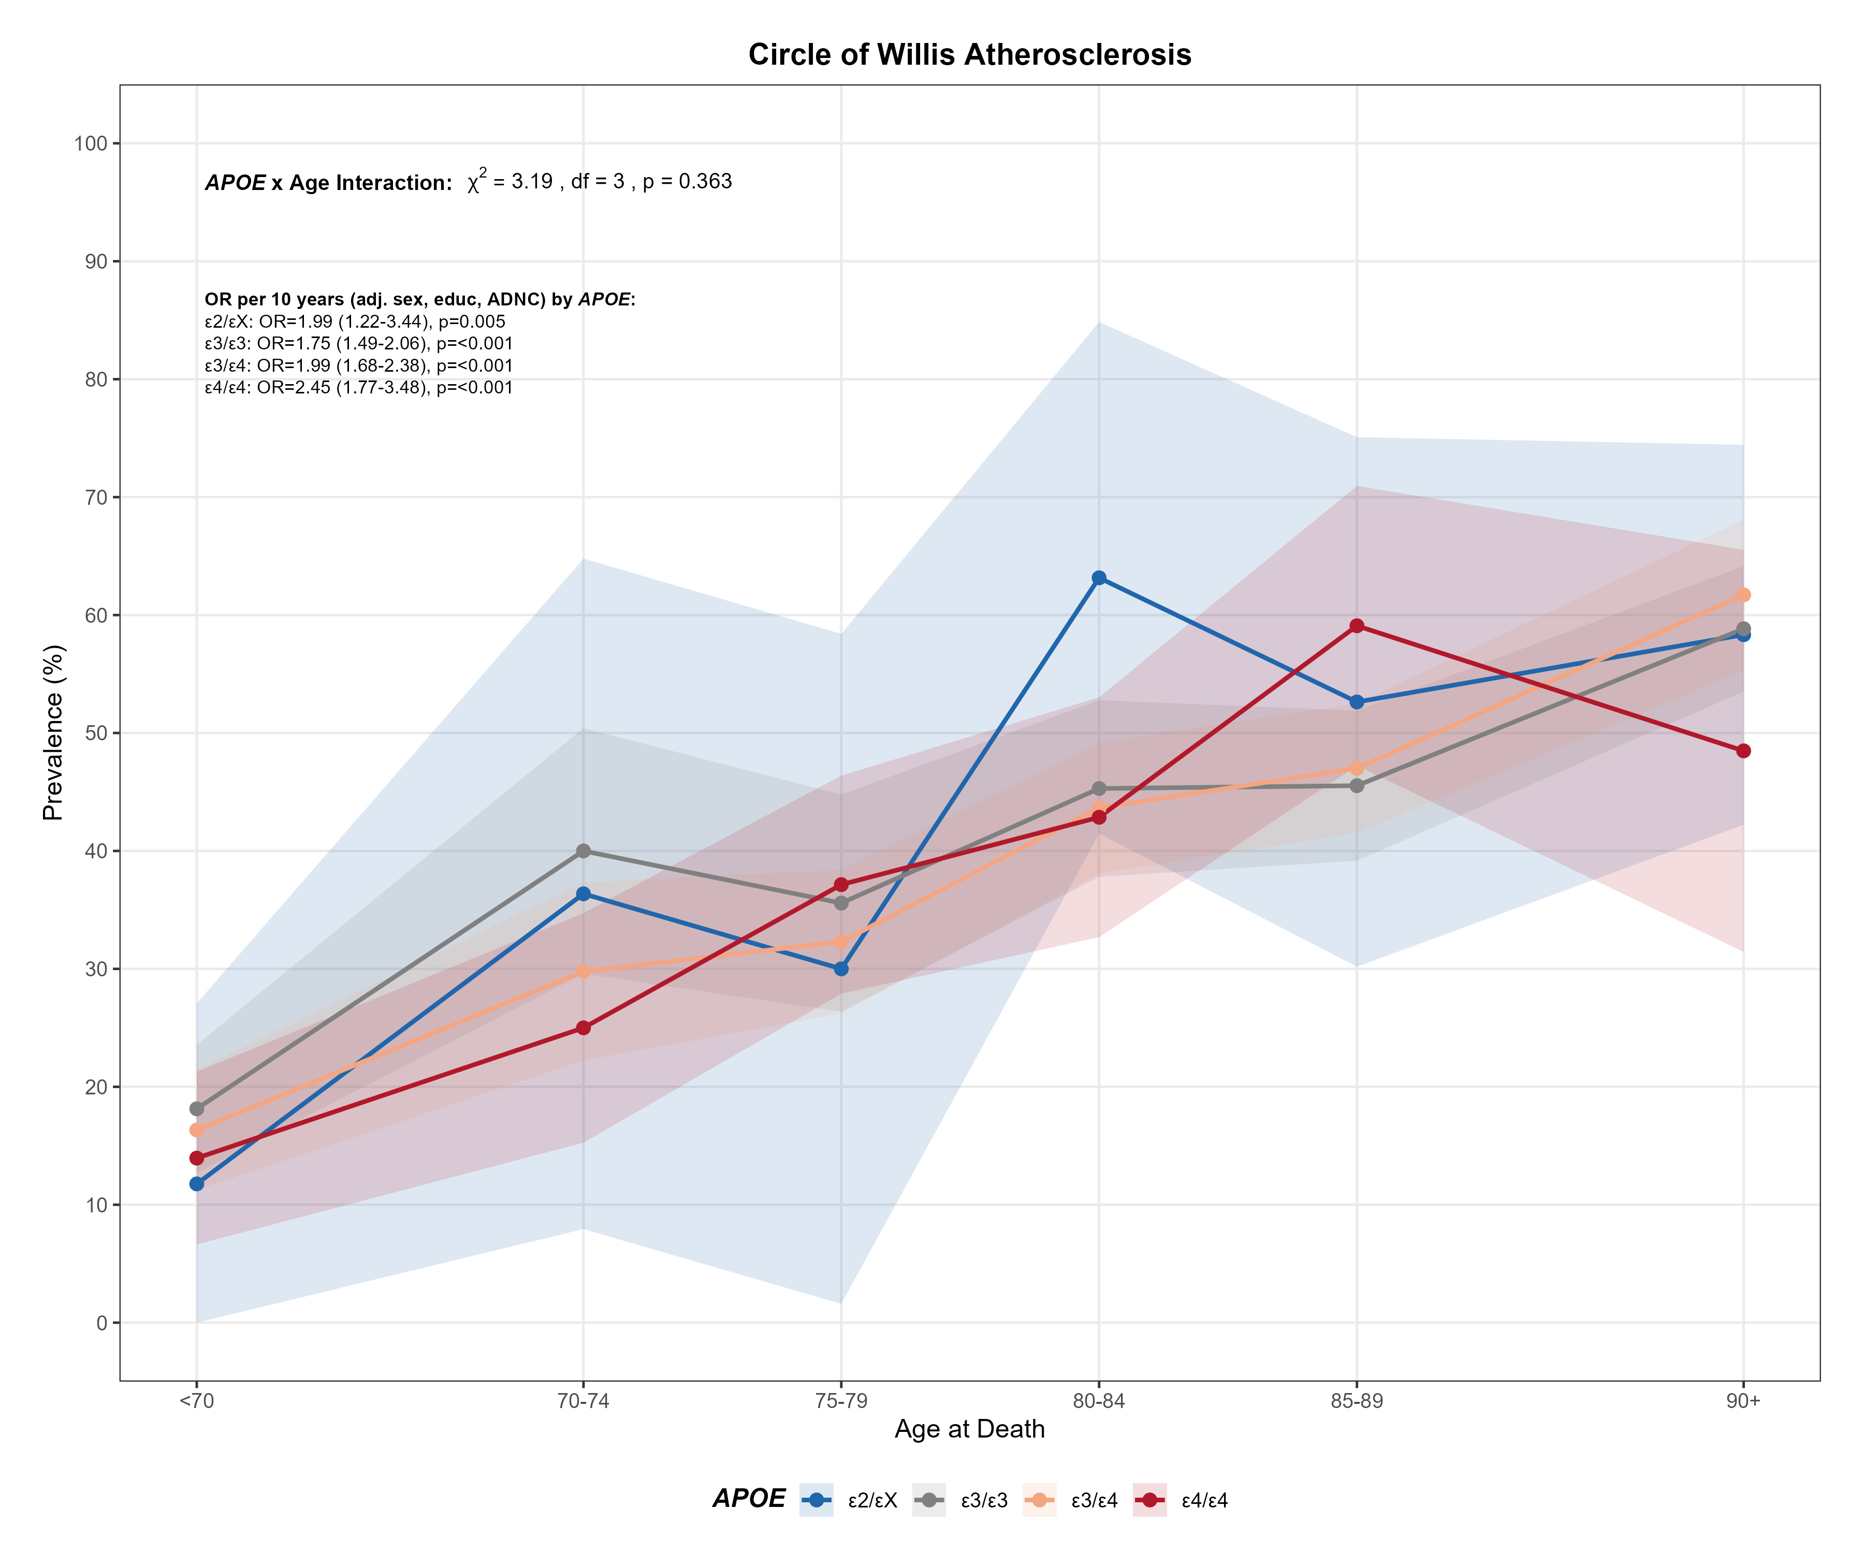

Supplementary Figure 5. Prevalence of Vascular-related pathologies prevalence by age at death and APOE haplotype in amyloid-positive Alzheimer’s disease dementia. Line plots show the prevalence (%) of vascular-related neuropathologies across age-at-death categories, stratified by APOE haplotype, for three outcomes: CAA (upper panel), arteriolosclerosis (middle panel), and atherosclerosis (bottom panel). Shaded areas represent 95% confidence intervals. Odds ratios are estimated per 10-year increase in age using models adjusted for sex, education, and ADNC. APOE × age interaction terms were tested for each pathology, with corresponding χ² statistics and p-values shown in each panel. Interaction labels shown in red indicate statistical significance (p < 0.05). AD, Alzheimer's disease; ADNC, Alzheimer's disease neuropathologic change; APOE, apolipoprotein E; CAA, cerebral amyloid angiopathy; educ, education; OB, olfactory bulb; OR, odds ratio.
Supplementary Table 1. A) Association between APOE haplotype, amyloid positivity, and Alzheimer's disease diagnosis. B) Sample sizes for primary outcome variables.

Supplementary Table 1A
Outcome | APOE haplotype | OR | 95% CI lower | 95% CI upper | p
Amyloid positive vs. negative | ε2/ε2 | 0.24 | 0.09 | 0.57 | 0.002
Amyloid positive vs. negative | ε2/ε3 | 0.51 | 0.43 | 0.61 | <0.001
Amyloid positive vs. negative | ε2/ε4 | 2.02 | 1.49 | 2.78 | <0.001
Amyloid positive vs. negative | ε3/ε3 | Ref. | — | — | —
Amyloid positive vs. negative | ε3/ε4 | 3.28 | 2.91 | 3.69 | <0.001
Amyloid positive vs. negative | ε4/ε4 | 10.30 | 7.70 | 14.11 | <0.001
AD vs. non-AD | ε2/ε2 | 0.81 | 0.37 | 1.71 | 0.586
AD vs. non-AD | ε2/ε3 | 0.67 | 0.56 | 0.80 | <0.001
AD vs. non-AD | ε2/ε4 | 2.18 | 1.62 | 2.97 | <0.001
AD vs. non-AD | ε3/ε3 | Ref. | — | — | —
AD vs. non-AD | ε3/ε4 | 2.56 | 2.30 | 2.86 | <0.001
AD vs. non-AD | ε4/ε4 | 5.24 | 4.22 | 6.58 | <0.001
Supplementary Table 1B
Outcome | n total | n positive | % positive
AD vs. non-AD | 7,262 | 4,212 | 58.0
Amyloid positive vs. negative | 7,262 | 4,620 | 63.6
Reference group: ε3/ε3 carriers.
Abbreviations: AD, Alzheimer's disease; APOE, apolipoprotein E; CI, confidence interval; n, number; OR, odds ratio; Ref., reference.

Supplementary Table 2. Association between APOE haplotype and concordant clinicopathological Alzheimer's disease.
APOE haplotype | n | n (AD, Aβ+) | % (AD, Aβ+) | n (Clinical AD) | % (Clinical AD) | Unadjusted OR (95% CI) | p | Adjusted OR¹ (95% CI) | p | Adjusted OR² (95% CI) | p
ε3/ε3 | 3,441 | 1,211 | 35.2 | 1,652 | 73.3 | Ref. | — | Ref. | — | Ref. | —
ε2/ε2 | 28 | 2 | 7.1 | 12 | 16.7 | 0.14 (0.02–0.48) | 0.008 | 0.14 (0.02–0.46) | 0.007 | 0.14 (0.02–0.51) | 0.010
ε2/ε3 | 585 | 129 | 22.1 | 224 | 57.6 | 0.52 (0.42–0.64) | <0.001 | 0.52 (0.42–0.64) | <0.001 | 0.50 (0.39–0.63) | <0.001
ε2/ε4 | 195 | 105 | 53.8 | 130 | 80.8 | 2.15 (1.61–2.88) | <0.001 | 2.13 (1.60–2.86) | <0.001 | 1.73 (1.24–2.43) | 0.001
ε3/ε4 | 2,399 | 1,490 | 62.1 | 1,688 | 88.3 | 3.02 (2.71–3.36) | <0.001 | 3.04 (2.73–3.39) | <0.001 | 2.73 (2.41–3.10) | <0.001
ε4/ε4 | 601 | 471 | 78.4 | 498 | 94.6 | 6.67 (5.44–8.23) | <0.001 | 6.79 (5.54–8.38) | <0.001 | 5.59 (4.46–7.07) | <0.001
Percentages represent proportion of each haplotype group with the specified outcome.
1-Adjusted for sex and years of education.
2-Adjusted for sex, years of education, and age at dementia diagnosis.
Abbreviations: AD, Alzheimer's disease; Aβ+, amyloid positive; APOE, apolipoprotein E; CI, confidence interval; OR, odds ratio; Ref., reference.

Supplementary Table 3. Associations between APOE haplotype, age, and ordinal Braak stage across dementia groups.
APOE haplotype | Group | Per 1 year unadjusted OR (95% CI) | p | Per 10 years unadjusted OR (95% CI) | p | Per 1 year adjusted OR (95% CI) | p | Per 10 years adjusted OR (95% CI) | p
ε2/εX | All-cause dementia | 1.05 (1.03–1.06) | <0.001 | 1.59 (1.36–1.86) | <0.001 | 1.04 (1.03–1.06) | <0.001 | 1.54 (1.32–1.81) | <0.001
ε2/εX | AD dementia | 0.96 (0.94–0.99) | 0.003 | 0.69 (0.54–0.88) | 0.003 | 0.96 (0.93–0.98) | <0.001 | 0.65 (0.50–0.84) | <0.001
ε2/εX | Aβ+ AD dementia | 0.94 (0.90–0.98) | 0.002 | 0.51 (0.33–0.78) | 0.002 | 0.93 (0.89–0.97) | 0.001 | 0.47 (0.30–0.74) | 0.001
ε3/ε3 | All-cause dementia | 1.03 (1.02–1.04) | <0.001 | 1.32 (1.23–1.41) | <0.001 | 1.03 (1.02–1.03) | <0.001 | 1.30 (1.21–1.39) | <0.001
ε3/ε3 | AD dementia | 0.94 (0.93–0.95) | <0.001 | 0.56 (0.50–0.62) | <0.001 | 0.94 (0.93–0.95) | <0.001 | 0.53 (0.47–0.59) | <0.001
ε3/ε3 | Aβ+ AD dementia | 0.93 (0.91–0.94) | <0.001 | 0.46 (0.39–0.55) | <0.001 | 0.92 (0.90–0.94) | <0.001 | 0.43 (0.36–0.52) | <0.001
ε3/ε4 | All-cause dementia | 1.01 (1.00–1.02) | 0.087 | 1.09 (0.99–1.20) | 0.087 | 1.01 (1.00–1.02) | 0.218 | 1.07 (0.96–1.18) | 0.219
ε3/ε4 | AD dementia | 0.93 (0.91–0.94) | <0.001 | 0.47 (0.41–0.56) | <0.001 | 0.93 (0.91–0.94) | <0.001 | 0.46 (0.40–0.55) | <0.001
ε3/ε4 | Aβ+ AD dementia | 0.93 (0.92–0.95) | <0.001 | 0.50 (0.41–0.61) | <0.001 | 0.93 (0.91–0.95) | <0.001 | 0.49 (0.40–0.60) | <0.001
ε4/ε4 | All-cause dementia | 1.02 (0.99–1.05) | 0.222 | 1.20 (0.90–1.60) | 0.224 | 1.02 (0.99–1.05) | 0.297 | 1.17 (0.87–1.56) | 0.301
ε4/ε4 | AD dementia | 0.98 (0.94–1.01) | 0.206 | 0.78 (0.54–1.14) | 0.204 | 0.98 (0.94–1.01) | 0.223 | 0.80 (0.55–1.16) | 0.231
ε4/ε4 | Aβ+ AD dementia | 0.97 (0.93–1.02) | 0.200 | 0.75 (0.49–1.16) | 0.198 | 0.98 (0.93–1.02) | 0.239 | 0.77 (0.51–1.19) | 0.242
Adjusted model for sex and education.
Abbreviations: Aβ+, amyloid positive; AD, Alzheimer's disease; APOE, apolipoprotein E; CI, confidence interval; OR, odds ratio.

Supplementary Table 4. Regional distribution of Lewy body (A) and TDP-43 pathology (B) by APOE haplotype in amyloid-positive AD dementia.
Supplementary Table 4A
APOE  haplotype | Lewy body stage | Comparison  n (%) | Reference  n (%) | χ² | Unadjusted OR  (95% CI) | p | Adjusted LRχ² | Adjusted OR  (95% CI) | p | ADNC-adjusted LRχ² | ADNC-adjusted OR  (95% CI) | p
ε2/εX | LB present/OB only | 4 (3.5%) | 35 (3.1%) | 0.06 | 1.14 (0.29–3.26) | 0.813 | 0.10 | 1.20 (0.35–3.09) | 0.747 | 0.51 | 1.82 (0.27–7.19) | 0.477
ε2/εX | Brainstem predominant | 6 (5.3%) | 32 (2.9%) | 2.06 | 1.90 (0.64–4.75) | 0.152 | 1.73 | 1.91 (0.70–4.38) | 0.189 | 0.00 | 1.00 (0.23–3.10) | 1.000
ε2/εX | Limbic/Amygdala predominant | 18 (15.9%) | 226 (20.2%) | 1.19 | 0.75 (0.42–1.28) | 0.276 | 1.27 | 0.74 (0.43–1.23) | 0.260 | 1.11 | 0.74 (0.41–1.28) | 0.292
ε2/εX | Neocortical | 16 (14.2%) | 123 (11.0%) | 1.02 | 1.33 (0.71–2.37) | 0.312 | 0.98 | 1.34 (0.74–2.29) | 0.322 | 0.02 | 1.06 (0.49–2.06) | 0.882
ε3/ε4 | LB present/OB only | 84 (5.9%) | 35 (3.1%) | 10.61 | 1.93 (1.28–2.98) | 0.001 | 10.29 | 1.89 (1.28–2.87) | 0.001 | 5.57 | 2.27 (1.14–4.93) | 0.018
ε3/ε4 | Brainstem predominant | 38 (2.7%) | 32 (2.9%) | 0.10 | 0.93 (0.56–1.54) | 0.754 | 0.01 | 0.98 (0.61–1.59) | 0.931 | 0.00 | 1.00 (0.53–1.88) | 0.993
ε3/ε4 | Limbic/Amygdala predominant | 331 (23.1%) | 226 (20.2%) | 3.16 | 1.19 (0.98–1.45) | 0.076 | 2.17 | 1.16 (0.95–1.40) | 0.141 | 0.83 | 1.11 (0.89–1.39) | 0.363
ε3/ε4 | Neocortical | 208 (14.5%) | 123 (11.0%) | 6.97 | 1.38 (1.08–1.76) | 0.008 | 6.54 | 1.36 (1.07–1.73) | 0.011 | 6.96 | 1.50 (1.11–2.04) | 0.008
ε4/ε4 | LB present/OB only | 34 (7.4%) | 35 (3.1%) | 14.30 | 2.48 (1.48–4.15) | <0.001 | 12.08 | 2.44 (1.48–4.03) | <0.001 | 0.99 | 1.68 (0.59–4.59) | 0.320
ε4/ε4 | Brainstem predominant | 9 (2.0%) | 32 (2.9%) | 1.03 | 0.68 (0.28–1.47) | 0.310 | 0.39 | 0.79 (0.34–1.63) | 0.531 | 2.91 | 0.32 (0.05–1.16) | 0.088
ε4/ε4 | Limbic/Amygdala predominant | 133 (29.0%) | 226 (20.2%) | 14.38 | 1.62 (1.25–2.09) | <0.001 | 8.05 | 1.45 (1.12–1.87) | 0.005 | 10.35 | 1.63 (1.21–2.19) | 0.001
ε4/ε4 | Neocortical | 65 (14.2%) | 123 (11.0%) | 3.15 | 1.34 (0.95–1.87) | 0.076 | 3.20 | 1.36 (0.97–1.88) | 0.074 | 2.99 | 1.46 (0.95–2.23) | 0.084
Supplementary Table 4B
APOE  haplotype | TDP-43 stage | Comparison  n (%) | Reference  n (%) | χ² | Unadjusted OR  (95% CI) | p | Adjusted LRχ² | Adjusted OR  (95% CI) | p | ADNC-adjusted LRχ² | ADNC-adjusted OR  (95% CI) | p
ε2/εX | Amygdala | 2 (5.4%) | 32 (10.8%) | 1.04 | 0.47 (0.05–2.00) | 0.308 | 1.07 | 0.49 (0.08–1.74) | 0.302 | 1.04 | 0.49 (0.08–1.75) | 0.307
ε2/εX | Hippocampus | 6 (16.2%) | 35 (11.8%) | 0.60 | 1.45 (0.46–3.87) | 0.439 | 0.37 | 1.35 (0.48–3.31) | 0.546 | 0.31 | 1.33 (0.46–3.33) | 0.578
ε2/εX | Entorhinal/inf. temporal | 11 (29.7%) | 109 (36.7%) | 0.69 | 0.73 (0.31–1.60) | 0.405 | 0.93 | 0.69 (0.31–1.45) | 0.335 | 0.69 | 0.73 (0.33–1.53) | 0.406
ε2/εX | Neocortex | 5 (13.5%) | 51 (17.2%) | 0.32 | 0.75 (0.22–2.08) | 0.574 | 0.23 | 0.79 (0.26–1.99) | 0.635 | 0.61 | 0.67 (0.21–1.75) | 0.435
ε3/ε4 | Amygdala | 67 (15.2%) | 32 (10.8%) | 3.02 | 1.49 (0.93–2.41) | 0.082 | 2.50 | 1.44 (0.92–2.28) | 0.114 | 2.26 | 1.41 (0.90–2.25) | 0.133
ε3/ε4 | Hippocampus | 57 (13.0%) | 35 (11.8%) | 0.22 | 1.11 (0.70–1.80) | 0.637 | 0.28 | 1.13 (0.72–1.80) | 0.596 | 0.23 | 1.12 (0.71–1.78) | 0.629
ε3/ε4 | Entorhinal/inf. temporal | 162 (36.8%) | 109 (36.7%) | 0.00 | 1.01 (0.73–1.38) | 0.974 | 0.10 | 1.05 (0.77–1.44) | 0.747 | 0.06 | 1.04 (0.76–1.43) | 0.802
ε3/ε4 | Neocortex | 61 (13.9%) | 51 (17.2%) | 1.51 | 0.78 (0.51–1.19) | 0.220 | 0.45 | 0.87 (0.57–1.32) | 0.503 | 0.32 | 0.89 (0.58–1.35) | 0.572
ε4/ε4 | Amygdala | 27 (19.6%) | 32 (10.8%) | 6.21 | 2.01 (1.10–3.65) | 0.013 | 3.50 | 1.75 (0.97–3.15) | 0.062 | 3.12 | 1.70 (0.94–3.05) | 0.077
ε4/ε4 | Hippocampus | 19 (13.8%) | 35 (11.8%) | 0.34 | 1.20 (0.62–2.25) | 0.559 | 0.80 | 1.35 (0.70–2.55) | 0.370 | 0.58 | 1.29 (0.67–2.43) | 0.445
ε4/ε4 | Entorhinal/inf. temporal | 49 (35.5%) | 109 (36.7%) | 0.06 | 0.95 (0.61–1.48) | 0.810 | 0.85 | 1.24 (0.78–1.96) | 0.358 | 0.72 | 1.22 (0.77–1.93) | 0.397
ε4/ε4 | Neocortex | 18 (13.0%) | 51 (17.2%) | 1.20 | 0.72 (0.38–1.33) | 0.273 | 0.28 | 0.85 (0.45–1.56) | 0.599 | 0.10 | 0.90 (0.47–1.68) | 0.749
Reference group: ε3/ε3 carriers with amyloid-positive AD dementia.
Bold rows indicate statistically significant associations (p < 0.05) in ADNC-adjusted models.
Adjusted models include sex, education, and age at death; ADNC-adjusted models additionally include ADNC.
Abbreviations: ADNC, Alzheimer's disease neuropathologic change; APOE, apolipoprotein E; CI, confidence interval; inf., inferior; LB, Lewy body; OB, olfactory bulb; OR, odds ratio; TAR DNA-binding protein 43.

Supplementary Table 5. Region-specific associations between age and Lewy body (A) and TDP-43 (B) pathology by APOE haplotype.
Supplementary Table 5A
APOE  haplotype | Lewy body stage | χ² | Unadjusted OR/10 yr  (95% CI) | p | Adjusted LRχ² | Adjusted OR/10 yr  (95% CI) | p | ADNC-Adjusted LRχ² | ADNC-adjusted OR/10 yr  (95% CI) | p
ε2/εX | LB present/OB only | — | — | — | — | — | — | — | — | —
ε2/εX | Brainstem predominant | 2.68 | 2.10 (0.88–6.67) | 0.102 | 4.45 | 3.31 (1.07–16.55) | 0.035 | 1.24 | 2.65 (0.51–27.99) | 0.266
ε2/εX | Limbic/Amygdala predominant | 0.00 | 1.00 (0.63–1.62) | 0.997 | 0.00 | 1.01 (0.64–1.65) | 0.973 | 0.45 | 1.21 (0.70–2.15) | 0.501
ε2/εX | Neocortical | 0.22 | 0.89 (0.56–1.46) | 0.638 | 0.05 | 0.95 (0.58–1.58) | 0.823 | 0.00 | 0.99 (0.48–2.10) | 0.980
ε3/ε3 | LB present/OB only | 3.81 | 0.75 (0.57–1.00) | 0.051 | 4.11 | 0.74 (0.56–0.99) | 0.043 | 0.87 | 1.31 (0.75–2.47) | 0.351
ε3/ε3 | Brainstem predominant | 1.53 | 1.23 (0.89–1.75) | 0.216 | 2.25 | 1.30 (0.93–1.89) | 0.134 | 1.49 | 1.33 (0.85–2.21) | 0.222
ε3/ε3 | Limbic/Amygdala predominant | 14.65 | 0.78 (0.69–0.89) | <0.001 | 13.81 | 0.78 (0.69–0.89) | <0.001 | 8.09 | 0.80 (0.68–0.93) | 0.004
ε3/ε3 | Neocortical | 0.14 | 1.03 (0.88–1.23) | 0.705 | 0.40 | 1.06 (0.89–1.26) | 0.530 | 1.24 | 1.14 (0.91–1.45) | 0.266
ε3/ε4 | LB present/OB only | 0.92 | 0.90 (0.72–1.13) | 0.338 | 0.51 | 0.92 (0.73–1.16) | 0.473 | 1.06 | 0.82 (0.57–1.20) | 0.303
ε3/ε4 | Brainstem predominant | 0.89 | 1.18 (0.84–1.70) | 0.346 | 1.79 | 1.28 (0.90–1.86) | 0.181 | 1.13 | 1.31 (0.80–2.25) | 0.288
ε3/ε4 | Limbic/Amygdala predominant | 4.89 | 0.87 (0.76–0.98) | 0.027 | 5.47 | 0.86 (0.76–0.98) | 0.019 | 0.61 | 0.94 (0.81–1.10) | 0.433
ε3/ε4 | Neocortical | 5.66 | 0.83 (0.72–0.97) | 0.017 | 5.59 | 0.83 (0.72–0.97) | 0.018 | 1.14 | 0.90 (0.74–1.09) | 0.285
ε4/ε4 | LB present/OB only | 2.19 | 1.37 (0.90–2.11) | 0.139 | 2.24 | 1.37 (0.91–2.11) | 0.134 | 0.48 | 1.36 (0.58–3.46) | 0.488
ε4/ε4 | Brainstem predominant | 2.19 | 1.84 (0.82–4.36) | 0.139 | 2.39 | 1.96 (0.84–4.91) | 0.122 | 0.48 | 1.81 (0.35–13.48) | 0.488
ε4/ε4 | Limbic/Amygdala predominant | 5.68 | 0.75 (0.59–0.95) | 0.017 | 6.19 | 0.74 (0.58–0.94) | 0.013 | 0.96 | 0.87 (0.65–1.15) | 0.328
ε4/ε4 | Neocortical | 0.01 | 1.01 (0.74–1.38) | 0.945 | 0.02 | 1.02 (0.75–1.39) | 0.902 | 0.01 | 1.01 (0.69–1.49) | 0.945
Supplementary Table 5B
APOE  haplotype | TDP-43 stage | χ² | Unadjusted OR/10 yr  (95% CI) | p | Adjusted LRχ² | Adjusted OR/10 yr  (95% CI) | p | ADNC-Adjusted LRχ² | ADNC-adjusted OR/10 yr  (95% CI) | p
ε2/εX | Spinal cord | — | — | — | — | — | — | — | — | —
ε2/εX | Amygdala | — | — | — | — | — | — | — | — | —
ε2/εX | Hippocampus | 0.04 | 1.09 (0.47–2.88) | 0.849 | 0.07 | 0.88 (0.33–2.45) | 0.788 | 0.00 | 1.00 (0.37–2.88) | 0.997
ε2/εX | Entorhinal/inf. temporal | 2.16 | 1.76 (0.84–4.41) | 0.141 | 2.66 | 1.97 (0.88–5.29) | 0.103 | 3.01 | 2.06 (0.92–5.51) | 0.083
ε2/εX | Neocortex | 0.79 | 1.59 (0.60–5.73) | 0.373 | 1.06 | 1.78 (0.62–7.17) | 0.304 | 0.28 | 1.44 (0.39–7.36) | 0.596
ε3/ε3 | Spinal cord | — | — | — | — | — | — | — | — | —
ε3/ε3 | Amygdala | 1.18 | 0.83 (0.60–1.16) | 0.278 | 1.14 | 0.83 (0.60–1.17) | 0.286 | 1.25 | 0.81 (0.57–1.17) | 0.263
ε3/ε3 | Hippocampus | 1.51 | 1.24 (0.89–1.78) | 0.219 | 1.19 | 1.21 (0.87–1.74) | 0.276 | 2.20 | 1.32 (0.92–1.97) | 0.138
ε3/ε3 | Entorhinal/inf. temporal | 14.09 | 1.56 (1.23–2.00) | <0.001 | 13.07 | 1.54 (1.21–1.98) | <0.001 | 10.01 | 1.51 (1.17–1.99) | 0.002
ε3/ε3 | Neocortex | 2.86 | 1.29 (0.96–1.76) | 0.091 | 2.65 | 1.28 (0.95–1.76) | 0.103 | 1.44 | 1.23 (0.88–1.75) | 0.230
ε3/ε4 | Spinal cord | — | — | — | — | — | — | — | — | —
ε3/ε4 | Amygdala | 4.59 | 0.73 (0.54–0.97) | 0.032 | 4.68 | 0.72 (0.54–0.97) | 0.031 | 4.07 | 0.73 (0.55–0.99) | 0.044
ε3/ε4 | Hippocampus | 0.26 | 1.09 (0.79–1.53) | 0.613 | 0.24 | 1.09 (0.79–1.52) | 0.625 | 0.02 | 1.03 (0.74–1.45) | 0.877
ε3/ε4 | Entorhinal/inf. temporal | 2.40 | 1.20 (0.95–1.51) | 0.122 | 2.17 | 1.19 (0.94–1.51) | 0.141 | 3.34 | 1.25 (0.98–1.59) | 0.067
ε3/ε4 | Neocortex | 16.61 | 2.08 (1.45–3.08) | <0.001 | 17.17 | 2.12 (1.47–3.15) | <0.001 | 13.79 | 2.01 (1.38–3.01) | <0.001
ε4/ε4 | Spinal cord | — | — | — | — | — | — | — | — | —
ε4/ε4 | Amygdala | 3.77 | 0.59 (0.34–1.01) | 0.052 | 4.09 | 0.57 (0.32–0.98) | 0.043 | 4.14 | 0.57 (0.31–0.98) | 0.042
ε4/ε4 | Hippocampus | 0.07 | 1.08 (0.59–1.97) | 0.798 | 0.06 | 1.08 (0.60–1.96) | 0.801 | 0.12 | 1.11 (0.61–2.03) | 0.728
ε4/ε4 | Entorhinal/inf. temporal | 1.53 | 1.31 (0.85–2.05) | 0.216 | 1.58 | 1.32 (0.86–2.08) | 0.209 | 1.38 | 1.30 (0.84–2.06) | 0.241
ε4/ε4 | Neocortex | 2.53 | 1.65 (0.89–3.14) | 0.112 | 2.28 | 1.60 (0.87–3.06) | 0.131 | 2.42 | 1.63 (0.88–3.13) | 0.120
Bold rows indicate statistically significant associations (p < 0.05) in ADNC-adjusted models.
Adjusted models include sex and education; ADNC-adjusted models additionally include ADNC.
Abbreviations: ADNC, Alzheimer's disease neuropathologic change; APOE, apolipoprotein E; CI, confidence interval; inf., inferior; LB, Lewy body; OB, olfactory bulb; OR, odds ratio; TAR DNA-binding protein 43; yr, years.

Supplementary Table 6. Region-specific associations between dementia duration and Lewy body (A) and TDP-43 (B) pathology by APOE haplotype.
Supplementary Table 6A
APOE  haplotype | Lewy body stage | χ² | Unadjusted OR/yr  (95% CI) | p | Adjusted LRχ² | Adjusted OR/yr  (95% CI) | p | ADNC-Adjusted LRχ² | ADNC-adjusted OR/yr  (95% CI) | p
ε2/εX | LB present/OB only | — | — | — | — | — | — | — | — | —
ε2/εX | Brainstem predominant | 0.45 | 0.91 (0.65–1.18) | 0.504 | 0.11 | 1.06 (0.72–1.48) | 0.739 | 0.03 | 1.04 (0.61–1.61) | 0.856
ε2/εX | Limbic/Amygdala predominant | 3.39 | 1.15 (0.99–1.34) | 0.066 | 3.19 | 1.16 (0.99–1.36) | 0.074 | 1.36 | 1.11 (0.93–1.32) | 0.244
ε2/εX | Neocortical | 0.96 | 0.92 (0.75–1.09) | 0.328 | 0.84 | 0.92 (0.74–1.10) | 0.360 | 0.04 | 0.98 (0.76–1.22) | 0.841
ε3/ε3 | LB present/OB only | 3.32 | 0.89 (0.78–1.01) | 0.068 | 5.44 | 0.86 (0.74–0.98) | 0.020 | 0.02 | 0.98 (0.78–1.22) | 0.883
ε3/ε3 | Brainstem predominant | 0.30 | 0.97 (0.85–1.09) | 0.583 | 0.01 | 1.01 (0.88–1.14) | 0.941 | 0.28 | 0.96 (0.82–1.11) | 0.599
ε3/ε3 | Limbic/Amygdala predominant | 49.88 | 1.19 (1.13–1.25) | <0.001 | 36.58 | 1.17 (1.11–1.23) | <0.001 | 10.06 | 1.10 (1.04–1.17) | 0.002
ε3/ε3 | Neocortical | 1.58 | 0.96 (0.90–1.02) | 0.208 | 0.80 | 0.97 (0.90–1.04) | 0.372 | 0.45 | 0.97 (0.89–1.06) | 0.502
ε3/ε4 | LB present/OB only | 9.43 | 0.89 (0.82–0.96) | 0.002 | 8.35 | 0.89 (0.82–0.97) | 0.004 | 4.04 | 0.88 (0.77–1.00) | 0.044
ε3/ε4 | Brainstem predominant | 2.80 | 0.91 (0.81–1.02) | 0.095 | 0.78 | 0.95 (0.84–1.06) | 0.378 | 1.13 | 1.08 (0.94–1.23) | 0.287
ε3/ε4 | Limbic/Amygdala predominant | 57.01 | 1.16 (1.11–1.20) | <0.001 | 46.52 | 1.15 (1.10–1.19) | <0.001 | 12.85 | 1.09 (1.04–1.14) | <0.001
ε3/ε4 | Neocortical | 0.52 | 0.98 (0.94–1.03) | 0.472 | 1.30 | 0.97 (0.93–1.02) | 0.255 | 1.91 | 0.96 (0.90–1.02) | 0.167
ε4/ε4 | LB present/OB only | 7.44 | 0.84 (0.74–0.96) | 0.006 | 4.80 | 0.87 (0.75–0.99) | 0.028 | 3.40 | 1.26 (0.99–1.64) | 0.065
ε4/ε4 | Brainstem predominant | 0.75 | 0.91 (0.71–1.12) | 0.388 | 0.01 | 0.99 (0.76–1.23) | 0.919 | 0.04 | 1.05 (0.62–1.72) | 0.851
ε4/ε4 | Limbic/Amygdala predominant | 19.76 | 1.16 (1.08–1.23) | <0.001 | 11.69 | 1.12 (1.05–1.20) | <0.001 | 0.00 | 1.00 (0.93–1.08) | 0.988
ε4/ε4 | Neocortical | 0.14 | 0.98 (0.90–1.07) | 0.707 | 0.07 | 0.99 (0.90–1.08) | 0.789 | 0.04 | 0.99 (0.89–1.10) | 0.835
Supplementary Table 6B
APOE  haplotype | TDP-43 stage | χ² | Unadjusted OR/yr  (95% CI) | p | Adjusted LRχ² | Adjusted OR/yr  (95% CI) | p | ADNC-Adjusted LRχ² | ADNC-adjusted OR/yr  (95% CI) | p
ε2/εX | Spinal cord | — | — | — | — | — | — | — | — | —
ε2/εX | Amygdala | — | — | — | — | — | — | — | — | —
ε2/εX | Hippocampus | 1.94 | 0.82 (0.58–1.07) | 0.164 | 1.97 | 0.79 (0.51–1.09) | 0.160 | 3.12 | 0.70 (0.37–1.03) | 0.077
ε2/εX | Entorhinal/inf. temporal | 3.72 | 1.21 (1.00–1.52) | 0.054 | 5.48 | 1.29 (1.04–1.68) | 0.019 | 5.84 | 1.31 (1.05–1.71) | 0.016
ε2/εX | Neocortex | 0.04 | 0.97 (0.73–1.25) | 0.835 | 0.02 | 1.02 (0.75–1.35) | 0.878 | 0.02 | 1.02 (0.73–1.39) | 0.882
ε3/ε3 | Spinal cord | — | — | — | — | — | — | — | — | —
ε3/ε3 | Amygdala | 0.05 | 0.99 (0.88–1.10) | 0.828 | 0.12 | 0.98 (0.87–1.10) | 0.735 | 0.19 | 0.97 (0.86–1.10) | 0.659
ε3/ε3 | Hippocampus | 0.20 | 1.03 (0.92–1.14) | 0.656 | 0.31 | 1.03 (0.92–1.15) | 0.575 | 0.48 | 1.04 (0.93–1.17) | 0.487
ε3/ε3 | Entorhinal/inf. temporal | 0.89 | 1.04 (0.96–1.11) | 0.347 | 2.84 | 1.07 (0.99–1.16) | 0.092 | 2.46 | 1.07 (0.98–1.15) | 0.117
ε3/ε3 | Neocortex | 1.40 | 1.06 (0.96–1.16) | 0.238 | 2.28 | 1.08 (0.98–1.19) | 0.131 | 1.98 | 1.07 (0.97–1.19) | 0.159
ε3/ε4 | Spinal cord | — | — | — | — | — | — | — | — | —
ε3/ε4 | Amygdala | 0.29 | 0.98 (0.91–1.06) | 0.589 | 0.84 | 0.96 (0.89–1.04) | 0.360 | 0.91 | 0.96 (0.89–1.04) | 0.340
ε3/ε4 | Hippocampus | 1.72 | 1.06 (0.97–1.14) | 0.190 | 1.69 | 1.06 (0.97–1.15) | 0.193 | 2.10 | 1.06 (0.98–1.16) | 0.147
ε3/ε4 | Entorhinal/inf. temporal | 0.44 | 1.02 (0.96–1.08) | 0.510 | 0.28 | 1.02 (0.96–1.08) | 0.598 | 0.14 | 1.01 (0.95–1.07) | 0.709
ε3/ε4 | Neocortex | 10.27 | 1.14 (1.05–1.23) | 0.001 | 16.08 | 1.19 (1.09–1.30) | <0.001 | 15.94 | 1.19 (1.09–1.30) | <0.001
ε4/ε4 | Spinal cord | — | — | — | — | — | — | — | — | —
ε4/ε4 | Amygdala | 0.14 | 0.98 (0.86–1.11) | 0.712 | 0.80 | 0.94 (0.82–1.08) | 0.370 | 0.92 | 0.94 (0.81–1.07) | 0.337
ε4/ε4 | Hippocampus | 0.49 | 1.05 (0.91–1.21) | 0.483 | 0.55 | 1.06 (0.91–1.23) | 0.460 | 0.47 | 1.05 (0.91–1.22) | 0.495
ε4/ε4 | Entorhinal/inf. temporal | 1.75 | 1.07 (0.97–1.20) | 0.185 | 1.75 | 1.08 (0.97–1.21) | 0.186 | 2.04 | 1.09 (0.97–1.22) | 0.153
ε4/ε4 | Neocortex | 0.03 | 0.99 (0.85–1.14) | 0.868 | 0.07 | 1.02 (0.87–1.19) | 0.799 | 0.05 | 1.02 (0.87–1.19) | 0.829
Bold rows indicate statistically significant associations (p < 0.05) in ADNC-adjusted models.
Adjusted models include sex, education, and age at dementia onset; ADNC-adjusted models additionally include ADNC.
Abbreviations: ADNC, Alzheimer's disease neuropathologic change; APOE, apolipoprotein E; CI, confidence interval; inf., inferior; LB, Lewy body; OB, olfactory bulb; OR, odds ratio; TAR DNA-binding protein 43; yr, years.

Supplementary Table 7. Severity distribution of cerebral amyloid angiopathy (A), arteriolosclerosis (B) and Circle of Willis atherosclerosis (C) by APOE haplotype.
Supplementary Table 7A
APOE haplotype | CAA severity | Comparison  n (%) | Reference  n (%) | χ² | Unadjusted OR  (95% CI) | p | Adjusted LRχ² | Adjusted OR  (95% CI) | p | ADNC-Adjusted LRχ² | ADNC-adjusted OR  (95% CI) | p
ε2/εX | None | 30 (26.5%) | 310 (27.9%) | 0.09 | 0.94 (0.58–1.47) | 0.764 | 0.12 | 0.93 (0.59–1.42) | 0.726 | 0.66 | 0.79 (0.44–1.37) | 0.417
ε2/εX | Mild | 38 (33.6%) | 416 (37.4%) | 0.63 | 0.85 (0.55–1.30) | 0.428 | 0.62 | 0.85 (0.56–1.27) | 0.431 | 0.27 | 0.88 (0.55–1.40) | 0.601
ε2/εX | Moderate | 33 (29.2%) | 235 (21.1%) | 3.91 | 1.54 (0.97–2.40) | 0.048 | 3.82 | 1.55 (1.00–2.37) | 0.051 | 2.74 | 1.56 (0.92–2.57) | 0.098
ε2/εX | Severe | 12 (10.6%) | 151 (13.6%) | 0.78 | 0.76 (0.37–1.42) | 0.377 | 0.81 | 0.76 (0.39–1.36) | 0.369 | 0.10 | 0.89 (0.42–1.73) | 0.752
ε3/ε4 | None | 219 (15.4%) | 310 (27.9%) | 58.54 | 0.47 (0.39–0.58) | <0.001 | 55.04 | 0.48 (0.39–0.58) | <0.001 | 16.27 | 0.58 (0.44–0.76) | <0.001
ε3/ε4 | Mild | 565 (39.8%) | 416 (37.4%) | 1.49 | 1.11 (0.94–1.30) | 0.223 | 1.03 | 1.09 (0.93–1.28) | 0.309 | 0.87 | 0.91 (0.74–1.11) | 0.350
ε3/ε4 | Moderate | 430 (30.3%) | 235 (21.1%) | 26.95 | 1.62 (1.35–1.96) | <0.001 | 26.72 | 1.62 (1.35–1.94) | <0.001 | 19.77 | 1.69 (1.34–2.15) | <0.001
ε3/ε4 | Severe | 206 (14.5%) | 151 (13.6%) | 0.44 | 1.08 (0.86–1.36) | 0.506 | 0.67 | 1.10 (0.88–1.38) | 0.414 | 0.03 | 1.03 (0.77–1.37) | 0.863
ε4/ε4 | None | 37 (8.1%) | 310 (27.9%) | 73.30 | 0.23 (0.16–0.33) | <0.001 | 75.32 | 0.24 (0.16–0.34) | <0.001 | 56.51 | 0.13 (0.07–0.25) | <0.001
ε4/ε4 | Mild | 92 (20.2%) | 416 (37.4%) | 43.86 | 0.42 (0.32–0.55) | <0.001 | 49.84 | 0.40 (0.31–0.52) | <0.001 | 45.89 | 0.34 (0.25–0.47) | <0.001
ε4/ε4 | Moderate | 166 (36.4%) | 235 (21.1%) | 39.62 | 2.14 (1.67–2.73) | <0.001 | 36.74 | 2.14 (1.68–2.74) | <0.001 | 27.78 | 2.33 (1.70–3.19) | <0.001
ε4/ε4 | Severe | 161 (35.3%) | 151 (13.6%) | 95.79 | 3.47 (2.66–4.53) | <0.001 | 86.62 | 3.52 (2.70–4.59) | <0.001 | 60.15 | 3.72 (2.67–5.21) | <0.001
Supplementary Table 7B
APOE haplotype | Arteriolosclerosis severity | Comparison  n (%) | Reference  n (%) | χ² | Unadjusted OR  (95% CI) | p | Adjusted LRχ² | Adjusted OR  (95% CI) | p | ADNC-Adjusted LRχ² | ADNC-adjusted OR  (95% CI) | p
ε2/εX | None | 18 (17.0%) | 173 (16.8%) | 0.00 | 1.01 (0.56–1.75) | 0.965 | 0.00 | 1.02 (0.58–1.70) | 0.953 | 0.01 | 0.97 (0.47–1.86) | 0.935
ε2/εX | Mild | 36 (34.0%) | 383 (37.2%) | 0.44 | 0.87 (0.55–1.34) | 0.508 | 0.40 | 0.87 (0.57–1.33) | 0.527 | 0.07 | 0.93 (0.56–1.52) | 0.785
ε2/εX | Moderate | 40 (37.7%) | 332 (32.3%) | 1.31 | 1.27 (0.82–1.96) | 0.253 | 1.25 | 1.27 (0.83–1.93) | 0.265 | 0.97 | 1.28 (0.78–2.06) | 0.325
ε2/εX | Severe | 12 (11.3%) | 141 (13.7%) | 0.47 | 0.80 (0.39–1.52) | 0.494 | 0.50 | 0.80 (0.41–1.45) | 0.480 | 0.50 | 0.78 (0.36–1.53) | 0.478
ε3/ε4 | None | 217 (16.2%) | 173 (16.8%) | 0.14 | 0.96 (0.77–1.20) | 0.711 | 0.74 | 0.91 (0.73–1.13) | 0.389 | 0.04 | 0.97 (0.72–1.31) | 0.833
ε3/ε4 | Mild | 479 (35.9%) | 383 (37.2%) | 0.47 | 0.94 (0.79–1.12) | 0.493 | 0.90 | 0.92 (0.78–1.09) | 0.344 | 0.19 | 0.95 (0.77–1.18) | 0.664
ε3/ε4 | Moderate | 440 (32.9%) | 332 (32.3%) | 0.12 | 1.03 (0.86–1.23) | 0.731 | 0.58 | 1.07 (0.90–1.28) | 0.448 | 0.01 | 0.99 (0.80–1.23) | 0.925
ε3/ε4 | Severe | 200 (15.0%) | 141 (13.7%) | 0.76 | 1.11 (0.87–1.41) | 0.384 | 2.77 | 1.22 (0.97–1.55) | 0.096 | 1.85 | 1.23 (0.91–1.65) | 0.174
ε4/ε4 | None | 64 (15.1%) | 173 (16.8%) | 0.62 | 0.88 (0.64–1.22) | 0.431 | 2.57 | 0.77 (0.56–1.06) | 0.109 | 0.77 | 0.83 (0.54–1.26) | 0.380
ε4/ε4 | Mild | 136 (32.2%) | 383 (37.2%) | 3.35 | 0.80 (0.62–1.02) | 0.067 | 6.73 | 0.72 (0.57–0.92) | 0.010 | 3.51 | 0.75 (0.55–1.01) | 0.061
ε4/ε4 | Moderate | 147 (34.8%) | 332 (32.3%) | 0.84 | 1.12 (0.87–1.43) | 0.360 | 2.92 | 1.24 (0.97–1.59) | 0.087 | 0.99 | 1.17 (0.86–1.59) | 0.320
ε4/ε4 | Severe | 76 (18.0%) | 141 (13.7%) | 4.29 | 1.38 (1.00–1.89) | 0.038 | 11.05 | 1.75 (1.26–2.41) | <0.001 | 6.14 | 1.69 (1.12–2.55) | 0.013
Supplementary Table 7C
APOE haplotype | Atherosclerosis severity | Comparison  n (%) | Reference  n (%) | χ² | Unadjusted OR  (95% CI) | p | Adjusted LRχ² | Adjusted OR  (95% CI) | p | ADNC-Adjusted LRχ² | ADNC-adjusted OR  (95% CI) | p
ε2/εX | None | 20 (17.9%) | 221 (19.8%) | 0.25 | 0.88 (0.50–1.48) | 0.618 | 0.14 | 0.90 (0.52–1.50) | 0.705 | 0.04 | 1.06 (0.58–1.87) | 0.852
ε2/εX | Mild | 40 (35.7%) | 411 (36.9%) | 0.06 | 0.95 (0.62–1.45) | 0.810 | 0.06 | 0.95 (0.63–1.42) | 0.801 | 0.88 | 0.80 (0.49–1.28) | 0.347
ε2/εX | Moderate | 39 (34.8%) | 328 (29.4%) | 1.42 | 1.28 (0.83–1.96) | 0.234 | 1.31 | 1.28 (0.84–1.93) | 0.252 | 3.31 | 1.58 (0.96–2.54) | 0.069
ε2/εX | Severe | 13 (11.6%) | 155 (13.9%) | 0.45 | 0.81 (0.41–1.50) | 0.501 | 0.53 | 0.80 (0.42–1.43) | 0.469 | 1.47 | 0.63 (0.27–1.30) | 0.226
ε3/ε4 | None | 285 (20.1%) | 221 (19.8%) | 0.04 | 1.02 (0.84–1.25) | 0.841 | 0.26 | 0.95 (0.77–1.17) | 0.609 | 0.02 | 1.02 (0.79–1.31) | 0.902
ε3/ε4 | Mild | 562 (39.7%) | 411 (36.9%) | 2.15 | 1.13 (0.96–1.33) | 0.143 | 1.70 | 1.11 (0.95–1.31) | 0.192 | 1.00 | 1.11 (0.90–1.37) | 0.318
ε3/ε4 | Moderate | 390 (27.6%) | 328 (29.4%) | 1.06 | 0.91 (0.76–1.09) | 0.304 | 0.00 | 1.00 (0.83–1.19) | 0.957 | 0.17 | 0.95 (0.75–1.20) | 0.676
ε3/ε4 | Severe | 178 (12.6%) | 155 (13.9%) | 0.95 | 0.89 (0.70–1.13) | 0.329 | 0.00 | 1.00 (0.79–1.27) | 0.999 | 0.00 | 1.00 (0.74–1.35) | 0.973
ε4/ε4 | None | 95 (20.8%) | 221 (19.8%) | 0.19 | 1.06 (0.80–1.40) | 0.664 | 2.10 | 0.81 (0.61–1.08) | 0.147 | 3.58 | 0.71 (0.49–1.01) | 0.059
ε4/ε4 | Mild | 198 (43.3%) | 411 (36.9%) | 5.71 | 1.31 (1.04–1.64) | 0.017 | 4.30 | 1.27 (1.01–1.59) | 0.038 | 4.79 | 1.38 (1.03–1.84) | 0.029
ε4/ε4 | Moderate | 115 (25.2%) | 328 (29.4%) | 2.90 | 0.81 (0.62–1.04) | 0.089 | 0.06 | 0.97 (0.75–1.25) | 0.814 | 0.02 | 0.98 (0.70–1.37) | 0.892
ε4/ε4 | Severe | 49 (10.7%) | 155 (13.9%) | 2.90 | 0.74 (0.52–1.06) | 0.089 | 0.17 | 1.08 (0.75–1.55) | 0.680 | 0.13 | 1.09 (0.68–1.71) | 0.718
Reference group: ε3/ε3 carriers.
Bold rows indicate statistically significant associations (p < 0.05) in ADNC-adjusted models.
Adjusted models include sex, education, and age at death; ADNC-adjusted models additionally include ADNC.
Abbreviations: ADNC, Alzheimer's disease neuropathologic change; APOE, apolipoprotein E; CAA, cerebral amyloid angiopathy; CI, confidence interval; OR, odds ratio.
Supplementary Table 8. Severity-specific associations between age and cerebral amyloid angiopathy (A), arteriolosclerosis (B) and Circle of Willis atherosclerosis (C) by APOE haplotype.
Supplementary Table 8A
APOE haplotype | CAA severity | χ² | Unadjusted OR/10 yr  (95% CI) | p | Adjusted LRχ² | Adjusted OR/10 yr  (95% CI) | p | ADNC-Adjusted LRχ² | ADNC-adjusted OR/10 yr  (95% CI) | p
ε2/εX | None | 5.77 | 1.66 (1.07–2.59) | 0.016 | 5.48 | 1.65 (1.06–2.58) | 0.019 | 7.42 | 2.51 (1.20–5.24) | 0.006
ε2/εX | Mild | 0.13 | 0.94 (0.66–1.34) | 0.718 | 0.04 | 0.96 (0.67–1.38) | 0.833 | 1.55 | 0.74 (0.46–1.19) | 0.213
ε2/εX | Moderate | 2.41 | 0.75 (0.52–1.08) | 0.120 | 2.36 | 0.75 (0.51–1.09) | 0.125 | 0.39 | 0.86 (0.53–1.39) | 0.534
ε2/εX | Severe | 0.22 | 0.88 (0.52–1.51) | 0.643 | 0.32 | 0.84 (0.47–1.51) | 0.573 | 0.10 | 0.90 (0.46–1.77) | 0.754
ε3/ε3 | None | 3.82 | 1.13 (1.00–1.27) | 0.051 | 3.45 | 1.12 (0.99–1.26) | 0.063 | 0.00 | 1.00 (0.84–1.19) | 0.993
ε3/ε3 | Mild | 0.59 | 0.96 (0.86–1.07) | 0.444 | 0.60 | 0.96 (0.86–1.07) | 0.440 | 0.04 | 1.01 (0.88–1.17) | 0.851
ε3/ε3 | Moderate | 0.85 | 0.94 (0.83–1.07) | 0.358 | 0.68 | 0.95 (0.83–1.08) | 0.408 | 2.30 | 0.88 (0.74–1.04) | 0.129
ε3/ε3 | Severe | 0.13 | 0.97 (0.84–1.13) | 0.719 | 0.12 | 0.97 (0.84–1.14) | 0.731 | 2.10 | 1.16 (0.95–1.42) | 0.147
ε3/ε4 | None | 0.82 | 1.07 (0.92–1.25) | 0.365 | 1.19 | 1.09 (0.93–1.27) | 0.276 | 1.53 | 1.14 (0.92–1.42) | 0.216
ε3/ε4 | Mild | 5.84 | 0.87 (0.78–0.98) | 0.016 | 6.93 | 0.86 (0.77–0.96) | 0.008 | 4.40 | 0.86 (0.74–0.99) | 0.036
ε3/ε4 | Moderate | 0.00 | 1.00 (0.89–1.13) | 0.965 | 0.00 | 1.00 (0.88–1.12) | 0.954 | 0.03 | 0.99 (0.85–1.15) | 0.870
ε3/ε4 | Severe | 5.82 | 1.22 (1.04–1.43) | 0.016 | 7.11 | 1.25 (1.06–1.47) | 0.008 | 3.97 | 1.23 (1.00–1.52) | 0.046
ε4/ε4 | None | 0.02 | 0.97 (0.65–1.44) | 0.887 | 0.05 | 0.96 (0.64–1.42) | 0.825 | 0.26 | 0.80 (0.34–1.90) | 0.612
ε4/ε4 | Mild | 12.15 | 0.62 (0.47–0.81) | <0.001 | 12.44 | 0.61 (0.46–0.81) | <0.001 | 9.41 | 0.59 (0.41–0.83) | 0.002
ε4/ε4 | Moderate | 3.41 | 1.24 (0.99–1.56) | 0.065 | 3.10 | 1.23 (0.98–1.54) | 0.078 | 3.88 | 1.33 (1.00–1.77) | 0.049
ε4/ε4 | Severe | 1.32 | 1.14 (0.91–1.44) | 0.250 | 1.77 | 1.17 (0.93–1.47) | 0.184 | 0.53 | 1.11 (0.84–1.47) | 0.466
Supplementary Table 8B
APOE  haplotype | Arteriolosclerosis severity | χ² | Unadjusted OR/10 yr  (95% CI) | p | Adjusted LRχ² | Adjusted OR/10 yr  (95% CI) | p | ADNC-Adjusted LRχ² | ADNC-adjusted OR/10 yr  (95% CI) | p
ε2/εX | None | 0.06 | 1.06 (0.67–1.73) | 0.800 | 0.19 | 1.11 (0.69–1.86) | 0.667 | 0.00 | 0.98 (0.49–2.04) | 0.965
ε2/εX | Mild | 3.53 | 0.70 (0.48–1.02) | 0.060 | 2.02 | 0.76 (0.51–1.11) | 0.155 | 3.38 | 0.62 (0.36–1.03) | 0.066
ε2/εX | Moderate | 2.03 | 1.31 (0.91–1.93) | 0.154 | 1.11 | 1.23 (0.84–1.82) | 0.293 | 1.64 | 1.37 (0.85–2.26) | 0.200
ε2/εX | Severe | 0.13 | 1.11 (0.64–2.01) | 0.721 | 0.04 | 1.06 (0.59–2.05) | 0.851 | 0.79 | 1.41 (0.67–3.29) | 0.374
ε3/ε3 | None | 18.57 | 0.73 (0.63–0.84) | <0.001 | 18.73 | 0.73 (0.63–0.84) | <0.001 | 17.46 | 0.64 (0.52–0.79) | <0.001
ε3/ε3 | Mild | 10.75 | 0.83 (0.74–0.93) | 0.001 | 8.51 | 0.84 (0.75–0.95) | 0.004 | 9.21 | 0.79 (0.68–0.92) | 0.002
ε3/ε3 | Moderate | 11.83 | 1.23 (1.09–1.40) | <0.001 | 9.23 | 1.21 (1.07–1.37) | 0.002 | 14.02 | 1.35 (1.15–1.59) | <0.001
ε3/ε3 | Severe | 24.51 | 1.55 (1.30–1.88) | <0.001 | 25.34 | 1.58 (1.32–1.93) | <0.001 | 13.14 | 1.53 (1.21–1.96) | <0.001
ε3/ε4 | None | 40.44 | 0.62 (0.54–0.72) | <0.001 | 35.95 | 0.64 (0.55–0.74) | <0.001 | 20.52 | 0.63 (0.51–0.77) | <0.001
ε3/ε4 | Mild | 3.72 | 0.89 (0.80–1.00) | 0.054 | 2.95 | 0.90 (0.80–1.02) | 0.086 | 5.19 | 0.84 (0.72–0.98) | 0.023
ε3/ε4 | Moderate | 11.15 | 1.23 (1.09–1.39) | <0.001 | 9.83 | 1.22 (1.08–1.38) | 0.002 | 6.98 | 1.23 (1.06–1.44) | 0.008
ε3/ε4 | Severe | 26.00 | 1.54 (1.30–1.84) | <0.001 | 21.60 | 1.49 (1.26–1.78) | <0.001 | 16.81 | 1.55 (1.25–1.95) | <0.001
ε4/ε4 | None | 1.75 | 0.81 (0.59–1.11) | 0.186 | 1.71 | 0.81 (0.59–1.11) | 0.191 | 2.39 | 0.72 (0.47–1.09) | 0.122
ε4/ε4 | Mild | 4.84 | 0.76 (0.60–0.97) | 0.028 | 5.00 | 0.76 (0.60–0.97) | 0.025 | 2.23 | 0.80 (0.59–1.07) | 0.135
ε4/ε4 | Moderate | 2.05 | 1.19 (0.94–1.51) | 0.152 | 2.17 | 1.20 (0.94–1.52) | 0.140 | 0.92 | 1.15 (0.86–1.55) | 0.337
ε4/ε4 | Severe | 4.62 | 1.38 (1.03–1.88) | 0.032 | 4.51 | 1.39 (1.03–1.89) | 0.034 | 3.97 | 1.46 (1.01–2.13) | 0.046
Supplementary Table 8C
APOE  haplotype | Atherosclerosis severity | χ² | Unadjusted OR/10 yr  (95% CI) | p | Adjusted LRχ² | Adjusted OR/10 yr  (95% CI) | p | ADNC-Adjusted LRχ² | ADNC-adjusted OR/10 yr  (95% CI) | p
ε2/εX | None | 3.17 | 0.67 (0.43–1.04) | 0.075 | 2.36 | 0.70 (0.44–1.11) | 0.124 | 2.24 | 0.64 (0.34–1.15) | 0.135
ε2/εX | Mild | 3.10 | 0.73 (0.50–1.04) | 0.078 | 2.56 | 0.73 (0.49–1.07) | 0.110 | 2.95 | 0.64 (0.37–1.06) | 0.086
ε2/εX | Moderate | 5.74 | 1.59 (1.09–2.43) | 0.017 | 5.76 | 1.61 (1.09–2.47) | 0.016 | 3.02 | 1.54 (0.95–2.62) | 0.082
ε2/εX | Severe | 1.86 | 1.49 (0.85–2.88) | 0.173 | 2.18 | 1.60 (0.87–3.35) | 0.140 | 3.45 | 2.23 (0.96–6.48) | 0.063
ε3/ε3 | None | 97.14 | 0.52 (0.45–0.59) | <0.001 | 98.37 | 0.51 (0.45–0.59) | <0.001 | 57.78 | 0.51 (0.43–0.61) | <0.001
ε3/ε3 | Mild | 0.98 | 0.95 (0.85–1.06) | 0.321 | 0.85 | 0.95 (0.85–1.06) | 0.356 | 0.37 | 0.96 (0.83–1.11) | 0.545
ε3/ε3 | Moderate | 26.87 | 1.38 (1.22–1.56) | <0.001 | 27.47 | 1.39 (1.22–1.58) | <0.001 | 13.55 | 1.36 (1.15–1.61) | <0.001
ε3/ε3 | Severe | 43.20 | 1.78 (1.48–2.16) | <0.001 | 42.26 | 1.79 (1.49–2.19) | <0.001 | 31.31 | 1.92 (1.51–2.48) | <0.001
ε3/ε4 | None | 109.81 | 0.49 (0.42–0.56) | <0.001 | 106.66 | 0.49 (0.42–0.56) | <0.001 | 67.69 | 0.48 (0.40–0.58) | <0.001
ε3/ε4 | Mild | 4.15 | 0.89 (0.80–1.00) | 0.042 | 3.38 | 0.90 (0.81–1.01) | 0.066 | 1.05 | 0.93 (0.80–1.07) | 0.306
ε3/ε4 | Moderate | 69.07 | 1.75 (1.52–2.02) | <0.001 | 65.98 | 1.74 (1.51–2.01) | <0.001 | 30.07 | 1.64 (1.37–1.98) | <0.001
ε3/ε4 | Severe | 27.38 | 1.61 (1.34–1.94) | <0.001 | 25.05 | 1.58 (1.32–1.92) | <0.001 | 25.21 | 1.81 (1.43–2.33) | <0.001
ε4/ε4 | None | 48.06 | 0.37 (0.27–0.49) | <0.001 | 47.32 | 0.37 (0.27–0.50) | <0.001 | 33.57 | 0.33 (0.22–0.49) | <0.001
ε4/ε4 | Mild | 0.71 | 0.91 (0.73–1.13) | 0.400 | 0.70 | 0.91 (0.73–1.13) | 0.403 | 0.45 | 0.91 (0.69–1.20) | 0.505
ε4/ε4 | Moderate | 16.91 | 1.72 (1.32–2.26) | <0.001 | 16.66 | 1.72 (1.32–2.26) | <0.001 | 10.52 | 1.74 (1.24–2.48) | 0.001
ε4/ε4 | Severe | 22.38 | 2.48 (1.68–3.75) | <0.001 | 21.56 | 2.43 (1.65–3.68) | <0.001 | 16.13 | 2.55 (1.59–4.22) | <0.001
Bold rows indicate statistically significant associations (p < 0.05) in ADNC-adjusted models.
Adjusted models include sex and education; ADNC-adjusted models additionally include ADNC.
Abbreviations: ADNC, Alzheimer's disease neuropathologic change; APOE, apolipoprotein E; CAA, cerebral amyloid angiopathy; CI, confidence interval; OR, odds ratio; yr, years.
Supplementary Table 9. Severity-specific associations between dementia duration and cerebral amyloid angiopathy (A), arteriolosclerosis (B) and Circle of Willis atherosclerosis (C) by APOE haplotype.
Supplementary Table 9A
APOE haplotype | CAA severity | χ² | Unadjusted OR/yr (95% CI) | p | Adjusted LRχ² | Adjusted OR/yr (95% CI) | p | ADNC-Adjusted LRχ² | ADNC-adjusted OR/yr (95% CI) | p
ε2/εX | None | 1.64 | 0.91 (0.79–1.06) | 0.200 | 0.14 | 0.97 (0.83–1.13) | 0.707 | 0.85 | 1.10 (0.90–1.33) | 0.357
ε2/εX | Mild | 0.05 | 1.02 (0.90–1.15) | 0.817 | 0.03 | 1.01 (0.89–1.16) | 0.860 | 0.17 | 0.97 (0.84–1.12) | 0.677
ε2/εX | Moderate | 0.14 | 0.98 (0.86–1.11) | 0.711 | 0.84 | 0.94 (0.81–1.08) | 0.359 | 1.96 | 0.89 (0.74–1.06) | 0.162
ε2/εX | Severe | 3.53 | 1.18 (1.00–1.40) | 0.060 | 3.37 | 1.21 (0.99–1.48) | 0.066 | 3.01 | 1.21 (0.98–1.49) | 0.083
ε3/ε3 | None | 16.18 | 0.91 (0.87–0.95) | <0.001 | 11.82 | 0.92 (0.88–0.97) | <0.001 | 5.50 | 0.93 (0.87–0.99) | 0.019
ε3/ε3 | Mild | 0.16 | 1.01 (0.97–1.05) | 0.692 | 0.03 | 1.00 (0.96–1.05) | 0.875 | 0.95 | 0.98 (0.93–1.03) | 0.330
ε3/ε3 | Moderate | 7.31 | 1.07 (1.02–1.12) | 0.007 | 6.09 | 1.07 (1.01–1.12) | 0.014 | 6.61 | 1.09 (1.02–1.16) | 0.010
ε3/ε3 | Severe | 1.80 | 1.04 (0.98–1.10) | 0.180 | 1.52 | 1.04 (0.98–1.10) | 0.218 | 1.45 | 1.05 (0.97–1.13) | 0.228
ε3/ε4 | None | 9.18 | 0.93 (0.89–0.98) | 0.002 | 6.24 | 0.94 (0.89–0.99) | 0.012 | 1.63 | 0.96 (0.90–1.02) | 0.202
ε3/ε4 | Mild | 0.01 | 1.00 (0.97–1.04) | 0.913 | 0.43 | 0.99 (0.96–1.02) | 0.514 | 3.03 | 0.96 (0.92–1.01) | 0.082
ε3/ε4 | Moderate | 2.08 | 1.03 (0.99–1.06) | 0.149 | 1.63 | 1.02 (0.99–1.06) | 0.202 | 3.48 | 1.05 (1.00–1.09) | 0.062
ε3/ε4 | Severe | 1.01 | 1.02 (0.98–1.07) | 0.316 | 3.26 | 1.05 (1.00–1.10) | 0.071 | 1.63 | 1.04 (0.98–1.10) | 0.202
ε4/ε4 | None | 2.88 | 0.91 (0.81–1.02) | 0.090 | 3.21 | 0.90 (0.80–1.01) | 0.073 | 0.16 | 1.04 (0.85–1.28) | 0.685
ε4/ε4 | Mild | 3.74 | 1.07 (1.00–1.15) | 0.053 | 0.70 | 1.03 (0.96–1.11) | 0.402 | 0.29 | 1.03 (0.94–1.12) | 0.593
ε4/ε4 | Moderate | 1.24 | 1.03 (0.98–1.10) | 0.266 | 1.89 | 1.05 (0.98–1.11) | 0.169 | 2.96 | 1.07 (0.99–1.16) | 0.086
ε4/ε4 | Severe | 3.37 | 0.94 (0.89–1.01) | 0.067 | 1.21 | 0.96 (0.90–1.03) | 0.271 | 5.78 | 0.91 (0.84–0.98) | 0.016
Supplementary Table 9B
APOE haplotype | Arteriosclerosis severity | χ² | Unadjusted OR/yr (95% CI) | p | Adjusted LRχ² | Adjusted OR/yr (95% CI) | p | ADNC-Adjusted LRχ² | ADNC-adjusted OR/yr (95% CI) | p
ε2/εX | None | 0.03 | 0.99 (0.83–1.15) | 0.855 | 0.00 | 1.00 (0.83–1.18) | 0.990 | 0.00 | 1.00 (0.79–1.24) | 0.986
ε2/εX | Mild | 0.01 | 1.00 (0.87–1.13) | 0.935 | 0.15 | 0.97 (0.84–1.12) | 0.699 | 0.33 | 0.95 (0.81–1.12) | 0.566
ε2/εX | Moderate | 0.97 | 1.06 (0.94–1.20) | 0.326 | 1.37 | 1.08 (0.95–1.25) | 0.243 | 1.47 | 1.10 (0.94–1.29) | 0.225
ε2/εX | Severe | 1.53 | 0.88 (0.68–1.07) | 0.216 | 1.36 | 0.86 (0.65–1.10) | 0.244 | 0.95 | 0.88 (0.65–1.13) | 0.329
ε3/ε3 | None | 4.29 | 0.94 (0.89–1.00) | 0.038 | 11.04 | 0.90 (0.85–0.96) | <0.001 | 3.83 | 0.93 (0.85–1.00) | 0.050
ε3/ε3 | Mild | 4.97 | 0.95 (0.91–0.99) | 0.026 | 7.64 | 0.94 (0.90–0.98) | 0.006 | 8.72 | 0.92 (0.87–0.97) | 0.003
ε3/ε3 | Moderate | 9.62 | 1.07 (1.03–1.12) | 0.002 | 13.29 | 1.09 (1.04–1.14) | <0.001 | 10.36 | 1.10 (1.04–1.16) | 0.001
ε3/ε3 | Severe | 1.19 | 1.03 (0.97–1.09) | 0.276 | 7.44 | 1.09 (1.03–1.16) | 0.006 | 3.22 | 1.07 (0.99–1.15) | 0.073
ε3/ε4 | None | 7.09 | 0.94 (0.90–0.98) | 0.008 | 10.10 | 0.92 (0.88–0.97) | 0.001 | 1.55 | 0.96 (0.90–1.02) | 0.213
ε3/ε4 | Mild | 0.00 | 1.00 (0.97–1.03) | 0.970 | 0.01 | 1.00 (0.96–1.03) | 0.912 | 0.36 | 1.01 (0.97–1.06) | 0.550
ε3/ε4 | Moderate | 1.22 | 1.02 (0.99–1.06) | 0.269 | 2.26 | 1.03 (0.99–1.07) | 0.133 | 0.17 | 1.01 (0.97–1.06) | 0.683
ε3/ε4 | Severe | 1.67 | 1.03 (0.98–1.08) | 0.197 | 3.07 | 1.04 (1.00–1.09) | 0.080 | 0.00 | 1.00 (0.94–1.06) | 0.963
ε4/ε4 | None | 1.30 | 0.95 (0.87–1.04) | 0.254 | 2.03 | 0.94 (0.85–1.02) | 0.154 | 0.25 | 0.97 (0.86–1.09) | 0.618
ε4/ε4 | Mild | 0.19 | 1.01 (0.95–1.08) | 0.663 | 0.08 | 0.99 (0.93–1.06) | 0.773 | 0.02 | 0.99 (0.92–1.08) | 0.889
ε4/ε4 | Moderate | 0.47 | 1.02 (0.96–1.09) | 0.491 | 1.19 | 1.04 (0.97–1.11) | 0.274 | 0.05 | 1.01 (0.93–1.09) | 0.825
ε4/ε4 | Severe | 0.11 | 0.99 (0.91–1.07) | 0.737 | 0.14 | 1.02 (0.93–1.10) | 0.709 | 0.07 | 1.01 (0.92–1.12) | 0.788
Supplementary Table 9C
APOE haplotype | Atherosclerosis severity | χ² | Unadjusted OR/yr (95% CI) | p | Adjusted LRχ² | Adjusted OR/yr (95% CI) | p | ADNC-Adjusted LRχ² | ADNC-adjusted OR/yr (95% CI) | p
ε2/εX | None | 0.00 | 1.00 (0.85–1.17) | 0.968 | 0.06 | 0.98 (0.81–1.17) | 0.812 | 1.20 | 0.89 (0.72–1.09) | 0.274
ε2/εX | Mild | 0.45 | 1.05 (0.92–1.19) | 0.501 | 0.04 | 1.02 (0.87–1.18) | 0.848 | 1.17 | 1.10 (0.92–1.33) | 0.279
ε2/εX | Moderate | 0.90 | 0.94 (0.82–1.07) | 0.344 | 0.00 | 1.00 (0.86–1.16) | 0.987 | 0.63 | 0.93 (0.78–1.10) | 0.428
ε2/εX | Severe | 0.11 | 1.03 (0.85–1.24) | 0.741 | 1.00 | 1.12 (0.89–1.40) | 0.316 | 2.17 | 1.22 (0.94–1.64) | 0.141
ε3/ε3 | None | 0.00 | 1.00 (0.95–1.05) | 0.949 | 7.21 | 0.93 (0.88–0.98) | 0.007 | 12.14 | 0.89 (0.82–0.95) | <0.001
ε3/ε3 | Mild | 0.07 | 1.01 (0.97–1.05) | 0.796 | 0.00 | 1.00 (0.96–1.04) | 0.995 | 0.01 | 1.00 (0.95–1.06) | 0.939
ε3/ε3 | Moderate | 0.51 | 0.98 (0.94–1.03) | 0.473 | 0.77 | 1.02 (0.98–1.07) | 0.379 | 3.80 | 1.06 (1.00–1.12) | 0.051
ε3/ε3 | Severe | 0.26 | 1.02 (0.96–1.07) | 0.613 | 6.42 | 1.08 (1.02–1.15) | 0.011 | 3.59 | 1.08 (1.00–1.16) | 0.058
ε3/ε4 | None | 3.90 | 0.96 (0.92–1.00) | 0.048 | 12.83 | 0.92 (0.88–0.96) | <0.001 | 13.57 | 0.90 (0.85–0.95) | <0.001
ε3/ε4 | Mild | 1.31 | 0.98 (0.95–1.01) | 0.252 | 1.58 | 0.98 (0.94–1.01) | 0.209 | 0.57 | 0.98 (0.94–1.03) | 0.451
ε3/ε4 | Moderate | 3.24 | 1.03 (1.00–1.07) | 0.072 | 11.50 | 1.07 (1.03–1.11) | <0.001 | 11.16 | 1.09 (1.04–1.14) | <0.001
ε3/ε4 | Severe | 2.55 | 1.04 (0.99–1.09) | 0.110 | 6.07 | 1.07 (1.01–1.12) | 0.014 | 3.16 | 1.06 (0.99–1.13) | 0.075
ε4/ε4 | None | 4.71 | 0.92 (0.85–0.99) | 0.030 | 14.38 | 0.85 (0.78–0.93) | <0.001 | 9.59 | 0.85 (0.76–0.94) | 0.002
ε4/ε4 | Mild | 0.14 | 1.01 (0.95–1.07) | 0.705 | 0.01 | 1.00 (0.94–1.07) | 0.933 | 0.21 | 0.98 (0.91–1.06) | 0.651
ε4/ε4 | Moderate | 0.51 | 1.02 (0.96–1.09) | 0.477 | 3.28 | 1.07 (1.00–1.15) | 0.070 | 4.95 | 1.11 (1.01–1.21) | 0.026
ε4/ε4 | Severe | 1.37 | 1.06 (0.96–1.15) | 0.241 | 5.07 | 1.12 (1.02–1.23) | 0.024 | 2.39 | 1.10 (0.97–1.25) | 0.122
Bold rows indicate statistically significant associations (p < 0.05) in ADNC-adjusted models.
Adjusted models include sex, education, and age at dementia onset; ADNC-adjusted models additionally include ADNC.
Abbreviations: ADNC, Alzheimer's disease neuropathologic change; APOE, apolipoprotein E; CAA, cerebral amyloid angiopathy; CI, confidence interval; OR, odds ratio; yr, year.
Supplementary Table 10. Sex differences in regional or severity distribution of copathologies by APOE haplotype in confirmed AD dementia.
Pathology | APOE haplotype | N (M/F) | Distribution (Male%/Female%) | Test | p (unadjusted) | Adjusted OR (95% CI) M vs. F | p (adjusted)
Lewy body | ε2/εX | 86 (40/46) | No LB: 60/65.2; Limbic/Amyg.: 20/19.6; Neocort.: 12.5/10.9 | Fisher | 0.967 | 1.70 (0.65–4.62) | 0.282
Lewy body | ε3/ε3 | 688 (347/341) | No LB: 53.6/61; Limbic/Amyg.: 28/26.4; Neocort.: 13/8.8 | Fisher | 0.100 | 1.33 (0.98–1.81) | 0.072
Lewy body | ε3/ε4 | 901 (433/468) | No LB: 45.3/50.6; Limbic/Amyg.: 31.2/30.6; Neocort.: 15.5/15 | χ²=8.4 | 0.079 | 1.08 (0.83–1.42) | 0.553
Lewy body | ε4/ε4 | 289 (146/143) | No LB: 41.8/40.6; Limbic/Amyg.: 38.4/44.8; Neocort.: 15.8/12.6 | Fisher | 0.155 | 1.35 (0.69–2.68) | 0.379
TDP-43 | ε2/εX | 37 (13/24) | None: 38.5/33.3; Spinal: 0/0; Amyg.: 7.7/4.2; Hippoc.: 7.7/20.8; Entorh.: 30.8/29.2; Neocort.: 15.4/12.5 | Fisher | 0.927 | 2.03 (0.37–13.68) | 0.429
TDP-43 | ε3/ε3 | 294 (144/150) | None: 28.5/18; Spinal: 0/0; Amyg.: 11.8/10; Hippoc.: 9.7/14; Entorh.: 32.6/40.7; Neocort.: 17.4/17.3 | Fisher | 0.191 | 1.16 (0.59–2.26) | 0.669
TDP-43 | ε3/ε4 | 440 (187/253) | None: 24.6/17.8; Spinal: 0.5/0.4; Amyg.: 13.9/16.2; Hippoc.: 12.3/13.4; Entorh.: 35.3/37.9; Neocort.: 13.4/14.2 | Fisher | 0.643 | 0.97 (0.54–1.72) | 0.923
TDP-43 | ε4/ε4 | 138 (68/70) | None: 22.1/14.3; Spinal: 0/0; Amyg.: 16.2/22.9; Hippoc.: 14.7/12.9; Entorh.: 29.4/41.4; Neocort.: 17.6/8.6 | Fisher | 0.244 | 0.94 (0.46–1.91) | 0.868
CAA | ε2/εX | 86 (40/46) | None: 20/23.9; Mild: 45/32.6; Moderate: 22.5/32.6; Severe: 12.5/10.9 | χ²=1.8 | 0.607 | 0.69 (0.26–1.79) | 0.443
CAA | ε3/ε3 | 689 (348/341) | None: 20.4/25.2; Mild: 42.8/43.1; Moderate: 22.4/18.2; Severe: 14.4/13.5 | χ²=3.4 | 0.338 | 1.30 (0.95–1.80) | 0.105
CAA | ε3/ε4 | 903 (432/471) | None: 14.8/13; Mild: 40.3/42; Moderate: 29.2/31.6; Severe: 15.7/13.4 | χ²=2.1 | 0.561 | 1.04 (0.79–1.36) | 0.779
CAA | ε4/ε4 | 289 (146/143) | None: 0/7; Mild: 19.2/24.5; Moderate: 36.3/37.8; Severe: 44.5/30.8 | Fisher | <0.001 | 1.78 (1.10–2.91) | 0.021
Arteriolosclerosis | ε2/εX | 82 (38/44) | None: 13.2/13.6; Mild: 44.7/25; Moderate: 28.9/50; Severe: 13.2/11.4 | χ²=4.6 | 0.201 | 1.11 (0.25–5.05) | 0.886
Arteriolosclerosis | ε3/ε3 | 648 (324/324) | None: 13.6/14.5; Mild: 42/32.7; Moderate: 29.9/38.9; Severe: 14.5/13.9 | χ²=7.6 | 0.054 | 0.80 (0.58–1.11) | 0.175
Arteriolosclerosis | ε3/ε4 | 863 (409/454) | None: 15.6/12.3; Mild: 40.3/33; Moderate: 32.8/34.8; Severe: 11.2/19.8 | χ²=15.2 | 0.002 | 0.76 (0.57–1.00) | 0.051
Arteriolosclerosis | ε4/ε4 | 273 (138/135) | None: 14.5/11.9; Mild: 31.9/34.8; Moderate: 37/34.8; Severe: 16.7/18.5 | χ²=0.8 | 0.860 | 0.89 (0.47–1.69) | 0.722
Atherosclerosis | ε2/εX | 85 (39/46) | None: 30.8/13; Mild: 20.5/43.5; Moderate: 38.5/34.8; Severe: 10.3/8.7 | Fisher | 0.079 | 1.61 (0.60–4.45) | 0.350
Atherosclerosis | ε3/ε3 | 681 (344/337) | None: 21.8/21.1; Mild: 39/36.2; Moderate: 26.2/27.6; Severe: 13.1/15.1 | χ²=1.0 | 0.795 | 1.01 (0.73–1.40) | 0.930
Atherosclerosis | ε3/ε4 | 887 (425/462) | None: 24.7/19.9; Mild: 42.4/37.2; Moderate: 22.6/27.1; Severe: 10.4/15.8 | χ²=10.5 | 0.015 | 0.79 (0.59–1.06) | 0.116
Atherosclerosis | ε4/ε4 | 286 (142/144) | None: 23.9/16.7; Mild: 43.7/46.5; Moderate: 19.7/27.1; Severe: 12.7/9.7 | χ²=4.2 | 0.240 | 0.80 (0.47–1.35) | 0.411
Adjusted models include age at death, education, and ADNC.
Bold rows indicate statistically significant associations (p < 0.05) in adjusted model.
Abbreviations: ADNC, Alzheimer's disease neuropathologic change; Amyg., Amygdala; APOE, apolipoprotein E; CAA, cerebral amyloid angiopathy; CI, confidence interval; Entorh., Entorhinal; F, female; Hippoc., Hippocampus; LB, Lewy body; M, male; Neocort., neocortical; OR, odds ratio; TDP-43, TAR DNA-binding protein 43.

Supplementary Table 11. APOE haplotype associations with TDP-43 pathology in all-cause dementia (A), AD dementia (B), and amyloid-positive AD dementia (C).
Supplementary Table 11A. All-cause dementia
APOE haplotype | Comparison n (%) | Reference n (%) | χ² | Unadjusted OR (95% CI) | p | Adjusted LRχ² | Adjusted OR (95% CI) | p | ADNC-Adjusted LRχ² | ADNC-adjusted OR (95% CI) | p
ε2/εX | 88 (69.3%) | 477 (70.1%) | 0.037 | 0.960 (0.627 to 1.491) | 0.847 | 0.000 | 0.999 (0.656 to 1.542) | 0.995 | 0.003 | 0.987 (0.643 to 1.538) | 0.954
ε3/ε4 | 465 (76.1%) | 477 (70.1%) | 5.791 | 1.355 (1.050 to 1.752) | 0.016 | 4.027 | 1.297 (1.006 to 1.675) | 0.045 | 3.604 | 1.305 (0.991 to 1.719) | 0.058
ε4/ε4 | 130 (78.8%) | 477 (70.1%) | 4.900 | 1.580 (1.039 to 2.451) | 0.027 | 7.848 | 1.784 (1.186 to 2.743) | 0.005 | 5.768 | 1.721 (1.103 to 2.734) | 0.016
Supplementary Table 11B. AD dementia
APOE haplotype | Comparison n (%) | Reference n (%) | χ² | Unadjusted OR (95% CI) | p | Adjusted LRχ² | Adjusted OR (95% CI) | p | ADNC-Adjusted LRχ² | ADNC-adjusted OR (95% CI) | p
ε2/εX | 46 (67.6%) | 300 (73.5%) | 1.016 | 0.753 (0.421 to 1.379) | 0.313 | 1.452 | 0.699 (0.397 to 1.259) | 0.228 | 0.792 | 0.763 (0.426 to 1.396) | 0.374
ε3/ε4 | 390 (79.9%) | 300 (73.5%) | 5.123 | 1.432 (1.036 to 1.982) | 0.024 | 7.310 | 1.563 (1.131 to 2.166) | 0.007 | 4.104 | 1.420 (1.011 to 1.995) | 0.043
ε4/ε4 | 116 (80.6%) | 300 (73.5%) | 2.830 | 1.490 (0.918 to 2.476) | 0.093 | 8.434 | 2.047 (1.256 to 3.421) | 0.004 | 5.242 | 1.816 (1.088 to 3.104) | 0.022
Supplementary Table 11C. Amyloid dementia
APOE haplotype | Comparison n (%) | Reference n (%) | χ² | Unadjusted OR (95% CI) | p | Adjusted LRχ² | Adjusted OR (95% CI) | p | ADNC-Adjusted LRχ² | ADNC-adjusted OR (95% CI) | p
ε2/εX | 24 (64.9%) | 227 (76.4%) | 2.357 | 0.570 (0.263 to 1.288) | 0.125 | 3.227 | 0.478 (0.219 to 1.072) | 0.072 | 3.458 | 0.462 (0.210 to 1.044) | 0.063
ε3/ε4 | 349 (79.3%) | 227 (76.4%) | 0.866 | 1.182 (0.816 to 1.709) | 0.352 | 1.279 | 1.238 (0.854 to 1.791) | 0.258 | 1.197 | 1.231 (0.847 to 1.785) | 0.274
ε4/ε4 | 113 (81.9%) | 227 (76.4%) | 1.641 | 1.393 (0.819 to 2.425) | 0.200 | 6.614 | 2.011 (1.177 to 3.529) | 0.010 | 6.355 | 1.989 (1.162 to 3.497) | 0.012
Reference group: ε3/ε3 carriers.
Adjusted models include sex, education, and age at death; ADNC-adjusted models additionally include ADNC.
Abbreviations: AD, Alzheimer's disease; ADNC, Alzheimer's disease neuropathologic change; APOE, apolipoprotein E; CI, confidence interval; OR, odds ratio.

